E
 | 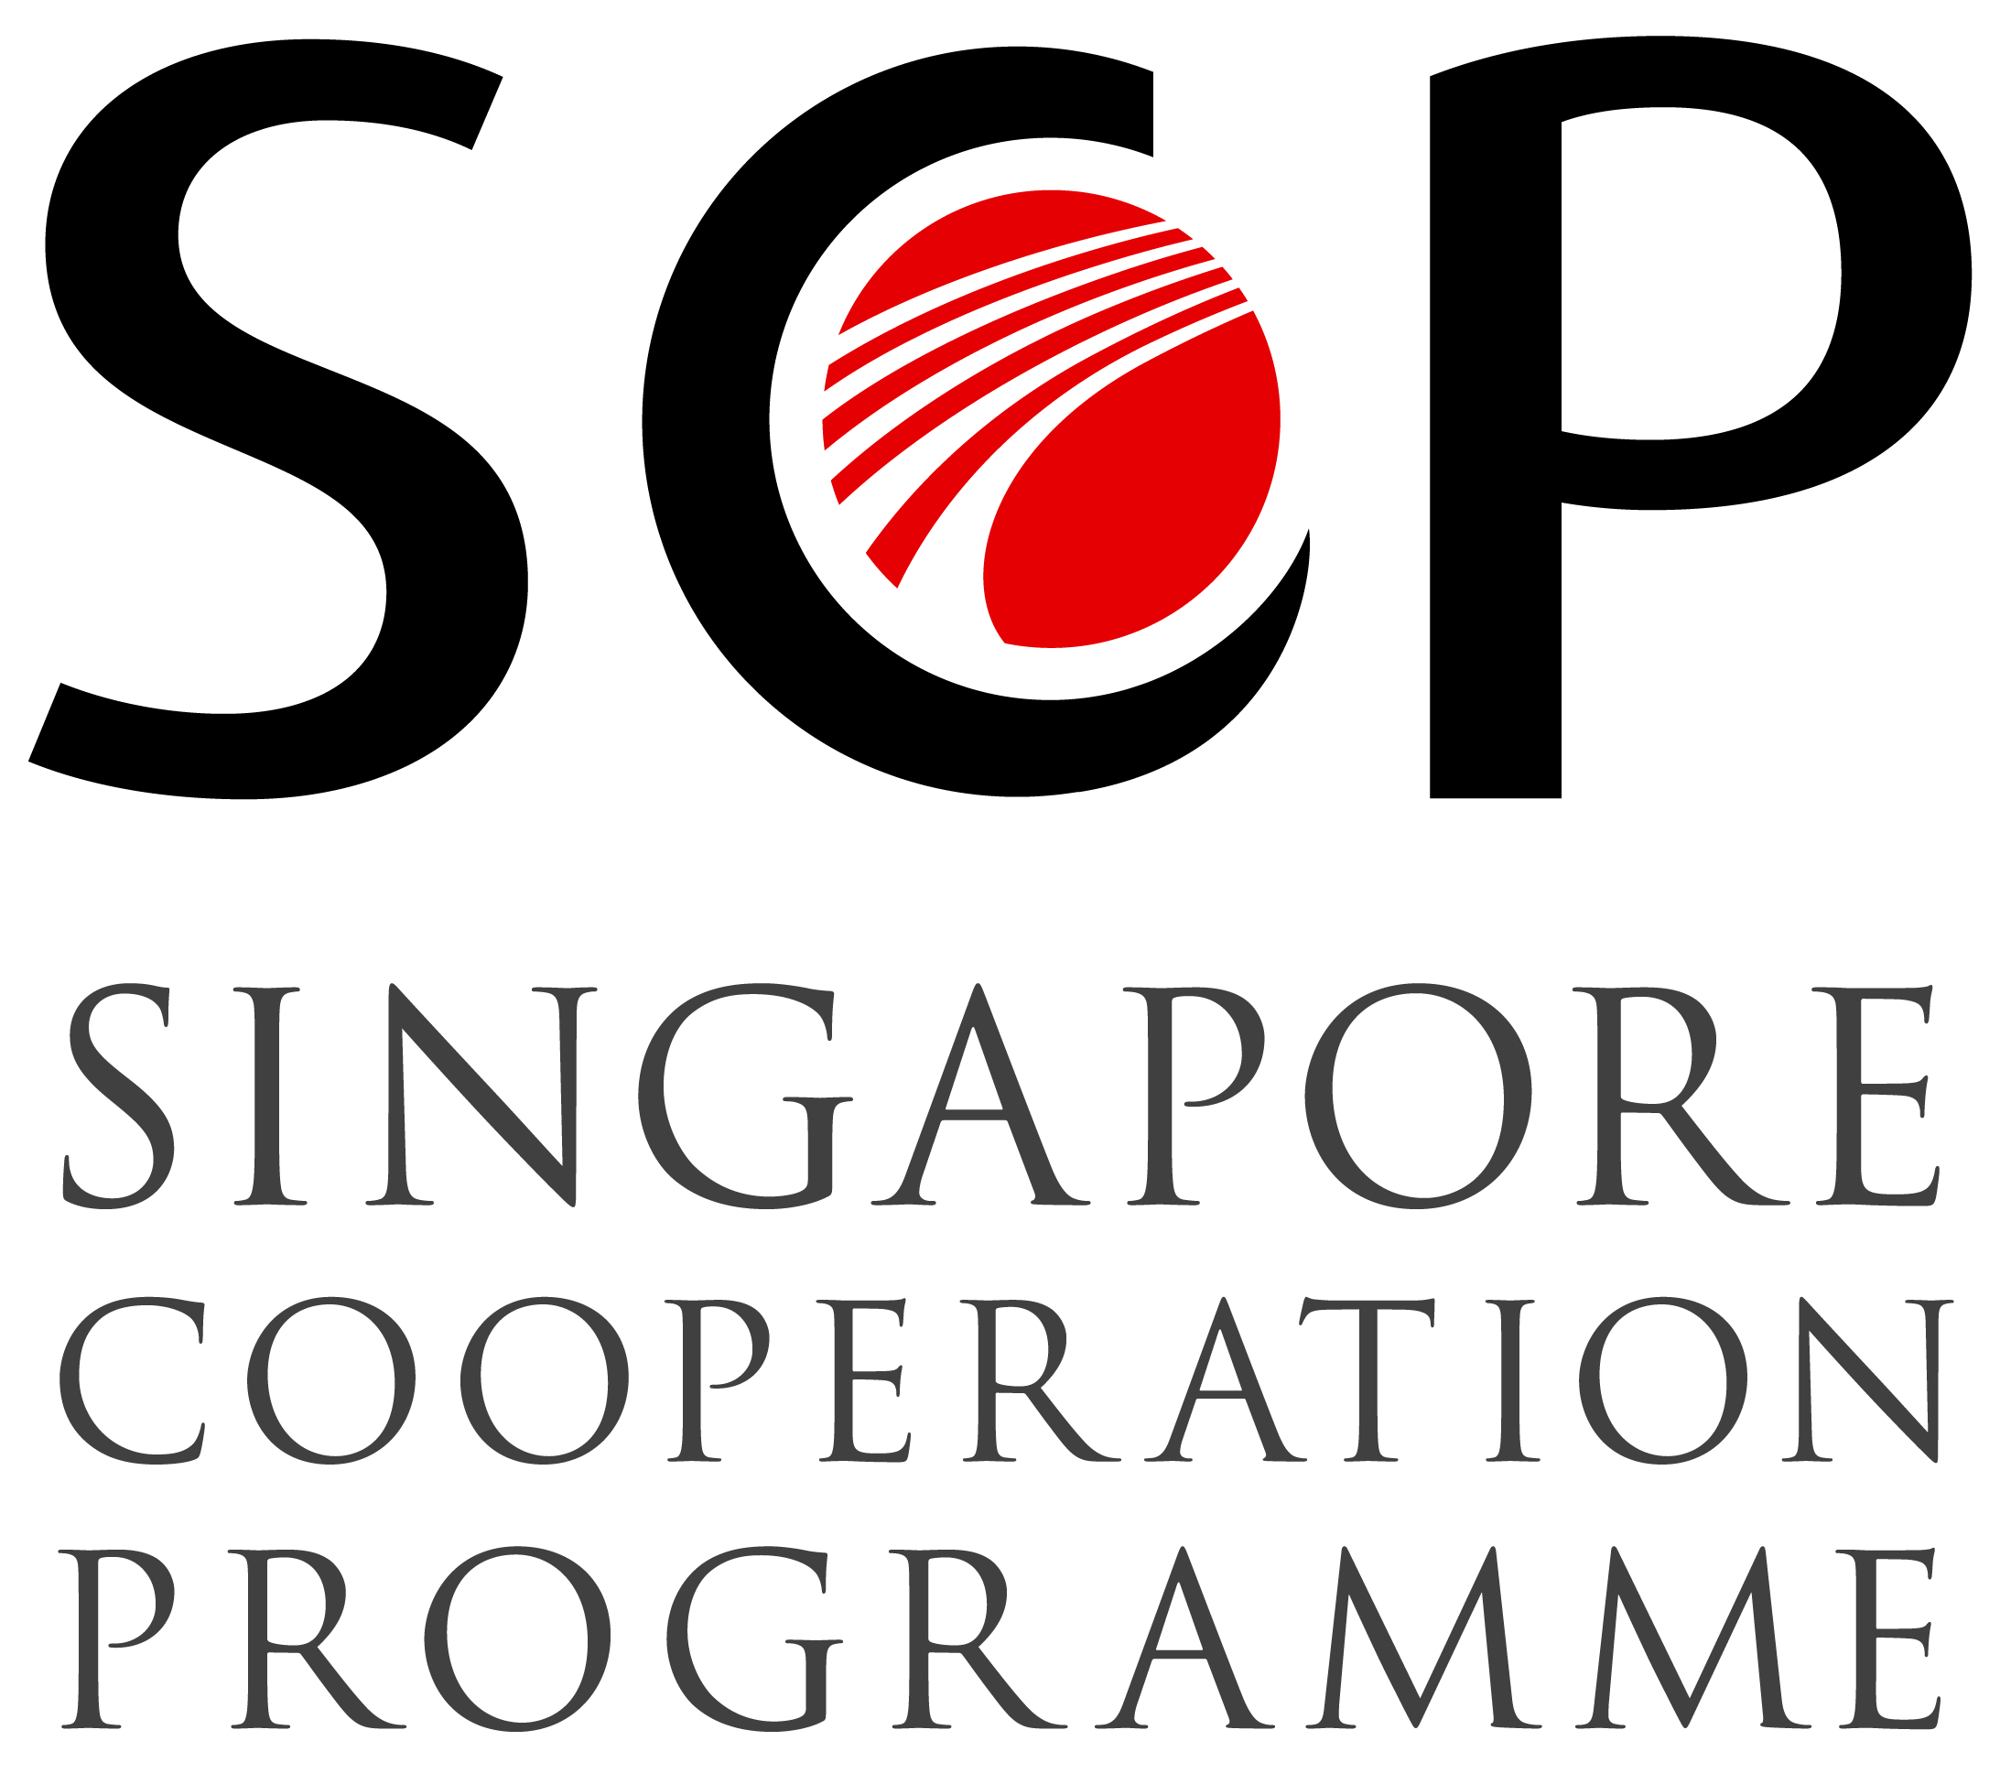 | 
SUB-Regional seminar
WIPO-ASEAN/IP/SIN/14/INF/1. PROV
ORIGINAL: English
DATE: august 6, 2014

Maximizing the value of patent-related platforms, tools and services for ASEAN

organized by
the World Intellectual Property Organization (WIPO)

in cooperation with
the Singapore Cooperation Programme (SCP)

and with the assistance of
the Intellectual Property Office of Singapore (IPOS)

Singapore, August 25 and 26, 2014

PROVISIONAL Program

prepared by the Secretariat

Monday, August 25, 2014 – Venue: WIPO Singapore Office

9.45 – 10.00 | Registration
10.00 – 10.30 | Opening ceremony
 | Opening remarks by:
 | Dr. Francis Gurry, Director General, World Intellectual Property Organization (WIPO)
 | Mr. Tan Yih San, Chief Executive, Intellectual Property Office of Singapore
 | Official photograph
10.30 – 10.45 | Coffee Break
10.45 – 11.45 | Topic 1: | The ASEAN Patent Examination Cooperation (ASPEC) and its benefits for innovators, patent professionals, and IP Offices
 | Speakers: | - Mr Eric Toh, Manager, Registry of Patents, IPOS  - Mr Akimichi Tanabe, Japanese Patent Attorney, Felicite IP Consulting Singapore  - Mr Kristian Robinson, Director, Spruson & Ferguson Asia and President, Association of Singapore Patent Attorneys
11.45 – 12:30 | Topic 2: | WIPO’s patent-related platforms, tools and services for innovators, patent professionals, and IP Offices
 | Speaker: | Mr. Matthew Bryan, Director, Patent Cooperation Treaty Legal Division, WIPO
12.30 – 13.30 | Lunch Break
13.30 – 15.00 | Topic 3: | Experience with WIPO’s patent-related platforms, tools and services: ASEAN IP Offices, patent professionals, and universities/R&D centers
 | Speakers: | - Dr Xie Rongguo, Patent Examiner, Search and Examination Unit, IPOS
 |  | - Ms. Le Thi Kim Dzung, Partner, Vision & Associates, Vietnam
 |  | - Prof. Roberto Pagulayan, Executive Director, Center for Research and Development, Angeles University Foundation, Philippines
15.00 – 16.00 | Topic 4: | International Collaboration: how the Patent Cooperation Treaty (PCT) is becoming an even more powerful tool for pursuing multinational patent protection
 | Speaker: | Mr. Matthew Bryan, Director, Patent Cooperation Treaty Legal Division, WIPO
16.00 – 16.20 | Coffee Break
16.20 – 17.00 | Topic 5: | Services provided by WIPO’s Arbitration and Mediation Center
 | Speaker: | Mr. Erik Wilbers, Director, WIPO Arbitration and Mediation Center
17.00 | WIPO Reception

Tuesday, August 26, 2014 – Venue: Marina Bay Sands Convention Centre

9.00 – 9.05 |  | Opening of IP Week @ SG 2014
 |  | Welcome Remarks
 | Speaker: | Mr.Tan Yih San, Chief Executive, IPOS
9.05 – 9.15 |  | Opening Address by Guest-of-Honour
 | Speaker: | Mr. K Shanmugam, Minister for Foreign Affairs/Law
9.15 – 9.20 |  | Launch of IP Valuation Centre
9.20 – 10.20 |  | Keynote address and Panel Discussion 1:  Global IP Landscape
 | Speakers: | - Dr. Francis Gurry, Director General, WIPO  - Mr. Mr Hitoshi Ito, Japan Patent Office, Commissioner  - Mr. Brian Hinman, Chief IP Officer, Philips  - Mr. Todd Dickinson, Former Director of USPTO
 | Moderator: | Mr. Geoffrey Yu, Adjunct Professor, Lee Kuan Yew School of Public Policy, National University of Singapore
10.20 – 10.40 | Coffee break
10.40 – 11.40 |  | Keynote Panel Discussion 2: Capturing Asia markets through intellectual property
 | Speakers: | - Mr. Kenichi Nagasawa, Group Executive of Corporate IP & Legal HQ, Canon  - Mr. Ben Wang, Head of Patents, Unilever, Shanghai  - Mr. Murali Neelakantan, Global General Counsel, CIPLA  - Mr. Kenneth K. Cho, Attorney, Kim & Chang
 | Moderator: | Ms. Toe Su Aung, Co-founder and Director, Elipe Limited
11.40 – 12.35 |  | Keynote Panel Discussion 3: IP in the Evolution of Business model: Past, present and future
 | Speakers: | - Dr. Tao Zhang, Director of IP Strategy, Huawei  - Mr. Tan Min-Liang, CEO and Chief Gamer, Razer  - Dr. N. Darius Sankey, Managing Director, Ocean Tomo
 | Moderator: | Ms. Audrey Yap Su Ming, Managing Partner, Yusarn Audrey
12.35 – 14.00 | Networking lunch
VENUE:  14.00 – 15.00 | Topic 6: | Angsana Junior Room,  Marina Bay Sands Convention Center  Issues facing patent professionals and R&D Institutions in the ASEAN region
 | Speakers: | - Ms. Yenny Halim, Partner and Managing Director, Acemark, Indonesia  - Mr Sanparwat Vithayasai, Manager of Technology Licensing Office, Chiang Mai University, Thailand
 | Moderator: | Mr. Matthew Bryan, Director, Patent Cooperation Treaty Legal Division, WIPO
15.00 – 15.15 | Coffee break
15.15 – 16.15 | Topic 7: | ASEAN IP harmonization: striking the delicate balance
 | Speaker: | Associate Professor Elizabeth Ng Siew Kuan, National University of Singapore
16.15 – 17.15 | Topic 8: | Working group session: R&D Sector/Patent Agent/IP Office collaboration to effectively use patent-related platforms, tools and services.
 | Speakers: | Delegates to form country groups to discuss collaboration strategies upon their return to their respective countries
 | Moderator: | Mr. Peter Willimott, Senior Program Officer, WIPO Office in Singapore
17.15 – 17.30 | Topic 9: | Seminar wrap up and conclusions
 | Moderator: | Mr. Matthew Bryan, Director, Patent Cooperation Treaty Legal Division, WIPO
17.30 – 17.40  18.30 – 19.00  19.00 – 21.00 | Closing ceremony  Cocktail Reception Venue: IP Ecosystem Fair  Gala dinner and WIPO-IPOS IP Awards 2014 at Marina Bay Sands

