WIPO |  | E  IIM/3/2  ORIGINAL: English  DATE: July 18, 2005
WORLD INTELLECTUAL PROPERTY ORGANIZATION
GENEVA
Inter-sessional Intergovernmental meeting
on a development agenda for WIPO

Third Session
Geneva, July 20 to 22, 2005
PROPOSAL BY MOROCCO ON BEHALF OF the AFRICAN GROUP ENTITLED
“THE AFRICAN PROPOSAL FOR THE ESTABLISHMENT OF A
DEVELOPMENT AGENDA FOR WIPO”
prepared by the Secretariat
1 In a communication dated July 15, 2005, the International Bureau received a proposal from Morocco on behalf of the African Group entitled “The African Proposal for the Establishment of a Development Agenda for the World Intellectual Property Organization (WIPO)” for the Third Session of the Inter-Sessional Intergovernmental Meeting (IIM) on a Development Agenda for WIPO, to be held in Geneva from July 20 to 22, 2005. Morocco has requested that the proposal be translated and distributed to Member States prior to the said meeting.

2 The said proposal is annexed to this document.

3 The IIM is invited to note the contents of the proposal of the African Group as contained in the Annex.

[Annex follows]
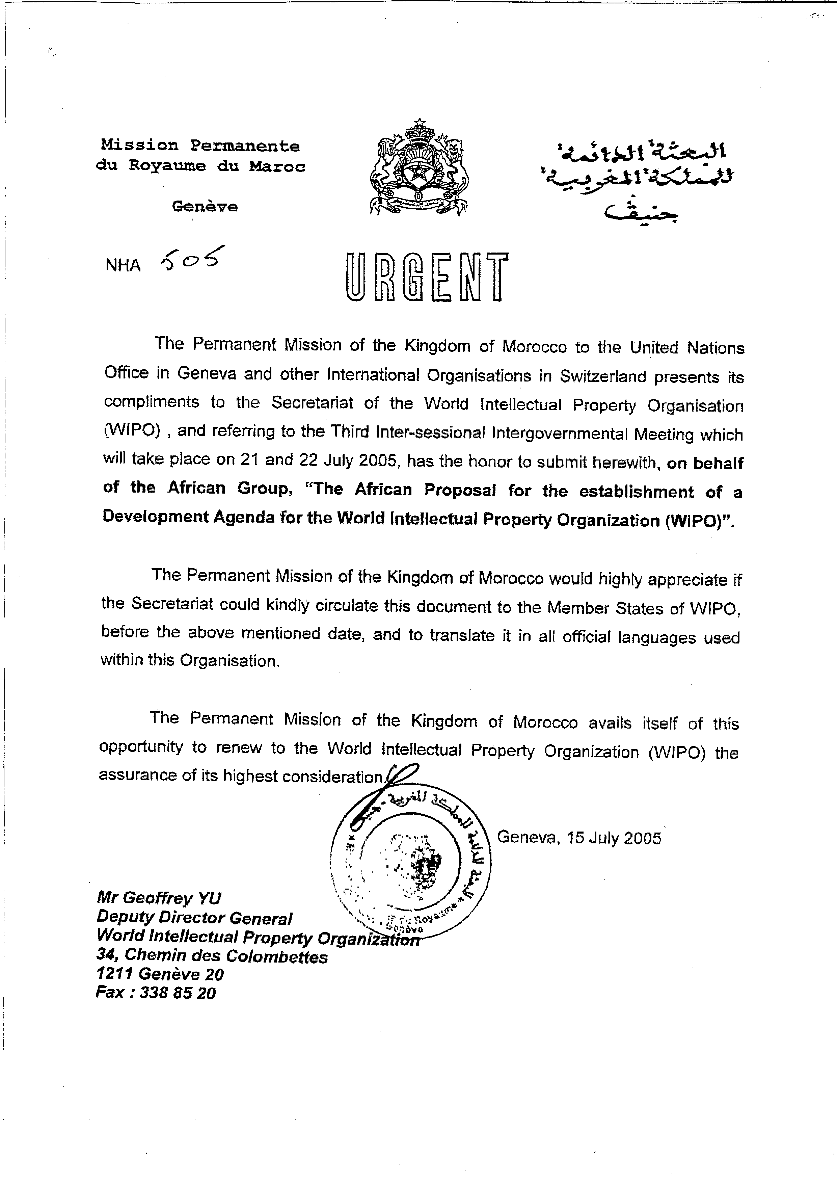
AFRICAN PROPOSAL FOR THE ESTABLISHMENT OF A DEVELOPMENT
AGENDA FOR THE WORLD INTELLECTUAL PROPERTY ORGANIZATION (WIPO).

A-Introduction:

1. The imperatives for development have never been more crucial or urgent for Africa than they are at the dawn of the 21st century. Africa's development needs have been underscored at several fora and by numerous declarations. In particular, they have been highlighted by the Millennium Summit (September 2000), the New Partnership for Africa's Development (NEPAD) Plan of Action (October 2001), the Monterrey Declaration on Financing for Development (March 2002), the Johannesburg Declaration on Sustainable Development (September 2002), The World Solidarity Fund (December 2002), the Marrakech High Level Conference on South-South Cooperation (December 2003), the first phase of the World Summit on the Information Society (WSIS, December 2003), the Digital Solidarity Fund (DSF, March 2004), the Asian-African Summit (April 2005) and the Doha South Summit Meeting (June 2005). The imperatives for development have also been underscored by several reports including those of the UNDP, the World Bank and the International Monetary Fund (IMF).

2. The African Group is of the view that development should be a comprehensive programme of attainment of better prospects in life for all people. As far as developing and least developed countries (LDCs) are concerned, development should mean the adoption of specific and integrated policy mechanisms for harnessing of their productive forces and natural resources for the upliftment of the quality of life of their populations. Any development agenda for these countries should therefore aim at overcoming their marginalization and improving their capacities for economic self-reliance and human development.

B- A Development Agenda for WIPO:

3. A development agenda for WIPO has become imperative in view of the expanding and deepening role that intellectual property (IP) plays in the social, economic and technological fabrics of the world. Creativity, innovation and scientific revolution are largely determining the course of human development, and intellectual property plays a key role in all these factors. In submitting a proposal for a development agenda for WIPO, the African Group is seeking to reinforce and elaborate its views and opinions that have been expressed severally at various venues in WIPO particularly at the Intersessional Intergovernmental Meetings (IIMs). The African Group also notes the proposals that have already been submitted by other delegations, notably the United Kingdom, the United States, Mexico and Bahrain.

4. It especially welcomes the proposal submitted by the Group of Friends of Development which it had previously supported in principle, as reflecting the concerns and interests of African countries.

5. The African Group is also guided in its call for a development agenda for WIPO by the outcome of the Second South Summit held in Doha, which inter alia called upon WIPO to integrate development agenda in its various activities.
C- Role of Intellectual Property (IP) in Development:

6. The African Group recognizes that IP can and does play an important role in fostering creativity, innovation and economic growth in developing countries. IP has therefore, became an important component of modem social, cultural, and economic systems of the world. Its importance has also been manifested in the existence of IP offices in Member States of WIPO, and the incorporation of IP laws into various national legislations. It is also underscored by individual countries' membership of WIPO and their accession to international instruments on intellectual property administered by the organization.

7. While appreciating these facts, it is necessary to underscore that IP is just one mechanism among many for bringing about development. It should be used to support and enhance the legitimate economic aspirations of all developing countries including LDCs, especially in the development of their productive forces, comprising of both human and natural resources. IP should therefore, be complimentary and not detrimental to individual national efforts at development, by becoming a veritable tool for economic growth.

8. Towards this objective, the existing international IP architecture should be made more democratic and responsive to the needs and aspirations of developing and least developed countries, especially in matters that are vital to the needs and welfare of their citizenry. IPRs and their enforcement should also be compatible with international human rights norms and standards, especially in matters relating to the livelihood and future prospects of people of developing countries. Their right to qualitative life, access to vital requirements such as medicines, food, knowledge and prospects for their intellectual and cultural development, should neither be unduly compromised nor hampered by rigid and indiscriminate enforcement of IPRs.

9. Societies develop at different rates depending upon their objective historical conditions. All human progress is based upon the foundation of knowledge, ideas, practices, innovations, creativity and industry that have been bequeathed to succeeding generations by previous ones. Therefore, knowledge has no bounds or confines, and has never had one single source. It is important in this context, to draw an acceptable balance between the legitimate and inalienable rights of nations to develop, and the need for enforcement of IPRs.

10. The African Group is also of the view in principle, that development is ultimately contingent upon the policies and objectives of individual countries themselves. Such policies should necessarily lead to programmes aimed at poverty reduction, income distribution, expansion of healthcare and educational facilities, building of infrastructure, etc, which would have a cumulative impact on economic growth and national capacity for development

D- Specific Proposals:

11. All WIPO activities in regards to development should, as much as possible, be consistent with existing international frameworks such as the MDGs, the Brussels Plan of Action for LDCs, the NEPAD Plan of Action, the World Solidarity Fund and others mentioned in this document. In this connection, the African Group proposes that the current discussion on the development agenda for WIPO should encompass the following substantive issues which are intrinsically related to development matters:

a- Imperatives for Development:

i. Technical Assistance: This should be development oriented and demand-driven. It should also be targeted at specific areas, including sub-regional and regional organizations, for maximum effect and should indicate time-frame for completion. Efficacy of technical assistance could be improved through, inter alia, impact assessments. Technical assistance should also strengthen national institutional capacity building with a view to making national intellectual property institutions more efficient and ensuring a fair balance between IP protection and safeguarding public interest. In this connection, WIPO should devote more resources to African countries with a view to further development of their infrastructure and other facilities to enable them make maximum use of intellectual property as a tool for national economic development. The African Group also calls for an increased level of assistance to WIPO especially by way of funding by upon donor countries, to enable the organization meet its commitments in regards to technical assistance work in Africa.

ii- Transfer of Technology : IP should facilitate rather than hinder the process of technology transfer to developing and least developed countries. Technology transfer is mainly governed by both national and international patent laws. WIPO should therefore, broaden its support for developing and least developed countries especially in enabling them to gain access to technology at reasonable cost. WIPO should also strengthen individual national capacity for patenting of local creations, innovations and inventions in order to develop national scientific and technological infrastructure. Furthermore, it should contribute effectively to individual nation's self-reliance in the area of technology by facilitating access to foreign patented information on technology and technical resources. Relaxation of patent rules should therefore, be considered as a policy option for developing and least developed countries to facilitate their drive towards technological and scientific development. In line with this requirement, WIPO should consider the creation of a new body for coordinating and implementing all transfer of technology policies and strategies.

In this respect, WIPO should also work jointly with UNCTAD and other organizations such as UNIDO, to develop and maintain a list of essential technologies, know-how, processes and methods that are necessary to meet the basic development needs of African countries aimed at protecting or rehabilitating the environment (water, sanitation, prevention of desertification, exhaustible natural resources), life and health of human being, animals and plants, education and food security. Furthermore, WIPO should work on developing criteria and a methodology to select essential technologies, monitor and facilitate the transfer and the diffusion of such technologies in accessible and affordable manner to African and other developing countries.

Transfer of technology should include any initiative intended to facilitate the implementation of technology-related provisions of Multilateral Environmental Agreements (MEAs) , so as to ensure that countries where biological, traditional or other environmental resources originate from, participate in the process of research and development; and share among themselves the results of such research.

iii. Reforming the Informal Sector in Africa: In order for African countries to develop and expand their economies, the challenge of the so called informal sector must be met. Its potential as major avenue of employment and income generation with a view to its full integration into national economy. WIPO's contribution should take into consideration African countries concerns regarding this sector, while creating the context for intellectual property protection. WIPO is therefore, called upon to conduct a study on obstacles to intellectual properly protection in developing countries with a
particular focus on the informal sector. WIPO should also undertake studies to determine the tangible costs and benefits of IP protection mainly in the informal sector, especially with regards to generation of employment. On the basis of such studies, specific areas in this sector could be targeted for assistance with a view to integrating them into the mainstream of economic activities in individual countries.

iv- Small and Medium Enterprises (SMEs): WIPO has rightly considered SMEs as engines of economic growth in developing countries. Therefore, the African Group welcomes the creation of the SME Unit within the International Bureau. WIPO should devise innovative ways and means, including the fostering of transfer of technology, to enable SMEs take better advantage of flexibilities as provided by relevant international agreements.

v- Information and Communication Technology (ICT) : The existing WIPOnet project should take into consideration the disparity between and among developing countries in their ICT infrastructure and facilities. WIPO should therefore expand the scope of its activities aimed at bridging the digital divide in accordance with the outcomes of the World Summit on the Information Society (WSIS). Therefore, future activities in this area especially in respect of existent proposals within the context of the development agenda should also take into account the significance of the Digital Solidarity Fund (DSF) as well as the forth-coming second phase of WSIS scheduled to hold in Tunisia in November 2005.

vi- Human Resources Development and the Brain Drain : National capacity for development is directly related to that nation's ability to train and retain a sufficient level of manpower relevant to its development needs. No development strategy would work in the face of large-scale exodus of highly trained and qualified work force. The trend needs to be reversed into a brain gain for Africa. The African Group also recognizes that the issue of brain drain is intricately linked to migration. African countries' economies should therefore, be assisted to become strong enough to retain higher levels of workforce domestically, in order to reduce and eventually eradicate the necessity for migration to other lands and climes for search of means of livelihood. WIPO, in cooperation with relevant international organizations, should therefore assist African countries to create, as appropriate, legal and regulatory framework in order to reverse brain drain into brain gain.

vii- Use of Flexibilities in International Instruments : WIPO should examine the flexibilities under the TRIPS Agreement and Doha with a view to giving practical advice to developing and least developed countries on how to enable them gain access to essential medicines and food, and also to information and knowledge for education and research. Developing and least developed countries need to be empowered to effectively use the flexibilities that have been provided in international instruments on intellectual property in order to enable them improve and expand their access to vital and indispensable factors of development. In this regard, they should in particular, have access to information and educational materials particularly of technical and scientific nature for their rapid development. They should also have access to medicines and healthcare facilities at affordable cost, Their populations should also be enabled to have access to adequate food and nutrition in order to survive and live decently. Protection of the environment, biodiversity, genetic resources, access to benefit sharing, etc, should also be considered within this context.

viii- Norm Setting: While the flexibilities outlined above could also be considered under norm setting, WIPO and its Member States are hereby urged to take a pragmatic and constructive posture in order to satisfactorily advance the negotiations currently going on in the Intergovernmental Committee on Intellectual Properly and Genetic Resources. Traditional Knowledge and Folklore (IGC). In this connection, the African Group requests the adoption of an internationally binding instrument on the protection of genetic resources, traditional Knowledge and folklore in the nearest future. Furthermore, the African Group is strongly of the opinion that there should be action in the following areas in terms of norm setting activities :
- Elaboration of a mechanism to facilitate access to knowledge and technology for developing and least developed countries;
- Conduct of an independent development impact assessment with respect to technical assistance, technology transfer and impact of new treaties on developing and least developed countries;
- Adoption of measures designed to improve participation by civil society and other stakeholders in WIPO activities relevant to their respective domains and interests.

In this respect, WIPO should also provide a specific assistance for LDCs, by establishing a Trust Fund within WIPO. Developed countries could provide, at this end, financial assistance to establish this Fund.

b- Institutional Mandates:

12. The African Group wishes to reiterate that the United Nations and all its specialized Agencies, including WIPO, as well as other international organizations, have an important role to play in development matters. It is therefore imperative that whenever necessary, these organizations should broaden their respective developmental programmes as far as developing and least developed countries are concerned. In this respect, WIPO should, intensify its cooperation with all UN agencies, in particular UNCTAD, UNEP, WHO, UNDP, WTO, ILO and other relevant international organizations bearing in mind the need for synergy, coordination and harmonization for maximum efficacy in undertaking of development programmes. WIPO's role and mandate in future should consist of development of an effective review and evaluation mechanism for efficient assessment of all its development-oriented activities. This evaluation should be a regular and continuous process to be carried out during each year.

[End of Annex and of document]

