 | 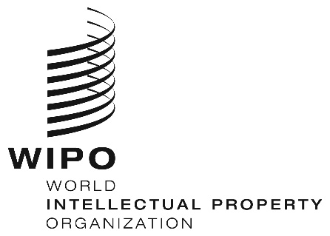 | E
CDIP/22/16
ORIGINAL: English
DATE: october 22, 2018

Committee on Development and Intellectual Property (CDIP)

Twenty-Second Session
Geneva, November 19 to 23, 2018

PROPOSAL FOR A DECLARATION ON WOMEN AND INTELLECTUAL PROPERTY SUBMITTED BY MEXICO

prepared by the Secretariat

In a communication dated October 15, 2018, the Permanent Mission of Mexico has submitted to the Secretariat a proposal entitled “Declaration on Women and Intellectual Property (IP)”, as its contribution to the discussion on Women and IP under the agenda item IP and Development.

The above-mentioned submission from the Permanent Mission of Mexico is contained in the Annex to this document.

3. The CDIP is invited to consider the information contained in this document.

[Annex follows]

PROPOSAL SUBMITTED BY THE DELEGATION OF MEXICO
Original text in Spanish

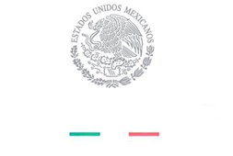

PERMANENT MISSION OF MEXICO

OGE03787

The Permanent Mission of Mexico to the United Nations Office and other International Organizations in Geneva presents its complements to the World Intellectual Property Organization (WIPO) and has the honor to share the document titled “Declaration on Women and Intellectual Property” for consideration at the 22nd session of the Committee on Development and Intellectual Property (CDIP) that will be held from November 19 to 23, 2018.

The Permanent Mission of Mexico presents this proposal as a contribution to the discussion on “Women and Intellectual Property”, which the Committee decided to discuss under Agenda Item “Intellectual Property and Development”. With this initiative, Mexico seeks to contribute to the examination of this important topic within WIPO and to continue the work of advancing the inclusion of women in intellectual property.
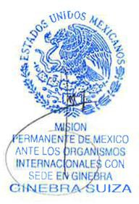
The Permanent Mission of Mexico to the United Nations Office at Geneva wishes to take the opportunity to reiterate to the World Intellectual Property Organization the assurances of its highest consideration.

Geneva, October 15, 2018

To the World Intellectual
Property Organization (WIPO)
Geneva

Original text in English
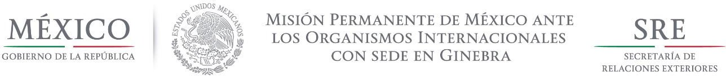

ANNEX
DRAFT PROPOSED BY MEXICO

Declaration on Women and Intellectual Property November 2018

Acknowledging the importance of incorporating a gender perspective into the promotion of inclusive economic growth, and the key role that gender-responsive policies can play in achieving sustainable socioeconomic development;
Acknowledging that inclusive IP policies can contribute to advancing gender equality and women’s and girls’ empowerment, which has a positive impact on innovation and economic growth;
Acknowledging that improving women’s access to opportunities and removing barriers to their participation in national and international economies contributes to sustainable economic development;
Acknowledging that innovation and creativity are the engines of human progress;
Having in mind that gender gaps reflect widespread gender inequality in social and economic life;
Bearing in mind the standout fact that far more men than women gain patents for their inventions;
Emphasizing the role of science and technology in finding solutions to tackle some of the major problems humanity faces through innovative solutions;
Taking into account the evidence that increased participation by women and girls improves the innovation performance of societies;
Reaffirming the commitment to effectively implement the obligations under the Convention on the Elimination of all Forms of Discrimination Against Women, adopted by the United Nations General Assembly on 18 December 1979;
Recalling Goal 5 of the Sustainable Development Goals in the United Nations 2030 Agenda for Sustainable Development, which is to achieve gender equality and empower all women and girls and the importance of mainstreaming gender equality through all the Agenda;
Recalling also Goal 9 “Industry, innovation and infrastructure” and the fact that investment in infrastructure and innovation are crucial drivers of economic growth and development;
Recognizing that gender equality and the empowerment of women and girls are integral to all dimensions of inclusive and sustainable development, and as such, a critical enabler to progress across the entire 2030 Agenda for Sustainable Development;
Bearing in mind WIPO is the lead agency within the United Nations on issues of IP, technology and innovation in line with the United Nations Sustainable Development Goals;
Recognizing WIPO´s Policy on Gender Equality in 2014 and the commitment of the Organization to making gender equality a cross-cutting issue which is mainstreamed across all Strategic Goals of WIPOi;
Acknowledging the 2018 World Intellectual Property Day campaign –Powering change: Women in innovation and creativity-; and
Recognizing that according to WIPO more women than ever before are using the international patent system, though there is still a long way to achieve gender parity.

WIPO Member states declare its commitment to the following:
- Reaffirm gender equality as a human right.

- Recognize the contribution of women innovators and creators.

- Express their interest to encourage innovation and creativity by making sure that women innovators and creators can gain a fair reward for their work and earn a living from it.

- Reduce the gender gap among innovators and creators.

- Work towards the implementation of policies and practices aimed to foster women and girls’ empowerment to have their full participation in innovation and creativity.

- Develop affirmative actions to promote the inclusion of women and girls on science and technology, as well as, in the innovation decision taken processes.

- Share experiences relating to policies and practices to enable women and girls’ participation in the field of IP.

- Share best practices on multi-stakeholder’s initiatives to encourage more girls and women to create valuable intellectual property.

- Share best practices for supporting women inventors and entrepreneurs and empowering women in IP management.

- Share programs to encourage and enable young women to foster their talents in science, technology, engineering and mathematics, (the STEM subjects) and the arts by facilitating their access to quality education and allowing them to develop the skills, information and knowledge necessary to support their labour market entry, in particular in the field of IP.

- Share best practices of an inclusive IP system used by everyone towards acquiring and owning IP rights.
- Work together with WIPO on the identification of barriers that limit women’s participation in IP.

In the same vein, member states encourage WIPO to:
- Compile comparable and disaggregated international data on the gender of IP rights owners and creators.

- Share methods and procedures for the collection of gender-disaggregated data, the use of indicators, the monitoring and evaluation methodologies, and the economic analysis of gender gaps related to IP.

- Strengthen the implementation of WIPO´s Policy on Gender Equality.

- Continue through WIPO Academy to empowering women through its range of IP training and capacity-building programs.

- Assist member states on the implementation of measures and programs aimed to encourage women and girl´s involvement in IP.

i As reflected in the Program and Budget for the 2018-2019 biennium.

[End of Annex and of document]

