E
CDIP/22/10
ORIGINAL: English
DATE: September 18, 2018

Committee on Development and Intellectual Property (CDIP)

Twenty-Second Session
Geneva, November 19 to 23, 2018

ASSESSMENT OF WIPO’S EXISTING TOOLS AND METHODOLOGIES FOR MEASURING THE IMPACT, EFFECTIVENESS AND EFFICIENCY OF ITS TECHNICAL ASSISTANCE ACTIVITIES

prepared by the Secretariat

The Committee on Development and Intellectual Property (CDIP) at its eighteenth session held from October 31 to November 4, 2016, approved a six-point proposal, which, inter alia, requested the Secretariat to “assess the existing tools and methodologies for measuring the impact, effectiveness and efficiency of technical assistance activities at various levels and, in this process, strive to identify areas for possible improvement.” This document seeks to respond to the above request.

As defined in the Compilation of WIPO’s Existing Practices, Methodologies and Tools for Providing Technical Assistance (Document CDIP/21/4, paragraph 10), WIPO’s technical assistance (TA) activities are categorized as follows: (a) National IP Strategies and Development Plans; (b) Technical and Administrative Infrastructure (solutions for IP Offices, databases); (c) Capacity Building; (d) Legislative Assistance; (e) Development Agenda-related projects; and (f) Public-Private partnerships (multi-stakeholder platforms). For assessing and measuring the impact, effectiveness and efficiency of technical assistance (TA) activities at the organizational, program, and project levels, as well as by geographical area, and by category of technical assistance, WIPO uses a multi-faceted approach as outlined below.
At the organizational level, the WIPO Results-Based Management (RBM) framework, defined and approved by Member States in the Program and Budget, sets the criteria, i.e. the performance indicators (PIs), baselines and targets, against which performance towards achieving the Expected results (ERs) in a biennium will be assessed, including for WIPO’s technical assistance activities. The WIPO Program and Budget also provides views of the RBM framework by Strategic Goal, ER and for each of WIPO’s 31 programs.

The principal accountability tool for reporting on organizational performance to Member States is the annual WIPO Performance Report (WPR), which forms an integral part of WIPO’s RBM framework. The WPR is prepared in accordance with Regulations 2.14 and 2.14bis of the Financial Regulations and Rules approved by the Assemblies in October 2017 and provides a comprehensive and transparent assessment of financial and programmatic performance in a given biennium. The assessment of performance is based on the results framework approved by Member States in the Program and Budget.

The performance assessment performed for the WPR also serves as an important learning tool to ensure that lessons learned from past performance are duly incorporated into the future implementation of WIPO’s activities and inform the definition of subsequent results frameworks. In this context, WIPO’s RBM framework has undergone continuous improvement since the 2012/13 biennium, as evidenced by the Internal Oversight Division (IOD) Validation Report of the WIPO Performance Report 2016/17 (Document WO/PBC/28/8).

To strengthen the validity of the performance assessment in the WPR, WIPO’s Internal Oversight Division (IOD) carries out a validation of the performance data on a biennial basis. The findings and recommendations of the validation provide a valuable tool for informing subsequent planning cycles, including, inter alia, with regard to strengthening performance indicators, baseline and target formulations, refining and streamlining the results framework, and enhancing data collection mechanisms to ensure that data are: (i) relevant/valuable; (ii) sufficient/comprehensive; (iii) efficiently collected/easily accessible; (iv) accurate/verifiable; (v) reported timely; and (vi) clear/transparent.

To further assess the effectiveness, efficiency, impact and sustainability of WIPO’s work, IOD carries out five primary types of in-depth evaluations: (i) program evaluations; (ii) strategic evaluations; (iii) thematic evaluations; (iv) geographical (country/regional) evaluations; and (v) project and process evaluations. The recommendations and findings from these evaluations are duly taken into consideration for subsequent organizational planning cycles and project planning with a view to continuous improvement of WIPO’s technical assistance.

In addition to the IOD evaluations, all DA Projects are evaluated after their completion by an independent, external expert selected specifically for a given project to measure the success of the project, ensure the sustainability of the outputs, and to facilitate the effective mainstreaming into the regular work of the Organization, when applicable.

The examples below provide concrete examples of the evolution of the tools, methodologies and indicator frameworks used for measuring the impact, effectiveness and efficiency of technical assistance activities related to: (i) National IP Strategies and Development Plans; (ii) Technology Innovation Support Centers (TISCs); and (iii) Capacity Building.

National IP Strategies and Development Plans

Since 2010/11, the formulation of national IP strategies and/or development plans has been an integral part WIPO’s work, facilitated through the development of a standardized, yet flexible, methodology and a set of practical benchmarking tools. These tools are intended to assist officials involved in the development of national IP strategies in assessing the status of their national IP system, identifying specific IP needs, and defining strategic targets.

The performance indicator framework used for measuring the impact of WIPO’s technical assistance in this area has evolved over the course of five biennia, informed by past performance cycles and incorporating lessons learned with a view to ensuring clear and measurable reporting of longer-term impact.

Biennium | Performance Indicator | Comments
2010/11 | - Up to five countries have launched the IP policy/strategy formulation process, four countries have adopted IP policies/strategies and 3 countries are implementing national IP plans (Africa)  - Some three national IP strategies formulated and adopted based on a multi-sectoral coordination and consultation (Arab)  - Nine new countries have formulated and/or adopted national IP policies/strategies/plans (Asian and the Pacific)  - Up to three new countries which have formulated and/or adopted national IP/policies, strategies and plans (Latin America and the Caribbean)  - IP Policy/strategies prepared in up to five LDCs during the biennium (LDCs) | - Inconsistent formulation of ERs and PIs across Bureaus resulting in a lack of comparability across regions  - PIs do not cover the full process of national IP strategy development, i.e. from formulation to adoption to implementation and to subsequent revision  - PIs measuring several things, i.e. lack of clarity  - Output-focused PIs with limited ability to measure the outcome of the technical assistance
2012/13 | - No. of countries that have formulated and/or are engaged in implementation of their IP Policies, Strategies and/or Plans each year (Africa)  - No. of countries with appropriate mechanisms for the development and implementation of IP strategies (Arab region)  - No. of countries with initiatives linked to the national IP plans (Arab region)  - No. of countries with IP policies and strategies in their national approval processes (Asia and the Pacific)  - No. of countries having adopted IP policies and strategies (Asia and the Pacific)  - No. of countries in which activities/projects have been carried out that contribute to the formulation of IP strategies/ policies (Latin America and the Caribbean)  - No. of countries in which activities/projects have been carried out that contribute to the implementation of IP strategies/policies (Latin America and the Caribbean)  - No. of LDCs that have included LDC-specific IP considerations in their national IP strategies and/or policies (LDCs) | - ERs harmonized at the organizational level  - Inconsistent formulation of PIs across Bureaus resulting in a lack of comparability across regions  - PIs do not cover the full process of national IP strategy development, i.e. from formulation to adoption to implementation to revision  - PIs measuring several things, i.e. lack of clarity  - Output-focused PIs with limited ability to measure the outcome of the technical assistance
2014/15 | - No. of countries which are in the process of formulating/adopting national IP strategies and/or development plans  - No. of countries which have adopted and are implementing national IP strategies and/or development plans | - PIs harmonized across Bureaus allowing comparability across regions  - PIs capture the process from formulation of a national IP strategy to implementation  - PIs measuring several things, i.e. lack of clarity
2016/17 | - No. of countries which are in the process of formulating national IP strategies  - No. of countries which have adopted national innovation and IP strategies  - No. of countries which are in the process of implementing national innovation and IP strategies and IP development plans | - PIs harmonized across Bureaus allowing comparability across regions  - PIs capture the process from formulation of a national IP strategy to adoption to implementation  - PIs clearly defined, i.e. each PI measure one stage of the process
2018/19 | - No. of countries that are in the process of formulating national IP strategies  - No. of countries that have adopted national IP strategies  - No. of countries that are in the process of implementing national IP strategies and IP development plans  - No. of countries which are revising their IP strategies | - PIs harmonized across Bureaus allowing comparability across regions  - PIs now capture the process from formulation of a national IP strategy to adoption to implementation to revision  - PIs clearly defined, i.e. each PI measure one stage of the process

The improvements to the performance indicator framework have strengthened WIPO’s ability to measure the evolution of results and longer-term impact across biennia, as illustrated in the chart below.

No. of Countries Having Adopted National IP Strategies | No. of Countries Implementing National IP Strategies
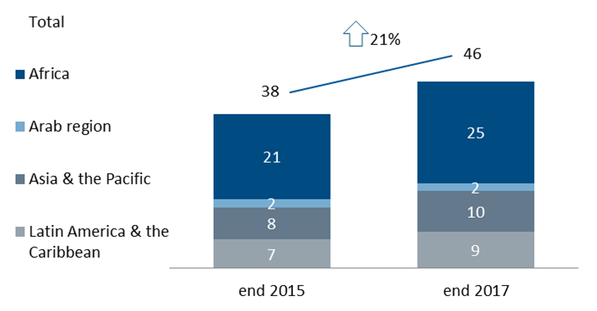 | 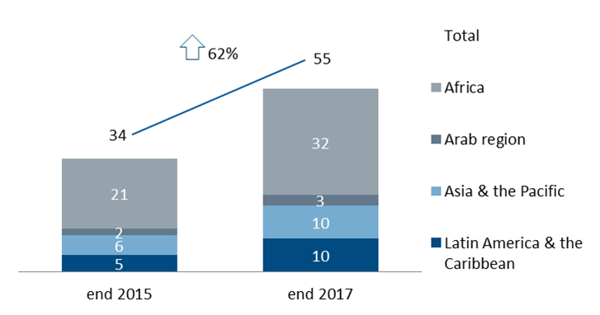

Technology Innovation Support Centers (TISCs)

The DA Project to establish TISCs was launched in 2009 and fully mainstreamed into the regular work of WIPO in 2014. The Program and Budget 2010/11 incorporated, for the first time, a TISC-specific performance indicator into the results framework to measure the impact of the project. The performance indicator framework used for measuring the impact of WIPO’s technical assistance in this area has evolved over the course of five biennia, informed by past performance cycles and incorporating lessons learned, from output-oriented to outcome-oriented results and a clearly-defined measurement methodology.

Biennium | Performance Indicator | Criteria
2010/11 | No. of TISC beneficiaries that perceived the TISCs as a central point of expertise for patent and technology information by country | - Performance data actually reported referred to the number of TISCs established and not the perception of TISCs as a central point of expertise  - Measurement criteria not clearly defined
2012/13 | No. of national TISC networks launched | - Performance data actually reported referred to both the number of TISC networks that were launched and the number of TISCs established  - Measurement criteria not clearly defined
2014/15 | No. of sustainable national networks of TISCs | - Measured the sustainability of the TISC network  - Sustainability criteria not clearly defined
2016/17 | Cumulative no. of sustainable national TISC networks | - Sustainability criteria clearly defined  - Measured through clearly defined levels of maturity
2018/19 | No. of sustainable national TISC networks | - Sustainability criteria clearly defined  - Measured through clearly defined levels of maturity  - Comparability across biennia feasible

14. Under the new methodology, sustainable TISCs are defined as financially and technically self-supporting institutions to which WIPO provides advice on demand. Sustainability is measured through the following levels of maturity:
- Maturity Level 1: (a) Signing of a Service Level Agreement (SLA) between WIPO and the National Focal Point; (b) signing of Institutional Agreements between the National Focal Point and TISC Host Institutions; and (c) provision of at least an annual report on national TISC activities; maturity Level 1 fully achieved when a + b + c.
- Maturity Level 2: Level 1 standards having been met plus the provision of basic patent information searches, e.g. state of the art patent searches; and
- Maturity Level 3: Level 2 standards having been met plus the provision of value added IP services, e.g. drafting of patent landscape reports.
The improvements to the performance indicator framework have strengthened WIPO’s ability to measure the evolution of results and longer-term impact across biennia, as illustrated in the chart below.

The Breakdown of Sustainable TISC Networks by Maturity Level (end 2017)

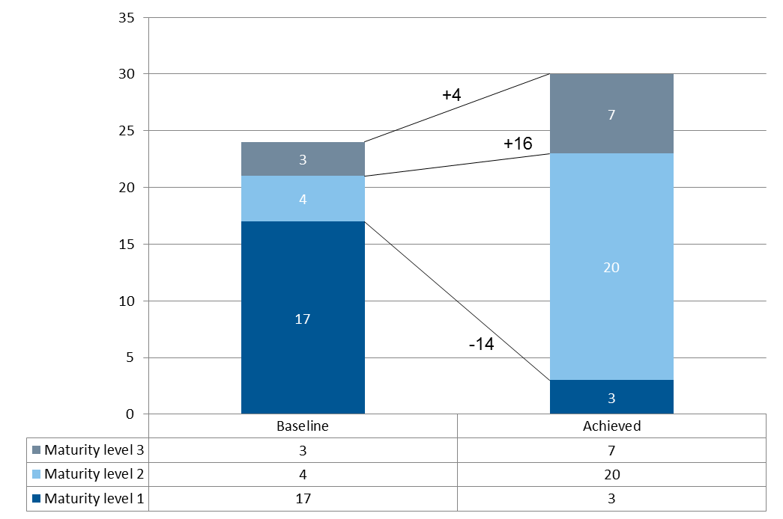

Capacity Building

15. WIPO invests a significant amount of resources to enhance human resource capacities for the effective use of IP in developing and transition countries and LDCs, and measuring the results of this work is essential to achieving the desired outcomes. The table below illustrates the types of performance indicators used for measuring the results of WIPO’s capacity building activities over five biennia, using the Kirkpatrick Model of Capacity Building Evaluation (Kirkpatrick Model).

 |  | Biennium
Kirkpatrick Level | What is measured | 2020/11 | 2012/13 | 2014/15 | 2016/17 | 2018/19
1 Reaction | Measures the level of satisfaction of the participant |  |  |  |  | 
2 Learning | Measures the increase in knowledge - before and after the training |  |  |  |  | 
3 Behavior | Measures the extent of applied learning on the job |  |  |  |  | 
4 Results | Measures the overall effect of the training on the business, environment and/or participant

16. Traditionally, the performance indicator framework to measure the impact of WIPO’s capacity building activities has primarily focused on satisfaction with WIPO capacity building events, i.e. Level 1 “Reaction” of the Kirkpatrick Model.

17. In line with WIPO’s continuous efforts to focus more on outcomes and the longer-term impact on improving beneficiaries’ institutional capacity, a pilot project to strengthen the capacity building performance indicator framework, applying a more systematic application of the Kirkpatrick Model, was launched for the 2018/19 biennium. The pilot project includes select programs across WIPO and focuses on: (i) clearly categorizing capacity building activities; (ii) enhancing the performance indicator framework to measure Level 2 “Learning” and strengthening the indicators to measure Level 3 “Behavior” of the Kirkpatrick model; (iii) strengthening and harmonizing formulation of performance indicators, baselines and targets across the Organization; (iv) developing more systematic and harmonized data collection mechanisms; and (v) fostering enhanced cross-sectoral collaboration and knowledge sharing. The table below provides examples of performance indicators from WIPO’s 2018/19 results framework, which form a part of the pilot.

2018/19 Results Framework: Capacity Building Performance Indicators- Pilot Project (examples)
Promotion & Awareness Raising Activities
Performance Indicator | Baseline | Target | Data Collection Mechanism | Kirkpatrick Level
No. and % of participants providing positive feedback with general awareness raising and promotional activities on trademarks, industrial designs and geographical indications (Program 2) | TBD | 80% of respondents provide positive feedback | Survey questionnaire | Reaction
Level of satisfaction of participants in general awareness raising and promotional activities related to GRs, TK and TCEs (Program 4) | n/a | 80% | Survey questionnaire | Reaction
Education Activities
Performance Indicator | Baseline | Target | Data Collection Mechanism | Kirkpatrick Level
Exam pass rate in advanced DL courses (Program 11) | 69% (2014/15) | 70% | Exams | Learning
Training & Capacity Building Activities
Performance Indicator | Baseline | Target | Data Collection Mechanism | Kirkpatrick Level
Level of satisfaction of participants in WIPO patent-related capacity building and training activities (Program 1) | TBD end 2017 | 90% | Survey questionnaire | Reaction
Level of satisfaction of participants in WIPO training and capacity building activities (Program 17) | Usefulness: 92%  Satisfaction: 92% | Relevance: > 85%  Usefulness: > 85% | Survey questionnaire | Reaction
% of participants in WIPO patent-related capacity building and training activities with a demonstrated increase in knowledge (Program 1) | TBD end 2017 | 90% | Short multiple-choice substantive questionnaires (pre-training & post-training) | Learning
No. and % of participants in training and capacity-building activities who obtain a 60% or higher score in a short multiple choice substantive questionnaire (Program 9) | n/a | Asia and the Pacific (80%) | Short multiple-choice substantive questionnaires (pre-training & post-training) | Learning
% of participants in WIPO training and capacity building activities from TMOs in universities or research organizations who apply the enhanced knowledge and upgraded skills in their work (Program 30) | n/a | 65% | 6-month post training questionnaires sent to both the trainee and the supervisor | Behavior
% of trained IP professionals and IP Officials using upgraded skills in their work (Program 10) | 83% | 80% | 6-month post training questionnaires sent to both the trainee and the supervisor | Behavior

18. WIPO will continue its concerted efforts to assess its existing tools and methodologies for measuring the impact, effectiveness and efficiency of technical assistance activities with a view to implementing value-added enhancements where possible and addressing deficiencies. WIPO will also continue to refine and enhance its performance indicator framework, incorporating lessons learned and considering relevant recommendations from evaluations, in order to strengthen its monitoring and assessment of the longer-term results of WIPO technical assistance.

19. The CDIP is invited to consider the information contained in this document.

[End of document]

Appendix I of the Summary by the Chair of the seventeenth session of the CDIP is available at http://www.wipo.int/meetings/en/doc_details.jsp?doc_id=335277.

