|  |  |  |
| --- | --- | --- |
|  | WIPO-E | **E** |
| CDIP/14/INF/5 | | |
| ORIGINAL: english | | |
| DATE:  SEPTEMBER 9, 2014 | | |

**Committee on Development and Intellectual Property (CDIP)**

**Fourteenth Session**

**Geneva, November 10 to 14, 2014**

study on the use OF intellectual property and Export Performance of Brazilian Firms

*prepared by the Secretariat in cooperation with Ms. Graziela Ferrero Zucoloto, Researcher, Instituto de Pesquisa Economica Aplicada (IPEA), Brazil, and Mr. Sergio Leão, Researcher, Pontifica Universidade Catolica, Rio de Janeiro, Brazil*

1. The Annex to this document contains a Study on the use of intellectual property in Brazil prepared under the Project on Intellectual Property and Socio-Economic Development (CDIP/5/7 Rev.) approved by the Committee on Development and Intellectual Property (CDIP) in its Fifth Session, held in April 2010.

2. The CDIP is invited to take note of the information contained in the Annex to this document.

[Annex follows]

# EXECUTIVE SUMMARY

This report aims to evaluate the strategies of Brazilian manufacturing firms in their use of intellectual property (IP) and its impact in their export performance.

The correlation between exports and innovative activities is already consolidated in the existing literature. Innovative firms tend to be more intensive in exports, compared to firms that do not innovate. Moreover, both exporting and innovative firms are, in general, larger, more productive and more intensive in skilled labor. Existing studies have already signaled a correlation between innovation and exports of Brazilian firms.

This report contributes to this literature by analyzing on which extent the better export performance of innovative firms may be related to different IP-related appropriation strategies. In order to answer this question, we analyze the export behavior of industrial innovative firms, aiming to identify the relevance of each IP appropriation instrument. The main appropriation methods analyzed in this report are invention patents, utility models, industrial designs and trademarks.

The data used in this report was consolidated from three different statistical sources: (1) the *Pesquisa de Inovação Tecnologica* (PINTEC) from the *Instituto Brasileiro de Geografia e Estatistica* (IBGE); (2) the *Secretaria de Comercio Exterior* (SECEX), under the *Ministério do Desenvolvimento, Indústria e Comercio* (MDIC); and, (3) the RAIS database of the *Ministério do Trabalho e Emprego* (MTE). The main reason we make use of PINTEC is that this is the only comprehensive statistical source with some information on the IP use by Brazilian firms available[1].

In particular, PINTEC contains basic information about appropriation methods used in order to protect innovation outcomes, which follows the standard of other innovation surveys. This standard has one crucial limitation concerning the measurement of IP use: only innovative firms during surveyed period have to respond the IP questions. Therefore, this excludes firms which have innovated before the surveyed period as well as IP users which are not technologically innovative. For instance, a firm successfully protecting its branding and reputation investments through trademark protection may well appear as not using trademarks in PINTEC. Another limitation of innovation surveys concerns the sampling process, which favors the inclusion of larger firms, which are responsible for 66% of total innovative expenditures and 88% of R&D expenditures in Brazil. Given this, we limit a substantial part of the analysis of this report to only innovative Brazilian firms with 500 or more employees.

Table E - - Exports and appropriation methods



Source: IBGE/PINTEC 2008 and MDIC/SECEX 2008.

## A descriptive analysis on IP use and export performance

Innovative firms tend to be more intensive in exports compared to firms that do not innovate. Brazilian innovative firms are more likely to export and they do it in a greater extent: 14.6% of innovative firms are exporters, while only 8.2% of non-innovative firms are. On average, the export sales of innovative firms (more than 3.3 million USD) represent almost ten times those observed among non-innovative ones (0.35 million USD). Added to this fact, both exporting and innovative firms are, in general, larger, more productive and more intensive in skilled labor.

Not surprisingly, there are higher shares of exporting firms making use of each appropriation method as an effective means to protect their innovation, regardless if the appropriation strategy is IP or non-IP based (Table E - 1). In proportional terms, we observe the highest differences for lead time, design complexity and patents.

Table E - - IP-related appropriation methods (Large firms)



Firms using any of the four IP-related appropriation methods – invention patents, utility models, industrial designs and trademarks –are more likely to export and they do it in a greater extent (Table E - 2). They also often account for a larger extent of the sector total exports.

However, this is also related to basic firm characteristics such origin or size, which can also be claimed to affect both exports and innovation. Most foreign controlled firms – either fully or partially – are exporters. Similarly, exporting firms have on average ten times more employees and forty times more sales than non-exporters. Moreover, the average exporting firm is also more knowledge intensive. They have 30 times more skilled labor exclusively associated with R&D activities and they expend more in innovation-related activities. This is particularly the case of R&D expenditures – either internal or external – for which exporting firms not only expend more than 100 times more than non-exporting ones but they also do it three times more intensively (Table E - 3). This is not the case for acquisition of external knowledge – which may be articulated through IP transfer – for which exporting firms expend quantitatively more, but almost equally in relative terms.

Table E - - Innovative expenditures and export propensity



Source: IBGE/PINTEC 2008 and MDIC/SECEX 2008.

## Multivariate analysis

The results from the previous descriptive analysis indicate a link between innovation and different measures of exporting activity. Nevertheless, we observed in the same analysis that exporting firms also relate to other firm characteristics such as capital origin or size. We have also observed that sector heterogeneity plays some role in these metrics and it needs to be considered more thoroughly. In order to account for these issues, we carry a series of multivariate analyses on the relationship between IP-related appropriation and export variables.

As in the descriptive section, we analyze the export performance of Brazilian firms through three different dependent variables: (i) exporting firm (yes/no), (ii) value of exports (in logs) and (iii) the firm’s share of the sector exports (calculated at the 3-digit level of ISIC). The main explanatory variables of our interest are four dummy variables capturing if the firm has used (1) invention patents, (2) utility models, (3) industrial designs and (4) trademarks to protect its innovation. In addition, we include control variables for sector (ISIC, 2-digit level), origin of capital, size and innovative expenditures.

We first investigate whether the use of each described IP-related method of appropriation is associated with a higher propensity to export. We observe that all four methods relate positively with the likelihood of being an exporting firm (Table E - 4, columns 1 and 2). However, in most specifications, only the use of invention patents appears statistically significant. Depending on the specification, firms using invention patents are around 9% more likely to export.

We obtain very similar results for the amount of export sales as dependent variable (Table E - 4, columns 3 and 4). Again, virtually all four methods have a positive impact on exports, but only invention patents are statistically significant. Moreover, the economic meaning of the estimated coefficient is substantial. Holding everything else constant, firms using invention patents export more than three times as much than those not doing it. Results change slightly when we turn to the dynamic analysis using firm level fixed-effects. Even if only statistically significant at 10%, we observe that firms which were not using patents in the first period increase their exports on average by 70% if they start using it in the second period (Table E - 4, columns 5 and 6). In the case of utility models, this increase is more than 50%, but also barely statistically significant. Curiously, trademarks have the most statistically significant effect but it is negative. Firms which were not using trademarks in the first period will export on average approximately 40% less when they start using it.

We turn now to third indicator of export activities: the share of the sector exports at the ISIC 3-digit level. These estimations are relatively similar to those for the amount of export sales when concerning the use of patents. Firms which have used patents on average account for 6% more of the sector total exports than those which not use patents (Table E - 4, columns 7 and 8). The other IP-related appropriation methods are virtually always not statistically significant. The results of the dynamic analysis using firm fixed-effects are also roughly similar to those for the amount of export sales (Table E - 4, columns 7 and 8). We observe a positive impact of the use of patents and a negative one of trademarks. Both are statistically significant, although the latter only at 10%. The economic meaning of these results are that on average firms that were not using patents in the first period increase about 4 percent points of their participation in the sector total exports when they start using patents in the second period. This means that on average they are not only growing their export sales but they are also doing it faster than the industry average. Conversely, we observe that the use of trademarks decreases it by 2.5%. Although it seems a counterintuitive outcome, one possible explanation is that these firms focused on national markets instead of export.

Table E - - Appropriation and exports (Large firms)



Notes: Robust standard errors in parenthesis. *** p<0.01, ** p<0.05, * p<0.1. Dummy coefficients correction as in Halvorsen and Palmquist (1980) in italic.

## Main conclusions

In this report we evaluate the relationship between different IP-related appropriation methods and export performance of Brazilian industrial firms. Even if Brazil has historically been characterized by the export of commodities (De Negri, 2005), our descriptive results suggest that not only innovative firms tend to export more, but also different IP methods – i.e. patents, utility models, industrial designs and trademarks – relate to better exporting performance. Conversely, we also observe that exporting firms are more likely to use IP-related appropriation methods, although they also do it for non IP-related methods, such as secrecy, lead-time or complexity. Based on the econometric analysis, we find robust results of a positive impact of the use of patents on any export performance indicator.

We have relied on the information about IP use by large Brazilian innovative firms from PINTEC, which was the best source at the time this study was carried. However, this means that our results may not hold for other groups, such as smaller and non-innovative firms. These limitations can be surmounted by the use of IP unit-record data from the *Instituto Nacional de Propriedade Industrial* (INPI), which are part of a complementary element of the project’s country study Brazil (CDIP/14/INF/6).

Use of intellectual property and export performance   
of Brazilian firms

# Introduction

This report aims to evaluate the strategies of Brazilian manufacturing firms in their use of intellectual property (IP) and its impact in their export performance.

The correlation between exports and innovative activities is already consolidated in the existing literature. Innovative firms tend to be more intensive in exports, compared to firms that do not innovate. Added to this fact, both exporting and innovative firms are, in general, larger, more productive and more intensive in skilled labor. Besides, if a firm not only innovates, but also appropriates the results of these innovations, its productivity advantages may become even more significant, as technological appropriation can boost market leadership and monopolistic position. This is both valid for the internal and external market, although the latter requires an international IP strategy.

Existing studies have already put forward a correlation between innovation and exports of Brazilian firms. Therefore, this report intends to complement these findings with the following empirical question: In which extent better export performance of innovative firms may be related to different technological appropriation strategies? In order to answer this question, we analyze the export behavior of industrial innovative firms, aiming to identify the relevance of each IP appropriation instrument. The main appropriation methods analyzed in this report are invention patents, utility models, industrial designs and trademarks.

The data used in this report was consolidated from three different statistical sources. The main firm characteristics – including the information about the use of the different appropriation methods and about expenditures in innovation activities – were sourced from the *Pesquisa de Inovação Tecnológica* (PINTEC) from the *Instituto Brasileiro de Geografia e Estatistica* (IBGE). Export related information was sourced from the data compiled by the *Secretaria de Comercio Exterior* (SECEX), under the *Ministério do Desenvolvimento, Industria e Comercio* (MDIC). Some additional information was sourced from the RAIS database of the *Ministério do Trabalho e Emprego* (MTE).

One of the challenges faced in the analysis relate to the known endogeneity concerns in the relation between innovation and exports. In a nutshell, it is not straightforward whether innovation is required to export or exporting stimulates new innovation. Furthermore, these are likely to be complementary outcomes of accessing and participating in the external market.

This report is organized as follows. In the next section, we provide an overview of previous findings on the relation of innovation and technological appropriation with exports. The following section lists the data employed in this study and where they were sourced from. This is followed by two analytical sections, one providing descriptive statistics and the other one deploying a multivariate analysis. Lastly, a section wraps-up the report with the main conclusions of the report.

# Existing evidence on innovation and exports

In his seminal study, Posner (1961) found that when firms develop a new product they create a monopoly in its country of origin, until the entry of imitators into the market. The author suggested that the technical change created in one country induces its trade until the rest of the world imitates its innovation. Posner’s work allowed the development of a number of concepts which became the basis for the theory of technology gaps. Contrary to Arrow (1962), he assumes that technology is not a free good which can be freely acquired and reproduced without any cost for the firms. Therefore, there are substantial advantages of being the first one to innovate. Following this line of thought, Vernon (1966) argued that the competitive advantages of American firms were linked to their innovative capacity in terms of products and processes. Similarly, Freeman (1963) concluded that technical progress leads to productive leadership when studying the plastic industry. When the innovative product starts being imitated, more likely it is that the traditional production factors – which are more cost related – would determine the trade flows. He emphasized that the technology gap between innovating and imitating countries may last long, but he also stressed the importance of patents and trade secrets for postponing the process of technological diffusion and guaranteeing monopoly profits.

After them, several empirical studies have attempted to explain the sector productivity according to the model of technology gaps. For instance, Soete (1987) observed whether sector exports were determined by technological performance – measured by patents – in a sample of 22 OECD countries. The results indicated the crucial role of the technology variable in explaining variations in export performance in 28 of 40 industries. Dosi *et al* (1990) extended this analysis in a dynamic version of technology gaps model at aggregate level. Among other results, these authors found that technological asymmetries are a main determinant of trade flows. Interestingly the authors also measured innovation using patenting activity, which was emphasized not to be an entirely appropriate indicator to represent the process of technological innovation, as many innovations may not be patentable. Other examples of these empirical studies are Amendola *et al* (1993), Amable and Verpagen (1995), Amendola *et al* (1998), Breschi and Helg (1996), Laursen (1999), Laursen and Drejer (1999), Meliciani (2001), Laursen and Meliciani (2000, 2002), Montobbio (2003), Anderson and Ejermo (2008), among many others. Most of these studies highlighted the relevance of technological progress to explain trade patterns.

Calvo (2003) estimated the influence of firms’ innovation activities to export performance using a sample of Spanish manufacturing firms, in 2000. He found that size, age and innovation activities affect the decision to export, but export propensity was independent of both firm size and innovative behavior. At the same time, the presence of foreign capital positively influenced both decisions. Focusing on small firms, Nassimbeni (2001) presented the results of an empirical study conducted on a sample consisting of 165 small manufacturing companies in the furniture, mechanics and electro-electronics sectors. The aim of the study was to point out which technological and innovative capacity-related factors mostly differentiate exporting from non-exporting small enterprises. He was motivated by the fact that, in the case of small businesses, many studies had failed to produce consistent results when examining the relationship between technology, innovation capacity and export performance. The author concluded that technology, and more generally, process innovations play a secondary compared to product innovation.

From a dynamic point of view, the technological and commercial performances interact, since, to remain competitive, firms are encouraged to adopt efficient processes and to invest in innovation. In this sense, participation in foreign trade would not only result from innovation, but also boost technological improvements, in a virtuous circle. As innovation and exports may be strongly correlated, some studies go further to identify whether there is some causal relation between them, or if both activities are boosted by external variables[2]. Bernard and Jensen (1997) asked whether good firms become exporters or whether exporting improves firm performance. For the authors, the evidence is quite clear on one point: good firms become exporters, since both growth rates and levels of success measures are higher ex-ante for exporters. However, the benefits of exporting for the firm are less clear. Being aware of this possible reverse causality, Lachenmaier and Woßmann (2006) empirically tested whether innovation fosters exports in German manufacturing firms. Their empirical strategy identified variation in innovative activity that occurs because of specific impulses and obstacles for innovative activity, which were treated as exogenous to firms’ export performance. Using the innovation impulses and obstacles as instrumental variables, they found that innovation emanating from these variations leads to a share of exports in a firm’s total revenue that is roughly seven percentage points higher on average. Therefore, their results support the hypothesis that innovation is a driving force for exports in industrialized countries. The effect is heterogeneous across sectors, being hardly detectable in relatively traditional sectors. Also, Damijan *et al (*2008) investigated the bidirectional causal relationship between firm innovation and export activity in Slovenian firms between 1996 and 2002. They found no evidence for the hypothesis that either product or process innovations increase the probability of a firm becoming a first-time exporter, although they found evidence of a causal link in the case of process innovation of medium and large firms. However, no such link was found among small firms.

The existing literature has also focused on the association of firm productivity to export performance. Empirical studies show that one of the most important sources of productivity heterogeneity at firm level is related to R&D and innovative activities. Cassiman *et al* (2010) argue that the positive association found between productivity and exports in the literature is related to the firm's innovative decisions. Using a panel of Spanish manufacturing firms they found strong evidence that product innovation affects productivity and induces small non-exporting firms to enter the export market. R&D and innovative activities seem to play an important role in explaining a firm's decision to export and export volumes. Damijan *et al* (2008), mentioned above, also explored the links between productivity and exporting, both related to firm innovation activities. Using plant-level data for the Taiwanese electronics industry, Aw *et al* (2011) estimated a dynamic structural model that captures both the behavioral and technological linkages among R&D, exporting and productivity. Among the conclusions, the report shows that the marginal benefits of both exporting and R&D increase with the plant’s productivity, and high-productivity plants have particularly large benefits from exporting. Also, Clerides *et al* (1998) analyzed the causal links between exporting and productivity using plant-level data, and identified that exporting firms are more efficient, although they don’t find a positive impact of export on productivity in Colombia and Morocco. The authors also observed a positive association between exporting and efficiency is explained by the self-selection of the more efficient firms into the export market.

## Relevance of technological appropriation

More recently, the literature sought to deepen the understanding about technological innovation, through the analysis of the importance of knowledge technological appropriation in economic and trade performance. The *appropriability* of innovation is a concern for inventors since one of the outputs of inventive activity is often knowledge, which is difficult to exclude others from using it due to its intangibility (Arrow, 1962).

According to Hanel (2008), the successful completion of an innovation process alone is not a sufﬁcient condition for obtaining the expected beneﬁts from innovation. A ﬁrm also has to be able to appropriate these beneﬁts, *i.e.* to prevent its competitors from imitating them, which can be achieved through IP rights or other strategies, such as secrecy or lead time. Other authors (Teece 1986, Levin *et al* 1987, Cohen *et al* 2000) also argued that the benefits of product innovations depend on the ability of firms to use appropriation methods.

The use of different appropriation methods differs between sectors and technological specificities and also depends on the strategic behavior of firms. In general, large, R&D-performing firms as well as multinational ones prefer patents. As mentioned in Hall *et al* (2012), most studies found that the use of patents is more associated with product than with process innovations. Arundel *et al* (1998) pointed out that the importance of patents increases with the relevance of global markets. They argue that patents are more important for ﬁrms exporting to the US or Japan. They also observed that patents play an important role in the ability of ﬁrms to enter foreign markets.

Levin *et al* (1987) carried a seminal study in this area, which was later updated by Cohen *et al* (2000). Both analyzed the extent to which firms in different industries choose IP and other methods to secure returns from their innovations. These studies showed that, on average, patents are not the most frequent mechanism of appropriation. Instead, secrecy and lead time advantages are the most frequently used strategies. However, this does not apply equally across all industries or innovation types, among other characteristics. In general, product innovators use more often patents than process innovators. Similarly, some specific industries – such as the pharmaceutical and the chemical ones – do use patents more often to secure their returns of technological investments.

Furthermore, as discussed by Graham and Somaya (2006), IP rights and other protection methods are often complementary rather than substitutes. In most empirical studies, it is difficult to determine which appropriation strategy – or which IP instrument – is protecting each innovation outcome. Different protection methods can be used at different stages of the innovative process. For example, secrecy may be applied in early stages of the innovative process, whether patents are likely to be used to protect it when it is close to commercialization (Basberg, 1987). After the invention has entered into the market, however, patents and secrecy are mutually exclusive because of the patent disclosure requirement. In this sense, Hall *et al* (2012) argue about what determines a firm’s decision to choose between patents and trade secrets. A fundamental question raised by these authors is why an innovative firm abled to use patent protection would choose not to? In the one hand, applying for patent protection requires direct and indirect financial expenses even before any certainty of grant. And, when granted, there is a considerable financial burden relating to maintenance fees – which is to be multiplied by every protected jurisdiction – in order to keep the patent in force. Moreover, patents are only valuable if enforceable, which can also be substantially costly not only because of the legal action related expenses, but also because it requires active monitoring of potential infringement. Besides, a patent also requires full disclosure of information in its application, which may be useful to competitors.

Indeed, patent costs have been suggested as one of the main reasons why firms avoid patent applications. Similarly, financially constrained firms tend to prefer other appropriation methods than IP rights. Therefore, the benefits that arise from excluding competitors and licensing patents must offset these costs. Moreover, these benefits have to be compared to other available alternatives. For example, in contrast to patents, which last 20 years, trade secrecy can potentially protect the invention indefinitely. Secrecy is also applicable to a much broader range of inventions than patents, as there is no restriction like that of patentable subject matter. However, secrecy also does have costs, including confidentiality agreements.

In a similar direction, Llerena and Millot (2012) assessed the interrelated effects of patents and trademarks. Based on a data set encompassing the IP activities of French firms, they found that patents and trademarks are complementary in life science sectors (pharmaceutical products and health services), but substitutes in high-tech business sectors (computer, electronic and optical products and electrical equipment). The temporal substitutability effect occurs while the patent is in force, reducing market competition, and the firm’s need to use trademarks to protect its reputation; while the complementarity effect is present as the trademark enables the firm to extend the reputational benefits of the monopoly period beyond the expiration of the patent. Following the conclusion of Teece (1986) that the profit gained from innovation depends on the possibility of the firm to use complementary assets, their model states that the relationship between the various assets is itself dependent on the context in which the firms operate.

Regarding lead time over competitors, it can prevail even without formal use of intellectual property rights. Dosi *et al (*1994) pointed out that the diffusion of innovations is not instantaneous, and depends on the heterogeneity among the agents, the adequate infrastructure for technological assimilation, and the time to learn how to master new technologies.

The literature has also focused on the impact of appropriability on firm performance. According to Hall *et al (*2012), the main performance variables used in these studies are profits (Hanel, 2008), percentage of sales of new products (Hussinger, 2006), productivity (Hall and Sena, 2011; Greenhalgh and Rogers, 2007) and market value (Seethamraju (2003); Greenhalgh and Rogers, 2007). Also, Amendola *et al (*1993) and Laursen and Meliciani (2000, 2002) showed that technological factors, measured by patent indicators, appear to be the main determinant of a country's export performance in the long run, while non-technological factors (labor costs and lagged export performance) are only significant in the short run. Dosso (2011) investigates, from an empirical perspective, the relative importance of technological vis-à-vis non-technological determinants of the dynamics of international productivity in manufacturing industries over the period of 1980-2005. He found that patent shares have a positive and significant impact on relative export performance in the long run. The adoption of technology also presented in some cases a positive and significant effect.

## Innovation and exports in the Brazilian context

One limitation of the above mentioned strands of literature is that most of these studies have focused on developed countries (Raffo et al, 2011; Avellar and Carvalho, 2013). There is however evidence about the Brazilian case for some of these which are worth noting.

De Negri (2005) examined the relationship between technological standards and foreign trade of Brazilian firms, concluding that technology is an important factor to their export performance, considering both their inclusion into the international market and the expansion of export volumes. Raffo et al (2011) have empirically tested the link between product and process innovation and export performance using a sample of industrial firms from Argentina, Brazil, Mexico, France, Spain and Switzerland. Similarly, Avellar and Carvalho (2013) have tested the relationship between innovative efforts – measured as new products, R&D expenditures or a cooperation index – and export performance using a sample of industrial firms from Brazil, India and China. In both cases, the innovation – either effort or output – increased the export behavior of firms. Conversely, Gonçalves *et al* (2007) assessed the impact of exports on innovation in Brazil and Argentina, observing a positive impact of trade integration on both countries’ propensity to innovate.

Regarding specifically to IP, Luna *et al* (2007) analyzed the impact of patents and trademarks on the economic performance of firms. Their results are not unequivocal, as they observe a positive relation of both trademarks and patents with labor productivity, but these are not robust across different estimation strategies.

# Data sources employed in the study

The main source for information in our study is the PINTEC –carried by the IBGE – whose main aim is to evaluate the innovative behavior of Brazilian firms. This survey is based on the OECD’s proposed guidelines which are known as the *Oslo Manual*. Moreover, PINTEC is mostly based on the Community Innovation Survey (CIS) typical questionnaire. This translates into innovation being measured during a three-year period, where some of the variables refer to the whole period – e.g. instance product or process innovation – and other ones correspond to the period’s last year – e.g. variables in nominal value.

We make use of three editions of the PINTEC, which refer to the periods: 2001-2003, 2003-2005 and 2006-2008. We also limit the coverage exclusively to manufacturing industries. Similarly to other innovation surveys, PINTEC has a stratified sampling strategy.[3] In practice, this implies that we apply sample weights when using the whole sample. Alternatively, in some analyses, we restrict to the subsample of firms which are present in all three editions of PINTEC – i.e. innovative firms with 500 or more employees – to build a panel containing three periods.

The main reason we make use of PINTEC is that this is the only comprehensive statistical source with some information on the IP use by Brazilian firms[4]. In particular, PINTEC contains basic information about appropriation methods used in order to protect innovation outcomes. Following the standard innovation survey structure, it distinguishes between IP-related methods of appropriation – invention patents, utility models, industrial design and trademarks – from non-IP related ones[5]. In concrete terms, the questions can be summarized as: “*Did the firm use any of the methods…* [invention patents/utility models/industrial designs/trademarks]*…to protect product and/or process innovations? Yes/No”.*

It is important to address here some limitations of this approach, which are shared with most CIS based innovation surveys. First, only those firms which have engaged in innovative activities during the surveyed period answer these questions. These include not only those which introduced product or process innovations but also those with incomplete or abandoned innovation projects during the surveyed 3-year period. However, this may exclude for instance a firm which has invested in R&D *prior* to the surveyed period but not *during* it, if it does not launch any innovation during it. If such firm applied for a given IP even during the surveyed period we will not observe its answers on appropriation methods. Thus, this formulation explicitly links IP to innovation outcomes. While patents are likely to relate to innovation, this might not be the case for other forms of IP, notably trademarks. For instance, a firm successfully protecting its branding and reputation investments through trademark protection may well appear as not using trademarks in PINTEC.

In any case, we combined this information on use of appropriation methods from PINTEC with export data from SECEX. Moreover, we add information about expenditures collected in the previous PINTEC surveys and information associated with the age of firm obtained from the RAIS Survey. The use of lagged information forces us to drop the earliest PINTEC in our analysis. Therefore, we end with two cross-sections containing respectively:

1. Export information from SECEX 2005 and 2008;
2. Current innovation and appropriation information from PINTEC 2003-2005 and 2006-2008;
3. Lagged innovation information from PINTEC 2001-2003 and 2003-2005; and
4. Firm age information from RAIS 2003 and 2005.

As part of the multivariate analysis, we merge these two cross-sections into a two-period panel, which includes only those firms with 500 or more employees. We provide summary statistics of this subsample in Annex Table A - 1. The following descriptive analysis refers to latest cross-section.

# A descriptive analysis on IP use and export performance

As shown in previous literature, there is a positive correlation between exports and innovative activities. Innovative firms tend to be more intensive in exports compared to firms that do not innovate. Added to this fact, both exporting and innovative firms are, in general, larger, more productive and more intensive in skilled labor.

Innovative firms are more likely to export and they do it in a greater extent (Table 1). Indeed, 14.6% of innovative firms are exporters, while only 8.2% of non-innovative firms are. On average, the export sales of innovative firms (more than 3.3 million USD) represent almost ten times those observed among non-innovative ones (0.35 million USD). Any heterogeneity in the sector distribution of innovative firms can only be claimed to account for this partially; the average innovative firm accounts for 0.43% of the sector exports, which is more than three times the average share of non-innovative firms (0.12%).

Table 1 - Export performance and innovation



Source: IBGE/PINTEC 2008 and MDIC/SECEX 2008. Notes: Average exchange rate in 2008 was 1.835

Not surprisingly, there are higher shares of exporting firms making use of each appropriation method as an effective means to protect their innovation (Table 2). The interesting result here is that this is the case regardless if the appropriation strategy is IP or non-IP based. In proportional terms, we observe the highest differences for lead time, design complexity and patents.

Table 2 - Exports and appropriation methods



Source: IBGE/PINTEC 2008 and MDIC/SECEX 2008.

Table 3 - IP-related appropriation methods (Large firms)



These results seem to hold when we turn to the panel containing *large innovative* firms only (Table 3). In all cases, firms using IP-related appropriation methods are more likely to export and they do it in a greater extent. As mentioned above, the effects of sector heterogeneity can be partially removed when considering the firm’s share on the total sector exports. With this metric, we observe as well that IP users perform on average better than non-users, although this difference is not statistically significant for trademarks and barely significant for utility models.

However, this is also related to basic firm characteristics such origin or size, which can also be claimed to affect both exports and innovation. Most foreign controlled firms – either fully or mixed – are exporters (Table 4). Similarly, exporting firms have on average ten times more employees and forty times more sales than non-exporters (Table 5).

Table 4 - Exporting firms by origin of capital



Source: IBGE/PINTEC 2008 and MDIC/SECEX 2008.

Table 5 - Firm characteristics and exports



Source: IBGE/PINTEC 2008 and MDIC/SECEX 2008. Notes: Average exchange rate in 2008 was 1.835.   
Highly-skilled employees refer to Master and PhD recipients exclusively dedicated to R&D activities per firm.

Moreover, the average exporting firm is also more knowledge intensive. They have 30 times more skilled labor exclusively associated with R&D activities (Table 5) and they expend more in innovation-related activities (Table 6). This is particularly the case of R&D expenditures – either internal or external – for which exporting firms not only expend more than 100 times more than non-exporting ones but they also do it three times more intensively. This is not the case for acquisition of external knowledge, for which exporting firms expend quantitatively more, but almost equally in relative terms. Interestingly, we observe non-exporting firms to have higher intensities in the other innovation-related activities. This is particularly true for acquisition of machinery and equipment, which represents on average the largest innovation expense for both exporters (1.3%) and non-exporters (4%).

In general, exporting firms are benefiting proportionally more of public financing instruments to support innovative activities (Table 7). We observe the most substantial difference between exporting and non-exporting firms in the use of fiscal incentives for R&D and technological innovation. Again, the main exception is the acquisition of machinery and equipment. This finding is consistent with those for innovation-related expenditures, where we observed that non-exporting firms acquire machinery and equipment more intensively than exporting ones.

Table 6 - Innovative expenditures and export propensity



Source: IBGE/PINTEC 2008 and MDIC/SECEX 2008.

Table 7 - Percentage of firms that used public incentives

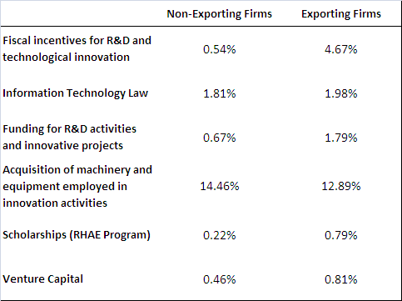

Source: IBGE/PINTEC 2008 and MDIC/SECEX 2008.

Regarding cooperation to innovate, 8.4% of non-exporting firms and 19.3% of exporting firms were involved in cooperative arrangements. Generally speaking, the valuation of partners does not show extreme difference across exporting and non-exporting firms (Table 8). Both indicate a preference for suppliers and customers as the cooperation partners. Interestingly, we observe that exporters rely slightly more often on customers and academia and they do it less on competitors than non-exporting firms.

Table 8 - Percentage of firms that considers cooperation as of high or medium importance

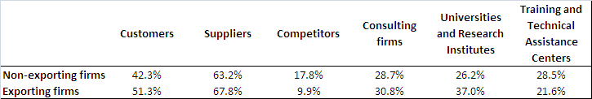

Source: IBGE/PINTEC 2008 and MDIC/SECEX 2008.

# Multivariate analysis

The results from the previous descriptive analysis indicate a link between innovation and different measures of exporting activity. Nevertheless, we observed in the same analysis that exporting firms also relate to other firm characteristics such as capital origin or size. We have also observed that sector heterogeneity plays some role in these metrics and it needs to be considered more thoroughly.

In order to account for these issues, we carry a series of multivariate analyses on the relationship between IP-related appropriation and export variables. As briefly mentioned in the data section, we forced temporal lags in most independent variables as a way out of any simultaneity bias arising in our main variables of interest. The inclusion of temporal lags requires firms to be present in at least two editions of the PINTEC survey, condition which is only met by those firms with 500 employees or more. This lag was not applied to the appropriation variables, as they already refer to a previous 3-year period.

As the innovation literature has shown, there are significant differences in the use of appropriation methods among industries. It is also worth remarking that most Brazilian innovative firms have declared not to use any method of protection (Zucoloto, 2013). Thus, besides technological appropriation, it is also important to evaluate the impact of innovative expenditures – such as in R&D, technology embedded in equipment or other innovative activities – on export performance. In addition to innovative activities, there are other characteristics related to export performance. Industrial economics traditionally are based on three relevant variables: firm size, origin of capital and sectors. In the case of origin of capital, Acioly and De Negri (2004) emphasized that the nature of foreign companies provides greater competitive advantage in international trade.

Finally, export variables are also subject to national and foreign economic performance. For example, along the 2000s, the economies of Asia have strengthened, compared to other regions, which may have favored Brazilian firms whose exported products were strongly demanded by these countries. Besides, the Brazilian economy was less affected by the 2008 world economic crisis than many developed countries, which may have caused a redirection of exported products to the internal market.

As in the descriptive section, we analyze the export performance of Brazilian firms through three different dependent variables: (i) exporting firm (yes/no), (ii) value of exports (in logs) and (iii) the firm’s share of the sector exports (calculated at the 3-digit level of ISIC). The main explanatory variables of our interest are four dummy variables capturing if the firm has used (1) invention patents, (2) utility models, (3) industrial designs and (4) trademarks to protect its innovation. In addition, we include control variables for sector (ISIC, 2-digit level), origin of capital, size and innovative expenditures.

As discussed in the literature review section, innovation and exports do not have an unambiguous causal relation, mostly due to endogeneity problems. It can be argued that these concerns may also be present in the link between export performance and patenting (or IP use more broadly). We attempt to limit this drawback by using fixed-effects estimation in some of the analysis. In this particular case, the fixed-effect estimation assumes that the causal effect of patenting on exports is measured by the association between individual changes in exports and individual movements related to IP use. Therefore, an individual’s propensity to use IP or the export sales may be endogenous, but the unobserved component of the effect of this propensity on exports is constant over time[6].

We first investigate whether the use of each described IP-related method of appropriation is associated with a higher propensity to export. We observe that all four methods relate positively with the likelihood of being an exporting firm (Table 9). However, in most specifications, only the use of invention patents appears statistically significant. Interestingly, this result holds even when including R&D and other innovation related expenditures, which should undermine at least partially the explanatory power of patents (Table 9, column 3). Depending on the specification, firms using invention patents are between 8 and 13% more likely to export.

Table 9 – Appropriation and probability to export (Large firms)



Notes: Marginal effects reported. Robust standard errors in parenthesis. *** p<0.01, ** p<0.05, * p<0.1.

We obtain very similar results for the amount of exports as dependent variable (Table 10, columns 1-3). Again, virtually all four methods have a positive impact on exports, but only invention patents are statistically significant. Moreover, the economic meaning of the estimated coefficient is substantial. Holding everything else constant, firms using invention patents export more than three times as much than those not doing it[7]. As robustness, we also applied a Tobit estimator (see Annex Table A - 4). Results remain qualitative the same, being all coefficients positive. However in one specification all four IP-related appropriation methods are statistically significant at 5% or less. In any case, by far, the use of patents always has the stronger effect.

Results change slightly when we turn to the dynamic analysis using firm level fixed-effects. Even if only statistically significant at 10%, we observe that firms which were not using patents in the first period increase their exports on average by 70% if they start using it in the second period (Table 10, columns 4-6). In the case of utility models, this increase is more than 50%, but also barely statistically significant. Curiously, trademarks have the most statistically significant effect but it is negative. Firms which were not using trademarks in the first period will export on average approximately 40% less when they start using it.

We turn now to third indicator of export activities: the share of the sector exports at the ISIC 3-digit level. Using the same methodology discussed above, we test the impact of the four different appropriation methods on the firm export sales share on its sector (Table 11). These estimations are relatively similar to those for the export value when concerning the use of patents. Firms which have used patents on average account for 6 to 10% more of the sector total exports than those which not use patents, depending on the econometric specification (Table 11, columns 1-3). The other IP-related appropriation methods are virtually always not statistically significant. Sometimes, we observe them to have a negative coefficient, as it is the case for utility models which is even significant once at 10% (Table 11, column 3). These results are robust when we applied a Tobit estimator (see Annex Table A - 5).

The results of the dynamic analysis using firm fixed-effects are also roughly similar to those for the amount exports (Table 11, columns 4-6). We observe a positive impact of the use of patents and a negative one of trademarks. Both are statistically significant, although the latter only at 10%. The main difference concerns utility models, which now turn to have a negative coefficient although not statistically significant. The economic meaning of these results are that on average firms that were not using patents in the first period increase about 4 percent points of their participation in the sector total exports if they start using patents in the second period. This means that on average they are not only growing their export sales – as seen Table 10, columns 4-6 – but they are also doing it faster than the sector average. Conversely, we observe that the use of trademarks decreases it by 2.5%, which is again a counterintuitive outcome.

Summing up, in all cases we identified a positive impact of invention patent and exporting activity, while in several cases a negative relationship between the use of trademark and exports was observed.

Table 10 – Appropriation and export value (Large firms)



Notes: Robust standard errors in parenthesis. *** p<0.01, ** p<0.05, * p<0.1. Dummy coefficients correction as in Halvorsen and Palmquist (1980) in italic.

Table 11 - Appropriation and share of sector exports (Large firms)



Notes: Robust standard errors in parenthesis. *** p<0.01, ** p<0.05, * p<0.1.

## Robustness of results

These results may suffer from some methodological limitations which are worth discussing here.

First, we have mentioned before that innovation and exports have been largely shown to be related. Given the limitation of PINTEC mentioned in the data section, we need to limit our previous estimations to innovative only firms if we want to use the variables relating to appropriation methods. How much of these results can be attributed to this constraint? In our sample (see Table A - 3), we observe that innovative firms are only 2.2% more likely to export. This is below the magnitudes found for IP-related methods, although only the likelihood for patents is substantially higher. Innovative firms export 33% more on average than non-innovative firms, but this is considerably below the 259% marginal effect for patents found using a similar econometric specification. Moreover, innovative firms account on average for barely 0.11% more of the sector total exports than non-innovative firms, which is almost negligible to the 6.8% percent difference found for patent using innovative firms.

Conversely, we can expect IP-related appropriation methods to affect innovation and economic performance more broadly defined. A careful analysis of such link is beyond the scope of this study, but basic results are presented in the annex using a similar framework just for robustness purposes. We observe again that there is a positive and significant correlation between the use of patents and the different variables selected (Table A - 11). Results are less apparent in statistical significance when controlling for firm fixed-effects (Table A - 12).

A second concern is the risk of collinearity between IP-related appropriation methods. As mentioned in the literature review, the use of patents does not exclude necessarily the use of trademarks and so on (Llerena and Millot, 2012). Moreover, a given innovative product may contain more than one technology and firms – particularly the large ones – may supply more than one innovative product. Therefore firms may protect each of these innovations differently, which may translate into a higher proportion of observations with more than one IP-related appropriation method. The positive correlation among all these variables seems to confirm this concern (Table A - 2). We observe the highest Pearson correlation coefficients between utility models and industrial designs (0.4367) and between invention patents and utility models (0.4181). These, however, are far from being a severe case of collinearity.

In any case, to further explore this issue, we disaggregate the IP-related appropriation methods in order to account of all possible interactions (Table A - 6 to A -10). We reproduce all the previous specifications including these interacted variables. Despite of what literature states about the joint use of these appropriation methods, the inclusion of the interactions did not significantly change the results nor improve the explanatory power of our specifications. Particularly, the main effect still is the one from patents, which remains statistically significant in most specifications.

# Conclusions

In this report we evaluate the relationship between different IP-related appropriation methods and export performance of Brazilian industrial firms. Information about appropriation methods to protect innovation was obtained at the Technological Innovation Survey, applied by the Brazilian Statistic Institute (PINTEC/IBGE).

Even if Brazil has historically been characterized by the export of commodities (De Negri, 2005), our descriptive results suggest that not only innovative firms tend to export more, but also different IP methods – i.e. patents, utility models, industrial designs and trademarks – relate to better exporting performance. Descriptive statistics show that, on average, innovative manufacturing firms are more likely to export and present a higher average export value than non-innovative firms. In a sub-sample including only innovative industrial firms, we found that exporting firms are larger (when the size is measured by the number of employed persons or by net sales) and invest proportionately more in R&D. Moreover, a proportionally higher percentage of firms with foreign capital are exporters. Conversely, we also observe that exporting firms are more likely to use IP-related appropriation methods, although they also do it for non IP-related methods, such as secrecy, lead-time or complexity.

Aiming to evaluate the impact of appropriation methods on export performance, the econometric analysis concentrate on large firms. It enabled the use of a temporal lag in most independent variables. In addition, within estimation using firm fixed-effects were used to deal with endogeneity problems. The results showed a positive and significant impact of invention patent on export performance. These results were robust for every export performance indicator and to virtually all econometric specifications. However, this was the only variable of interest that shows consistent and meaningful results. The impact of other IP methods is at least ambiguous. One particular odd result concerns trademarks, which are found sometimes to affect exports negatively. This result may indicate that trademark users may focus on national market instead of export their production. Also, it may indicate the limitations that often innovation surveys have to measure the use of IP.

We have relied on the information about IP use by large Brazilian innovative firms from PINTEC, which was the best source at the time this study was carried. However, this means that our results may not hold for other groups, such as smaller and non-innovative firms. Moreover, a given innovative product may contain more than one technology and firms – particularly the large ones – may supply more than one innovative product. The fact that PINTEC does not allows us to establish the IP portfolio of firms limits the analysis substantially. These limitations can be surmounted by the use of IP unit-record data from the *Instituto Nacional de Propriedade Industrial* (INPI), which are part of a complementary element of the project’s country study Brazil (CDIP/14/INF/6).

# Acknowledgements

The authors are extremely thankful to the IBGE team for the data availability; Mr. Alessandro Pinheiro, manager of the PINTEC/IBGE for his helpful comments and information and Ms. Glaucia de Sousa Ferreira for her assistance to the preparation of this report.

# References

AMABLE, B. VERSPAGEN, B. (1995). "The role of technology in market shares dynamics", Applied Economics, 27, pp 197-204.

AMENDOLA, G., GUERRIERI, P.; PADOAN, E. "International patterns of technological accumulation and trade", in Trade, Growth and Technical change pp 83-97, eds Archibugi and Michie, Cambridge University Press, 1998.

ANDERSSON, M., EJERMO, O. (2008). Technology specialization and the magnitude and quality of exports. Econ. Innov. New Techn., 17(4), 355-375.

ARROW, K. (1962). Economic Welfare and the Allocation of Resources for Invention. In The Rate and Direction of Inventive Activity: Economic and Social Factors (pp. 609–626). NBER.

ARUNDEL, A., KABLA, I., 1998. What percentage of innovations are patented? Empirical estimates for European ﬁrms. Research Policy 27, 127–141.

AVELLAR, A. P., & CARVALHO, L. (2013). Esforço Inovativo e Desempenho Exportador: Evidências para Brasil, Índia e China. *Estudos Econômicos (São Paulo)*, *43*(3)

AW, B. Y., ROBERTS, M. J., & XU, D. Y. (2011). R&D investment, exporting, and productivity dynamics. *The American Economic Review*. 101, 1312-1344

AW, B. Y., ROBERTS, M. J. & XU, D. Y. (2008). “R&D Investments, Exporting, and the Evolution of Firm Productivity.” *The* *American Economic Review*, 98(2): 451–56.

BASBERG, B. L. (1987). Patents and the measurement of technological change: A survey of the literature. Research Policy, 16(2-4), 131–141. doi:10.1016/0048-7333(87)90027-8

BERNARD, A. B., & BRADFORD JENSEN, J. (1999). Exceptional exporter performance: cause, effect, or both?. Journal of international economics, 47(1), 1-25.

BRESCHI, S. & HELG, R. (1996). Technological change and international productivity: the case of Switzerland*. Liuc Papers* n. 31, serie Economia e Impresa 7, junho.

CALVO, J. L. (2003, August). The Export Activity of Spanish Manufacturing Firms: Does Innovation Matter?. In 23th Congress of the European Regional Science Association.

CAMERON, A. C., & TRIVEDI, P. (2005) Microeconometrics: Methods and Applications.

CAMERON, A. C., & TRIVEDI, P. K. (2009). *Microeconometrics using Stata* (Vol. 5). College Station, TX: Stata Press.

CASSIMAN, B., & GOLOVKO, E. (2010). Innovation and internationalization through exports. Journal of International Business Studies, 42(1), 56-75.

CASSIMAN, B., GOLOVKO, E., & MARTÍNEZ-ROS, E. (2010). Innovation, exports and productivity. International Journal of Industrial Organization, 28(4), 372-376.

CLERIDES, S. K., LACH, S., & TYBOUT, J. R. (1998). Is learning by exporting important? Micro-dynamic evidence from Colombia, Mexico, and Morocco. The Quarterly Journal of Economics, 113(3), 903-947.

COHEN, W. M., R. R. NELSON, AND J. WALSH (2000). Protecting Their Intellectual Assets: Appropriability Conditions and Why U.S. Manufacturing Firms Patent (or Not). Cambridge, MA: NBER Working Report No. 7552.

DAMIJAN, J. P., KOSTEVC, Č., & POLANEC, S. (2010). From innovation to exporting or vice versa? The World Economy, 33(3), 374-398.

DE NEGRI, F. (2005). Inovação Tecnológica e Exportações das Firmas Brasileiras. Anais do XXXIII Encontro Nacional de Economia – Anpec. Natal.

DE NEGRI, J. A.; ACIOLY, L. (2004). Novas evidências sobre os determinantes do investimento externo na indústria de transformação brasileira. Brasília. Texto para discussão; 1019. IPEA, Brasília.

DOSI, G.; PAVITT, K; & SOETE, L.G. (1990). The Economics of Technical Change and International Trade, London: Harvester Wheatsheaf.

DOSI, G; FREEMAN, C. & FABIANI, S. (1994). The process of economic development: introducing some stylized facts and theories on technologies, firms and institutions. Industrial and Corporate Change, vol 3, n.1.

DOSSO, M. (2011). Sectoral dynamics of international trade and technological change. Available at: <http://www.lem.sssup.it/WPLem/documents/papers_EMAEE/dosso.pdf>.

GONÇALVES, E., LEMOS, M. B., & DE NEGRI, J. (2007). Condicionantes Da Inovação Tecnológica Na Argentina E No Brasil. In Anais do XXXV Encontro Nacional de Economia [Proceedings of the 35th Brazilian Economics Meeting] (No. 117). ANPEC-Associação Nacional dos Centros de Pósgraduação em Economia [Brazilian Association of Graduate Programs in Economics].

GRAHAM, S. J. H., and D. SOMAYA (2006). Vermeers and Rembrandts in the same attic: Complementarity between copyright and trademark leveraging strategies in software. Available at: http://papers.ssrn.com/sol3/papers.cfm?abstract_id=887484

GREENAWAY, D. and KNELLER, R. (2007). “Firm Heterogeneity, Exporting and Foreign Direct Investment.” Economic Journal, 117(517): F134–61.

HALL, B. H., HELMERS, C., ROGERS, M., & SENA, V. (2012). The choice between formal and informal intellectual property: a literature review (No. w17983). National Bureau of Economic Research.

HALVORSEN, R., & PALMQUIST, R. (1980). The Interpretation of Dummy Variables in Semilogarithmic Equations. The American Economic Review, 70(3), 474–475. doi:10.2307/1805237

HANEL, P. (2008). The use of intellectual property rights and innovation by manufacturing firms in Canada. *Economics of Innovation and New Technology* 17(4): 285‐309. Instituto Brasileiro de Geografia e Estatística – IBGE (2010). Pesquisa Industrial – Inovação Tecnológica. Rio de Janeiro.

KLETTE, T. J., & KORTUM, S. (2002). Innovating firms and aggregate innovation (No. w8819). National Bureau of Economic Research.

LAURSEN, K. (1999). The impact of technological opportunity on the dynamics of trade performance. Structural Change and Economic Dynamics, 10(3), 341-357.

LAURSEN, K., & DREJER, I. (1999). Do Inter-sectoral Linkages Matter for International Export Specialisation?. Economics of Innovation and New Technology, 8(4), 311-330.

LAURSEN, K., & MELICIANI, V. (2002). The relative importance of international vis à vis national technological spillovers for market share dynamics.Industrial and Corporate Change, 11(4), 875-894.

LEVIN, R. C., A. K. KLEVORICK, R. R. Nelson, and S. G. Winter (1987). Appropriating the Returns from Industrial Research and Development. Brookings Papers on Economic Activity 3: 783‐831.

LLERENA, P., & MILLOT, V. (2013). Are Trade Marks and Patents Complementary or Substitute Protections for Innovation (No. 2013-01). Bureau d'Economie Théorique et Appliquée, UDS, Strasbourg.

LUNA, F., & BAESSA, A. (2007). Impacto das marcas e das patentes no desempenho econômico das firmas. In Anais do XXXV Encontro Nacional de Economia [Proceedings of the 35th Brazilian Economics Meeting] (No. 155). ANPEC-Associação Nacional dos Centros de Pósgraduação em Economia [Brazilian Association of Graduate Programs in Economics].

MONTOBBIO, F. (2003) "Sectoral patterns of technological activity and export market share dynamics", Cambridge Journal *of Economics*, vol. 8, No.3, pp 435-470.

NASSIMBENI, G. (2001). Technology, innovation capacity, and the export attitude of small manufacturing firms: a logit/tobit model. Research Policy,30(2), 245-262.

NEUHÄUSLER, P. (2012). The use of patents and informal appropriation mechanisms—Differences between sectors and among companies.Technovation.

POSNER, M. V. (1961). International trade and technical change. *Oxford Economic Papers*, *13*(3), 323-341.

RAFFO, J., LHUILLERY, S., FREITAS, F., MIOTTI, L., & DE NEGRI, J. A. (2011). Innovation, productivité et exportation : une comparaison entre pays européens et latino-américains. In L’innovation dans les entreprises : moteurs, moyens et enjeux. *Paris: DGCIS*.

SOETE, L. (1987*).* The impact of technological innovation on international trade patterns: the evidence reconsidered. *Research Policy*, vol.16, n.3-5, pp 101-130, julho.

VERNON, R. (1966). International investment and international trade in the product cycle. *Quartely Journal of Economics*, n. 83.

TEECE, D.J. (1986). Profiting from technological innovation: implications for integration, collaboration, licensing and public policy. *Research Policy* 15, pp. 285-305, junho.

TEECE, D.J. (1996). Firm organization, industrial structure, and technological innovation. *Journal of Economic Behavior & Organization*, Vol. 31, 193-224.

TIGRE, P.B. (2002) Papel da política tecnológica na promoção de exportações. IE/UFRJ, março.

TOMIURA, E. (2007). Effects of R&D and networking on the export decision of Japanese firms. Research Policy, 36(5), 758-767.

ZUCOLOTO, G.F.. Intellectual Property and Socio-Economic Development - Country Study Brazil. Forthcoming.

# Annex – Additional information and statistics

Table A - 1 - Summary Statistics of the sample of large firms (2005)

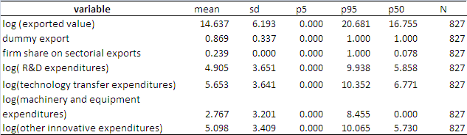

Table A - 2 - Correlation of variables (panel, large firms)

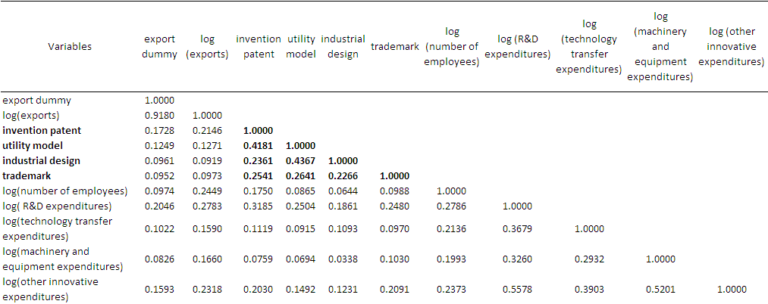

Table A - 3 - Innovative and export performances

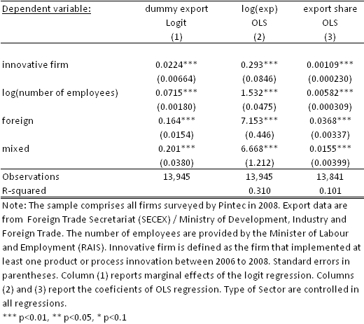

Table A - 4 - Technological appropriation and exports  
(Method=Tobit model, DV= Exports (logs), sample=large firms)



Table A - 5 - Technological appropriation and exported value of large firms   
(Method=Tobit model, DV= Share of sector exports)

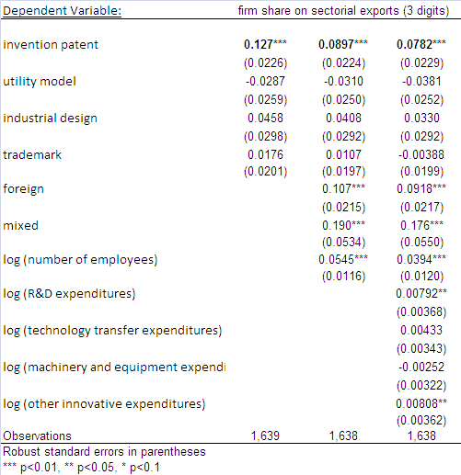

Table A - - List of interaction variables of interest



Table A - - Technological appropriability and probability to export of large firms - including interactions (OLS model)

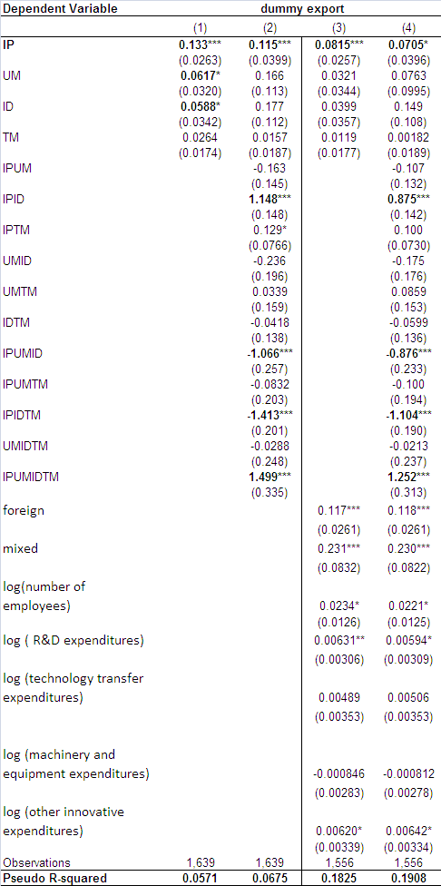

Table A - - Technological appropriation and exported value of large firms   
(Method=Pooled OLS, Full interactions)

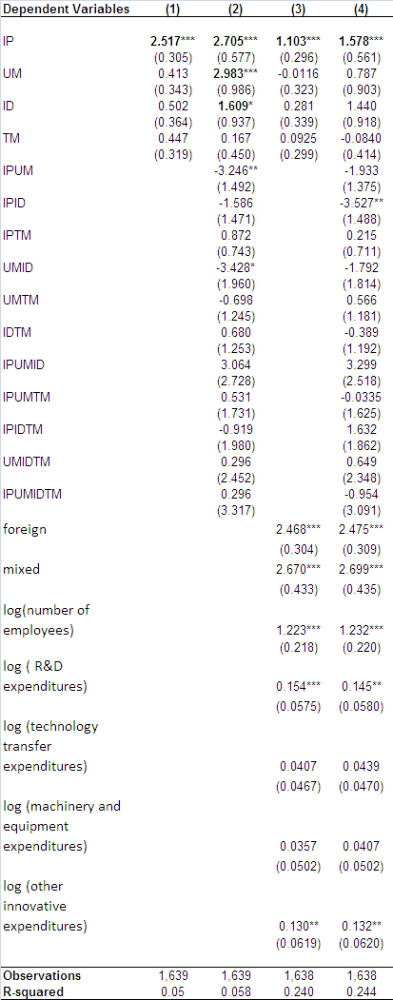

Table A - - Technological appropriation and share of sector exports   
(Method=Pooled OLS, Full interactions, sample=Large firms )

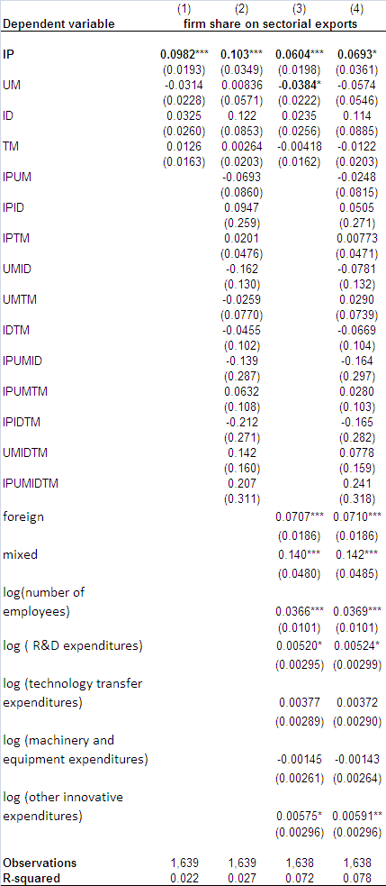

Table A - 10 - Technological appropriation and exports   
(Method=FE effects, Full interactions)

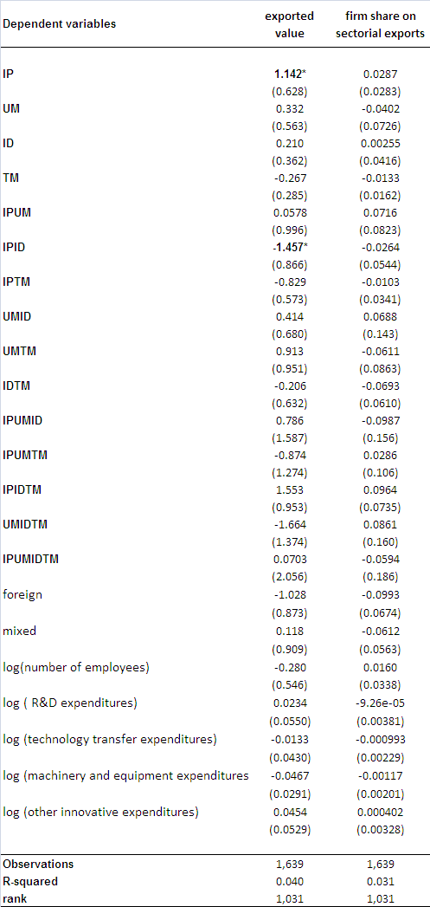

Table A - - Technological appropriation and selected economic variables   
(Method=Pooled OLS, sample=Large firms)

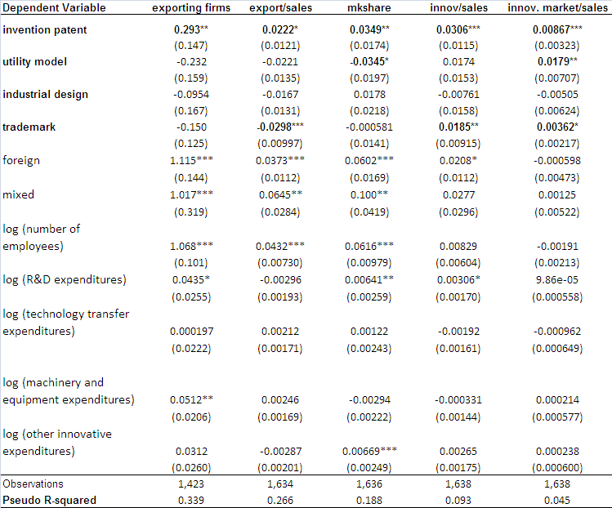

Table A - 12 - Technological appropriation and selected economic variables   
(Method=FE effects, sample=Large firms)

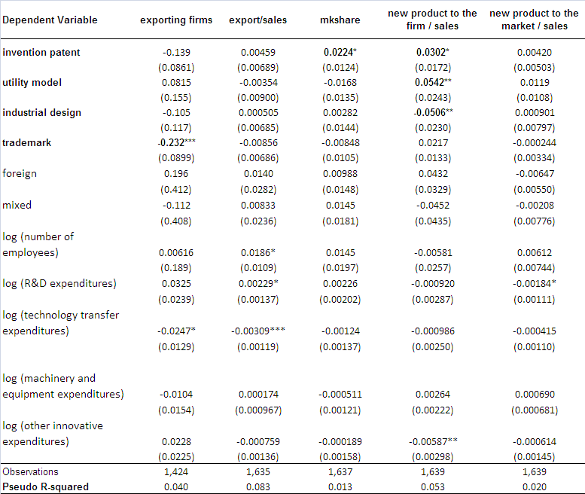

[End of Annex and of document]

1. In parallel to this report and as part of the project’s Country Study Brazil (CDIP/14/INF/6), the Brazilian IP office and WIPO have undertaken the creation of statistical source for IP unit-record data.
2. For a summary of the recent literature refer to Greenaway and Kneller (2007).
3. One singularity of the Brazilian sampling method is that all industrial firms with 500 or more employees are included in the sample. In addition, innovative firms are also more likely to be included in the sample than non-innovative firms.
4. In parallel to this report and as part of the CDIP/5/7 Country Study Brazil, the Brazilian IP office and WIPO have undertaken the creation of statistical source for IP unit-record data.
5. This are often referred as *strategic* or *informal* means of appropriation.
6. See a detailed example in Cameron and Trivedi (2005), section 21.4.1.
7. In the whole study, we apply the correction for semi-logarithmic equations as in Halvorsen and Palmquist (1980). This concerns in particular equations where the dependent variable is the amount of export sales expressed in natural logarithms.