|  |  |  |
| --- | --- | --- |
|  | WIPO-E | **E** |
| CDIP/13/INF/4 | | |
| ORIGINAL: english | | |
| DATE: february 26, 2014 | | |

**Committee on Development and Intellectual Property (CDIP)**

**Thirteenth Session**

**Geneva, May 19 to 23, 2014**

COUNTRY STUDY ON INNOVATION, INTELLECTUAL PROPERTY AND THE INFORMAL ECONOMY: informal manufacturers of home and personal care products in south africa

*prepared by Erika Kraemer-Mbula, Senior Lecturer and Research Fellow, Institute for Economic Research on Innovation (IERI), Tshwane University of Technology, South Africa, Vincent Tau, Technology Station Manager, Technology Station for Chemicals, Tshwane University of Technology, South Africa[1]*

1. The Annex to this document contains a Study on Innovation, Intellectual Property and the Informal Economy in South Africa, undertaken in the context of the Project on Intellectual Property (IP) and the Informal Economy (CDIP/8/3) approved by the Committee on Development and Intellectual Property (CDIP) in its eighth session, held in November 2011.

*2. The CDIP is invited to take note of the information contained in the Annex to this document.*

[Annex follows]

# EXECUTIVE SUMMARY

Whereas South Africa contributes substantially to Africa’s overall GDP, the economic progress of the country is constrained by its inability to reduce the legacies of apartheid and redress persistent inequalities. The distribution of income in South Africa is currently one of the most unequal in the world, and disparities between rich and poor have worsened in the last decades. In an economic environment characterized by high and persistent formal unemployment, particularly amongst the youth, the informal economy continues to provide income opportunities to a substantial segment of the South African population. The future transformation of the country has been identified with its ability to connect the relatively faster economic growth in the ‘first’ (formal) economy with the development of the ‘second’ (largely informal) economy.

This study focuses on the informal manufacture of home & personal care products, using it as a lens to explore innovation activities in the informal economy, as well as the role of intellectual property in such context. The range of manufactured products subject of this study fall within the ISIC Code 2424 “*Manufacture of soap and detergents, cleaning and polishing preparations, perfumes and toilet preparations*”[2], and includes products such as cosmetics, fragrances, moisturizers, hair care, detergents, cleaning products and the like.

This study acknowledges that the presence and continued growth of the informal economy in South Africa must be understood within the peculiar political history of South Africa, which has shaped the conditions leading to the informal economy as it is today.

**Methodology**

The study adopts a systemic approach to examine the informal economic activities generated around the manufacturing of home & personal care products, exploring these activities as part of a broader economic, social and institutional system in which informal manufacturers operate. By mapping the innovation system around them, the study identifies the key actors comprising the productive chain of home & personal care products (including formal and informal suppliers, informal manufacturers and distributors or retailers), as well as an array of educational and training organizations, funding organizations, government and regulatory bodies, knowledge and technology transfer organizations and industry representative bodies. Unstructured interviews were conducted with key informants in these organizations.

In addition, structured interviews were conducted for a sample of 25 informal manufacturers directly enraged in the production of home & personal care products, in two South African provinces (Gauteng and Eastern Cape). The analytical framework was common to the three case studies in Ghana, Kenya and South Africa, as agreed in a workshop in Pretoria at the Institute for Economic Research on Innovation (IERI) in November 2012, and summarized in the conceptual study (de Beer et al, 2013)[3].

**Main findings**

The results of this study indicate that formality and informality are part of the same socio-economic fabric, often inseparable, where actors with various degrees of formality interact, compete and exchange knowledge, skills, products and services.

*Profile of the industry*: the South African home & personal care industry is dominated by a few large formal enterprises (both foreign multinationals and large domestic companies). However, the sector also accommodates a numerous population of micro-enterprises many of which operate informally, dedicated to the production of lotions, fragrances, cosmetics, soaps, detergents, etc, targeting very specific market niches – especially low-income consumers seeking lower-cost products and small unit sizes. High fragmentation of the demand, rapid urbanization and the current economic downturn have increased the demand for low-cost home & personal care products in South Africa, creating opportunities for micro-informal manufacturers.

*The productive value chain*: informal manufacturers of home & personal care products operate within a production chain where they connect with both formal and informal suppliers of packaging and raw materials (e.g. waxes, alcohols, natural oils & extracts, glycerines, etc.), as well as formal and informal retail and distribution channels. This report highlights that it is important to understand this value chain if we are to explore the mechanisms of knowledge dissemination and knowledge appropriation in the informal economy.

*Innovation:* the results of the study indicate that informal manufacturers very often engaged in incremental innovations in products by introducing significant improvements in formulations and packaging. These innovations were considered important means for product differentiation and to reach a wider customer base (e.g. using tribal designs in packaging to attract specific customers, adding healing properties to cosmetic products on the basis of known natural remedies, replacement of ingredients to satisfy the demand for more “natural” products, etc.). Whilst less frequent, there was also evidence of incremental process innovations, such the introduction of quality control mechanisms in the production process and the acquisition of modern equipment (e.g. electrical mixer, crimping machine, etc.) – in some cases allowing critical changes in the business model – for instance allowing bulk production and re-selling, instead of relying on unit sales to individuals.

*Sources of knowledge*: The level of education amongst the informal manufacturers in the sample was considerably high, since one third of the respondents had some type of tertiary education. However, insufficient education and knowledge was reported to be a main obstacle to further innovation. Informal manufacturers acquired knowledge and learn from multiple sources. Suppliers and formal technology transfer agencies featured as key sources of knowledge useful for innovation. However, informal sources of knowledge appeared to be equally relevant, such as learning by doing/experimentation, self-training and learning from each other between micro-manufacturers. Moreover, informal training, apprenticeships and passing knowledge to others in the community were often attached to a sense of responsibility and duty towards the communities in which informal manufacturers operate.

*The system of innovation:* innovation activities by informal manufacturers influence and are influenced by a rage of actors around them. In other words, innovation is of systemic nature, and therefore it is critical to understand the socio-economic and political economy in which productive and innovation activities take place. The system surrounding informal manufacturers shapes the configuration of the skills and capabilities available, as well as the rate of dissemination and use of innovations. This report identifies some of the key players including education & training organizations, funding and support organizations, government agencies, technology transfer organizations, industry representative bodies – i.e. formal organizations connected to formal institutions (formal rules and legislations). In addition, consideration must be given to the wider community, who plays an important role not only as a source of demand, but also setting up the ‘informal institutions’ guiding many of the decisions made by of informal entrepreneurs. The results of the study indicate that informal manufacturers able to connect with the wider innovation system were more likely to succeed in their innovation efforts.

*Mechanisms of knowledge appropriation*: concerns related to knowledge appropriation by informal manufacturers often respond to their perception of strong competition especially in the geographical area in which they operate. Most respondents protected their ideas in some way. Selective sharing of information, secrecy, division of duties and management of customer relationships were some of the most common mechanisms used, whilst the use of formal mechanisms of knowledge appropriation such as patents or trademarks was marginal. It is worth noting that informal manufacturers in home & personal care products appreciate the benefits of open transfer of ideas, although they are often unaware of mechanisms of knowledge appropriation that would suit their needs. Other experiences (Essegbey et al, 2013; Bull et al, 2013) indicate that these caveats could be largely assisted by intermediary agents, or knowledge brokers such as semi-formal industry associations inclusive of informal manufacturers.

*Policy implications*: The South African broad policy vision recognizes informal economic activities as key contributions to job creation, poverty alleviation and inclusive development. This recognition transpires throughout multiple policy strategies guiding economic growth and development at both national and provincial levels. Several efforts have emerged towards promoting employment by facilitating start-ups and providing various types of support to micro enterprises – such as financial support, training and technology transfer. Whilst some of these initiatives have implications for informal entrepreneurs, deficiencies remain regarding the establishment of programs that explicitly target the needs of innovators in the informal economy, or that connect innovations generated in the informal economy with the wider innovation system. This report argues that redressing inequality and avoiding the social and economic risks of endemic unemployment require the deployment of all local creative capacities. Inclusive approaches to innovation policy and intellectual property need to make explicit connection with innovations generated in the informal economy.

Contents

EXECUTIVE SUMMARY 1

Section I: Introduction 5

1.1. Background of the study 5

1.2. Purpose of the study 6

1.3. Methodology 6

Section II: Informal economy and informal manufacturers of home & personal care products in South Africa 8

2. The formation and current profile of the informal economy in South Africa 8

2.1.1. Manufacture of home & personal care products in South Africa and informal enterprises 14

2.1.2. Description of the sector and demand trends 14

2.1.3. The value chain in manufacturing of home & personal care products 15

2.1.4 Profile of informal manufacturers of home and personal care products 19

2.1.5. Main products 22

Section III: Innovation in informal manufacturers of home & personal care products 28

3. Innovation in informal manufacturers of home & personal care products 28

3.1 Innovation profile of informal manufacturers 28

3.2 Obstacles to innovation and scalability 33

3.3. Knowledge and technological profile of the sector 34

3.3.1. Key technologies used 34

3.3.2. Sources of knowledge 37

3.3.3. Knowledge flows 39

**3.4. Mapping the innovation system of the informal manufacturing of home & personal care products** 42

**Section IV: Mechanisms of knowledge appropriation** 45

**4.1.** **Intellectual Property landscape in South Africa** 45

**4.2.** **Appropriation mechanisms in informal manufacturers** 47

**4.3.** **Awareness and attitudes towards IP** 50

**4.4.** **Scenario building** 51

**Section V: Policy** 53

**Conclusion** 58

**References** 60

Appendix I 62

# Section I: Introduction

## Background of the study

Whereas South Africa contributes substantially to Africa’s GDP, the economic progress of the country is constrained by its inability to reduce the legacies of apartheid and redress persistent inequalities. The distribution of income in South Africa is highly unequal and disparities between rich and poor have worsened in the last decades – Gini coefficients using per capita income show that South Africa’s income inequality increased from 0.57 in 2000 to around 0.7 in 2011 (WDI, 2013). The coexistence of two economic domains in South Africa is commonly referred to as the ‘first’ and ‘second’ economies[4]. In the South African context, the ‘first economy’ comprises modern, urban economic activities; whilst the ‘second economy’ includes the majority of the less advantaged rural and urban population, constrained by poverty and marginalization. Within this depiction, to a large extent the first economy would be formal, accounted for and subject to legally enforceable rights and duties. The second economy would be largely informal, regulated by informal institutions, community norms, and based on cash transactions. It appears that in reality, formality and informality are part of the same socio-economic fabric, often inseparable, where actors with various degrees of formality interact, compete and exchange knowledge, skills, products and services.

Unemployment in the formal economy remains endemic in South Africa, with official estimated figures of over 25% in 2012 (Stats SA, 2013a) particularly affecting the youth, with half of young South Africans between 15 and 24 being unemployed[5]. Meanwhile, the informal economy continues to provide employment opportunities to a large segment of the population – with various estimations ranging from 12% to 33% of employment[6]. Nevertheless, there is general agreement that informal employment is on the rise (Stats SA, 2013a; Adcorp, 2013) and it has been estimated that without the informal economy, the unemployment rate would rise from currently 25% to 47.5% (SALGA, 2012). The future transformation of the country has been identified with its ability to connect the relatively faster economic growth in the first (formal) economy with the development of the second (informal) economy. In this regard, South Africa provides an interesting context to explore issues around knowledge diffusion and intellectual property issues related to innovations that intersect the formal and informal dimensions.

This study uses the informal manufacturing of home & personal care products in South Africa as a lens to explore innovation activities in the informal sector and the role of intellectual property in such context. The range of manufactured products subject of this study fall within the ISIC Code 2424 “*Manufacture of soap and detergents, cleaning and polishing preparations, perfumes and toilet preparations*” – and include a broad range of products such as: beauty and skin care, hair care products, oral care, cosmetic preparations, perfumes, soaps, detergents, bleaches, other cleaning products, air fresheners, polishes and waxes. This sub-sector is within the ISIC Code 242 “*Manufacture of other chemical products*”, which is part of the larger chemical manufacturing industry. The South African government has identified the chemical sector as holding high growth potential and opportunities for development, particularly for SMMEs. Moreover, the Industrial Policy Action Plan (IPAP2) highlighted in 2011 the manufacturing of chemicals as one of the sectors with high employment multipliers and strong backward linkages. Within IPAP2, the cosmetics subsector has also been identified as a national priority.

The formal home & personal care industry is dominated by a few large enterprises (both foreign multinationals and large domestic companies). However, the sector also accommodates hundreds of micro enterprises; and although there are not statistics on the representation of informal manufacturers, recent reports (DTI, 2012) acknowledge the existence of many enterprises operating informally dedicated to the production of lotions, cosmetics, soaps, detergents and the like. These informal businesses do not only provide a form of employment and livelihood to South Africa’s most disadvantaged segments of the population, but also target a large existing demand for cheap and affordable consumer goods, a section of the demand that is often overlooked, misunderstood and underestimated in South Africa.

## Purpose of the study

The overall purpose of the study is to provide an empirical base to both scholarly and policy discussions on innovation and knowledge appropriation, inclusive of the creative activities that take place within enterprises that operate outside the formal boundaries in South Africa. More concretely, the purpose of this study is fivefold:

1. Mapping the key actors in the innovation system surrounding informal manufacturing of home & personal care products in South Africa;
2. Develop an understanding of the obstacles that hinder the performance of micro-enterprises situated in the informal economy;
3. Identification of innovation activities – learning, knowledge flows, technology transfer;
4. Understanding mechanisms of knowledge appropriation and role of IP; and
5. Identifying existing policy measures and making recommendations on the basis of our findings.

## Methodology

The study adopted a systemic approach to examine the informal economic activities generated around the manufacturing of home & personal care products, exploring them as part of a broader economic, social and institutional system in which informal manufacturers operate.

* Choice of the sector: the home & personal care industry was selected for this study for the following reasons:
  1. It is an industry with high prospects of growth – for instance, the formal sub-sector of “cosmetics” is one of the fastest growing sectors in South Africa (at about 10% annual growth rate in terms of turnover (Euromonitor, 2013a).
  2. The current economic turndown has generated a growing demand for affordable home & personal care products – inclusive of the majority of low-income consumers. This brings in new opportunities for micro informal businesses.
  3. Cultural diversity in South Africa and the associated demand for a diversity of products provides ample room for the establishment of micro enterprises catering for small market niches.
  4. Gender component – many of these products are addressed to women as the key decision makers; and it is one of the few manufacturing sectors where women appear to be relevant players in the demand and as manufacturers too.
* The range of actors that were interviewed included:
  1. 25 informal manufacturers: enterprises dedicated to manufacturing personal care products (e.g. skin care, hair care, fragrances and toiletries) and home care products (e.g. detergents and cleaning products). Interviews were conducted in three informal settlements situated in two South African provinces (Gauteng and the Eastern Cape) as well as in metropolitan areas. It is interesting to note the contrast between the two provinces in which the study was conducted, being Gauteng the wealthiest province in South Africa whilst the Eastern Cape is one of the most disadvantaged in the country in terms of income;
  2. Interviews to formal companies supplying informal manufacturers: including contract manufacturers (outsourcing manufacturing);
  3. Interviews to consumers – mainly hair salons and individuals;
  4. Interviews to government and regulatory bodies – Department of Trade and Industry (Cosmetics Desk) and CTFA (Cosmetic, Toiletry & Fragrance Association of South Africa);
  5. Interviews to three intermediary organizations engaged in knowledge transfer – technology and business incubators (Hope Factory, Chemin and the Tshwane University of Technology – Technology Chemical Station); and
  6. Interviews to agencies providing training and skills – Coschem (Society of Cosmetic Chemists South Africa).
* Sampling process

Since there is no database on informal manufacturers of home & personal care products in South Africa, the study used a snowball sampling, or chain referral sampling method. This method is commonly used for the identification of rare populations for which data does not exist. An initial set of 9 companies was identified in collaboration with two technology incubators (Tshwane University of Technology – Technology Chemical Station located in Gauteng, and [Chemin](http://www.chemin.co.za/‎) located in the Eastern Cape) and two business incubators (Awethu Project and the [Hope Factory](http://www.thehopefactory.co.za/‎)) , and the rest were referrals emanating from the interviewees. It must be noted that interviewees were more positive to provide names of other potential participants after they had responded the interview themselves and knew what types of questions it involved.

* Data collection

Data collection from informal manufacturers was obtained using structured interview guides – See Appendix I. Interview guides included both open and closed questions to allow capturing unexpected phenomena and personal experiences that would inform the study. Interview guides were implemented with the intention to generate a conversation with each of the interviewed individuals preferably at the location where manufacturing and/or retailing of the products took place. Several of the interviews were conducted in three main informal settlements in Gauteng (Soweto, Alexandra and Katlehong). In other cases interviews took place at informal retailing locations in the city centers of Johannesburg and Pretoria (Gauteng Province), and Port Elizabeth (Eastern Cape). Companies were not selected according to their location, but based on their qualification as ‘informal manufacturers’ as defined by de Beer et al (2013) and using five specific criteria (business registration, book keeping, use of formal finance, use of formal contracts with employees and registration of products) – explained in more detail in Section II below. The location of the informal manufacturers in informal settlements was coincidental and not explicitly sought after.

The data was collected between March and July of 2013 by a team of two researchers from Tshwane University of Technology, through personal interviews and complemented with photographic evidence. After collection, the data was coded, entered into Excel software and then cleaned and analyzed. The analysis mainly involved descriptive statistics. A description of the characteristics of participants was undertaken so as to compare demographic variables. These demographic variables include the type of business, sub-sector, geographical location and gender.

Unstructured interviews were conducted also with key staff of government organizations (Cosmetic Desk of the Department of Trade and Industry), regulatory agencies (Cosmetic, Toiletry & Fragrance Association of South Africa), technology transfer and training organizations (Coschem, Hope Factory, Chemin and Tshwane University of Technology - Technology Station in Chemicals). These interviews provided valuable information regarding the institutional system surrounding informal manufacturing activities and allowed collecting relevant situational and policy strategy reports.

# Section II: Informal economy and informal manufacturers of home & personal care products in South Africa

## The formation and current profile of the informal economy in South Africa

The presence and continued growth of the informal economy in South Africa must be understood within the peculiar political history of South Africa, which has shaped the conditions leading to the informal economy as it is today. Apartheid policies based on social segregation and economic discrimination have been central to the formation of South Africa’s informal economy. The apartheid regime defined the political, economic and social landscape throughout most of the 20th century, until the country’s first democratic elections in 1994. The regime was implemented through the systematic exclusion of the majority of the population (i.e. black South Africans) by imposing constraints to public participation, access to property rights, education, labor and mobility.

The effect of apartheid on labor-capital distributions and industrial development in South Africa has been a source of considerable debate[7]. In relation to industrial development, the operationalization of apartheid resulted in the convergence of interests of business and political forces, leading to the rise of industrial groups that had been formed on the basis of the preferential constitutional rights given to the white minority and the simultaneous deprivation of rights to the rest of the population.

Regarding to emergence of entrepreneurship, apartheid restrictions limited opportunities in the formal economy for black South Africans (which constitute the vast majority of the population) and placed further restrictions on the right of those entrepreneurs that were not white to establish and operate businesses. Curtailed access to capital, education, and property ownership rights for black people made it virtually impossible to acquire resources, skills or assets that could serve as collateral to obtain finance loans (DTI, 2003). Moreover, such legislation limited the range of goods that could be produced and sold, and set up an array of bureaucratic processes conducive to discouraging the registration of any small-scale economic activity.

As Maharajh (2011) describes for this period “[b]lack business emerged initially on the margins of apartheid and in spite of it” (Maharajh, 2011: 69). This regulatory and legislative framework did not only cripple the emergence of formal small businesses, but also prosecuted those created out of the margins of the existent formal regulations. In the late 1980s Rogerson and Hart (1989) found that “South African urban authorities have fashioned and refined some of the most sophisticated sets of anti-street trader measures anywhere in the developing world” (Rogerson and Hart, 1989:32), pointing out that hawkers were subject to “a well-entrenched tradition of repression, persecution and prosecution” (Rogerson and Hart, 1989:29). The transition to democracy in the mid-1990s opened up new opportunities for entrepreneurship and industrial development, generating new rules for street trading and leading to a dramatic increase of such activities especially in metropolitan areas.

The informal economy in South Africa can therefore be understood as an entrepreneurial response to the legislative limitations experienced by majority of the society which was excluded at the time. It has been noted that an analysis of the contemporary informal economy in South Africa must take into consideration the legacy of more than a century of restrictive and repressive legislation (UN-Habitat, 2006). Moreover, the high level of inequality that was generated during this period continues to be a central feature of the South Africa’s contemporary economic reality, which remains one of the most unequal countries in the world (UNDP, 2010). As South Africa transitions beyond the apartheid era it is important that the opportunities for participation of historically excluded segments of the society, largely represented today in the informal economy, are carefully considered.

Formal unemployment remains an endemic problem in South Africa, at over 25% (Stats SA, 2013a); and it is argued that without the informal economy, the unemployment rate would rise from currently 25% to around 47.5% (SALGA, 2012). Moreover, the pace of employment creation in the informal sector continues to rise (Stats SA, 2013a; Adcorp, 2013). The South African informal economy is very diverse, and includes a wide range of economic activities – from street vendors, taxi drivers, rubbish collectors, traditional doctors, manufacturers and home-based care workers – making it practically as diverse as the formal economy.

Furthermore, there is no clear line to separate the formal from the informal economies, as the two seem to interact, merge at times and complement each other.

The results of this study indicate that most informal manufacturers of home & personal care products connect with the formal economy along some point of the value chain, at the point of supply, retail or distribution. Nevertheless, it is important to recognize that each sub-sector has its own unique socio-economic dynamics, and distinct connections with the formal economy. Retail activities dominate South Africa’s informal economy with trade of goods and services concentrating 44% of the total informal employment. Manufacturing comprised 10% of the informal employment in 2012 (Stats SA, 2013a), where the sample for this study is located.

**Figure 1: Informal employment by economic activity in South Africa**



**Source: Stats SA (2013a)**

A survey in 2007 estimated that about 60% of businesses with an annual turnover of R300 000 and less decide to stay informal rather than formalize their business operations (FIAS, 2007).

The same survey indicated that the rate of informality decreases as turnover of the businesses increase, suggesting that higher income creates the conditions to formalize. Informal economic activity goes unrecorded and it is therefore difficult to obtain precise and updated measures of its contribution in terms of income and employment, but some estimates have indicated that the informal economy may generate around 28% of South Africa’s GDP (SALGA, 2012).

Currently, the informal economy predominates in “informal settlements”, also known as homelands or townships. Territorial separation implemented under apartheid policies of “resettlement” reproduced in the development informal settlements artificially created for the migrant unskilled labor force. These segments of the population were to be granted passes outside these areas with the sole purpose of performing work (Maharajh, 2011). Since the end of apartheid, however, informal settlements have multiplied in South Africa, and nowadays are densely populated and remain a hallmark of South Africa’s landscape.

According to the 2012 General household Survey (Stats SA, 2013b), over 1.2 million households (12% of all households in South Africa) live in informal dwellings (shacks), and the 2007 Community Survey (Stats SA, 2007) indicates that nearly 40% of these shacks provide shelter to four or more people. Since access to public services is very limited in these contexts, communities living in informal settlements often lack sanitation facilities, electricity, water and other infrastructure, and the use of scrap materials in construction is common. In 2010, it was estimated that 43% of the population of South Africa survived on less than US$ 2 a day[8]. Revenues from small business activities by informal entrepreneurs are essential to ensure food security and to support the diverse financial needs of their families – this general observation is supported by the findings of this case study.

It is worth noting that Gauteng, the smallest and wealthiest of the nine South African provinces, hosts the largest number of informal settlements in the country, with over 500 of them. Over 20% of all households in the Gauteng province live in informal dwellings (HDA, 2012). Although data remains imprecise, estimates indicate that the number of households who live in shacks has grown since 2001 as the number of informal settlements in South Africa escalated from 1,066 in 2001 to 2,628 in 2010 (HDA, 2012). Income and formal employment levels in these communities are very low[9], and residents suffer from deprivation of the most basic needs[10].

According to the Labor force Survey in 2004 (Stats SA, 2004) 27% of employed individuals living in informal settlements reported to be employed in the informal economy, a proportion that is above the national average (21%) - although it is acknowledged that the informal economy is likely to be widely under-represented given the high level of unemployment in the formal economy observed in informal settlements (over 60%) (HDA, 2012).

The present case study interviewed informal manufacturers established in various locations – both in metropolitan areas and also in informal settlements – in two South African provinces (Gauteng and the Eastern Cape). These two provinces illustrate the existing provincial disparities in South Africa. Gauteng is the wealthiest province in South Africa, and the business centre of the country; whilst the Eastern Cape is one of South Africa’s most deprived provinces in terms on income, unemployment and public service delivery. As shown in Table 1, Gauteng province, the wealthiest and most industrialized province in South Africa, counts with the largest percentage of informal enterprises - about one quarter of the national total.

**Table 1: Provincial distribution of formal and informal SMMEs**

|  |  |  |
| --- | --- | --- |
| **Province** | **Formal** | **Informal** |
| Gauteng | 48.3% | 24.6% |
| KwaZulu-Natal | 13.0% | 18.8% |
| Limpopo | 2.9% | 14.3% |
| Eastern Cape | 5.3% | 13.4% |
| Mpumalanga | 4.1% | 7.7% |
| North-West Province | 3.2% | 8.0% |
| Free State | 3.2% | 6.6% |
| Western Cape | 19.0% | 5.9% |
| Northern Cape | 1.2% | 0.7% |
| **Total** | **100%** | **100%** |

**Source: GEM (2009)**

Some features of the informal settlements that were visited are summarized in table 2 below, to provide an overview of the socio-economic environment surrounding the informal economy.

**Table 2: Characteristics of research sites: informal settlements**

| **Site** | **Province** | **Demographics\*** | **Socio-economic features** | **Spatial influences** |
| --- | --- | --- | --- | --- |
| Alexandra | Gauteng | Population: 179,624  Ethnic profile: Black African 98.95% | * Critical problems of overcrowding * Majority of unemployed population (63% in 2004) * Majority population live in shacks and informal dwellings * 30% population without electricity access (b) * 64.2 % of poverty incidence | Area: 6.91 km²  Location: North-Eastern outskirts of Johannesburg, close to the wealthy suburb of Sandton. |
| Soweto | Gauteng | Population: 1,271,628  Ethnic profile: Black African 98.54% | * Biggest township in South Africa. * 53 % unemployment rate * 27.6% access to water in the household (c) | Area: 200 km²  Location: Part of the City of Johannesburg |
| Katlehong | Gauteng | Population: 407,294  Ethnic profile: Black African 98.43% | * Second biggest township after Soweto (together with Thokoza) * Unemployment rate between 65% and 95% (d) | Area: 55.36 km²  Location: in the Metropolitan Municipality of Ekurhuleni, 35 km East of Johannesburg |

**Various sources: (a) Data from Census 2011, (b) Alexandra Benchmark Survey (2005), (c) Latest available data from Census 2001, (d) Naledi projects (2013)**

**Figure 2: Illustrations of informal settlements**

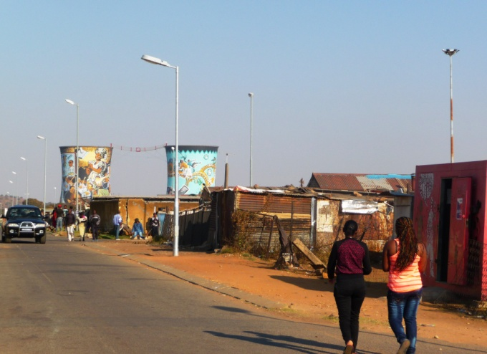 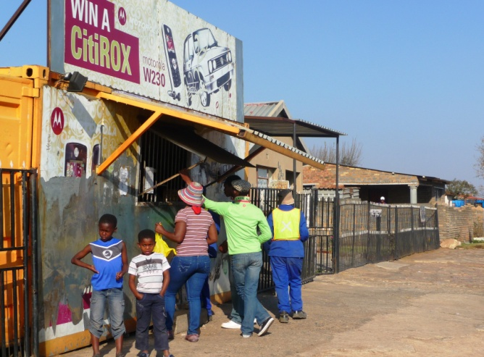

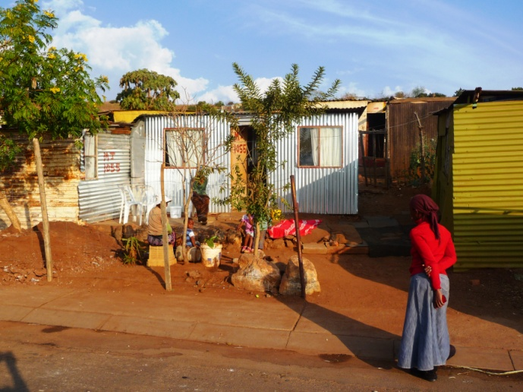 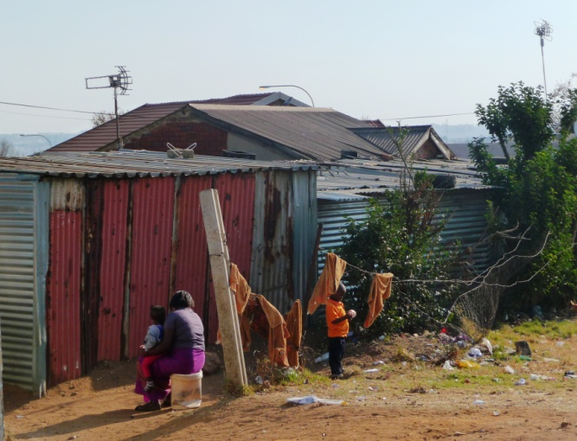

**Source: Fieldwork, 2013; Photo: Kraemer-Mbula, E.**

## Manufacture of home & personal care products in South Africa and informal enterprises

## Description of the sector and demand trends

Home & personal care products play an essential role in the lives of those segments of the population that have managed to cover their most basic needs of food and shelter. One striking feature of the industry is the wide range of consumer needs and preferences involved. The demand for these products considerably changes as it relates to multiple factors, such as income, lifestyle, culture, etc. For instance, whilst certain products and ranges may address very basic functions (i.e. keep persons and their households healthy and clean – such as bar soaps, washing up liquid or multipurpose cleaning products); other products fulfill a much more aesthetic function (i.e. improving the physical appearance of persons and their households – such as cosmetics, fragrances, air fresheners or floor wax). Moreover, within each category of products, we would find a variety of ranges fulfilling necessities such as oral care, skin care, bath and shower and hair care, detergents, etc. for different household income levels, demographic segments, tastes, and preferences. Given such broad and fragmented market, the industry of home & personal care products has space for small and micro manufacturers targeting very specific market niches.

The demand for home & personal care products in South Africa is highly fragmented, reflecting the profound inequalities affecting the country. However, overall, it appears that the demand is growing in both subsectors. The formal personal care industry in South Africa was estimated at 25b Rand (approximately US$ 3.5b) in 2010[11], and growing at an annual rate of 10% in 2012 (Euromonitor, 2013a). The demand for home care products is also high and rising, along with rapid urbanization (and consequently increasingly overcrowded and polluted urban spaces) and consumers being increasingly aware of health and hygiene in their households.

Some of the products generally included in home & personal care sub-sectoral definitions include:

1. Personal care products:

* Skin care (e.g. lotions, moisturizers, etc.)
* Hair care (e.g. shampoo, conditioners, etc.)
* Oral care
* Bath and shower (e.g. soaps, gels, salts, foams, etc.)
* Cosmetics
* Deodorants
* Fragrances
* Sun care

1. Home care products

* Dishwashing
* Bleach
* Laundry care
* Air Care (e.g. air fresheners)
* Polishes
* Surface care
* Toilet care
* Insecticides

Formal manufacturing and distribution of home & personal care products in South Africa is broadly dominated by a few large multinationals that concentrate between 30% and 90% of the market, depending of the sub-sector and product range[12] – for the beauty and personal care industry six large formal companies concentrate 45% of the value sales (DTI, 2012). However, the current economic downturn and increase in the cost of living, has resulted in price-sensitive consumers seeking out low-price products that cover a range of functions (e.g. multipurpose cleaners, bleaches, bar soap, etc.), and allowing space in the market for informal manufacturers catering for the low-price end of the demand. Although the existence of informal manufacturers has been widely recognized, their share of the small and informal sector has not yet been estimated in this industry[13].

It has been estimated that South African low-income households spend approximately 4% per cent of their incomes on household consumables (Das Nair and Hawthorne, 2006), and about 3% on personal care (HAD, 2012). These are significant percentages, and therefore the prices of these products matter for low income households. The demand appears to be significantly influenced by the income levels, as higher incomes usually entail larger houses and more intensive exposure to advertising, image and health concerns[14]. Many of these products are considered necessities and demand is typically steady and long term (e.g., deodorant, soaps, etc.). However, the demand for specific brands and product features is influenced by several factors, including price of the product, the consumer’s discretionary household income, the demographics of consumers, and the innovation of the product.

Home & personal care products are typically characterized by brand loyalty. Despite the low value per purchase, loyalty is critical for home & personal care manufactures, since a loyal consumer is likely to purchase the products regularly over his/her lifetime. However, brand loyalty is difficult to create since switching costs are low; with consumers moving from one brand to another if the experience of the product is not satisfactory. This industry is therefore, characterized by the constant efforts by manufacturers to increase the bond between the consumer and the brand.

Many of the personal care products target women as their main customers. Homecare products, such as home cleaning and detergents are typically addressed to women as the primary decision makers or decision influencers. Although, market trends indicate that there seems to be an emergence of cosmetic products aimed at men and children (Euromonitor, 2013a).

## The value chain in manufacturing of home & personal care products[15]

The concept of value chain integrates a wide range of activities and products required to bring a product or service through the different phases of production to the end users (Kaplinsky and Morris, 2001). It is a multi-agent model, where the generation of products and services requires inputs from various agents with specific capabilities and competences. In order to illustrate the connections between informal manufacturers and other agents in the economic and productive system, this section portraits the value chain for informal manufacturing of home & personal care products – including suppliers, manufacturers, and the range of retailers that bring the products to the final consumers. Informal and formal enterprises can be found at any and each of these levels of the value chain. They are depicted in Figure 3 below.

**Figure 3: Value chain of formal and informal manufactures of home & personal care products**

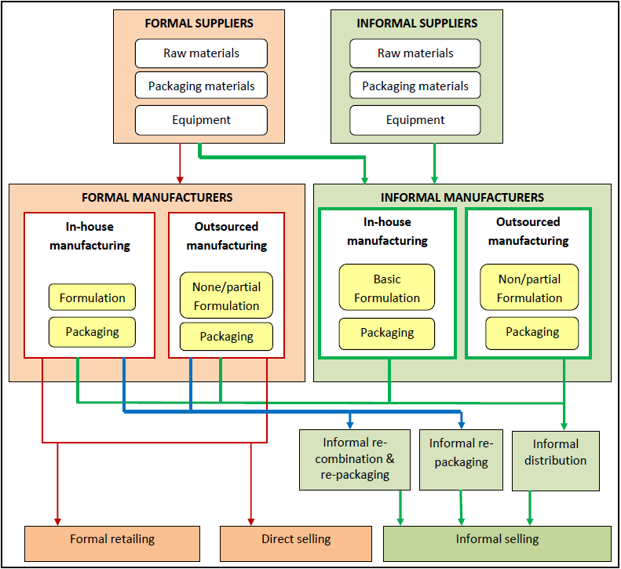

**Source: Elaborated by authors; modified from DTI (2012)**

* **Suppliers** to informal manufacturers of home & personal care products can be both formal and informal enterprises. Raw materials represent a large portion of the production cost for cosmetics and personal care product manufacturers, and have been estimated to constitute up 80% of the cost of the product (DTI, 2012).

1. Formal suppliers – include those supplying:

* Raw materials: such as waxes, solvents, alcohols, pigments, fillers, natural extracts, glycerines, emulsifiers, petroleum jelly, waxes, etc. The vast majority of raw materials are imported to South Africa by foreign large companies or multinationals; therefore formal suppliers in South Africa tend to be distributors of imported raw materials.
* Packaging material, containers and components: at the time of the study there were around 30 formal suppliers of packaging that serve home & personal care product manufacturers. Packaging is an important component of chemical cleaners and cosmetic products – especially in cosmetic products as it affects the perception of quality of the product. Along with the aesthetic value of packaging, there are also other characteristics of specific chemical products that may affect decisions related to packaging materials. For instance, certain chemical products cannot be packaged in plastic because they degrade in color; others require to remain at a certain temperature to maintain their consistency (e.g. Vaseline); other products require air-lock as they can get contaminated through air exposure; essential oils deteriorate if they exposed to light and need to be in dark glass; or perfumes often need to be sealed in glass containers with a crimping machine to avoid evaporation and deterioration.
* Equipment: such as manual and electric mixers, crimping machines, manual and electric bottle fillers, precision scales, etc.; are also mostly imported by large distributors from foreign equipment manufacturers (such as Germany, Italy and China).

1. Informal suppliers of raw materials, equipment and packaging materials: they mostly cater to informal manufacturers, who usually display a preference to make smaller transactions on a cash basis. Informal suppliers have the advantage of supplying smaller quantities, suiting informal manufacturers that operate in conditions of limited resources and often inexistent manufacturing premises to store raw materials and equipment. Raw materials and equipment offered by informal suppliers tend to be more expensive, since their customers (i.e. informal manufacturers) cannot afford to buy large quantities in bulk, which usually result in discounts.

* **Manufacturers** of home & personal care products also comprise both formal and informal enterprises. The main players identified are described below.

The **formal segment** consists mainly of in-house manufacturers and outsourced “brand-owners” (i.e. companies that sell and promote products based upon brand awareness). These companies produce their own formulas in-house and also package their own products. In some cases they outsource some or all of their product manufacturing and packaging functions in order to focus on brand building, marketing and selling functions (DTI, 2012). Some major multinational brand-owners are fully importers as from an economies-of-scale perspective it may not economically viable to do local formulation –for instance Revlon used to have their manufacturing site in South Africa but closed its factories to import the products instead. In some cases, product ranges that target specifically the local market (e.g. cosmetic ethnic ranges) are formulated locally. Most products by formal manufacturers are sold formally via retailers (especially supermarkets), or through direct sales (Euromonitor, 2013a, 2013b).

The **informal segment** of manufacturing home & personal care consists primarily of two types of activities:

1. Informal “in-house” manufacturers: these micro enterprises usually perform their manufacturing activities from kitchens, garages or backyards. Such companies tend to rely on very basic equipment and technology (e.g. kitchen utensils). Both formulation and packaging are typically basic and unsophisticated. Formulation mostly consists of mixing manually semi-elaborated raw materials (e.g. paraffin, fragrances, alcohol, basic lotion, etc.). They often package their products in small and affordable containers, to be sold at reduced prices.

In some instances, the manufacturing activities of in-house manufacturers consist of buying generic products (e.g. moisturizing lotion, generic soap, etc.) from contract manufacturers and making small modifications to these products (for instance adding colorants, fragrances and essential oils to basic skin lotions and or soaps). Due to the small size of the business, informal in-house manufacturers tend to rely on a limited number of suppliers of raw material (less than 5 suppliers) normally found in the vicinity of their manufacturing premises. In other instances (less frequently) informal in-house manufacturers do engage into the entire manufacturing process, using only raw materials (e.g. natural oils and other natural substances or generic chemicals).

In general, this type of enterprise usually lacks formal company structures and raw materials are purchased on a cash and ad-hoc basis, either from formal or informal suppliers. They often operate without company or tax registrations. Similarly, their products are not tested or registered. They usually sell their products using their own brand name but sometimes they operate without a brand.

1. Informal outsourced “brand owners”: these micro enterprises do not engage into manufacturing *per se*; instead, they buy in their products from other companies (i.e. contract manufacturers) to whom they outsource most of the production process: from product development, to manufacturing and packaging of the products. The relationship between contract manufacturers and informal “brand owners” can take many forms, and is shaped to a large extent by the ability of the informal company to negotiate and pay for exclusive rights of the formulation and/or package of the products they source in. Informal “brand owners” usually have a clear idea of the product they would like to sell to a specific market (e.g. ethnic hair products), so they get contract manufacturer to develop a product for them (exclusively or non-exclusively depending on the negotiated terms of the contract), package it (also using exclusive packaging or not) and label it. The cost of developing an exclusive (although basic) formula through a contract manufacturers is usually in the range of 5,000 ZAR – 10,000 ZAR (between US$520 – 1 040[16]) depending on the product. However, the price often poses limits the ability of informal brand owners to buy an exclusively formulated product – instead they sometimes outsource a generic formulation that may be also outsourced by the same contract manufacturer to other informal “brand owners” and labeled under a different brand name. In general, informal “brand owners” tend to work with small amounts of units, and rely on one small contract manufacturer to develop a product for them while they focus on creating brand awareness. These companies invest most of their efforts in building their brand name in various forums – local trade fairs, exhibitions, etc. Informal “brand owners” also lack formal systems and structures; sales are done on a cash basis and their products are usually untested and unregistered, although quality is usually ensured by the contract manufacturers which are predominantly formal companies. It is important to note that business registration not a necessary requirement to purchase from a contract manufacturer, especially from small ones, which tend to be open to flexible arrangements.

* **Distribution**: informal manufacturers (both in-house manufacturers, and outsourced), usually sell their products on a cash basis either directly to the community or indirectly via a network of informal redistributors. However, along the distribution channels we can identify two other types of informal actors:

1. ‘Re-packager’s: these are enterprises re-packaging products purchased in large containers from formal producers (e.g. petroleum jelly, lip balms, skin lotions, detergents, etc.). These actors usually do not sell using their own brand. The competitive advantage is obtained from their ability to sell small unit sizes (e.g. sachets or small containers) to low-income customers at reduced prices. These types of enterprises also lack formal structures and registration, and they distribute informally either to individuals in the community of in informal markets.
2. ‘Mixers’: enterprises recombining existing products and repackaging – this is usually the case of informal hair salons. Informal hair salons sometimes make their own combinations of existing products repackaging them in order to create a “unique” product that attracts and maintains their customer base. This product may or not be branded with a new label. The combination of products results in a new formulation, although the composition and quality of the new product is inconsistent and often depends on the available stock at the time.

The competitive advantage of informal manufacturers is primarily on the price, as they make a range of products available at a fraction of the price that the consumer would pay for formal products sold in formal establishments. But also other factors, such as distributions networks and unit sizes, also constitute sources of competitive advantage in specific products and specific sale locations. For instance, for customers living in informal settlements, where formal establishments are scarce and transport options limited, delivering products at the customers’ doorstep can become another source of competitive advantage for informal manufacturers. For those operating in metropolitan areas (e.g. tuck shops in taxi ranks or small informal shops in the city center), competition appears to be more intense than for those operating in informal settlements, sometimes resulting in smaller profit margins. In these cases, offering small unit sizes that are not available in formal establishments also constitutes a source of competitive advantage (see the example of fragrance manufacturers in the section 2.2.4 below).

## 2.1.4 Profile of informal manufacturers of home and personal care products

This section summarizes the main characteristics of the 25 informal manufacturers interviewed for this study. This information should be interpreted in the context of the innovation system presented in Section III, and the qualitative data obtained from the fieldwork as explained below. Table 3 below provides a summary of the key characteristics of the surveyed companies.

The sample comprised companies from Gauteng and the Eastern Cape provinces, with 68% of companies based in Gauteng. The sample is balanced in terms of gender, with 52% of the companies owned by women and 48% by men. One quarter of the respondents had stopped their education at primary level, 44% had achieved at least a matriculation level of education (i.e. primary and high school), and 32% had Diplomas or some kind of tertiary education. None of the interviewees had postgraduate education.

**Table 3: Profile of the informal manufacturers of home & personal care products**

|  |  |  |
| --- | --- | --- |
| Location | Gauteng | 68% |
|  | Eastern Cape | 32% |
| Sub-sector | Personal care products | 68% |
|  | Home care products | 32% |
| Gender owner | Female | 52% |
|  | Male | 48% |
| Type of activity | In-house manufacturer | 92% |
|  | Outsourced “brand owner” | 8% |
| Time in the business | 1-3 years | 60% |
|  | 3-5 years | 12% |
|  | More than 5 years | 28% |
| Level of education | No education | 0% |
|  | Primary | 24% |
|  | Secondary | 44% |
|  | Tertiary | 32% |
| Number of employees | Only owner | 32% |
|  | 1-2 employees | 56% |
|  | 2-10 employees | 12% |

**Source: Fieldwork, 2013**

The majority of companies were micro-enterprises, with one third of the companies (32%) comprised solely by the owner, and 56% with 1-2 employees[17]. Most companies were young, with 60% operative for 1-3 years – it is interesting to note that there was a relatively low percentage (12%) of informal companies operating for 3 to 5 years in comparison to those operating for more than 5 years (28%), suggesting that whilst informality may be a temporary/pre-formal stage for some companies during which they may test their products and grow up to certain size, for other companies there may be an “informality trap” hindering their chances of formalization after being operative for longer than 5 years.

One third (32%) of the interviewed companies reported to have an estimated annual turnover of R50,000 or less per year (equivalent to about US$ 5,200), and 64% reported less than R200,000 turnover per year (approximately less than US$ 20,600 per year). Only 4% of the companies reported an annual turnover of more than R200,001 per year (approximately US$ 20,600 per year or more)[18].

**Figure 4: Annual turnover reported by respondents**

**Source: Fieldwork, 2013**

It is interesting to note that there does not seem to be a direct relationship between age of the firm and annual turnover, as for our sample companies that had been operative for a longer period of time (over 5 years) did not necessarily display higher annual turnover compared to younger companies – se Figure 5 below.

**Figure 5: Annual turnover by age of the firm (percentage of respondents)**

**Source: Fieldwork, 2013**

De Beer et al. (2013) described informality as a continuum, where transitions from informality to formality are gradual, and boundaries are blurry and inconsistent within organizations – for instance within an organization we may find that some activities are carried out formally whilst others informally at the same time. In this respect, there would be “degrees of informality” that vary from one firm to another. The degree of informality in this study was identified by means of five specific questions related to: (a) business registration, (b) contract with employees, (c) regular book keeping, (d) use of formal financing mechanisms (i.e. bank loans), and (e) products registration. Companies that indicated informality in 4 out of 5 of these aspects were included in this study as informal businesses.

It must be noted that informality can be either intentional (e.g. to avoid the implicit costs involved in business registration), or it may be unintentional – as informal entrepreneurs often do not deem their activities as a business enterprises *per se*, but rather a survival activity not worthy of being considered as a business. In our sample, although most entrepreneurs were conversant with the use of banking they appeared to have virtually no access to bank loans or overdrafts, and had relied mainly on their own savings and family loans to set up their business. It was often mentioned by the respondents that the intermittency of sales, posed difficulties to business owners to set up formal contracts with their employees and achieve financial flexibility to pay for medical aid, paid leave and unemployment benefits for themselves and their employees.

**Table 4: ‘Degree of informality’ of respondents**

|  |  |  |  |
| --- | --- | --- | --- |
|  |  | **Yes** | **No** |
| 1 | Is your business registered? | 52% | 48% |
| 2 | Do you have formal contract with your employees? | 8% | 92% |
| 3 | Do you keep regular accounts of your business? | 32% | 68% |
| 4 | Have you obtained a loan from the bank? | 4% | 96% |
| 5 | Are your products registered? | 0% | 100% |

**Source: Fieldwork, 2013**

Another indicator of informality is the lack of internal structures and systems within the companies, for which regular book keeping is an essential basis. Book keeping was reported as cumbersome by many of the entrepreneurs interviewed, and 68% reported to lack a system to keep track of regular accounts.

## Main products

The varieties of products examined in this study include two sub-sectors: (a) Personal care products: including cosmetics, perfumes and toiletries and (b) Home care products: including soaps and cleaning chemicals.

1. Personal care products: skin care, hair care, cosmetics and toiletries

Fragrances and body lotions were the products most frequently targeted by informal manufacturers of personal care products. Producing fragrances appeared to be a relatively easier entry point for many informal manufacturers of cosmetics. Informal manufacturers of fragrances very often obtain essential oils from formal suppliers who offer mixed combinations of perfume oils that have similar scent to mainstream perfumes. Once the informal manufacturer buys the mixed scent, the process of mixing the oils with alcohol and other ingredients to obtain the final perfume entails little equipment requirements. The quality of the final fragrance is usually determined by:

* The quality of raw materials (including various types of alcohol – such as benzyl alcohol and ethanol – , and essential oils)
* The process of manufacturing (for instance, access to refrigeration during the process of production)
* The knowledge and technical ability of the producer to combine the raw materials,
* The equipment – for instance perfume bottles sealed using a crimping machine lead to less evaporation and better preservation of the product
* The packaging (glass, plastic, closing mechanism (e.g. air-lock), aesthetic quality of packaging, etc)

The resulting product is usually sold for about one-tenth of the price of the original perfume, and is also made available in smaller (and hence more affordable) size units of 10-30 milliliters; instead of the usual 50-100 milliliters offered by mainstream formal manufactures. Despite the underlying intention to imitate main international brands, the obtained fragrances have a different formulation to the original brands, and are sold under different brand names and with different packaging to the original. It is important to note that consumers are not led to believe that they are buying the original brand. The resemblance of the product to the original brand is used as a marketing strategy, taking advantage of the consumers’ familiarity with their preferred (and much more expensive) original brand.

Entering the manufacture of perfumes and creating a stable customer base sometimes creates an incentive for the informal entrepreneur to further product diversification, using the same fragrances and scents to produce a range of lotions, roll-ons and bath salts. Gift packs and baskets represent a considerable volume of sales in this line of business.

Fragrances, however, are not the only entry point to manufacturing a wider range of cosmetics and toiletries. Especially in the case of hair care products, informal entrepreneurs sometimes start off with a clear intention to target a niche market, in particular, addressing an existing gap in the market for affordable ethnic hair products. A growing segment of both the formal and informal enterprises is targeting ethnic hair and skin, mainly inspired by trends from United States and the tastes of the African-American community.

The production of bar soaps and color cosmetics were noted by many interviewees as two of the markets they were seeking to enter on the basis of the observation of a sizeable gap in the market for affordable products. However, we found less manufactures dedicated to this line of products due to the technology and equipment requirements for production.

**Figure 6: Range of cosmetic products and frequency observed – percentage of respondents manufacturing each product in the sample**

**Source: Fieldwork, 2013**

**Sample size= 25 informal manufacturers**

**Note (*) respondents occasionally noted more than one product, therefore percentages do not add to 100%**

**Figure 7: Examples of personal care products elaborated by in-house informal manufacturers**

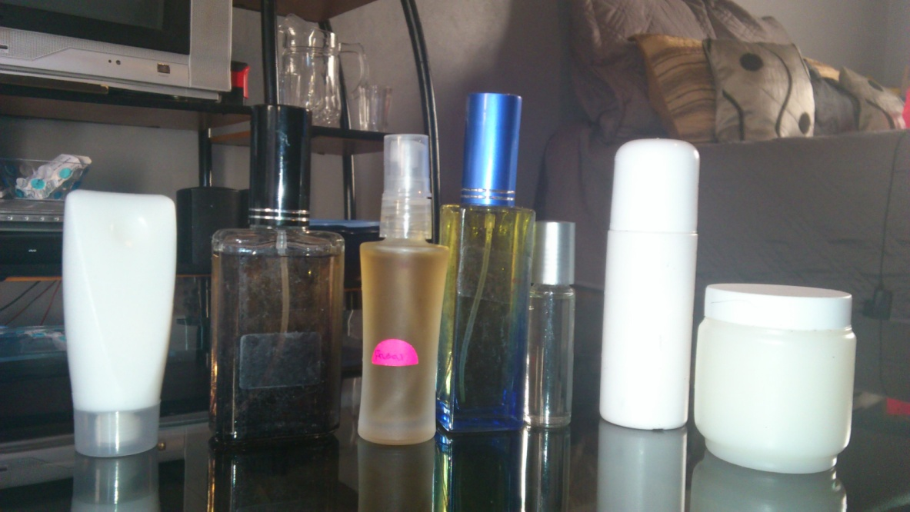 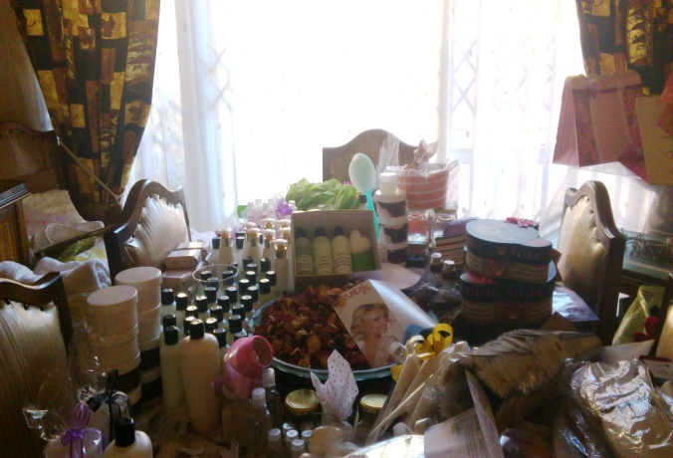

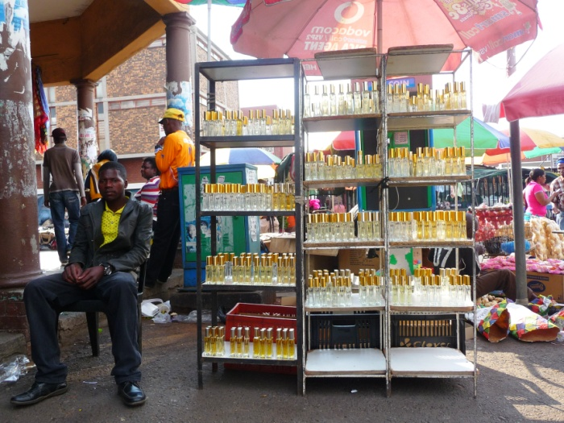 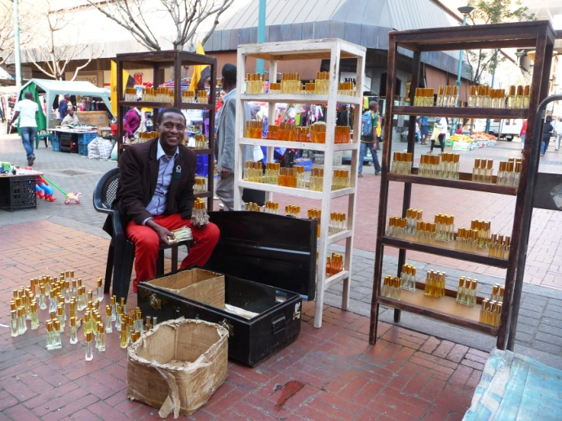

**Source: Fieldwork, 2013; Photo: (top two) Kraemer-Mbula, E.; (bottom two) Hendrikz, R.**

1. Home care products

Manufacturing home care products usually requires a relatively higher level of technical knowledge as compared to personal care products, especially regarding the raw materials, health and safety in the manufacturing process and the formulas needed to achieve the final product. Dish washing liquid was the most frequent product observed in our sample, followed by pine gel (general purpose cleaner and disinfectant) and bleach.

**Figure 8: Range of home care products and frequency observed – percentage of respondents manufacturing each product in the sample**

**Source: Fieldwork, 2013**

**Sample size= 25 informal manufacturers**

**Note (*) respondents occasionally noted more than one product, therefore percentages do not add to 100%**

Whilst standards and guidelines are provided by the CTFA (Cosmetic, Toiletry & Fragrance Association of South Africa) and the SABS ([South African Bureau of Standards](http://www.sabs.co.za/‎)), it is not compulsory to either test nor register cosmetics or cleaning products in South Africa. Moreover, formal testing and product registration with the South African Bureau of Standards (SABS) appeared relatively costly to most respondents. Formal testing of products has an average cost of R7, 000 per product (US$ 720), ranging from R3, 000 (approximately US$ 310) for a dishwashing liquid to R11, 000 (approx. US$ 1,140) for laundry detergent. Product certification costs also vary across products but were reported to reach R150, 000 – R200, 000 (approximately US$ 15,500- 20,700)[19]. None of the respondents in our sample had their products formally tested or registered with SABS.

**Figure 9: Examples of home care products elaborated by in-house informal manufacturers**

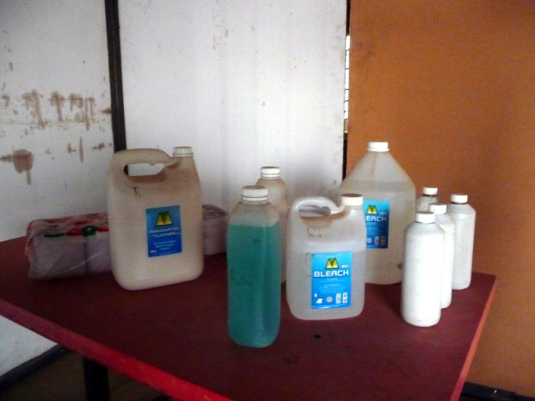

**Source: Fieldwork, 2013; Photo: Kraemer-Mbula, E.**

The location of sales varies across informal manufacturers. Door to door appears to be the most common mode of retailing (32% of respondents), along with setting up stalls in informal markets (32%).

**Figure 10: Main sales locations, as reported by respondents – percentage of respondents**

**Source: Fieldwork, 2013**

**Sample size= 25 informal manufacturers**

**Note (*) respondents occasionally noted more than one location, therefore percentages do not add to 100%**

Tuck shops in taxi ranks and small shops in informal markets in the city center are common places for the retailing on these products. Some examples are illustrated below.

**Figure 11: Examples of sales location for informal home and personal care products**

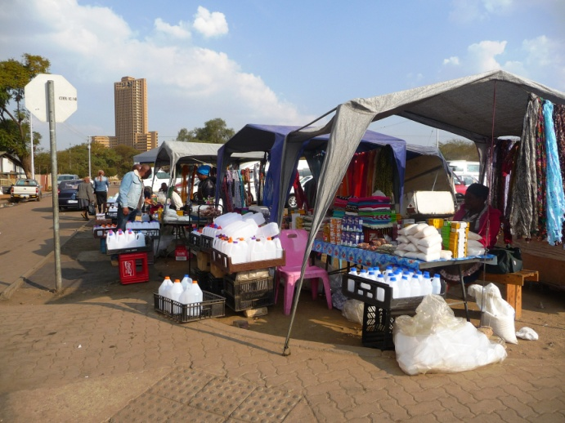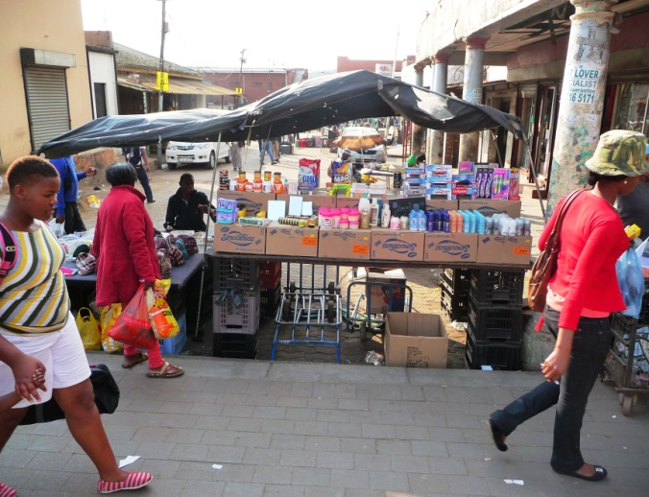

**Source: Fieldwork (2013); Photo: Hendrikz, R.**

Informal manufacturers of cosmetics and cleaning products tend to sell on a one-to-one basis, mainly to individuals in their immediate community. A significant percentage of the manufacturers, especially those that produce in a larger scale, sell larger quantities at reduced prices to informal re-sellers who then add their own profit margin.

The South African retail sector of cosmetic products as identified by DTI (2012) consists of about 33,000 outlets, with an estimation of 10,000 to 12,000 informal salons. It was also noted that South African customers are increasingly valuing natural ingredients and products developed for specific skin and hair types.

**Figure 12: Examples of informal hair salons**

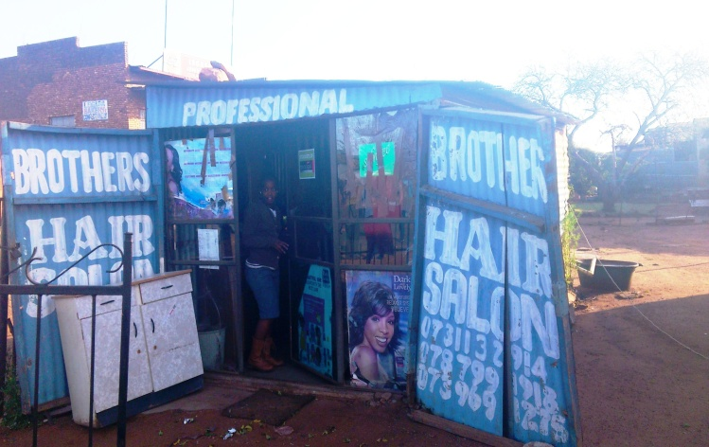 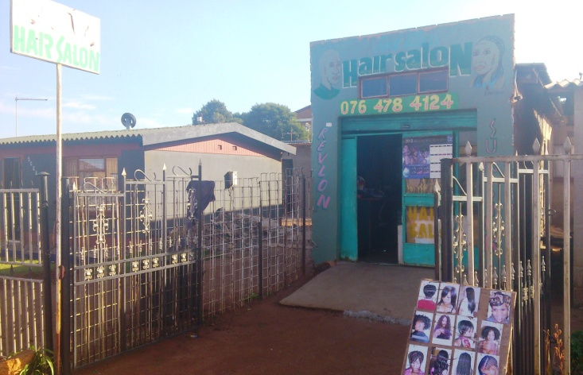

**Source: Fieldwork, 2013; Photo: Kraemer-Mbula, E.**

As indicated in Table 5 below, low income individuals, informal re-sellers, and hair salons usually constitute the demand base for affordable cosmetic products, which is the market usually targeted by informal manufacturers.

**Table 5: Main customers of informal manufacturers of home & personal care products**

|  |  |
| --- | --- |
| **Main customers** | **Percentage of firms\*** |
| Individuals | 49% |
| Informal re-sellers | 23% |
| Hair salons | 10% |
| Schools | 8% |
| Government departments | 5% |
| Clinics | 3% |
| Churches | 3% |

**Source: Fieldwork, 2013**

**Note (*) respondents occasionally noted more than one type of customer, therefore percentages do not add to 100%**

# Section III: Innovation in informal manufacturers of home & personal care products

## Innovation in informal manufacturers of home & personal care products

The commonly used definition of innovation provided the OECD describes it as the “implementation of a new or significantly improved product (good or service), or process, a new marketing method [e.g. a novel product design], or a new organizational method in business practices, workplace organization or external relations” (OECD/Eurostat, 2005; para.146). Whilst this definition provides space for incremental innovations and “significant improvements”, it has been noted that it exclusively focuses on the implementation of the new product or service in the market, without considerations of the types of *impact* that innovations may have on different communities (positive or negative) or the extent to which such innovation are creating access of products and services to certain types of *users*, or user segments (Gault, 2013).

The concept of development itself is currently being expanded to explain the reality of fast growing developing countries. Therefore, contemporary views of development are increasingly looking beyond traditional perspectives based on economic growth, and including a range of *impact* parameters such as inclusion, poverty reduction and sustainable livelihoods. These perspectives are also manifesting in the field of innovation, where the research community is starting to propose broader definitions of innovation and innovation systems that can explain the context of developing countries, where economic activities are largely informal and a lot of economic activity takes place in sectors outside traditional manufacturing. De Beer et al (2013) point out some of these emerging definitions such as “grassroots” innovation, “base of the pyramid” innovation, innovation “for the poor by the poor”, “frugal” innovation, “jugaad” innovation and “inclusive” innovation. Common to these definitions is their intention to capture the creative and value-generating activities by economically disadvantaged people.

## 3.1 Innovation profile of informal manufacturers

At the level of the firm or productive unit, innovation requires channeling resources to certain activities and not others. It implies a change in the way things are done in an organization. In small informal businesses, engagement in innovation very much depends on the willpower of one individual, usually the firm owner. This willingness to some extent may be reflected in the owner’s perception of his/her own product, which may give us an indication of the areas in which innovative efforts may be directed to. In this study informal manufacturers were questioned “what makes your product successful?” The results are shown in Table 6 below.

**Table 6: Perception of own product quality by informal manufacturers of home and personal care products**

|  |  |  |  |  |  |  |  |  |  |  |  |  |  |  |  |
| --- | --- | --- | --- | --- | --- | --- | --- | --- | --- | --- | --- | --- | --- | --- | --- |
| **What makes your products successful?** | | **Percentage of firms\*** |  |  |  |  |  |  |  |  |  |  |  |  |  |
| Customer service | 56% | |
| Quality compared to competitors | 40% | |
| Lower price | 32% | |
| Good quality raw materials | 16% | |
| Attractive packaging and branding | 16% | |
| Good knowledge of product & market | 8% | |
| Attractive brand | 8% | |
| Not good products | 12% | |

**Source: Fieldwork, 2013**

**Note (*) respondents occasionally noted more than one factor, therefore percentages do not add to 100%**

A small percentage of the respondents (12%) displayed low confidence in their products describing them as “not good”. However, a larger share of respondents showed substantial confidence in their products, as 40% of the manufacturers mentioned “quality” as an important feature of their products – it is worth mentioning that higher quality was measured in comparison to immediate competitors, usually also operating at a small scale in the same geographical area. 56% of respondents indicated customer support services to be central to their sales:

*“[My] brand is not known yet, so the most important thing at this stage is building the trust of my customers, and to do that I must spend a lot of time with them, reassuring them about the quality of my products, responding to their questions, building personal relationships with my customers*” *[Tshamupo co-owner, manufacturer of natural beauty products]*

“*Almost anybody can start producing [therefore] customer service is critical in this industry” [Manufacturer of fragrances and skin care products]*

Regarding the types of innovations, many respondents made occasional mention to incremental innovations in products, often related to significant product improvements (in formulations or packaging) rather than the generation of radically ‘new’ products[20]. Significant improvements to the production process were less frequent, with 76% of the respondents reporting no changes or improvements in this regard. Process innovations were related to the introduction of new quality control mechanisms to the production process, the acquisition of new equipment, or changes in the way production processes were structured. It is important to note that all innovations observed were new to the company rather than to the industry as a whole, and were often based on copying and imitation of other micro manufacturers (both formal and informal), or on the advised provided by other external actors (such as suppliers and technology transfer agencies) – as explained in sub-section 3.3 below.

**Table 7: Significant improvements to products and processes, as reported by respondents**

|  |  |
| --- | --- |
| **Improvements in products** | **Percentage of firms\*** |
| None | 44% |
| Improved formulations | 32% |
| Packaging and branding improvements | 16% |
| **Improvements in processes** |  |
| None | 76% |
| Introduction of quality control mechanisms in manufacturing | 16% |
| Acquisition or improvements in equipment | 12% |
| Organizational changes in the structure of the production | 8% |

**Source: Fieldwork, 2013**

**Note (*) respondents occasionally noted more than one improvement, therefore percentages do not add to 100%**

1. Significant improvements in products: the respondents identified them with both internal changes to the product (i.e. improved formulations) as well as external changes (i.e. improved packaging and labeling).

* Improved formulations – about one third of the respondents (32%) claimed to have made significant modifications to the original formulation of their products. Some of the most mentioned improvements related to improving the formula to make cosmetics stronger and more durable (for instance adding a larger proportion of oils to perfume recipes), or adding healing properties to cosmetic products on the basis of known natural remedies (for instance adding vinegar to foam bath or hair products to treat various types of bacterial conditions). Improved formulations were often a response to explicit requests from customers (e.g. asking for long-lasting fragrances), inputs from suppliers (e.g. newly available raw materials or packaging), regulatory pressures to increase the quality of their products (e.g. safety concerns), or replacement of certain ingredients & addition of more “natural” ingredients to target a new market and increase the profit margin.
* Improved packaging and labeling – packaging was often reported to be a critical component of cosmetics, and 16% of respondents acknowledged to have introducing significant improvements to their packaging and labeling. It was also noted most interviewees had started their business using the most basic packaging, often plastic containers recycled from other products (e.g. soft-drink bottles) and hand-written labels. As businesses became more established, improvements in packaging became more frequent in order to reach a broader customer base. These innovations often involved adding decorative layers to the products or using wrapping paper with specific tribal designs to attract specific customers. Improvements in packaging and labeling were often a means for product differentiation, knowledge appropriation and a source of competitive advantage.

**Figure 13: Examples of improvements in soap packaging**

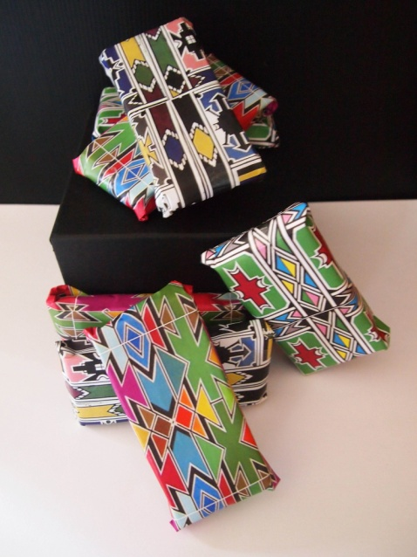 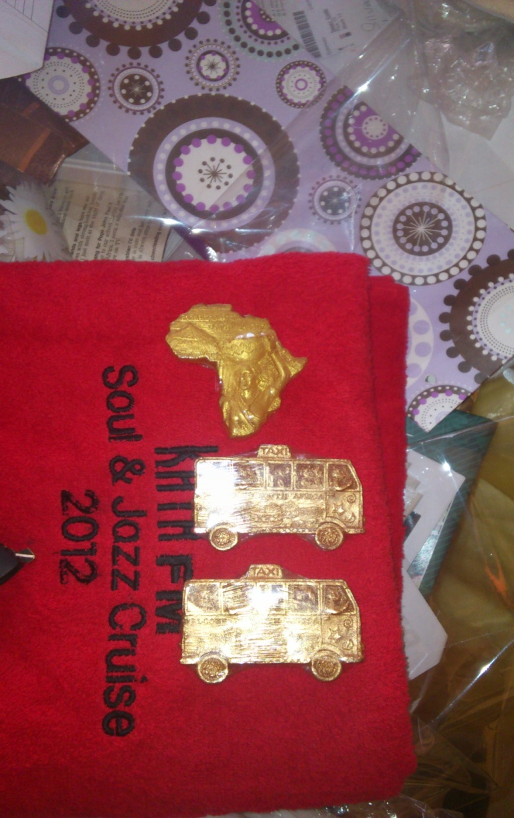

**Source: Fieldwork, 2013; Photo: Kraemer-Mbula, E.**

1. Significant improvements in processes: manifested in quality control mechanisms, new or improved equipment and organizational changes in the structure of the production.

* Introduction of quality control mechanisms in production – since home & personal care products depend heavily on chemical substances, it is normal practice for formal manufacturers to ensure that quality control mechanisms are an intrinsic part of the manufacturing process. However, quality control mechanisms such as stability tests – to measure the pH value, texture, viscosity – microbiological tests and testing the impact of packing on the product (packaging stability), usually has costs implications that informal manufacturers are not able to face. Nevertheless, some of these quality control mechanisms are more affordable than others, and easy perform – for instance measuring the pH using pH stripes, or ensuring the stability of fragrances through refrigeration are relatively low cost . 16% of the companies reported to have introduced quality control mechanisms in their production process. In most cases good practices were transferred amongst manufacturers, or between suppliers and manufacturers.
* Acquisition or improvement of equipment – we found cases of informal enterprises crafting affordable versions of expensive equipment by re-assembling various pieces of equipment. For instance, a company that had reproduced an electric mixer by using a second-hand electrical drill and a metal piece found in a scrap yard. Making low-cost equipment resulted in an investment of R500 (around US$50) in crafting the machine, instead of R30 000 (around US$3100)[21] of investment in a new machine. Having this piece of equipment allowed the company to mix lotions, soaps and bath foams in larger volumes and at a faster rate, as compared to doing it by hand. This machine implied that the company could produce larger quantities and change its business model, selling in bulk to re-sellers rather than selling individual units to their customers.

**Figure 14: Example of process innovation – crafting low-cost equipment**

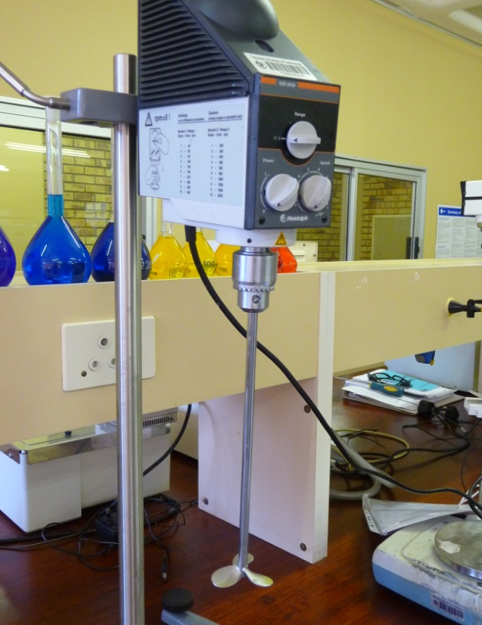 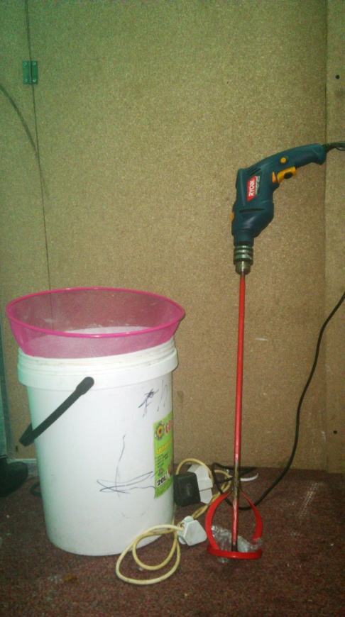

**Source: Fieldwork, 2013; Photo: Hendrikz, R.**

**Note: example of electric mixer on the left side - available at TUT Technology Station for Chemicals; and low-cost replica of electric mixer on the right side**

* Organizational changes in the structure of the production – 8% of the respondents reported to have introduced significant changes in the way the manufacturing process was organized. These improvements appeared to be strongly related to the shift from manual to mechanical processes, as the majority of manufacturers still relied on manual techniques to generate the products.

Table 8 below summarizes the key characteristics of the innovation activities observed for informal manufacturers of home & personal care products on the basis of our sample:

**Table 8: Key features of innovation by informal manufacturers of home & personal care products**

|  |  |
| --- | --- |
| **Features of innovation** | **Description** |
| *Incremental* | * The types of innovations observed are new to the company, rather than new to industry, nationally or globally. They mainly manifest in improvements to the formulation or the aesthetic value of the product. |
| *Reactive* | * *Reacting to customers*– modifications and improvements to manufactured products are mostly done to respond to explicit customers’ requests. Informal manufacturers seem to rarely pay attention to emerging opportunities or trends in the national and international markets. The strong dependency on a small customer base for the business survival makes them very responsive to their immediate demand. * *Reacting to suppliers –* Since informal manufacturing of home & personal care products is largely based on mixing raw material and packaging the obtained product, suppliers (either formal or informal) play a big role in generating innovation in informal entrepreneurs. Given the strong competition amongst suppliers, it is their interest that informal entrepreneurs increase their range of products and that they do well in their businesses, as that will ensure future business with them as suppliers. |
| *Proactive* | * Packaging and labeling improvements are examples of product innovations introduced by informal manufacturers to reach out to a wider market. |
| *Collaborative* | * Informal entrepreneurs lack the resources to invest in research and development, and often rely on collaboration and exchange of ideas with other informal manufacturers that materialize in product or process innovations. |

Source: Authors

## 3.2 Obstacles to innovation and scalability

Informal entrepreneurs confront multiple challenges, simply to survive in a marketplace dominated by formal and often more competitive producers. The obstacles to innovate appear to be strongly linked to the obstacles for their survival as micro-enterprises. In this study, the most frequently mentioned by informal manufacturers include “insufficient education and knowledge” and “lack of machinery and equipment”, mentioned by one third of the respondents – see Table 9 below. Interviewees often indicated that although they had ideas for the introduction of significant improvements, these two factors stood in the way of their ability to innovate.

Informal manufacturers generally lack premises for production, and they conduct their activities from their backyards, kitchens and garages – with the additional limitation in terms of access to infrastructure characteristic of informal settlements as described in section I. In this respect, 28% of the respondents indicated that the lack of adequate premises posed a major constraint to their ability to come up with new products. Access to finance was mentioned as a main obstacle to innovate by 24% of informal manufacturers, who often operate their businesses purely based on cash transactions and without a bank account.

**Table 9: Obstacles to innovation, as reported by respondents**

|  |  |
| --- | --- |
|  | **Percentage of respondents\*** |
| Insufficient education and knowledge | 32% |
| Lack of machinery and equipment | 32% |
| Inadequate premises | 28% |
| Access to finance | 24% |
| Access to raw materials | 16% |
| Physical access to larger markets | 16% |
| Lack of testing facilities | 8% |
| Lacking R&D facilities | 4% |

**Source: Fieldwork, 2013**

**Note (*) respondents occasionally noted more than one obstacle, therefore percentages do not add to 100%**

## 3.3. Knowledge and technological profile of the sector

## 3.3.1. Key technologies used

The technology intensity found in informal manufacturing enterprises surveyed was generally low. Informal manufacturers lack capital to invest in equipment as well as adequate premises to host it. Therefore, informal enterprises often rely on manual techniques and production processes, leading to substantial waste of raw materials during the production process, uneven levels of quality amongst batches, and low productivity.

The equipment used by most informal manufacturers of home & personal care products is rather basic and mainly consists of kitchen utensils (pots, pans, manual blenders, microwaves, stoves, refrigerators, etc.). The manufacturing process is mainly a “recipe-based” activity, consisting of mixing raw materials in specific proportions following a specific formula. Measuring jars and scales are therefore indispensable pieces of equipment, to ensure that raw materials are combined in the right proportions. Sterilization of manufacturing equipment and raw materials is performed using microwaves and ovens.

Refrigeration is sometimes part of the manufacturing process, with the use of domestic refrigerators when electricity is available.

**Table 10: Manufacturing equipment used by informal manufacturers**

|  |  |
| --- | --- |
| **Equipment** | **Percentage of firms\*** |
| Mixing pots | 76% |
| Measuring jars | 60% |
| Refrigerator | 28% |
| Stove | 24% |
| Funnels and squeezers | 24% |
| Microwave machine | 20% |
| Computer | 20% |
| Kitchen scales | 20% |
| **Electrical/ motor mixer** | 16% |
| pH Stripes | 16% |
| Oven | 16% |
| Printer | 12% |
| Soap molds | 8% |
| **Crimping machine** | 8% |
| **Precision scales** | 8% |
| **Bottle filling equipment** | 4% |

**Source: Fieldwork, 2013**

**Note (*) respondents indicated all pieces of equipment used, therefore percentages do not add to 100%**

**Figure 15: Examples of equipment commonly used by in-house informal manufacturers**

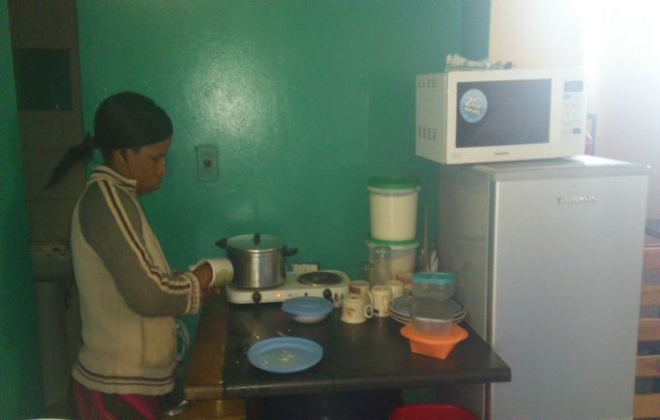 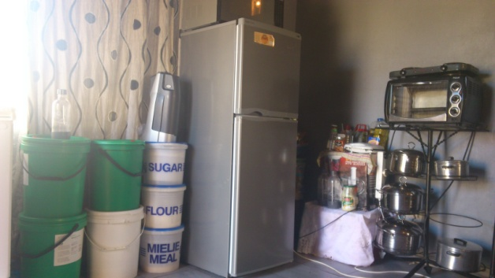

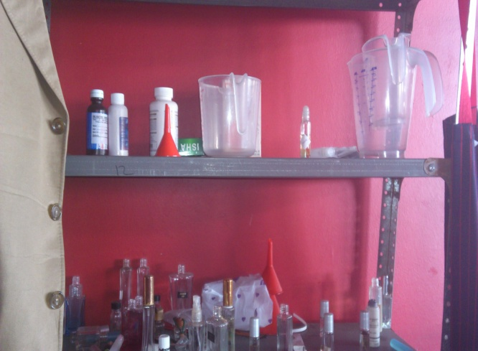

**Source: Fieldwork, 2013; Photos: Kraemer-Mbula, E.**

**Note: stoves, measuring jars, microwaves, pots and pans, are the most commonly found equipment used in manufacturing household chemicals and cosmetic products**

More sophisticated equipment generally used for the production of home & personal care manufacturing includes:

* Precision scales – to ensure that the mix of ingredient is exact and results are consistent.
* Crimping machines: widely used in perfume manufacturing, to crimp glass bottle pumps on it. Using this equipment not only increase the quality of the products, but also reduces the evaporation of the perfume once it is bottled.
* pH testing devices – the pH of chemical solutions can be tested manually using pH test strips which are available at low cost; or by using digital pH meters, which provide precise pH values.

**Figure 16: Example of digital pH meter**

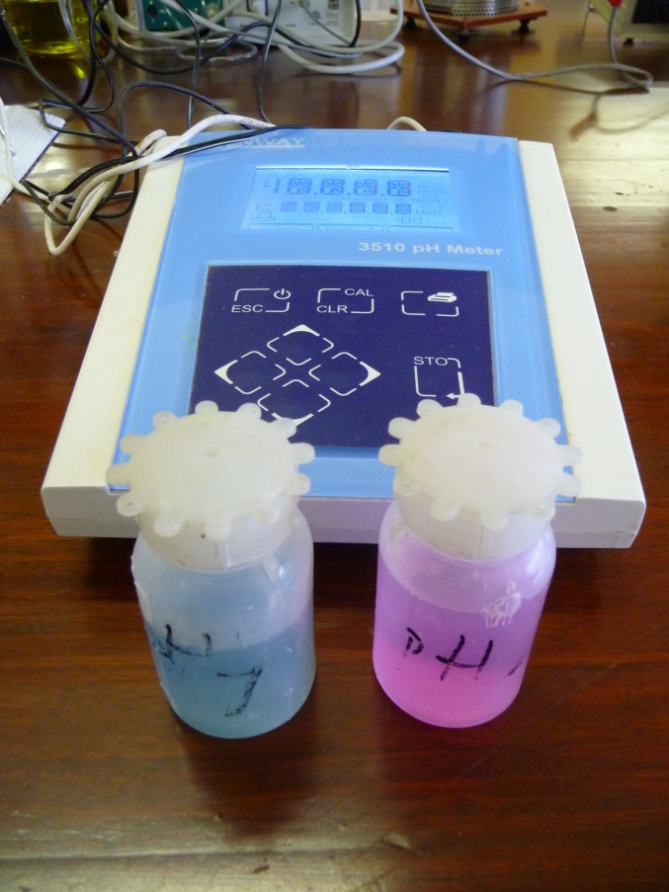

**Source: Fieldwork, 2013 – digital pH meter available at the Technology Station in Chemicals (Tshwane University of Technology); Photo: Hendrikz, R.**

* Electric and manual mixers are indispensable in the manufacturing of cosmetics and detergents to achieve a homogenous mix of the components. This type of technology creates a significant competitive advantage in relation to manual methods, but requires a significant investment as their prices range from R30, 000 to R70, 000 depending on quality and functionality (US$3,100 – 7,200)[22].
* Bottle filling equipment: can be either manual or electrical, and is designed specifically for bottling cosmetic creams and lotions, liquid and semi-liquid cosmetics (shampoo, detergents, foam bath, etc.). This type of equipment significantly reduces waste and increase hygiene in the process packaging.

Only 16% of the respondents reported to have acquired a motor/electrical mixer – it must be noted the study identified companies that elaborated their own equipment. More sophisticated technology such as crimping machines, and precision scales were found much less frequently (in only 8% of the companies interviewed), while bottle filling equipment was used only by 4% of the respondents.

**Figure 16: Examples of more sophisticated equipment used by in-house informal manufacturers**

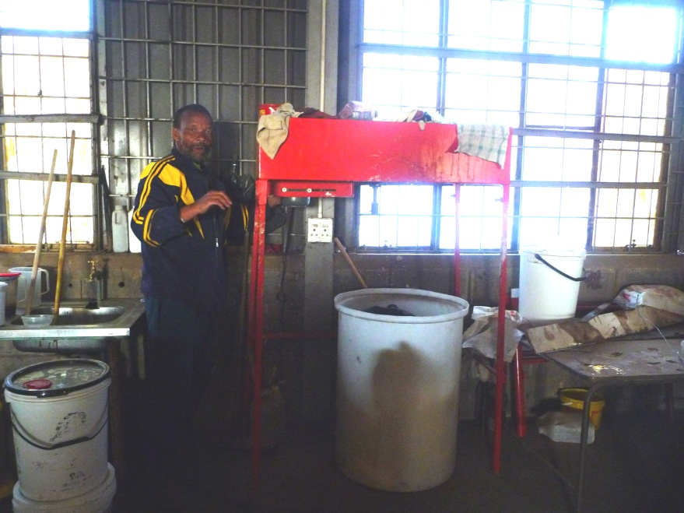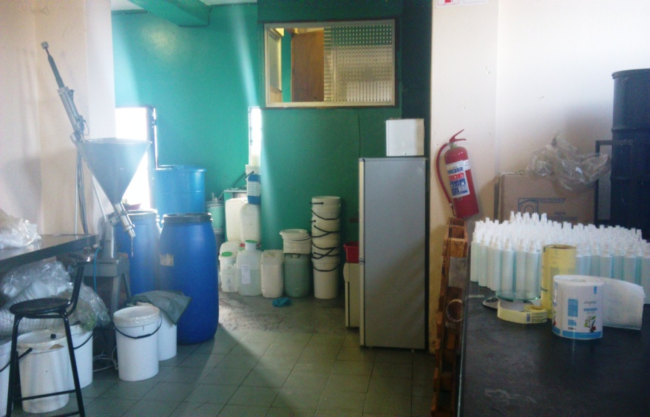

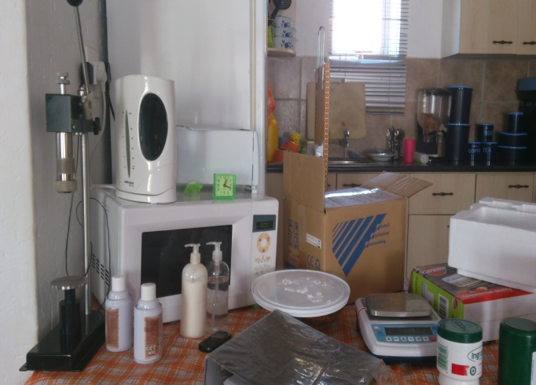

**Source: Fieldwork, 2013; Photo: Kraemer-Mbula, E.**

**Note: top left picture illustrates and example of a motor mixer, top right pictures has an example of manual filling machine, and bottom left picture has an example of crimping machine and a precision scale.**

## 3.3.2. Sources of knowledge

Suppliers appear to be a critical source of knowledge for the informal manufacturers interviewed. Suppliers are both formal and informal companies supplying with raw materials, packaging, equipment, labels, etc. Whilst formal suppliers do supply both formal manufacturers and informal manufacturers, informal suppliers tend to supply only to informal manufacturers. The formal or informal structure of the suppliers’ company does not seem to be a concern for informal manufacturers, which indicates that level of formality of the supplier does not appear to be an important factor in their choice. Informal manufacturers choose their suppliers on the basis of a variety of reasons including: proximity, reliability, price, option to purchase on credit, etc. Price, however, plays an important role, and information about cheap suppliers was mentioned to be a valuable asset for any informal manufacturer.

In South Africa there are a relatively small number of formal suppliers of raw materials[23], packaging, etc, that cater for small manufacturers of home & personal products. The suppliers’ market is dominated by large formal companies that usually work with a system of minimum orders involving high volumes, and upfront payment. This system creates a cash flow pressure on small informal manufacturers, who usually have limited resources. For instance, one informal manufacturer explained the difficulties experienced to buy bottles for her new range of lotions:

“*I approached [a known formal supplier of packaging for personal care products] but they tell me they require a minimum order of 50,000 bottles. I do not need so many bottles; I cannot make an upfront payment for such a big order. I do not have a reliable postal address where they can send me the order, and I cannot carry or store such a big amount of bottles”. [Informal manufacturer of skin care products]*

For these reasons, informal manufacturers usually rely on smaller (and often informal) suppliers who operate in their vicinity, and can supply smaller volumes. Small suppliers catering for micro-manufacturers must compete between themselves, to attract the low-income micro-manufacturers and secure their clientele[24]. As part of their marketing strategies, suppliers become a regular source of training and manufacturing advice, as well as a steady source of support to product diversification by micro-manufacturers. Such services are often provided free of charge, as a way to establishing closer and durable relationships with their clients. As a result, almost one third of the interviewed informal manufacturers reported to have obtained relevant knowledge in the form of training from a supplier company – see Table 11 below.

**Table 11: Main sources of knowledge reported and frequency**

|  |  |
| --- | --- |
| **Where did you acquire the knowledge to manufacture home & personal care products?** | **Percentage of firms\*** |
| Training by suppliers | 28% |
| Formal training by technology transfer agency | 24% |
| Previous work experience | 24% |
| Learnt informally from other manufacturers | 24% |
| Self-training by experimentation (trial & error) | 24% |
| Books and manuals | 20% |
| Learnt informally from people with previous experience in the industry (retired) | 12% |
| Internet | 12% |
| Relatives | 12% |

**Source: Fieldwork, 2013**

**Note (*): respondent indicated all sources of knowledge used, so percentages do not add to 100%**

Technology transfer organizations (e.g. [TUT Technology Station in Chemicals](http://www.tut.ac.za/Students/facultiesdepartments/ebe/citci/tsc/Pages/default.aspx), [Chemin](http://www.chemin.co.za/‎), [Sasol Chemcity](http://www.chemcity.co.za) and [EgoliBio](http://www.egolibio.co.za)) are key sources of knowledge, through the provision of formal training on manufacturing processes. Each of the technology transfer organizations provides different services, but common services offered include:

* Training on product manufacturing and safety
* Technical demonstration
* Technology commercialization assistance
* Intellectual property management
* Connection with suppliers, research organizations and funding opportunities
* Product testing

The services provided by technology transfer organizations have cost implications for the micro-enterprise, although informal micro manufacturers tend to get subsidies and reduced costs. Nearly one quarter (24%) of the companies interviewed had received some form of formal learning interaction with a technology transfer agency[25], whilst an equivalent percentage reported to have obtained some of their knowledge informally from other manufacturers/producers in the industry. For this later group of respondents, it was indicated that obtaining knowledge from peer manufacturers usually required developing a relationship of trust, in which the knowledge exchanged had to be equally beneficial to both parties. Also 24% of respondents reported to had obtained relevant knowledge through prior experience working in sector, in many cases employed in manufacturing companies (often formal companies) and lost their jobs. Learning through experimentation (trial and error), also appears to constitute a critical source of knowledge for informal manufacturers, as it was reported by 24% of the respondents as relevant.

Barriers of entry in these manufacturing activities are rather low and largely determined by the entrepreneurs’ ability to gather the necessary capital to acquire raw materials and equipment to start-up the business. Interviewees often reported that the knowledge to manufacture home & personal care products – for instance perfumes and lotions – is widely available in books, manuals and the internet.

Interestingly, knowledge passed on by relatives does not feature in our sample as a key source of knowledge, and only 12% of the respondents reported to have obtained the knowledge on how to manufacture the products from their relatives (in these particular cases, their grandmothers).

Informal manufacturers were questioned about their reliance on traditional knowledge. 76% of the respondents claimed that their products did not rely at all on traditional knowledge, whilst 16% of the respondents stated that their products were partially based on traditional knowledge; in these cases the TK was described as widely available and easily accessible as part of common knowledge. Only 12% of the respondents indicated to be largely reliant on TK, which had passed to them by their grandmothers as indicated above. It must be noted that the concept of traditional knowledge is wide and open to interpretations, which calls for closer attention of its role in this manufacturing sector and possibly further research.

## 3.3.3. Knowledge flows

Although family members did not feature as relevant source of knowledge, the evidence suggested that knowledge does get transferred from individual to individual via informal training in the community. In this regard, 44% of the informal manufacturers reported to have trained other people – in many cases to members of the community that were in particular situations of need. Passing on knowledge to others indicated a sense of responsibility and duty towards the community in which entrepreneurs operate. In the cases where informal training had been provided, each producer had passed on some of his/her knowledge to an average of 2.2 additional people.

**Table 12: Reported knowledge flows**

|  |  |  |
| --- | --- | --- |
|  | **Yes** | **No** |
| Have you trained other people? | 44% | 56% |
| If so, how many? (average) | 2.2 |  |

**Source: Fieldwork (2013)**

More than half of the respondents reported to have had no interaction with any formal or semi-formal organization (52%) –for the definition of semi-formal organization please see concept study (de Beer et al, 2013). The remaining 48% reported to obtain knowledge from: (1) technology transfer organizations (TUT Technology Station for Chemicals, Chemin, or Sasol Chemcity), (2) business incubators (e.g. Awethu project and the Hope Factory, Young Business SA), (3) representative associations (CTFA, Proudly South African), and (4) networking initiatives for entrepreneurs (e.g. Hook up Dinner, Enablers, Branson Centre of Entrepreneurship, etc.). It was often the case that manufactures would connect with various organizations at the time, and it was often mentioned that establishing a connection with one formal organization often opened opportunities to connect with other initiatives.

**Figure 17: Engagement with formal organizations, percentage of respondents**

**Source: Fieldwork, 2013**

88% of manufacturers that interacted with formal organizations reported a range of benefits as a result, whilst in 12% of the cases the services provided by formal organizations did not seem to suit their needs. The benefits reported ranged from using manufacturing facilities, products manufacturing training (mostly linked to those interacting with technology transfer organizations), support with book keeping, mentorship and networking with other entrepreneurs.

**Table 13: Reported benefits of connecting with formal organizations**

|  |  |
| --- | --- |
| **What have been the benefits of connecting with formal organizations?** | **Percentage of firms\*** |
| *Not useful* | *12%* |
| Using manufacturing facilities | 16% |
| Product manufacturing training | 16% |
| Support with book keeping | 16% |
| Business management support/ mentorship | 12% |
| Networking with other entrepreneurs | 12% |
| Connecting with other support organizations | 8% |
| Access to seminars and workshops | 4% |
| Market exposure | 4% |
| Testing products | 4% |

**Source: Fieldwork, 2013**

**Note (*): respondents occasionally indicated more than one benefits, so percentages do not add to 100%**

The results of the interviews indicated that interactions between producers and manufacturers in the industry took place regardless of the formal or informal status of the business – although being registered as a business opened up many more opportunities to obtain support from formal organizations. Informal manufacturers often exchanged information and knowledge about cheaper suppliers, given their expressed difficulties to access affordable raw materials in bulk. However, they also exchanged ideas related to product innovation (20% of the respondents exchanged this type of information and knowledge with peer manufacturers), markets (12%), branding (8%) and customer service support (8%) – see Table 14 below.

Sharing knowledge led in some instances to the establishment of cooperative arrangements between micro-manufacturers to obtain discount benefits by making collective (larger) orders of raw materials from formal suppliers.

**Table 14: Knowledge flows amongst producers/manufacturers**

|  |  |  |  |  |  |  |  |  |  |  |  |  |  |  |  |  |  |  |  |  |  |  |  |
| --- | --- | --- | --- | --- | --- | --- | --- | --- | --- | --- | --- | --- | --- | --- | --- | --- | --- | --- | --- | --- | --- | --- | --- |
| **Do you interact with other producers?** | | | | | |  | |  | |  | |  | |  | |  | |  | |  | |  | |
|  |  | **Yes** | | **No** | | |  |  | | |  | |  | |  | |  | |  | |  | |
|  |  | 72% | | 28% | | |  |  | | |  | |  | |  | |  | |  | |  | |
| **If yes, what kind of knowledge do you exchange?** | | | | | **Percentage of firms\*** | | |  |  |  | |  | |  | |  | |  | |  | |  | |  |
| Cheaper suppliers | | | 36% | | | | |
| Product innovation / new & improved products | | | 20% | | | | |
| Joint orders of raw materials/packaging | | | 12% | | | | |
| Markets and general ideas about the industry | | | 12% | | | | |
| Branding and labels | | | 8% | | | | |
| Services and customer support | | | 8% | | | | |
| Business strategies | | | 4% | | | | |

**Source: Fieldwork, 2013**

**Note (*): respondents occasionally indicated more than one type of knowledge exchanged, so percentages do not add to 100%**

## 3.4. Mapping the innovation system of the informal manufacturing of home AND personal care products

De Beer et al (2013) make reference to the systemic nature of innovation, providing an interpretation of an innovation systems framework for the informal economy. An important contribution of a systemic approach is the recognition of the importance of the socio-economic and political context in which the productive and innovation activities are embedded. The system surrounding these activities influences the configuration of the capabilities and skills, as well as rate and direction of the dissemination and use of innovations. Consequently, productive and innovation reflect the combination of prevailing institutions and the socio-economic structures forming the system (Lastres and Cassiolato, 2005; de Beer, 2013).

The innovation system around informal manufacturing of home & personal care products in South Africa is illustrated in Figure 18 below. Within this system we identified the actors comprising the productive value chain as described in section II (including formal and informal suppliers, manufacturers and distributors or retailers). This productive value chain operates within the immediate boundaries of the community who plays an important role not only as a source of demand, but also setting up the ‘informal institutions’ guiding the behavior of informal entrepreneurs. Formal organizations are represented by an array of educational organizations (as main generators of skills and training), funding and support organizations, knowledge and technology transfer organizations, and representative bodies. Formal rules of engagement are shaped by government agencies, the broader regulatory framework, as well as international standards.

**Figure 18: System of innovation and production in the informal manufacturing of home & personal care products in South Africa.**

**Source: Authors. Note: Green arrows indicate closer connections to informal economic activities. Red arrows indicate closer connections to formal economic activities.**

**GLOBAL INTERNATIONAL MARKET TRENDS, STANDARDS & TECHNOLOGIES**

Medicines Control Council (MCC)

Regional/local government

Department of Trade & Industry (DTI)

IPR regulatory bodies (CPIC)

**Regulatory**

**Framework**

Informal traders assoc.

Formal associations (CTFA, ACA)

**Education organisations**

**Knowledge & technology transfer**

**Representation associations**

Technology transfer orgs.

Business incubators

Private

COSCHEM

Public

(Universities)

**Funding**

**& financial support orgs**

**Service providers**

Private consultants

Formal

Formal suppliers

Formal retailer

Formal manufacturers

Final consumer/ user

Informal

Informal retailer

Informal suppliers

Testing orgs (SABS)

**Informal manufacturers**

**Community**

**CULTURAL, SOCIO-ECONOMIC AND HISTORICAL CONTEXT**

It must be noted that since the industry is dominated by a few large foreign and national large companies, the innovation system is largely biased towards the needs of large formal companies. Only recently targeted efforts are being directed to the development of micro, small and medium enterprises in the sector – mainly through the recently established Cosmetics Desk at the Department of Trade and Industry (DTI) and a range of other support programs – explained in more detail in Section V below. The nature of the interactions of each actor of the innovation system with informal manufacturers is examined below.

1. **Education organizations** are key providers of valuable skills and training. In South Africa, public universities provide a range of diplomas in chemistry, business management and other disciplines that are useful for establishing and running a business in the industry. In this study 32% of the interviewed companies had completed some type of tertiary education, which points out an existing and substantial relationship between formal education & training organizations and informal manufacturers. However, beyond the diplomas provided by universities, other training organizations appear to be oriented to catering for formal enterprises. [Coschem](http://www.coschem.co.za) (The Society for Cosmetic Scientists) is currently the only provider in South Africa of a formal qualification (2 year Diploma) in Cosmetic Sciences. The diploma covers training on product development, packaging, product safety and evaluation, scientific research, microbiology, legislation, process development; and sales & marketing. Coschem accepts a maximum of 40 people into their diploma per year. Led by industry, Coschem also engages in the dissemination of new scientific information relevant to the cosmetic community to a range of stakeholders – including suppliers of raw materials, local companies and scientific community through seminars and networking events available to its members. It currently has around 400 members (almost exclusively individuals in formal businesses) and counts with a network of expert consultants in the industry providing mentorship and guidance to micro enterprises in return of a fee. These consultants play a role of intermediaries and connectors in the innovation system, although given their fee structure they are not connected to the informal manufacturers. In this study, the interaction of Coschem with informal manufacturers was found to be small, as it predominantly caters for scientific-based start-up companies and large suppliers of raw materials.
2. **Knowledge and technology transfer organizations** This study identified a number of organizations playing a key role in transferring valuable knowledge to micro enterprises: the business incubators supporting micro-enterprises through mentorship and book keeping (such as the [Hope Factory](http://www.thehopefactory.co.za/‎) and Awethu project) and organizations dedicated to the transfer of technology and technical expertise in relation the manufacturing of chemicals (such as [TUT Technology Station in Chemicals](http://www.tut.ac.za/Students/facultiesdepartments/ebe/citci/tsc/Pages/default.aspx), [Chemin](http://www.chemin.co.za/‎), [Sasol ChemCity](http://www.chemcity.co.za/‎) and [EgoliBio](http://www.egolibio.co.za/)). These organizations mostly cater for formal enterprises, but appear to play a critical role in connecting with informal manufacturers of home & personal care products, providing subsidized technical training, testing facilities, and manufacturing support. Organizations dedicated to technology transfer usually provide a valuable platform for micro-enterprises to learn formulas to manufacture chemical products (recipes), use manufacturing facilities, and test their products for stability and safety. One of the requirements to access their services is to obtain company registration for which they also provide assistance. Technology transfer organizations, however, recognize that company registration does not automatically imply “formalization” and interviews to key members of their staff indicated that it takes substantial amount of time of effort and time for a company to be achieving full “formality” in its business practices.
3. **Representation organizations** include those representing mainly formal enterprises – such as The [Cosmetic, Toiletry & Fragrance Association of South Africa](http://www.ctfa.co.za/) (CTFA) and The [Association for Communication and Advertising](http://www.acasa.co.za/) (ACA). CTFA is a self-regulated, industry-led, membership-based association for manufacturers of cosmetics. The CTFA produces a Cosmetic Compendium compiling a number of Codes of Practice and Standards pertaining to various aspects of the cosmetic industry, as well as seven Annexes which deal with the ingredients that are allowed and banned for cosmetic products. It is important to note that the CTFA provides guidelines to its members but has no enforcing power. Members of CTFA are mostly large formal enterprises, although the organisation claims to be making efforts to reach out to SMMEs in the sector (30% of their members were reported to be SMMEs in 2013).

The Association for Communication and Advertising (ACA) is the official representative body of South Africa's communications profession. ACA also oversees the claims that are made by manufacturing companies – for instance if a cosmetic product claims in its label to visibly reduce wrinkles, ACA would verify it. In general the interaction between the representation associations with informal manufacturers appears to be minimal at the moment. Our interviews indicated that there is very little interaction between representative associations and the informal manufacturers, as interactions are restricted to those companies that have business registration and sufficient funding to pay for the membership fees.

1. **Service providers** to manufacturers of home & personal care products – including private consultants, and testing facilities. Testing organizations provide important services for manufacturing companies. Relevant testing services (e.g. stability testing, shelf life testing, product testing or packaging testing) are provided by a range of agencies including private labs, large supplier companies with lab facilities, University labs and the [South African Bureau of Standards](http://www.sabs.co.za/‎) (SABS). The cost of testing varies depending on the product, but they average R7,000 per product (approximately US$ 720) and range from R2,000 to R11,000. This fees are substantial for informal manufacturers, when compared to their annual turnover (32% of companies have an annual turnover of less than R50, 000). Therefore, these service providers are usually out of the reach of many informal manufacturers.
2. **The** **regulatory framework**. South African legislation affecting the manufacture of home & personal care products is fragmented resulting in difficulties for many stakeholders and interested and affected parties to ascertain which legislation is specifically relevant to their specific field of operation. South Africa has a legal and regulatory framework that pertain home & personal care products which include: South Africa’s Foodstuffs, Cosmetics and Disinfectants Act (Act 54 of 1972), the Hazardous Substances Act, the Occupational Health and Safety Act (in particular the Regulations for Hazardous Chemical Substances) and the Fertilizer, Farm Feeds, Agricultural Remedies and Stock Remedies Act particular with regards to management of hazardous substances, packaging and labeling and wear of personal protective equipment in manufacturing activities. Although the chemical sector is highly regulated internationally due to the potentially hazardous nature of the manufacturing process, in South Africa there are overlaps between these legislations and while it exists in many areas of the above de-facto compliance is often limited to the larger companies (DTI, 2005). It has been acknowledged that the lack of a coordinating mechanism and overseeing body, often results in many smaller companies avoiding effective regulatory control.

The [South African Medicines Control Council](http://www.mccza.com/) (MCC) governs the medicines landscape to ensure that all medicines available to the public meet strict criteria. It is the only body mandated to guarantee the safety and efficacy of registered drugs. However, personal care products are not subject to registration. There is an in-market control system rather than a pre-market control system (only triggered when a problem arises). However, all formulas containing ethyl alcohol and manufactured in South Africa must be registered with the Department of Customs and Excise for duty rebate on alcohol usage.

The Department of Trade and Industry (DTI) established a Cosmetics Sector Desk in 2012 which is a directorate within the Chemicals, Cosmetics, Pharmaceuticals and Plastics (CCPP) chief directorate of the DTI. As part of its mandate the DTI Cosmetics Sector Desk manages a range of technical and financial support programs for small, micro and medium enterprises (SMMEs), and also facilitates product compliance and enterprise development.

On the basis of this overview, Table 15 below summarizes the assessed influence that each of the relevant actors in the identified innovation system may have in the innovation activities of informal manufacturers of home & personal care products.

**Table 15: The functions of the actors of the Innovation System and assessed impact on informal manufacturers of home and personal care products**

|  |  |  |
| --- | --- | --- |
| **Actor** | **Functions** | **Assessed level of impact on innovation by informal manufacturers** |
| Public universities and higher education organizations | Provides specialized skills in natural and social sciences | Medium |
| Representation organizations | Providers of training, guidelines, manufacturing standards, training and dissemination of good practice | Low |
| Business incubators | Provide guidance and training on business management and strategy to SMMEs | Medium |
| Technology transfer agencies | Provide subsidized technical training, testing facilities, and manufacturing support to SMMEs | Medium -High |
| South African Bureau of Standards (SABS) | Testing and certification of products; provides standards | Low |
| The Department of Trade and Industry | Oversees the industry, provides technical and financial support to SMMEs in the industry | Medium |
| Medicines Control Council (MCC) | Tests and approves or bans medical products | Low |
| Formal suppliers of raw materials | Provide raw materials, testing and training | High |
| Informal suppliers of raw materials | Provide raw materials | Low |
| Customers | Feedback about product improvements | High |

**Source: Fieldwork data, 2013; Authors’ assessment**

# Section IV: Mechanisms of knowledge appropriation

## Intellectual Property landscape in South Africa[26]

South Africa is generally seen as quite advanced by international standards in terms of its IPR legislation (WEF, 2013)[27]. General protection is provided by the Consumer Affairs Act, 2008 (No 68 of 2008) and specific protection for industrial property is provided by, inter alia, the Merchandise Marks Act (1941), the Trade Marks Act (1993), the Patents Act (1978), the Designs Act (1993), the Copyright Act (1978), the Counterfeit Goods Act (1997), the Intellectual Property Rights from Publicly Financed Research and Development Act (act 51 of 2008), and their respective amendments. The Indigenous Knowledge Systems (IKS) Policy was adopted by Cabinet in 2004, with a first bill (IP Laws Amendment Bill No. 8B of 2010 (IPLAB), and a second Bill (draft Protection of Traditional Knowledge Bill) recently published for public comment.

In terms of the South African Patent Act 57 of 1978, the Companies and Intellectual Property Commission (CIPC) is the custodian of all new patent applications that are filed within the Republic of South Africa. An individual can privately file a provisional patent application. However, only a patent attorney can file a non-provisional patent application and assist in drafting the patent specification. South Africa is one of 142 countries that is a member of the Patent Co-operation Treaty (PCT). This Treaty allows an individual to file an international application as well as a national application. In terms of the SA Patent Act, there is a requirement for absolute novelty – i.e. the invention must be not known or used anywhere in the world on or before the filing date/priority date.

For a South African national, the patenting procedure usually starts off with the filing of a provisional patent application in South Africa. The cost for a patent attorney to prepare and file a provisional patent application can be from R 8, 000 to R 20,000 (US$ 830 – R2,100)[28] or more if the invention is complex and much time is required to prepare the patent specification. After the provisional patent has been filed, the applicant has one year to take the next step – the filing of a complete patent application. The complete application can cost from R 15,000 – R 35,000, or more depending on the complexity of the invention.

Table 16: Cost of Appropriation (in South African Rands)

|  |  |  |  |  |  |
| --- | --- | --- | --- | --- | --- |
| **Type** | **Official fees** | **Attorney’s fees** | **Granting Body** | **Enforcement** | **Duration** |
| Patent:  Provisional application  Complete appl./ PCT National Phase appl.  PCT International Phase appl. | R60(a)  R590 | R8,000 +  R8,000/  R27,000 | CIPC | By owner | 20 years(b) |
| Trademark | R590 |  | CIPC | By owner/ assisted by Government | 10 years(c) |
| Copyright | R 0 |  | CIPC | By owner/ assisted by government | Life of the original creator + 50 years(d) |
| Cinematograph Films(e) | R510 |  | CIPC | By owner/ assisted CIPC |  |
| Designs | R240 |  | CIPC | By owner | Aesthetic designs: 15 years  Functional designs: 10 years(f) |

Source: Companies and Intellectual Property Commission (CIPC), South Africa

1. R60 only includes the cost for an individual to file a provisional patent without the assistance of a patent attorney. A provisional patent gives the applicant 12 months to file either a complete patent in South Africa only at a cost of about R8,000 or an international patent application (PCT) that costs R8,000 for individuals (legible for fee reduction of 90% of the filing fee and 75% of the search fee done by the Austrian patent Office) and R 27,000 for all other applicants.
2. Maximum of 20 years provided that it is renewed annually before the expiration of the third year\
3. A trade mark should be renewed every 10 years and can last indefinitely
4. Specifications vary for literary works, computer programs, recording and films. Most works eligible for copyright protection do not require registration or other formalities except for cinematograph films.
5. Registration of a film is once off and protection for the duration of normal copyright protection.
6. Registered designs have to be renewed annually before the expiration of the third year

Essentially, intellectual property rights are private civil rights. It is therefore the primary responsibility of the right holder to seek remedies in order to protect those rights. They must monitor the activities of competitors as well as developments in the marketplace, and take action to stop any infringement of rights or obtain recovery of losses. Such action may be taken in terms of the Counterfeit Goods Act, 1997 with the assistance of inspectors that act in their capacity as Government officials.

## Appropriation mechanisms in informal manufacturers

Appropriation mechanisms commonly utilized in the formal economy are described in the concept study (de Beer et al, 2013) and range from legally-codified titles through to informal methods. The same study also indicates that formal mechanisms of knowledge appropriation (such as patents and trademarks) – used to protect innovators from imitation – may have limited applicability and coverage for certain industries and companies. As a result, other appropriation mechanisms, such as secrecy and division of duties, are likely to be more applicable for the context of micro enterprises and informal enterprises.

The perception of a need to appropriate knowledge may be expected to be associated to the perception of “ownership” of knowledge itself. In this case study, 76% of informal manufacturers of home & personal care products in South Africa indicated that they did not consider that the ideas of the products they made belonged to them – see Table 17 below. This is an important premise upon which an analysis of suitable mechanisms of knowledge appropriation for the informal sector must be interpreted.

However, the study also indicated that informal manufacturers are in fact concerned about knowledge protection. These concerns relate mostly to their perception of strong competition and their fear to lose their market share if new competitors get established in the same geographical area in which they operate. In this respect, 56% of the respondents reported to use some type of mechanism (either formal or informal) to protect their knowledge.

Table 17: Opinions about knowledge appropriation, by respondents

|  |  |  |
| --- | --- | --- |
|  | **Yes** | **No** |
| Do you own the ideas of the new products you make? | 24% | 76% |
| Do you protect your ideas in any way? (formally or informally) | 56% | 44% |
| Would you like to make use of formal mechanisms to protect your ideas? | 32% | 68% |
| Is open transfer of innovative ideas useful in this sector? | 88% | 12% |

Source: Fieldwork, 2013

It is important to note that 80% of the interviewees reported to have their own brand, in the sense that they identified their product with a name and/or a logo, often displayed on the product. Using a brand was not necessarily associated to having a registered business – since 75% of non-registered business, and 85% of companies that were registered, reported to be brand-owners. It must be noted, however, that having an attractive brand, was not identified by informal manufacturers as one of the current strengths adding to product quality (see Section III), which already indicates a potential area to support.

Formal mechanisms of knowledge protection were the least used – 4 % of the interviewees reported to hold a trademark, and 4% had a contractual agreement with a manufacturer to whom they had outsourced the development of formulas. None of the interviewees reported to have filled a patent or used copyrights. Secrecy was widely used, with nearly half of the companies (47%) reporting to keep some of their innovative ideas secret. However, informal manufacturers often saw secrecy as a barrier to growth and expressed their concerns in training new people as they feared they would start their own business and become competitors. This is an acute problem when the geographical location of the manufacturer is his/her key competitive advantage – for instance, this would be the case of a manufacturer located in an informal settlement where there is little access to formal enterprises and poor infrastructure. In this case the manufacturer’s market is composed by his/her immediate neighbors and the impact of having one additional competitor could be devastating for the business. On the other hand, secrecy implies that the business will struggle to grow in size, given the limitations in terms of volumes produced and distributed by the micro-enterprises (often one person or a married couple).

Table 18: Appropriation mechanisms used by informal manufacturers, reported by respondents

|  |  |
| --- | --- |
|  | **Percentage of firms\*** |
| **Formal mechanisms** | |
| Trademark | 4% |
| Contractual agreements with contract manufacturers | 4% |
| **Semi-formal** | |
| Secrecy | 48% |
| **Informal** | |
| Effective sharing of information | 72% |
| Division of duties | 64% |
| Customer relationship management | 56% |
| Packaging | 20% |

Source: Fieldwork, 2013

Sample size= 25 informal manufacturers

Note (*) respondents occasionally noted more than one mechanism, therefore percentages do not add to 100%

The use of other informal mechanisms of knowledge protection was examined on the basis of an analysis of the business practices reported. However, it must be noted that interviewees did not regarded them explicitly as mechanisms of knowledge protection. The interviews revealed that effective sharing of information was the most commonly found mechanism of knowledge protection. Through this practice, companies would share some of their knowledge to other micro-manufacturers in exchange of other type of knowledge that would be useful for their own business. This type of exchange does not involve monetary transactions, but appears to be guided by a code of honor and trust amongst producers, and a sense of responsibility to their community.

“*When my mother passed away, I had to look after my family. I had nothing. I could not spend time studying and I needed to learn to make something that would bring money to the house. An old lady in the neighborhood knew how to make candles, and she taught me the basics, so with her I learnt how to mix wax and fragrances. [Then I learnt more from different places and different people]... and now I am making perfumes, lotions and hair masks. The knowledge I have, I have received it from elsewhere. I don’t mind sharing it, but it must be in exchange of other information I need, or it must be to somebody that is in a difficult situation*” *[Informal manufacturer of skin and hair care products, 23 years old]*

64% of the interviewed companies had established some kind of division of duties to ensure that knowledge was protected within the company. Given the small size of the companies, the division of duties usually implied that the owner of the company would make the manufacturing, whist their employees would do tasks related to packaging and sales. Managing customer relationships was seen as essential a large share of interviewees, and 56% explicitly indicated the importance of customer relationship management. The statement from the co-owner of Tshamupo is a good illustration of this aspect:

*“The knowledge on how to make these products is widely available; we have not invented anything, but rather put together bits of knowledge publicly available. We are all about free revealing what makes the difference to the business is not keeping things secret, but building trust around your brand and to do that you need to invest a lot of time and effort building a close relationship with your customers” [Tshamupo co-owner, manufacturer of natural beauty products]*

## Awareness and attitudes towards IP

The information collected indicates that informal manufacturers are often unaware of the technicalities of the intellectual property right regime. Interviews requested an assessment of the IP legislation in South Africa. 36% of the respondents indicated that they were not aware of IP issues, 32% referred to it as unsuitable or inaccessible to micro-manufacturers, indicating that they perceived it to be out of the reach of micro-enterprises. 20% of the companies were not bothered about IP policy or considered it inapplicable for their line of business; and 12% said it was applicable but too expensive.

**Table 19: Respondents’ assessment of the IP policy landscape in South Africa**

|  |  |
| --- | --- |
|  | **Percentage of firms\*** |
| Do not know | 36% |
| Not suitable/inaccessible to micro-manufacturers | 32% |
| Not bothered about it/ inapplicable for this kind of business | 20% |
| Useful but too expensive | 12% |

**Source: Fieldwork, 2013**

Amongst respondents, intellectual property was almost exclusively understood as equivalent to formal mechanisms such as patents and trademarks. It must be noted, however, that the vast majority of firms 92% of the respondents had never attempted to fill up a patent, trademark or another formal mechanism of knowledge appropriation. In the case where a trademark had been filled, it had been with the assistance of a business incubator guiding the process. Most interviewees (72%) did not have any suggestions in response to suitable mechanisms of knowledge appropriation beyond the ones that they were already using (semi-formal and informal); 20% suggested trademarks as suitable means of knowledge appropriation, since trademarks allow building brand recognition through the registration of the brand name, a logo or even a bottle shape – See Figure 19 below. Innovation in these areas was considered to be more likely in micro-manufactures of home & personal care products than patentable innovations (new to the world), and respondents considered trademarks to be potentially useful to get an identity in the market place. However, it was also acknowledged that the costs of enforcement would prevent them to pursue formal action in case of infringement.

**Figure 19: Respondents’ suggestions of suitable mechanisms of knowledge appropriation – frequency of suggested mechanisms**

**Source: Fieldwork, 2013**

**Sample size= 25 informal manufacturers**

The suggestions by the participants in this study can be interpreted against the existing national data on IP filings in South Africa, as summarized in Figure 20 below, where industrial designs appear to be the most used mechanism for formal knowledge appropriation in South Africa, in relation to a much lower use of patents and trademarks.

**Figure 20: IP filings in South Africa**

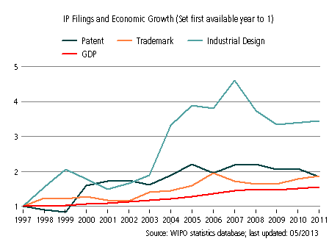

## Scenario building

On the basis of the information obtained in this study, the present section builds three possible scenarios to conjecture what an increased use of IP would entail for the informal manufacturers in terms of innovation and income. It is important to note that most respondents considered open transfer of ideas to be a useful practice in the sector. However, 32% of the respondents indicated that they would like to make use of some kind of formal mechanisms to protect their ideas – see Table 20 below.

**Table 20: Opinions about knowledge appropriation, by respondents**

|  |  |  |
| --- | --- | --- |
|  | **Yes** | **No** |
| Would you like to make use of formal mechanisms to protect your ideas? | 32% | 68% |
| Is open transfer of innovative ideas useful in this sector? | 88% | 12% |

**Source: Fieldwork, 2013**

The three scenarios developed below, are largely exploratory and present tentative pathways for an increased use of IP in the informal economy. These tentative scenarios have been developed on the basis of the information collected through this study. They are not mutually exclusive, but rather can be thought as coexisting and complementary of each other.

***Scenario 1: Creation of semi-formal industry associations or geographically-based associations, inclusive of informal manufacturers*.**

The results of the study indicate that representative associations for manufacturers of home & personal care products are mostly representative of large manufacturers and large supplying companies, which reflects to some extent the large concentration of the sector. Micro and small entrepreneurs (either formal or informal) in this sector lack a platform to voice their particular needs, interests and practices. Studies in other sectors and other countries indicate that semi-formal associations can be very instrumental as platforms for the collective exchange and protection of knowledge amongst informal entrepreneurs (Essegbey et al, 2013, Bull et al, 2013). In the case of South Africa, the exchange of ideas between micro-manufacturers (both formal and informal) appears to be valuable mechanism to exchange ideas and innovate. However, these exchanges are mostly ad-hoc and limited by the geographic areas in which informal actors operate.

In this scenario, an association representative of micro manufacturers would act as a knowledge broker or intermediary, being responsible for developing collective semi-formal protection mechanisms – such as documentation and developing a database of ideas for product and process improvement to be made accessible to their members, without the immediate requirement of business registration. As an intermediary, this type of representative organization would serve as a bridge between informal manufacturers and the wider support and innovation system, connecting informal actors to opportunities emerging in formal organizations related to technology transfer, training and the like. The impact of such arrangement is likely to be reflected in a higher access to technical and business management knowledge, leading to innovation, higher income and business growth. As business revenues increase, it is expected that more micro-enterprises would be willing to register their businesses and their products (as evidence suggest – see FIAS, 2007), increasingly also the health, safety and quality standards of the products. A sectoral or geographically-based association, inclusive of informal manufacturers could draw from the experience and link up to existing South African networks such as The South African National Informal Economy Forum (SANIEF)[29], as well as other relevant examples provided by Essegbey et al. (2013) in Ghana and Bull et al. (2013) in Kenya.

***Scenario 2—Accessibility: Raising awareness and reducing prices of formal knowledge appropriation instruments to informal enterprises***.

The results of the interviews indicated that lack of awareness and the costs involved in IP protection are two of the main obstacles for individual informal manufacturers to access knowledge appropriation mechanisms. This scenario would require government bodies and local IP agencies to engage in two simultaneous efforts: (1) Running awareness campaigns targeting informal settlements and metropolitan areas with a high concentration of informal activity; in collaboration with technology transfer organizations, incubators and higher education institutions (which are the formal actors that appear to have a closer connection with informal manufacturers). These campaigns would reach out and specifically target micro and informal manufacturers to make them aware of the possibilities offered by the existing IP framework in the country; and (2) Develop appropriation mechanisms suitable for informal enterprises with lower costs and easier access, possibly using cell phones for updates given the wide use of mobile telephony across informal networks. This scenario would potentially lead to broader use of formal mechanisms of knowledge appropriation by informal manufacturers. It can be expected that such scenario would generate economics advantages for those informal enterprises that manage to access information and make use of formal knowledge appropriation mechanisms (such as reputation effect, access to finance and other benefits) possibly leading to higher income and higher propensity of formalization. The broader economic and social impacts of this scenario would need deeper analysis as this scenario may leave behind the most marginalized micro-entrepreneurs that remain unable to access information and make use formal IP mechanisms. In other words, whilst this scenario would provide opportunities for some micro-enterprises, if it is not complemented with additional initiatives that reach out to the most marginalized actors, it may trigger wider inequalities amongst informal micro manufacturers, affecting the social fabric in which these entrepreneurs live and survive on a daily basis.

***Scenario 3: Wider use of informal mechanisms of knowledge appropriation***

A third scenario would be one in which informal mechanisms of knowledge appropriation become the norm, and are used more widely by informal enterprises. The results of the study indicate that the majority of informal manufacturers in the sector observed currently make use of appropriation mechanisms that are informal in nature, with effective sharing of information, division of duties, sales or service efforts, customer loyalty, and after-sales efforts being the most important mechanisms. This scenario would imply that the informal mechanisms of knowledge appropriation would be strengthened and more widely used. Some potential positive results would be that employment relationships within informal enterprises would be carefully cultivated in order to prevent knowledge leakages, and that innovation would often manifest in new modes of customer support and product differentiation (for instance through packaging). As employment conditions and on-the-job learning opportunities improve, this scenario may manifest in larger informal employment, broader diversification of home & personal care products, as well as improved social networks in informal settlements where informal activities predominate. The overall potential impact of this scenario, however, would require careful analysis as it could put a crimp in the possibilities for business and market growth.

# Section V: Policy

This section reviews the policy framework that affects the informal economy in South Africa in general and the manufacturing of home & personal care products in particular. It is worth noting that the South African broad policy vision recognizes the importance of informal economic activity. However, the implementation of the broad vision into manageable programs remains limited and subject to debate. For instance, the Gauteng Employment Growth and Development Strategy (GEGDS) for 2009-2014 makes explicit mention to the importance of innovation in the informal economy, understanding innovation as inclusive of “science and technology innovation, socio-economic innovation, environmental innovation and even the innovating spirit of the everyday entrepreneur in both formal and informal sectors of the economy” (GEGDS). This vision, however, has seen little translation into dedicated and funded programs seeking to enhance innovations generated in informal settings of by informal actors. Moreover, the Gauteng Innovation Strategy (2012) in its interventions does not have explicit programs targeting innovations generated in communities and/or by informal entrepreneurs. The present study indicates that it is important to address the specific needs of innovators in the informal economy as the country seeks to promote “a developmental and equitable society”. In order to achieve this goal, national and regional policies must be shaped, coordinated and implemented to enhance innovation and its benefits in the informal economy.

In their policy strategic vision, main metropolitan areas in South Africa have embraced informal trading as part of their growth and development strategies, considering it as a positive development in the micro business sector and key contributor to job creation, poverty alleviation and potential source to expand the economic base. In this line, the City of Johannesburg adopted an Informal Trading Policy in 2012 with a vision “to create a well-managed informal trading sector, which addresses the needs of its citizens and stakeholders who are affected by informal trading in one way or another. It further wants to ensure informal trading is effectively integrated into the economic, spatial and social development goals of the city”. This policy is enforced by The City Informal Trading by-laws which recognizes “the need to adopt a·developmental approach to enable access to job and entrepreneurial opportunities within the Informal Trading sector, to harmonize the relationship between the Informal Trading sector and the formal trading sector and to facilitate the migration of Informal Trading into the formal trading sector”(2012). Despite the explicit consideration of the informal economy in the development plans, the implementation of this vision remains largely contested**[30]**, and varies across regions in South Africa[31].

The Department of Trade and Industry (the DTI) through its [Small Enterprise Development Agency](http://www.seda.org.za/‎) (SEDA) has made significant efforts to approach the informal economy. Moreover, SEDA has been instrumental in facilitating the development of the [Informal/ Street Trading Policy Framework](http://led.co.za/files/SEDA_SANIEF_INFORMAL_STREET_TRADING_POLICY_FRAMEWORK.pdf) for metropolitan & local municipalities in 2008. SEDA has a division focused on technology business incubation, quality & standards and technology transfer services & support to small enterprises (called SEDA Technology Programme - STP). As a program of the Department of Trade and Industry (DTI), SEDA STP is responsible for the provision of both financial and non-financial technology transfer, business incubation and quality support services for small enterprise. This division provides a range of services that assist small enterprises, particularly informal enterprises, to access and acquire technology. In their coverage of informal enterprises they include small enterprises (registered or not registered) that are marginalized with respect to: (1) access to funds; (2) access to markets; (3) limited business skills; (4) limited technical know-how; and (5) access to appropriate technology. Moreover, the Technology Transfer Unit (TTU) of STP has two main objectives, namely:

* To provide technology transfer services to small enterprises; and
* To provide specific technology support to women-owned enterprises

Recent programs appear to be growing aware of the social and economic risks of sustained endemic unemployment in South Africa, and several efforts seem to be geared towards promoting employment opportunities by supporting micro and small businesses. In this regard, a government initiative called the [Jobs Fund](http://www.jobsfund.org.za/‎) was set up in 2011 to assist start-ups and small businesses with a special focus on creating job opportunities for young people. The Fund is managed by The Development Bank of Southern Africa (DBSA) and counts with an allocated budget of R9 billion for a period of 3 years. Amongst other projects, the Jobs Fund has supported creative models of business incubation that search and upscale the ideas from innovative entrepreneurs in the informal economy and under-resourced South African communities (e.g. Awethu Project)[32]. In addition, an agency was formed in 2012 to address the financial needs of micro, small and medium enterprises the [Small Enterprise Finance Agency](http://www.sefa.org.za) (SEFA). Unlike other initiatives that only fund SMEs through banks and other intermediary institutions, SEFA aims to provide cash directly to entrepreneurs wishing to start small businesses or expand existing ones. The government has also created development agencies at provincial level to assist in the development of small businesses, and SEFA’s role is also to establish a link between all small business initiatives. The [Youth Enterprise Development Strategy](http://www.thedti.gov.za/news2013/YEDS_strategy2013.pdf) 2013-2023, launched in 2013 targets youth and self-taught informal entrepreneurs, aiming to promote youth self-employment and youth-owned and managed enterprises.

Whilst it is positive that these initiatives have emerged, it is also important that the needs of small businesses in townships particularly are better understood. Raising awareness about the existence of these initiatives appears critical as the identification of suitable innovative projects to upscale continues to be a challenge. [The South African Local Government Association](http://www.salga.net) suggests that it is important that government recognizes and directs policy development to multiple sub-sectors existing within the informal economy. However, translating policy into action remains a major constrain as small businesses in townships are often not aware of these opportunities.

Under the current policy framework, formalization through business registration is usually required in order to access support from government in the form of funding, training and access to technology.

Below we take the framework set out in the conceptual study to assess innovation policies for the informal economy (Table 9 (de Beer, Fu et al. 2013) and populate with the relevant information for South Africa.

**Table 21: Innovation policy framework and its influence on the informal manufacture of home & personal care products in South Africa**

|  |  |
| --- | --- |
| **1) Providing a functioning property rights system and functioning economic institutions** | |
| * Ensuring that clear rights to property exist (e.g., protection of formal ownership) | * The Companies Intellectual Property Trade Marks Act (1993), the Patents Act (1978), the Designs Act (1993), the Copyright Act (1978), the Counterfeit Goods Act (1997), the Intellectual Property Rights from Publicly Financed Research and Development Act (act 51 of 2008) |
| **2) Improving the infrastructure and providing urban spaces** | |
| * Ensuring access to basic infrastructure such as electricity, water and waste disposal * Ensuring the informal economy has access to production sites (e.g., permitting the use of residential allotments) | * Metropolitan municipalities, District municipalities and Local municipalities * The establishment of production units in residential areas is controlled by Land Use Management in the Department of Planning, which sets up is the system of legal requirements and zoning regulations. Other legislations include National Building Regulations and Building Standards Act (Act 103 of 1977), the Public Health Bylaws and various other Municipal Bylaws. |
| **3) Facilitating access to markets and participation in the formal economy** | |
|  | * City Informal trading by-laws. * Trade shows and exhibitions allow informal manufacturer to showcase their products * Youth Enterprise Development Strategy 2013-2023; Support scheme targeting youth and self-taught informal entrepreneurs, aiming at facilitating start-ups. |
| **4) Providing access to finance** | |
| * Facilitating the necessary investment and increasing efficiency and productivity. Microfinance, financial services aimed at the rural economy and the informal economy, financial inclusion to assist households | * Most informal manufacturers make use of informal sources of funding from friends and relatives. * Informal financial systems (e.g. local moneylenders, *stokvels*, rotating savings, etc.) * DTI Small Enterprise Development Agency – and the Jobs Fund. * The Small Enterprise Finance Agency (sefa), targeting survivalist, micro, small and medium enterprises. |
| **5) Improving education and skills, including entrepreneurship capacity** | |
| * Ensuring basic literacy and numeracy * Developing skills of informal workers through education, training, including basic skills as well as more advanced business and financial skills, and language skills | * Public and private primary education organizations * Support schemes by DTI and its Small Enterprise Development Agency assisting township and rural businesses with basic business management skills; Technology transfer organizations (technology incubators) and business incubators also offer some informal entrepreneurs advanced support with business management (including book keeping, market strategy, etc) |
| **6) Fostering the innovation system and improving the capacity to innovate** | |
| * Putting in place good monitoring and evaluation mechanisms to assess or quantify the contribution of IE innovations to improving the livelihood of workers in the informal economy   + Identification of innovative and creative potential (who innovates where and how?) * Facilitating start-ups   + Adaptation of SME and entrepreneurship policies for the informal economy * Stimulating linkages between formal and informal actors, and the integration of the IE in formal sector value chains with a view to transferring skills to IE workers   + Efforts to enhance forward and backward linkages, including to the formal sector and public institutions * Facilitating the assimilation of innovations created elsewhere by effectively channeling existing knowledge and technology * Fostering access to technology and information * *Others potential interventions\** | * Statistics South Africa only records national statistics for informal employment. Other organizations also collect indicators on informal employment (e.g. Adcorp). The Housing Development Agency and the National Department of Human Settlements also monitor living conditions in informal settlements. * South Africa collects data on innovation activities through a national Innovation Survey, in order to establish a baseline set of science and technology indicators for monitoring, reporting on, and fine tuning the National System of Innovation and under the African Science, Technology and Innovation indictors (ASTII) - however, data does not cover innovation activities by informal enterprises. * A few initiatives (such as the Awethu Project) are proactively seeking for innovative potential in marginalized communities. * Support schemes by DTI - the Youth Enterprise Development Strategy, and the Small Enterprises Development Agency (SEDA); business incubators and NGOs across the country, aim at facilitating start-ups. * Programs or initiatives proactively seeking to integrate informal economy actors into formal value chains are scarce and much needed. City Informal Trading By-Laws aim to harmonize the relationship between informal and formal economic activities. * The recently established Youth Enterprise Development Strategy (YEDS) seeks partnerships between government, the private sector and civil society to materialise its support to informal youth entrepreneurs. * SEDA Technology Programme (STP), and technology transfer organizations (such as TUT Technology Station in Chemicals, Chemin and others) facilitate access of informal entrepreneurs to existing knowledge and technology. * Other interventions, such as demand-side measures; prizes for informal entrepreneurs; improving IE actor organization; strengthening of intermediary organizations, etc., remain scarce and have been pointed out as critical in order to support the vast potential of informal entrepreneurship. |
| **7) Intellectual property policies** | |
| * Needs assessment * Overcoming the hurdles in accessing the IP system   + Awareness-raising and training on IP   + Technological information and advisory services   + Financial assistance   + Assistance in IP exploitation and technology transfer * Redesigning certain features of the IP system, such as conceptualizing a set of “informal” IP norms to offer IP protection that is cheaper and better suited to the IE milieu | * The Companies and Intellectual Property Commission (CIPC), is mandated by the Companies Act, 2008 (Act 71 of 2008) and is the custodian of the IP regulatory framework in South Africa. The National Intellectual Property Management Office (NIPMO) established in 2011, aims to ensure that recipients of funding from a government funding agency assess, record and report on the benefit to society of IP emanating from publicly financed R&D – in response to the Intellectual Property Rights from Publicly Financed Research and Development Act 51 of 2008. NIPMO has awareness sessions, training and patent grant incentives, targeting publicly funded research organizations. |

*\* Creating local knowledge-sharing networks to connect innovators, adopters and intermediaries and help innovators to gain recognition for their work and to increase knowledge generation for further innovation; Making public research and other innovation actors more relevant to the IE, including the adaptation of scientific findings to local needs to improve the impact of research funding; Setting up public-private bodies to serve as a bridge between national and global research centers and IE firms for the diffusion and adaptation of technologies; Improving the design of IE innovations; Implementing demand-side measures; Stimulating particular innovations targeted at the special needs of the poor; Using public procurement or procurement of non-governmental organizations (NGOs; Establishing prizes, grants, etc., to foster IE innovation; Improving IE actor organization; Providing help to cooperatives, self-help groups, business and workers associations in creating organizational capacity, cooperation, clustering and political representation; Strengthening the intermediary parties (e.g., informal sector associations, cooperatives, NGOs) to address the needs of the IE for skill development and technology transfer.*

# Conclusion

Informal economic activities continue to provide income opportunities to large segments of the population in South Africa, particularly amongst the unemployed youth. Whilst a lot of informal economic activities remain survivalist and unskilled, the evidence collected in this study indicates that some sub-sectors do count with substantial skills, entrepreneurship and creativity that translate into innovation. This study focused on the practices of informal manufacturers in the home & personal care sector in South Africa. The evidence suggests that informal economic activity in this sub-sector is not only considerable but appears to be growing as knowledge becomes increasingly available and accessible, and opportunities for employment in the formal economy remain limited.

The results indicate that informal manufacturers in this sub-sector are usually micro-enterprises, ran by young entrepreneurs, who satisfy specific demands from low-income consumers seeking lower-cost products and small unit sizes. These manufacturers engage in production activities acquiring knowledge (both technological and non-technological) from a range of sources – both informally from the community, from other micro-manufacturers, suppliers and formal organizations. The knowledge acquired often translates into innovations – and we found a significant number of innovations manifest in significantly improved formulations, packaging and manufacturing processes. These processes of knowledge dissemination and innovation bring up interesting questions related to knowledge appropriation and IP policy.

Knowledge passed from one individual to another can allow him/her to start off a new business and generate an income, often providing a chance to survive and sometimes prosper in an environment where income opportunities are scarce. Passing knowledge to others in the community also allows informal actors to return something to a community that also supports them during hard times (social safety net). Knowledge passed through formal training (by technology transfer organizations, education & training organizations, business incubators, and the like) provide informal entrepreneurs a valuable opportunity to upgrade their products, innovate, access new markets and refine their business strategy. Linking to networking initiatives offers informal entrepreneurs the opportunity to engage with other entrepreneurs often leading to fruitful connections and collaborations. However, informal manufacturers were also aware of the potential negative consequences that could emerge if their innovative ideas where copied without their consent. In this regard, increased competition in their immediate geographical area could have devastating effects in their business.

It is important to note that whilst these actors often operate outside of formal regulatory frameworks, policies and government programs have an important influence on them, as the regulatory framework shapes the broader reality within which informal entrepreneurs operate. Most success stories amongst the interviewees had received some type of support and had interacted with the wider innovation system. In this respect, technology transfer organizations, business incubators, training organizations and other intermediaries can play a critical role in materializing the aspirations of informal entrepreneurs into larger markets, new products and more efficient processes. Meanwhile, those informal entrepreneurs that remained isolated from the wider innovation system somehow seemed to get stuck into survivalist economic activities, despite their aspirations for better and improved products.

It is also important to understand ‘informal institutions’, which are highly influential on the behavior and decisions of informal entrepreneur. The results of the study indicate that informal mechanisms of knowledge appropriation predominate amongst informal manufacturers, who manage the processes of dissemination and appropriation of knowledge largely guided by community rules of engagement.

Innovation policies and IP strategies must provide an enabling environment for informal entrepreneurs, through explicit programs and initiatives that target their needs. These needs are better identified, managed and addressed at the level of the local government. Some initiatives have recently emerged but they remain scattered and shaped at the national level, whilst the connection with the intellectual property framework remains weak. Examples in other countries have shown that the identification of needs can be facilitated by creating local platforms where the interests of informal actors are represented – e.g. though representative organizations inclusive of informal actors, able to communicate with local governments.

The informal economy is fuelled by young entrepreneurship, and in many cases is used as a test bed or platform for experimentation and learning. A scenario where informal entrepreneurship is not acknowledged, supported and upgraded would result in yawning inequalities, decreasing levels of entrepreneurship and innovation, growing youth unemployment, increase in crime, and ultimately underutilization of creative potential to construct an inclusive and sustainable future. In other words, the risks of not adopting an inclusive and systemic approach to innovation and IP policies are too high. This requires rethinking innovation policy and intellectual property beyond its current focus on science and formal R&D, in such a way that it is mindful of the economic reality of South Africa, one where economic agents with various degrees of formality interact, exchange ideas and innovate.

**References**

Adcorp (2013), Adcorp Employment Index Report, June, 2013. Available at: http://www.adcorp.co.za/Documents/

Bull, C., Daniels, S, Kinyanjui, M., Hazeltine, B. (2013), Country study on innovation, intellectual property and the informal economy: The informal metalworking sector in Nairobi, Unpublished draft.

Charmes, J. (2012). The Informal Economy Worldwide: Trends and Characteristics. Margin: The Journal of Applied Economic Research, 6(2), 103–132.

Das Nair, R. and Hawthorne, R. (2006), Trade and Poverty in South Africa: The Relationship between Trade and Poverty for Household Consumables Products, TIPS paper series.

de Beer, J., Kun F. & S. Wunsch-Vincent, 2013. "The informal economy, innovation and intellectual property - Concepts, metrics and policy considerations," WIPO Economic Research Working Papers 10, World Intellectual Property Organization - Economics and Statistics Division. <http://www.wipo.int/export/sites/www/econ_stat/en/economics/pdf/wp10.pdf>

DTI (2003), Department of Trade and Industry: South Africa’s Economic Transformation: A Strategy for Broad-Based Black Economic Empowerment.

DTI (2005), Department of Trade and Industry: Promotion of Small and Medium Enterprises in the South African Chemicals Sector, Prepared for Chemicals Summit NEDLAC.

DTI (2012), Department of Trade and Industry: The Study of the quantitative and qualitative analysis of SMME’s in the cosmetics sector of South Africa, Ozone Business Consulting.

Essegbey, G.O., Stephen, A., Essegbey, I.T, Micah, E.B., Akuffobea, M. (2013), Country study on innovation, intellectual property and the informal economy: Traditional herbal medicine in Ghana, Unpublished draft.

Euromonitor (2013a), Beauty and Personal Care in South Africa, Country report. Euromonitor report summary available at: http://www.euromonitor.com/beauty-and-personal-care-in-south-africa/report

Euromonitor (2013b), Home Care in South Africa, Country Report, Euromonitor report summary available at: http://www.euromonitor.com/home-care-in-south-africa/report

FIAS (2007) South Africa: tax compliance burden for small businesses: a survey of tax practitioners. Available at: https://www.wbginvestmentclimate.org/uploads/FIAS_Tax_Practitioners_Report_-_FINAL_29+Aug.pdf

Gault, F. (ed.) (2013), Handbook of Innovation Indicators and Measurement, Edward Elgar, Cheltenham.

GEM (2009), Global Entrepreneurship Monitor: GEM South Africa 2009 Report.

HDA (2012), The Housing Development Agency: South Africa: Informal settlements status, Research series published by the Housing Development Agency, Johannesburg

Kaplinsky, R. and Morris, M. (2001), A Handbook for Value Chain Research, Brighton: Institute for Development Studies.

Lastres, H and Cassiolato, J. (2005), Innovation systems and local productive arrangements: New strategies to promote the generation, acquisition and diffusion of knowledge. Innovation: Management, Policy & Practice: Vol. 7, 2-3

Maharajh, R. (2011), Innovating beyond Racial Capitalism: A Contribution towards the Analysis of the Political Economy of Post-Apartheid South Africa, Lund Studies in Research Policy 3, Lund University, Lund.

OECD/Eurostat (2005), Oslo Manual, Guidelines for Collecting and Interpreting Innovation Data, Paris: OECD.

Rogerson, C M. And Hart, D.M. (1989) The struggle for the streets: Deregulation and hawking in South Africa's major urban areas, Social Dynamics: A journal of African studies Volume 15, Issue 1, pages 29-45.

SALGA (2012a): Making the Informal Economy Visible: Guidelines for Municipalities in respect of Adopting a More Developmental Approach towards the Informal Economy.

SALGA (2012b), South African Local Government Association: Municipal Guidelines for Informal Economy Policy: June 2012.

Scerri, M. (2009), The Evolution of the South African System of Innovation since 1916, Cambridge Scholars Publishing, UK.

Stats SA (2004), Statistics South Africa: 2004 Labour Force Survey, Statistical release P0210, Pretoria, South Africa.

Stats SA (2007), Statistics South Africa: Community Survey 2007; Municipal data on household services, Pretoria, South Africa.

StatsSA (2013a), Statistics South Africa, Quarterly Labour Force Survey, Quarter 2, 2013, Statistical release P0211, Pretoria, South Africa.

Stats SA (2013b), Statistics South Africa: 2012 General Household Survey, Statistical release P0318, Pretoria, South Africa.

UNDP (2010), United Nations Development Programme: Human Development Report: The Real Wealth of Nations, New York: Palgrave Macmillan for the UNDP.

UN Habitat (2006): Innovative policies for the Urban Informal Economy, UN-HABITAT: Nairobi.

WEF (2013), The Global Competitiveness Report 2013–2014, World Economic Forum, Geneva.

WIEGO (2012): Working Paper No 1: The Informal Economy: Definitions, Theories and Policies

World Bank (2013) World Development Indicators 2013, World Bank Publications: Washington DC.

# Appendix I

**Interview guide for the study of informal manufacturing of home & personal care products in South Africa**

|  |
| --- |
| **GENERAL INFORMATION** |

**Name** of Respondent……………………………………………. **Gender**: Male [ ] Female [ ]

**Age:** [____]

**Educational level**: Primary [ ] Secondary [ ] Tertiary [ ] No formal education [ ]

**Location** of practice: …………………… **District**: ………………… **Region**: …………………

|  |
| --- |
| 1. **INFORMATION ABOUT THE BUSINESS** |

1. Does your company have a name? If yes, name of business:
2. Description of your main line of products and services (specialty of the respondent)

………………………………………………………………………..…………..……………….................

1. Why did you start your own business? (motivation)
2. Is your business registered? Yes [ ] No [ ]

4.a. If yes, what was the motivation to register your business?

4.b. If yes, was it difficult to register your business?

Very difficult [ ] Difficult [ ] Easy [ ] Very Easy [ ]

1. Do you employ other people? Yes [ ] No [ ]

5.a. If yes, please describe the employment (temporary, permanent, seasonal)

…………………………………………………………………………………………………................

5.b. If yes, do you have formal contract with your employees? Yes [ ] No [ ]

1. How long have you had this business? [ ] years, [ ] months

6.a. What did you do before?

………………………………………………………………………..…………..……………….................

1. What are your main products? ………………………………………………………………..............

7.a. Which one(s) did you start with? …………………………………………………………..............

7.b. Please describe how did you gradually moved into new products or services...............................................................................................…………………………................

1. Are all your products registered? Yes [ ] No [ ]

8.a. If yes, please indicate the institution you registered the products with………….………………………………………………………………………………....................

8.b. If yes, was it difficult to register your products?

Very difficult [ ] Difficult [ ] Easy [ ] Very Easy [ ]

8.c. If yes, what was the motivation to register your products?

…………………………………………………………………………………………………….................

8.d. Please explain the process and requirements for product registration

…………………………………………………………………………………………………….................

1. How did you get the funding to start your business?

Own funds [ ] Loan [ ] Friends and family [ ] Other [ ]

Please describe…………………………………………………………………………………..............

9.a. Have you ever obtained a loan from the bank for your practice? Yes [ ] No [ ]

9.b. Have you ever received any financial assistance from government? Yes [ ] No [ ]

1. How profitable do you find your business?

Very profitable [ ] Quite Profitable [ ] Not profitable [ ]

1. Do you get other benefits from your business beyond the financial profit? (value)
2. Do you keep regular accounts of the business? Yes [ ] No [ ]
3. Would you be able to give us a rough estimate of your business sales over the last year?
4. Where do you sell your products? ……………………………………………………………..............
5. Who are your main customers? ………………………………………………………………..............
6. Do you produce on large scale for people to collect and retail for you? Yes [ ] No [ ]
7. Do you have some of your products in formal establishments or shops? Yes [ ] No [ ]

|  |
| --- |
| 1. **SOURCES OF KNOWLEDGE** |

1. Where did you obtain the knowledge to manufacture your products? Please describe:

………………….............................................................................................................................................

1. Have you received any type of training? Yes [ ] No [ ]

19.a. When did you do your training [ ] year, and how long was your training? [ ] (number of years/months/days)

19.b. Please describe the nature of your training ….………………………………………….................

1. Have you provided training to other people?

20.a. If yes, to how many?

20.b. Please describe the nature of the training provided ….………………………………….................

1. Are your products based to some extent on indigenous/ traditional knowledge?

Yes [ ] No [ ] Partially [ ]

21.a. If yes, how did you acquire that knowledge? Please describe:

….…………………………………………………………………………………………………..............

|  |
| --- |
| **III INNOVATION** |

1. What do you think makes your products successful?

…………………………………………………………………………………………………….................

1. Please describe your main method, or production process

…………………………………………………………………………………………………….................

1. Please describe the equipment you use for manufacturing/production

…………………………………………………………………………………………………….................

1. Describe new technologies, machines, production techniques or innovations you adopted in the last 2-3 years

…………………………………………………………………………………………………….................

1. Have introduced new or significantly improved products in the last 2-3 years? Yes [ ] No [ ]

26.a. If yes, please describe:

…………………………………………………………………………………………………….................

1. Have you introduced any new or significantly improved method of production or production practices the last 2-3 years? Yes [ ] No [ ]

27.a. If yes, please describe

……………………………………………………………………………………………………...............

1. What exactly do you do to improve on your products or practice?

…………………………………………………………………………………………………….................

1. What/who is your inspiration to develop new products/ processes?

…………………………………………………………………………………………………….................

1. What are your main challenges to come up with new products and processes? (please describe)

……………………………………………………………………………………………………...............

|  |
| --- |
| **IV. NETWORKING AND KNOWLEDGE FLOWS** |

1. Do you belong to any association? Yes [ ] No [ ]

31.a. If yes, name of the association(s)

…………………………………………………………………………………………………….................

1. Have you interacted with any formal organisations (i.e. recognised institution in South Africa, such as research centres, NGOs, incubators, etc) while seeking support for your practice?

Yes [ ] No [ ]

32.a. If yes, please name the organisations

…………………………………………………………………………………………………….................

32.b. If yes, please describe the nature of the interaction

…………………………………………………………………………………………………….................

32.c. If yes, please indicate the benefits of those interactions

……………………………………………………………………………………….……………................

1. Do you interact or collaborate with other producers? Yes [ ] No [ ]

33.a. If yes, what kind of knowledge do you exchange?

……………………………………………………………………………………………………...............

1. Do you interact or collaborate with your suppliers? Yes [ ] No [ ]

34.a. If yes, what kind of knowledge do you exchange?

……………………………………………………………………………………………………...............

1. Do you interact or collaborate with your customers? Yes [ ] No [ ]

35.a. If yes, what kind of knowledge do you exchange?

……………………………………………………………………………………………………...............

1. Do you interact or collaborate with members of your community? Yes [ ] No [ ]

36.a. If yes, what kind of knowledge do you exchange?

……………………………………………………………………………………………………...............

1. Do you share knowledge about manufacturing with your employees? Yes [ ] No [ ]

Please explain:

……………………………………………………………………………………………………...............

1. Would you want to team up with somebody to commercialise on a large scale? Yes [ ] No [ ]

|  |
| --- |
| **V. INTELLECTUAL PROPERTY AND KNOWLEDGE APPROPRIATION** |

1. Do you have your own brand? Yes [ ] No [ ]
2. Do you feel that you own the ideas of the new products you make? Yes [ ] No [ ]

Please explain: ………………………………………………………………………………...............

1. Are you concerned of possible commercialization of your innovations/innovative ideas without your knowledge or consent? Yes [ ] No [ ]
2. Do you protect your ideas in any way? Yes [ ] No [ ]

42.a. If yes, what mechanisms do you use to protect your innovation or innovative ideas? (formal or informal)

……………………………………………………………………………………………………...............

1. Do you think open transfer or exchange of innovative ideas useful in your sector?

Yes [ ] No [ ]

1. What mechanisms for the protection of knowledge (e.g. patent, trade mark, secrecy) do you think are most appropriate for the manufacture of home & personal care products?

Please describe: ………………………………………………………………………………..............

1. Would you like to make use of formal mechanisms of knowledge appropriation to protect your ideas? (e.g. patents, trademarks) Yes [ ] No [ ]
2. How do you assess South African IP legislation in connection to your sector?

…………………………………………………………………………………………………….................

1. What are your suggestions to improve the appropriation of knowledge of micro-producers of home & personal care products in South Africa?

…………………………………………………………………..………………………………….............

[End of Annex and of document]

1. The views expressed in this Study are those of the authors and do not necessarily reflect those of the WIPO Secretariat or any of the Organization’s Member States.
2. United Nations Statistics Division, explanatory note available at: <https://unstats.un.org/unsd/cr/registry/regcs.asp?Cl=17&Co=2424&Lg=1>
3. Conceptual Study available at: <http://www.wipo.int/meetings/en/doc_details.jsp?doc_id=232525>
4. The term was coined by then President Thabo Mbeki in an address to the Nation in 2003.
5. South Africa has been rated as having third highest unemployment rate in the world for people between the ages of 15 to 24, according to the World Economic Forum (WEF) Global Risk 2014 report.
6. Official estimations of informal sector employment (non-agricultural) reach 12% of the labor force (Stats SA, 2013a); Estimations by Charmes of informal economy employment for the five-year period 2005-2010 reach 32% as share of non-agricultural employment ( Charmes, 2012); and the Adcorp Employment Index (AEI) estimates the ‘unofficial sector’ to represent about 33% of total employment (Adcorp, 2013).
7. For a detailed review of interpretations see Maharajh (2011) and Scerri (2009)
8. Quoted in Maharajh (2011)
9. That data source indicates that over 85% of households who live in shacks have a household income of less than R3 500 per month (around US$340), of which 30% of households live with less than US80 per month. Note that each household is composed by several people.
10. The General Household Survey 2009 indicated that over a quarter of households with children who live in shacks say they have had insufficient food for their children in the past year. Almost one fifth indicate that children in their households went to bed hungry in the previous year.
11. Using the average annual exchange rate for 2010 1US$=7.3ZAR, www.x-rates.com
12. Euromonitor (2013a) identified Unilever, Avon, Reckitt Benckiser, Colgate-Palmolive, Revlon and SC Johnson as being some of the leading global players. Private label brands are also growing in South Africa
13. A report cited in DTI (2012) suggested the existence of 60,000 informal businesses in the South African cosmetics sector although the accuracy of the figure could not been verified. Nevertheless the DTI report (2012) recognized the existence of a substantial amount of companies operating informally manufacturing from backyards, but without an estimation of their number.
14. Euromonitor (2013b)
15. This section has benefitted largely from an early study by DTI (2012)
16. Using the average annual exchange rate for 2013 1US$=9.6 ZAR, www.x-rates.com
17. The Integrated Small Business Development Strategy in South Africa 2004-2014 defines micro-enterprises as follows: “Micro-enterprises are very sm all businesses, often involving only the owner, some family member(s) and at the most one or two paid employees. They usually lack 'formality' in terms of business licenses, VAT registration, formal business premises, operating permits and accounting procedures. Most of them have a limited capital base and only rudimentary technical or business skills among their operators [...] Earning levels of micro-enterprises differ widely, depending on the particular sector, the growth phase of the business and access to relevant support”.
18. Using the average annual exchange rate for 2013 1US$=9.6 ZAR, www.x-rates.com
19. Using the average annual exchange rate for 2013 1US$=9.6 ZAR, www.x-rates.com
20. Note that the definition of innovation provided above considers both ‘significant improvements’ and ‘new’ products as innovations.
21. Using the average annual exchange rate for 2013 1US$=9.6 ZAR, www.x-rates.com
22. Using the average annual exchange rate for 2013 1US$=9.6 ZAR, www.x-rates.com
23. Around 20-30 large contract manufactures, as suggested by our interviews.
24. It is worth noting that interviews with informal manufacturers were complemented with contract manufacturers and suppliers of raw materials, who explained the heavy competition that takes place at the level of small suppliers
25. Although this high percentage may be a reflection of the process of identification of informal manufacturers, which was facilitated in some instances by technology transfer agencies.
26. The authors particularly thank Astrid Ludin, Elena Zdravkova, Amanda Lotheringen, and the rest of the Companies and Intellectual Property Commission (CIPC) team for their assistance with this section.
27. According to the Global Competitiveness Index published by the World Economic Forum (WEF), South Africa does well on measures of the quality of its institutions, including intellectual property protection (18th).
28. Using the average annual exchange rate for 2013 1US$=9.6 ZAR, www.x-rates.com
29. The South African National Informal Economy Forum (SANIEF) is an informal initiative of Municipal LED Practitioners working on the area of Informal Economy mainly Street Trading. The forum was initiated out of a number Best Practice Studies between Municipalities. The overall objective of SANIEF was to establish, maintain and manage an informal trading Network/Forum of metros and municipalities which would, among other outcomes, develop and operationally a national policy framework on street trading that would facilitate and encourage micro-trading.
30. Over 1,200 informal traders were forcibly removed from their trading sites as part of the 'Mayoral Clean Sweep Initiative', undertaken by the City of Johannesburg during October 2013.
31. For instance Durban appears to have been more progressive in their approach to the informal sector than other metropolitan areas in the country (UN-Habitat, 2006)
32. See http://awethuproject.co.za/