E
CDIP/13/INF/3
ORIGINAL: English
DATE: February 17, 2014

Committee on Development and Intellectual Property (CDIP)

Thirteenth Session
Geneva, May 19 to 23, 2014

COUNTRY STUDY ON INNOVATION, INTELLECTUAL PROPERTY AND THE INFORMAL ECONOMY: THE INFORMAL METALWORKING SECTOR IN kenya

prepared by Mr. Christopher Bull, Senior Research Engineer and Senior Lecturer, Brown University School of Engineering, United States of America, Mr. Steve Daniel, Makeshift Magazine, United States of America, Ms. Mary Njeri Kinyanjui, Faculty Member, University of Nairobi, Institute for Development Studies, Kenya, and Mr. Barrett Hazeltine, Faculty Member, Brown University School of Engineering, United States of America

1. The Annex to this document contains a Study on the Informal Metalworking Sector in Kenya, undertaken in the context of the Project on Intellectual Property (IP) and the Informal Economy (CDIP/8/3) approved by the Committee on Development and Intellectual Property (CDIP) in its eighth session, held in November 2011.

2. The CDIP is invited to take note of the information contained in the Annex to this document.

[Annex follows]

Executive Summary

This case study examines the attitudes about intellectual property of those engaged in and with the informal metalworking sector in Kenya. In addition, the study provides an overview of the sector, the national innovation system, the available appropriation mechanisms, and related policies and programs. Finally, we present several scenarios that may enhance access to, and use of, appropriation mechanisms by those working in the informal sector.

This study is a companion to two other case studies and a conceptual study. One of the case studies examines the informal chemical sector in South Africa, the other examines informal medicine in Ghana. The three case studies inherit a language and analysis framework developed in the conceptual study.

In Kenya the informal metalworking sector produces goods ranging from pots and pans to sculptures. It also provides custom manufacturing and repair services. A few informal workers develop new technologies for energy conversion and transportation. Our methods for understanding this sector and the demographics and attitudes of those working in it included a scripted survey which was given to individuals working in the a specific cluster, interviewing informal metalworkers in other clusters and interviewing two craftsmen/designers who were not associated with any cluster, interviewing government and NGO officials who were engaged with intellectual property issues and/or informal sector development. We relied on government documents and websites for information on related policy and programs and their effectiveness.
In addition to producing a range of good and services the informal metalworking sector also sells into a range of markets. Commodity goods like pots and pans are sold to those who cannot afford the imported versions. Sculptures and other artworks are sold to middle and upper income customers as well as to export customers. New technologies are either sold directly to consumers or licensed to other manufacturers. We found a correlation between the market for an enterprise’s products and attitudes regarding intellectual property.

We observed many forms of innovation, the three most striking were:
- adaptation of existing products to available materials, tools, skills and markets. This was most often seen in clusters producing commodity goods (e.g. Kamukunji);
- developing metal representations of iconic Kenyan images e.g. giraffes, elephants and Maasi tribesman. This type of work was prevalent at the Racecourse cluster; and
- isolated workers developing new and novel products.
The innovations were driven by market demand, competition, and an inventive attitude. The innovation was aided by government agencies and NGOs, and informed by customers, the media and suppliers.

Those seeking to appropriate their intellectual property in Kenya have a typical set of formal mechanisms from which to choose: patents, utility patents, industrial designs, technovations, patents, trademarks and copyrights. Members of the informal sector, for the most part, use informal appropriation mechanisms when they see the need. These mechanisms include secrecy, first to market advantage and scattered component production.

The Kenyan government has enacted legislation intended to support development of the informal sector. Informal enterprises are typically classified as micro and small enterprises (MSEs) and therefore we take references to MSEs in policy documents as applicable to informal enterprises unless it is clearly stated otherwise. As examples, the Procurement Act of 2008 provides incentives for vendors that partner with MSEs, and a Ministry program provides transportation to trade shows for products manufactured by informal enterprises. Recent legislation explicitly calls for the support of innovation by MSEs. At the time of writing work was beginning to create programs that will implement the legislation.

Findings

Those working in clusters producing commodity goods for low income consumers put high value on trust- based relationships and on sharing resources to adapt to changing demand. However, there was also a willingness to take advantage of being first to market and of exclusive relationships with customers.

Those working in clusters making products for middle and upper income markets put more energy into maintaining any advantage. They used secrecy by keeping the production process hidden from outsiders and on occasion distributed the manufacture of components across several suppliers so that only the owner had access to all the components necessary to assemble a product.

Those working in isolated conditions, that is, not working in clusters, showed the most interest in protecting their intellectual property and has pursued formal mechanisms including trademarks and utility patents. This group expressed frustration with the appropriation process.

Scenarios

Threats to the existence of each type (commodity, artwork, isolated) of enterprise motivated our thinking about supportive scenarios. The commodity producers thrive because they can produce goods at a price lower than imports. Should the price advantage shift towards imports, the Kenyan manufacturers will wither. Most of the material used in production is recycled. If the price of the material on the global market rises, the informal maker’s price may also rise, strengthening the import position. For this group import tariffs are more urgent than IP protection. Should the commodity goods producers develop a middle/upper income market for their products the value of registering of trademarks and industrial design patents increases.
The main threat to artwork producers is a local competitor who has a price or style advantage. The price advantage may be due to a process innovation and may be protected under a utility patent. The style advantage may be protected by an industrial design patent. Therefore, if the value proposition works, there is a strong incentive to seek protection.

For the non-cluster enterprises, threats may come from competitors (in the cases of furniture and housewares manufacturers) or from those eager to misappropriate a new technology. In these cases trademarks, industrial design patents, utility patents, and patents offer an existing set of protections.

All interviewees who showed interest in protecting their ideas also had concerns about the costs (time, effort, learning the system, money) that accompanied acquiring IP protection. MSEs must analyze the value proposition in a way that is complete enough to validate seeking protection. This is challenging even for large firms, which indicates the need for some assistance to MSEs.
The value proposition would be more likely to favor seeking protection if the costs are reduced. This would require effort on the policy side, to create new classes of appropriation mechanisms, to reduce the filing requirements, to streamline the process, to provide clear descriptions of the processes, together with easy access to the various components, and to reduce the fees.
While pursuing these ideas, it is critical to recognize that the values prized by those working in clusters - relationships based on trust and the sharing of resources - are vital to the functioning of the larger society. These values are sometimes seen as being at odds with protecting an individual’s intellectual property. This is not necessarily true and it behooves those charged with making changes to seek innovative solutions that nurture valuable cultural norms and individual rights.

Table of Contents
Executive Summary 1
Findings 2
Scenarios 2
Table of Contents 3
Section 1: Introduction 5
Background 5
Purpose of this study 5
Organization of this study 5
Methodology 6
Section 2: Sector Characteristics 7
Informal Economy of Kenya 7
Role of Metalworking 8
Demographic profile of survey respondents 11
Products manufactured in the Kamumkunji cluster 11
Art objects manufactured at Racecourse 18
Section 3: Innovation 20
Defining the Innovation System 20
Case: Moses Metalwork 23
A custom micro enterprise 23
Case: Housemark 23
Case: Simply Logic 23
Innovation Profile of the Sector 24
Obstacles to Innovation and Scale 29
Case: Gikomba Sofas 29
Continuous informal innovation 29
Case: Kenyan Ceramic Jiko 30
Open-sourcing design 30
Section 4: Appropriation Mechanisms 30
Formal Mechanisms 30
Semi-formal Mechanisms 31
Informal Mechanisms 31
Survey and Interview Indications 31
Scenarios 33
Sidebar 35
Section 5: Policy 35
Conclusion 42
Appendices 44
Appendix 1: Survey 44
Appendix 2: Maps 56
References 59

Section 1: Introduction

Background
This study is part of a project commissioned by the World Intellectual Property Organization (WIPO) to characterize intellectual property practice in the informal sector. Companion pieces to this study are a conceptual study (de Beer, Fu, & Wunsch-Vincent, 2013), a study of the informal chemical sector in South Africa (Kraemer-Mbula & Tau, 2013), and a study of the traditional medicine sector in Ghana (Essegbey, Stephen, Essegbey, Micah, & Akuffobea, 2013). The conceptual study develops a framework for understanding the relationships between the informal sector and conventional and unconventional appropriation mechanisms used to secure intellectual property.

Purpose of this study
This case study presents an understanding of the flow of innovations through Kenya’s informal metalworking sector and how appropriation mechanisms (both conventional and unconventional) regulate that flow. The authors examine how activity around intellectual property in the sector aligns with the ideas developed in the conceptual study and identify sources and conduits of innovation and factors that promote or inhibit the dissemination or adoption of new ideas.
In Kenya, informal manufacturers are relevant not only economically but also culturally. Known as jua kali (Kiswahili for “hot sun”), their contributions pervade all parts of society—from the built environment to music—and many take pride in this work as an identity. Originally reserved only for makers, or fundi, the term now applies to all informal workers. We will use the word fundi frequently to identify a craftsperson or skilled worker and the phrase jua kali to include not just the skilled workers, but also traders, brokers, trainees, and casual laborers within the informal economy.

Organization of this study
We begin by describing the methods used to gather information about the informal metalworking sector and the related innovation systems. Surveys, interviews, field observation, and photo-documentation are combined to describe and analyze conditions.
This is followed by a section on sector characteristics (Section 2) where we describe, in general, the informal sector in Kenya and, more specifically, using data collected in 2013, the metalworking sector in Nairobi. The section on innovation systems (Section 3) documents the national innovation system in Kenya, the innovation system in a metalworking cluster, and the linkages within and between systems.
Formal intellectual property appropriation mechanisms are available in Kenya. In Section 4 we lay out the forms of appropriation available, identify some of the opportunities and challenges faced by informal sector workers in gaining access to appropriation, and lay out some scenarios that might reduce those challenges and improve the opportunities.
Despite the lack of formal standing, the government recognizes the valuable production, employment, and training services of the informal sector. There are ongoing efforts to support the sector and to increase the effect it has on the economy. Section 5 on policy examines some of the government pledges and programs and the linkages that exist between the government and sector. This section also elaborates on Kenya specific policies discussed in Section 4 of the conceptual study.
Using the understanding gained, we suggest some answers to the question: “What are the implications of applying conventional intellectual property appropriation mechanisms to innovation, and the diffusion of ideas, in the informal metalworking sector?”

Methodology
Our work focuses on activity within Nairobi, with detailed data obtained for a metalworking area known as the Kamukunji cluster. During early 2013 (January – March) we surveyed 53 members of this cluster, both those directly making products and those employing the makers. We observed conditions within the area, and documented products and processes with photos. We also interviewed others working in or with the sector, talked with government officials, academics, and formal sector actors, and investigated relevant government policies and programs.

Survey
The survey administered contained 59 questions, designed to obtain a demographic profile of actors in the cluster, and gain understanding of how they acquire their skills, where ideas for new (to the cluster) products and processes come from, and the importance of IP appropriation mechanisms to workers and business people in the informal metalworking sector. The survey was divided into three sections, the first asked general information about the interviewee (gender, how long they have been in the cluster, what products they make); the second was directed to business owners and asked about training, hiring, annual business income, innovation, and collaboration; and the third probed fundi’s perspective on training, hiring, innovation, and collaboration.
We chose the Kamukunji cluster as the area to administer the survey as it is the main metalworking cluster in the city. The cluster is located near the center of Nairobi, was the first metalworking cluster to develop there, and continues to thrive as a center of production and training. One of the authors (Kinyanjui) had connections to facilitate access. Kinyanjui has been working with the Kamukunji Jua Kali Association for many years and has good relationships with the Association officers. Further cluster details are given in Section 2.
The products manufactured there are commodities (cook stoves, pots, pans, wheelbarrows, and metal boxes) sold to the low income population in Kenya and are representative of goods produced in other metalworking clusters in Nairobi. Beyond the makers and business owners, the cluster includes Association officers (who are also active in production), input suppliers, trainees (who typically pay the fundi or business owner for training), and brokers (on and off-site) who bring together producers and buyers.
After training, graduate students from the University of Nairobi surveyed randomly chosen fundi, the skilled workers who make and train others to make the products; fundi who owned businesses in the cluster; and non-fundi business owners who hired fundi for production. The survey was administered face-to-face at the interviewee’s place of work, with questions put to respondents in Kiswahili and answers noted by the student administering the survey.

Meetings and interviews

In addition to surveying in the cluster, we met with:

- informal metalworkers not in the cluster who produce sculpture for domestic and export markets;
- a fundi who left a cluster to develop products for the agricultural sector;
- officers of the Kenya Industrial Property Institute (KIPI) who administer the regulations for patents, industrial designs, utility models, and trademarks;
- the director of an NGO that works to promote the understanding and use of intellectual property rights;
- the secretary of a jua kali association;
- a designer who trains and employs fundi to manufacture home furnishings;
- the director of product development for a formal sector manufacturer; and
- an academic who studies the informal furniture making sector.
Some of these individuals were recommended by prior interviewees and some are contacts the authors had from previous research. These interviews provided additional insights into the context of innovation and individual choices.

Photo documentation - Typical products

We photographed in the cluster and on the street to illustrate the range of products, the variations in details of specific products, and the formal to informal adaptation of products that takes place.
In documenting innovation in Nairobi’s metalworking sector (whether through photography or interviews), we specifically sought out cases where products were originated or improved, new manufacturing processes were adopted, or copyrightable stylistic changes were made to a product. This included incremental innovations that were new to a particular firm or cluster.

Section 2: Sector Characteristics

Informal Economy of Kenya
The informal economy is a vital job creation engine in Kenya. The most recent national survey (Kenya National Bureau of Statistics, 2009) estimates the sector employs 72 percent of the non-agricultural workforce, data from the Kenya Integrated Household Budget Survey
of 2004/6 indicated that 61 percent of the non-agricultural urban workforce is informal (Budlender, 2011). Another study (Kenya National Bureau of Statistics, 2009) showed the sector contributing over 90 percent of new jobs each year. The informal economy is also a valuable contributor to GDP at 34 percent (Kenya National Bureau of Statistics, 1999). More recent estimates put the GDP contribution of the informal sector at about 20 percent (Ouma, Njeri, Khainga, Kiriga, & Kamau, 2007) which is still a very significant portion.
More than one third of the informal workforce is urban, with the densest concentration in Kenya’s capital, Nairobi. Here, due to colonial-era segregation, most informal workers can be found in the Eastlands, an area where industry continues to expand. While informal industry can be found anywhere, including residential zones like Kibera and Kawangware, the most productive businesses are usually organized in industry-based clusters of mixed manufacturing and trade. The positive effects of cluster organization on industry growth, both informal and formal, are well-documented (Kenya National Bureau of Statistics, 1999), but we also found clusters to be loci of ideas. Clusters of businesses can be known for particular products and designs, reflecting a type of specialization. Those working in a particular segment (e.g. artwork or auto parts) tend to cluster in certain geographic locations. The informal metalworking sector in Nairobi produces products and services ranging from automotive repair and customization, consumed by the local market, to commissioned sculptures destined for hotels in Great Britain.

Role of Metalworking
While employing a small portion of the informal workforce (18 percent, (Kenya National Bureau of Statistics, 1999)), the manufacturing sector is highly productive and particularly relevant to the domestic and regional populations. Most informal manufacturers sell locally or within East Africa, and whether due to price or adaptation of product design, certain segments of the market find these products more accessible than imported alternatives. And while some clusters produce commodity products for the so-called “bottom of the pyramid” consumers, like the metal boxes shown in Figure 3, others make furniture, art, and architectural elements for middle- and upper-income markets locally and abroad. Some clusters produce items for other businesses, including fabricating inputs for more advanced machinery.

Among the major manufacturing sectors—metalwork, woodwork, and textiles—metalwork has a particularly rich history. Metalworking has been centralized in the Kamukunji jua kali cluster since Kenya’s independence in 1963 due to proximity to the Machakos bus station which allows for easy distribution of products to the rest of the country (see Figure 1). The founding entrepreneurs were reportedly highly skilled workers moving from the formal sector (Kinyanjui, 2009), but mainly unskilled labor followed, giving rise to Kamukunji’s apprenticeship system and its reputation as an informal training center. Due to the lack of machinery, skills narrowed over time. The Kamukunji Jua Kali Association was unofficially founded in 1984 to represent the artisans working there. This marked Kenya’s first informal manufacturing association, which persists today. In 1986, the cluster was recognized by the government following a visit from President Daniel Moi, who promised “shades” to provide workplaces out of the sun. The Association was formally registered in 1992. (Kamukunji Jua Kali, 2013).

Figure 1. Kamukunji cluster is outlined in red to the east (right) and Machakos bus terminus is outlined in red to the west (left).
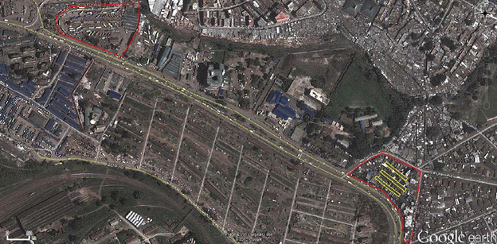
Source: Google Earth September 2013, modified by authors.
President Moi made good on his promise, providing three long (70m), narrow (about 7m) shades arranged parallel to each other with about 20m between (see Figure 2). The shades have corrugated metal roofs, timber frames, and are open beneath the roof. Originally constructed to house about 375 artisans, each shade was subdivided into sheds of about 40m² with 10 artisans settled in each shed.

Figure 2. Aerial image of Kamukunji. The three original shades are outlined.

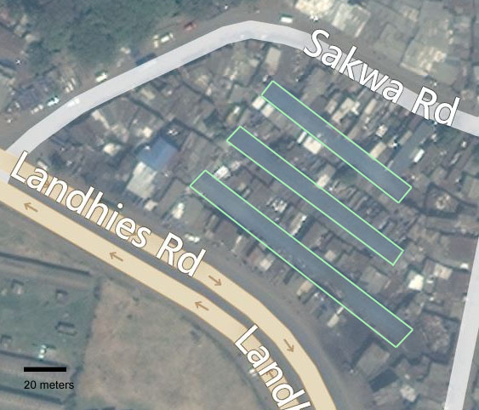
Source: Google Earth September 2013, modified by authors.

Over time the sheds have been further subdivided and added to, so that the 20m separating the sheds, as well as the surrounding area, has largely been roofed, as can be seen in Figure 2. There are footpaths wide enough to get goods in and out, but too narrow for cars or trucks. This means that deliveries come to the perimeter and are loaded on to hand trucks to traverse the cluster. The Association now (2013) has about 4000 members and the population in the cluster is estimated to be about 5000 artisans, business owners, suppliers, brokers, and service providers. (Kamukunji Jua Kali, 2013)

Smaller clusters have emerged around Nairobi. These are often populated with “graduates” of Kamukunji and the workers are highly skilled and the premises more established. Of note are the Racecourse cluster of furniture- and art-makers, the Gikomba furniture makers and the Kariobangi cluster of machine-makers. Maps showing locations of studied production are in APPENDIX 2: Maps. The table below (Table 1) lists the types of businesses studied and the specific representative organizations which took part along with the markets served and the priorities of each market.
Table 1: Producers taking part in this case study.
Type | Represented by – in this case study | Method of study | Market | Market’s first priority | Market’s second priority
Commodity Cluster | Kamukunji | Survey, interview | Low income | Low cost | Function
Furniture Cluster | Gikomba, Racecourse | Interview in prior work(Daniels, 2010), revisit during this study(Osanjo, 2010) | Middle income | Visual appeal | Function
Artwork Cluster | Racecourse | Interview in prior work(Daniels, 2010), revisit during this study | Middle and high income | Visual appeal | Quality
Non-cluster worker/business 1 | Housemark, | Interview | Middle and high income | Visual appeal | Quality
Non-cluster worker/business 2 | Simply Logic | Interview | Lower middle income | Function | Low cost

Figure 3. Metal boxes, ready for sale. They are used primarily for secure storage by students at boarding schools.

Photo: S. Daniels

Demographic profile of survey respondents
The survey was administered to 53 Kamukunji cluster members, selected at random by students walking through the area, within the objective of including those occupying different positions. Of those surveyed 32.1% (17) were fundi workers (who were hired by others to produce goods); 20.8% (11) were fundi owners who hire others; 37.7% (20) were non-fundi business people who contract fundi, and 9.4% (5) were fundi business owners who did not hire others. Since not all of the survey questions are applicable to all respondents the number of respondents will vary depending on the question.
The respondents included 43 males and 10 females who reported completing formal education from pre-primary (1.9%), primary (43.4%), secondary (34%), college (18.9%), to university (1.9%). Once they join the cluster members tend to stay, as 58% have been members for more than 10 years and 92% have been members for 5 years or more.
Of the fundi hired for production 77% stay with an enterprise a year or more, 3% for 6 months, and 19% work on a casual or as-needed basis. Most of the owners (24 of 31) pay piece-work and the amount for each piece depends on the complexity or typical fabrication time. The rest of the owners pay day wages. When owners hire, their first concern is the skill and experience of the fundi, with preference given to those who demonstrate they have made a similar product before and that their work is of high quality. Reputation, honesty, trustworthiness, and willingness to learn were also mentioned as qualifications. It is rare that someone from outside the cluster is hired for production, so most fundi are known to those hiring.
Training usually happens in the cluster (as 17 of 24 report), with trainees paying fundi or business owners for their training. The process generally takes 3 to 6 months, with 2 weeks being the shortest and 2 years being the longest reported.

Products manufactured in the Kamumkunji cluster
The manufacturers in the cluster produce commodity goods bought by those who cannot afford or choose not to buy similar imported items.
Figure 4 shows the distribution of goods.

Figure 4. Products manufactured by interviewees in Kamukunji (n=84; businesses produce more than one product).

Source: fieldwork 2013
In the cluster, 20 of the 53 respondents produced metal boxes (used by primary and secondary boarding school students for secure storage). Figure 3 is typical of the production. The size and shape is relatively uniform across producers; there is some variation in design elements (color, stenciling) and in the quality of manufacture and finish. Figure 6 shows boxes similar to but less well made than those in Figure 3. Hermsen provides a detailed description of box production in his master’s thesis. (Hermsen, 2010)
The boxes have been produced in the Kamukunji cluster since its beginning and the origin of the product has been lost. The paint scheme seems to indicate that the box is intended to replicate what might be called footlockers. The silver paint on the hardware and corners visually approximates the bright chrome or nickel plating found on boxes from formal sector manufacturers (see Figure 5). Formal sector boxes are typically made from fiber board rather than steel. This brings up a questions that we will revisit several times: is there something innovative about the boxes and is there some intellectual property that might be appropriated? The creative act in producing boxes in the cluster is that of adapting the essence of a box produced in the formal sector to the tools and materials available. The cluster produced box is not an exact copy; it is a product that maintains the form and function of the original but uses the design language of the informal sector. With the technology available in the cluster it would be impossible to produce exact replicas at anything close to a profitable rate.
Figure 5. Footlocker from US manufacturer.
Source: C&N Footlockers, http://www.cnmfg.com/
Traders from rural areas come to Nairobi to purchase these boxes for retail sale in smaller markets. The traders rely on inter-urban buses to transport their goods, hence proximity of the Kamukunji cluster to Nairobi’s major inter-urban bus terminus gives the cluster an edge over manufacturers farther from the bus station.
The second most manufactured product was the charcoal cookstove known as a Jiko, with 13.1% of those surveyed producing them. The production ranges from small single family stoves, as shown in Figure 7, to institutional versions about 1m in diameter. Jikos come in two distinct types, one is all sheet metal, the other adds a ceramic liner to the fuel box. This addition improves the efficiency so that the user requires less charcoal. Jikos with the ceramic liner are also known as “improved Jikos.” For further details see the “Case: Kenyan Ceramic Jiko” in the Innovation section.
Figure 6. Metal box close up to show the variation in detail, finish, and quality.

Photo: S. Daniels
Eleven businesses (13%) manufactured “pots” that ranged from chapati pans (slightly concave aluminum pans) to institutional scale vats, along with lids to go with them. This category includes many distinct products. In the foreground of Figure 8 is a cooking basin that is similar to a Chinese wok. It is important to note sheet steel is required for manufacturing the body and steel wire is used for the handles. During production disks are cut from a large sheet and then are beaten (cold worked) to shape with a hammer and convex anvil. Holes are punched for the handles, either with a hammer and punch on an anvil, or for those who can afford it, with a lever actuated punch. The wire handle is threaded through the holes and then hammered to form a head that keeps the handle in place. Typically there is a division of labor, with one worker marking the sheets, another cutting the disks, several forming the bowl, and one cutting and installing the handles. Because the sheet steel feedstock can come in a range of hardness’s (it is scrap metal, so there is no telling the condition) the Association maintains an “annealing oven” that firms may use to soften steel that is too hard to be worked as received.
Figure 7. Typical cook stoves. The one to the right with black finish incorporates ceramic liners to improve the efficiency.

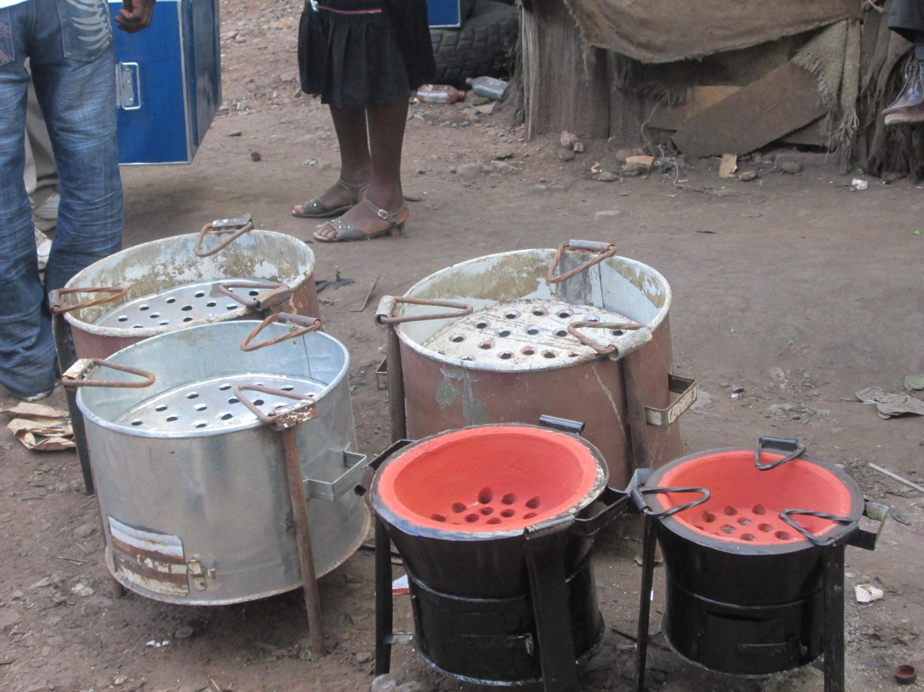
Photo: B. Hazeltine

The third most manufactured product is the wheelbarrow, with 10 respondents (11.9%) reporting them as part of their product mix. Figure 9 and Figure 10 show wheelbarrows in production and then ready for sale. We were told by the Secretary of the Association that an imported wheelbarrow was brought to one of the businesses in the cluster for repair and the fundi quickly copied the basic design and began producing their own version.
Figure 8. Pots, pans, and cooking utensils manufactured in Kamukunji.

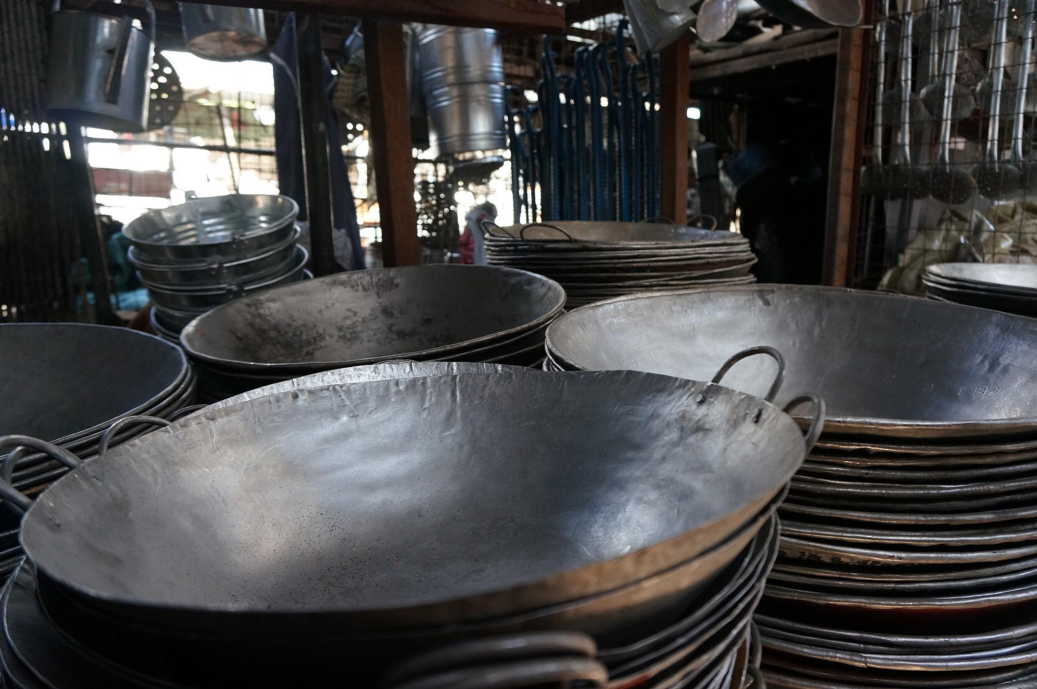
Photo: S. Daniels

The wheelbarrow is a good example of how products are adapted so that they can be made using the available tools and materials. Those produced in the cluster can be identified by the square corners of their boxes and the variation of wheels and wheel mountings. Imported wheelbarrows typically have drawn steel boxes. This process takes a flat sheet of ductile steel and uses a large (expensive) press to deform the sheet into a box with corners of large radii. To get the proper shape, the press is fitted with a die that has the same shape as the box and a punch that has the inverse shape - the sheet steel is sandwiched between the two and the press—brings the punch and die together. A press of this scale, and the punch and die for the box, would be 15 to 20 times the highest annual value of goods sold by a firm in the cluster; hence the need to adapt the product to fit the available production machinery.
The variation in wheels is a response to the wheel supply chain in the informal sector. The wheels are typically ones removed from vehicles that have reached the end of their useful life, so they could be from a car, motorbike, scooter, or anything else that uses wheels with pneumatic tubes and tires. So, there is a wide variation in both the size of the wheel and the mounting configuration. This is in contrast to the manufacturer of the imported wheelbarrows, who would order as many identical wheels as he needed for a production run.
Figure 9. A fundi welding the box for a wheelbarrow. The workspace and level of personal protection (note the cardboard face shield) is typical for the cluster.

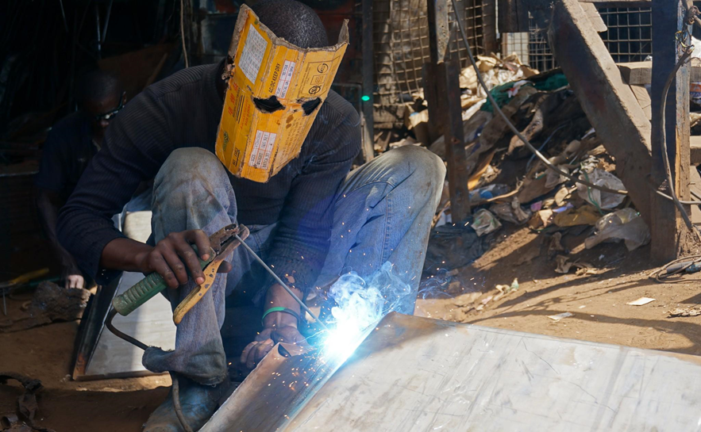
Photo: S. Daniels

Figure 10. Wheelbarrows (and metal boxes) ready for sale.

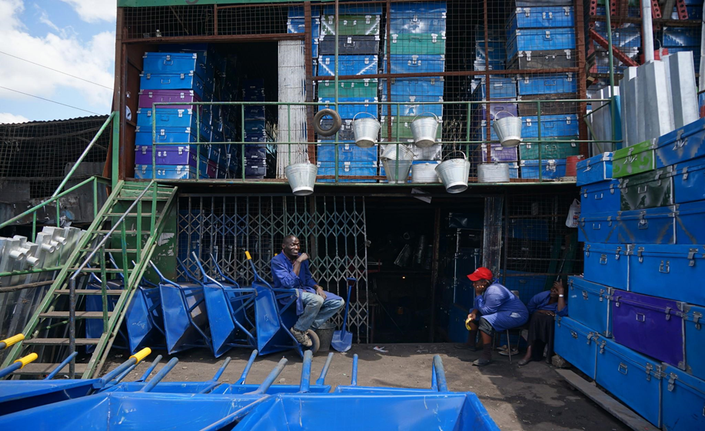
Photo: S. Daniels

The adaptation of the imported wheelbarrow design to informal sector production using the available tools, techniques, materials, and components exemplifies the intellectual capital of the sector. Broad knowledge of the market served in addition to knowledge of what it will take to do the fabrication, are used to design the product. The calculus is then to determine at what cost the goods can be sold while maintaining or growing the business.
Typically, ideas for products do not originate in clusters. The craftspeople in the cluster take ideas from products they see in the markets, suggestions from customers, manufactured items that customers bring for them to repair, or any other source. The innovation that occurs is the development of techniques and processes that allow those in the cluster to create products that, at least functionally, are very close to the original. As we’ve seen, the product mix tends to be commodities whose origins predate ideas about protecting one’s intellectual property; things like wheelbarrows, metal boxes, cooking pots, and rain gutters.
Chips cutters, which are devices to cut potatoes into chips for frying, were brought into production after the Association purchased one at a trade show. Figure11 shows one manufactured by the formal sector and the informal sector copy. These products are commodities, sold to those who cannot afford similar items (typically imported) sold in shops.
The imported model uses aluminum castings for the handle, base, and pusher plate assembly.
Figure 11. Chips cutters. Imported model on the right, informal adaptation on the left. The adaptation translates castings to sheet metal and adds a return spring to the mechanism.

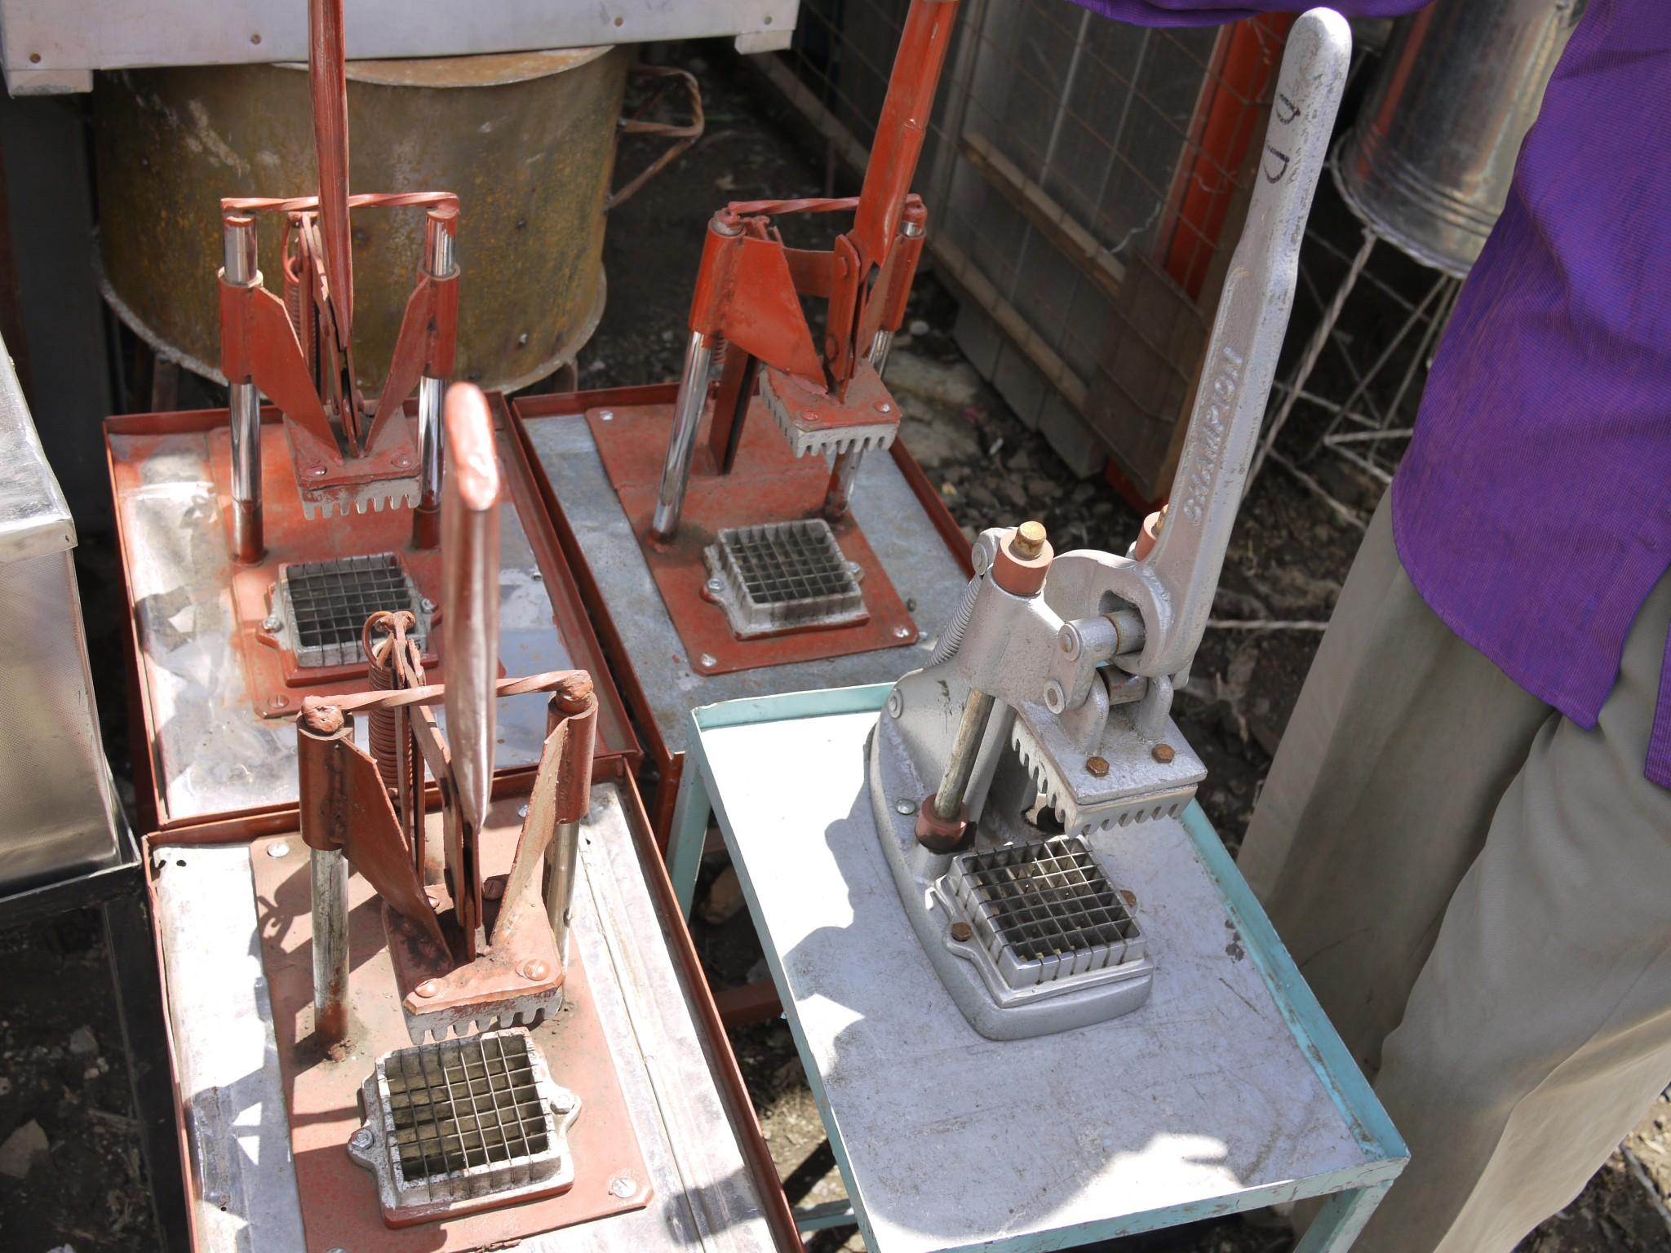
Photo: C. Bull

Producing a cast part requires the capacity to create a suitable mold and the capacity to melt (in terms of energy an adequate source of heat is needed) and pour aluminum. The informal version translates the castings to sheet metal and stabilizes the guide pins by adding a steel bar welded across their top. The pusher plate assembly incorporates the same serrated pusher as the cast version and the cutting assemblies look identical. This means that the informal producer was able to find a manufacturer who could produce those parts.

Art objects manufactured at Racecourse
A segment of informal metalworkers in Nairobi, located on the western edge of Nairobi in an area called “Racecourse,” produces art objects. (The name refers to the area’s proximity to the horse track.) The customers for these goods are middle class Kenyans, foreign tourists, and interior designers (one craftsperson was producing 75 elephants for export to England, destined for hotel lobbies - see Case: Moses Metalwork in the Innovation section for further details).
Racecourse is located along Ngong Road, a major artery between the city center and the western suburbs, about 11km west of the Kamukunji cluster and the Machakos bus depot. (see APPENDIX 2: Maps) As the number of shops has grown, the infrastructure to support them has grown as well, with suppliers of tools, hardware, and materials interspersed with production shops. At this point (2013) the cluster does not have a formal association; however, we heard anecdotes about the sharing resources among shops, when needed.
The social structure here is similar to that of Kamukunji—there is a cluster of businesses, they hire fundi and also train those without experience (usually for a fee). Because the products are intended for middle and high income consumers who can afford imported goods, the quality, visual appeal and novelty of the products are more important than in Kamukunji. The value that the maker adds to the raw materials is significantly higher. Since the customer places a premium on novelty there is a strong motivation to develop products that are distinct from other producers. Makers tend to be more secretive and their production areas are not as open as in Kamukunji.
The physical layout differs from Kamukunji, as each business has its own shed. While this makes it is easier to keep some things hidden from competitors, in order to attract business shops display their best wares out front along the main thoroughfare. Figure 12 and Figure 13 show examples of products from this area.
Figure 12. Animal sculptures at the Racecourse cluster.

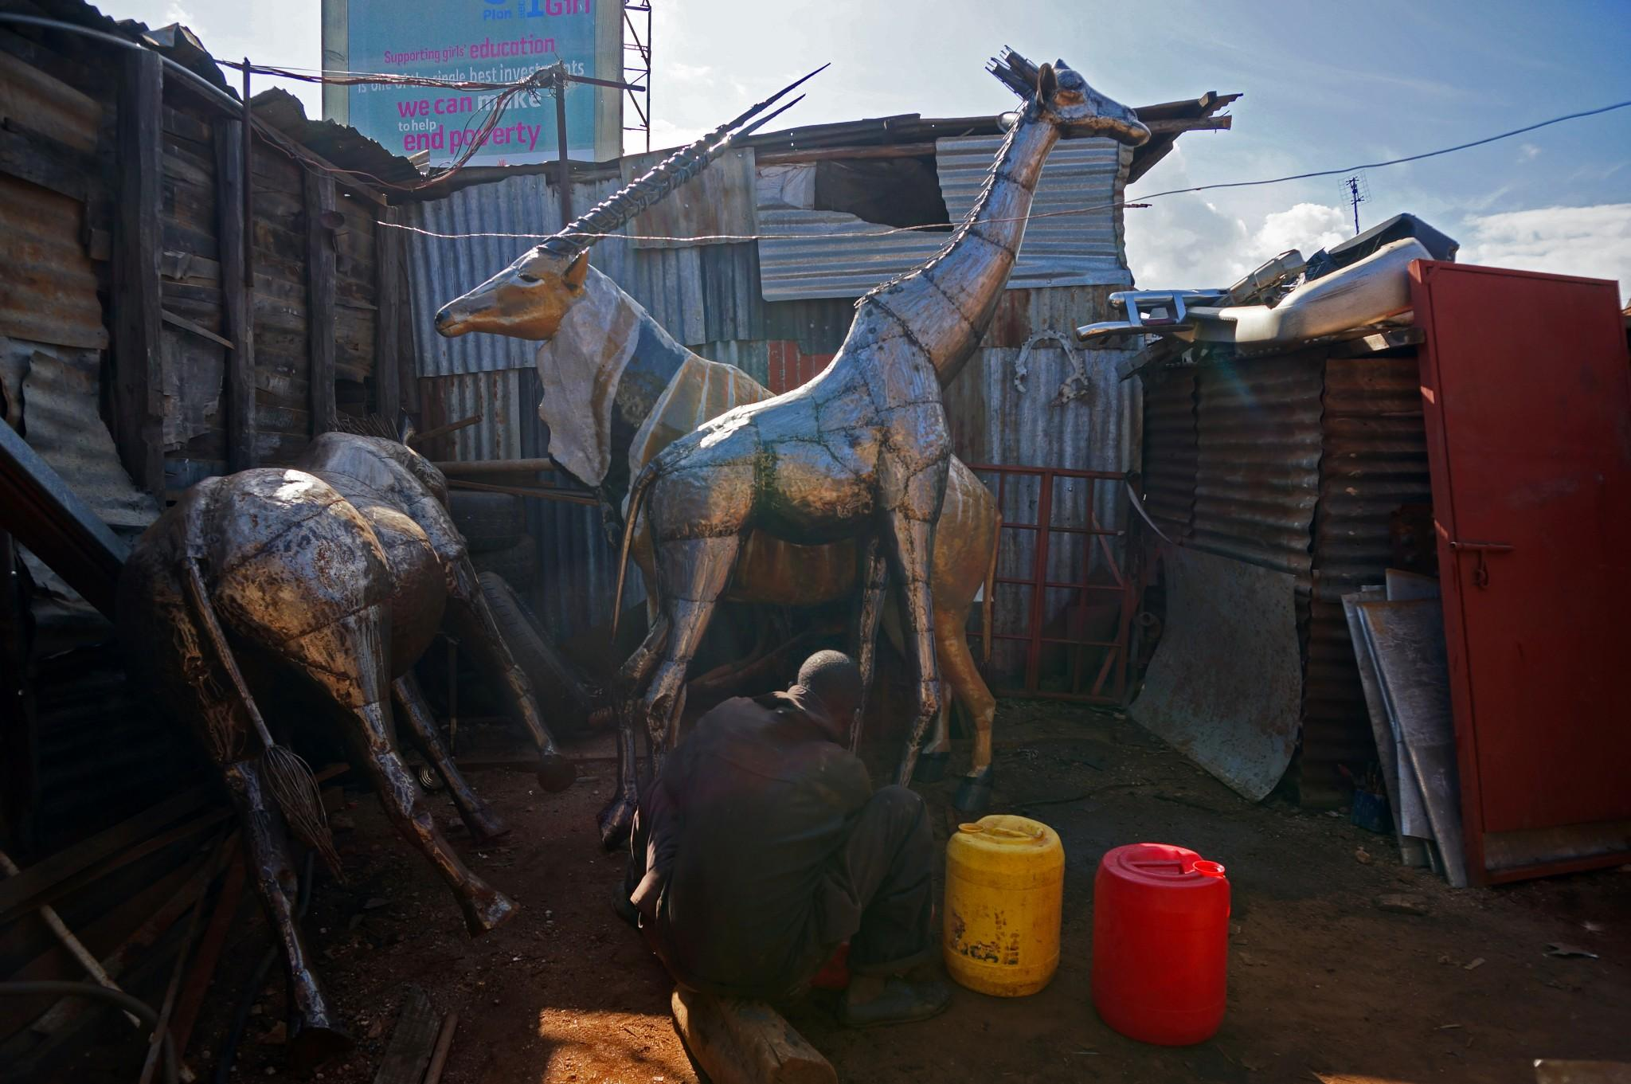
Photo: S. Daniels

Figure 13. Fundi holding a photo of a recent sculpture. Because these are higher value products the artisans are less likely to have a stock, so many rely on a catalog of photos to show buyers.
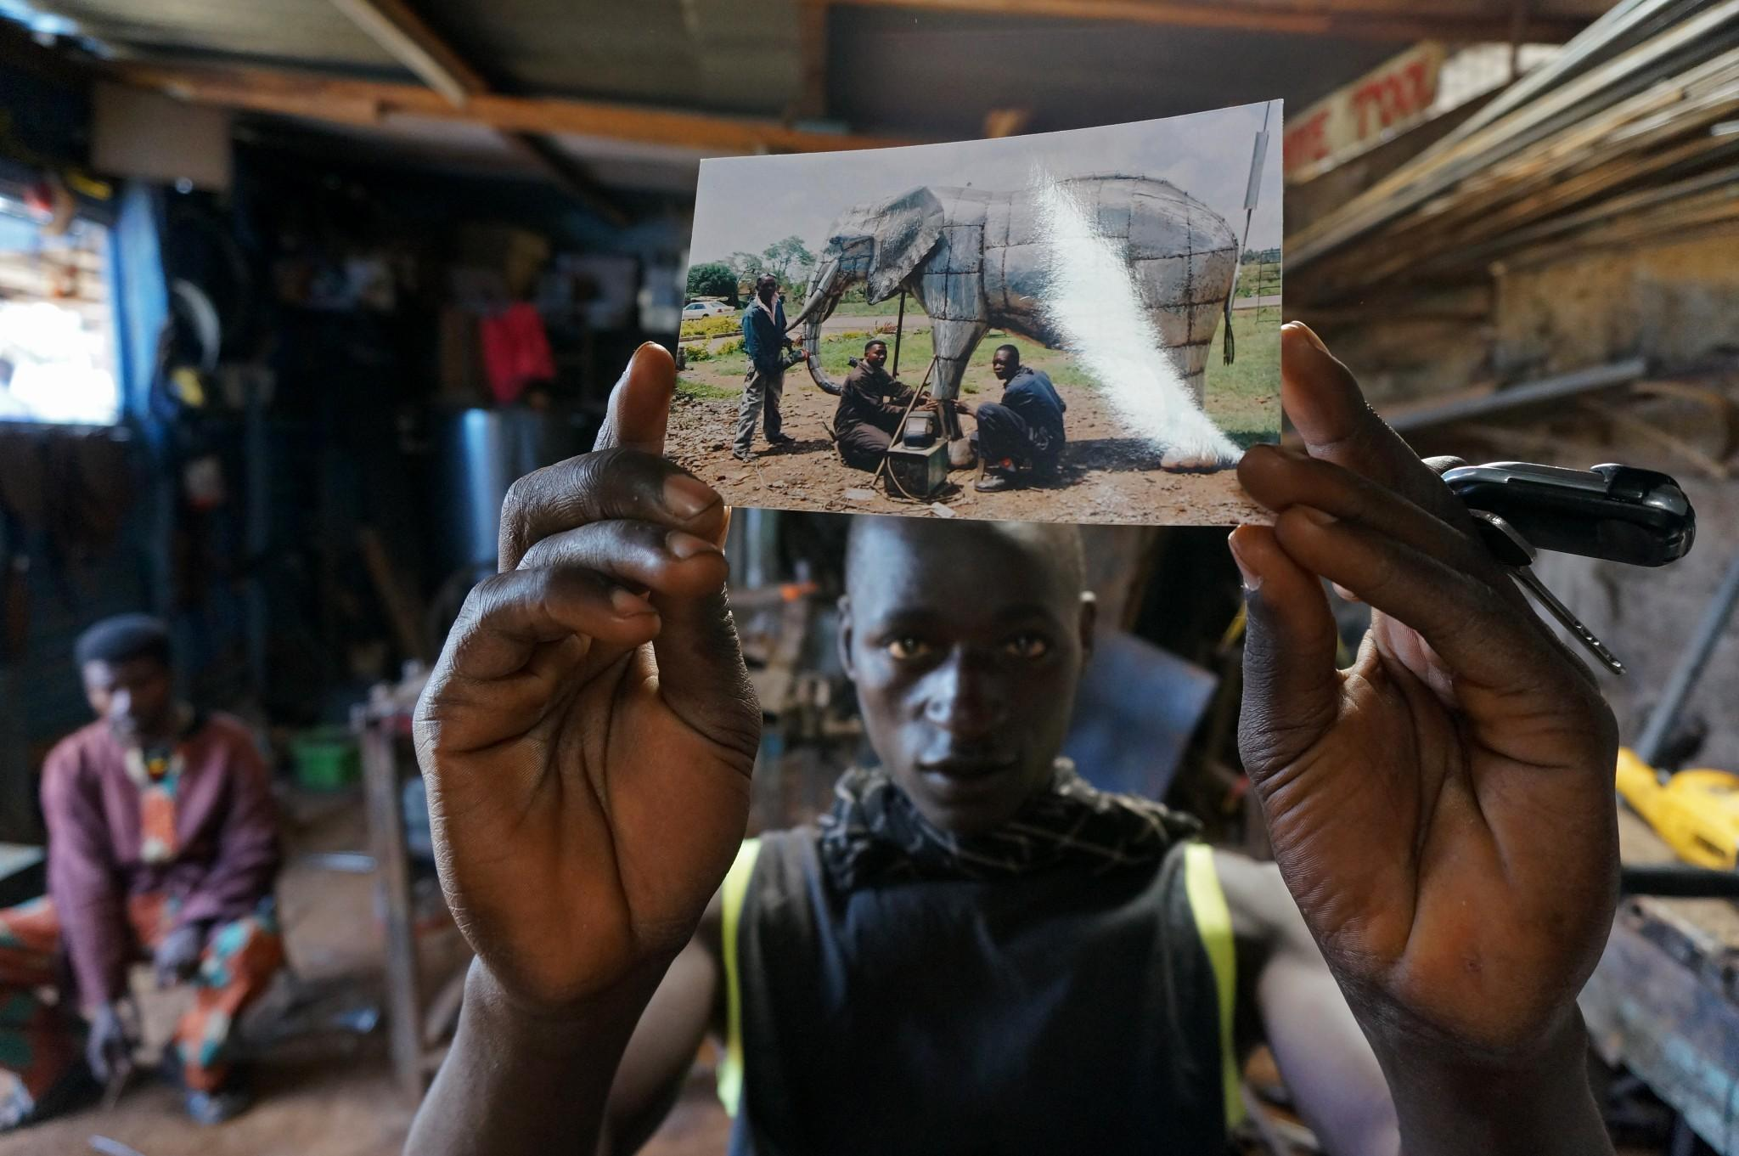
Photo: S. Daniels

Section 3: Innovation

Defining the Innovation System
The innovation system of informal producers comprised the firms themselves, as well as staff, service providers, suppliers, brokers, customers, end users, sources of creative inspiration (such as market trends, new technologies, and cultural context), and the supporting infrastructure. These features span the formal and informal sectors, as well as the private and public sectors.
Figure 14 diagrams the innovation system in Kenya. The blue lines represent formal paths and the green lines, informal paths. The dotted box encloses the value chain for manufacturing.
Figure 14. The innovation system of manufacturers in Kenya includes cluster businesses (suppliers and retailers), support and service organizations, education and knowledge transfer institutions, associations, and regulatory bodies, as well as international trends and standards from above and cultural context from below.
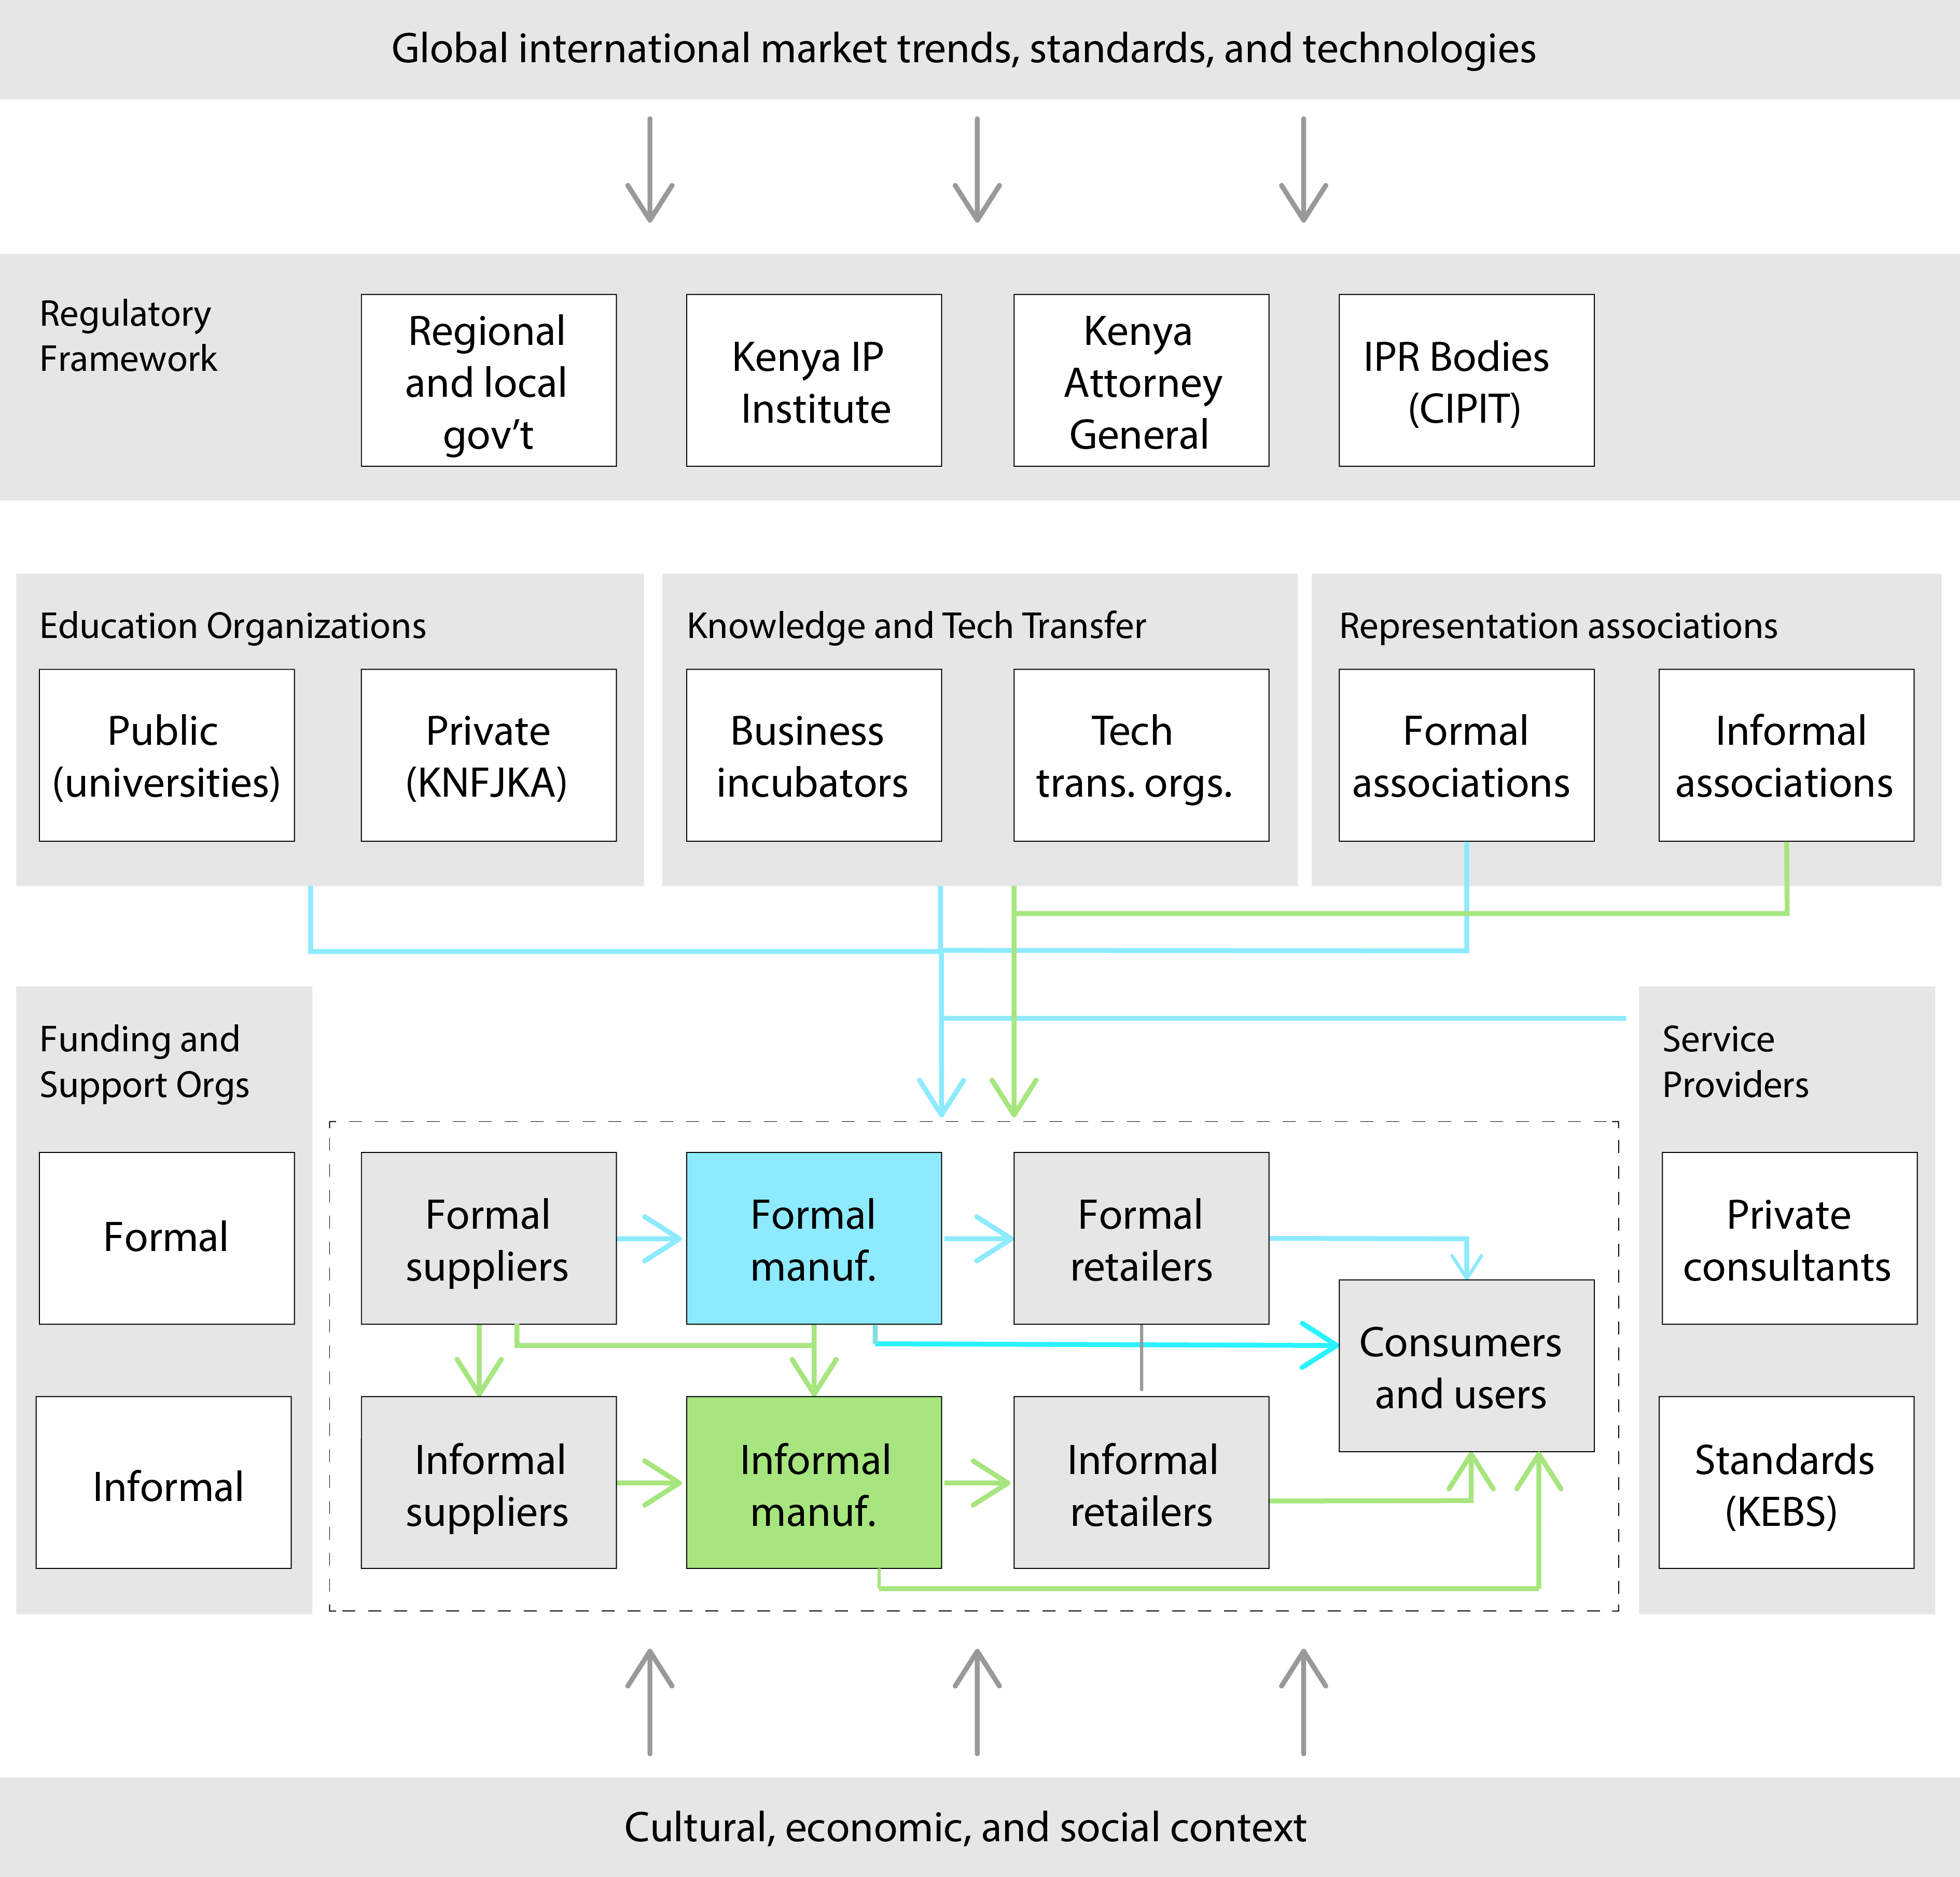

Informal businesses are often referred to as “micro and small enterprises” (MSEs). The Kenya Micro and Small Enterprise Act of 2012 defined micro enterprises as having fewer than 10 employees and less than KES 500,000 in annual turnover and small enterprises as having 10 to 50 employees and 500,000 to 5 million in annual turnover (P. Republic of Kenya, 2012) (see Section 5 for more from this Act). This is somewhat misleading in a Kenyan context, where it is estimated that 70 percent of all non-agricultural MSEs employ just one person. Business size tends to be slightly larger in Kamukunji, where apprentices are common.
Of the 40 Kamukunji business owners who gave an annual value of goods sold, 32% (13 of 40) put the value at KES 100,000 or less, and 50% put the value at KES 300,000 or less. Figure 15 shows the distribution.
In policy documents MSEs are also referred to as “small and micro enterprises” (SMEs), which is easily confused with “small and medium enterprises”. In our case we will not be referring to medium enterprises no matter what acronym is used.
Figure 15. Annual value of goods sold reported by 40 firm owners in the Kamukunji cluster.

Source: Fieldwork 2013

We categorize the documented businesses by size and mode of production (mass vs. custom). In our two-by-two matrix (Figure 16). Businesses in Kamukunji generally fell into micro scale and mass production. Enterprises in the Racecourse cluster were generally micro and produced custom furniture and art (see Case: “Moses Metalwork”). We also found examples of larger furniture and furnishings businesses (see Case: “Housemark”). Enterprises in Kariobangi were also larger with some producing for mass consumption and others producing equipment for commercial manufacturers.

Figure 16. Enterprises based on size and mode of production. Examples referenced in this section are mapped onto the 2x2 matrix.
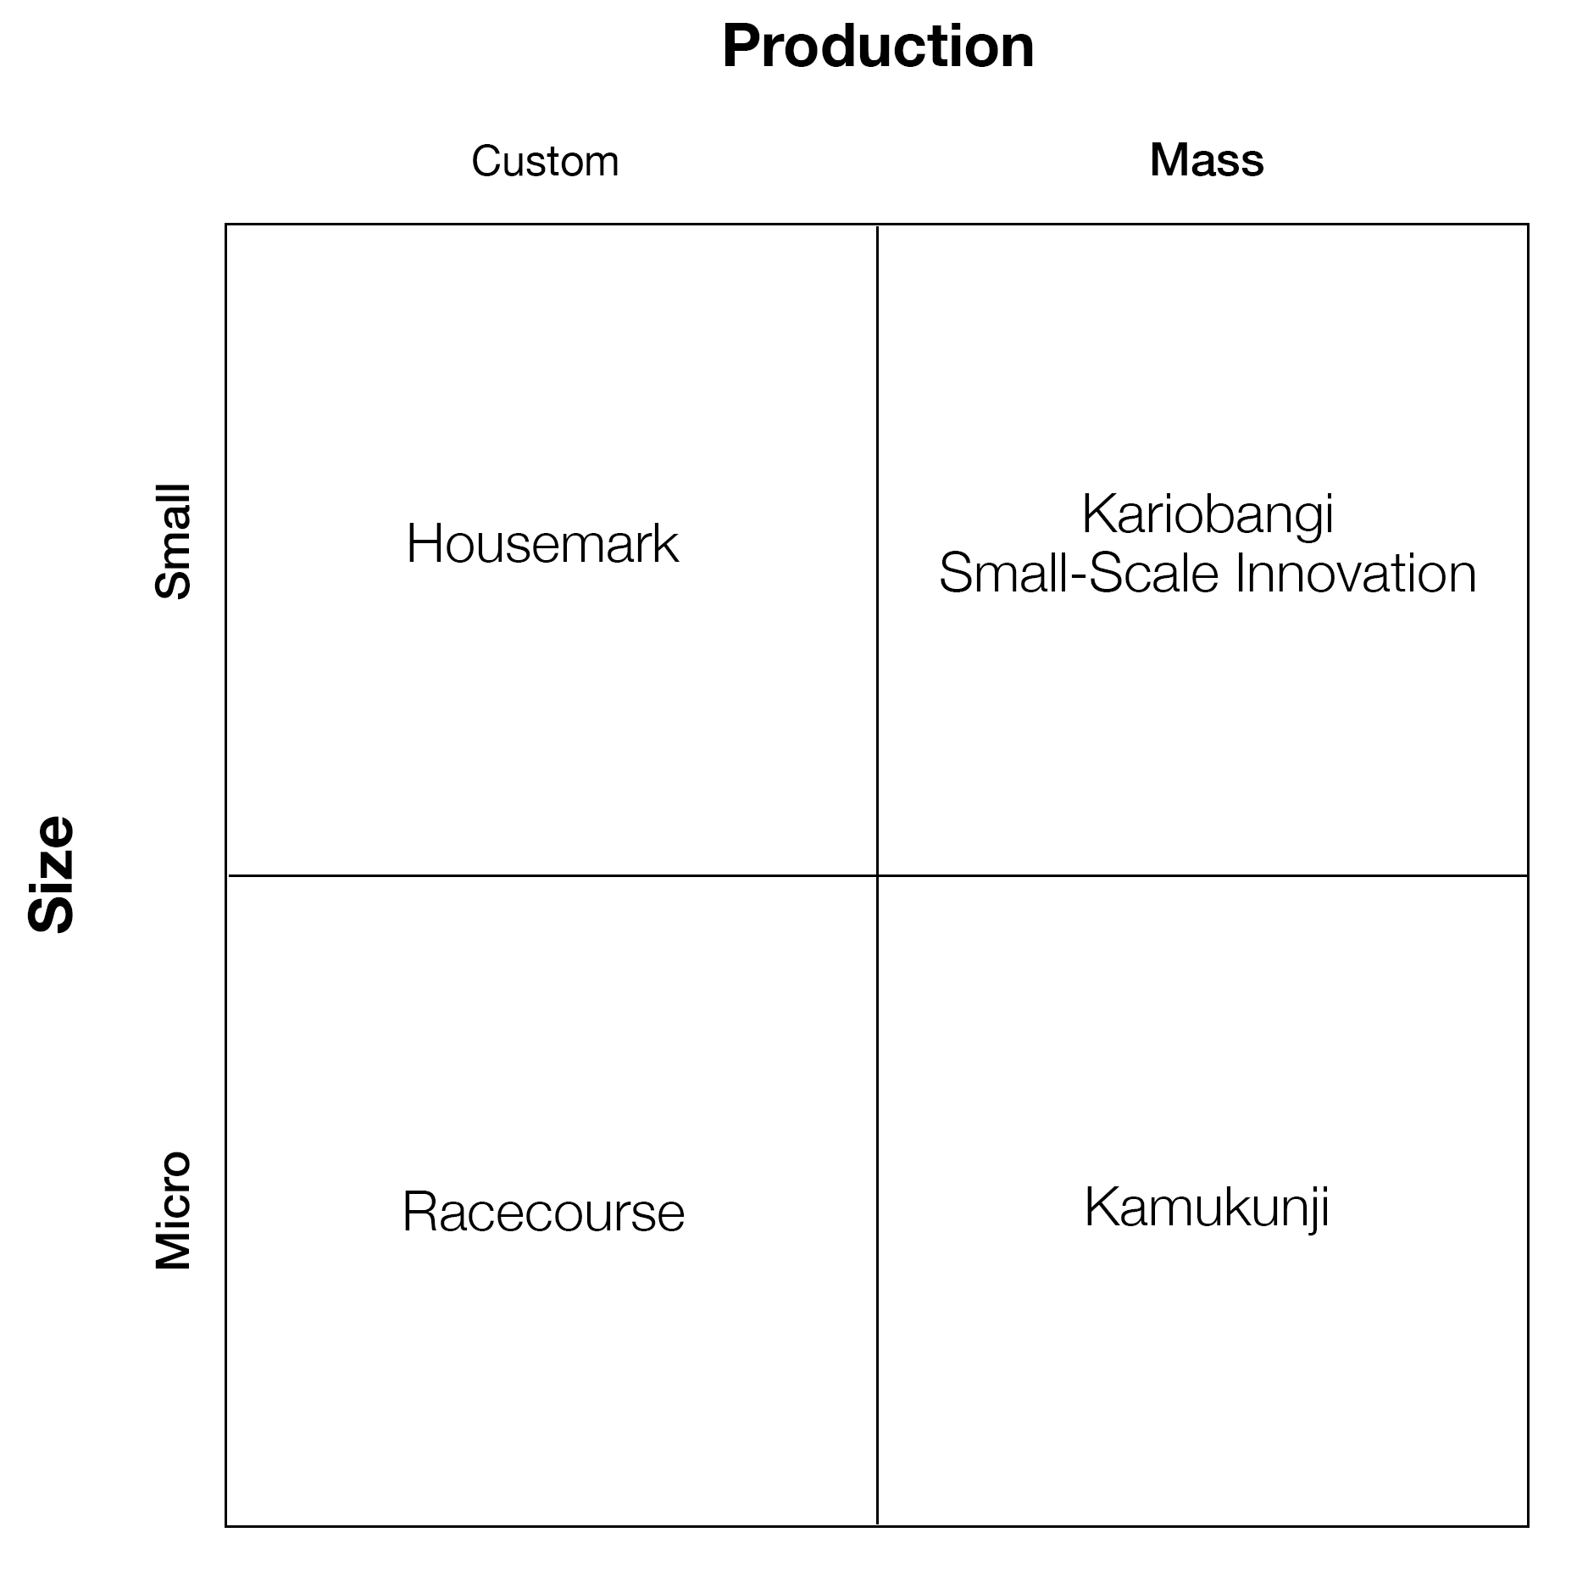
We also found a special category of business that was not geographically clustered. These are small-scale, highly innovative start-ups, often founded by more skilled or creative jua kali or formal entrepreneurs (See “Case: Simply Logic”). We call this the “small-scale innovation sector (SSI).”
Each type of business has a different innovation network. Highly informal businesses like those in Kamukunji rely heavily on networks within the cluster and loosely link to formal institutions via the Kamukunji Jua Kali Association, contractors, and occasionally microfinance or training institutions. One grievance aired by jua kali in Kamukunji was the recent emergence of brokers who sought out customers in the market, took high margins from the producers, and engaged in unethical sales practices. This emergence could provide a vehicle for better access to market needs and drivers, which in turn could encourage producers to innovate, but in practice it has been a market inefficiency that has forced producers to compete on price.
More formal businesses who had “graduated” from Kamukunji were more likely to have access to formal training, financing, and suppliers. Those in the small-scale innovation sector are likely to have an active network of support organizations, for instance, the founder of Simply Logic worked with the staff at the Kenya Industrial Property Institute (KIPI) and at the Center for Intellectual Property and Information Technology (CIPIT) to pursue patents and funding. (Further details in Case: Simply Logic) Actors in this sector also are exposed to creative inspiration, though many still struggle to find suitable support and protection.

Case: Moses Metalwork

A custom micro enterprise

Moses Metalwork sits among the clanking of hammers and sizzles of arc welders at Racecourse, a cluster of informal furniture makers along Ngong Road. Moses started his custom micro workshop nine years ago by fabricating typical furniture pieces but switched to large-scale sculpture when he came across an interested European buyer. Now he stands out from his neighbors by making high-end sculptures out of scrap metal and is one of the most successful entrepreneurs in the cluster.
He started with just an arc welder and a small premise but has since reverse engineered the welding machine and fabricated over 10 from scratch. He has also expanded his premises significantly and takes on as many as 13 apprentices at a time depending on demand. At the time of interview, he and his workers were filling a large order of giraffes, warthogs, and windmills to be shipped to the United Kingdom.
Others at Racecourse have already copied his designs. Despite the contentious issues of competition and intellectual property, the area is showing signs of an emerging cluster that may over time develop a reputation and attract buyers. The businesses might benefit by coordinating operations, pooling resources, and further specializing.

Case: Housemark

A custom small enterprise

Lawi Muriuki started his furniture workshop in his backyard, and like other jua kali, he’ll produce custom furniture and furnishings out of any catalog. But he’s not a typical fundi, and Housemark isn’t a typical shop.
Lawi was trained at a technical school, studied entrepreneurship, and worked for five years at an incubator program called Advancing Kenyan Industry through Local Innovation (AKILI). At AKILI, he learned to research market needs and identified opportunities for shoe racks, towel racks, and other products jua kali could make. Over the last 12 years, he and his co-founder have grown Housemark, moving to increasingly larger facilities and broadening product lines.
His design skills have provided an important foundation for his business, and he trains his fundis both to design and to produce high-quality products by hiding welds and adding details like notching. He organizes his staff into project teams with diverse sets of skills.
Today, Housemark sits in a large, secure facility next to Kamukunji. The company sells over 2,000 products—too many, Lawi says, to patent or copyright. He worries more about retaining talent than rights to his designs. But he does have issues with his trademarked brand: competitors like Housemart and Houseman have popped up nearby. Lawi’s response is to call the competitor and threaten litigation and he says that this approach has been successful.

Case: Simply Logic

A small-scale innovator

Dominic Wanjihia’s yard is littered with inventions: methane digesters, stoves, pumps, dryers, refrigerators, and purifiers. These prototypes comprise his laboratory, showroom, and vision for Simply Logic. Some designs are patented, and all sit securely behind a gate in the Nairobi suburb of Karen. He’s building a business, and he wants to make sure he and other inventors like him are protected.

For decades, Dominic struggled to obtain Kenyan patents for his products, which he attributes to ministry incompetence, as well as discrimination against the informal sector. Today, with help from the staff at CIPIT, he has patented his methane digester design and successfully enforced its protection by threatening both formal and informal copycats.
He’s not like most jua kali: he has formal training, and when he ran an auto shop, he demanded extreme precision from his apprentices and worked with high-end customers. But Dominic says inventive minds can be found hiding in most clusters around Nairobi; they’re just hiding to protect their ideas. That’s why he’s building an incubator for those inventive minds.
Dominic wants to provide the resources aspiring inventors need to grow their businesses, including intellectual property rights. So he’s teamed up with CIPIT to provide services to future small-scale innovators. For now, the incubator is based on Dominic’s own property rather than within any specific cluster.

Innovation Profile of the Sector

In interviews and surveys across these sectors, we sought out cases of innovation as defined in “Methodology”: origination or improvements of products, adoption of new manufacturing processes, or copyrightable stylistic changes made to a product. This included incremental innovations that were new to a particular firm or cluster.
Overall, we found the most product innovation (Figure 17) occurring in the formal small-scale innovation sector, a moderate amount in semi-formal mass and custom small enterprises, and the lowest amount in highly informal mass and custom micro enterprises. Kamukunji, which falls into the last category, is a particularly interesting case because a free flow of ideas is central to the way the cluster operates but this also reduces the incentive to innovate in terms of designing new products. Currently, the Kamukunji Jua Kali Association, representing the cluster’s reputation as a “training center,” discourages entrepreneurs and inventors from protecting their ideas by requiring that sheds be open and the work going on visible to passersby. As mentioned earlier, the innovation happening in the cluster revolves around adapting existing designs to the available methods of production. Entrepreneurs generally supported this approach.
In our survey of business owners in Kamukunji, we asked about both product and process innovations, as well as the sources of these improvements. About one-third of respondents had been making their product for over a decade, while 20 percent had started making the product in the last five years. Only five percent claimed the product was his or her original design. Nearly 60 percent were confident about the market for the product when they began producing it.
Figure 17. Product innovation levels of enterprises of varying levels of formality. While the formal SSI sector showed the most continuous innovation, formality was not necessarily a predictor of product innovation level.
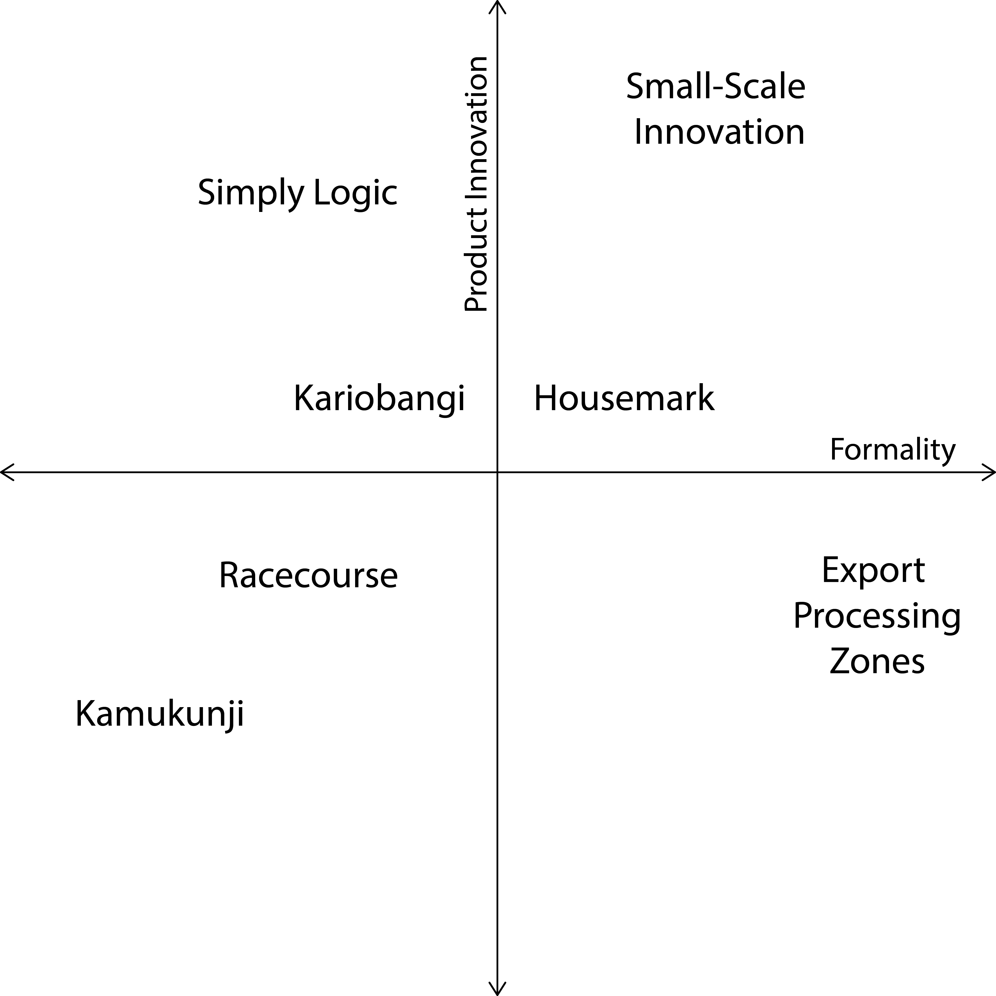

Figure 18. Most business owners focused on quality or style to differentiate their offerings, rather than modifications to the products themselves.

Source: fieldwork 2013

The most common way to differentiate a product (Figure 18) was quality; more than half of respondents cited quality of materials and product as a differentiator. More than a third focused on style and decoration, while just nine percent focused on modifications to the product itself. Since they started producing, only four percent have changed their manufacturing process, though 13 percent say they do research to make improvements.
Figure 19. Most business owners said they collaborated with other business people and/or fundis to improve their production processes. Very few received institutional support or worked in complete isolation.

Source: fieldwork 2013
An overwhelming majority—97 percent—said they collaborate with businesses in the cluster, producing the same product as them. When asked about formal competitors outside the cluster, 55 percent said they collaborate with them. Of the sources of aid to the production process (Figure 19), the most common—reported by 50 percent of business owners—was fellow business people, and 24 percent sought help from fundis. While only five percent had received any assistance from formal training institutions, 52 percent said they would feel comfortable working with one.
We asked a similar set of questions to the fundis of Kamukunji and found slightly more innovation among the craftsmen than the business owners. About 20 percent said they had originated a new product since they started working as fundis, and eight percent had modified a production process since working in Kamukunji.
Among those with original designs, over half said they received help from their employer, trainer, or business owner. About a quarter said they received assistance from a friend or fellow fundi. In general, training came from a variety of sources (Figure 21): other fundis in the cluster (42 percent), friends or relatives (29 percent), employers (17 percent), and trainers (13 percent).
Nearly 80 percent said they had trained other fundis, and over 90 percent said they allow other fundis to copy their designs.

Figure 20. This generalized model shows the typical flow of innovation between and within the informal sector. Jua kali innovators most often adapt formal designs to available materials, production methods, style trends, and customer needs. Other jua kali rapidly copy these adapted designs. On occasion, a “reverse innovation” may occur in which formal solutions are adapted from informal ones.
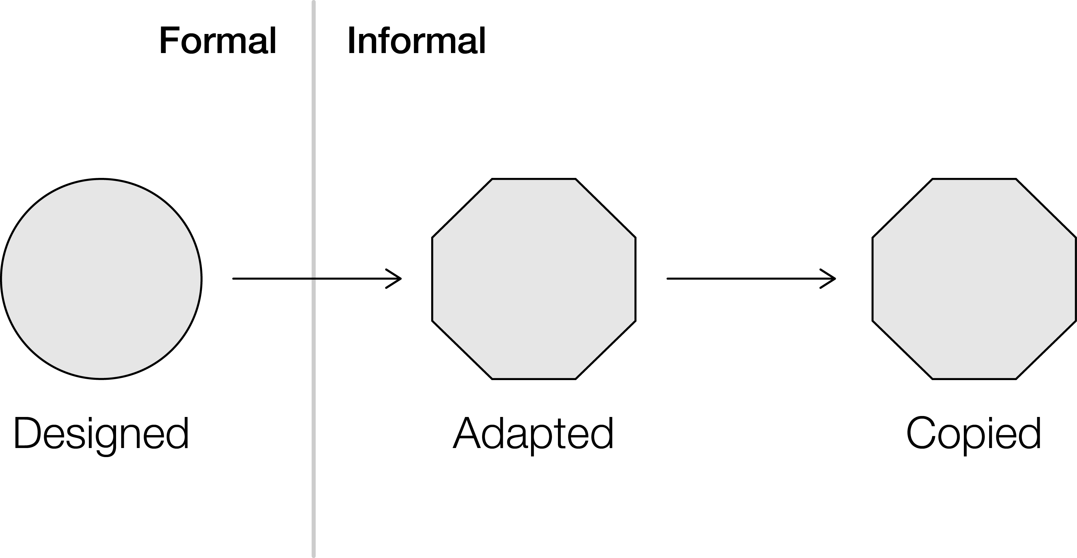

Our results show that innovation in the Kamukunji cluster occurs mainly through adaptation of product designs and stylistic modifications (Figure 20). Those who had originated a product or design were likely to have reverse engineered the product from an external source. For example, the chips cutters entered the sector when a customer asked a jua kali to repair one. He then reverse engineered it and began manufacturing his modified design at scale.
Figure 21. Fundis most often received training from other fundis in the cluster. Some received training from employers, relatives, or friends. Very few received training from professional instructors.

Source: fieldwork 2013
The Kamukunji Association leadership spoke of inspiration from trade shows, where those who attend survey competitive products. If there is a new product, they might buy it, bring it back, and collaboratively reverse engineer it. The association actively encourages information sharing by holding meetings and intervenes when an inventor tries to work in secrecy. If someone gets a head start, the association estimates he or she has about two months before competition is widespread.
New designs often undergo a modification process to adapt to available materials and production methods. The chip cutter’s original lever was cast aluminum, but the jua kali version is sheet metal. The wheelbarrow’s rounded corner is now a welded angle, and its wheels are derived from whatever used parts are available. The end products are often not uniform in appearance or performance.
Discussions and related research revealed isolated cases of continuous innovation in and around Kamukunji (see "Case: Gikomba Sofas"). It is also apparent, from discussions with jua kali in other clusters, such as Kibera's Toi Market, that some stylistic modifications spread not only within the cluster but also between clusters over time. For example, boxes in Toi Market used similar stencils to those in Kamukunji but had unique silver clasps.

Obstacles to Innovation and Scale

From these results it is clear that while many jua kali in Kamukunji differentiated their products based on quality and style, most did not continuously make product or process innovations. We put forward three hypotheses to explain this phenomenon: (1) there is a lack of source material to inspire innovations with clear market demand, (2) there is a lack of skills, and (3) there is a lack of incentive to innovate.

Hypothesis 1 is validated by the limited scope of help offered to jua kali in generating innovations. Most sought help from others within the sector and cited few external sources. Among the external sources cited were customers and previous training. Discussions with the Kamukunji Jua Kali Association revealed a few more: trade shows and large supermarkets like Nakumat. Very few jua kali had received training since entering the cluster.

The lack of training also supports Hypothesis 2. While most of the business owners—78 percent—said there are enough skilled fundis, one wrote that "it is not easy [to differentiate products] as we all use the same fundis." Nearly three-quarters of business owners do not train their fundis.
Anecdotally, a number of jua kali cited lack of protection as a disincentive to innovate, supporting Hypothesis 3. It was agreed that any designs introduced to the market would be copied, though some acknowledged a first-mover advantage. For example, a fundi who reverse engineered a telephone booth sold the product for KSH 35,000 (USD 400) for a few months, before having to drop the price to KSH 8,000 (USD 90) due to competition.

Case: Gikomba Sofas

Continuous informal innovation
Not all jua kali are stuck in a design rut: the sofa-makers of Gikomba churn out new models continuously, and they produce in large volumes. Gikomba market sits adjacent to the Kamukunji metalworking cluster, and its carpenters have struck a new model of coordination. The 33 microenterprises involved in the sofa trade share staff, and as many as four jua kali spend their time experimenting with new designs. They also co-own machinery, and the operators pay a fee back to the owners.
The brainstorming team prototypes sofa frames using drawings and small-scale models, drawing inspiration from a variety of sources, from large retail chains like Nakumatt to popular political figures. Fewer than 10 designs are popular at any given time, and their models usually reflect political zeitgeist. When we spoke with researcher Dr. Lilac Osanjo, she said “Odiam” and “Lucy” (first name of the country’s first lady) were the most popular frames. (Osanjo, 2010)
The carpenters churn out about 1,500 frames per week, and the finished sofas sell for one-third to one-half the prices of competitors at Nakumatt. While the frames are copied as early as the brainstorming phase, the cluster is quick to replace a design with a new one.

Case: Kenyan Ceramic Jiko

Open-sourcing design
In 1982, Dr. Maxwell Kinyanjui, working for Kenya’s Ministry of Energy, set out to change how Kenyans cooked food. Traditional stoves used too much wood and created polluted homes. He could have incubated a stove manufacturer, but public-sector spin-offs often fail. Instead, he recognized that designs and techniques spread more rapidly in the informal sector.

His design was simple and manufacturable by many artisans across urban and rural Kenya. He changed the shape slightly from the traditional jiko, or stove, and added a clay insert to the scrap steel housing to insulate the jiko and use less firewood. The Kenyan Ceramic Jiko costs KES 350 (USD 5) and is 30 to 50 percent more efficient than the traditional stove.

The technology has circulated widely because it was an easy switch from the traditional stove, Kinyanjui educated artisans on production of the housing and community groups on the ceramic insert, and he educated consumers on cost savings from reduced energy consumption. USAID funded Kinyanjui to produce 5,000 units, but 250,000 were produced and sold by microenterprises within four years. Today, artisans in virtually every village and trading center in Kenya produce some variation of Kinyanjui’s design.(Enterprise, 2010)

Section 4: Appropriation Mechanisms

In this section we review the appropriation mechanisms available in Kenya and use the formal/semi-formal/informal framework discussed in the conceptual study(de Beer et al., 2013). We then report the attitude of survey respondents and interviewees toward these mechanisms.

Formal Mechanisms
Kenyan law recognizes seven formal appropriation mechanisms for intellectual property: “(1) trademarks and service marks; (2) patents; (3) utility models; (4) industrial designs; (5) rationalization models; (6) copyrights; and (7) plant-breeders rights (Economist Intelligence, 2012). Of these mechanisms, trademarks and service marks (A. G. Republic of Kenya, 2001), patents, utility models, industrial designs (M. o. T. Republic of Kenya, 2001), and copyrights
(A. G. Republic of Kenya, 2001) are the most useful for actors in the informal metalworking sector as ways of holding on to innovations they develop.
According to the EIU:

“The Kenya Industrial Property Institute (KIPI), part of the Ministry of Trade and Industry, oversees patents, trademarks and trade secrets. KIPI has been a designated patent office since Kenya's entry into the Patent Co-operation Treaty in 1994; foreign patents approved by KIPI are in effect in all member countries. The attorney-general supervises copyrights, under the terms of the Copyright Bill of 2001. Kenya has de jure enforcement bodies in place to prevent or penalise the infringement of property rights. KIPI has an industrial-property tribunal, and the Kenya Copyright Board (KCB) has a copyright tribunal.”(Economist Intelligence, 2012)

We can rank the mechanisms in terms of filing costs (for this study we used the filing costs published by the granting body and did not include attorney’s fees and other costs), duration, and enforcement process, to gain a sense of how difficult it might be for fundi to gain some level of appropriation for their innovations.

Table 2: KIPI filing costs and duration from the Kenya Industrial Property Journal (Institute, 2013), Copyright cost and duration from Copyright Board website (Board, 2013)

Mechanism | Granting Body | Filing Cost (KES) | Enforcement | Duration (years)
Copyright | Kenya Copyright Board | 1,000 | By owner | 50**
Trademark | KIPI | 4,000 | By owner | 10*
Utility Model | KIPI | 7,500 | By owner | 10
Industrial Design | KIPI | 6,000 | By owner | 5*
Patent | KIPI | 10,000 | By owner | 20
* indicates renewable; trademarks are renewable indefinitely; utility models may be renewed for 5 additional years.
**Duration of copyright depends on the type of work.
Literary, musical or artistic work other than photographs: Fifty years after the end of the year in which the author dies.
Audio-visual works and photographs: Fifty years from the end of the year in which the work was either made, first made available to the public, or first published, whichever date is the latest
Sound recordings: Fifty years after the end of the year in which the recording was made.
Broadcasts: Fifty years after the end of the year in which the broadcast took place.

Semi-formal Mechanisms
These generally refer to contracts between stakeholders to limit the dissemination of ideas or innovations that one of the stakeholders deems valuable. Examples include non-disclosure agreements, transfer of rights from employee to employing organization, trade secrets, and non-competition clauses.

Informal Mechanisms
Informal mechanisms tend to be indirect ways of appropriation and include first to market advantage, hiding production processes, monopolizing production resources, and dividing tasks to keep the knowledge of a particular individual incomplete.

Survey and Interview Indications
Our survey and interviews asked about access to and use of formal appropriation mechanisms, attitudes about sharing ideas, ownership of ideas, and cultural norms around collaboration. Of the groups we talked to, there were marked differences in awareness of formal mechanisms, interest in pursuing appropriation, and desire to share advantages.

Those in the Kamukuji cluster favored collaboration and sharing, which is the cultural norm. When asked “Do you collaborate with jua kali making the product?” 38 of 39 (97.4%) said yes. The interest in collaboration decreased when cluster workers were asked about working with those outside the cluster: when asked “Do you collaborate with non-jua kali producing the same product?” 22 of 40 (55%) said yes. The question is asked in an active sense, i.e. “do you?” rather than “would you?” so a portion of the reason for the decrease may be geographic logistics.

When fundis were asked “Do you collaborate with fundis making similar products?” 20 of 24 said yes. The forms of the collaborations included sharing job opportunities, raw materials, tools, and processes. In determining with whom to collaborate fundi considered trust and honesty to be as important as the skill and experience of the collaborator.

Workers were not concerned about others copying the products they made. When fundis were asked “Do you allow fellow fundi to copy your ideas and products?” 23 of 24 said yes. When fundis were asked “Do you feel you own the ideas for the products you make?” 6 in 24 said yes.
The cluster worker’s rarely (1 out of 37) considered securing intellectual property rights and none of the fundi in the cluster had secured any intellectual property. Fundi also rarely (2 of 24) thought that the association might help securing intellectual property rights.
However they recognized the first-to-market advantage and did not hesitate to use it when the opportunity arose. Secrecy was discouraged (the cluster was seen as a training school for craftsmen and those trying to hide their work were asked to leave (KJKA Secretary) and the layout of the workplaces made it almost impossible (cheek-to-jowl with no solid walls between).
From the survey and observations the picture that emerges is a community willing to share ideas and production with little concern for protecting ideas. This raises questions of the economic and social calculi that determine fundis behavior around intellectual property. From an economic perspective, appropriation mechanisms have costs of time and money. For an individual fundi engaged in production (in contrast to a business owner), the opportunity cost is lost production.
Those at the Racecourse (they were not part of the survey but were interviewed during our 2013 fieldwork) were more likely to take advantage of informal appropriation mechanisms. The layout of their workplaces (more isolated than Kamukunji) and the migration of workers between workplaces (trainees tended to start their own enterprises rather than moving to another employer) made processes and novel products less visible.
Lawi Muriuki at Housemark relied on being better than any of his competition. Better in the sense that he could develop new products faster than any of his competitors could copy his existing designs. When asked about others copying his work he laughed and said, “I don’t worry about copiers - it’s easy for me to just make a new design. I have a book of about 2000 designs and continue to add to them.” He also worked at cultivating loyal employees who saw value in being employed there. Muriuki’s enterprise would be considered small, as opposed to micro and he had registered the business with the government. He also went to the trouble of trademarking his business name and did not hesitate to call competitors who he felt were infringing.
Of all that we talked with, Dominic Wanjihia was the most interested in formal appropriation mechanisms and had, on several occasions sought patents. His experience (in his own words) was mix. He had experience with KIPI and expressed the opinion that “the system is not designed for informal sector individuals to protect their ideas.” He related a story of attempting to patent one of his ideas and being told that KIPI could not help him. In another instance, he stated, “a government backed incubator attempted to appropriate his idea rather than helping him protect it” (see Case: Simply Logic). We would remind the reader that this is uncorroborated. The evidence base is not sufficiently large to make a broad claim.
In most of our study producers relied on what were called informal appropriation mechanisms in the conceptual study (de Beer et al., 2013). In the clusters this meant having a two week first mover advantage. For those able to work in secrecy it meant they had to use care in exposing their products.
What we found in this study seems to bear out the three hypothesis suggested in the conceptual study(de Beer et al., 2013) and reproduced with comments below.

- Innovations in the IE do not meet the necessary threshold to qualify for formal IP protection, as many are based on imitation and adaptation of existing products;
(ILO, 1992)

This was the case for many of the products manufactured in the Kamukunji cluster where the target market the low income population. It was less the case at Racecourse where we found examples of original work.
- Actors in the IE have not heard about IP and lack the necessary awareness of, skills concerning and access to the formal IP system;
In general we found that those we spoke with had heard of and were aware of IP. However, there did not seem to be mechanisms in place that help those in the informal sector gain the needed skills and access.
- Actors in the IE are pessimistic about their ability to register and enforce their IPRs; this is so despite the fact that extensive copying among artisans and the production of cheap copies abroad is threatening their income.(Finger & Schuler, 2004)
This hypothesis was most strongly validated by an entrepreneur who had made several attempts to gain IP protection, with little success. (See Case: Simply Logic)

Scenarios

We can envision a range of scenarios in which informal sector metal workers might appropriate their ideas. For any of these to be adopted (assuming that the obstacles are to putting implementing programs in place) it is critical that there is a trusted champion. That is, someone from the cluster who is well respected and who can demonstrate the benefits accrued by protecting his intellectual property. It is also critical that learning the PATENTING process be part of the training that apprentices receive; this is best done in the workplace and in parallel with learning to make.
The scenarios are variations on several themes. One theme is group ownership of rights, another reduces the time, cost, and complexity for filings, and a third develops branding and brand awareness through trademarks. The themes are not mutually exclusive, so combining them in creative ways may be a useful exercise.

Association as Rights Owner

One scenario would apply to clusters with cluster associations acting as agents for members of the cluster and protect ideas developed in the cluster from copying by those outside the cluster. The association is what we have come to call “semi-formal” because it is recognized by and has direct contact with the government while serving as a linkage between association members and the government. A cluster wide appropriation mechanism would distribute the cost over all the members and thus not be an excessive burden on individuals. It would support and build collaboration within the cluster and would not disrupt the social fabric.

Streamlined IP Rights Process

The second scenario would require the government to develop a new appropriation mechanism, with a low barrier to registration and a streamlined process specifically designed for informal sector enterprises. Costs could be related to the projected sales price of an innovation or the projected monthly gain for a process innovation. In this case the clients would be individual innovators rather than clusters. In addition to the mechanism, a robust method for supporting and encouraging those seeking protection of their ideas is required and could be addressed through the employment of fundi as agents for the program.

A third scenario could apply to the enterprises at Racecourse that are producing sculptures. Typically multiple copies of the same item are produced, making industrial design protection applicable, rather than one-of-kind art objects which could be copyrighted. If an industrial design protection assured producers that they could maintain exclusive rights to produce an item and that the profits would well exceed the filing costs (and any enforcement actions), this could function as intended.

In the clusters we studied, box makers tended to train more box makers, which leads to many entities doing very similar work (horizontal expansion) with very little opportunity to grow (vertical expansion). An easy to apply for, inexpensive, and quickly granted industrial design patent might limit the number of box making enterprises and enable more vertical expansion. The same idea applies to the makers at Racecourse and Gikomba.

A licensing mechanism would allow the non-patent holders (for instance former trainees) who wanted to compete in the box market to pay a license fee to produce boxes. This revenue stream would enable the patent holder to acquire production equipment, hire more makers, and fund product development.

Capital to Fund Filings

It is worth noting, all the scenarios suggested have the drawback of requiring payment at the beginning of the process. For most of these businesses, once material is bought and salaries paid, there is little left to pay filing fees. With all the available appropriation mechanisms the owner of the intellectual property initiates action against those who might be infringing, so an additional concern of business owners and innovators is how these protections are actually enforced.

A fund that provides low or no interest loans to those from the informal sector seeking IP protection would lower one of the barriers. This could be seeded by the government, and made sustainable through fees paid by those who file successfully.

Branding

The makers of Kamukunji are, for the most part, anonymous to the final consumer. Having a trademark system, that again, is easy to apply for, inexpensive, and quickly granted, gives the makers an opportunity to establish an identity with the consumers. This has the potential to provide feedback to the producer on quality value – that is, the trademark allows consumers to distinguish superior brand from inferior ones.
Branding, through industrial design and trademarks, is one of the ways that businesses manifest themselves as entities separate from the individuals that make them up. Brand recognition can serve as a non-monetary measure of growth.

Sidebar

For January through May of 2013, KIPI issued 21 patents to foreign entities and no patents to Kenyan entities. Of the 15 industrial designs registered, 4 of them appear to be manufacturable in the informal sector. Of the 4 utility models registered none appeared to be aligned with informal sector production. (This information was gathered from the Kenya Industrial Property Journal, published monthly by KIPI and reflects patents, designs, and models that were granted, not the number submitted.) (Institute, 2013).

This is in line with data from previous years. In 2011 there were 59 patents granted; 4 to Kenya residents and 55 to non-residents. Interestingly, in the same year there were 135 resident patent applications and 122 non-resident applications (WIPO, 2013). The fact that there are fairly few patents granted to residents may indicate that there are not sufficient resources to produce successful applications.

Section 5: Policy

In this section we will describe the relevant policies, the programs that implement the policies, and discuss the effect of the policies and programs on the informal metalworking sector in Nairobi. The primary aim of policies in place are to increase the informal sector’s access to markets and to support the integration of the informal economy with the formal sector, with an overall goal of improving the Kenyan economy through job creation and market development. In most cases supporting innovation is a secondary element of a policy.

Typically policies are enabled by acts of parliament and implemented through programs developed in one or more of the ministries. The parliamentary acts are usually vague as to which ministry will oversee the programs and the implementing ministry may change from time to time.

Table 3 identifies some of the relevant acts, ministries, and programs.

Table 3: Acts, agents, programs and targets for policies related to IP and the informal sector.

Act | Ministry | Program | Target Sector
Micro and Small Enterprise Act of 2012 | Labor | Small and Micro Enterprise Authority | SMEs
None | Labor | Department of Micro and Small Enterprise Development | SMEs
Industrial Property Act of 2001, Industrial Property Regulations of 2002 | Industrialization and Enterprise Development | KIPI | All
None | Industrialization and Enterprise Development | Department of Small and Micro Industries | SMEs
None | Higher Education, Science, Technology, and Information | Policy papers proposing innovation programs | All
None | Trade | Assistance to Small and Micro Enterprises Programme | SMEs
Public Procurement and Disposal Act | Finance | Procurement preferences for SMEs | SME

For most policies, the informal sector is lumped with small and micro enterprises and we will take policy mentions of them to indicate inclusion of the informal sector. In the Micro and Small Enterprise Act of 2012 (MSEA 2012), a micro enterprise is defined as:
“a firm, trade, service, industry or a business activity--
(a) whose annual turnover does not exceed five hundred thousand shillings;
(b) which employs less than ten people; and
(c) whose total assets and financial investment shall be as determined by the Cabinet Secretary from time to time, and includes:
(i) the manufacturing sector, where the investment in plant and machinery or the registered capital of the enterprise does not exceed ten million shillings; and
(ii) the service sector and farming enterprises where the investment in equipment or registered capital of the enterprise does not exceed five million shillings;”
((P. Republic of Kenya, 2012), Section 2)
Therefore, with the exception of Housemark, all the businesses surveyed fall into the micro category.

Similarly, small enterprises are defined as:
“a firm, trade, service, industry or a business activity—
(a) whose annual turnover ranges between five hundred and five million shillings; and
(b) which employs between ten and fifty people; and
(c) whose total assets and financial investment shall be as determined by the Cabinet Secretary from time to time,
and includes—
(i) the manufacturing sector, where the investment in plant and machinery as well as the registered capital of the enterprise is between ten million and fifty million shillings; and
(ii) service and farming enterprises, where the equipment investment as well as registered capital of the enterprise is between five million and twenty million shillings;” ((P. Republic of Kenya, 2012), Section 2)

The purpose of the Act is:

”to provide a legal and institutional framework for the promotion, development and regulation of micro and small enterprises by—
(a) providing an enabling business environment;
(b) facilitating access to business development services by micro and small enterprises;
(c) facilitating formalization and upgrading of informal micro and small enterprises;
(d) promoting an entrepreneurial culture; and
(e) promote representative associations” ((P. Republic of Kenya, 2012), Section 3)

As stated in item (c) above, one of the purposes is to formalize informal enterprises; which we might consider somewhat conflicted with those who choose to maintain an informal enterprise. The act offers some flexibility by having representative associations (like the Kamukunji Jua Kali Association) that would represent a group of informal micro enterprises in the policy sphere. This allows the micro enterprises to maintain their informality (if they so desire) while also giving them access to the programs that the policy will promulgate. In the Act an association must have at least 35 member small and micro enterprises to register.
This leaves informal enterprises with three options:

- to register directly, and thus lose some degree of informality and gain access to programs;
- to become a member of a representative association, which would maintain enterprise level informality and give access to programs; or
- not to register, which maintains informality and foregoes access to programs.

Although not explicit, we can imagine that phrases like “enabling business environment”, “business development services” and “entrepreneurial culture” include measures to aid the micro enterprises in protecting their innovations.
In terms of innovation, the act establishes the Small and Micro Enterprise Authority (MSE Authority) and charges it to “promote innovation and development of products by micro and small enterprises;”(Section 31.(h)), “encourage innovation and transfer of technology- in order to increase competitiveness of micro and small enterprises products and services;” (Section 50.(b)), “provide incentives to encourage invention and innovation by micro and small enterprises;” (Section 50.(d), and “finance research, development, innovation and transfer of technology.” (Section 51.(2)(d)).
The only mention of intellectual property in the Act charges the Authority with “facilitate the registration and protection of intellectual property rights for micro and small enterprises;” (Section 50.(c)).
The Science, Technology, and Innovation Bill of 2012 (STIB 2012) establishes The Kenya National Innovation Agency. One of the agency’s charges is to “increase awareness of intellectual property rights among innovators”.(M. o. H. E. S. T. Republic of Kenya, 2012)
Since both of these Acts are only recently passed by the Parliament, they have not yet had an impact on the informal metalworking sector. In terms of impact the government office most mentioned by workers in this sector is the Department of Micro and Small Enterprise Development (DMSED) in the Ministry of Labor. It is this group that provides transport to trade shows for goods produced in the informal sector and that gives the metalworkers feedback on how to improve their products.
The current sentiment regarding programs for SME development is summed up on the Department of Micro and Small Enterprise Development website at the Ministry of Labor:

“The department’s capacity to facilitate the MSE sector’s development has, so far, been hampered by unfavourable policy environment, poor co-ordination as some of the activities are still scattered in other ministries/departments, as well as a weak monitoring and evaluation framework. Within the MSE Associations themselves low management and technical skills as well as persistent leadership wrangles have frustrated the department's efforts in promoting the sector. Consequently, and in spite of the many programmes/projects worth billions of shillings that been availed to the sector over the years, there has been little impact in reducing neither the mortality rates nor improving the structure within the MSE sector. The department will have to address these constraints satisfactorily for it to have the requisite capacity to attain the expected objectives.” (Directorate of & Small Enterprise, 2013)

While this seems to be a pessimistic perspective, it does highlight the concerns raised by others working in the area.
As described in Section 4, Appropriation Mechanisms, policies, regulations, and governing bodies are in place to protect the rights of innovators. Recent policy declarations have been made which are intended to improve the access to IP protection for micro and small (small and micro) enterprises. For instance, in 2008, the Ministry of Science and Technology published “Science, Technology and Innovation Policy and Strategy”. In it, one of the stated goals was:
“Ensure that existing Intellectual Property Rights (IPR) regimes are judiciously enforced to provide impetus for the generation, protection and utilization of intellectual property by all categories of inventors, in particular community, Micro, Small and Medium Enterprises (MSMEs) to foster achievement of Kenya’s national development objectives.”(Government of Kenya & Technology, 2008)

The program pointed to by some interviewees was one which transports selected association members and some of their products to trade shows. The association secretary tells “someone in the Department of Micro and Small Industries (Ministry of Industrialization and Enterprise Development) sends a lorry to take some of the products we make to trade shows. We select the products based on quality. Some members go as well. At the trade shows we see what “the opposition” is doing and assess whether the association has the capacity to compete. Is there a place in the market? Can we grow the market share? People from the ministry give feedback to the members on quality and how to improve products”. (F. Dawa, personal communication, January 2013).

The Public Procurement Act (Republic of Kenya, 2010) provides incentives for formal enterprises that incorporate components from informal enterprises in their products. The goal is to integrate informal suppliers into the supply chain for items purchased by the government. While not directly tied to innovation, the act at least challenges both formal and informal enterprises to develop creative ways to collaborate. In Kenya public procurement accounts for about 9 percent of GDP (Njiraini & Moyi, 2006), so the potential for informal sector manufactures is large.
Below (Table 4) we take the framework set out in the conceptual study to assess innovation policies for the informal economy (Table 9 (de Beer et al., 2013)) and populate with the relevant Kenya information.
Table 4: Innovation policies and their implementation in Kenya.

1) Providing a functioning property rights system and functioning economic institutions
- Ensuring that clear rights to property exist (e.g., protection of formal ownership) | - Industrial Property Act, Copyright Act
2) Improving the infrastructure and providing urban spaces
- Ensuring access to basic infrastructure such as electricity, water and waste disposal  - Ensuring the IE has access to production sites (e.g., permitting the use of residential allotments) | - All sites had electricity, most had water, not much waste generated but what was generated, was removed.  - Government sanctioned areas in Kamukunji and Kariobangi in close proximity to residential allotments.
3) Facilitating access to markets and participation in the formal economy
- Trade show transport for informal sector manufacturers,
- Public Procurement Act gives incentives for projects that include informal sector partners
4) Providing access to finance
- Facilitating the necessary investment and increasing efficiency and productivity. Microfinance, financial services aimed at the rural economy and the IE, financial inclusion to assist households | - MSEA 2012 sets policy in place.  - Programs to implement are under development.
5) Improving education and skills, including entrepreneurship capacity
- Ensuring basic literacy and numeracy  - Developing skills of informal workers through education, training, including basic skills as well as more advanced business and financial skills, and language skills | - Public and private primary education is the norm.  - Recognized clusters intended to train skilled workers, MSEA 2012 has put policy in place, programs are being developed
6) Fostering the innovation system and improving the capacity to innovate
- Putting in place good monitoring and evaluation mechanisms to assess or quantify the contribution of IE innovations to improving the livelihood of workers in the informal sector  - Identification of innovative and creative potential (who innovates where and how?)  - Facilitating start-ups  - Adaptation of SME and entrepreneurship policies for the IE  - Stimulating linkages between formal and informal actors, and the integration of the IE in formal sector value chains with a view to transferring skills to IE workers  - Efforts to enhance forward and backward linkages, including to the formal sector and public institutions  - Facilitating the assimilation of innovations created elsewhere by effectively channelling existing knowledge and technology  - Creating local knowledge-sharing networks to connect innovators, adopters and intermediaries and help innovators to gain recognition for their work and to increase knowledge generation for further innovation  - Making public research and other innovation actors more relevant to the IE, including the adaptation of scientific findings to local needs to improve the impact of research funding  - Setting up public-private bodies to serve as a bridge between national and global research centers and IE firms for the diffusion and adaptation of technologies  - Fostering access to technology and information  - Establishing technology commons that allow the sharing of innovations between IE actors (“horizontal learning”)  - Improving the design of IE innovations  - Implementing demand-side measures  - Stimulating particular innovations targeted at the special needs of the poor  - Using public procurement or procurement of non-governmental organizations (NGOs)  - Establishing prizes, grants, etc., to foster IE innovation  - Improving IE actor organization  - Providing help to cooperatives, self-help groups, business and workers associations in creating organizational capacity, cooperation, clustering and political representation  - Strengthening the intermediary parties (e.g., informal sector associations, cooperatives, NGOs) to address the needs of the IE for skill development and technology transfer | - Kenya National Bureau of Statistics lists an ongoing Micro and Small Enterprises Survey (Statistics, 2013) no further information available.  - MSEA 2012 has put policy in place, programs are being developed  - Public Procurement Act gives incentives for projects that include informal sector partners  - KIPI Gazette publishes detailed information including IP applications  - MSE Authority and STIB 2012 have areas within the act and bill that address most of these.
7) Intellectual property policies
- Needs assessment  - Overcoming the hurdles in accessing the IP system  - Awareness-raising and training on IP  - Technological information and advisory services  - Financial assistance  - Assistance in IP exploitation and technology transfer  - Redesigning certain features of the IP system, such as conceptualizing a set of “informal” IP norms to offer IP protection that is cheaper and better suited to the IE milieu | - KIPI  - Centre for Intellectual Property and Information Technology (CIPIT) working on these issues.  - MSEA starts to get at a reconceptualization with recognition of associations representing informal enterprises

Conclusion

The gulf between the majority of people in the informal metalworking sector and those where formal or conventional IP appropriation is accessible and aligned with norms is wide. There are both cultural and economic reasons for this. From a cultural perspective, the norm in the clusters is to share resources and to freely copy other’s work. From an economic perspective, the cost of securing intellectual property rights far exceeds the perceived benefit to the owner. While this is true for the majority, there is a small segment of informal enterprises who seek to formally appropriate their ideas as illustrated in “Case: Simply Logic.” In the scenarios sub-section we gave a series of ideas that may be used to begin to bridge this gulf.
Copying is sometimes characterized as disincentive to innovation but it also makes new technologies diffuse easily. This brings an interesting dilemma to policy makers; it could be argued that the diffusion of new technologies encourages a vibrant system of producers and the attendant creation of jobs. If copying is prohibited, the innovator may maintain ownership of an invention, and the question becomes: does patenting an invention lead to success in the market?
Trademarks can serve as a baseline for branding. Survey respondents cited quality and style as important product differentiators. It certainly would be possible to further enhance this by working with enterprises to develop trademarks that add to the differentiation. Frequently the threat of litigation is used to dissuade others from copying trademarks, so that a phone call serves as a first round in enforcement.
On the whole, we consider the small-scale innovation, sculpture reproduction, and commodity manufacturing as all places that would benefit from better access to intellectual property rights. The small-scale innovation area is most directly in line to use patents. Obstacles include the high cost and the gap in institutional experience in serving this group. Owners of sculpture reproduction enterprises would benefit from registering industrial designs. Commodity manufacturing would benefit from easy access to trademarking.
There are institutional gaps in experience serving all of these constituents, and there are gaps in the experience of those seeking property rights. This suggests that a program that “fast tracked” some pilot cases could help build the needed experience. The cost obstacle must also be addressed, and here, small grants to producers would start a shift in the culture.
A fast track pilot program does not address the problem that fees alone have the potential to exceed any benefit the registrant may gain. A program that collaborates with inventors to analyze the value proposition could benefit those planning to apply for IP rights.

There also appear to be structural problems in the informal metalworking sector as well. For the commodity producers to survive they need to be able to sell their goods for less than competing imports. Aiding the development of higher production throughput along with higher quality output is a measure to deflect this threat, and having higher-quality output also opens markets beyond those currently served.

Appendices

APPENDIX 1: Survey
QUESTIONNAIRE
SECTION I
CHARACTERISTICS OF THE JUA KALI OPERATORS |  | Write the code in the unshaded box
1 | Gender : 1- Male 2- Female
2 | What is your highest level of education?  - No formal education  - Pre-primary  - Primary  - Secondary  - College  - University
3 | Which category of jua kali operator do you belong?  - Fundi worker  - Fundi owner who hires workers  - Businessman/woman who contracts fundi to work for me  - Other (specify)
4 | What is the value of your business?
5 | When did you join the cluster?

PRODUCTION HISTORY |  | Write the code in the unshaded box
6 | What product do you make?  - Chips cutter  - Chips warmer  - Wheelbarrow  - Popcorn maker  - Other (specify)
7 | Was this your first product?  Yes [1]  No [2]
8 | When did you start making the product?
9a. | Is this product your original design?  Yes [1]  No [2]
b. | If “yes”, specify how you came up with design
c) | If “no”, explain where you obtained the design from?
10 | How did you choose the product?
11a | Did you know whether a market for your product already existed?  Yes [1]  No [2]
b | If “yes”, specify
c | If “no”, explain
12 | What motivated you to begin production?
13 | Where did you obtain the idea of making the product from?
14 | Where did you learn process of making the product from?
15 | If you imitated the product design, what adjustments have you made to the product since you introduced to it?
16a | Have you changed the process of producing the product?  Yes [1]  No [2]
b | If “yes”, Why did you change?
c | If “no”, why have you not changed?
17 | Where did you learn the about the new process?
18 | Do you keep secrets about the changes you have made?
19 | What benefits have you made from the recent changes in production?
20 | How do you secure the skills of the fundi who has learnt about the changes in production?
21 | Do you keep your fundi for a long time?
22a | Do you do any research to improve on the process of production?  Yes [1]  No [2]
b | If “yes”, describe the research you do to improve the process
c | If “no” explain the reasons why you do not do any research to improve the process of production.
23 | What major obstacles do you face in improving the process of production?
24 | What are your weakest areas in the process production?
25 | How do you overcome your production process weaknesses?
26 | Whom do you seek help from in case you have production process weaknesses?
27 | Have any of the following institutions assisted you in improving the process of production?  - Youth polytechnic  - National polytechnics  - Institutes of technology  - Universities
28 | Which of the following institutions would you comfortably work with to improve your processes of production?  - Youth polytechnic  - National polytechnics  - Institutes of technology  - Universities
29 | What are the positive and negative issues of people in the same cluster producing the same things?  Positive Negative

COLLABORATION IN PRODUCTION |  | Write the code in the unshaded box
30 | How do you relate with people producing similar products like yours?
31 | Do you collaborate with people producing the same product as your?  Yes [1]  No [2]
32 | Do you feel threatened by people producing the same product as yours?  Yes [1]  No [2]
33 | Do you feel threatened by non-jua kali people producing the same product as yours?  Yes [1]  No [2]

34a | Do you have an idea to stop non-jua kali people from producing similar products to yours?  Yes [1]  No [2]
b | If “yes”, Specify
c | If “no”, Explain
35a | Do you collaborate with non-jua kali people producing the same product?  Yes [1]  No [2]
b | If “yes”, specify
c | If “no”, explain
36 | What should be the relationship between Jua kali people producing the same product?
37 | What should be the relationship between non-jua kali people and jua kali people producing the same product?

TRAINING |  | Write the code in the unshaded box
38 | Where were you trained?
39a | Have you had to go back for training to improve the process of making your product?  Yes [1]  No [2]
b | If “yes”, Specify
c | If “no”, explain

ACQUISITION OF INTELLECTUAL PROPERTY RIGHTS |  | Write the code in the unshaded box
40 | Have you considered securing intellectual property rights for your product?  Yes [1]  No [2]
41 | If “no”, why have you not considered securing property rights for your products?
42 | Has the association assisted you in securing intellectual property rights?  Yes [1]  No [2]
43 | Is there government support in securing the property rights of your products?  Yes [1]  No [2]
44 | What limitations do you face in securing the property rights of your products?
45 | How should jua kali products property rights be secured?

EMPLOYMENT AND TRAINING OF FUNDIS |  | Write the code in the unshaded box
46 | How do you recruit your fundi?
47 | What employment contract do you have with your fundi?
48 | What do you consider when hiring a fundi?
49 | How long do you keep your fundi?
50a | Do you provide them with further training on production process?  Yes [1]  No [2]
b | If “yes”, where do they go for training?
c | If “no”, explain
51 | How do you prepare your fundi when introducing a new product?
52a | Do you change your fundi often?  Yes [1]  No [2]
b | If “yes”, explain
c | If “no”, explain
53a | Do you provide incentives to your fundi to facilitate them acquire new production technology?  Yes [1]  No [2]
b | If “yes”, explain
c | If “no”, explain
54 | Is there enough supply of fundis with enough technological know-how?  Yes [1]  No [2]
55 | Where do they come from?
56 | Do you train your own fundi?  Yes [1]  No [2]
57 | What role do fundis play in spreading jua kali production process and products to others?

SECTION II- FUNDIS
EMPLOYMENT |  | Write the code in the unshaded box
58 | What is the relationship between you and the business owner?
59 | How do you relate with the business owner?
60 | Did you know the business owner before he/ she hired you?  Yes [1]  No [2]
61 | What do you consider when taking a job from a business owner?
62a | Do you change jobs frequently?  Yes [1]  No [2]
B | If “yes”, explain
C | If “no”, explain

TRAINING |  | Write the code in the unshaded box
63 | Where did you obtain your skills from?
64 | When did you receive training?
65 | How long did it take?
66 | Who trained you?
67 | What is your relationship with the trainer?
68 | Have you trained others?  Yes [1]  No [2]
69 | Have you attended further skill training since you started work?  Yes [1]  No [2]

PRODUCTION PROCESS |  | Write the code in the unshaded box
70 | Have you originated a new product since you started working as a fundi?  Yes [1]  No [2]
71 a | Have you changed the production process since you start working in the cluster?  Yes [1]  No [2]
b | If “yes” specify
c | If “no” explain
72 | Who assisted you in the origination of this product?
73 | Where did you obtain the design from?

74 | Have you received support from any of these institutions in technology upgrading?  - Youth polytechnic  - National polytechnic  - Institutes of technology  - University  - National Youth Service  - NGO  - KIDRI
75 | If you had an idea of originating a new product, which of the following institutions would you go to?  - Youth polytechnic  - National polytechnic  - Institutes of technology  - University  - National Youth Service  - NGO  - KIDRI

ACQUISITION OF INTELLECTUAL PROPERTY RIGHTS |  | Write the code in the unshaded box
76a | Have you secured intellectual property rights for your products?  Yes [1]  No [2]
b | If “yes” specify
c | If “no” explain
77 | What difficulties do you encounter when securing intellectual property rights?
78 | Do government agencies assist in securing property rights?  Yes [1]  No [2]
79 | Does the association assist you in securing property rights?  Yes [1]  No [2]
80 | Do you feel you own the idea and the product you make?  Yes [1]  No [2]
81a | Do you allow your fellow fundi to copy your idea and product?  Yes [1]  No [2]
b | If “yes”, specify
c | If “no”, explain

COLLABORATION IN THE CLUSTER |  | Write the code in the unshaded box
82a | Do you collaborate with fundis who are making similar products?  Yes [1]  No [2]
b | If “yes”, specify how you collaborate
C | If “no”, explain why you do not collaborate.
83a | Do you feel threatened by fundi making similar product in the cluster?  Yes [1]  No [2]
b | If “yes”, explain
c | If “no”, explain
84 | How do you determine which fundi to collaborate with?
85 | Are they relatives’ friends or people from the same village or area of resident?
86a | Do you collaborate with non-jua kali fundi who make similar products?  Yes [1]  No [2]
b | If “yes”, specify
c | If “no”, explain
87a | Do you feel threatened by non-jua kali fundi?  Yes [1]  No [2]
b | If “yes”, specify
c | If “no”, specify

PRODUCT DESIGN |  | Write the code in the unshaded box
88 | How do you modify the design?
89 | Why do you modify the design?
90 | What factors do you consider when modifying the design?
91 | Do you consider the function of the product cosmetics in production?  Yes [1]  No [2]
92 | When you make a job move do you keep or share the secrets of production from your previous employer?  Yes [1]  No [2]

APPENDIX 2: Maps

Figure 22. Nairobi City with study areas highlighted. Nairobi West (Racecourse and Simply Logic) is to the west (left) and east central Nairobi (Kamukunji, Kariobangi, Machakos, Gikomba, and Housemark) is at the center, the small square overlays all but Kariobangi

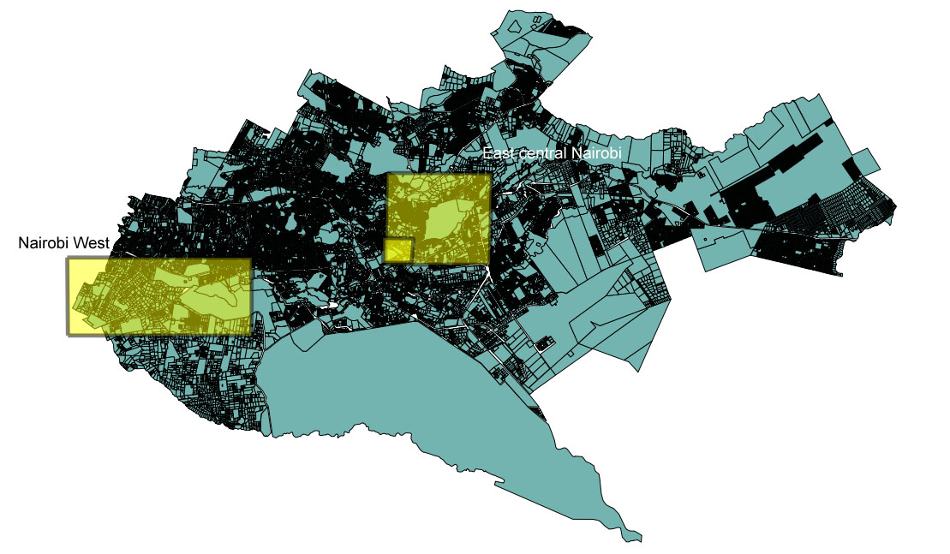
Source: Authors
Figure 23. Nairobi West. Simply Logic is located at the small yellow polygon to the west, the Racecourse cluster is the collection of yellow blocks to the east.
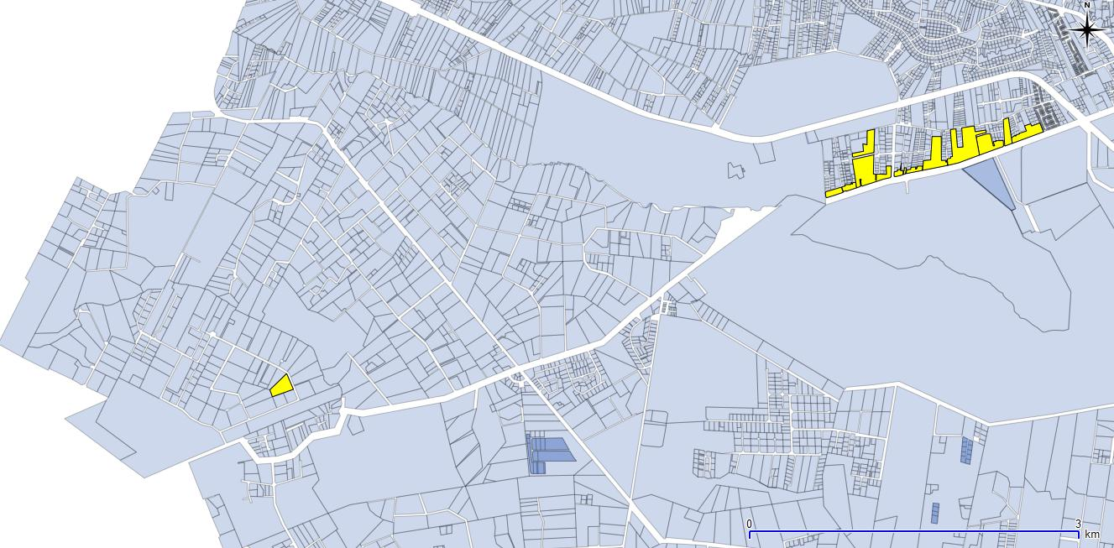
Source: Authors
Figure 24. East central Nairobi study areas, Kariobangi is in the north east, Kamukunji, Gikomba, and Housemark are in the southwest.

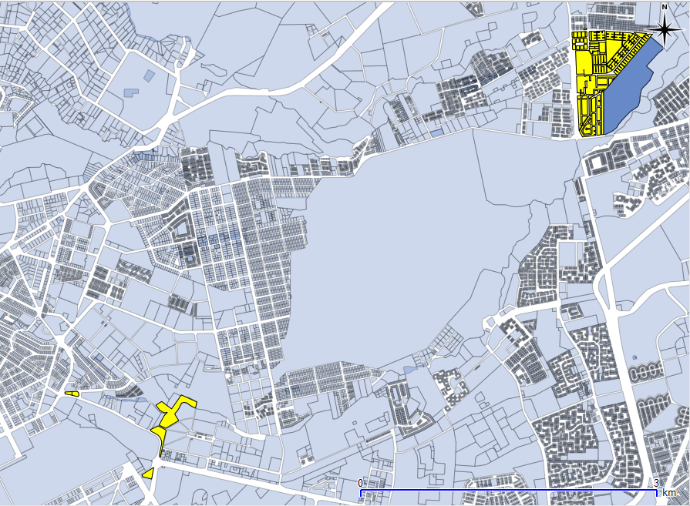
Source: Authors

Figure 25. East central Nairobi showing locations of Machakos, Gikomba, Kamukunji, and Housemark.

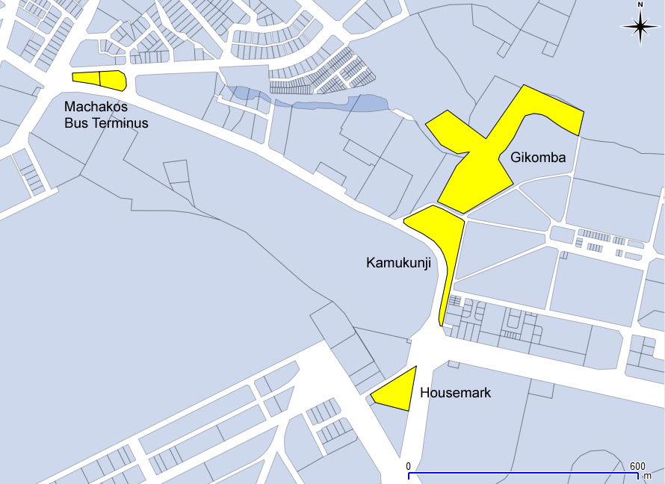
Source: Authors

References
Board, K. C. (2013). COPYRIGHT REGISTRATION | Kenya Copyright Board. from http://www.kenyacopyrightboard.co.ke/?q=registration
Budlender, D. (2011). Statistics on Informal Employment in Kenya: Women in Informal Employment: Globalizing and Organizing.
Daniels, S. (2010). Making Do: Innovation in Kenya's Informal Economy. New York, NY: Analogue Digital.
de Beer, J., Fu, K., & Wunsch-Vincent, S. (2013). The Informal Economy, Innovation and Intellectual Property - Concepts, Metrics and Policy Considerations. (10). http://www.wipo.int/export/sites/www/econ_stat/en/economics/pdf/wp10.pdf
Directorate of, M., & Small Enterprise, D. (2013). [Directorate of Micro and Small Enterprise Development]. Web Page.
Economist Intelligence, U. (2012). Kenya: Licensing and intellectual property (pp. n/a). New York: The Economist Intelligence Unit.
Enterprise, M. (2010). Renewable Energy Solutions in Kenya. Retrieved 9/8/2013, 2013, from http://reskqu.blogspot.com/
Essegbey, G., Stephen, A., Essegbey, I., Micah, E., & Akuffobea, M. (2013). STUDY OF THE TRADITIONAL HERBAL MEDICINE IN GHANA. Unpublished Draft.
Finger, M., J., & Schuler, P. (2004). Poor People's Knowledge: Promoting Intellectual Property in Developing Countries. Washington: Oxford University Press and World Bank
Government of Kenya, M. o. S., & Technology. (2008). SCIENCE, TECHNOLOGY AND INNOVATION POLICY AND STRATEGY.
Hermsen, W. (2010). Collective efficiency in the Kamukunji metalwork cluster? (Masters), Wageningen University. Retrieved from http://edepot.wur.nl/171758
ILO. (1992). Technological Capability in the Informal sector - Metal manufacturing in developing countries.
Institute, K. I. P. (2013). Industrial Property Journal. 2013(6), 7/15/2013. http://www.kipi.go.ke/index.php/past-ip-journals
Kamukunji Jua Kali, A. (2013). [Kamukunji Jua Kali Association]. Web Page.
Kenya National Bureau of Statistics (1999). Micro and Small Enterprise Survey 1999. Nairobi, Kenya.
Kenya National Bureau of Statistics (2009). Kenya Economic Survey 2009. Nairobi, Kenya.
Kinyanjui, M. (2009). The Kamukunji Metalwork Cluster in Kenya. In D. Zeng (Ed.), Knowledge, Technology, and Cluster-based Growth in Africa (pp. 25). Washington, D.C.: The World Bank.
Kraemer-Mbula, E., & Tau, V. (2013). STUDY OF INFORMAL CHEMICAL MANUFACTURERS IN SOUTH AFRICA. Unpublished Draft.
Njiraini, P., & Moyi, E. (2006). Supporting MSEs to Access Public Procurement Market in Kenya. Nairobi, Kenya: Kenya Institute of Public Policy Research and Analysis.
Osanjo, L. (2010). Product Design Practice within Micro and Small Enterprise in Kenya: Case Study of Sofa-makers in Gikomba Market, Nairobi. (PhD), University of Nairobi Nairobi, Kenya.
Ouma, S., Njeri, J., Khainga, D., Kiriga, B., & Kamau, A. (2007). Estimating the Size of the Underground Economy in Kenya. Nairobi, Kenya: Kenya Institute of Public Policy Research and Analysis.
Republic of Kenya, A. G. (2001). The Copyright Act.
Republic of Kenya, M. o. F. (2010). The Public Procurement and Disposal Act, Chapter 412C.
Republic of Kenya, M. o. H. E. S. T. (2012). Science, Technology and Innovation Act, 2012.
Republic of Kenya, M. o. T. (2001). The Industrlal Property Act (Vol. 3).
Republic of Kenya, P. (2012). The Micro and Small Enterprise Act (Vol. 55).
Statistics, K. N. B. o. (2013). Summary surveys/Censuses Undertaken over the years at KNBS. Retrieved 15 December, 2013, 2013, from http://www.knbs.or.ke/index.php?option=com_content&view=category&id=104&Itemid=590
WIPO. (2013). Statistical Country Profiles - Kenya. Retrieved December15, 2013, from http://www.wipo.int/ipstats/en/statistics/country_profile/

[End of Annex and of document]

The views expressed in this Study are those of the authors and do not necessarily reflect those of the WIPO Secretariat or any of the Organization’s Member States.
Document CDIP/11/INF/5, presented to the eleventh session of the CDIP and available at: http://www.wipo.int/meetings/en/doc_details.jsp?doc_id=232525
Document CDIP/13/INF/2, presented to the thirteenth session of the CDIP

