E
WIPO-OECS/IP/JU/ROS/06/1
ORIGINAL: English
DATE: July 18, 2006
 | 
ORGANIZATION OF EASTERN  CARIBBEAN STATES | WORLD INTELLECTUAL  PROPERTY ORGANIZATION
WIPO–OECS COLLOQUIUM FOR THE JUDICIARY ON The PROTECTION OF INTELLECTUAL PROPERTY RIGHTS
organized by
the World Intellectual Property Organization (WIPO)
in cooperation with
the Organization of Eastern Caribbean States (OECS)
through
the Judicial Education Institute
of the Eastern Caribbean Supreme Court
Roseau, July 28 and 29, 2006
counterfeiting and piracy: (b) from a judicial perspective
Document prepared by the Honorable Judge Louis T. C. Harms,
Supreme Court of Appeal, Johannesburg, South Africa

Slide 1
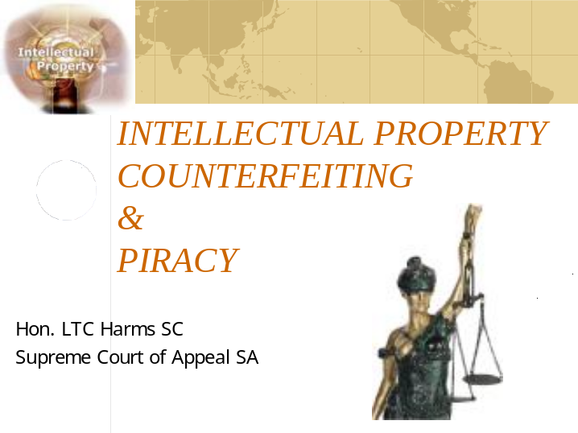

Slide 2
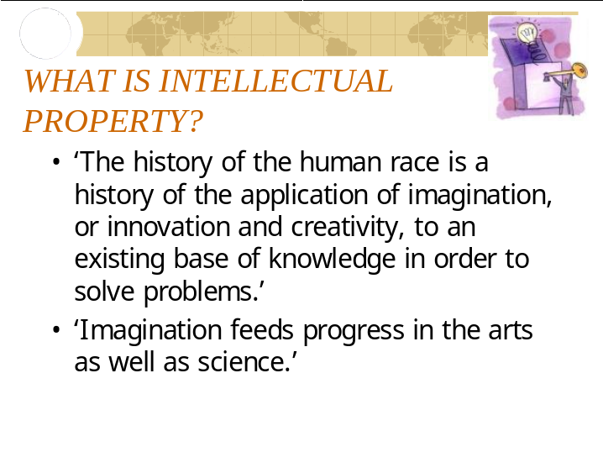

Slide 3
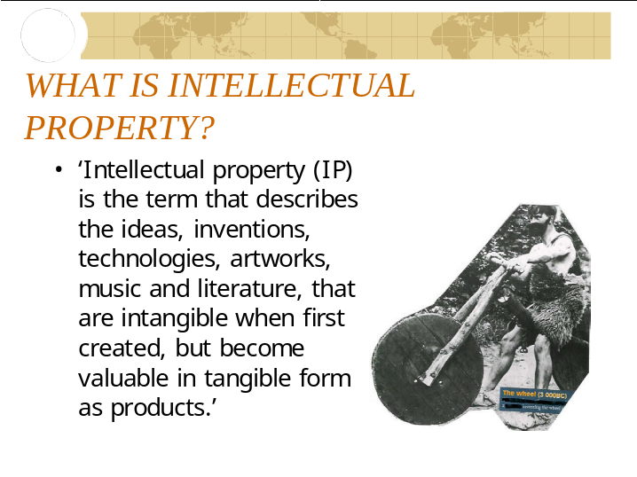

Slide 4
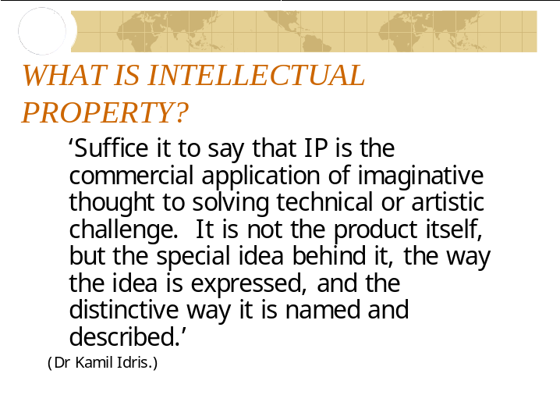

Slide 5
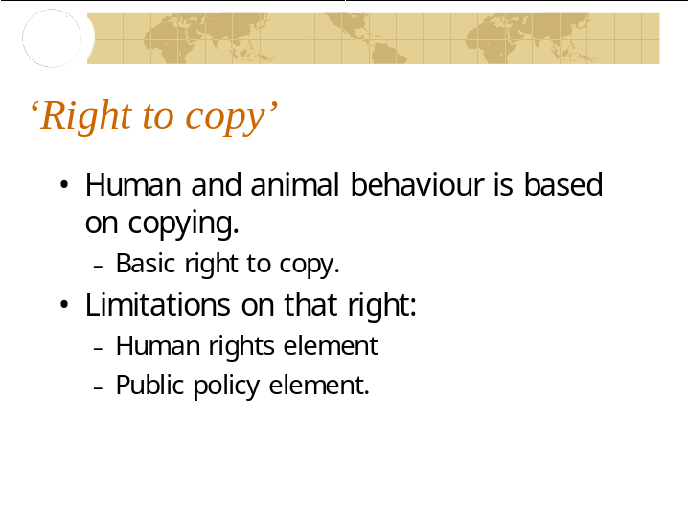

Slide 6
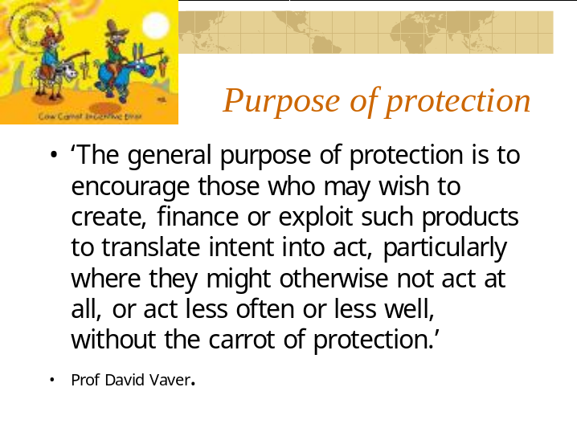

Slide 7
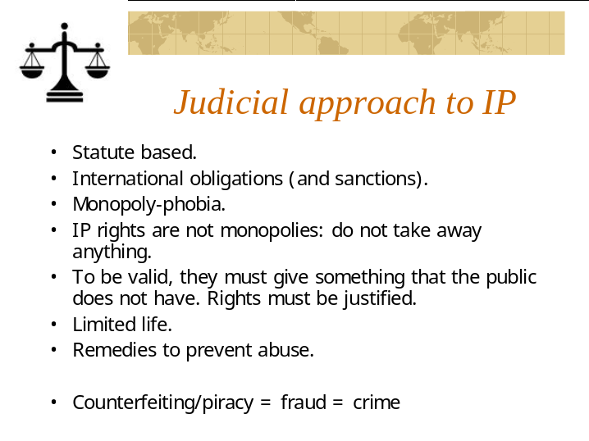

Slide 8
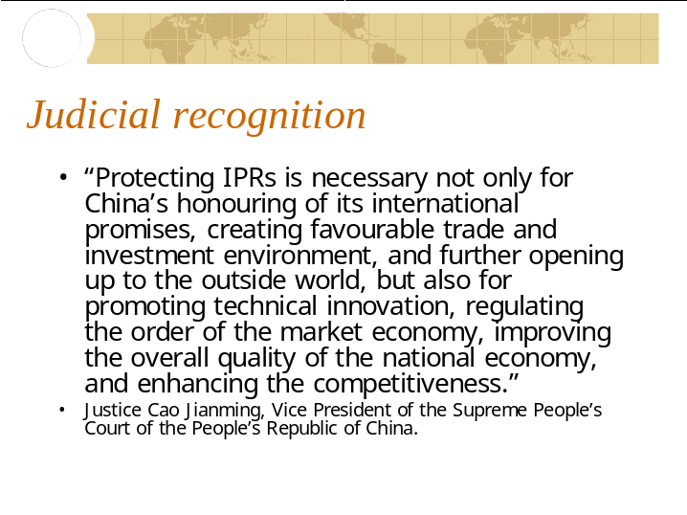

Slide 9
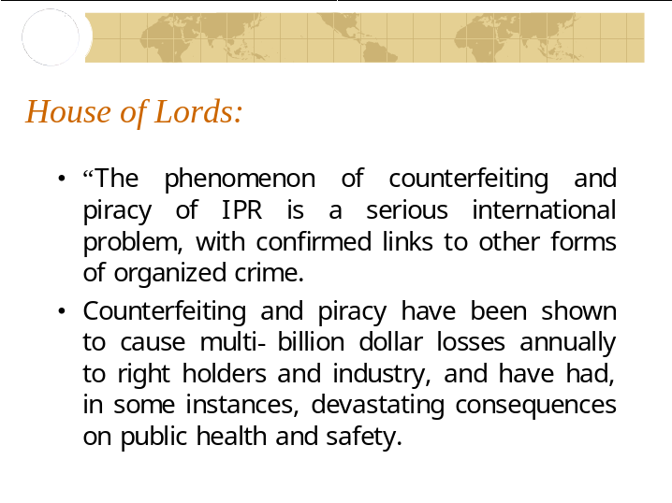

Slide 10
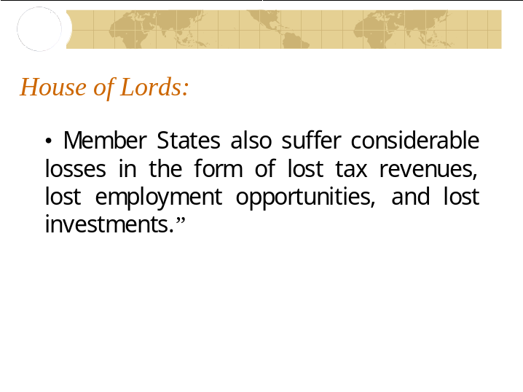

Slide 11
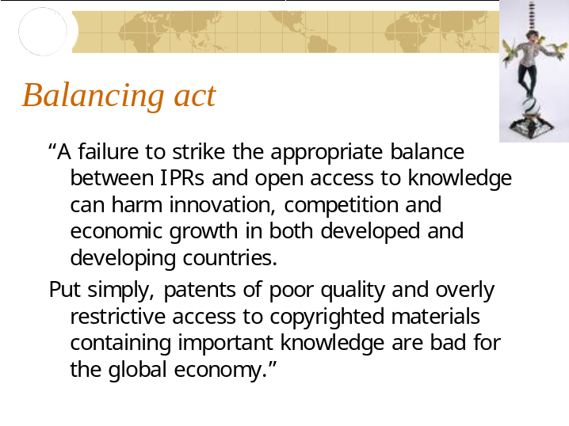

Slide 12
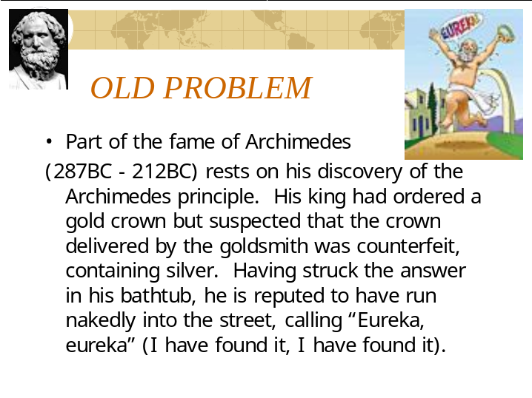

Slide 13
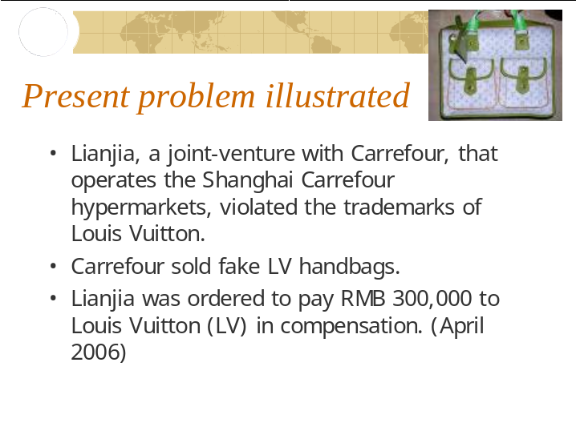

Slide 14
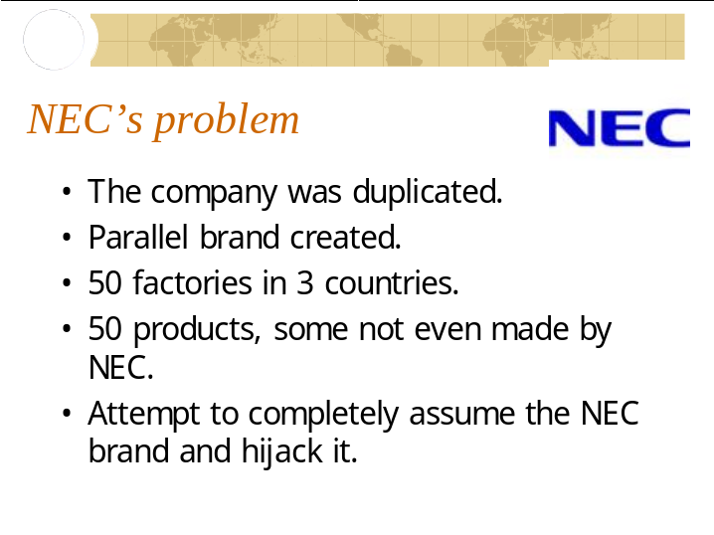

Slide 15


Slide 16
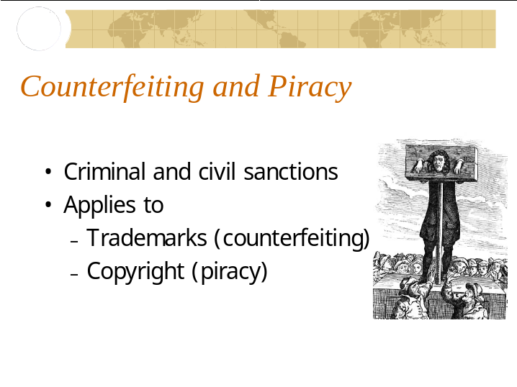

Slide 17
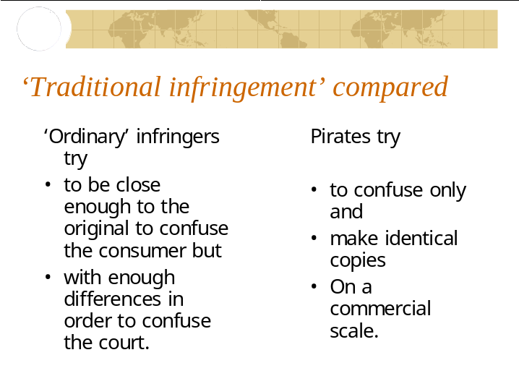

Slide 18
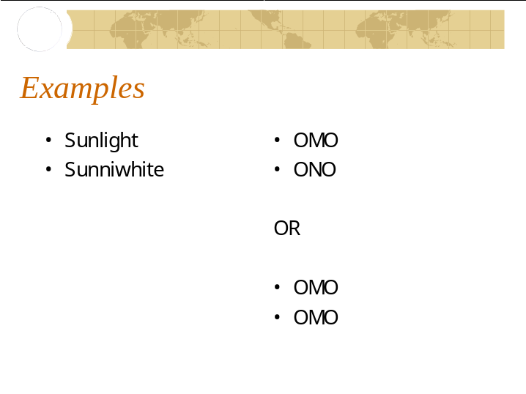

Slide 19
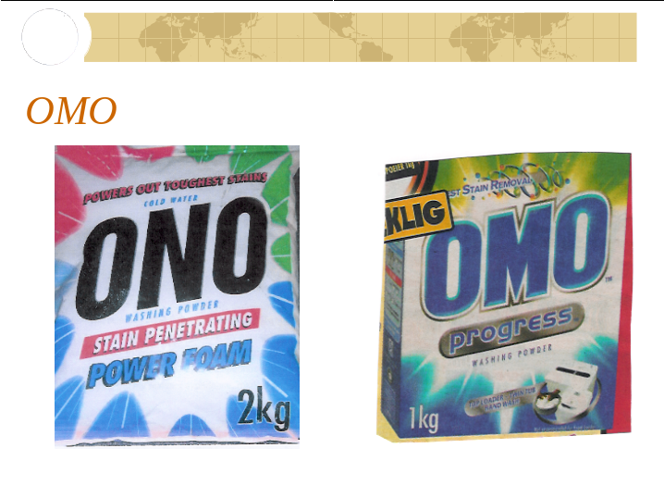

Slide 20
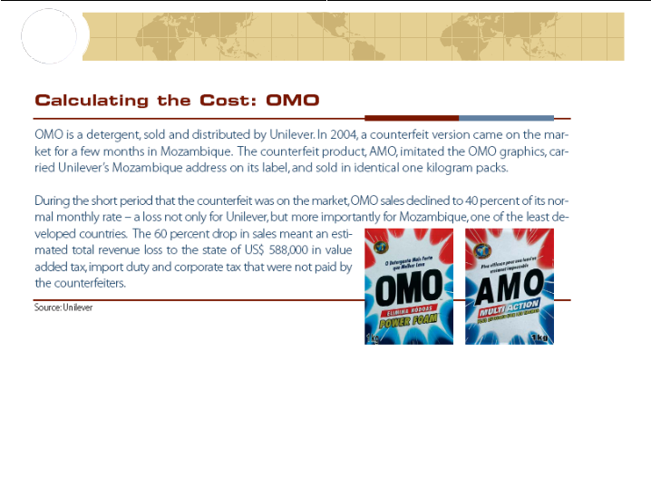

Slide 21
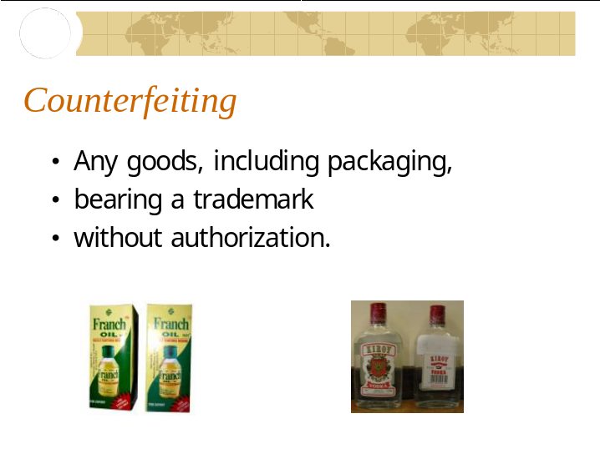

Slide 22
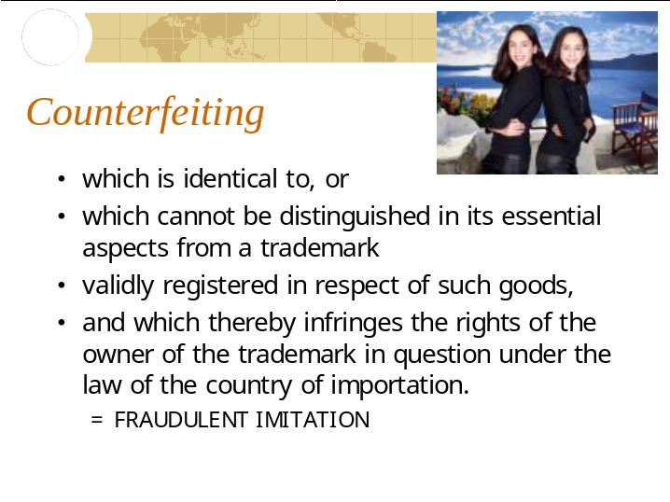

Slide 23
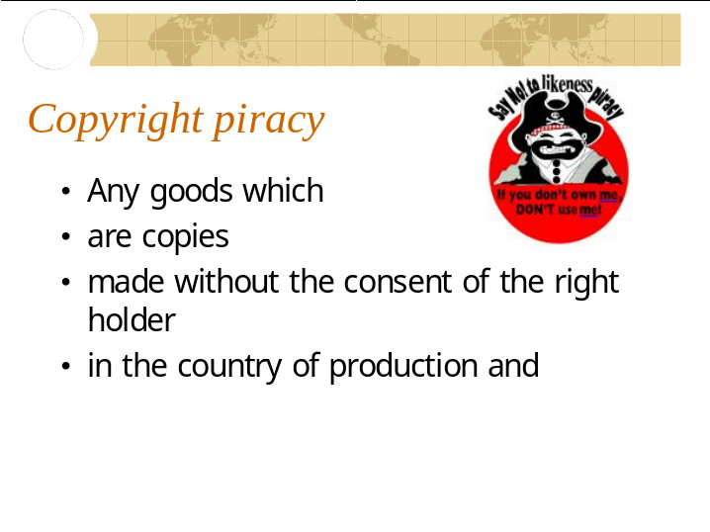

Slide 24
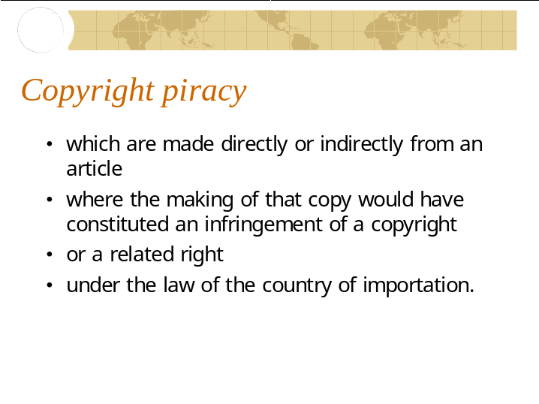

Slide 25
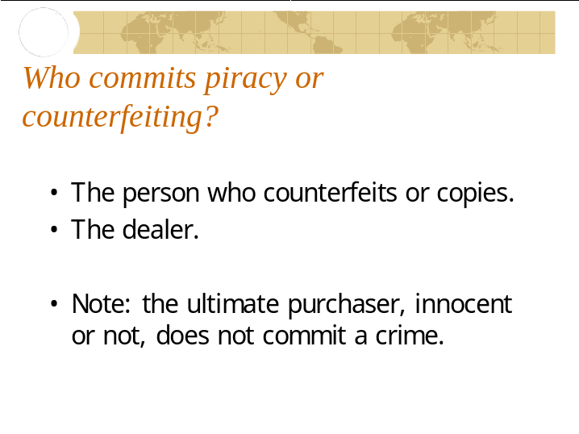

Slide 26
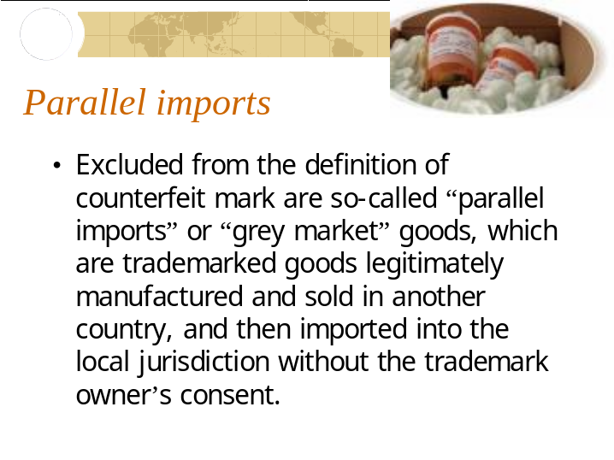

Slide 27
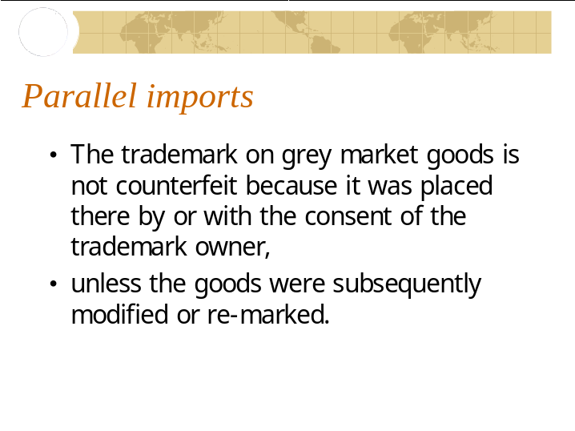

Slide 28
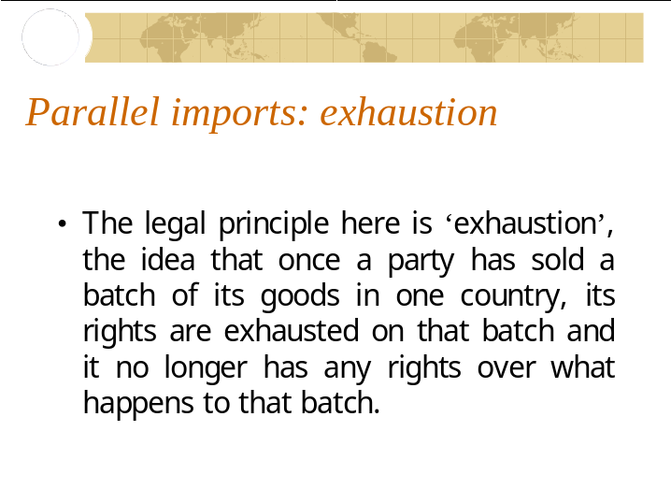

Slide 29
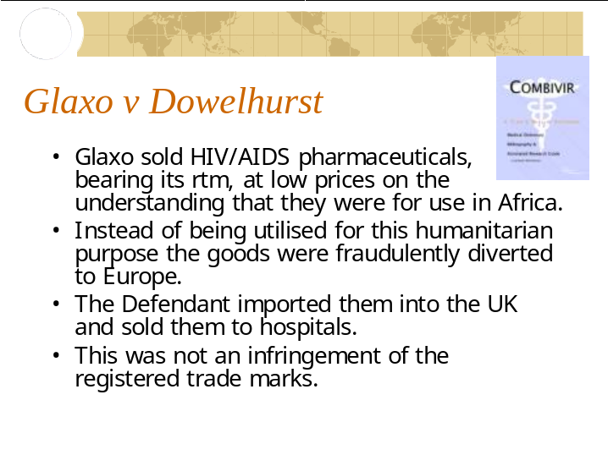

Slide 30
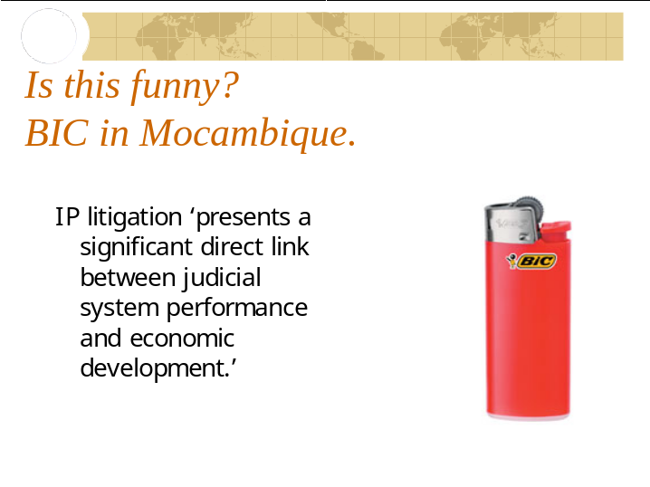

Slide 31
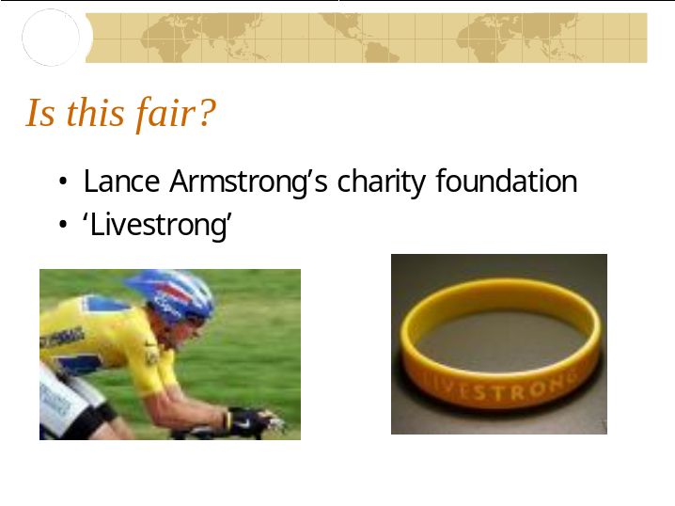

Slide 32
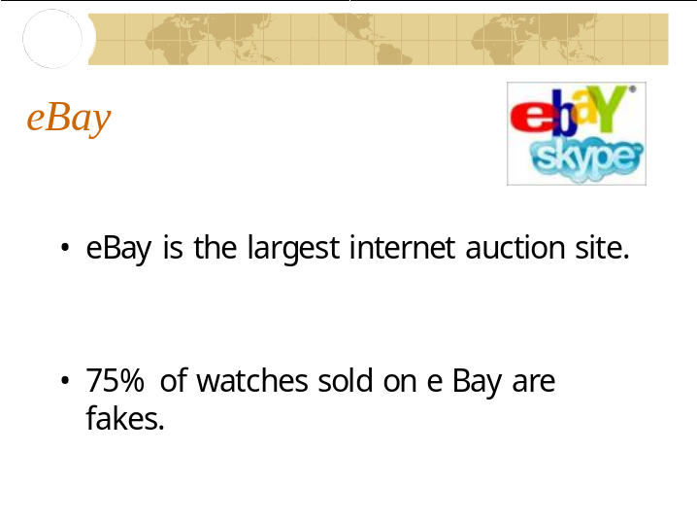

Slide 33
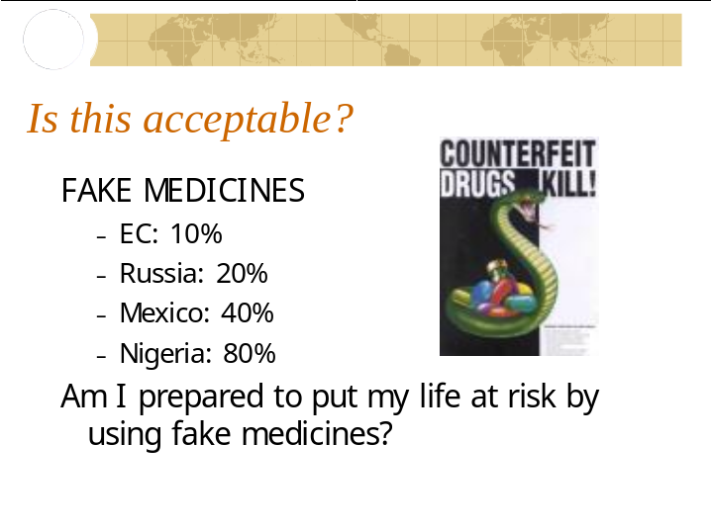

Slide 34


Slide 35


Slide 36
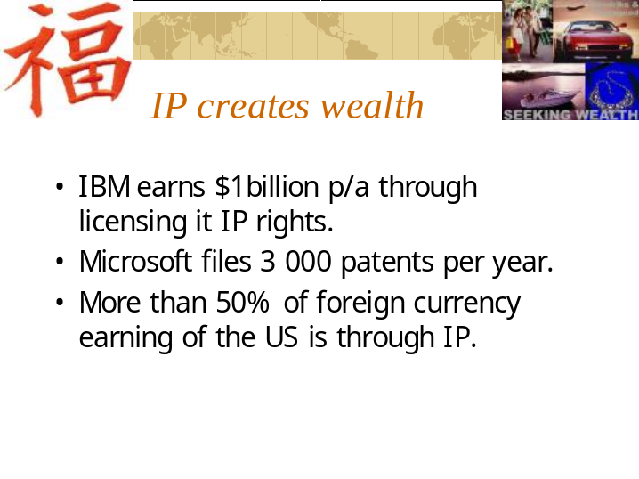

Slide 37
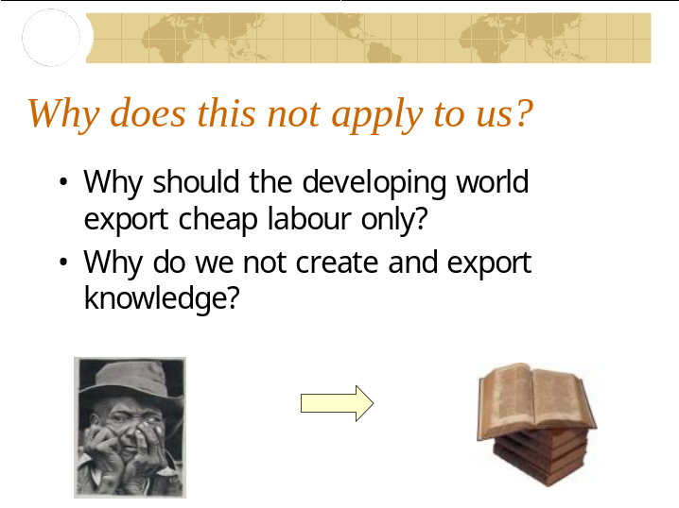

Slide 38
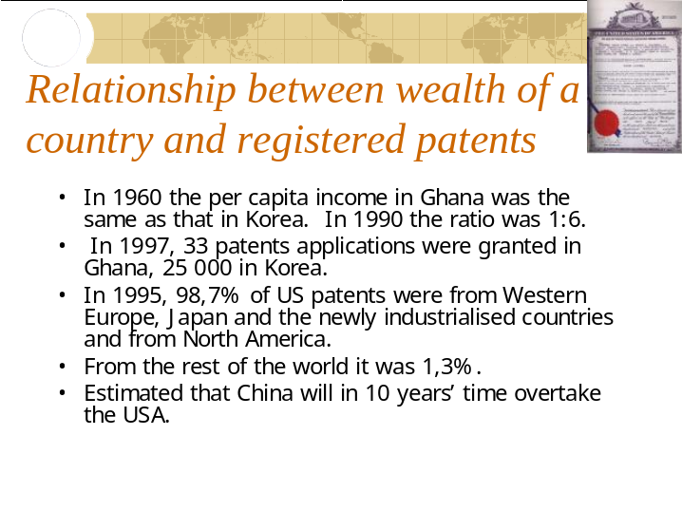

Slide 39
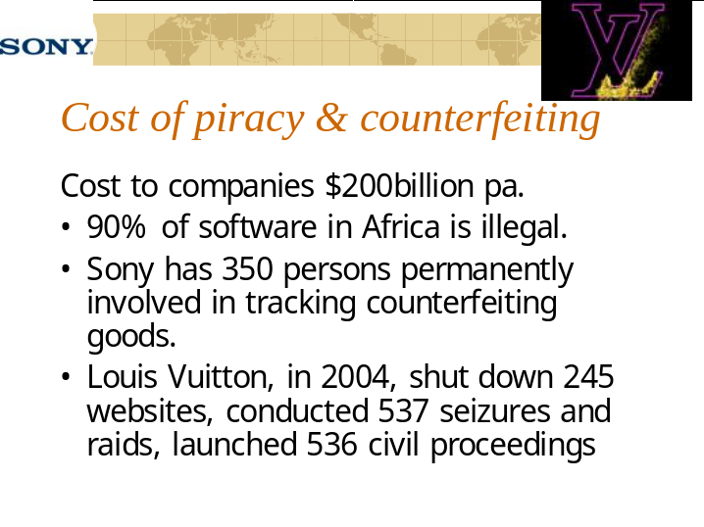

Slide 40
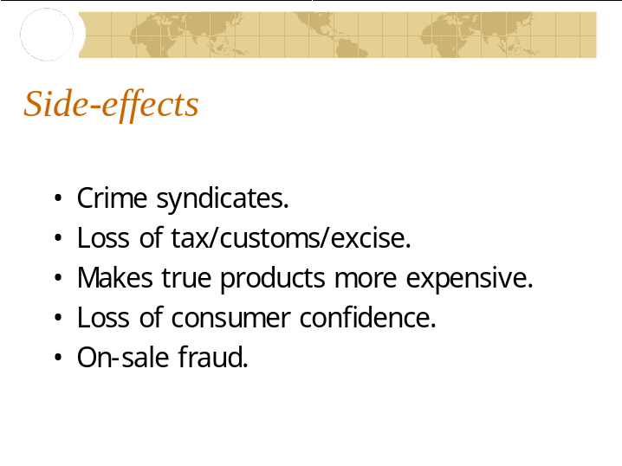

Slide 41
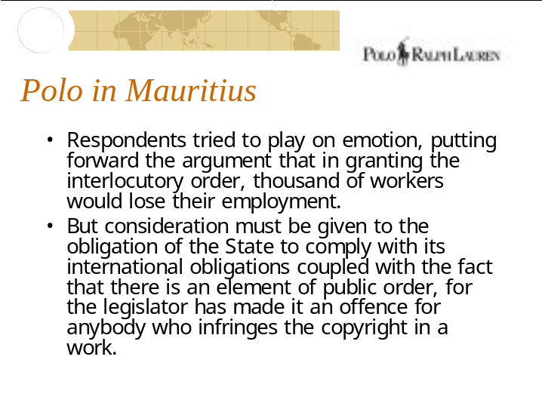

Slide 42
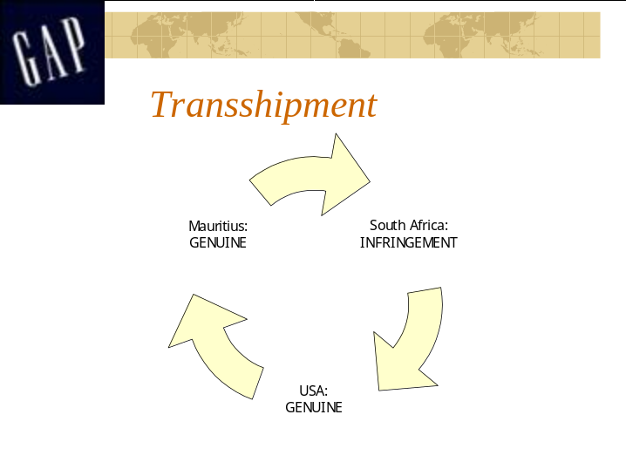

Slide 43
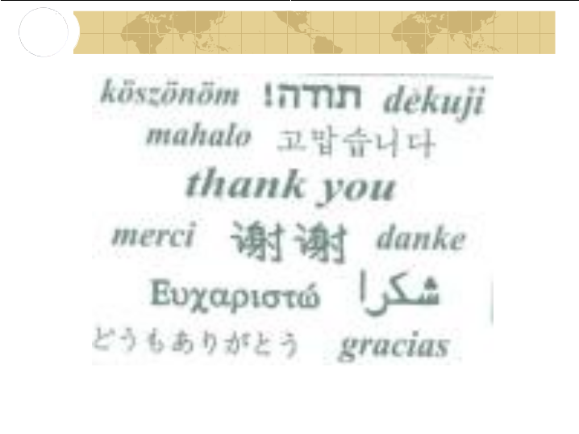

[End of Document]

