E
WIPO/IP/BRI/01/1
ORIGINAL: English
DATE: May 3, 2001
 | 
GOVERNMENT OF  BARBADOS | WORLD INTELLECTUAL  PROPERTY ORGANIZATION
wipo EXPERT group MEETING ON the AUTOMATION of the intellectual property offices of the CARIBBEAN COUNTRIES
organized by
the World Intellectual Property Organization (WIPO)
in cooperation with
the Ministry of Industry and International Business of Barbados
Bridgetown, May 2 and 3, 2001
FINAL REPORT
Adopted by the Meeting

WIPO/IP/BRI/01/1

CONTENTS

I. INTRODUCTION

II. PARTICIPANTS

III. OPENING OF MEETING AND AGENDA

IV. WIPO’S WORK IN THE FIELD OF INTELLECTUAL PROPERTY OFFICE AUTOMATION

V. OVERVIEW AND DISCUSSION OF DRAFT PROTOTYPE

VI. RECOMMENDATIONS

VII. DISCUSSION OF THE DRAFT REPORT OF THE MEETING AND ADOPTION OF RECOMMENDATIONS

VIII. CLOSING OF THE MEETING

ANNEX I. LIST OF PARTICIPANTS

ANNEX II. AGENDA

ANEXE III WORLD INTELLECTUAL PROPERTY ORGANIZATION PROPOSED IP SYSTEM FOR THE CARIBBEAN OFFICES

I. INTRODUCTION

1. During the Ministerial level Meeting held in St. Lucia in October, 2000, a Resolution on the Automation of Intellectual Property Offices (IPO’s) of the Caribbean countries was adopted. This Resolution called for the launching of a regional information system development project in the field of automation of the IPO’s of Caribbean countries. For this purpose, the Ministers further resolved that a small group of Caribbean experts with appropriate skills be formed to work closely with WIPO in the design of the system; and that WIPO secure funding to facilitate the work of this group.

2. In order to meet this request, WIPO convened and organized a two (2) day meeting of the Expert Group on the Automation of the Intellectual Property Offices of the Caribbean Countries. The meeting took place in Bridgetown, Barbados on May 2 and 3, 2001. The meeting was organized by WIPO in cooperation with the Government of Barbados.

3. The purpose of this Experts meeting was to discuss the basic functionalities of a new intellectual property automated system to be developed for Caribbean IPO’s, the development tools to be used in its design, and to formulate recommendations on the overall strategy for design, development, installation and training in the use of the system.

II. PARTICIPANTS

4. The Meeting was attended by four (4) industrial property and automation experts from four (4) Caribbean countries, namely, Barbados, Jamaica, Saint Lucia, and Trinidad and Tobago and was serviced by four (4) WIPO officials and consultants. A number of information technology experts specially invited by the Government of Barbados also attended the meeting. The list of participants is attached hereto as “Annex 1.”

III. OPENING OF MEETING AND AGENDA

5. After the introductions and opening remarks by Mrs. Maureen Crane-Scott, Registrar of the Corporate Affairs and Intellectual Property Office on behalf of the Government of Barbados and Mr. Alejandro Roca Campana, Director-Advisor, Development Cooperation Bureau for Latin America and the Caribbean on behalf of WIPO, the meeting adopted the Draft Agenda prepared by the International Bureau. A copy of the Agenda adopted for the meeting is attached to this Report as “Annex II.”

IV. WIPO’S WORK IN THE FIELD OF INTELLECTUAL PROPERTY OFFICE AUTOMATION

6. Mr. Alejandro Roca Campana briefed the participants on the work being conducted by WIPO in the field of intellectual property office automation, including a progress report on the WIPONET Project and the Intellectual Property Digital Libraries (IPDL) Project.

7. Mr. Jorge Zarate, a WIPO Consultant on automation for Latin America and Caribbean countries, presented the current status of automation in the Caribbean region from WIPO’s perspective.
V. OVERVIEW AND DISCUSSION OF DRAFT PROTOTYPE

- Mr. Alberto Bossio, a WIPO Consultant gave a detailed presentation of the draft prototype of basic functionalities for a new intellectual property automated system for Caribbean countries. The presentation was made using Powerpoint tools and was conducted in an interactive manner with the presenter responding to queries from participants. The presentation included an overview of the draft prototype (document prepared by WIPO attached as Annex III) including the functionalities, the technical characteristics, installation, training and post-installation support.

9. The proposed system will allow the recording of all relevant information concerning trademark applications and the related user documents, and allow the user to perform bibliographic, phonetic and figurative searches. Official documents and the journal will be produced during the process. The system makes provision for the access to the trademark database by external users via Internet. Extensive customisation features will involve the provision of a single core containing common functionality shared by all IPOs, while permitting the interface and outputs to be configured to meet local legal and administrative needs or uses. This “one system, many faces” approach will maximise the benefits of sharing new or improved functionality, while offering a customised interface.

10. The participants commended WIPO for the work which had begun on development of the prototype and made a number of recommendations for enhancing the functionality of the prototype in order to (a) facilitate data capture by IPOs of information concerning intellectual property applications; (b) enable Caribbean IPOs to provide modern IP-related services to end-users, taking into account the use of new information technologies and (c) meet the legal and procedural requirements of individual IPOs.

VI. RECOMMENDATIONS

11. The participants expressed general acceptance of the draft prototype as presented and adopted the following recommendations:

(a) Recommendations for enhancing the functionality of the Proposed System:

- That WIPO, in the bibliographic search, develop a new query option to enable a search to be performed using a list of filing numbers, as well as the Boolean operator “or”;

- That WIPO include in the search options, a filter for trade mark searches by a list of Nice classes;

- That WIPO develop and deliver with the system an additional module for use by trade mark agents or applicants which would facilitate the data capture by IPOs of information concerning trade mark applications and other user documents. This module should provide the option of submitting the information either on computer diskettes or via e-mail, but will not replace the existing system of filing paper applications;

- That WIPO should extend the module for Agents so that new user documents defined by the Office can be accommodated;

- That WIPO should develop in a second phase a “Pre-Filing” module, which would enable the pre-capture of information via the Internet. This module would involve the IPOs making their application forms available on a website where the forms could be filled out online, a pre-filing number generated and the application forms printed;

- That WIPO should extend the “User documents” module to enable any total payments received by IPOs and referable to multiple files to be associated with individual files;

- That WIPO should extend the system to support associated marks and divisional applications. The modification in relation to divisional applications will be done in a second phase.

- That WIPO should further develop in a second phase the Patent Module of the proposed system and that a small group of Caribbean experts with appropriate skills be formed to work closely with WIPO in the design of those modules and that WIPO secure funding to facilitate the work of this group.

(b) Recommendations on the Work Programme and Schedule for development, testing, installation and training in the use of the new system:

- That WIPO should prepare and send to all the IPOs the specifications of the hardware and software requirements needed to operate the new system;

- That by the end of May, 2001, WIPO provide an Excel spreadsheet for use by IPOs in the Caribbean with no trademark databases in order to facilitate the process of data entry. This would enable data entry to commence ahead of the installation of the new system;

- That the first version of the new system in the form of a CD-ROM, containing a demo version of the system be made available to the four pilot IPOs by the end of July, 2001, together with a questionnaire designed to identify customisation requirements;

- That the same questionnaire be provided to the other Caribbean IPOs by the end of July, 2001;

- That by the end of August, 2001, feedback in the form of completed questionnaires from the four pilot IPOs and if possible, also from the other countries, be forwarded to WIPO for analysis;

- That individual configurations for each pilot IPO be completed by WIPO by the end of September, 2001;

- That installation in one of the pilot IPOs take place during October 2001, under the supervision of WIPO. Installation will involve the migration of existing trademark databases into the new system, testing the adequacy of the installation instructions prepared by WIPO, training and the active use of the system by the IPO;

- That depending on the outcome of the pilot installation, WIPO organise and facilitate a training session/s to be held at the regional level for a minimum of one week. Any training should take place if possible before the end of 2001 to facilitate installations taking place in other IPOs during this period.

- That the second phase commence as soon as possible in 2002.

VII. DISCUSSION OF THE DRAFT REPORT OF THE MEETING AND ADOPTION OF RECOMMENDATIONS

12. The draft Report and the recommendations were discussed and adopted by the meeting.

VIII. CLOSING OF THE MEETING

13. The Registrar thanked WIPO for hosting the meeting and looked forward to the implementation of the work plan. All the participants and WIPO expressed their gratitude to the Government of Barbados for the excellent hospitality and arrangements made for the hosting of the meeting.

[Annex I follows]

ANNEX I

LIST OF PARTICIPANTS

I. GOVERNMENT EXPERTS

BARBADOS

Maureen CRANE-SCOTT (Mrs.), Registrar, Corporate Affairs and Intellectual Property Office (CAIPO), Bridgetown (Email Address: caipo@caribsurf.com)

Chris BIRCH, Deputy Registrar, Corporate Affairs and Intellectual Property Office (CAIPO), Bridgetown (Email Address: bajancopyright@hotmail.com)

Kenneth FORDE, Systems Analyst, Corporate Affairs and Intellectual Property Office (CAIPO), Bridgetown (Email Address: caipo@sunbeach.net)

Reneé WOOD (Mrs.), Corporate Affairs and Intellectual Property Office (CAIPO), Bridgetown (Email Address: red_volcano@yahoo.com)

Suzette CUMBERBATCH (Ms.), Corporate Affairs and Intellectual Property Office (CAIPO), Bridgetown (Email Address: c_suzette@hotmail.com)

Chester COPPIN, Systems Administrator, Ministry of Industry and International Business, Bridgetown (Email Address: chesterfield_coppin@Barbadosbusiness.gov.bb)

Olvin HAREWOOD, Government of Barbados “Smart Stream” Information Technology Advisor, Ministry of Finance, Bridgetown (Email Address: harewoodo@gob.bb)

Nicholas ROCK, Systems Administrator, National Insurance Department, Bridgetown (Email Address: nis-mis@caribsurf.com)

JAMAICA

Jason WONGSAM, Intellectual Property Systems Supervisor, Jamaica Intellectual Property Office (JIPO), Kingston (Email Address: jasonmark526@yahoo.com)

SAINT LUCIA

Kimberley CENAC-PHULGENCE (Mrs.), Registrar of Companies and Intellectual Property, Castries (Email Address: rocip@candw.lc) or (rocip2@hotmail.com)

TRINIDAD AND TOBAGO

Anne Marie JOSEPH (Ms.), Deputy Controller of Intellectual Property, Port of Spain (Email Address: omed.joseph@ipo.gov.tt) or (omedj@hotmail.com)

II. INTERNATIONAL BUREAU OF THE WORLD INTELLECTUAL PROPERTY ORGANIZATION (WIPO)

Alejandro ROCA CAMPANA, Director Advisor, Cooperation for Development Bureau for Latin America and the Caribbean (Email Address: alejandro.roca@wipo.int)

Jorge ZARATE, WIPO Consultant on Automation (Email Address: jorge.zarate@wipo.int)

Luis Alberto BOSSIO, WIPO Consultant on Automation (Email Address: abossio@adinet.com.uy)

Laura A. PENDLETON (Mrs.), Freelance, Advisor in the field of interface design and documentation (Email Address: pendleto@internet.com.uy)

[Annex II follows]

ANNEX II

EXPERT MEETING ON AUTOMATION FOR CARIBBEAN COUNTRIES

Bridgetown, Barbados, May 2 and 3, 2001

AGENDA

1. Opening.

2. WIPO’s work in the field of intellectual property office automation.

3. Present status on the development of automated systems in the Caribbean region.

4. Draft prototype of basic functionalities for a new intellectual property automated system for Caribbean countries.

5. Discussions on basic functionalities, design and development strategy of the new intellectual property automated system for Caribbean countries .

6. Recommendations on the work program and schedule for the design, development, installation and training in the use of the new System in the Intellectual Property Offices of the Caribbean countries.

7. Adoption of the Report.

8. Closing Remarks.

[Annex III follows]

ANNEX III

WORLD INTELLECTUAL PROPERTY ORGANIZATION
PROPOSED IP SYSTEM FOR THE CARIBBEAN OFFICES

CONTENTS

1. INTRODUCTION

2. TRADEMARKS SYSTEM FUNCTIONALITY

2.1. GENERAL FEATURES
2.2. TRADEMARKS DATABASE
2.3. MARKS SIMILARITY SEARCH
2.4. FILE TRACKING
2.5. USER DOCUMENTS
2.6. DATA CAPTURE CONTROL
2.7. PROCESS TRACKING
2.8. PRINTING OF OFFICE DOCUMENTS
2.9. JOURNAL PUBLISHING
2.10. ACCES CONTROL AND AUDITING
2.11. INTERNET ACCESS FOR EXTERNAL USERS
2.12. STATISTICS

3. TECHNICAL CHARACTERISTICS

4. INSTALLATION

4.1. INITIAL DATA LOADING
4.2. BASE SOFTWARE INSTALLATION
4.3. SYSTEM INSTALLATION AND CONFIGURATION
4.4. LEARNING HOW TO USE THE SYSTEM

5. POST-INSTALLATION SUPPORT

6. PATENTS SYSTEM FUNCTIONALITY

6.1. PATENTS DATABASE
6.2. PATENT SEARCH
6.3. COMMON FUNCTIONALITY

1. INTRODUCTION

Development of ad-hoc trademarks and patent system for the Caribbean IP offices.

Will show a prototype depicting key aspects of functionality. In order to gain understanding of administrative processes, laws from Trinidad and Tobago and Dominica were used as a guide.

Presentation highlights:
- functionality: what the system does (can be extended to support local needs).
- technical characteristics: nuts and bolts within the software.
- learning how to use the system: documentation and test environments.
- installation: how to start.
- post-installation support: once the system is up and running.

2. TRADEMARKS SYSTEM FUNCTIONALITY

The basic functionality of the system is described. Extensions to meet local needs can be made.

2.1. General features

Some features apply to all modules:

- Use of Microsoft’s MDI (Multiple Document Interface as featured in Microsoft Word or Excel) which allows multiple windows to be in use at the same time and switching between them by means of the “Windows” menu

- Windows size and location can be adjusted by the user. The system will remember these settings.

- Broad use of lookup and zoom-in buttons so that there is no need to memorise any codes.

- Online help.

- Customisation of terms for each office: the use of local terms to identify specific concepts eases the learning process and minimises comprehension difficulties. To enable customising, the system will be built around a “dictionary” concept that will allow any term in any window to be adjusted to local practices: one system, many faces. E.g. in some countries the term “journal” is used, while in others “gazette” is used.

2.2. Trademarks database

Holds information concerning pending applications and registered trademarks. The main characteristics are:

- Bibliographic data search: by application number, application date, registration number, registration date, trademark name, applicant name, etc.

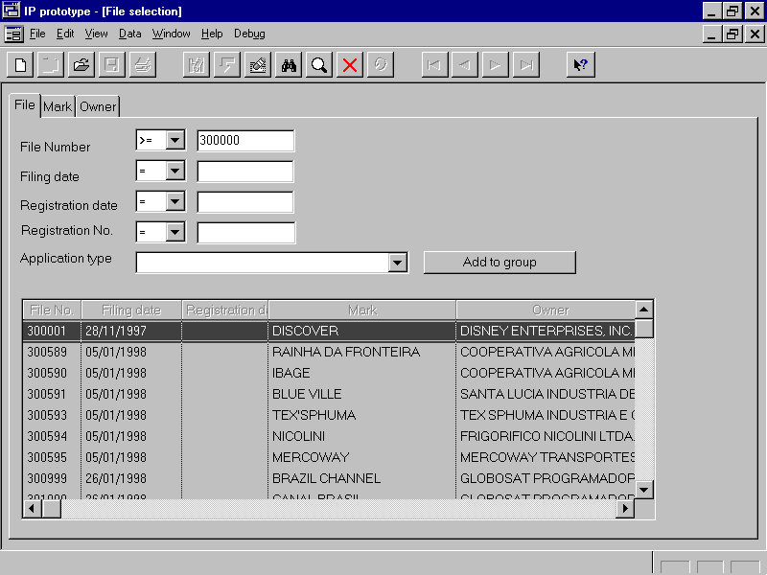
- Flexible file numbering, which builds the identification of a file by the combination of one or more of “file type”, “series”, “file number” and “origin”. This will allow the system to manage multiple numeration schemes, such as:

- a single numeration for all applications.
- a different numeration for each mark type (by using a different “file type” for each mark type).
- a different numeration for each law (by using a different “series” for each law).
- a different numeration for each year (using a different “series” for each year).
- a different numeration for each receiving office (using a different “origin” for each receiving office).
- repeated numbers to account for clerical mistakes (by using a special “origin” to identify those mistakes).
- a combination of any of the above.

- Other filing data: date, fees received, etc.

- Mark data: name; disclaimer; mark type (ordinary trade or service mark, certification mark, collective mark, trade name, etc.); colour logo (described by Vienna classes including a colour description); translation; sound marks can be played back if a multimedia kit is available.

- 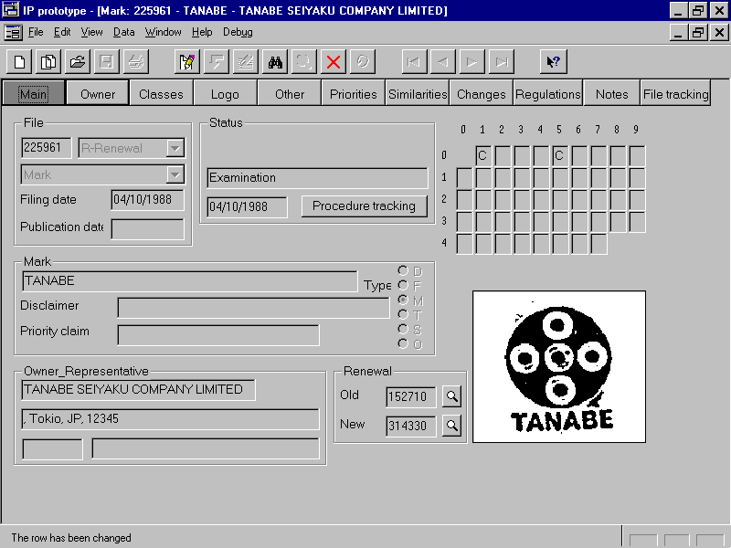Goods and services protected: several Nice classes including a detailed description of each; same support for national classes; some classes (or even parts of a single class) could be registered and others rejected.
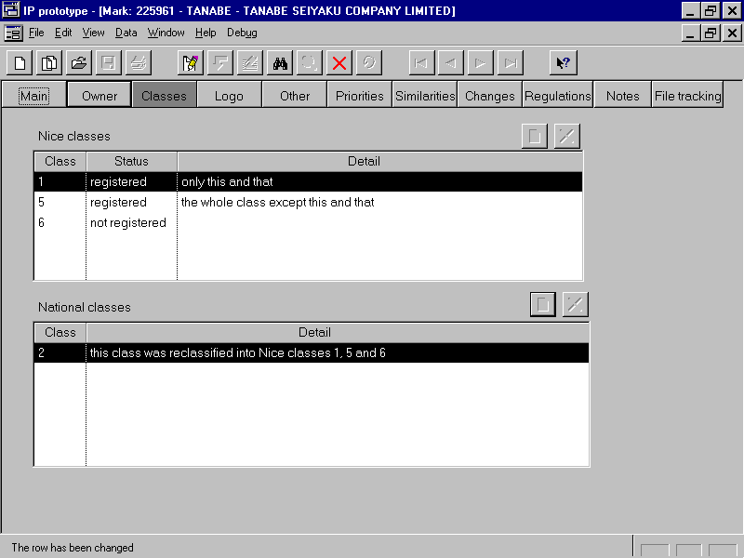
- Applicant/Owner: name (individual or a legal entity) and full address; support for joint applicants including details concerning how ownership of the trademark is shared

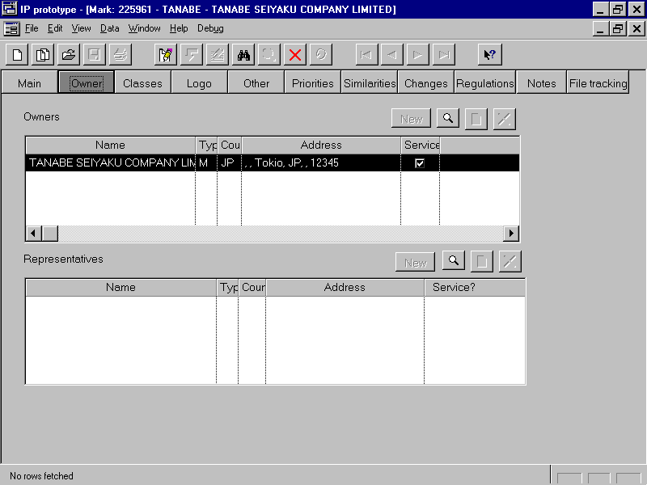

- Representative: agent code (if applicable), name and address of person given power of attorney by the applicant; list of all employees authorised by agent to act on his or her behalf.

- Priorities: country, identification and filing date; the user can accept or deny each one, system uses first accepted date as priority date.

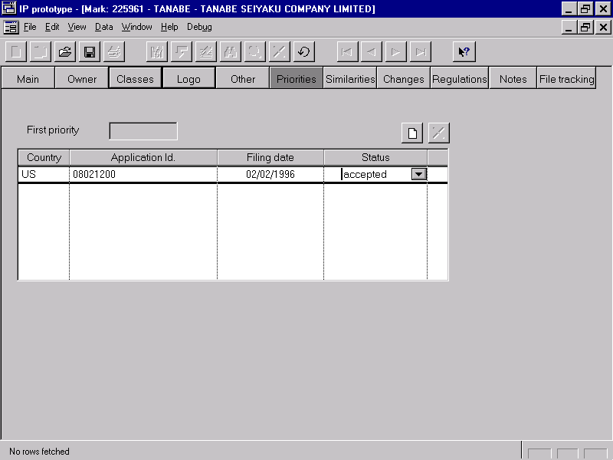
- Renewal: depending on the configuration, the file number can be the same as in the original application or a new number can be used. In the latter case, both files are linked.

- Status: present status, from date, due date (if applicable), user responsible (if applicable). In addition, access is available to a detailed screen showing a log of all actions taken by the office and all user documents received.

- Advertising: journal number and date are automatically assigned by the journal publishing module.

- File tracking: user who has the file in his or her possession at present and a log of the deliveries showing date, users and departments involved. This data is automatically assigned by the file tracking module.

- Trademarks Register: register number and entitlement, registration and expiration dates are automatically assigned by the process tracking module. The register number can be configured to be the same or different from application number.

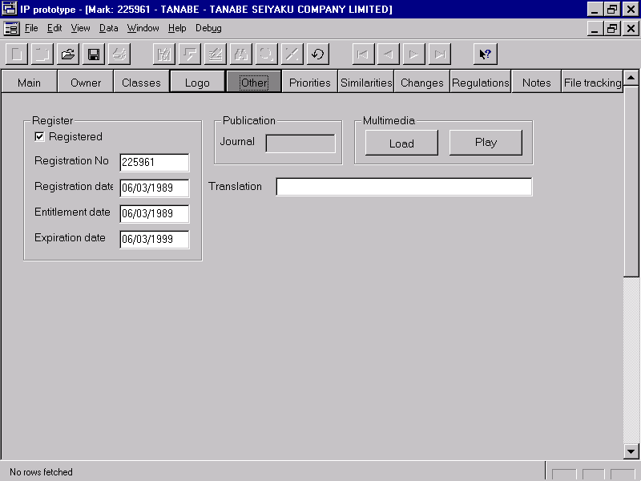

2.3. Marks similarity search

There are two tools used in searching for similarities:

- automatic similarity search.
- logo search.

Automatic similarity search uses an algorithm that computes an estimated similarity percentage between a new trademark and those already in the register. The search can be performed:

- in just the classes covered by the application.
- in all classes related to those covered, according to “sets of related classes” defined by each IP office.
- in all 42 classes.

There are several ways to perform similarity search:

- interactive search: the trademark and classes are captured on screen, and the results are shown on screen or printed.

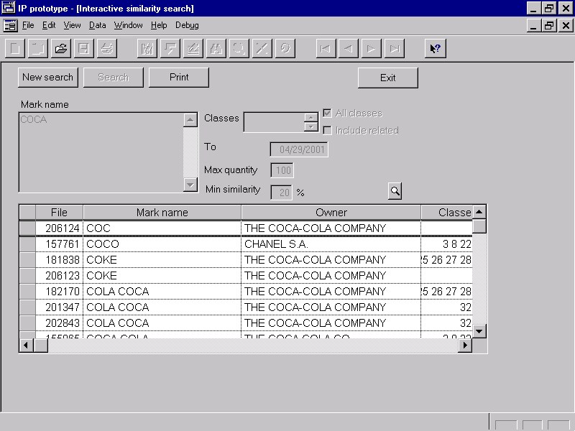

- preliminary search: the trademark and classes are captured following a preliminary search application, and the system prints a list of potential similarities.

- new applications search: all new applications within a range are searched for, and the results can be printed or stored in the database as prior trademarks for later analysis.

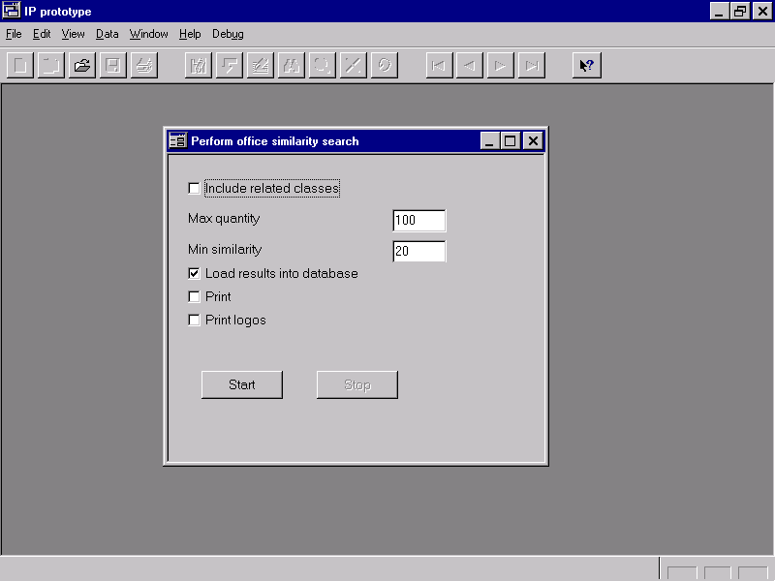

Logo search following the Vienna classes is also possible. By combining classes and logical operators AND/OR, results are shown on screen which allows the operator to visually analyse similarities and select relevant trademarks. There are two variations:
- interactive search, in which Vienna classes to be searched must be captured “on the fly”.

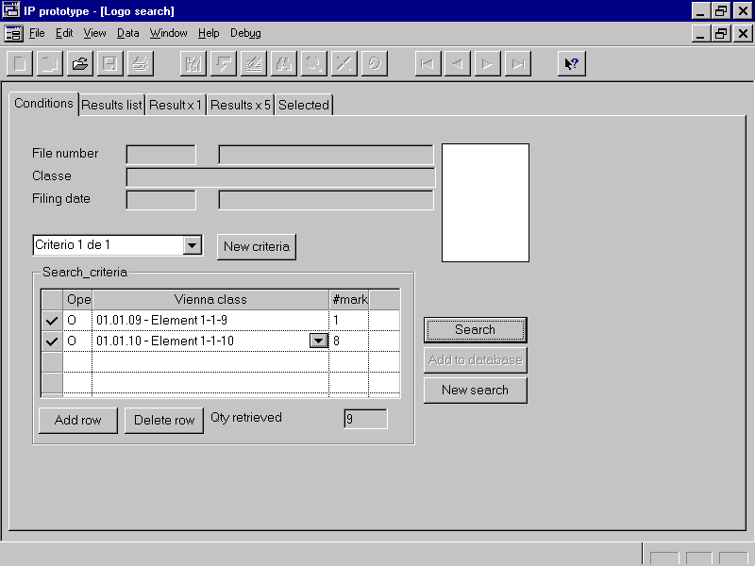

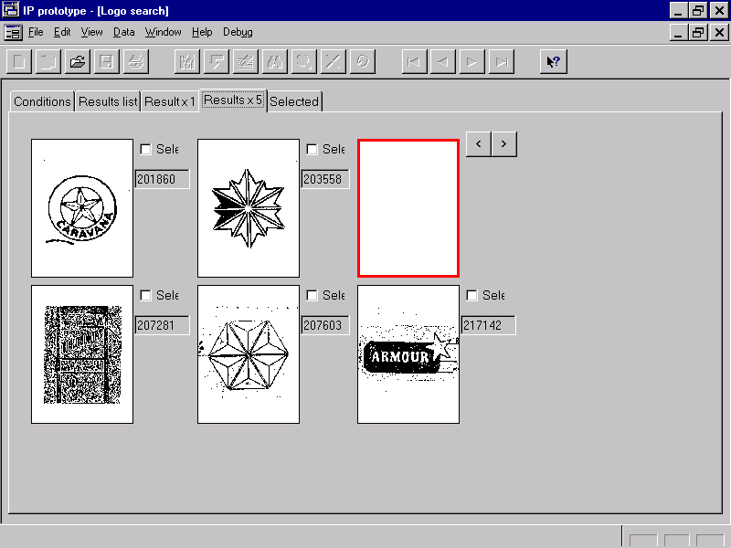
- new applications search, in which the file number to be searched must be captured, and the system reads the applicable Vienna classes from that application. In these cases, the selected applications will be stored within the database together with the prior trademarks.

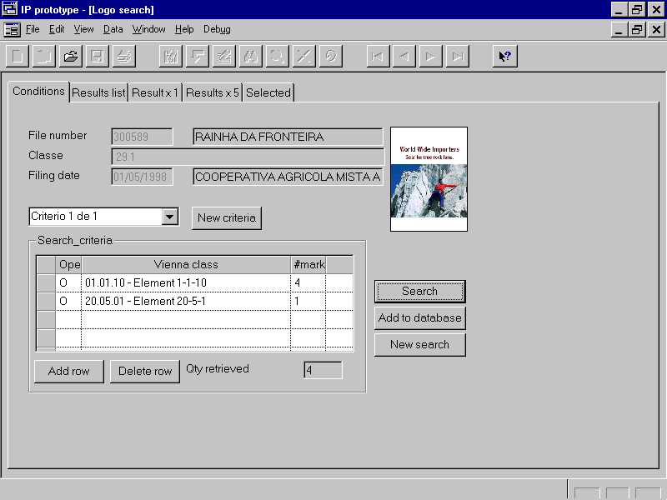
2.4. File tracking

Transfer of files between office members is made easier and tracked by:

- construction of a new delivery list, identifying the sending user, the receiving department (and optionally the receiving user within it), and the set of files involved. The list is in “print pending” status.

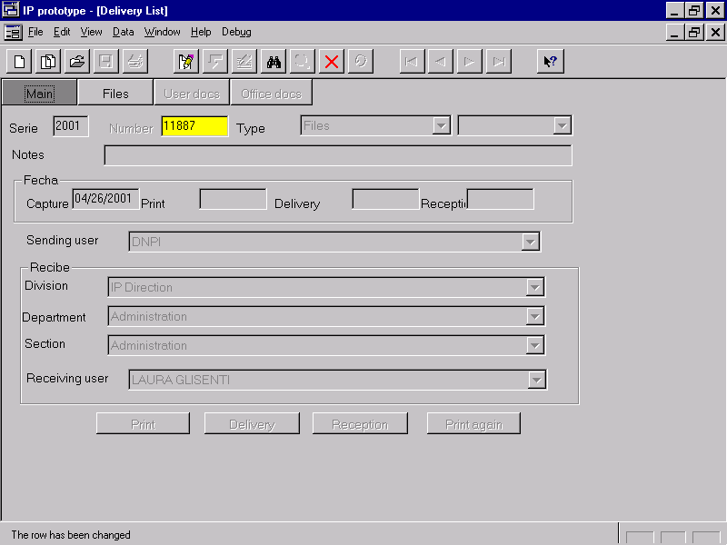
- printing of the lists (the sheet can be used as a cover of the file group). The list is in “delivery pending” status.

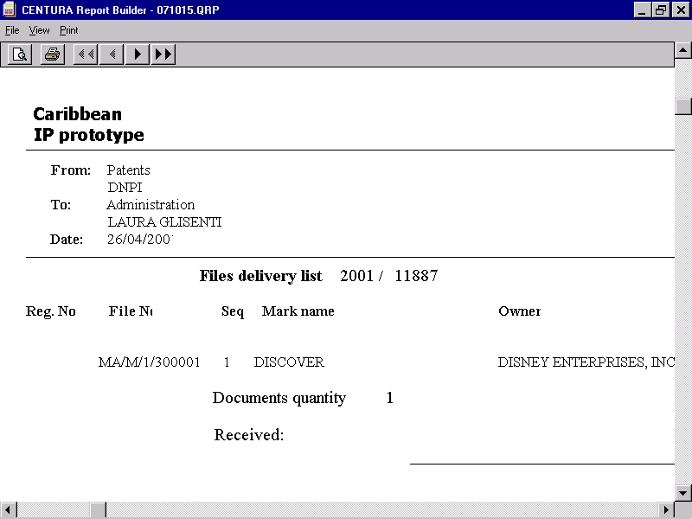

- during physical delivery, the recipient checks whether the list is complete. If any errors are found, the list is rejected and the sender builds a duplicate of it, corrects any errors, prints it and repeats delivery. When the list is OK, the recipient signs it.

- after physical delivery, the sending user stores the signed list and registers this action into the system. The list is in “reception pending” status.
- the receiving user registers this action into the system (the “Reception” button is only enabled if the “connected” user is the same as the “receiving” user, and thus this action deems acknowledgement by the receiving user). The list is in “delivered” status.

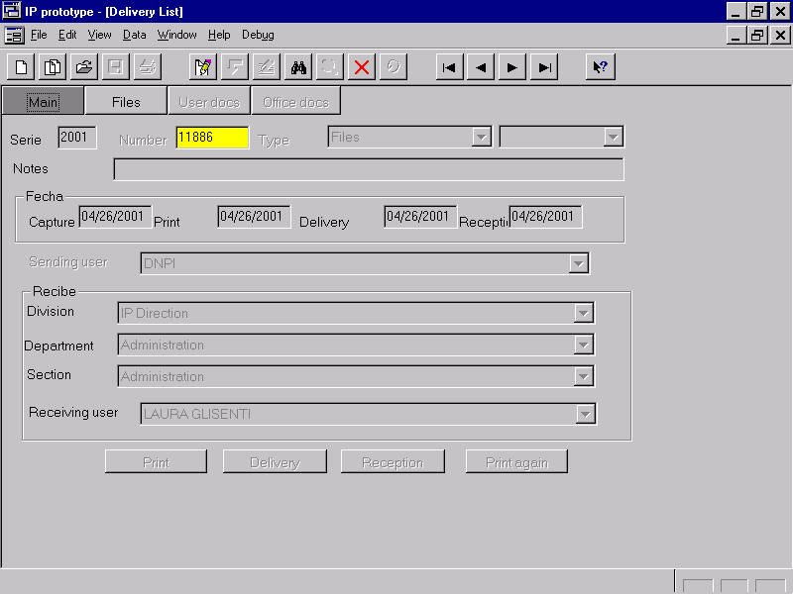

- the system automatically generates a delivery record in the file tracking log of each affected file.
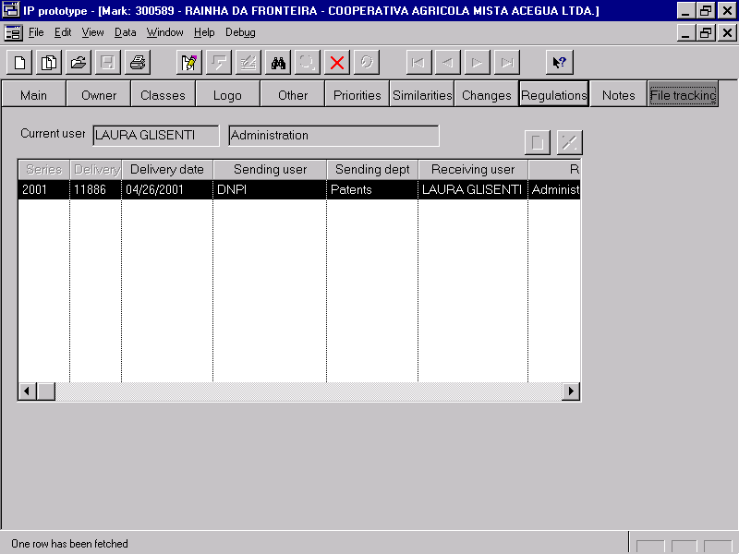

2.5. User documents

Once applications are filed, all user documents will be captured. A user document can be:

- related to one or more applications, thus affecting:
- a single file (e.g. a voluntary amendment).
- a set of files (e.g. an assignment of many registered trademarks).

- not related to applications (e.g. an information request from the Court, or an application of a new agent to be allowed to operate).

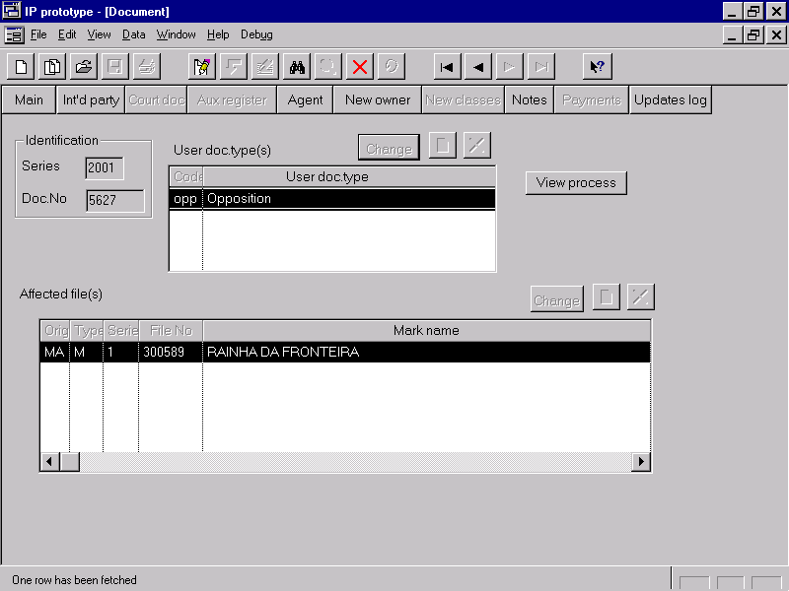

Depending on who presents the user document, they will be classified as:

- user documents filed by the applicant, e.g. voluntary amendments, replies to objections made during examination, counter statement of opposition, assignments, licenses, etc.
- user documents filed by third parties, e.g. oppositions to the registration, actions aimed at nullifying registrations, etc.
- user documents filed by legal authorities, e.g. Court orders.
New user document types are easily configured within the system.

All user documents related to a trademark are merged into the corresponding log of actions taken by the office.

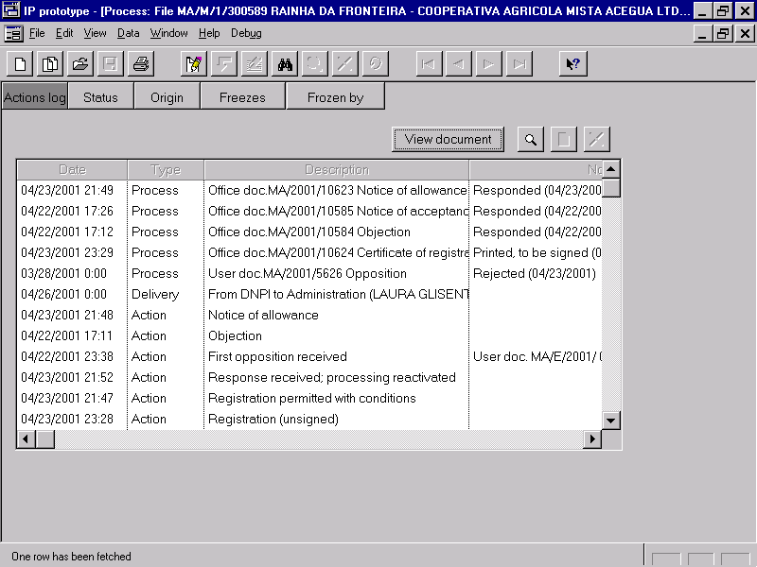

When a user document indicates a change in ownership, information concerning the new owner will be captured. Once the user document is accepted to be entered in the register, the system will automatically change the owner in the database for all marks affected.
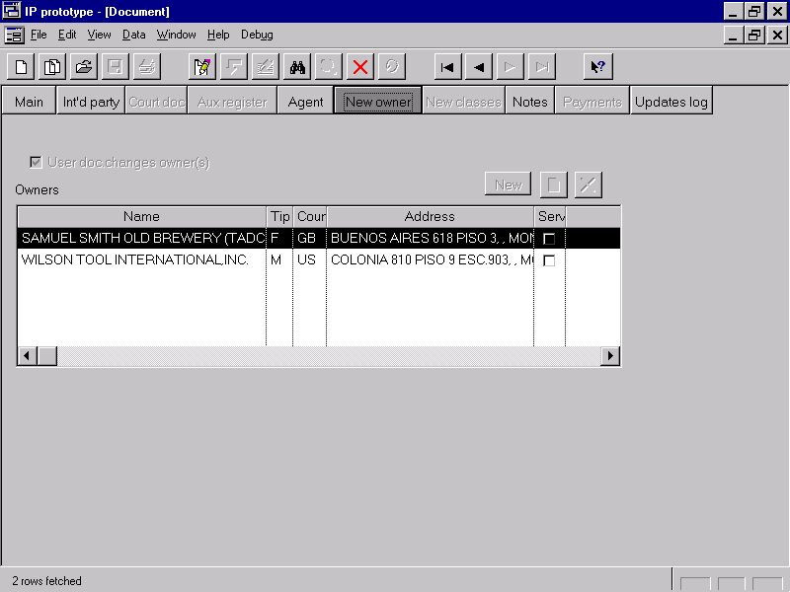

2.6. Data capture control

In order to assure that every application and user document received is captured into the system, a series of controls are available:

- daily input logs ease tracking by assigning a sequential number to both applications and user documents received.
- receipts can be printed for applications and user documents received, thus substituting electromechanical numbering machines.
- each daily input log will be opened and closed by the user, and the system automatically insures that only one daily input log is in use.
- once capture is complete, the user will initiate an “end of data capture” action in the daily input log. This causes the system to validate that every application and user document received during the day has been duly captured into the system (“no holes” guarantee).
- a similar control is used in the scanning of logos and the capture of Vienna classifications. The three controls (end of data capture, end of logo scanning and end of Vienna classification) are independent of each other which allows tracking processes assigned to different office members.

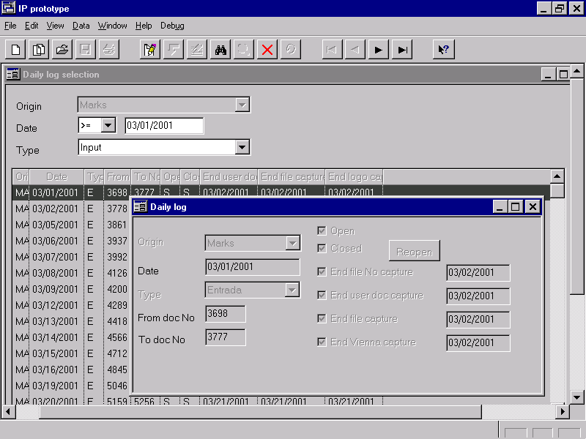

When all daily input log controls are completed, the system will assure that all applications and user documents received during the day are duly captured into the system, including the logos of trademarks and its Vienna classifications.

2.7. Process tracking

The system allows tracing of actions carried out by the office for each application and user document received, as follows:

- The structure of each process is defined by a state transition diagram, showing the succession of statuses and actions that produce changes in the current status (i.e. an action can only be taken if the process status so allows).

- Different process structures can be defined for each application type, e.g. trademarks could have a different process structure than names of origin. To ease definition of a single process structure for different application types, some actions can be configured so that they only apply to a particular law or to a particular kind of application.

- The system generates a process for each application, where all actions are recorded. A log of these actions can be shown, depicting how the process evolved over time and what is its current status.

- When entering an administrative action, the user can capture additional information through a set of fields and lists of previously coded options. For example, the system can be configured so that when entering an action of “administrative requests” type, the user can select one or several options that represent reasons for which requests are made. Each option will include a short text shown on the screen and a long text printed on the corresponding office document as mentioned below.

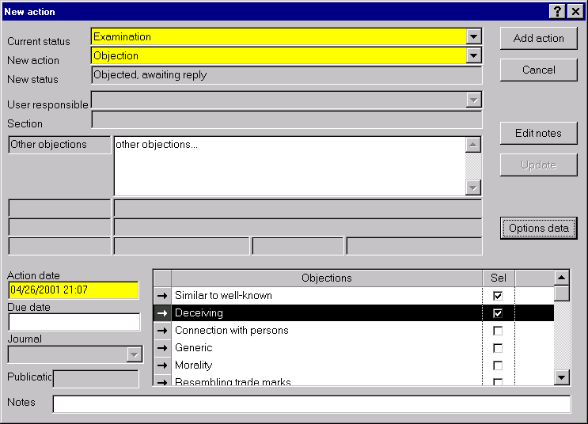

- Each status can have a due date which is calculated by the system using a specified base data (action date, notification date, application date, first priority date, etc.) and a quantity of working or calendar days or months. Non-working days are supported and due dates are calculated accordingly.

- To aid in automating certain sections of the processes, the system supports many automatic actions which are not entered by the user but are generated by the system when the necessary conditions are met. For example: date is due date (for status configured as using a due date), publication of journal, etc. (these actions are drawn with dotted lines in the diagrams).

- processes can also be defined for each user document type, e.g. oppositions could have a different process structure than assignments. These user document processes are also included as “secondary processes” within the action log of the affected application’s process, showing the current status of the secondary process. If needed, its details can be shown by double-clicking on it.

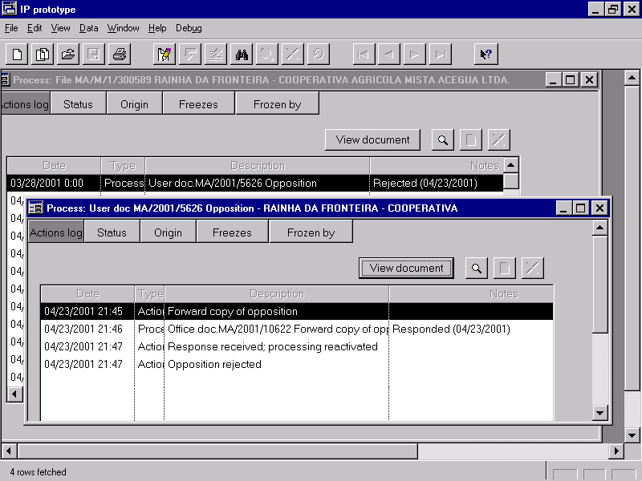

Groups of applications can be defined for administrative purposes. Each user defines his or her own groups. Files can be included in a group by:

- identifying each file individually.
- copying the files in another group.
- copying the files in a delivery list (or vice versa).
- selecting those files that have received a specified action during a specified period.
- selecting those files that are in a specified status.

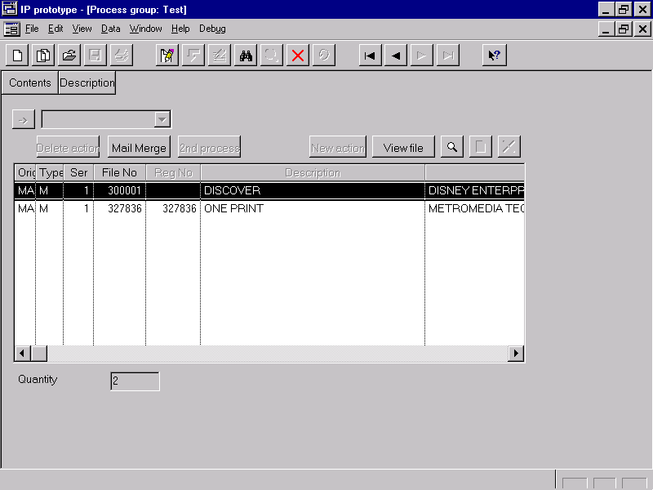

Files can be easily transferred within groups.(By selecting applications and redirect them to a second group)

Once a group is formed, it can be used to:

- apply an administrative action to each of the files. For example, a group containing all applications in the “To be registered” status can be built, and then the administrative action “Registration” can be entered once for the entire group, instead of entering once for each application in the group.
- remove the last action applied (in case of clerical errors).
- generate a report using a set of predefined formats created with the same flexible tools used for publishing the journal or printing official documents.

2.8. Printing of office documents

Each type of administrative action can be configured so that the system generates an office document with information concerning the action and the affected file. The format of the office document will be defined by the user with Microsoft Word and the system will allow:

- use of Microsoft Word’s mail merge commands so that pre-defined database fields can be included in the appropriate place in the Word document. This information can come from the action (date, observations, options entered, etc.) or from the affected application (mark, owner, classes, logo, etc.). For example, for an action where the user has selected several requests, the system can print an office document containing the reasons for the request.

- the database fields available for mail merging can be configured by a technical user, by means of one or more SQL statements (i.e. any piece of information within the database is available for inclusion in office documents).

- Standard Microsoft Word mail merge capabilities have been expanded to support including images. In other words, the office document can include the logo of a trademark or the main drawing of a patent. This allows, for example, printing trademark certificates of registration including the logo.

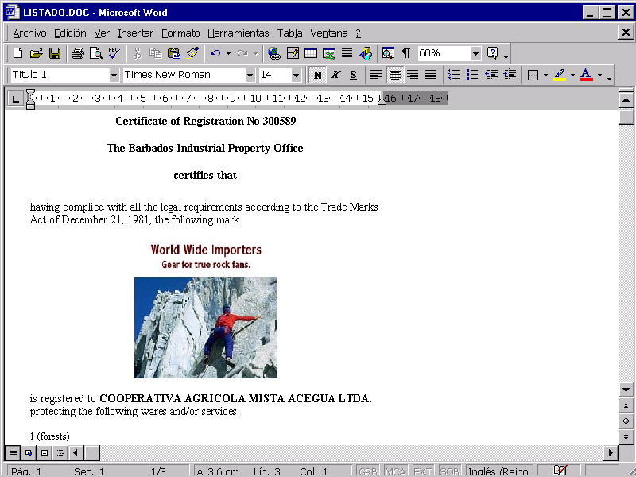

- In order to maximise the flexibility of office documents layout, the system has also been expanded to offer the use of “conditional text”. This allows the user to insert text in the Microsoft Word document if certain conditions are met by defined database fields.
The system generates a sub-process to keep track of the actions needed to be carried out concerning the office document, and shows this sub-process (and its current status) within the affected application’s actions log. There are basically three different process structures used for office documents:

- just printing the document. The action is automatic, so in this case no action needs to be captured by the user.
- printing the document and notifying it to the applicant.
- printing the document, notifying it to the applicant and waiting until a reply is received from the applicant (or expiration of the allowed period has elapsed). In this case, the affected application’s process is “suspended” until the office document’s process is finished, and then it resumes.

2.9. Journal publishing

The system can be configured so that pre-determined types of administrative actions be included in specific sections of the office journal (e.g. registrations, changes order by the Court, etc.), and the generation of the journal is automated as follows:

- each new journal must be defined and an identification assigned.

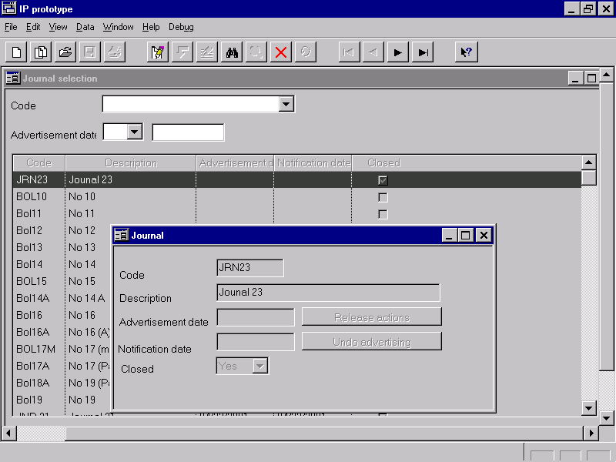
- from the list of available action types to be included in the journal, a due date and some action types must be selected. The system selects all actions of those types before that date provided they were not included in a previous journal. This process defines which actions are to be advertised by the IP office.

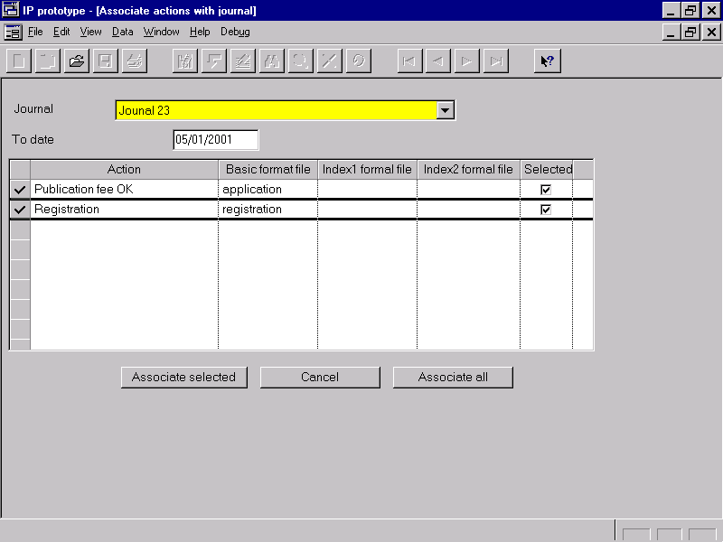

- individual actions can be added or removed from the prospective journal.(By editing the “Journal” field , as seen below).

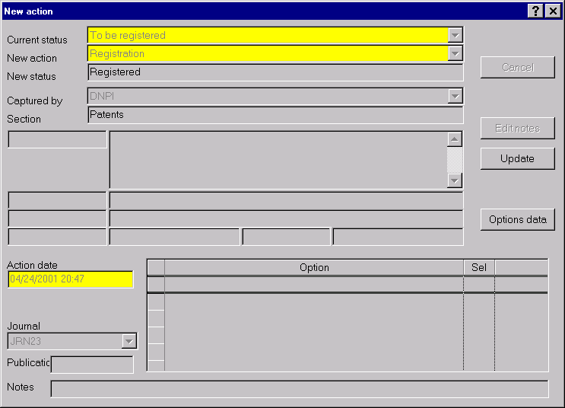
- the journal is closed, and a report is printed showing all actions to be included in the journal.

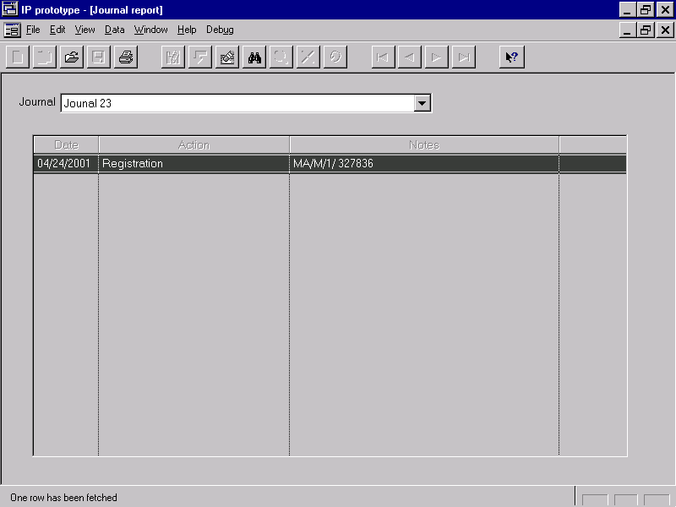

- the Microsoft Word files for the journal are generated, according to the specified formats for each action type.

- when the journal has been made available to the public, the date is captured in the system and automatically:

- the availability date and the journal identification era loaded in every application included in the journal (applications are included in the journal through some action that indicated office approval, e.g. an action type of “approval for advertising”).
- the date and the journal identification are loaded in every action included in the journal.
- the due dates that are calculated using the “publication date” as a base, are thus calculated.
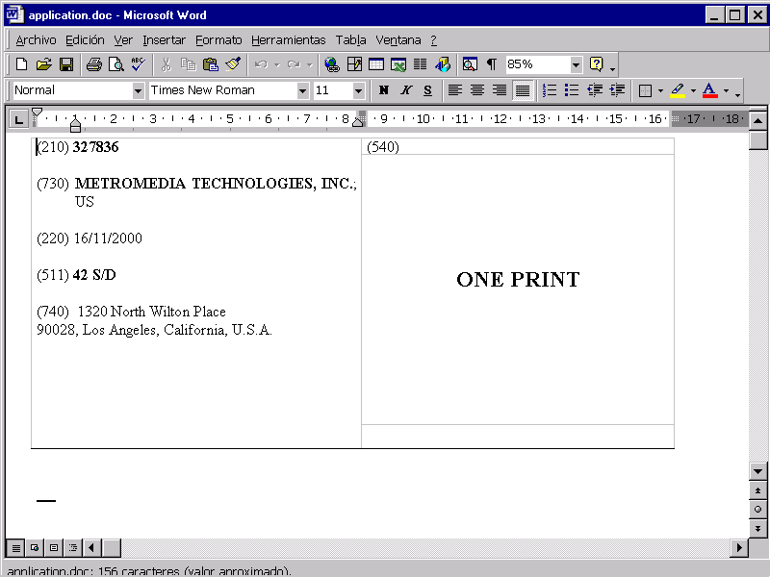

2.10. Access control and auditing

Access authorisation to the different system functions is defined by means of roles. Each user will be assigned one or several roles and for each role definitions are made for:

- Application window access, e.g. preventing some users from even viewing certain windows.
- Permission to insert, modify, delete (or any combination of them) information in each database table.
- For trademark and patent information it is also possible to define specific data that is allowed to be modified and data that cannot be modified. For example, certain users could change the trademark name, while others could only view it.
- Permission for entering administrative actions of certain types. For example: some users will be allowed to enter “Registration” actions while the rest will not.

Every change made to any trademark field is audited in a log containing:

- user responsible.
- date and time.
- information before the change.
- information after the change.

This log can be accessed globally or by mark.

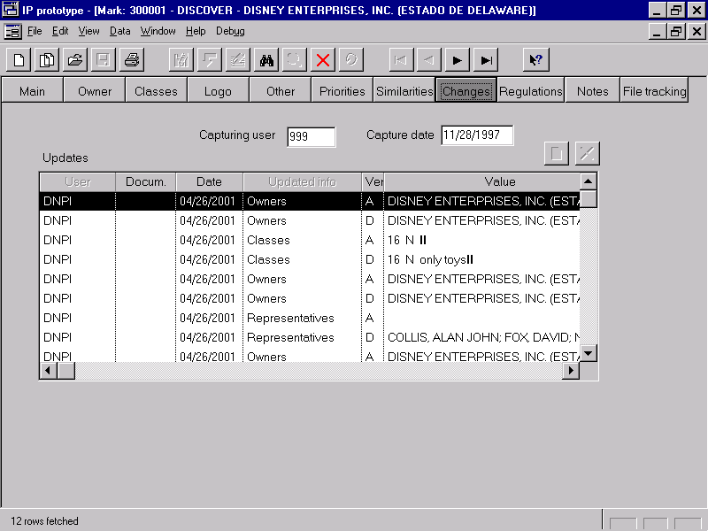

2.11. Internet access for external users

External users (e.g. agents or the public) will have Internet access to trademarks information, allowing searches by file identification and basic bibliographic data (mark name, owner, etc).

All trademark information is shown, including the logo and the actions performed by the office and user documents received.

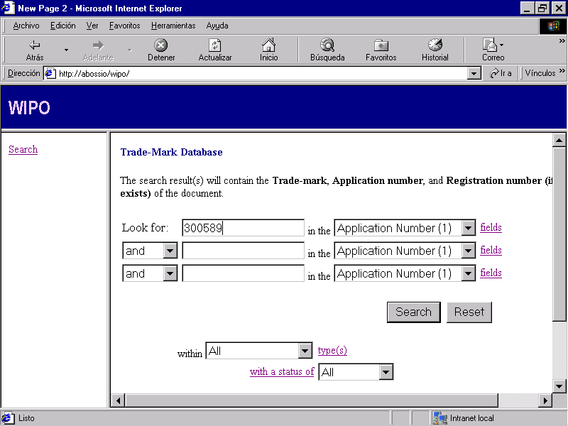

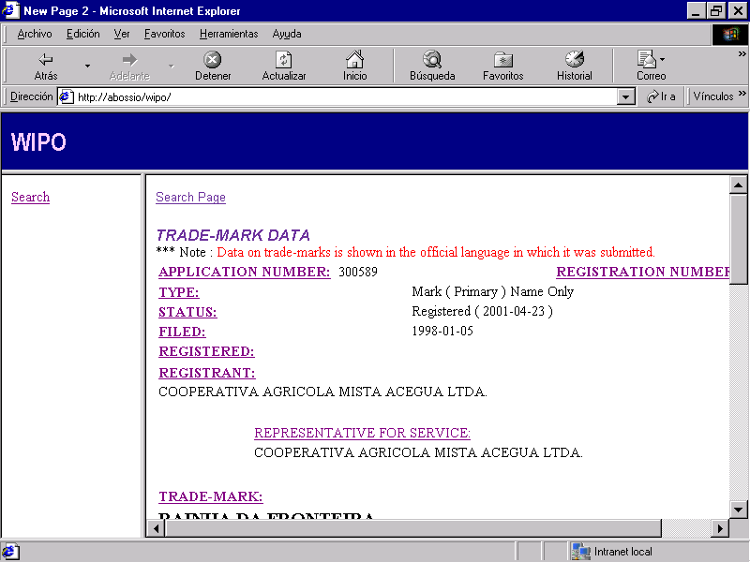

2.12. Statistics

The system generates:

- Statistics related to the productivity of each area measured as quantity of actions during a certain period and totalled by action type / user / month / mark type. This information is generated as Excel spreadsheets so that it can be analysed by using standard pivot tables functionality.

- Ageing of processes, i.e. length of time files have been in particular administrative statuses.

- Statistics required by WIPO will be generated automatically through the generation of a series of Excel spreadsheets with pre-defined formats in order to use COPY/PASTE commands in the spreadsheets supplied by WIPO in the statistics CD. For example, these spreadsheets are MRKMAST.XLS, MARKTB3.XLS, MRKTBVS.XLS, MRKTBLV.XLS y MRKTBVI.XLS.

3. TECHNICAL CHARACTERISTICS

The system is developed with Centura tools to be use in a client-server environment with a Windows client and an Oracle database server.

For small offices with a single PC a version of “Personal Oracle” would be sufficient, but “Oracle Server” is required for multiple users.

Update access at the Oracle level is managed through a special role whose password is encrypted within the application, thus forbidding access to the information for users that may happen to have access to Oracle client tools such as SQL*Plus.

Select access at the Oracle level could be granted to all users or as necessary.

The database objects containing the information used by the system (tables and columns) will have descriptive names and extensive documentation and can be used as a source of information for further local development.

Centura allows powerful tools for object-oriented programming, enhancing the modularity and robustness of the software design.

In addition to Centura, some parts of the system are developed in more specialised languages:

- parts of the similarity algorithms in the trademarks search module are developed in Visual C++.
- for generating the journal files and for printing office documents Microsoft Word 97 (or higher) is used. The communication with Centura and certain extensions (e.g. the “mailmerge” of figures) are developed in Visual Basic and embedded Word macros which are made available though a .DOT file.

Centura licensing is required only for countries performing local developments in this language. Otherwise, the Centura run-time environment is royalty-free.

4. INSTALLATION

4.1. Initial data loading

Options for initial data loading are:

- For countries which already have industrial property systems previously developed by WIPO, a module for migrating data automatically will be provided.

- For countries which do not have industrial property systems, a module for capturing data with Excel spreadsheets and subsequently loading this data in the database will be provided.

- For countries which have industrial property systems not developed by WIPO, local programs must transfer this data to the mentioned spreadsheets where the capture module can process it.

4.2. Base software installation

Base software must be installed locally, but a set of extensive instructions will ease the process and no technical expertise will be necessary. This includes:

- “Oracle Server” database management system.
- “Microsoft Office” tools (Word will be used for printing office documents and journal publishing).
- “Symantec pcAnyWhere” remote control software (to ease post-installation support).

4.3. System installation and configuration

The software will be distributed in CDs and the installation process will be so structured as to require minimal expertise.

In order to be configured according to local needs of each IP office, the system will have a wide range of configuration features, many of which were previously described. In general terms, the user will be able to:

- define the numbering scheme, by combining file type, series, file number and origin.

- define the trademark and document types to be received.

- configure data items available for inclusion in office documents or journal sections: a technical user can define the SQL statements that must be executed by the system in order to get any piece of data from the database.

- for configuring processes, the user will be able to:
- define the detailed statuses and actions, possibly limiting actions according to applications’ type or law.
- define which actions generate office documents and the layout of each one (with Word and extended features such as logo inclusion).
- define the lists of options that will be available for selection when actions are taken.
- define which actions will be included in the journal and the layout of each section (similar to office documents).

- regarding local customisations aimed at maximising the comprehension of the terms used throughout the system, the user will be able to:
- configure which texts should appear in any combo box.
- configure the desired background texts, columns names, window names, and in general any fixed part of the interface: by using a “dictionary” users will be able to add a “local flavour” to any screen.

4.4. Learning how to use the system

The set of user manuals describe the operating aspects of the system exhaustive detail so that no further training will be required.

In addition, a set of administration manuals allow trained users to modify system setting parameters in order to adapt configuration to changes in administrative processes.

Windows help will also be available online.

A test environment will be made available, through which users will be able to rehearse all necessary operations in an isolated environment devoted exclusively to testing and training.

A third separate environment will include a sample database with detailed step-by-step tutorials illustrating the most important system features, allowing self-instruction.
5. POST-INSTALLATION SUPPORT

In addition to basic telephone and e-mail communication, support will be available through Internet resources (this will require a modem and a connection to the Internet through a local Internet Service Provider). This facilities are:

- Internet telephone services (e.g. Net2Phone) will allow minimal cost person-to-person communication.
- remote control software (e.g. pcAnyWhere) over an Internet connection will allow low cost machine-to-machine communication. The support technician will “take control” of the machine requiring support as if he or she was personally available. The application could be remotely executed, configuration parameters adjusted, and explanations be issued through dialog screens.

6. PATENTS SYSTEM FUNCTIONALITY

6.1. Patents database

Contains information concerning patents. Main characteristics are:

- Bibliographic data search: by application number, application date, registration number, registration date, title, name, applicant name, words contained within the applicant name, etc.

- Filing data, status data, applicant/owner data, agent data, priority data, advertising data, file tracking data: similar to the features already discussed in the trademarks case.

- Inventors data: similar to applicants data.

- Technical data: title; summary; main drawing; IPC classifications (or Locarno in case of designs). A special version of the title in Microsoft Word containing special characters such as Greek letters can be captured for printing office documents. The summary can be syntax checked by Word. Support for dividing applications is available, i.e. when there is no unity of invention and the original application must be divided in two or more.

- Annual payments: when the application is registered, annual payments are automatically generated with their due dates. Through the reception of the annual payments, each one is checked as “paid”. If unpaid ones remain after their due date, an action to analyse possible abandonment is automatically generated.

- PCT data: for countries adhering to this treaty, additional features are available:

- from the “PCT Gazette in CD-ROM” bibliographic data can be downloaded for those international applications designating the country as a potential candidate for the national phase. This includes applicants, inventors, IPC codes, priorities, PCT publication, title, summary, etc. The main figure can also be downloaded.
- when capturing the application once in the national phase, the publication information can be used as an index to identify the previously downloaded bibliographic data and automatically insert this information within the national application.

- Register data: register number and dates of registration and expiration are automatically assigned by the process tracking module.

6.2. Patent search

A technical search is available supporting the logical combination by AND/OR of complex conditions such as:

- by one or more words within the applicant name.
- by one or more words within the inventor name.
- by the country and the priority number ignoring special characters, e.g. “97/755” is equivalent to “97755”.
- by one or more IPC codes at any level of detail combined with AND/OR.
- by one or more words within the title combined with AND/OR.
- by one or more words within the summary combined with AND/OR.

6.3. Common functionality

Similar features are available for patents as those discussed under “trademarks system functionality” concerning file tracking, additional documents received after the application, data capture control, process tracking, printing of office documents, journal publishing, access control and auditing, and statistics.

[End of Annex III and of document]

