E
WIPO/INN/BRI/99/8
ORIGINAL: English
DATE: November 1999
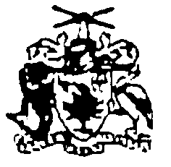 | 
GOVERNMENT OF BARBADOS | WORLD INTELLECTUAL  PROPERTY ORGANIZATION
wipo national seminar on innovation promotion
organized by
the World Intellectual Property Organization (WIPO)
in cooperation with
the Ministry of Industry and International Business,
Government of Barbados
Bridgetown, November 22 to 23, 1999
SERVICES AND ASSISTANCE TO LOCAL INVENTORS AND SMALL AND MEDIUM ENTERPRISES (SMES)

prepared and presented by Mr. Larry Udell, Managing Director,
Intellectual Property International (IPI),
Castro Valley, California
(Abstract)

1. What is an inventor?

2. Where are they?

3. What do they look like?

4. What language do they speak?

5. Are they genius or crazy?

All the above are good questions. Here are the answers:

- What is an inventor?

An inventor is in all of us to be human, is to be creative.

- Where are they?

Inventors are everywhere - all races & ages.

- What do they look like?

Just like you and me.

- What language do they speak?

Every language on the face of the earth.

- Are they genius or crazy? Both.

Can you teach inventing?

Yes. Courses on how to invent have been conducted at various universities and corporations for several decades.

They have primarily focused on those individuals with engineering and science degrees and/or experience.

What I would like to point out today, is that many of our greatest inventions have emanated from average folks.

PATENTS PR0VIDE N0 VALUE UNTIL THEY ARE COMMERCIALIZED
INTELLECTUAL PROPERTY WILL BE THE CURRENCY
OF THE NEXT CENTURY and
IT IS AN INEXHAUSTIBLE RESOURCE

[End of document]

