E
WIPO/INN/ABJ/99/26
ORIGINAL: English
DATE: September 1999
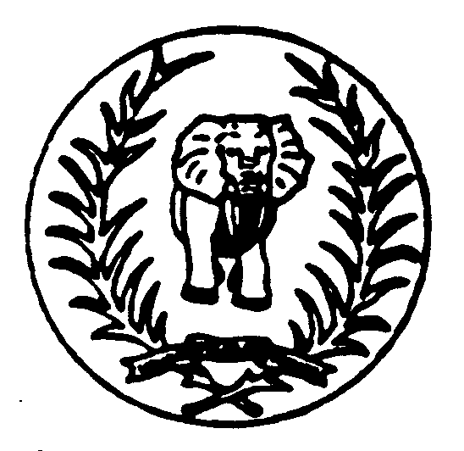 | 
GOVERNMENT OF THE REPUBLIC  OF CÔTE D’IVOIRE | WORLD INTELLECTUAL  PROPERTY ORGANIZATION
wipo regional seminar on invention and
innovation in africa
organized by
the World Intellectual Property Organization (WIPO)
in cooperation with
the Government of the Republic of Côte d’Ivoire
Abidjan, September 1 to 3, 1999
ROLE AND FUNCTIONS OF INVENTORS’ ASSOCIATIONS
(experience of the Sudanese Inventors Association)

prepared by Mr. Abdel Wahab Musa, President, Sudan Inventors Association, Khartoum

In the late sixties the founders of the Sudan Inventors’ Association quickly realized that they had to start from scratch. They discovered that the country had no legal instrument for the protection of intellectual property other than a flimsy “Cautionary Notice” in the Official Gazette. So, with the help of WIPO experts, headed by Dr. Farag Moussa, they worked hard on the relevant decision-makers in the Ministry of Commerce to introduce a patent law in the country.

That was not an easy task. It needed calibre, stature and a pioneering spirit on both sides of that joint effort. But, while it was easy to find the requisite calibre amongst the decision-makers, it was only by chance that there were matching counterparts among the founders. That may be the case in many other developing countries, where inventors and their leaders seldom measure up to the level of education that will enable them to play an effective role in the promotion of innovation and inventive activity with the top echelons of the relevant government authorities.

Apart from that, the leadership of an inventors’ association in any country must be qualified by education and experience to see the issue in its national and international context, and with that in mind it must avoid working as a self-centered “pressure group”.

That is what we did in the Sudan in our various contacts with the Government. The first patentee was a seasoned former civil servant and a classmate of the then President of the then Republic. Those credentials enabled him to request the President to see his working model and come to his home for cold drinks. A chat followed on the vital role of indigenous inventors in the national economic and social development of the country.

The way was thus opened up to senior executive whose jobs and duties brought them into contact with inventive activity in one form or another.

As a result, the above-mentioned first patentee was made a member of the National Council for Research where he kept insisting on the need for a national science and technology policy to be formulated by the Council and adopted by the Government. During his time there he also worked hard to forge a close link between the Council and the Industrial Property Office, so that the representatives of the two bodies would consult each other on the acceptability or otherwise of patent applications. The exercise was meant to initiate the employees of the now-related bodies in the rudiments of inventive activity and intellectual property protection.

Such a statement may seem exaggerated, but the reality in many developing countries tends to support it. Indeed even the very people who are engaged in handling intellectual property get quite mystified when they consider the phenomenon of “inventiveness”. To them an inventor is either a crank or an impostor unless he can prove the contrary.

In an environment like this, an inventors’ association has a lot of groundwork to do before it can move to the next phases and aspects of invention promotion. Above all there is the task of dispelling the unjustifiable inhibition that regards inventing as the monopoly of the Western world, with the Third World’s only hope being to live on the spillover from that monopoly. Potential inventors, research workers and entrepreneurs were all in dire need of a dose of morale-boosting to get rid of their negative attitude to inventive thought.

To achieve that end senior members of our Association took it on themselves not to lose any chance of enlightening the appropriate Government decision-makers on the beneficial role of indigenous technology in the industrial and economic development of the country and the need for government sponsorship of the inventive activity underlying that technology. They attended relevant lectures and conferences, participated in the discussions and were eventually recognized as knowledgeable speakers on the technological aspects of various development projects.

In one such case the President of the Association was asked to comment on a lecture delivered before a conference of agriculturalists on the mechanization of certain agricultural operations on various crops. In another case he was asked to address a seminar on small industries on the role of inventors in boosting the engineering industry.

As the President was neither an agriculturalist nor an engineer, the two incidents serve to show the level of recognition we attained through our modest effort to create awareness of and arouse interest in the promotion of inventive activity.

In the meantime we continued to write at length to key ministers on the role of the Government in promoting innovation and invention in the country through action of various kinds. We wrote to the Minister of Finance, asking him to set aside adequate funds in his national development budget to finance inventive efforts that promised to result in inventions or research findings that would enhance economic development.

We wrote to the Director General of the Government’s Agricultural Bank, requesting him to provide grants and loans on easy terms for people engaged in the creation of agricultural technologies that were submitted as realistic projects for financing.

While the response was negative in the first case and lukewarm in the second, we did manage to make them think seriously about the possibilities.

However, we look at the results of our efforts, we consider them positive, so we are not going to give up; indeed we look on a disappointing response as a temporary situation that with patience can be rectified.

A case in point is the difficulty we faced in legalizing the existence of our Association. There was no law to accommodate it immediately so we had to accept registration under a law on charitable organizations. But that status did not give us the image that we needed for moving about at high levels. We therefore kept up the pressure until the Minister of Justice was persuaded to allow the Association to be registered among other professional associations, such as the Associations of engineers, doctors, agriculturalists, advocates, and so on.

That was quite a leap forward, and it gave us the stature to address the President of the Republic on various aspects of inventive activity in the country; as a result we were placed under the patronage of the Minister of Higher Education and Scientific Research, who was already responding to previous approaches with adequate donations and an open mind on all the issues that we raised in our correspondence with him, especially those concerning ways and means of promoting inventive activity in universities and other higher education institutions.

While on this subject, it may be worth mentioning that, a few years before that contact with the Minister of Higher Education, the President of the Association was approached by members of the General Association of Sudan University Students on the organization of competitions among students to reward excellence in inventing. A year later he was asked to be on the advisory council of an organization sponsoring student inventors. That organization has now become a fully-fledged, government-financed authority for the promotion of innovation and invention in many fields. Last month it launched its first project for rewarding participants who come up with good ideas, inventions and research results.

With such promising developments, we felt that the General Registrar of Intellectual Property might need our help in introducing potential patent applicants to the intricacies of the relevant laws and regulations. So we offered to collaborate with him in setting up a joint office to help inventors produce proper documentation to back up their ideas and file patent applications correctly.

The offer, which is still under consideration, goes to show how close our relations are with the Registrar and his assistants; indeed, they are exemplary: we are always welcome visitors to their offices, and we very much appreciate their inviting us to join in their technical discussions and relevant seminars.

For our part, we receive many inventors at our offices. They come with enquiries on many subjects, and we spare no effort in giving them the information and guidance that they need. When we receive notice of a national or international competition, we advertise it to them in various ways, and those who decide to apply are helped to do so.

Those efforts may seem enough to enhance national awareness of the need for promoting innovation and inventive activities in the interest of economic and social progress. Yet they need to be backed by moral support and technical assistance from such high-ranking organizations as WIPO and IFIA. Our relations with both are excellent, and we shall enlist their help and draw on their resources in promoting innovation and invention in our country.

[End of document]

