E
WIPO-IFIA/SEL/02/24
ORIGINAL: English
DATE: December 2002
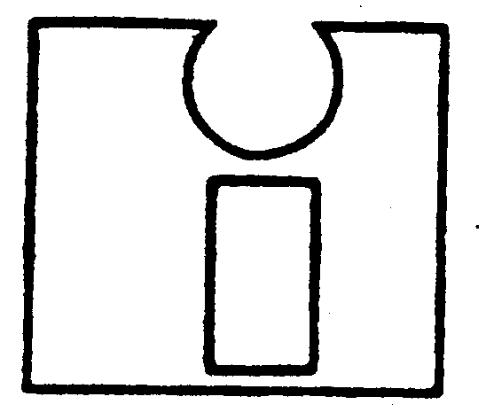 | 
INTERNATIONAL FEDERATION OF  INVENTORS’ ASSOCIATIONS | WORLD INTELLECTUAL  PROPERTY ORGANIZATION
WIPO-IFIA INTERNATIONAL SYMPOSIUM ON
THE commercialization of inventions
in the global market
organized by
the World Intellectual Property Organization (WIPO)
and
the International Federation of Inventors’ Associations (IFIA)
in cooperation with
the Korean Intellectual Property Office (KIPO)
and
the Korea Invention Promotion Association (KIPA)
Seoul, December 4 to 7, 2002
PARTNERING WITH VENTURE CAPITALISTS AND FINANCING THE DEVELOPMENT AND COMMERCIALIZATION
OF INVENTIONS

Document prepared by Mr. Stephen Ong, Managing Director, Asian Direct Capital Holdings Sdn Bhd, Kuala Lumpur

[End of document]

