E
WIPO-IFIA/SEL/02/21
ORIGINAL: English
DATE: December 2002
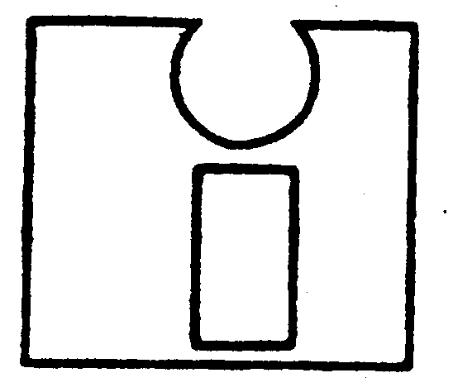 | 
INTERNATIONAL FEDERATION OF  INVENTORS’ ASSOCIATIONS | WORLD INTELLECTUAL  PROPERTY ORGANIZATION
WIPO-IFIA INTERNATIONAL SYMPOSIUM ON
THE commercialization of inventions
in the global market
organized by
the World Intellectual Property Organization (WIPO)
and
the International Federation of Inventors’ Associations (IFIA)
in cooperation with
the Korean Intellectual Property Office (KIPO)
and
the Korea Invention Promotion Association (KIPA)
Seoul, December 4 to 7, 2002
INVENTIVE ACTIVITIES IN THE FRAMEWORK OF UNIVERSITIES AND SMALL AND MEDIUM-SIZED ENTERPRISES
AN OVERVIEW OF THE STRATEGIES AND ACTIVITIES OF THE small and medium-sized enterprise (SMES) division of wipo
Document prepared by Mr. Jae Kap Yoon, Senior Counselor, Small and Medium-Sized Enterprise Division (SMEs), WIPO, Geneva

