E
WIPO-IFIA/SEL/02/13 Rev.
ORIGINAL: English
DATE: December 2002
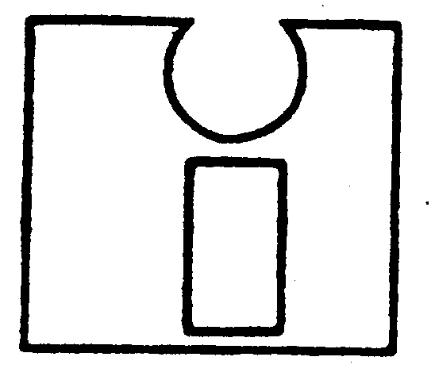 | 
INTERNATIONAL FEDERATION OF  INVENTORS’ ASSOCIATIONS | WORLD INTELLECTUAL  PROPERTY ORGANIZATION
WIPO-IFIA INTERNATIONAL SYMPOSIUM ON
THE commercialization of inventions
in the global market
organized by
the World Intellectual Property Organization (WIPO)
and
the International Federation of Inventors’ Associations (IFIA)
in cooperation with
the Korean Intellectual Property Office (KIPO)
and
the Korea Invention Promotion Association (KIPA)
Seoul, December 4 to 7, 2002
ONLINE MARKET PLACES FOR INVENTIONS

THE THREE-YEAR EXPERIENCE OF THE IFIA INTERNET
INVENTIONS STORE (IFIS)

Document prepared by Mr. Farag Moussa, President, International Federation of Inventors’ Associations (IFIA), Geneva

I. Introduction

1 Trade fairs and invention exhibitions are a typical method of marketing inventions, a traditional way, a good method, and we can be sure that it is a method that will continue to exist in the future, as its usefulness has been proved a thousand times.

2 And then came the Internet. What an invention that was! It was just a few years ago, and in no time ways of doing business started to change. The computer screen is rapidly becoming an essential tool for marketing inventions, in addition to the traditional paper leaflets and brochures, or the more modern CDs and videos. Some inventors now advertise their inventions on their personal websites, while several organizations and companies publish long lists of inventions for sale or licensing on their websites.

3 This new, virtual online market is now within reach of the inventor and of all those, and they are many, who are interested in the fascinating world of inventions. And one need only think of the possible benefits, which are not virtual at all!

4 Now, what exactly are we talking about when we speak of a virtual market? We mean that, at the click of a mouse, a person looking for new products and new business opportunities can go online for relevant information on new inventions available for commercialization, and if that business person so desires, he can approach the inventor or his representative. The potential business partners of the inventor are the same as in a real invention exhibition. They could be manufacturers, investors, venture capitalists, distributors, licensing agents, wholesalers or retailers.

5 What people see on the screen will of course vary from one website to another. In some cases very little information is provided, the minimum being the title or a very brief abstract of the invention plus a contact address. Some might add that if the visitor wants to see a description or a prototype of the invention, that can be arranged, but only after a “disclosure statement” has been signed. In fact, however, most websites disclose more information than just a title or abstract and a contact address. The information may appear in text form only, or also with drawings and pictures, depending on the website.

II. The THREE-Year experience of IFIS: Summary

- What is IFIA and what is IFIS?
- The preparatory work and launch of IFIS on November 15, 1999.
- Three years on: 404 inventions from 92 countries.
- The uniqueness of IFIS: it is the only online marketplace in the world offering
inventions from so many countries (92).
- The other qualities and advantages of IFIS.
- The difficulties encountered by IFIA in promoting, managing and developing
IFIS.
- Future developments.
[End of document - Annexes follow]

