E
WIPO/IFIA/BUE/00/INF.1 Rev.
ORIGINAL: English
DATE: September 2000
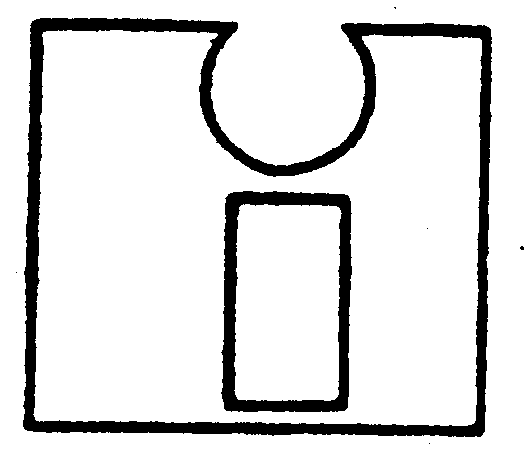 | 
INTERNATIONAL FEDERATION OF  INVENTORS' ASSOCIATIONS  (IFIA) | WORLD INTELLECTUAL  PROPERTY ORGANIZATION
inventors at the dawn of the new millennium:
wipo-ifia international symposium
organized by
the World Intellectual Property Organization (WIPO)
and
the International Federation of Inventors' Associations (IFIA)
in cooperation with
the Government of Argentina
and
the Argentine Association of Inventors (AAI)
Buenos Aires, September 5 to 8, 2000
PROGRAM
prepared by the International Bureau of WIPO

Tuesday, September 5, 2000

10.00 - 10.30 Opening ceremony

Addresses by:

The representative of the Government of Argentina
Mr. Farag Moussa, President, International Federation of Inventors’ Associations (IFIA)
Mr. Eduardo Fernández, President, Argentine Association of Inventors (AAI)
The representative of the Director General of the World Intellectual Property Organization (WIPO)

10.30 - 11.15 Creation of Employment and Generating Wealth by Inventors and Innovation

Speaker: Ing. Ricardo A. Ferraro, Politics and Sciences and Technological Administration, University of Buenos Aires, Buenos Aires, Argentina
Ref.: WIPO/IFIA/BUE/00/1

Discussion

11.15 - 11.30 Break

11.30 - 12.45 How the Internet and New Information Technologies Influence the Work of Inventors, Innovators and Innovative Small and Medium Enterprises (SMEs) (Multimedia, Web pages, Modeling, Prototyping, Communication)

Speaker: Mr. Guillermo González Camarena Becerra Acosta, General Director, Guillermo González Camarena Foundation, Mexico City, Mexico
Ref.: WIPO/IFIA/BUE/00/2

12.45 - 14.00 Lunch Break

14.00 - 16.00 Dr. András Vedres, Secretary General, Association of Hungarian
Inventors (MAFE), Budapest, Hungary
Ref.: WIPO/IFIA/BUE/00/3
and
Mr. Subash K. Bijlani, President, Magnus Engineers Pvt. Ltd., Chandigarh, India
Ref.: WIPO/IFIA/BUE/00/4

Discussion

16.00 - 16.30 Break
Tuesday, September 5, 2000 (cont’d)

16.30 - 18.00 Networking and Promotion of National Invention and Innovative Activities
Presentation on Projeto Inventiva

Speaker: Mrs. Ana Regina de Holanda Cavalcanti, Coordinator, National Institute of Industrial Property (INPI), Ministry of Development, Industry and Foreign Trade, Rio de Janeiro, Brazil
Ref.: WIPO/IFIA/BUE/00/5

Discussion

18.30 WIPO-hosted reception

Wednesday, September 6, 2000

9.00 - 10.45 Small and Medium Enterprises (SMEs), Inventors and Intellectual Property:
In the Global Marketplace
WIPO’s Initiatives and Programs: Presentation of the Programs and Activities of WIPO - A Progress Report

Speakers: Mr. Carlos Correa, Professor, University of Buenos Aires, Buenos Aires, Argentina
Ref.: WIPO/IFIA/BUE/00/7
and
Ms. Carlotta Graffigna, Director-Advisor, Cooperation for
Development Sector, WIPO
Ref.: WIPO/IFIA/BUE/00/6

Discussion

10.45 - 11.00 Break

11.00 - 13.00 Patenting Strategies - When, What and Why: How Should Inventors and SMEs Plan for Obtaining Protection for Their Inventions
Use of Public or Private Services
Intellectual Property Information (including the Patent Cooperation Treaty (PCT), etc.)

Speakers: Mr. Eduardo Fernández, President, Argentine Association of Inventors (AAI), Buenos Aires, Argentina
Ref.: WIPO/IFIA/BUE/00/8
and
Mr. Vladimir Yossifov, Director, Division for Infrastructure Services and Innovation Promotion, WIPO
Ref.: WIPO/IFIA/BUE/00/9

Discussion

13.00 - 14.00 Lunch Break
Wednesday, September 6, 2000 (cont’d)

14.00 - 18.00 IFIA-General Assembly

Thursday, September 7, 2000

9.00 - 11.00 Employed Inventors - An Important Asset of Enterprises and Nations: How to Protect Their Rights and Interests

Speakers: Mr. W. Roman Pawlak, Representative of the Association of Polish Inventors and Rationalizers (SPWiR), and Division Director, Technology Agency (ATT), Warsaw, Poland
Ref.: WIPO/IFIA/BUE/00/10
and
Mr. Vladimir Yossifov, WIPO

Discussion

11.00 - 11.15 Break

11.15 - 12.45 Round-table discussion on Employed Inventors and Inventors as Initiators of Start-up Companies

Moderator: Ms. Carlotta Graffigna, WIPO

12.45 - 14.00 Break

14.00 - 15.30 How Can Patent Offices Encourage Inventive and Innovative Activities?

Speaker: Mr. Nestor Ramirez, Supervisory Patent Examiner, Office of Independent Inventor Programs (OIIP), United States Patent and Trademark Office (USPTO), Washington, D.C., U.S.A.
Ref.: WIPO/IFIA/BUE/00/11

Discussion

15.30 - 16.00 Break

16.00 - 16.45 The Protection of Inventions and the Provision of Support Services to Inventors: Recent Developments at the European Level

Speaker: Mr. Umberto Zamboni di Salerano, Minister Plenipotentiary,
Ministry of Foreign Affairs, Rome, Italy
Ref.: WIPO/IFIA/BUE/00/12

Discussion

Thursday, September 7, 2000 (cont’d)

16.45 - 18.00 Round-table discussion on The Important Role of Support Services for Inventors, Research and Development (R&D) Organizations and Innovative Small and Medium Enterprises (SMEs) in the Development and Industrial and Commercial Use of New Inventions and Technologies

Moderator: Mr. Vladimir Yossifov, WIPO

Friday, September 8, 2000

09.00 - 11.00 Round-table discussion on the Internet, New Information Technologies and Cooperation Among Inventors and Inventors’ Organizations

Moderator: Mr. Vladimir Yossifov, WIPO

11.30 – 12.30 Closing ceremony

14.00 - 17.00 IFIA General Assembly

[End of document]

