E
WIPO/ECTK/SOF/01/1.2
ORIGINAL: English
DATE: May 2001
 | 
THE PRESIDENT OF THE  REPUBLIC OF BULGARIA | WORLD INTELLECTUAL  PROPERTY ORGANIZATION
international conference on
intellectual property, the internet,
electronic commerce and traditional knowledge
organized
under the auspices of
His Excellency Mr. Petar Stoyanov, President of the Republic of Bulgaria
by
the World Intellectual Property Organization (WIPO)
in cooperation with
the National Intellectual Property Association of Bulgaria
Boyana Government Residence
Sofia, May 29 to 31, 2001
INTELLECTUAL PROPERTY, THE INTERNET AND ELECTRONIC COMMERCE
INTELLECTUAL PROPERTY, DOMAIN NAMES AND E-COMMERCE
A LATIN AMERICAN CHALLENGE - THE BRAZILIAN FOCUS
Document prepared by Mrs. Vanda Scartezini, National Secretary for Information Technology Policy, Ministry of Science and Technology, Brasilia

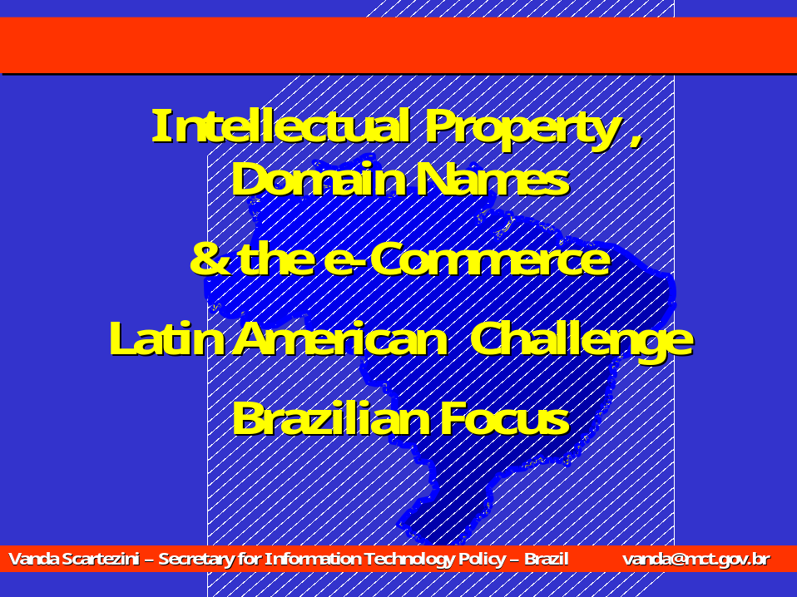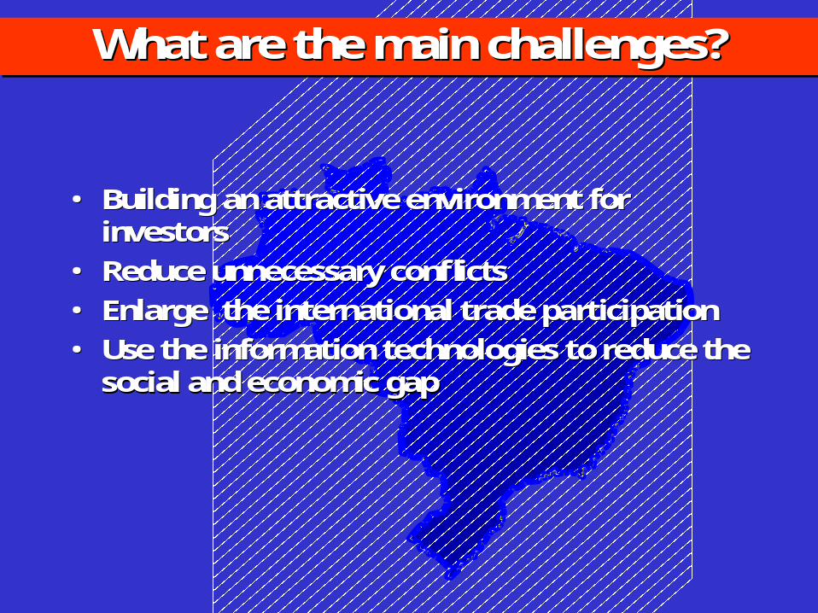

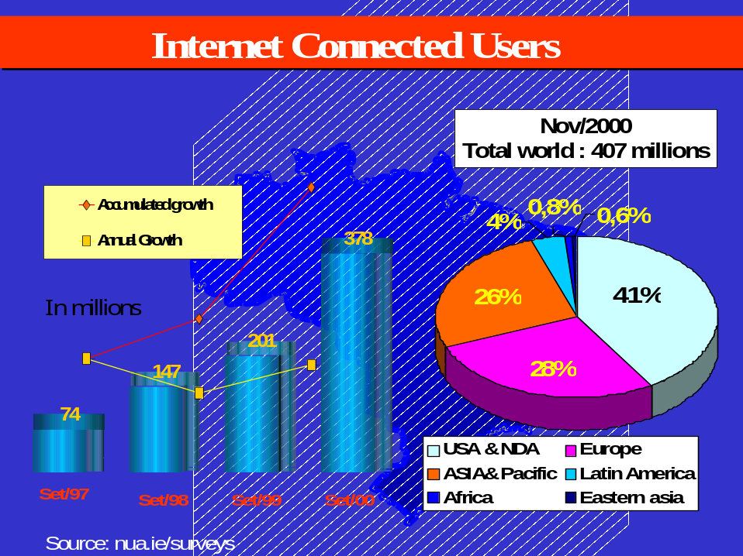

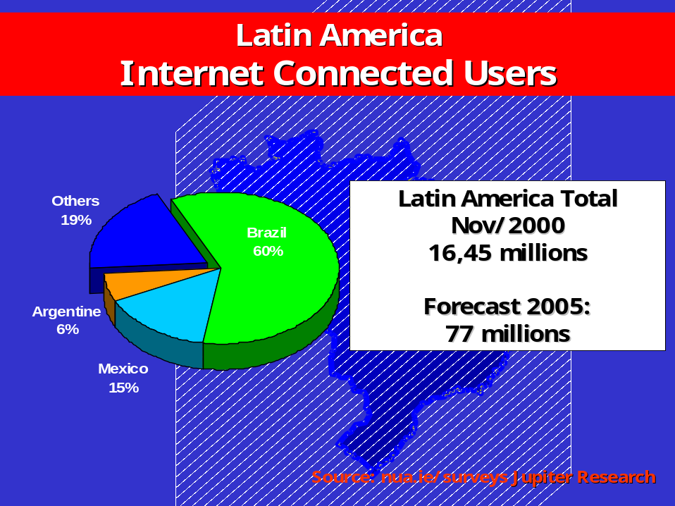

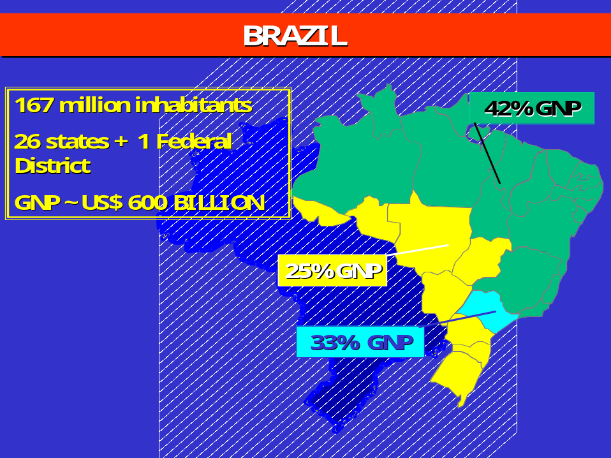

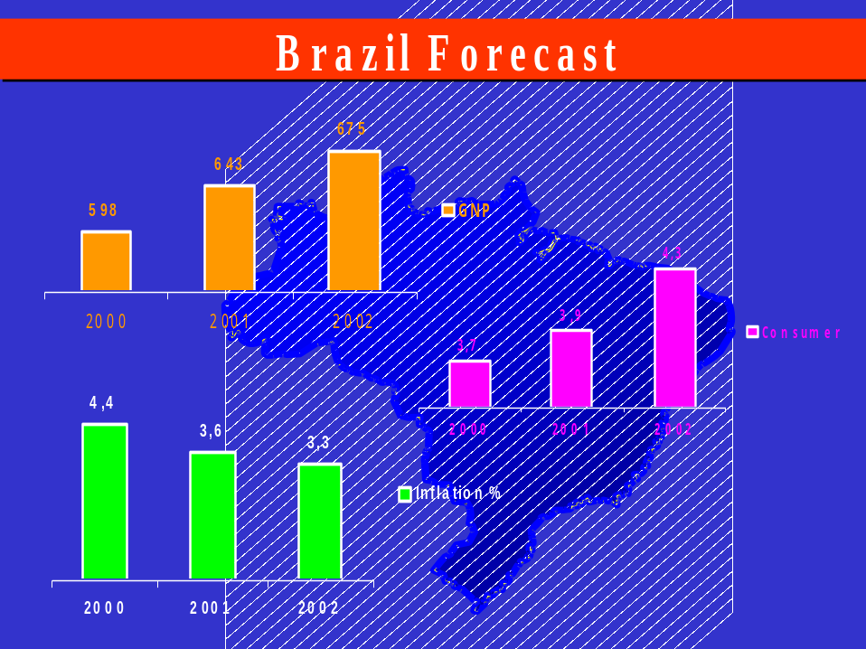

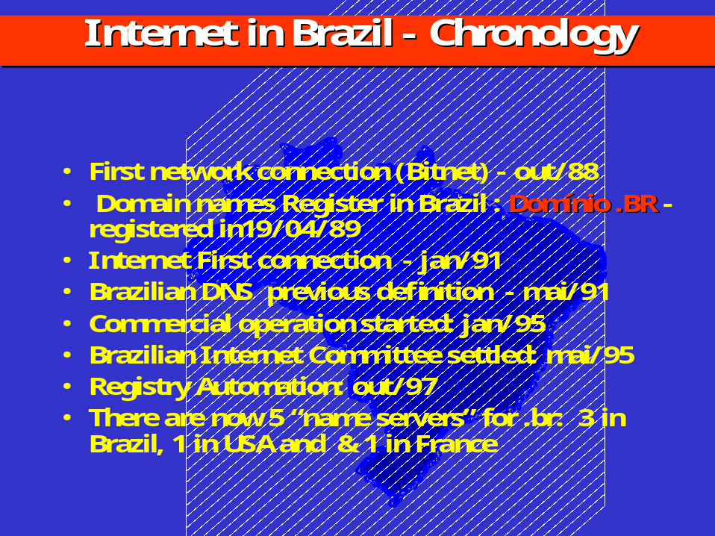

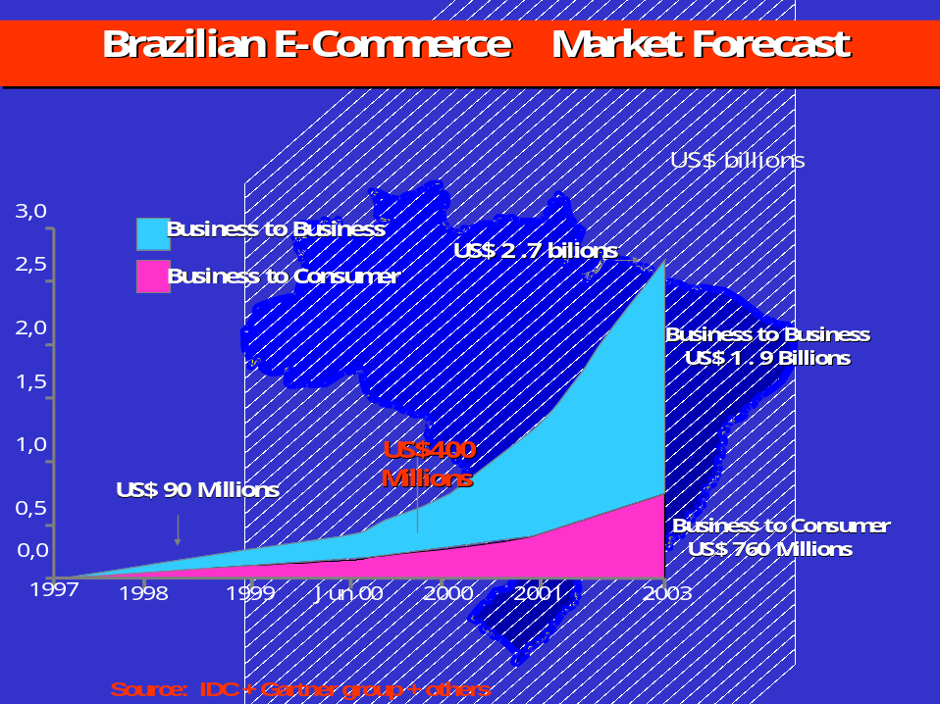

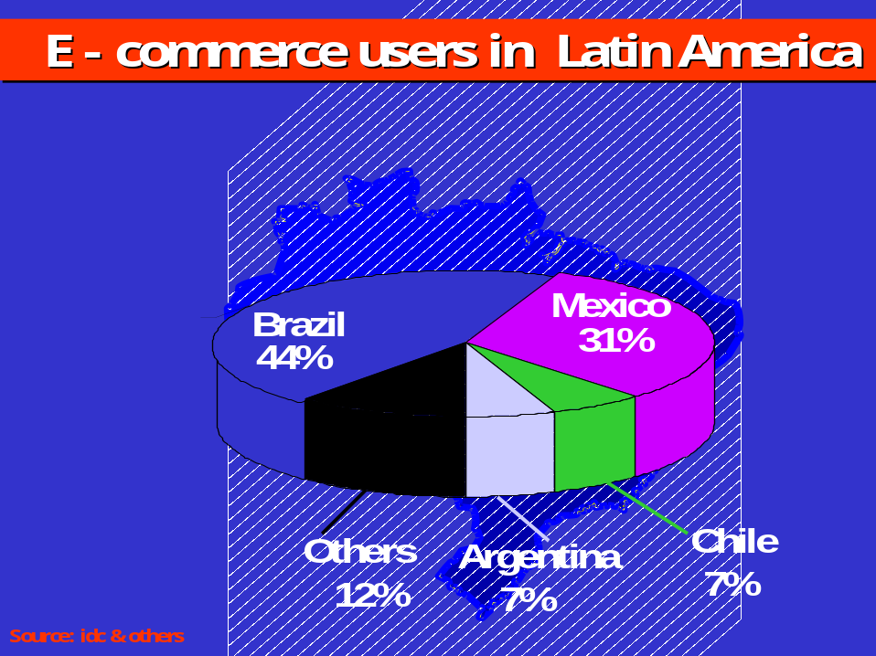


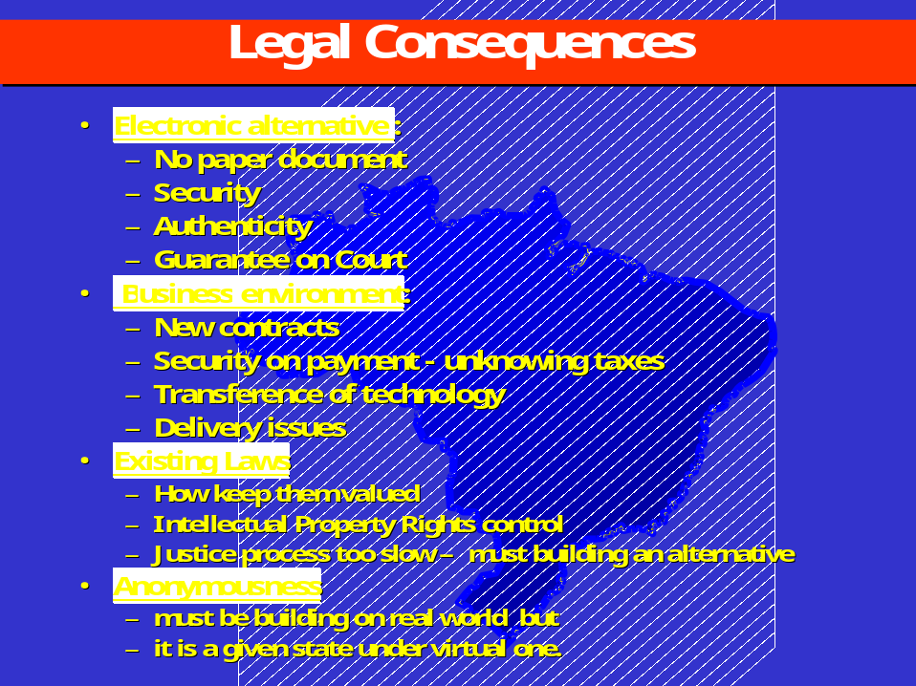

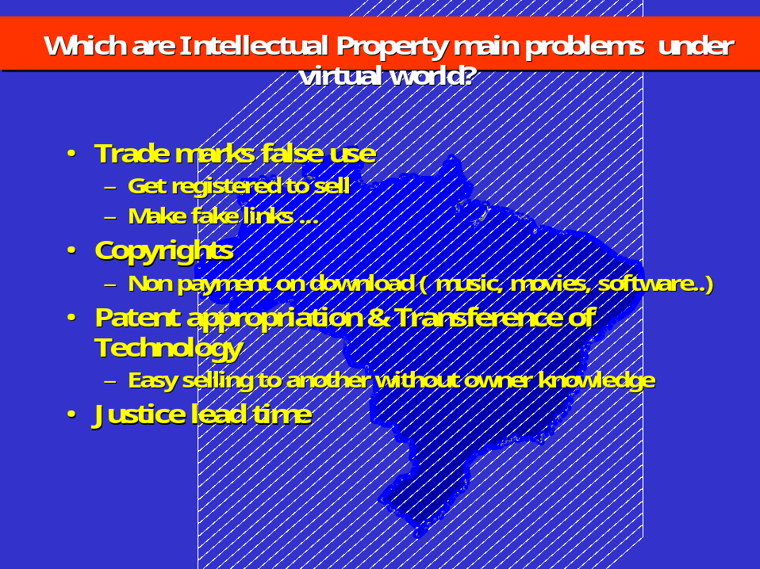

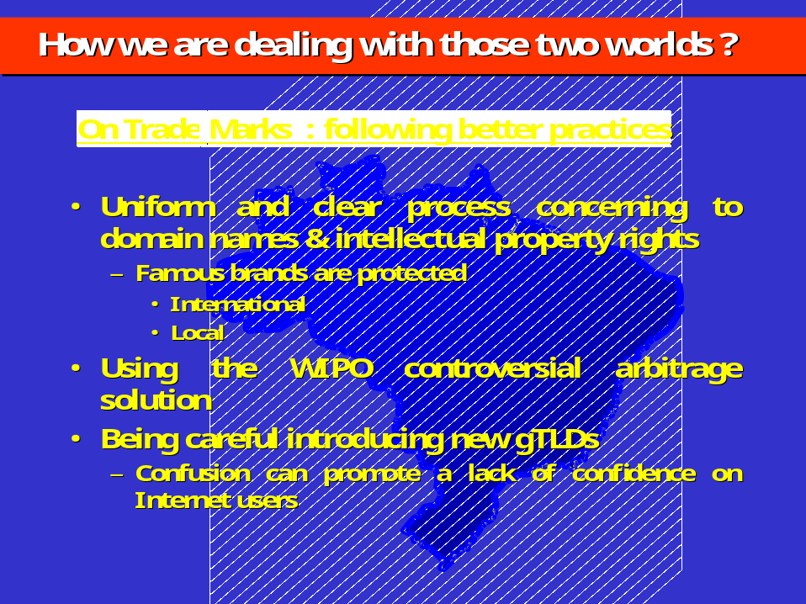


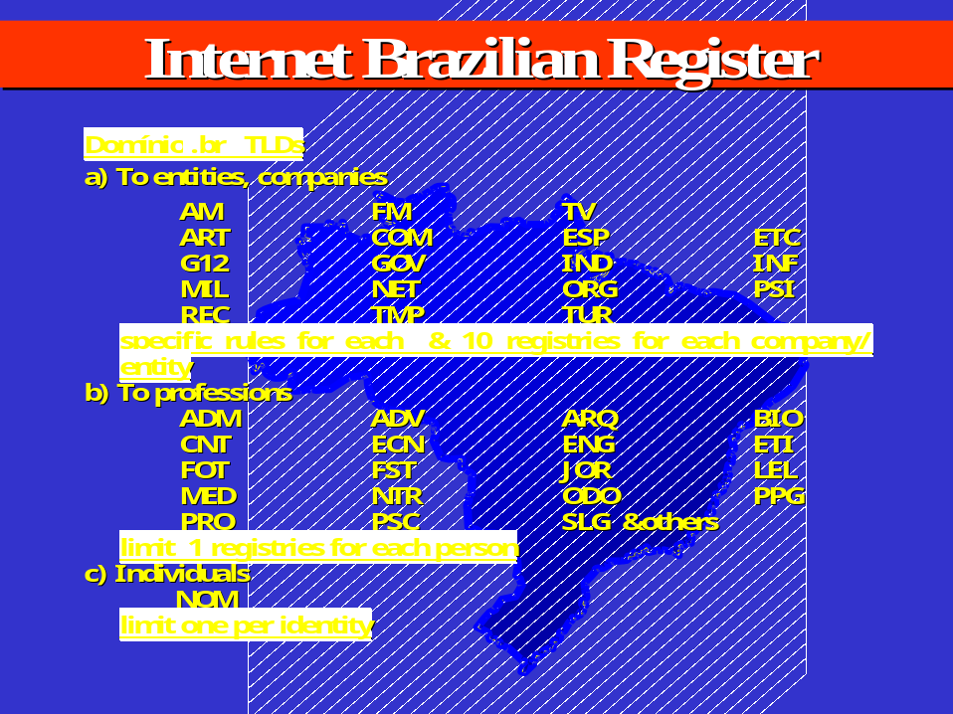

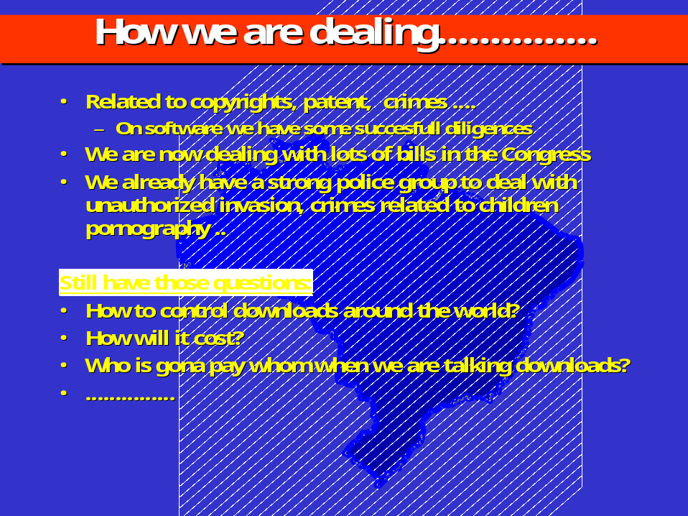

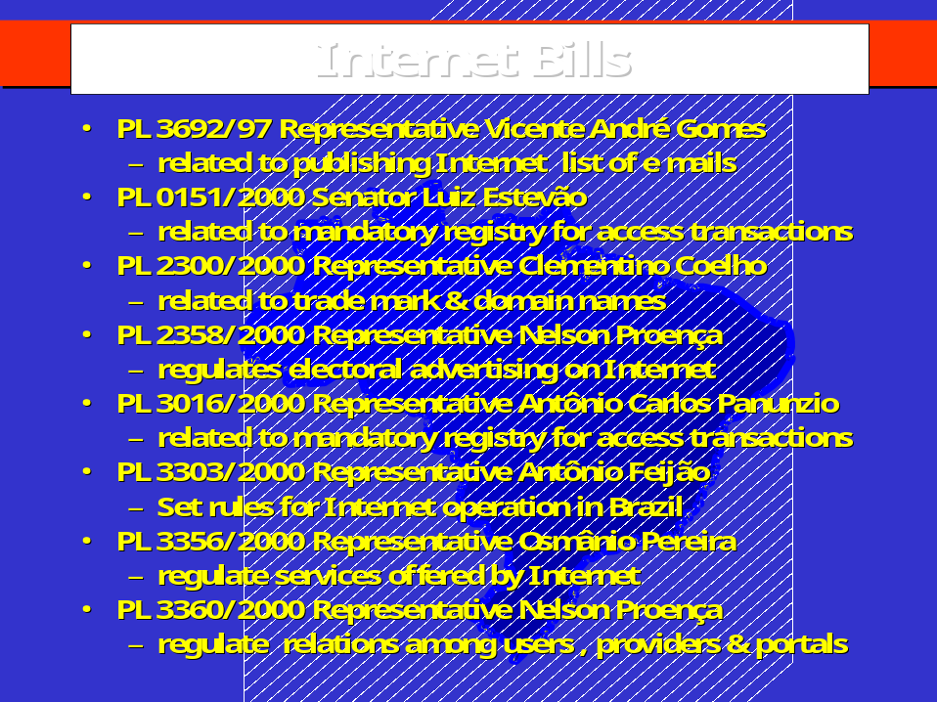
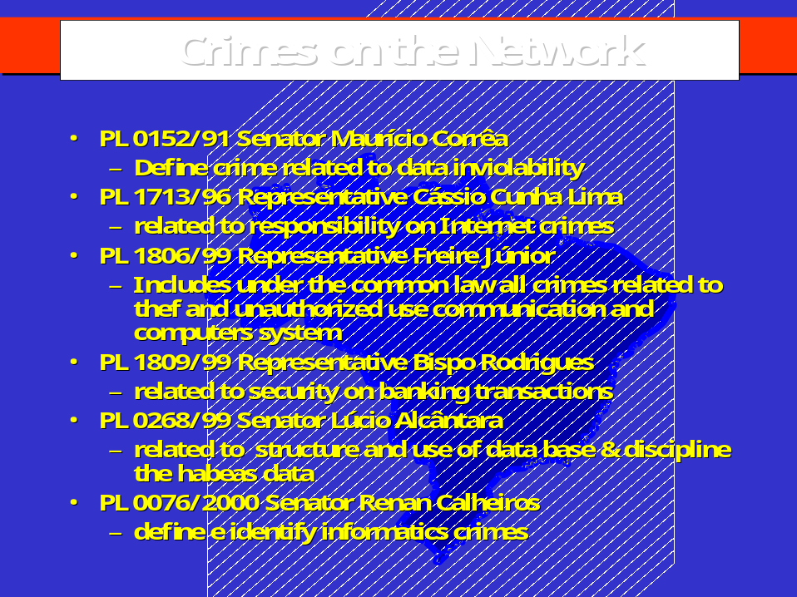

[End of document]

