E
H/LD/WG/8/5
ORIGINAL: English
DATE: October 7, 2019
Working Group on the Legal Development of the Hague System for the International Registration of Industrial Designs
Eighth Session
Geneva, October 30 to November 1, 2019
Possible Options for the Introduction of New Languages Into the hague System
Document prepared by the International Bureau

I. INTRODUCTION
At the seventh session of the Working Group on the Legal Development of the Hague System for the International Registration of Industrial Designs (hereinafter referred to as the “Working Group” and the “Hague System”), held from July 16 to 18, 2018, the Delegation of the Russian Federation presented a proposal for the introduction of Russian as an official language of the Hague System.
In March 2018, the International Bureau also received from the Commissioner of the State Intellectual Property Office of the People’s Republic of China (SIPO) a request to consider the possible inclusion of Chinese as a working language of the Hague System. China has indicated its likely accession to the Geneva (1999) Act of the Hague Agreement in the near future.
At the seventh session of the Working Group, the International Bureau presented an information paper on the language regime of the Hague System (document H/LD/WG/7/INF/2). The paper described the trilingual regime under Rule 6 of the Common Regulations Under the 1999 Act and the 1960 Act of the Hague Agreement (hereinafter referred to as the “Common Regulations”). It also described the language regime under the Madrid System for the International Registrations of Marks and under the Patent Cooperation Treaty System (hereinafter referred to as the “Madrid System” and the “PCT System”).
The aforementioned information paper stated that an in-depth study would be necessary to analyze the implications of introducing new languages into the Hague System and suggested that the study identify various possible models for this purpose. The Working Group requested the International Bureau to prepare, for discussion at its eighth session, a detailed analysis describing models and their implications for a possible expansion of the language regime of the Hague System.
This document elaborates on the implications for the Hague System of the introduction of new languages, proposes possible criteria for introducing new languages, presents various options for such introduction, and discusses their advantages and disadvantages. The estimated translation costs for each implementation option for the International Bureau are presented in the Annex to this document.

II. Possible criteria for Introducing New Languages

current three languages: statistical overview on filings and decisions
International applications may be filed in English, French or Spanish under the Hague System. Since 2016, the share of applications filed in English has been around 86 per cent, French around 12 per cent and Spanish around one per cent (refer to the chart below). On the other hand, more than 99 per cent of decisions received from Offices have been in English.
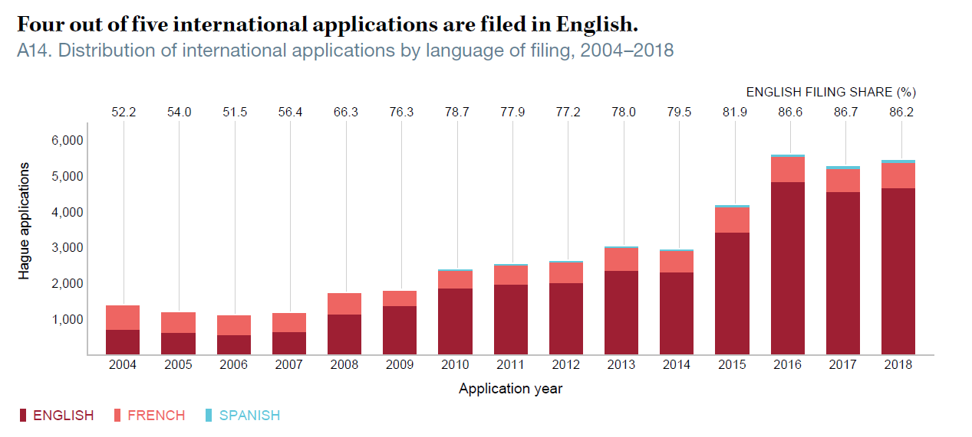
There is a great difference observed in their usage among the current three languages. Before outlining the implementation options for introducing new languages, the Working Group may consider specific criteria that should be met for their possible introductions. For example, the Assemblies of the PCT Union and of the Madrid Union have discussed possible criteria for introducing new languages into the respective systems.

Current filing activities
As a first criterion, the filing activity - both the number of international applications filed under the Hague System and direct applications filed abroad – may be taken into account.

Number of International Applications and Designs Contained Therein Under the Hague System
The Working Group could take into account the number of international applications filed by applicants from a Contracting Party or Contracting Parties, as well as the number of designs contained in such international applications, where a given language, other than English, French or Spanish, may be used to file domestic applications. These numbers could indicate the potential filings of international applications in that language under the Hague System.
In 2018, there were 5,429 international applications filed under the Hague System containing 19,344 designs. Looking in detail at the top 10 origins of international applications, by order of the number of international applications, applicants from the Republic of Korea where Korean is the official language filed 917 applications (containing 1,531 designs), applicants from Germany where German is the official language filed 710 applications (containing 3,948 designs), applicants from Switzerland where German, French, Italian and Rheto-Romanic are the official languages filed 630 applications (containing 2,374 designs); applicants from Japan where Japanese is the official language filed 396 applications (containing 1,251 designs), applicants from Italy where Italian is the official language filed 323 applications (containing 1,258 designs), applicants from the Netherlands where Dutch is the official language filed 179 applications (containing 1,353 designs); and applicants from China where Chinese is the official language filed 139 applications (containing 315 designs).

International Applications from the Top 20 Origins in 2018
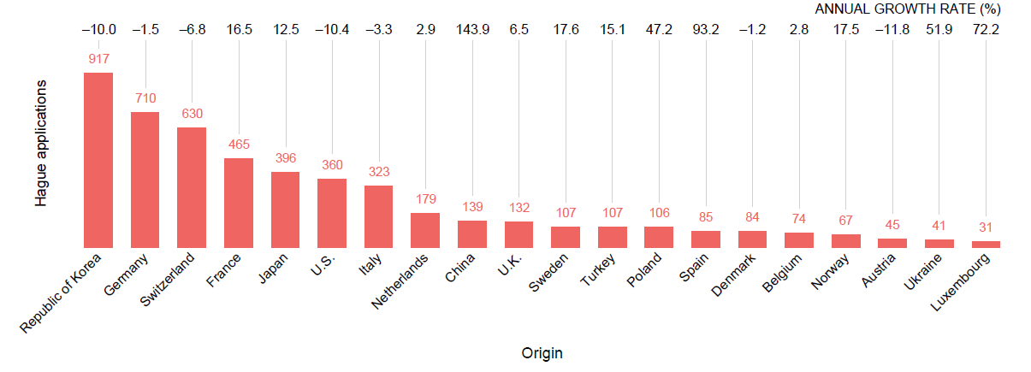

Designs Contained in International Applications from the Top 20 Origins in 2018
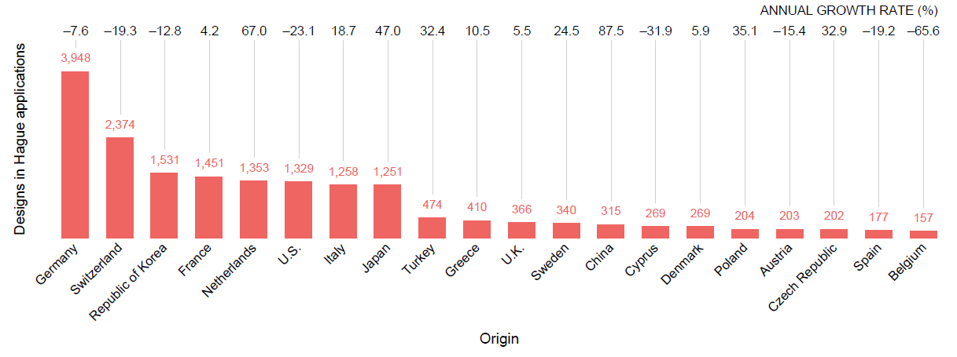
In addition, in terms of the number of designs contained in international applications by the top 10 origins (not also contained in the top 10 of international applications filed), applications originating from Turkey where Turkish is an official language contained 474 designs (in 107 applications) and applications from Greece where Greek is an official language contained 410 designs (in 10 applications).

Number of Designs Contained in Applications Filed Abroad
Applicants seeking design protection in foreign jurisdictions can either file applications directly with a national or regional Office or, where possible, through the Hague System. Thus, the Working Group could also consider the number of designs contained in applications filed abroad – directly or through the Hague System – by residents in countries where a given language, other than English, French or Spanish, is an official language of that State.
In this regard, the top 20 origins for applicants seeking protection abroad for their designs are provided in the table below. In 2017, 278,766 designs were contained in applications filed abroad (direct filing and through the Hague System) by those applicants. In that year, by order of the number of designs, applications filed abroad originating from Germany contained 35,539 designs, from the United States, 34,008 designs, from France, 25,460 designs, from Switzerland, 20,497 designs, from Japan, 17,854 designs, from China, 16,849 designs, from Italy, 16,707 designs, from the United Kingdom, 12,534 designs, from the Republic of Korea, 8,663 designs, from the Netherlands, 6,318 designs, from Spain, 5,912 designs, from Poland, 5,167 designs, from Sweden, 3,541 designs, from Austria, 3,122 designs, from Denmark, 2,901 designs, from the Czech Republic, 1,994 designs, from Australia, 1,950 designs, from Belgium, 1,921 designs, from Turkey, 1,816 designs and from Canada, 1,749 designs.

Designs Contained in Applications Filed Abroad from the Top 20 Origins in 2017

Official languages of the United nations
The Working Group may take into account that Arabic, Chinese, English, French, Russian and Spanish are the six official languages of the United Nations. Language coverage for documentation for meetings of the World Intellectual Property Organization (WIPO) Main Bodies, Committees and Working Groups, as well as for core and new publications, extends to the six official languages of the United Nations, in accordance with the language policy adopted by the General Assembly of WIPO in September 2010. Nevertheless, that policy does not currently apply to services provided under WIPO-administered treaties, such as, international registration services provided under the Madrid and Hague Systems.

III. Further considerations for Introducing New Languages
One significant consequence of introducing new languages into the Hague System is the need for translation and the developments of the ICT systems that would enable the use of the new languages. Thus, the document elaborates on the implication for the Hague System of a possible introduction of new languages, from a general point of view, before exploring various options.

current operational translation work
On a daily basis, translation transactions concern certain text matters in the international application. These are the indication of the product which constitutes the industrial design or in relation to which the industrial design is to be used (Rule 7(3)(iv) of the Common Regulations), a description of the characteristic features of the industrial design (Rules 7(4)(b) and (5)(a) and 11(2)), and a brief description of the reproduction (so-called “legend”) (Rule 7(4)(b) and (5)(a) and Section 405(c) of the Administrative Instructions for the Application of the Hague Agreement).
From January to November in 2018, the International Bureau translated 362,641 words, which were contained in 4,942 international applications. Of those words, 92.2 per cent were in English, 6.9 per cent in French and 1 per cent in Spanish.
At present, the translation of those text matters is performed by in-house translators mainly working for the operation of the Madrid System. This means that, in terms of translation, the operation of the Hague System relies entirely on the Madrid translation resources. As long as this situation continues, a potential development of the Hague language regime should be limited to the translation resources available under the Madrid System.

possible approach: introducing one new language at a time
In view of the above, at its last and seventeenth session held in July 2019, the Working Group on the Legal Development of the Madrid System for the International Registration of Marks (hereinafter referred to as the “Madrid Working Group”) discussed the possibility to introduce new languages into the Madrid System one at a time, following an agreed upon sequence (refer to document MM/LD/WG/17/7 Rev., paragraphs 19 to 24). There was, however, no consensus during the seventeenth session in this regard. The International Bureau was requested to prepare a comprehensive study of the cost implications and technical feasibility of the gradual introduction of the proposed new languages into the Madrid System.
Depending on the implementation options, in general, should a new language be introduced, the International Bureau would be required to either acquire or retrain human resources skilled in the new language to perform all relevant functions, such as, data-entry, examination, translation, record-management, customer service, quality assurance, information and promotion, ICT and legal skills to meet users’ needs and expectations.
The introduction of a new language into the Hague System, particularly of a language in non-Latin script, would require introducing changes to the internal and external ICT systems of the International Bureau. Those changes would be required to process, display, publish and communicate information in the new language. All ICT systems changes must be defined as detailed technical specifications, developed, and tested before they are deployed.
Furthermore, an investment must be made to populate reference databases that are essential for the proper administration of the Hague System with information in the new language. For example, all standard communications and the Locarno classification database must be available in the new language.
The organizational and ICT changes described above are likely to result in a period of adjustment for the operations under the Hague System. For historical reference, the Hague System was initially operated in French only. English was introduced in 1984 and Spanish in 2010. In the case of the Madrid System, after a long monolingual regime in French, English was introduced in 1996 and Spanish in 2004. The PCT System started in 1970 with five publication languages, namely, English, French, German, Japanese and Russian. Subsequently, Spanish (in 1985), Chinese (in 1994), Arabic (in 2006), Korean and Portuguese (both in 2009) were added.

possible change to the current translation practices
In view of a possible expansion of the language regime of the Madrid System, the Madrid Working Group also considered at its seventeenth session different translation practices and their implications, in particular, the possibility to introduce an “indirect translation” practice. For detailed explanations and implications, reference is made to document MM/LD/WG/17/7 Rev., paragraphs 25 to 44.
Under the “direct translation” currently in place, a text is translated from one language (hereinafter referred to as the “source language”) in parallel into the other two languages (hereinafter referred to as the “target language”). As an alternative, translation could be done from the source language into one of the target languages and then from this language into the other target languages.
For example, should Russian be introduced into the Hague System, a text in Russian would be translated into English as the “relay language”, and from English into French and Spanish. Similarly, a text in French and Spanish would be translated into English, and from English into Russian.
The relay language would be the language in which most international applications are received because this would decrease the overall need for relay translation and for which high quality translation resources are already available at a reasonable cost. Under the Hague System, as under the Madrid System, most communications received from applicants, holders and Offices are in English. As mentioned in paragraph 6, above, 86 per cent of international applications were filed in English in the past few years. Both systems operating in the same three languages sharing the same translation resources, the implications of direct and indirect translation practices described in document MM/LD/WG/17/7 Rev., paragraphs 35 to 42, would apply equally to the Hague System.
One significant difference is, however, the nature of the text matter to be translated. While a product indication and a brief description of the reproduction are, for the most part, short and simple texts, similar to indications of goods and services for trademarks, a description of the characteristic features of the industrial design is a complex text that can become very long. Thus, the introduction of new languages could result in additional quality implications, as well as processing time implications, as far as the translation of that particular item is concerned.
The difference in cost implications between the two practices would vary depending on the new language to be introduced in the Hague System and the implementation option selected for the inclusion. Further information about the cost implications of both practices under each option can be found in the Annex to this document. However, the nuance explained in the previous paragraph stemming from the nature of the text matter is not reflected in the cost estimates.

IV. Possible implementation Options for Introducing New Languages
Possible implementation options for introducing new languages into the Hague System are described below by order of complexity. The first option, the filing language option, is the least complex option. Each one of the options successively described below increases in complexity by providing for additional features, and would have increasingly higher operational and cost implications. Each name given to each option should be considered to be tentative and remain rather descriptive.

Similar options are set out in document MM/LD/WG/17/7 Rev., presented to the seventeenth session of the Madrid Working Group (refer to paragraphs 45 to 71 of the said document). In this regard, it should be noted that, under the Hague System, applicants are always given the possibility to file international applications in any language available through these options, while under the Madrid System the applicant’s choice in terms of filing languages is naturally reduced to the Office of origin’s choice of the prescribed languages (usually a single language).

(A) FILING Language
Under this option, applicants would be able to file international applications in the new language.
The International Bureau would examine the international application in that language. It would also communicate with the applicant in that language, unless the applicant has indicated that it wishes to receive communications from the International Bureau in English, French or Spanish.
After examination has been completed, the International Bureau would translate the relevant information in the international application into English, French and Spanish and would record and publish the international registration in these three languages.
However, all further communications concerning the international registration with the holder and Offices would continue to be in English, French or Spanish only.

Remarks/Implications
Applicants would be able to complete all steps of the international application process in the new language.
The International Bureau would have to develop and maintain the international application form (DM/1) and the filing interface under eHague in the new language.
The international application would have to be translated into three languages, as opposed to two languages which is the current situation. There would be no increase in processing time before examination as the formal examination would be carried out in that new language.
The International Bureau would be required to hire, train and retain examiners and translators/senior translators proficient in the new language.
This implementation option would result in a moderate increase in translation costs, depending on the number of international applications filed in the new language.

(B) publication Language
Building on the previous option where the international application was filed and examined in the new language, the International Bureau would furthermore record the international registration in that language. Accordingly, and following its translation into English, French and Spanish, the international registration would be recorded and published in those four languages.

Moreover, for international registrations published in that new language only, Offices of designated Contracting Parties would be able to send communications (i.e., notifications of refusal and statements of grant of protection) in that language, as well as English, French or Spanish.
The holders of international registrations published in the new language would be able to send communications to the International Bureau in that language (i.e., present a request for the recording of a change) and receive communications from the International Bureau in that language.
44. The recording, publication and communications concerning international registrations that result from an application filed in English, French or Spanish would continue to be in those languages only.

Remarks/Implications
45. This option would introduce a new language already beyond the level of the current 10 publication languages under the PCT System, since the international registration would not only be “recorded” and “published” in the new language, but also “the Office of a designated Contracting Party would be allowed to send communications” in that language.
46. This option would facilitate both users and Offices, so as to be able to communicate in their mutually preferable language, while avoiding the use of that language in other irrelevant contexts. For instance, if the international application was filed in either of the current three languages, the holder would not receive communications from any Office in any new language.
47. As under the previous option, the International Bureau would have to develop and maintain the international application form and electronic interface in the new language. In addition, such technical development and maintenance would need to be extended to other official forms, publication (i.e., International Designs Bulletin) and relevant database (i.e., Global Design Database), as well as communications between Offices and the International Bureau.

(C) publication and office communication language
48. This is an extended version of the previous option. Under this option, the Office of a Contracting Party could choose to send communications (i.e., notifications of refusal and statements of grant of protection) in a new language, irrespective of the language in which the international application was filed.
49. The International Bureau would record the international registration in the language in which the application was filed and would make the necessary translations for its publication into English, French and Spanish, as well as another new language if the Office of any designated Contracting Party has selected that language.

Remarks/Implications
50. This option would not extend the applicants’ convenience further than the previous option, except that additional translations of certain texts (i.e., a product indication and, if any, a description and/or legends) would be made available and published by the International Bureau in the new language, depending on the Contracting Parties designated in the international application, which may help enforce rights in a given jurisdiction.

51. On the other hand, unlike under the previous option, the holder could receive communications from the Office of a designated Contracting Party in a new language, regardless of the language of filing. Therefore, a holder not familiar with that language could face difficulties in understanding and handling the decisions.
52. Additional translation and operational workload, in particular for handling communications from Offices in new languages, would require the International Bureau to hire, train and retain more personnel proficient in the new language than under the previous options.

(D) Working Language
53. Under this option, the regime currently envisaged in Rule 6 of the Common Regulations would also apply to the new language. In other words, in contrast with the previous options, the International Bureau would be required to translate all international registrations (in all cases) into any new language in addition to English, French and Spanish.

Remarks/Implications
54. International registrations and all recordings would be available in all working languages. Accordingly, more Offices and third parties would be able to understand the international registration and the decisions in the new language if they are more familiar with that language.
55. Such routine translations into all working languages would, however, create a number of unnecessary translations that would not be used, at a high cost for the Hague Union. The average number of designations in an international application in 2018 was 3.6 Contracting Parties. At present, most of the Offices of designated Contracting Parties carry out the examination in English (over 99 per cent of decisions received in 2018 were in English).

additional remarks on cost implications
56. Cost estimates for each of the above implementing options are presented in the Annex to this document. The costs are estimated based on the possible inclusion of Russian or Chinese, whose methodology and format follow, with some adjustments, similar cost estimates contained in the annex to document MM/LD/WG/17/7 Rev.
57. The cost estimates cover “operational translation costs” only, excluding the resources and costs that would be required for the developments and adjustments to the ICT systems (including relevant database and publication platform) of the International Bureau and for their maintenance. The International Bureau would also need to develop and maintain all official forms DM/1 to DM/9, electronic tools (eHague; eRenewal), information materials (i.e., users guide and other website contents) in the additional language, depending on the implementation options.
58. Finally, all options will require additional human resources in the Hague Operations Service. The introduction of a new language would affect all other areas of the Hague Registry, where resources proficient in the new languages would be required.

Possible Review of the Current Language Regime
59. Developing the Hague System by introducing new languages may be beneficial due to the geographical expansion of the system but also desirable because it brings the system closer to all its users.
60. However, introducing new languages under the current language regime envisaged in Rule 6 of the Common Regulations would not be possible without placing a heavy financial and administrative burden on the Hague Union which already has a recurrent deficit and thus could further threaten the long-term sustainability of the Hague System.
61. The objective of having a linguistically diverse Hague System serving the needs of its global user base could be achieved only if the benefits and implications are carefully balanced among all stakeholders. With that objective in mind, the Working Group may wish to consider whether a comprehensive review of the current language regime of the Hague System should be undertaken.
62. The Working Group is invited to:
    - discuss and comment on the criteria for the introduction of new languages into the Hague System presented in this document;
    - indicate its preferred implementation option for introducing a new language amongst those set out in paragraphs 32 to 58; and,
(iii) indicate whether it would undertake a comprehensive review of the current language regime of the Hague System and, if so, provide guidance on how to proceed with such review.
[Annex follows]

implementation Options for introducing New languages into the Hague System: translation cost estimates

Filing Language; and (B) publication Language
Russian only |  |  |  |  |  | Chinese only
 | Direct Translation |  | Indirect Translation through English |  |  |  | Direct Translation |  | Indirect Translation through English
 | Outsourced Translation Editing (CHF) | Translation Quality Control (Work Days) | Outsourced Translation Editing (CHF) | Translation Quality Control (Work Days) |  |  | Outsourced Translation Editing (CHF) | Translation Quality Control (Work Days) | Outsourced Translation Editing (CHF) | Translation Quality Control (Work Days)
2019 | 9,164 | 0.63 | 2,540 | 0.21 |  | 2019 | 3,346 | 0.29 | 800 | 0.10
2020 | 9,973 | 0.68 | 2,764 | 0.23 |  | 2020 | 3,902 | 0.34 | 932 | 0.11
2021 | 10,841 | 0.74 | 3,004 | 0.25 |  | 2021 | 4,546 | 0.39 | 1,086 | 0.13
2022 | 11,772 | 0.81 | 3,262 | 0.27 |  | 2022 | 5,291 | 0.46 | 1,264 | 0.15
2023 | 12,768 | 0.87 | 3,538 | 0.29 |  | 2023 | 6,150 | 0.53 | 1,470 | 0.18
2024 | 13,830 | 0.95 | 3,832 | 0.32 |  | 2024 | 7,140 | 0.62 | 1,706 | 0.21
2025 | 14,960 | 1.02 | 4,146 | 0.34 |  | 2025 | 8,278 | 0.72 | 1,978 | 0.24
2026 | 16,159 | 1.10 | 4,478 | 0.37 |  | 2026 | 9,583 | 0.83 | 2,290 | 0.28
2027 | 17,426 | 1.19 | 4,829 | 0.40 |  | 2027 | 11,075 | 0.96 | 2,647 | 0.32
2028 | 18,759 | 1.28 | 5,198 | 0.43 |  | 2028 | 12,778 | 1.10 | 3,054 | 0.37
2029 | 20,156 | 1.38 | 5,585 | 0.46 |  | 2029 | 14,715 | 1.27 | 3,516 | 0.42

(c) publication and office Communication Language
Russian only |  |  |  |  |  | Chinese only
 | Direct Translation |  | Indirect Translation through English |  |  |  | Direct Translation |  | Indirect Translation through English
 | Outsourced Translation Editing (CHF) | Translation Quality Control (Work Days) | Outsourced Translation Editing (CHF) | Translation Quality Control (Work Days) |  |  | Outsourced Translation Editing (CHF) | Translation Quality Control (Work Days) | Outsourced Translation Editing (CHF) | Translation Quality Control (Work Days)
2019 | 13,700 | 1.70 | 6,892 | 0.57 |  | 2019 | 9,680 | 2.41 | 6,655 | 0.80
2020 | 15,408 | 1.97 | 7,979 | 0.66 |  | 2020 | 10,427 | 2.52 | 6,964 | 0.84
2021 | 16,560 | 2.10 | 8,492 | 0.70 |  | 2021 | 11,251 | 2.63 | 7,284 | 0.88
2022 | 17,789 | 2.23 | 9,036 | 0.74 |  | 2022 | 12,169 | 2.76 | 7,622 | 0.92
2023 | 19,071 | 2.37 | 9,587 | 0.79 |  | 2023 | 13,164 | 2.88 | 7,953 | 0.96
2024 | 20,378 | 2.50 | 10,116 | 0.83 |  | 2024 | 14,219 | 2.98 | 8,250 | 0.99
2025 | 21,765 | 2.63 | 10,676 | 0.88 |  | 2025 | 15,424 | 3.10 | 8,584 | 1.03
2026 | 23,052 | 2.74 | 11,093 | 0.91 |  | 2026 | 16,788 | 3.24 | 8,951 | 1.08
2027 | 24,372 | 2.84 | 11,495 | 0.95 |  | 2027 | 18,307 | 3.37 | 9,332 | 1.12
2028 | 25,726 | 2.93 | 11,884 | 0.98 |  | 2028 | 20,001 | 3.52 | 9,731 | 1.17
2029 | 27,338 | 3.08 | 12,477 | 1.03 |  | 2029 | 21,909 | 3.68 | 10,167 | 1.23

(d) Working Language
Russian only |  |  |  |  |  | Chinese only
 | Direct Translation |  | Indirect Translation through English |  |  |  | Direct Translation |  | Indirect Translation through English
 | Outsourced Translation Editing (CHF) | Translation Quality Control (Work Days) | Outsourced Translation Editing (CHF) | Translation Quality Control (Work Days) |  |  | Outsourced Translation Editing (CHF) | Translation Quality Control (Work Days) | Outsourced Translation Editing (CHF) | Translation Quality Control (Work Days)
2019 | 47,926 | 10.19 | 41,301 | 3.40 |  | 2019 | 30,739 | 10.19 | 28,192 | 3.40
2020 | 51,002 | 10.81 | 43,793 | 3.60 |  | 2020 | 32,863 | 10.81 | 29,893 | 3.60
2021 | 54,239 | 11.45 | 46,402 | 3.82 |  | 2021 | 35,135 | 11.45 | 31,675 | 3.82
2022 | 57,641 | 12.12 | 49,131 | 4.04 |  | 2022 | 37,564 | 12.12 | 33,537 | 4.04
2023 | 61,210 | 12.83 | 51,980 | 4.28 |  | 2023 | 40,163 | 12.83 | 35,482 | 4.28
2024 | 64,946 | 13.56 | 54,948 | 4.52 |  | 2024 | 42,942 | 13.56 | 37,508 | 4.52
2025 | 68,849 | 14.32 | 58,034 | 4.77 |  | 2025 | 45,914 | 14.32 | 39,615 | 4.77
2026 | 72,915 | 15.11 | 61,234 | 5.04 |  | 2026 | 49,092 | 15.11 | 41,799 | 5.04
2027 | 77,140 | 15.93 | 64,543 | 5.31 |  | 2027 | 52,487 | 15.93 | 44,058 | 5.31
2028 | 81,515 | 16.77 | 67,955 | 5.59 |  | 2028 | 56,111 | 16.77 | 46,386 | 5.59
2029 | 86,028 | 17.63 | 71,457 | 5.88 |  | 2029 | 59,976 | 17.63 | 48,777 | 5.88
[End of Annex and of document]

Refer to document H/LD/WG/7/5.
SIPO became the China National Intellectual Property Administration (CNIPA) after the submission of the said request.
Refer to documents H/LD/WG/7/10, paragraph 21, and to H/LD/WG/7/11 PROV., paragraph 140.
Extracted from Hague Yearly Review 2019.
Refer to documents PCT/A/38/4 and PCT/A/38/6, Annex III.
Refer to documents MM/A/42/1 and MM/A/42/4.
The origin of an application is defined as the country/territory of the stated address of residence of the applicant. Applicants residing in a non-member country can file international applications if they have a real and effective industrial or commercial establishment within the jurisdiction of a Contracting Party of the Hague System.
Domestic design applications may be filed with the Swiss Federal Institute of Intellectual Property in German, French, Italian and Rhaeto-Romanic. According to the said Office, in 2018, 497 domestic applications were filed in German, 172 in French, 35 in Italian and none in Rhaeto-Romanic. This means that around 71 per cent were filed in German, 24 per cent in French and 5 per cent in Italian.
Domestic design applications must be filed with the Benelux Office for Intellectual Property (BOIP) which accepts filings in Dutch, French or English.
Extracted from the Hague Yearly Review 2019.
Extracted from the Hague Yearly Review 2019.
Some jurisdictions have a single design application system, while others have a multiple design application system. Thus, the number of designs is used as opposed to the number of applications for this comparison.
Refer to the World Intellectual Property Indicator 2018, pages 164 to 167. The data for applications filed directly with national or regional IP Offices are only available up to 2017, as of the date of this document.
Refer to documents A/48/26, paragraph 250 and A/49/18, paragraphs 173 to 184.
No data is available for December 2018, due to the replacement of the IT system in November 2018.
Of which 34 per cent were translated using automated translation tools. The remaining words were translated by human translation resources.
Furthermore, the technology and terminology databases are now centralized under the PCT’s Translation and Terminology Technology Section.
The International Bureau received proposals to include three additional languages in the Madrid System, namely, Arabic, Chinese and Russian.
Refer to document MM/LD/WG/17/11, paragraph 23.
At the same time as the 1960 Act entered into force.
It is recalled that the International Bureau does not translate a decision received from an Office (i.e., refusal grounds and amended product indications or descriptions or other added information).
Also refer to document MM/LD/WG/17/7 Rev., paragraph 74.
The cost estimate is based on the following conditions and takes into account the expected growth rates of the number of international applications: – 20 per cent automated translation in 2019, increasing by 2.5 per cent each year; – fee per word from Chinese to English is CHF0.157; to French, CHF0.25; to Spanish, CHF0.25; – fee per word from Russian to English is CHF0.23; to French, CHF0.3; and to Spanish, CHF0.3; and, – quality control consists of revising a random sample of about 7 per cent of the edited work. A senior translator whose first language is the target language should conduct quality control. A senior translator reviews 3,700 words for translation per day.
In this and all subsequent options, resources fluent in the new language are required to process applications filed in that language.
The cost of outsourcing the translation and editing work and the resources required for controlling the quality of this work are the same as under these options.
Applicants from the following Contracting Parties are likely to present international applications in Russian: Armenia, Azerbaijan, Georgia, Kyrgyzstan, Republic of Moldova, Russian Federation, Tajikistan, Turkmenistan and Ukraine. The growth rate is forecast from the trend of international applications filed by applicants from those Contracting Parties from 2015 to 2018; the resulting average annual increase would be 12 per cent.
Only applicants from China are likely to present international applications in Chinese. The growth rate of the number of international applications is forecast by the Economic and Statistics Division.
Three senior translators would be required for “direct translation” from the new language (Chinese or Russian) into English, French and Spanish.
One senior translator would be required for “indirect translation” from the new language (Chinese or Russian) through English.
In this option, the International Bureau would translate into the new language if the international application designates a Contracting Party having selected that language for communication. Accordingly, the cost estimates take into account the expected number of international applications filed in English, French or Spanish and which designate China or the Russian speaking Contracting Parties. For designations of the Russian speaking Contracting Parties, the 11.5 per cent designation rate in 2018 is used. For China, 20.3 per cent, which was the designation rate for the current Contracting Parties from the same region (Japan, the Republic of Korea and Singapore) in 2018 is used.
In this option, unlike the previous two options, a “direct translation” practice would require no fewer than four senior translators to control the quality of the outsourced work from the new language (Chinese or Russian) into English, French and Spanish and from these languages into the new language (Chinese or Russian). This would also apply for the “Working Language” option.
In this option, unlike the previous two options, an “indirect translation” practice would require no fewer than two senior translators to control the quality of the outsource work from the new language (Chinese or Russian) into English, French and Spanish and from these languages into the new language (Chinese or Russian). This would also apply for the “Working Language” option.
The additional translation workload resulting from the introduction of Chinese or Russian as a working language is practically the same for both languages. Accordingly, the resources required to conduct quality control are the same. However, the cost of outsourced translation is different due to the different rates of translation from and into those languages.

