|  |  |  |
| --- | --- | --- |
|  | WIPO-E | **E** |
| H/LD/WG/8/4 | | |
| ORIGINAL: English | | |
| DATE: September 16, 2019 | | |

**Working Group on the Legal Development of the Hague System for the International Registration of Industrial Designs**

**Eighth Session**

**Geneva, October 30 to November 1, 2019**

financial sustainability of the hague System; possible revision of the schedule of fees

*Document prepared by the International Bureau*

# I. BACKGROUND

## FINANCIAL SUSTAINABILITY OF THE HAGUE UNION

1. The principle of financial sustainability of the Hague Union is prescribed by Article 23(3)(i) of the 1999 Act of the Hague Agreement Concerning the International Registration of Industrial Designs (hereinafter referred to as the “1999 Act”) in conjunction with Article 23(4)(b) which stipulates that “the amounts of the fees referred to in paragraph (3)(i) [of Article 23] shall be so fixed that the revenues of the Union from fees and other sources shall be at least sufficient to cover all the expenses of the International Bureau concerning the Union”[1].
2. As prescribed by Article 23(3) of the 1999 Act, the budget of the Hague Union shall be financed primarily from “fees relating to international registrations”[2]. Article 23(4)(a) further provides that the amounts of the fees shall be fixed by the Assembly of the Hague Union on the proposal of the Director General of the World Intellectual Property Organization (WIPO). The Schedule of Fees is part of the Common Regulations Under the 1999 Act and the 1960 Act of the Hague Agreement (hereinafter referred to as the “Common Regulations”) whose amendments are subject to approval by the Assembly of the Hague Union.

## WIPO ASSEMBLIES

1. A performance audit was conducted by external auditors in December 2016. In the context of the recurrent deficit of the Hague Union, the report contained the following two recommendations[3]:
   * 1. the Management may consider framing an actionable strategy early for making the Hague System self-sufficient and overcoming the recurrent deficits;
     2. the Management may consider placing in the Hague Union Assembly proposal for revisiting the existing fee structure periodically, with incremental changes for making the Hague Union self-sustaining.
2. During the WIPO Assemblies in October 2017, the representative of the external auditor indicated that “even though there was significant revenue deficit over the years, fee structure of the Hague System had not been revised for over 20 years”[4]. Furthermore, in the process of approving the Proposed Program and Budget for the 2018/19 Biennium, the WIPO Assemblies[5]:

“(ii) Recalled that, in accordance with the treaties of the fee-financed unions, each union should have revenue sufficient to cover its own expenses;

“(iii) Noted that fee-financed unions with a projected biennial deficit in the 2018/19 biennium should examine measures in accordance with its own treaty to address that deficit.”

## HAGUE UNION ASSEMBLY AND WORKING GROUP

1. At its fifth session held in December 2015, the Working Group on the Legal Development of the Hague System for the International Registration of Industrial Designs (hereinafter referred to as the “Working Group”) already discussed a possible revision of the Schedule of Fees aiming to improve the financial sustainability of the Hague System, taking into account the increasing workload of the International Bureau[6] (refer to paragraphs 28 and 29, below, for the outcomes of the discussion).
2. Given the continuing rapid expansion of the Hague System to new jurisdictions and the ongoing development of the new IT platform requiring a certain period for stabilization, a concrete proposal to revise the Schedule of Fees was not presented at the sixth and seventh sessions of the Working Group.
3. At its seventh session held in July 2018, the Delegation of the United States of America presented to the Working Group a document entitled “Contributing to the Financial Well-being of the Organization” and emphasized the need of a comprehensive review of the fee structure and current fees and of an examination of measures to address the deficit[7].
4. Furthermore, at the thirty-eighth (17th extraordinary) session of the Hague Union Assembly held in September 2018, the Delegation of the United States of America took the floor and stated that “…[t]he long-term financial stability of the fee-financed systems was of utmost importance. It would therefore be important for the Working Group to review fees associated with the Hague System. […] The Delegation expected that the Hague Union would respond to the mandate of the WIPO Assemblies of 2017, and that the Secretariat would take the issue into account in its preparation of the agenda of the Working Group in 2019”.

## PURPOSE OF DOCUMENT

1. This document aims to respond to the aforementioned recommendations noted by the Assemblies of WIPO and to seek the views of the Working Group as to whether a revision of the Schedule of Fees should be considered in that regard.

# II. FINANCIAL SITUATION AND ANALYSIS

## HISTORY OF THE DEFICIT

1. The evolution of the Hague Union financial results from the 1994/95 biennium to 2018[8] is presented in Chart 1 below, whilst Chart 2 below shows the number of international registrations, renewals and decisions during the same period.
2. A more comprehensive picture is provided by the chart in Annex I. That chart shows both income and expenditures alongside operational figures and historical events. In essence, the main drivers influencing the financial results during this period appear to be as follows:
3. The Hague Union had a deficit in the 2002/03 biennium for the first time. In 2003, the number of international registrations dropped by 41 per cent against the previous year. It further dropped by 43 per cent in 2004[9]. This was due to the introduction of the community design system in the European Union[10]. At that time, the majority of designations were made for Contracting Parties that were members of the European Union. The number of international registrations reached their lowest point in 2005. The situation, which did not improve until 2008 (the year in which the European Union joined the Hague System), would further have an enduring negative effect on the number of renewals as from 2008[11].
4. Reducing the expenditures – and principally the number of examiners – since the 2004/05 biennium brought a little surplus in the 2008/09 biennium. However, the creation of Program 31 in the 2012/13 biennium has allowed for a situation where specific resources can be associated to the management and development of the Hague System and can be identified as such.
5. While the accessions of the Republic of Korea and Japan and the ratification of the United States of America particularly led to a strong increase in the number of international registrations from 2014 to 2016[12], formal examination by the International Bureau also became increasingly complex as these are all examining jurisdictions. For that same reason, the number of decisions increased by 3.7 times from 2014 to 2017[13]. To cope with the increasing workload, four examiner posts were created between 2015 and 2018[14].
6. In view of supporting both the Madrid and Hague international registration procedures in the long term, the approved IT Modernization Program with a primary focus on the Madrid IT system was developed and deployed between 2007 and 2016. However, as its own business and strategy evolved, it became crucial that the Hague Registry required a modern global IP platform that was specifically developed for, and focused on, its specific requirements[15]. The new Hague IT system was developed and deployed in the course of 2017 and 2018, with near-full reliance on external contractors as the new IT support team were not yet in place, which entailed a total project cost of 6.6 million Swiss francs.

## TEN-Year Projections: Income and Cost

1. In order to explore possibilities for addressing the deficit of the Hague System, projections have been carried out to better understand the projected evolution of application-related activities (volume), income (based on fees) and cost.
2. The application forecast for the Hague System from 2018 to 2029 (Chart 3) has been prepared by the Chief Economist. The volume of applications is expected to increase significantly, reaching 13,210 applications in 2029, i.e., an increase of 7,790 applications, or 143.7 per cent, as compared to 2018. The largest driver of growth in applications is the anticipated accession of China in 2020.

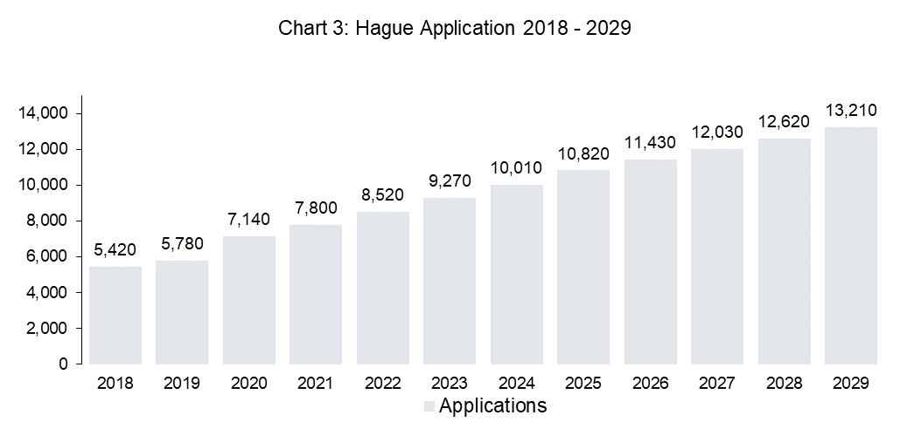

Growth (%)



1. Based on the application forecast and the current fee structure, the Chief Economist has projected the Hague income over the same time period (Chart 4)[16]. The increase in applications is expected to almost double the income over the 10-year horizon to reach 9.7 million Swiss francs in 2029, i.e., an increase of 4.8 million Swiss francs, or 99.5 per cent, as compared to 2018.

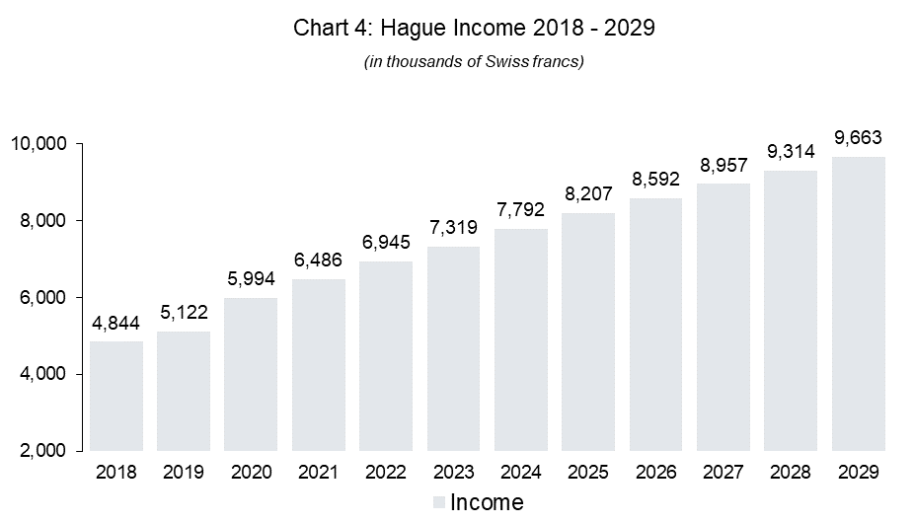

Growth (%)

1. In light of the expected application increase and associated growth in income, a 10-year cost projection has been simulated based on the following framework (see details of assumptions in Annex II):
2. the cost structure of the Hague System is composed of different categories as follows:

(i) administration and management of the Hague Registry;

(ii) legal support;

(iii) development and promotional support;

(iv) operations; and

(v) organizational administration and management support (e.g. premises, HR, IT, finance, etc.).

1. the projection is simulated utilizing 2018 actual expenditure, except for IT which has been based on figures in the Proposed Program and Budget for the 2020/21 biennium;
2. the cost projection considers both fixed cost and variable cost elements. Whilst the variable cost elements are correlated to workload increase, it is assumed that the fixed cost elements will evolve in incremental steps based on reaching critical thresholds of work (i.e., work generated by new accessions).
3. The variable cost elements for the Hague System are assessed considering the volume of transactions, composition of the workload and levels of automation as follows (Chart 5):
   1. the volume of transactions generated per application (ratio of  0.6 renewals, 0.2 changes and 2.3 decisions) is calculated based on 2017/18 trends, and is considered constant over the 10-year projection period with the exception of decisions. In light of recent and expected accessions to the 1999 Act (i.e. jurisdictions issuing decisions), the number of decisions per application is expected to increase to reach 4.2 in 2029;
   2. the processing of the different transactions does not require an equal amount of resources; hence, they are weighted differently in the calculation of the workload. The weighting considers the time required to process one international application;
   3. an examiner can process eight renewals, four changes or four decisions (workload ratio = 1:8:4:4)[17]. This assumption has been maintained at the same level over the 10‑year projection;
   4. the automation capability is expected to improve over the 10-year projection period by five per cent per year for renewals and decisions. The automation for changes at five per cent is introduced from 2022.

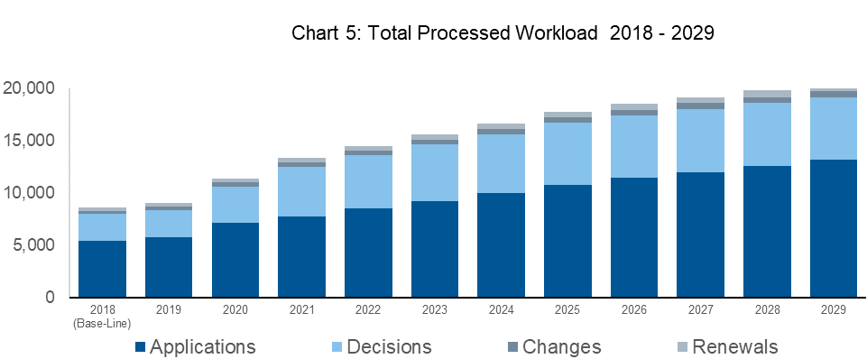

Growth (%)

1. Based on the volume and workload assumptions, the evolution of cost over the 10-year period (Chart 6) is expected to increase from a base-line of 10.2 million Swiss francs in 2018 to reach 15.4 million Swiss francs in 2029, i.e., an increase of 5.2 million Swiss francs, or 51.2 per cent (see calculation details in Annex III).
   1. The year-over-year increase is mainly driven by:
2. the anticipated significant growth of applications and associated processed workload; and
3. new accessions to the 1999 Act (i.e., Canada, China, Russian Federation).
4. The cost structure is expected to remain dominated by fixed cost elements. Even though the anticipated increase in applications and associated workload is expected to somewhat shift the balance, the split of fixed versus variable cost remains at approximately 70/30 at the end of the period under review versus an approximate 80/20 split in the base-line calculation.
5. Based on the application, income and cost estimations, the Hague System is projected to continue with an operational annual deficit over the 10-year period under review, resulting in an estimated accumulated deficit amounting to 95.2 million Swiss francs at the end of 2029. It is to be to noted that this observation is made based on the current fee structure and conservative assumptions for potential productivity improvements. Furthermore, in view of the many different options currently envisaged for an evolution of the language regime of the Hague System, the observation was based on the regime as it currently stands.

# III. possible REVISION OF THE SCHEDULE OF FEES

## CURRENT FEE STRUCTURE AND MAIN SOURCES OF INCOME

1. The Schedule of Fees comprises several items, among which, fees intended for the International Bureau are the following:

### International Application Fee (Items I.1 to I.3 of the Schedule of Fees)

1. These comprise the following items:

– basic fee for international application: 397 Swiss francs for one design and 19 Swiss francs for each additional design contained in the application;

– publication fee: 17 Swiss francs for each reproduction (and, in the case of an application filed on paper, 150 Swiss francs for each page, in addition to the first); and

– additional fee where the description exceeds 100 words: 2 Swiss francs per word exceeding 100 words.

1. Charging the fee per design is common in national and regional systems accepting multiple designs. Although a single international application may contain up to 100 industrial designs, the average number of designs per application has been decreasing over the past years (from 5.5 designs in 2007 to 3.7 designs in 2019).
2. In addition to the basic fee, a publication fee is charged per reproduction. Some national or regional systems also charge per reproduction,

### Renewal Fee (Item III.7 of the Schedule of Fees)

1. This fee is charged per design, which is also common in national and regional systems accepting multiple designs. The current amounts of the basic fee are 200 Swiss francs for one design and 17 Swiss francs for each additional design.

### Other Fees (Items V and VI of the Schedule of Fees)

1. Fees are charged for the recording in the International Register of a change in ownership or of the name and/or address of the holder, of a limitation or a renunciation. Thus, the fee for requesting the recording of a change in ownership or of the name and/or address of the holder is 144 Swiss francs under the current Schedule of Fees. For reference, the corresponding fees under the Madrid System are 177 Swiss francs for a change in ownership and 150 Swiss francs for a change of name and/or address of the holder.
2. Finally, fees are also charged for the provision of certified copies, extracts and other information.

### Income

1. Table 1, below, indicates the amounts received under these respective fee items in 2018[18].

Table 1: The Hague System – Fees and income in 2018

|  |  |  |  |  |
| --- | --- | --- | --- | --- |
| Fees for the International Bureau | | Cases[19] | Amount[20] | Share |
| International applications (items I.1 to 3) | | 4,768 filings | 3,635 | 75.7% |
|  | Basic fee for the first design | 4,767 designs | 1,892 | 39.4% |
| Basic fee for additional designs | 12,467 designs | 237 | 4.9% |
| Publication fee per reproduction | 81,875 reproductions | 1,392 | 29.0% |
| Publication fee per page (for paper filing) | 349 pages | 52 | 1.1% |
| Additional fee for description per word exceeding 100 words | 25,048 words | 50 | 1.0% |
| Applications abandoned (Rule 14(3)) | 28 filings | 11 | 0.2% |
| Renewal (item III.7) | | 3,258 renewals | 845 | 17.6% |
|  | Basic fee for the first design | 3,258 designs | 652[21] | 13.6% |
| Basic fee for additional designs | 11,344 designs | 193 | 4.0% |
| Other fees (items V and VI) | |  |  | 6.7% |
|  | Change in ownership/name/address (V. items 13 and 14) | 657 registrations | 95 | 2.0% |
| Renunciations/limitations (V. items 15 and 16) | 38 registrations | 5 | 0.1% |
| Certified copies; extracts and other information (item VI) | 2,332 cases[22] | 221 | 4.6% |
| Total | |  | 4,801 | 100% |

## DISCUSSION OF THE WORKING GROUP: BASIC FEE FOR INTERNATIONAL APPLICATIONS

1. The last time that the basic fees (for both international applications and renewal) were increased was in 1996[23]. In other words, the amounts of the basic fees have been the same for over 20 years.
2. In view of the above and as mentioned in paragraph 5, above, at its fifth session, the Working Group discussed a possible revision of the Schedule of Fees. The document proposed two scenarios to increase the amount of the basic fee: (i)  a simple increase of the existing basic fee and (ii)  a possible introduction of the concept of a designation-tied basic fee[24]. The latter approach would allow the International Bureau to be compensated specifically for the additional workload caused by the designations of examining jurisdictions.
3. While some delegations indicated that they could not support the idea of introducing a designation-tied basic fee, the Chair noted that “several delegations supported the idea that the fees be revised so as to allow the International Bureau to cover its expenses”. In particular, it was noted that “the current structure of the basic fee, consisting of a larger fee amount for the first design, complemented by a smaller fee amount for an additional design, could be contemplated with a proportionate increase of fee for additional designs, as an alternative approach”. It was thus concluded that the Secretariat would prepare some scenarios for a revision of the Schedule of Fees[25].

## STUDY OF FEE STRUCTURES AND AMOUNTS IN NATIONAL OR REGIONAL MULTIPLE DESIGN SYSTEMS

1. As noted by the Working Group, there is a significant difference between the amount of the basic fee for the first design (397 Swiss francs) and that for each additional design contained in the same international application (19 Swiss francs per design). This means that each additional design is only charged at a rate of 4.8 per cent of the amount of the basic fee payable for the first design, despite the fact that the formal examination of international applications is, to a growing extent, carried out per design.
2. In view of the above, the Secretariat conducted a comparative analysis of the fee structure in 37 jurisdictions[26]. Out of these 37 jurisdictions, 20[27] have a fee structure similar to the Hague System, meaning that multiple designs are accepted and fees are charged per design with or without a discount for each additional design[28]. In those 20 jurisdictions, the average rate applied for each additional design against that for the first design was 62.8 per cent (the median thereof is 67.5 per cent).
3. Under the Hague System, in addition to the basic fee, a publication fee of 17 Swiss francs is required for each reproduction. In 2018, the average number of reproductions per design was approximately 4.8. Taking into account the publication fee with the above average number, the rate applied for each additional design versus the amount for the first design still remains low – around 21.1 per cent[29].
4. By comparison, out of the 20 jurisdictions mentioned above, nine charge a publication fee (or a similar fee), either per design or reproduction, in addition to the application fee, as under the Hague System. Therefore, by using the above average number (4.8) of reproductions per design, the analysis further compared the rates of an application fee and a publication fee (where applicable) for each additional design against those for the first design and concluded as follows:
   * 1. in those nine jurisdictions that charge the publication fee separately, the average rate applied for each additional design is 60.2 per cent of the fee for the first design (the median thereof is about 73.2 per cent);
     2. in all 20 jurisdictions, the average rate applied for each additional design against the amount for the first design is approximately 62.8 per cent (the median thereof is about 67.5 per cent).
5. Thus, the 4.8 per cent rate (or taking into account the publication fee, the 21.1 per cent rate) for each additional design under the Hague System remains far lower than the prevailing average rates in other multiple design systems.
6. Finally, it is observed that in respect of level two of the standard designation fee[30], the rate applied for each additional design against that of the first design is 33.3 per cent.
7. The aforementioned 33.3 and 62.8 per cent of 397 Swiss francs correspond to 160 and 302 Swiss francs, respectively. Applying the same calculation as used in paragraph 32, above, the resulting theoretical amounts of the basic fee for each additional design would be 78 and 220 Swiss francs, respectively[31].

## POSSIBLE INCREASE OF THE AMOUNT OF THE BASIC FEE FOR AN ADDITIONAL DESIGN: SIMULATION

1. Based on the above outcomes, the Secretariat made a simulation increasing the current amount (19 Swiss francs) by 30 Swiss francs tranches, up to the maximum amount of 220 Swiss francs, their respective amounts being as follows: 50, 80[32], 110, 140, 170, 200 and 220 Swiss francs. The simulation is based on the same 10-year projection used in Chapter II. Chart 7 below shows the “estimated total and additional income” according to each scenario[33].

Chart 7: Simulation – Raising the basic fee for each additional design in total income

*1: “Income relating to additional designs” includes basic fee for additional designs (19 to 220 Swiss francs) and publication fee (17 Swiss francs) for those designs.  
*2: The estimated income from 2018 to 2029 is provided by the Economics and Statistics Division.

**CHF 50**

**CHF 19**

**CHF 200**

**CHF 220**

**CHF 80**

**CHF 110**

**CHF 140**

**CHF 170**

Income other than additional designs

Income relating to additional designs

1. In Chart 7, above, the red line shows projected annual expenditures. Thus, taking the scenario to increase the amount to 200 Swiss francs would be deemed to be necessary to recoup the estimated costs in 2029, if no other measure were taken.
2. This being said, 200 Swiss francs corresponds to more than 10 times the current amount of 19 Swiss francs. Even raising the amount to 80 Swiss francs would quadruple the current amount. Careful consideration would be required for increasing the amount of any fee, so as not to diminish the attractiveness of the Hague System.

## POSSIBLE IMPACT ON APPLICANTS’ BEHAVIOR

1. In view of the above, the Economics and Statistics Division of the International Bureau has been consulted to comment on the “fee elasticity or responsiveness”. Due to the constraint of the data, the attempted analysis was not conclusive from a general point of view. It is however commented that, although an increase in the amount of the basic fee for each additional design could encourage applicants to include fewer designs in the same application, a fee increase in that manner would be in all likelihood revenue increasing.

# IV. PROPOSAL

## INCREASE OF THE AMOUNT OF THE BASIC FEE FOR AN ADDITIONAL DESIGN

1. Pursuant to the mandate given by the Working Group at its fifth session and given the above considerations, it is proposed to proceed carefully and consider amending the amount of the basic fee for each additional design included in the same international application (item 1.2) by replacing 19 Swiss francs with 50 Swiss francs, as reproduced in the annex to this document. Accordingly, 2 Swiss francs indicated in the footnote of “Item 1. Basic fee”, as the corresponding reduced amount of the aforementioned fee, applicable for international applications filed by applicants from a least developed country (LDC), would be replaced by the amount of 5 Swiss francs.

## POTENTIAL COST IMPLICATIONS FOR USERS

1. As indicated in Table 1, in 2018 the International Bureau received 3,635 thousand Swiss francs in relation to 4,768 international applications. Those applications contained 17,234 designs, which represents 12,467 “additional” designs and thus an average of 2.6 additional designs per application.

A simulated application of the proposed 50 Swiss francs for each additional design on those international applications in 2018 reveals that the resulting additional income for the International Bureau would have been 386 thousand Swiss francs, an increase of 10.6 per cent.

For those users who had actually filed multiple design applications in 2018, the proposed increase means that they would have paid on average 80.6 Swiss francs more. It is, however, to be noted that 2,919 out of 4,768 international applications contained a single design, meaning that over half (61.2 per cent) of the total number of international registrations would not have been affected at all by the proposed increase.

## PERIODICAL REVIEW OF THE FINANCIAL SITUATION AND THE SCHEDULE OF FEES

1. If the proposed increase of the amount of the basic fee for each additional design for international application was considered favorably by the Working Group and adopted by the Assembly of the Hague Union, it would be considered as a small yet significant first step to respond to the discussions of the Assemblies of WIPO at the fifty-seventh series of meetings, as well as the recommendations of the External Auditor (refer to paragraphs 4 and 5).
2. Furthermore, as recommended by the external auditor and noted by the Assemblies of WIPO, the recurrent deficit of the Hague Union requires monitoring and periodical reviews of the existing fee structure. Thus, the International Bureau would continue developing further proposals aiming to ascertain the financial sustainability of the Hague System, taking into account the effects of the current proposal alongside the evolution of further parameters in the System and its management.
3. *The Working Group is invited to:*

*(i) consider and comment on the proposal made in this document; and*

*(ii) indicate whether it would recommend to the Assembly of the Hague Union for adoption, the proposed amendments to the Common Regulations with respect to the Schedule of Fees, as provided in the draft contained in Annex IV hereto, and suggest a date for its entry into force.*

[Annexes follow]

One examiner post created.

Hague Union Financial Results

from 1996 to 2018

2017

2018

1997

1999

1998

2000

2001

2002

2004

2003

2005

2006

2007

2009

2008

2010

2012

2011

2013

2015

2014

2016

1996

1996

1997

1998

1999

2000

2001

2002

2003

2004

2005

2006

2007

2008

2009

2010

2011

2012

2013

2014

2015

2016

2017

2018

Modest increase in the number of new filings from 2008 – EU became a CP in January 2008, which resulted in 30 per cent increase of new filings in 2008. EU has been the most designated CP since 2010. However, the increase was slowed down by the global crisis from 2009. (FMR 2010/11, page 27).

Three examiner posts were created to support the additional examination and language demands following the accessions by the Republic of Korea, Japan and the USA. One examiner post was created in 2018.

IPSAS introduced (since the biennium 2010/11).

The new Hague IT system was developed and deployed in the course of 2017 and 2018.

Significant increase in the number of decisions as a result of accessions by the Republic of Korea, Japan and the USA.

Program 31 created (in the biennium 2012/13).

The Hague Registry established, separated from the Madrid Registry in 2009.

As a consequential result of the drop in new filings from 2003..

Drop of new filings: Filing for RCDs became possible in April 2003.

EC Regulations for CDs adopted in December 2001.

*(In thousands of CHF)*

*(number of cases)*

*(Number of CPs)*

[Annex II follows]

Hague Cost Assumptions (2019-2029)



[Annex III follows]

Hague Cost Calculation Details (2019-2029)



[Annex IV follows]

**Common Regulations**

**Under the 1999 Act and the 1960 Act**

**of the Hague Agreement**

(as in force on [….., 20xx])

[…]

SCHEDULE OF FEES

# (as in force on [….., 20xx])

##### *Swiss francs*

I. *International Applications*

1. Basic fee[34]*

1.1 For one design 397

1.2 For each additional design included in the same  
international application 50

[…]

[End of Annex IV and of document]

1. As regards the part of the Hague Union that is composed of the Contracting Parties to the Hague (1960) Act of the Hague Agreement, the same principle is prescribed in Article 4(3)(i), Article 4(4)(a) and (b) of the Complementary Act of Stockholm of July 14, 1967.
2. According to Article 23(3) of the 1999 Act, the budget of the Hague Union shall be financed from the following sources:

   (i) fees relating to international registrations;

   (ii) charges due for other services rendered by the International Bureau in relation to the Union;

   (iii) sale of, or royalties on, the publications of the International Bureau concerning the Union;

   (iv) gifts, bequests and subventions; and

   (v) rents, interests and other miscellaneous income.
3. Refer to document A/57/4 (WO/PBC/27/3) “Report by the External Auditor”, paragraphs 100 to 105.
4. Refer to document A/57/12 “General Report”, paragraph 44.
5. Refer to document A/57/11 ADD.3 “Summary Report Addendum”, paragraph 1.
6. Refer to document H/LD/WG/5/6.
7. Refer to document H/LD/WG/7/9.
8. Refer to Financial Management Reports (FMR 1994-2013), WIPO Performance Report (2016-2017) and Annual Financial Report and Financial Statements (2018).
9. The number of international registrations in 2002, 2003 and 2004, were 4,180, 2,477 and 1,416, respectively.
10. Council Regulation (EC) No. 6/2002, which was adopted on December 12, 2001, and entered into force on March 6, 2002, created both a registered and an unregistered Community design with effect in the entire territory of the European Union. The unregistered Community design came into effect on March 6, 2002, while the registered Community design came into effect on April 1, 2003.
11. An international registration is effected for a period of five years after which it may be renewed.
12. The number of international registrations in 2014, 2015 and 2016, was 2,703, 3,581 and 5,233, respectively.
13. The number of decisions in 2014 and 2017, was 3,169 and 11,688, respectively.
14. Furthermore, two additional examiner posts were advertised in 2019.
15. They were in particular:

    * accepting UTF8 languages to prepare for anticipated new accessions;
    * data granularization (ST96) to deal with evolving requirements from Contracting Parties;
    * improved security and system resilience;
    * reducing risk in terms of legacy infrastructure and unavailability of associated skills; as well as
    * compliance with new and evolving WIPO technical standards.

   
16. Note: “4,844” is used as the base-line fee income of 2018. “4,919” is indicated in the Annual Financial Report and Financial Statements 2018 (page 78). Besides, Annex I uses the amount of “5,336” as the revenue of the “Hague Union”.
17. Aligned with the assumption in the Proposed Program and Budget for the biennium 2020/21.
18. According to the internal monthly report provided by the Income Section of the Finance Division.
19. As to international applications and renewals, all their case figures are conceptual, simply calculated based on the amounts provided by the Income Section. As to modifications, all their cases are on a recorded basis in 2018.
20. In thousands of Swiss francs.
21. It is understood that this amount includes the surcharge collected pursuant to Rule 24(1)(c) for a late renewal.
22. The breakdown is: extracts (158), certified copies (2,169), and others (5).
23. The amount of the “international deposit fee” for one design was increased from 385 Swiss francs to 397 Swiss francs, and “for each additional design included in the same deposit”, the said fee rose from 18 Swiss francs to 19 Swiss francs. The amount of the “international renewal fee” for one design was increased from 194 Swiss francs to 200 Swiss francs, and “for each additional design included in the same deposit”, the said fee rose from 16 Swiss francs to 17 Swiss francs.
24. Refer to document H/LD/WG/5/6.
25. Refer to document H/LD/WG/5/8, paragraphs 138 to 147.
26. Those jurisdictions have been selected using the following three objective criteria (in design count):  
    – frequently designated Contracting Parties: top 20 most designated Contracting Parties in international applications in 2018,  
    – active users of the Hague System: top 20 origins from which most international applications were filed in 2018, and  
    – jurisdictions in which design systems are used actively: top 20 jurisdictions which received most design applications in 2017.
27. Those jurisdictions are from the highest rate to the lowest one: Australia, Singapore, Republic of Korea (same amount up to here), Serbia, Sweden, Norway, Bosnia and Herzegovina, Czech Republic, Denmark, Benelux (for each additional design from 2nd to 10th design), Egypt, European Union (for each additional design from 2nd to 10th design), Liechtenstein, Switzerland, Turkey, Russian Federation, Iran (Islamic Republic of), Austria (for each additional design from 2nd to 10th design), Ukraine (for each additional design from 2nd to 10th design), Greece. Japan and the United States of America are excluded as they have a single design system. Germany is also excluded due to its unique fee system charging a single set of fee (60 Euro for e-filing) up to 10 designs.
28. The data are those available on the websites of the Offices or through the WIPO Lex website (as of March 2019). Where the jurisdiction provides different fees for filing electronically and on paper, the former fee was taken, since electronic filings accounted for 98 per cent of all Hague international applications (directly or indirectly) in 2018.
29. In 2018, the average amount received by the International Bureau for filing an international application for the first design would be 479 Swiss francs (397 Swiss francs plus 82 Swiss francs for the publication of 4.8 reproductions), and 101 Swiss francs (19 Swiss francs plus 82 Swiss francs for the publication of 4.8 reproductions) for an additional design.
30. Refer to Rule 12(1)(b)(ii) of the Common Regulations. Level two is intended for Contracting Parties whose Office carries out examination on substantive grounds, other than novelty. The amount of level two of the standard designation fee is 60 Swiss francs for one design, and 20 Swiss francs for each additional design.
31. The 33.3 per cent rate corresponds to 160 Swiss francs (78 Swiss francs plus 82 Swiss francs for the publication of 4.8 reproductions); 62.8 per cent rate corresponds to 302 Swiss francs (220 Swiss francs plus 82 Swiss francs for the publication of 4.8 reproductions).
32. This amount corresponds nearly to the ratio under level two of the standard designation fee (refer to paragraph 35).
33. This includes all incomes, including renewal and other fee incomes. “Income relating to additional designs” includes both “basic fee for 2.6 (3.6-1) additional designs (according to each scenario)” and “publication fee   
    for 4.8 reproductions per additional design”.
34. * For international applications filed by applicants whose sole entitlement is a connection with a least developed country (LDC), in accordance with the list established by the United Nations, or with an intergovernmental organization the majority of whose member States are LDCs, the fees intended for the International Bureau are reduced to 10% of the prescribed amounts (rounded to the nearest full figure). The reduction also applies in respect of an international application filed by an applicant whose entitlement is not solely a connection with such an intergovernmental organization, provided that any other entitlement of the applicant is a connection with a Contracting Party which is an LDC or, if not an LDC, is a member State of that intergovernmental organization and the international application is governed exclusively by the 1999 Act. If there are several applicants, each must fulfill the said criteria.

    Where such fee reduction applies, the basic fee is fixed at 40 Swiss francs (for one design) and 5 Swiss francs (for each additional design included in the same international application), the publication fee is fixed at 2 Swiss francs for each reproduction and 15 Swiss francs for each page, in addition to the first, on which one or more reproductions are shown, and the additional fee where the description exceeds 100 words is fixed at 1 Swiss franc per group of five words exceeding 100 words.