E
H/LD/WG/8/3
ORIGINAL: English
DATE: august 29, 2019
Working Group on the Legal Development of the Hague System for the International Registration of Industrial Designs
Eight Session
Geneva, October 30 to November 1, 2019
Situation of the 1960 Act
Document prepared by the International Bureau

I. introduction
- The Hague Agreement Concerning the International Registration of Industrial Designs (hereinafter referred to as the “Hague Agreement”) currently comprises two different Acts, namely the Hague (1960) Act, which was adopted on November 28, 1960 (hereinafter referred to as the “1960 Act”); and the Geneva (1999) Act, which was adopted on July 2, 1999 (hereinafter referred to as the “1999 Act”).
- The purpose of this document is to update the Working Group on the Legal Development of the Hague System for the International Registration of Industrial Designs (hereinafter referred to as the “Working Group”) on the situation of the 1960 Act for its information and possible consideration in relation to the long-term evolution of the legal framework of the Hague System.

II. current membership of the hague agreement
- Since its coming into operation on April 1, 2004, the membership of the 1999 Act has quickly surpassed and largely overlapped the membership of the 1960 Act. Further to the initial 11 States whose ratifications or accessions brought the 1999 Act into force, 47 States became party to the 1999 Act (some of which were already party to the 1960 Act). In addition, two
intergovernmental organizations namely, the African Intellectual Property Organization (OAPI) and the European Union, whose combined geographical scopes currently cover the territories of 45 States, became party to the 1999 Act.
- In contrast, while the 1960 Act remains open to States party to the Paris Convention for the Protection of Industrial Property, there has been no ratification or accession to it since 2007.
- As of the date of this document, the total number of Contracting Parties to the Hague Agreement is 70. A list of the Hague Union members and a chart presenting the number of Contracting Parties according to the latest Act are provided in Annexes I and II. The overall membership can be categorized as follows:
– 60 States or intergovernmental organizations are party to the 1999 Act.
– 34 States are party to the 1960 Act. Out of those 34 States,
– 24 States are also party to the 1999 Act, and
– 10 States remain party only to the 1960 Act. Out of those 10 States,
– six States, namely, Benin, Côte d’Ivoire, Gabon, Mali, Niger and Senegal are member States of OAPI, which is party to the 1999 Act; and
– two States, namely, Greece and Italy are member States of the European Union, which is party to the 1999 Act.
- As regards the aforementioned eight States party to the 1960 Act that are not bound by the 1999 Act but are member States of OAPI or the European Union, their membership to such an intergovernmental organization leads to a double consequence as to the applicability of the 1999 Act. Firstly, applicants from any of these States are also entitled to designate Contracting Parties to the 1999 Act. Secondly, protection of industrial designs in the territories of these States can be secured by designating the intergovernmental organization to which they belong.
- The two remaining Hague Union members, namely Morocco and Suriname, find themselves completely outside the realm of the 1999 Act.

III. Decrease of the Use of the 1960 Act Versus Expansion of the 1999 Act
- The registration activity under the 1960 Act has diminished significantly since the coming into force of the 1999 Act. Thus, only a single of the 4,767 international registrations entered in the International Register in 2018 was governed exclusively by the 1960 Act. Six hundred and five designations over a total of 16,873 designations recorded in that year were made under the 1960 Act, representing 3.6 per cent only.

- Obviously, this overall situation is largely attributable to the rapid expansion of the 1999 Act. However, even if one sets aside that part of the Hague Union that is bound exclusively by the 1999 Act, it is evident that, even within its own membership, the 1960 Act applies more and more rarely.
- There are clear legal reasons for this phenomenon. Firstly, Article 31(1) of the 1999 Act gives precedence to that Act as regards the mutual relations between States party to both the 1999 and 1960 Acts. Accordingly, if an applicant originates from a Contracting Party bound by both the 1999 and 1960 Acts and designates a Contracting Party also bound by both Acts, such designation is governed by the 1999 Act.
- Moreover, the designation of a Contracting Party bound by both Acts is also governed by the 1999 Act, where the applicant enjoyed cumulative but independent entitlement connections under each of those Acts. For example, if an applicant claims two independent entitlement connections through Contracting Party A bound exclusively by the 1960 Act and Contracting Party B bound exclusively by the 1999 Act, the designation of a Contracting Party C that is bound by both Acts is governed by the 1999 Act. Similarly, if an applicant originates from Contracting Party D, bound exclusively by the 1960 Act, but Contracting Party D is also a member State of an intergovernmental organization bound by the 1999 Act (Contracting Party E), the designation of a Contracting Party C that is bound by both Acts is governed by the 1999 Act.
- Thus, statistics on designations of all the States bound – exclusively or not – by the 1960 Act and recorded over the 2004 – 2010 – 2018 period are provided in Annex III. It results from these statistics that in 2004, i.e. for the first year of operation of the 1999 Act, designations that were governed by the 1960 Act were still the majority. However, the situation gradually got inverted in the course of the following years. Thus, in 2010, the 1960 Act only applied in respect of 23.9 per cent of the designations of all States party to the 1960 Act, and this proportion further dropped to 13.4 per cent in 2018. The fact that the 1960 Act now rarely applies is better illustrated by the graph provided in Annex IV. This graph shows that regarding the designations of States party to the 1960 Act that were recorded in the first half of 2019, that Act almost never applied when the State was also a Contracting Party to the 1999 Act.
- Furthermore, as mentioned in paragraph 6, protection in the territories of the States party to the 1960 Act that are also member States of an intergovernmental organization party to the 1999 Act can be secured by designating that organization to which they belong, instead of designating each of those States party to the 1960 Act individually.
- Thus, for example, for the year 2007, that is the year before the European Union became party to the 1999 Act, Italy was designated in 42 per cent of all international registrations. In 2018, and although a designation under the 1960 Act still remained the only way for an applicant not entitled under the 1999 Act to seek protection in Italy, the percentage dropped to 1.1 per cent of all international registrations, meaning it was designated in 54 international registrations only. In contrast, the European Union was the most frequently designated Contracting Party in 2018, with 3,307 designations representing a 69.4 per cent designation rate.

IV. Complexity due to the Persistence of the 1960 ACT
- There are a number of requirements which have to be fulfilled for international applications but which may differ depending on the Act governing each of the designations contained in a given international application.

- For instance, the additional mandatory contents of an international application provided for in Rule 7(4) of the Common Regulations Under the 1999 Act and the 1960 Act of the Hague Agreement (hereinafter referred to as the “Common Regulations”) is applicable only when a given designation is governed by the 1999 Act.
- As an example, when Romania is designated under the 1999 Act, the International Bureau will examine the elements referred to in Article 5(2)(b)(i) and (ii) of the 1999 Act, pursuant to Rule 7(4)(b). However, this does not apply if Romania is designated under the 1960 Act. Moreover, if such is the case and those elements are missing from the international registration, the Office of Romania cannot issue a refusal to require them (Article 8(1) of the 1960 Act and Article 12(1) of the 1999 Act).
- Differences also apply in respect of the maximum period for deferment of publication (Rule 16(1)). For instance, if the international application is governed exclusively by the 1999 Act, designating Switzerland (only), the applicant may defer publication up to 30 months counted from the filing date, or if any, from the priority date. However, the maximum deferment period should be limited to 12 months if Switzerland is designated under the 1960 Act.
- Similarly, a different refusal period may apply depending on which Act governs a given designation. For example, if the Republic of Moldova is designated under the 1960 Act, the default six-month refusal period will apply, while the 12-month period will apply if the same Contracting Party is designated under the 1999 Act, pursuant to its declaration under Rule 18(1)(b).
- Differences are also found in the designation fees payable for the renewal of an international registration. Both under the 1999 and 1960 Acts, a Contracting Party whose Office is an Examining Office can make a declaration to receive an individual designation fee instead of a standard designation fee (Article 7(2) of the 1999 Act and Rule 36(1) of the Common Regulations). In this regard, under Article 7(2) of the 1999 Act, the Contracting Party may receive an individual designation fee with respect to any international applications designating that Contracting Party and to the renewal of any international registrations resulting from such an international application. In contrast, Article 15(1)2(b) of the 1960 Act allows the Contracting Party to receive an individual designation fee for the purpose of a novelty examination of an international registration only (thus not with respect to the renewal of an international registration), through a declaration under Rule 36(1). Some Contracting Parties to the 1999 and 1960 Acts, such as Hungary, Kyrgyzstan and the Republic of Moldova, have made those two declarations. Accordingly, a different designation fee (standard or individual) is payable, if the international registration is to be renewed with respect to the designations of those Contracting Parties, depending on which Act governs their designations (Rule 24(1)(a)(ii) and (iii)).
- Finally, where the international application is governed exclusively by the 1999 Act and it is filed through an Office, the date on which it was received by the Office will be the filing date, provided that it is received by the International Bureau within one month of that date (Rule 13(3)(i)). However, if any of the designated Contracting Parties is eventually designated under the 1960 Act – thus, the international application is governed exclusively or partly by the 1960 Act – the filing date will have to be the date on which the international application is received by the International Bureau (Rule 13(3)(ii)).

V. conclusions
- While the use of the 1960 Act has been decreasing, full account is still taken of the said Act. However, the coexistence of two Acts with their parallel proceedings not only creates some legal and procedural complexity as described in the foregoing paragraphs, but also increases the management costs. Thus, in the proposed Program and Budget for the 2020/21 biennium, “predominance of the 1999 Act in the System” continues to be a performance indicator linked to the expected result of “Improved productivity and service quality of Hague Operations”. As more Contracting Parties to the 1960 Act continue acceding to the 1999 Act, it is expected that the practical relevance of the 1960 Act will diminish to a point where proactive measures allowing to focus the system solely around the 1999 Act could be envisaged. The International Bureau will continue to monitor the situation and to inform the Working Group of its evolution.
- The Working Group is invited to take note of the content of the present document.
[Annexes follow]

HAGUE UNION MEMBERS

Bound by the 1999 Act only
African Intellectual Property Organization (OAPI), Armenia, Azerbaijan, Bosnia and Herzegovina, Botswana, Brunei Darussalam, Cambodia, Canada, Denmark, Egypt, Estonia, European Union, Finland, Ghana, Iceland, Japan, Latvia, Lithuania, Namibia, Norway, Oman, Poland, Republic of Korea, Russian Federation, Rwanda, San Marino, Sao Tome and Principe, Singapore, Spain, Syrian Arab Republic, Tajikistan, Tunisia, Turkey, Turkmenistan, United Kingdom, and United States of America (36)

Bound by the 1999 and 1960 Acts
Albania, Belgium, Belize, Bulgaria, Croatia, Democratic People’s Republic of Korea, France Georgia, Germany, Hungary, Kyrgyzstan, Liechtenstein, Luxembourg, Monaco, Mongolia,
Montenegro, Netherlands, North Macedonia, Republic of Moldova, Romania, Serbia, Slovenia, Switzerland, and Ukraine (24)

Bound by the 1960 Act only
Benin, Côte d’Ivoire, Gabon, Greece, Italy, Mali, Morocco, Niger, Senegal, and Suriname (10)
[Annex II follows]

HAGUE UNION MEMBERSHIP ACCORDING TO THE LATEST ACT

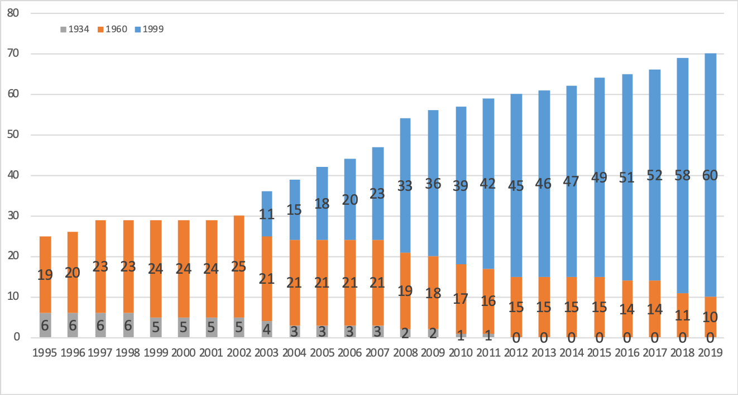

[Annex III follows]

DESIGNATIONS OF CONTRACTING PARTIES TO THE 1960 ACT: DESIGNATIONS RECORDED IN 2004, 2010 AND 2018

Number of Designations Under Each Act by Contracting Parties to the 1960 Act
Designated CP (which are at least CP to the 1960 Act) | 2004 |  | 2010 |  | 2018
 | 60 | 99 | 60 | 99 | 60 | 99
AL |  |  | 0 | 176 | 0 | 133
BG | 472 |  | 0 | 23 | 0 | 63
BJ | 39 |  | 8 |  | 13
BX | 919 |  | 111 |  | 55 | 0
BZ | 222 |  | 98 |  | 42
CH | 785 | 416 | 3 | 1,508 | 2 | 1,705
CI | 65 |  | 13 |  | 16
DE | 956 |  | 28 | 116 | 1 | 163
FR | 931 |  | 7 | 145 | 1 | 173
GA | 112 |  | 11 |  | 14
GE | 57 | 223 | 0 | 203 | 0 | 111
GR | 582 |  | 55 |  | 51
HR | 111 | 142 | 1 | 463 | 0 | 57
HU | 301 |  | 0 | 39 | 0 | 23
IT | 963 |  | 115 |  | 54
KG | 23 | 214 | 0 | 132 | 0 | 77
KP | 385 |  | 69 |  | 0 | 43
LI | 131 | 330 | 1 | 303 | 0 | 194
MA | 443 |  | 323 |  | 318
MC | 476 |  | 317 |  | 0 | 227
MD | 143 | 231 | 0 | 184 | 0 | 102
ME |  |  | 251 |  | 0 | 168
MK | 440 |  | 0 | 325 | 0 | 161
ML |  |  | 8 |  | 4
MN | 240 |  | 1 | 165 | 0 | 82
NE | 1 |  | 5 |  | 3
RO | 302 | 243 | 0 | 25 | 1 | 92
RS | 510 |  | 0 | 225 | 0 | 192
SI | 225 | 253 | 0 | 69 | 0 | 60
SN | 59 |  | 11 |  | 14
SR | 50 |  | 14 |  | 16
UA | 208 | 258 | 0 | 509 | 0 | 521
Total | 10,151 | 2,310 | 1,450 | 4,610 | 605 | 4,347
Total number of designations (independent of the Acts) | 12,461 |  | 6,060 |  | 4,952
Distribution by Act | 81.5% | 18.5% | 23.9% | 76.1% | 12.2% | 87.8%
[Annex IV follows]

[End of Annex IV and of document]

Following the ratification by Spain on September 23, 2003, the conditions required under Article 28(1) and (2) of the 1999 Act for its entry into force were met.
The last accession to the 1960 Act was by Albania and this came into force on March 19, 2007. Albania also acceded the 1999 Act which came into force on May 19, 2007.
An international registration governed exclusively by the 1960 Act means an international registration in respect of which all designated Contracting Parties are Contracting Parties designated under the 1960 Act. The case is International Registration No. DM/102 573 in which only Italy (1960 Act) is designated.
Or, where no other designated Contracting Parties has made a declaration under Article 11(1) of the 1999 Act.
Refer to document WO/PBC/30/10, page 54.
In this context, it is recalled that the application of the London (1934) Act, which was adopted on June 2, 1934, was frozen as from January 1, 2010. The 1934 Act was eventually terminated, effective on October 18, 2016. Refer to Information Notices Nos. 9/2009 and 10/2016, available at: https://www.wipo.int/hague/en/notices/.
List of members as of August 29, 2019, grouped according to the Act or Acts by which they are bound.
Member State of OAPI.
Member State of OAPI.
Member State of OAPI.
Member State of European Union.
Member State of European Union.
Member State of OAPI.
Member State of OAPI.
Member State of OAPI.
List of members as of August 29, 2019.
The 1999 Act entered into force with respect to Benelux on December 18, 2018.
The 1999 Act entered into force with respect to Belize on February 9, 2019.

