E
H/LD/WG/4/4
ORIGINAL: English
DATE: April 16, 2014

Working Group on the Legal Development of the Hague System for the International Registration of Industrial Designs

Fourth Session
Geneva, June 16 to 18, 2014

REVISED PROPOSAL FOR A STANDARD DOCUMENT FOR THE PURPOSE OF ARTICLE 16(2) OF THE 1999 ACT OF THE HAGUE AGREEMENT AND ITS POSSIBLE SUBMISSION THROUGH THE INTERMEDIARY OF THE INTERNATIONAL BUREAU

Document prepared by the International Bureau

I. INTRODUCTION

- The third session of the Working Group on the Legal Development of the Hague System for the International Registration of Industrial Designs (hereinafter referred to as “the Working Group” and the “Hague system”), which met from October 28 to 30, 2013, discussed the contents of a draft standard document for a certificate of transfer of the international registration(s) of industrial design(s) in respect of the designated Contracting Party(ies) having made a declaration under Article 16(2) of the Geneva (1999) Act of the Hague Agreement Concerning the International Registration of Industrial Designs (hereinafter referred to as “the 1999 Act” and “the Hague Agreement”) and the possible means of submitting it to the Offices concerned and ensuring its entry into effect in each Contracting Party.
- At the end of the discussion, the Working Group further invited the International Bureau to review the contents of the proposed standard document, taking into account comments made by the Working Group. In revising the document, the International Bureau further consulted the Offices of current and prospective Contracting Parties which had made a declaration under Article 16(2) of the 1999 Act or which intended to do so and endeavored to take these comments into account without departing from the original concept of a standard document that would, in itself, be sufficient before the Offices of all Contracting Parties concerned.
- In addition, the Working Group favorably considered the possibility of submitting the document through the International Bureau to the Offices requiring such a document and requested the International Bureau to explore this possibility further.
- Finally, the International Bureau was requested to make a proposal on a text that would ensure that the document would be acceptable in support of a change in ownership resulting from a transfer by contract for the purposes of any declaration made under Article 16(2) of the 1999 Act. The text could then be submitted to the Assembly of the Hague Union for adoption as a recommendation.
- In this context, it is recalled that at the time of preparing the present document, three Contracting Parties, namely the African Intellectual Property Organization (OAPI), Denmark and the Republic of Korea have made a declaration under Article 16(2).

MAIN ISSUE: TRANSFER BY CONTRACT BETWEEN TWO PARTIES (TRANSFEROR AND TRANSFEREE)

- It is recalled that the proposed standard document only relates to a change in ownership of the international registration(s) by contract. The document does not cover other reasons for change in ownership, such as a court decision, or operation of law such as an inheritance, bankruptcy, or the merger of two companies, since the requirements under the various national law might be too diverse to be covered by a single document. In other words, the purpose of the proposed standard document is to replace the submission of the contract of transfer between two parties (transferor and transferee), by the submission of a standard document for a certificate of transfer, signed/sealed by either or both the parties (transferor and transferee), as may be required under national law (all these possibilities are covered by the revised standard document as produced in Annex I to the present document).
- In the case of a change in ownership for other reasons such as those listed in the previous paragraph, the required documents may only be submitted directly to the Office having made a declaration under Article 16(2). This is because the International Bureau would not have the expertise to ascertain the provisions under different national laws governing the documents required concerning, for example, inheritance, bankruptcy or the merger of two companies. The documents that may be submitted through the International Bureau should be strictly limited and specific, otherwise the workload of the International Bureau could substantially increase.
- Furthermore, it is worth recalling that the form and contents of the proposed standard document follows the form and contents of the Model International Form under the Patent Law Treaty (PLT) “Certificate of Transfer” (see Annex IV of the present document). It is to be noted that Rule 16(2)(a)(iii) of the Regulations under the PLT reads:
“(a) Where the change in applicant or owner results from a contract, a Contracting Party may require that the request include information relating to the registration of the contract, where registration is compulsory under the applicable law, and that it be accompanied, at the option of the requesting party, by one of the following:
[…]
(iii) an uncertified certificate of transfer of ownership by contract drawn up with the content as prescribed in the Model International Form in respect of a certificate of transfer and signed by both the applicant and the new applicant, or by both the owner and the new owner.”
- Finally, the proposed standard document shall, alone without any cover sheets or attachments, qualify as a valid certificate of transfer by contract before the Office concerned. This issue has often been raised during consultations with the Offices of some prospective Contracting Parties to the 1999 Act which are expected to make a declaration under Article 16(2). However, since the application of the standard document is limited to transfer by contract between two parties, the standard document alone is intended to cover such a transfer.

NEXT STEPS AS PROPOSED IN THE PRESENT DOCUMENT

- Chapter II of the present document deals with the contents of the revised standard document and Chapter III sets out the possible means of submission of the document through the International Bureau. In addition, Chapter III contains a proposal for amendments to the Schedule of Fees, since the submission of the standard document would be an additional service to be provided by the International Bureau. Finally, Chapter IV proposes a draft text for a recommendation to be adopted by the Assembly of the Hague Union so as to ensure the effect of the standard document in each Contracting Party concerned.

II. Revised standard document

- At the third session of the Working Group, comments were made concerning the contents of the standard document for a certificate of transfer of an international registration. The draft standard document has been modified accordingly and is attached to the present document (see Annex I), along with the “Instructions on the Completion of the Certificate of Transfer”. The following is the outline of those modifications.

TITLE OF the STANDARD DOCUMENT

- It is proposed that the purpose of the document should be specified in the title of the standard document as follows: “Certificate of Transfer by Contract of International Registration(s) of Industrial Design(s) in Respect of a Designated Contracting Party(ies) Having Made a Declaration Under Article 16(2) of the Geneva (1999) Act”.

Item 1

- “Effective date of the transfer” is now a mandatory element for some Contracting Parties, which are enumerated in the endnotes of the document. During consultations with the Office of the United States of America, the requirement under its national law concerning “date of execution” was mentioned. It appears that the “effective date of transfer” mentioned in item 1 of the standard document may be considered as the “date of execution” under the United States of America national law. However, if such is not the case, it is proposed that “date of execution” should be added to the standard document and the endnotes should specify which Contracting Parties require that element.
- Furthermore, a reference to the proposed recommendation by the Assembly of the Hague Union is added under this item. Those Contracting Parties which have made a declaration under Article 16(2) of the 1999 Act and have specified in that declaration that the standard document for a certificate of transfer is considered as a valid document to give effect for the recording of a change in ownership in the International Register in that Contracting Party are listed at the end of this item.

Items 3 and 4

- If the transferor(s) and/or transferee(s) is/are a legal entity, sub-item (b) requires an indication of the “State of Incorporation”, in addition to an indication of the entity’s full official designation.

Item 5

- A new endnote which indicates that the words “signature” and “seal” also include the plural form, as the case may be, has been inserted. In addition, a new endnote on the Contracting Parties which require “signature(s)” and do not accept “seal(s)” not accompanied by a signature has been inserted.
- New sub-items (a)(ii) and (b)(ii) regarding the “entity’s full official designation and the capacity in which the person [indicated under item (i)] who signs or whose seal is used under item (iv)”, have been added. Such indication is required if the transferor(s) and/or transferee(s) is a legal entity and such capacity is not obvious.

III. submission of the standard document to Offices of contracting parties having made a declaration under article 16(2)

submission of the standard document through the international bureau

- In the Hague legal framework, there is no provision that documents/statements required by Offices of Contracting Parties that have made a declaration under Article 16(2) may be submitted through the International Bureau. However, since the recent improvements in the Hague IT environment enable the electronic submission and distribution of documents through the International Bureau, the International Bureau may offer this opportunity, as an additional service, to the users of the system.
- As explained in document H/LD/WG/4/2, entitled “Types of documents and Other Material Under Rule 7(5)(f) and (g) of the Common Regulations and Their Submission Through the Intermediary of the International Bureau”, the E-filing interface and official form DM/1, entitled “Application for International Registration”, will be revised to allow the submission of supporting documents to an international application to the Offices requiring such documents through the International Bureau. The premise is that in the future, the electronic submission of the standard document for certificate of transfer through the International Bureau would also be possible.
- It is recalled that, at present, the request for the recording of a change in ownership may only be made on the official form DM/2, entitled “Request for the Recording of a Change in Ownership”, on paper. The DM/2 form will be revised by the International Bureau to allow the attachment of the standard paper document to that form.
- Upon receipt of the standard document, the International Bureau will scan the document and a digital copy will be attached to the data relating to the international registration concerned.
- It is envisaged that an electronic environment to allow for a request for the recording of a change in ownership will be introduced in the future in the Hague system. The envisaged electronic submission of a request for the recording of a change in ownership would allow the submission of the standard document at the time of filing the request. However, any late submission of the standard document would have to be made directly to the Office concerned.
- Hence, when considering the possible means of submission of the request and the accompanying standard document through the International Bureau, the most pragmatic way would be through an electronic interface or a stand-alone electronic form, to be made available on the WIPO web site, either by the holder or the new owner of the international registration. These solutions are technically feasible but would require additional development of the IT administration of the Hague system.

electronic Distribution of the standard document to the Offices concerned

- Offices can incorporate the international registrations designating their Contracting Parties and the relevant data concerning such international registrations, for example, recording of a change in ownership, published in the International Designs Bulletin (hereinafter referred to as “the Bulletin”), in a computer-readable format in their IT system. To do so, the Office may download the information from a public repository available on the WIPO web site at: ftp://ftpird.wipo.int/wipo/hague/.
- The International Bureau would make the standard document available for download by the Offices. The standard document would be made available in pdf format and linked to the recording of the change in ownership in the International Register using the same computer-readable format as in the Bulletin. This would allow the Offices concerned to incorporate the document into their IT systems. The computer-readable format makes it easy for Offices to set up automatic checks and procedures. Unlike the Bulletin, which is available in a public repository, the standard document would be available through a private repository, to which only the Office concerned would have access.
- However, while the aforementioned possibility of submission of the standard document to the International Bureau and its electronic distribution to the Offices concerned would appear to be beneficial for most of the parties concerned, there are some concerns.

Authentication of a transfer document

- To authenticate the change in ownership of the international registration, some of the prospective Contracting Parties that would make a declaration under Article 16(2) of the 1999 Act might, according to their respective national laws, require the submission of the original certificate of transfer in paper form signed by either the holder or the new owner of the international registration, or both of them. In a situation where the International Bureau would scan the original paper document and distribute it electronically to the Offices concerned, the International Bureau would not have the expertise to authenticate the original paper document according to the national laws and/or standards. Therefore, scanning and electronically distributing the paper document would not meet the requirements of Offices with regard to authentication of the certificate of transfer. Thus, for those Contracting Parties, the holder or new owner would need to submit the documentation required directly to each Office of the Contracting Parties concerned.
- However, if the Offices concerned were prepared to alleviate their requirements concerning the authentication of the documentation and accept electronic distribution via the International Bureau, this would reduce the burdens of costs and procedures for the applicants.

Timing of submission of the standard document THROUGH the International Bureau

- The standard document may be submitted at the time of a request for recording a change in ownership of the international registration. The possibility of late submission, through the International Bureau, of the standard document after the filing of the request would be difficult to implement in the administration of the system. Connecting the standard document to the right international registration, to the right recording of change in ownership in respect of the right Contracting Parties might not be easily automated and would involve more work for the International Bureau.
- Finally, it might happen that a standard document is submitted as a reply to a declaration under Rule 21bis, issued by an Office, stating that a change in ownership recorded in the International Bureau has no effect in its Contracting Party. A typical case could be a failure to submit the standard document or the omission of some mandatory elements of the document. In such a case, in a reply to the declaration, the standard document would have to be submitted directly to the Office that issued the said declaration. The Office should withdraw its declaration once the reasons for which the change in ownership did not have effect in its Contracting Party are no longer present.

Fee for submission of the standard document

- Electronic submission and distribution of the standard document would not create additional work for the International Bureau, whereas receiving and managing the paper documents would. Nevertheless, the payment of a fee for the services of the International Bureau for receiving and distributing the document would be required since expenses would be incurred by the development of IT-based tools for such electronic communications. Even so,
the amount of the fee would be less than the expenses incurred for submitting the document directly to the Offices concerned, taking into account the fees of a local agent in those Contracting Parties.
- In this context, it is recalled that in document H/LD/WG/4/2, also to be discussed in the fourth session of the Working Group, it is proposed that the Schedule of Fees be amended to authorize the International Bureau to collect a fee for additional services not otherwise covered by the Schedule of Fees. The Working Group is invited to consider this proposal as well in light of the present document.
- In document H/LD/WG/4/2 it is envisaged that, in addition to the services for “the late submission” of supporting documents to an international application through the International Bureau to Offices, further services could also be provided to the users of the Hague system. To cover the possible increased administration costs for such services, including submission of the standard document through the International Bureau, it is proposed that a new Chapter VII, entitled “Services Provided by the International Bureau”, be inserted into the Schedule of Fees, which would read as follows:
“The International Bureau is authorized to collect a fee, whose amount it shall itself fix, for services not covered by this Schedule of Fees.”

IV. recommendation encouraging the acceptance of a standard document

- To ensure that the holders can effectively rely on a standard document as a valid certification of a transfer by contract before the Offices of the present and future Contracting Parties concerned, it is proposed that the Working Group make a recommendation to the Assembly of the Hague Union to adopt a recommendation that the standard document be accepted by Contracting Parties which have made the declaration under Article 16(2) of the 1999 Act and which have specified in that declaration that the standard document is accepted as a valid document to give effect to a change in ownership of the international registration resulting from a contract. A draft recommendation is attached to the present document (see Annex III).
- As to the form of the draft text, it is in the form of a “recommendation” to all of the Contracting Parties of the Hague Union, rather than in the form of an “agreed statement” or “resolution” which were both referred to during the third session of the Working Group by the International Bureau. Although “agreed statements” or “resolutions” have been adopted in certain diplomatic conferences, there are no precedents for such instruments being adopted by an Assembly. Conversely, several recommendations have been adopted by some Assemblies. Thus, it would be appropriate to make a proposal in the form of a “recommendation”.
- The Working Group is invited to consider and comment on the format and contents of the proposed standard document as reproduced in Annex I to the present document; to consider and comment on the instructions for the completion of the standard form as contained in Annex II to the present document; and to suggest a way forward.
- The Working Group is invited to consider a proposal to amend the Common Regulations with respect to the Schedule of Fees as set forth in the draft contained in Annex II to document H/LD/WG/4/2, also in the context of the present document.
- The Working Group is invited to consider and comment on the possible means of submitting the standard document through the International Bureau to the Offices requiring such a document.
- The Working Group is invited to consider and comment on the contents of the proposed draft recommendation which will be submitted to the Assembly of the Hague Union in 2014 for making a standard document an acceptable document in the Contracting Parties having made a declaration under Article 16(2) of the 1999 Act, as reproduced in Annex III to the present document.

[Annexes follow]

CERTIFICATE OF TRANSFER by contract of international registration(s) of industrial design(s) In respect of a designated Contracting Party(IES) having made a declaration under article 16(2) of the Geneva (1999) Act

Certificat de cession PAR CONTRAT d’un ou plusieurs enregistrements internationaux de dessins ou modèles industriels à l’égard d’une ou de plusieurs parties contractantes désignées ayant fait une déclaration en vertu de l’article 16.2) de l’acte de Genève (1999)¹ ²

certificado de transferencia mediante contrato de registro(s) internacional(es) de dibujos o modelos industriales respecto de parte(s) contratante(s) designada(s) que haya(N) efectuado una declaración en virtud del artículo 16.2) del ACTa de ginebra (1999)¹ ²

Submitted to the Office of/
Présenté à l’Office de³/
Presentado en la Oficina de³:

This certificate contains the following number of continuation sheets/Le présent certificat comprend le nombre suivant de feuilles supplémentaires/El presente certificado contiene el siguiente número de hojas adicionales:
FOR USE BY THE OFFICE ONLY/RÉSERVÉ À L’OFFICE/PARA USO DE LA OFICINA ÚNICAMENTE

1. Certification/Certification/Certificación
The undersigned transferor(s) and transferee(s) hereby certify that the ownership of the international registration(s) and/or industrial design(s) identified below has been transferred by contract/Le (les) cédant(s) et cessionnaire(s) soussignés certifient que la titularité de l’enregistrement international/des enregistrements internationaux et/ou du (des) dessin(s) ou modèle(s) industriel(s) indiqué(s) ci-après a été cédée par contrat/El (los) cedente(s) y cesionario(s) abajo firmante(s) certifica(n) que la titularidad del (de los) registro(s) internacional(es) identificado(s) y/o del (de los) dibujo(s) o modelo(s) industrial(es) a continuación ha sido transferida por contrato.
Effective date of the transfer/Date of execution ___/___/____
Date de prise d’effet de la cession⁴/Date d’exécution⁵ DD/MM/YYYY
Fecha efectiva de la transferencia⁴/Fecha de ejecución: JJ/MM/AAAA
DD/MM/AAAA

Certificate of Transfer, page 2/Certificat de cession, page 2/Certificado de transferencia, página 2
Recommendation adopted by the Assembly of the Hague Union: xxxx/Recommandation adoptée par l’Assemblée de l’Union de La Haye : xxxx/Recomendación adoptada por la Asamblea de la Unión de La Haya: xxxx
The following Contracting Party(ies) have made a declaration under Article 16(2) of the 1999 Act and specified in that declaration that this certificate of transfer is considered as a valid document to give effect for the recording of a change in ownership in the International Register in that Contracting Party/La(les) partie(s) contractante(s) ci-après a (ont) fait la déclaration visée à l’article 16.2) de l’Acte de 1999 en précisant dans cette déclaration que le présent certificat de cession est considéré comme un document valide pour donner effet à l’inscription d’un changement de titulaire au registre international de cette (ces) partie(s) contractante(s)/La(s) Parte(s) Contratante(s) que figura(n) a continuación ha(n) efectuado la declaración contemplada en el Artículo 16.2) del Acta de 1999 y han especificado en dicha declaración que el certificado de transferencia se considera un documento válido a los efectos de la inscripción de un cambio en la titularidad en el Registro Internacional de dicha(s) Parte(s) Contratante(s):

2. International Registration(s)/Industrial Design(s) Affected by the Transfer/ Enregistrement(s) international (internationaux)/Dessin(s) ou modèle(s) industriel(s) concerné(s) par la cession/Registro(s) internacional(es)/Dibujo(s) o modelo(s) industrial(es) objeto de la transferencia
(Indicate the number of the international registration(s) that have been transferred. If the transfer has been partial, indicate the number(s) of the industrial design(s) that have been transferred/Indiquer le numéro de l’ (des) enregistrement(s) international (internationaux) qui a (ont) été cédé(s). Si le transfert est partiel, indiquer le(s) numéro(s) du (des) dessins(s) ou modèle(s) industriel(s) qui a (ont) été cédé(s)⁶/Indique el número del (de los) registro(s) internacionale(s) transferido(s). Si se trata de una transferencia parcial, indique el (los) número(s) del (de los) dibujo(s) o modelo(s) industriale(s) transferido(s)⁶).
(11) Number of the international registration/Numéro de l’enregistrement international/Número del registro internacional | (53) Number of the industrial design(s) transferred, if the transfer has been partial/ Numéro du (des) dessin(s) ou modèle(s) industriel(s) cédé(s), si le transfert est partiel/ Número del (de los) dibujo(s) o modelo(s) transferido(s), si se trata de una transferencia parcial
Certificate of Transfer, page 3/Certificat de cession, page 3/Certificado de transferencia, página 3

If the space under item 2 is not sufficient, check this box and provide the information on further international registrations and/or industrial designs on a continuation sheet/Si la place prévue à la rubrique 2 est insuffisante, cocher cette case et fournir les éléments d’information concernant d’autres enregistrements internationaux et/ou dessins et modèles industriels sur une feuille supplémentaire/Si el espacio disponible en el punto 2 no es suficiente, márquese este recuadro y proporciónese la información sobre los demás registros internacionales y/o dibujos o modelos industriales en una hoja complementaria.

3. Transferor(s)/Cédant(s)7/Cedente(s)7
(73) Name and address of transferor(s)/Nom et adresse du (des) cédant(s)/Nombre y dirección del (de los) cedente(s)
(a) If the transferor(s) is (are) a natural person, the person’s/Si le(s) cédant(s) est (sont) une personne physique,/Si el (los) cedente(s) es (son) una persona natural, indíquense:
(i) family or principal name/nom de famille ou nom principal/los apellidos:

(ii) given or secondary name(s)/prénom(s) ou nom(s) secondaire(s)/los nombres:

(b) If the transferor(s) is a legal entity, the entity’s full official designation and its State of Incorporation/Si le(s) cédant(s) est (sont) une personne morale, dénomination officielle complète et État dans lequel elle a été constituée/Si el (los) cedente(s) es (son) una persona jurídica, indíquese la designación oficial completa de la entidad y el Estado en el que fue constituida:

(c) Address (including postal code and country)/Adresse (y compris le code postal et le pays)/Dirección (incluidos el código postal y el país):

(d) Telephone number(s) (with country and area code)/Numéro(s) de téléphone (avec les indicatifs de pays et de zone/Número(s) de teléfono (con el indicativo de país y zona):

(e) Facsimile number(s) (with country and area code)/Numéro(s) de télécopieur (avec les indicatifs de pays et de zone/Número(s) de facsímil (con el indicativo de país y zona):

Certificate of Transfer, page 4/Certificat de cession, page 4/Certificado de transferencia, página 4
(f) E-mail address/Adresse électronique/Dirección de correo electrónico:

Check this box if there is more than one transferor; in that case, list them on a continuation sheet and indicate, in respect of each of them, the data referred to in items 3(a) to 3(f)/Cocher cette case en cas de pluralité de cédants; si tel est le cas, en dresser la liste sur une feuille supplémentaire et indiquer, pour chacun d’eux, les éléments d’information demandés aux points 3.a) à 3.f)/Márquese este recuadro si hay más de un cedente, en cuyo caso, indíquense los cedentes adicionales en una hoja complementaria con los datos mencionados en los puntos 3.a) a 3.f) respecto de cada uno de ellos.

4. Transferee(s)7/Cessionnaire(s)7/Cesionario(s)7
(78) Name and address of Transferee(s)/Nom et adresse du (des) cessionnaire(s)/Nombre y dirección del (de los) cesionario(s)
(a) If the transferee(s) is a natural person, the person’s/Si le(s) cessionnaire(s) est (sont) une personne physique,/Si el (los) cesionario(s) es (son) una persona natural:
(i) family or principal name/nom de famille ou nom principal/los apellidos:

(ii) given or secondary name(s)/prénom(s) ou nom(s) secondaire(s)/los nombres:

(b) If the transferee(s) is a legal entity, the entity’s full official designation and its State of Incorporation/Si le(s) cessionnaire(s) est (sont) une personne morale, dénomination officielle complète et État dans lequel elle a été constituée/Si el (los) cesionario(s) es (son) una persona jurídica, indíquese la designación oficial completa de la entidad y el Estado en el que fue constituida:

(c) Address (including postal code and country)/Adresse (y compris le code postal et le pays)/Dirección (incluidos el código postal y el país):

(d) Telephone number(s) (with country and area code)/Numéro(s) de téléphone (avec les indicatifs de pays et de zone/Número(s) de teléfono (con el indicativo de país y zona):

Certificate of Transfer, page 5/Certificat de cession, page 5/Certificado de transferencia, página 5
(e) Facsimile number(s) (with country and area code)/Numéro(s) de télécopieur (avec les indicatifs de pays et de zone/Número(s) de facsímil (con el indicativo de país y zona):

(f) E-mail address/Adresse électronique/Dirección de correo electrónico:

Check this box if there is more than one transferee; in that case, list them on a continuation sheet and indicate, in respect of each of them, the data referred to in items 4(a) to 4(f)/Cocher cette case en cas de pluralité de cessionnaires; si tel est le cas, en dresser la liste sur une feuille supplémentaire et indiquer, pour chacun d’eux, les éléments d’information demandés aux points 4.a) à 4.f)/Márquese este recuadro si hay más de un cesionario, en cuyo caso, indíquense los cesionarios adicionales en una hoja complementaria con los datos mencionados en los puntos 4.a) a 4.f) respecto de cada uno de ellos.

5. Signature or seal /Signature ou sceau⁸ ⁹ ¹⁰/Firmao sello⁸ ⁹ ¹⁰
  - Signature or seal of the transferor(s)/Signature ou sceau du (des) cédant(s)/ Firma o sello del (de los) cedente(s):
(i) (73) Name of the natural person(s) who signs or whose seal is used under item (iv), below/Nom de la (des) personne(s) physique(s) qui signe(nt) ou dont le(s) sceau(x) est (sont) utilisé(s) en vertu du point iv) ci-dessous/Nombre y apellido de la(s) persona(s) natural(es) que firma(n) o cuyo sello se utiliza en el punto iv), infra:

(ii) If the transferor(s) is(are) a legal entity, the entity’s full official designation and the capacity in which the person(s) signs or whose seal is used under item (iv), below (if such capacity is not obvious)/Si le(s) cédant(s) est (sont) une personne morale, dénomination officielle complète et qualité en laquelle la (les) personne(s) mentionnée(s) au point i) signe(nt) ou dont le(s) sceau(x) est (sont) utilisé(s) en vertu du point iv) ci-dessous (si cette qualité n'est pas évidente)/Si el (los) cedente(s) es (son) una persona jurídica, indíquese la designación oficial completa de la entidad y la calidad en la que la(s) persona(s) firman o cuyo sello se utiliza en el punto iv), infra (si dicha calidad no es evidente):

(iii) Date of signature or of sealing/ ___/___/____
Date de signature ou d’apposition du sceau/ DD/MM/YYYY
Fecha de la firma o del estampado del sello: JJ/MM/AAAA
DD/MM/AAAA

Certificate of Transfer, page 6/Certificat de cession, page 6/Certificado de transferencia, página 6
(iv) Signature(s) or seal(s)/Signature(s) ou sceau(x)/Firma(s) o sello(s):

Check this box if there is more than one transferor and list them on a continuation sheet and indicate, in respect of each of them, the data referred to in items 5(a)(i) to (iii) together with the signature or seal of the transferor as required under item (iv)/Cocher cette case en cas de pluralité de cédants et en dresser la liste sur une feuille supplémentaire en indiquant, pour chacun d'eux, les éléments d'information demandés aux points 5.a)i) à iii) et en apposant la signature ou le sceau du cédant comme prescrit au point iv)/Márquese este recuadro si hay más de un cedente, en cuyo caso, enumérense los cedentes adicionales en una hoja complementaria e indíquense los datos mencionados en los puntos 5.a)i) a iii) respecto de cada uno de ellos junto con la firma o sello del o de los cedentes, como se estipula en el punto iv).
(b) Signature or seal of the transferee(s)/Signature ou sceau du (des) cessionnaire(s) / Firma o sello del (de los) cesionario(s):
(i) (78) Name of the natural person(s) who signs or whose seal is used under item (iv), below/Nom de la (des) personne(s) physique(s) qui signe(nt) ou dont le sceau est utilize en vertu deu point iv) ci-dessous/Nombre y apellido de la(s) persona(s) natural(es) que firma(n) o cuyo sello se utiliza en el punto iv), infra:

(ii) If the transferee(s) is(are) a legal entity, the entity’s full designation and the capacity in which the person signs or whose seal is used under item (iv), below (if such capacity is not obvious)/Si le(s) cessionnaire(s) est (sont) une personne morale, dénomination officielle complète et qualité en laquelle la (les) personne(s) mentionnée(s) au point i) signe(nt) don’t le sceau est utilize en vertu du point iv) ci-dessous (si cette qualité n'est pas évidente)/Si el (los) cesionario(s) es (son) una persona jurídica, indíquese la designación oficial completa de la entidad y la calidad en la que la(s) persona(s) firman o cuyo sello se utiliza en el punto iv), infra (si dicha calidad no es evidente):

(iii) Date of signature or of sealing/ ___/___/____
Date de signature ou d’apposition du sceaux/ DD/MM/YYYY
Fecha de la firma o del estampado del sello: JJ/MM/AAAA
DD/MM/AAAA

Certificate of Transfer, page 7/Certificat de cession, page 7/Certificado de transferencia, página 7

(iv) Signature(s) or seal(s)/Signature(s) ou sceau(x)/Firma(s) o sello(s):

Check this box if there is more than one transferee and list them on a continuation sheet and indicate, in respect of each of them, the data referred to in items 5(b)(i) to (iii) together with the signature or seal of the transferee as required under item (iv)/Cocher cette case en cas de pluralité de cessionnaires et en dresser la liste sur une feuille supplémentaire en indiquant, pour chacun d'eux, les éléments d'information demandés aux points 5.b)i) à iii) et en apposant la signature ou le sceau du cessionnaire comme prescrit au point iv)/Márquese este recuadro si hay más de un cesionario, en cuyo caso, enumérense los cesionarios adicionales en una hoja complementaria e indíquense los datos mencionados en los puntos 5.b)i) a iii) respecto de cada uno de ellos junto con la firma o sello del o de los cesionarios, como se estipula en el punto iv):

Instructions on the completion of the CERTIFICATE OF TRANSFER

It is recalled that the details of the transfer by contract shall be given ONLY with respect to the Contracting Party(ies) to the Office of which the present document is submitted.
The list of Contracting Parties having made the declaration under Article 16(2) of the Geneva (1999) Act is available on the WIPO web site at: http://www.wipo.int/hague/en/declarations/declarations.html.

Preliminary information

Indicate the full name of the State(s) or intergovernmental organization(s) to whose Office the present document is submitted: for example, Denmark or African Intellectual Property Organization (OAPI).

Item 1

Indicate the effective date of transfer and/or the execution date in the form dd/mm/yyyy. For example, 20/09/2013.

Item 2

Indicate the number of the relevant international registration(s) having been transferred with respect to the concerned State(s) or intergovernmental organization(s) in the form DM/123456 or DM/123456A.
If the transfer has been partial, indicate the number(s) of the industrial design(s) that have been transferred in the form 1, 3, 4, etc.

Item 3

(a)(i) and (ii): The names to be indicated are those recorded in the International Register.

(b) The entity’s full official designation to be indicated is the one recorded in the International Register.

(c) For example, 34, chemin des Colombettes, 1202 Geneva, Switzerland.

(d)(e) For example, +41-22 338 9111.

(f) For example, abcde@wipo.int.

Item 4

(a)(i) and (ii) The names to be indicated are those recorded in the International Register.

(b) The entity’s full official designation to be indicated is the one recorded the International Register.

(c) For example, 34, chemin des Colombettes, 1202 Geneva, Switzerland.

(d)(e) For example, +41-22 338 9111.

(f) For example, abcde@wipo.int.

Item 5

(a) (i) For example, John JOHNSON.

    - The entity’s full official designation to be indicated is the one recorded in the International Register.
    - Full date of signature in the form dd/mm/yyyy: for example, 20/09/2013.
    - Handwritten signature or seal.
  - (i) For example Elizabeth SMITH.
(ii) The entity’s full official designation to be indicated is the one recorded in the International Register.
(iii) Full date of signature in the form dd/mm/yyyy: for example, 20/09/2013.
(iv) Handwritten signature or seal.

If there are several transferors or transferees, all of them must sign the document or use their seals, in accordance with the applicable national/regional law of the concerned State(s) or intergovernmental organization(s).

[Annex III follows]

RECOMMENDATION

The Assembly of the Special Union for the International Deposit of Industrial Designs (Hague Union),
in terms of Article 16(2) of the Geneva (1999) Act of the Hague Agreement Concerning the International Registration of Industrial Designs (hereinafter referred to as the “Geneva Act”) which allows a Contracting Party to the Geneva Act to notify the Director General, in a declaration, that a recording of a change in ownership of the international registration shall not have the same effect as if it had been made in the Register of the Office of the Contracting Party concerned until the Office of that Contracting Party has received the statements or documents specified in that declaration,
recommends that where a change in ownership of an international registration in respect of a designated Contracting Party having made a declaration under Article 16(2) of the Geneva Act is recorded in the International Register, for the purpose of meeting a requirement specified in such a declaration, if
(a) a “Certificate of transfer by contract of international registration(s) of industrial design(s) in respect of a designated Contracting Party(ies) having made a declaration under Article 16(2) of the Geneva (1999) Act” (hereinafter referred to as a “certificate of transfer”) established by the International Bureau of the World Intellectual Property Organization (hereinafter referred to as the “International Bureau”) is submitted to the Office of the designated Contracting Party concerned through the International Bureau at a time and in a manner and format to be ascertained by the International Bureau according to Sections 204 and 205 of the Administrative Instructions for the Application of the Hague Agreement, or
(b) a certificate of transfer is submitted to the Office of the Contracting Party concerned directly,
that Office accepts the certificate of transfer as having the same effect as a statement or document which may be submitted for the same purpose under the law of the Contracting Party concerned.

[Annex IV follows]

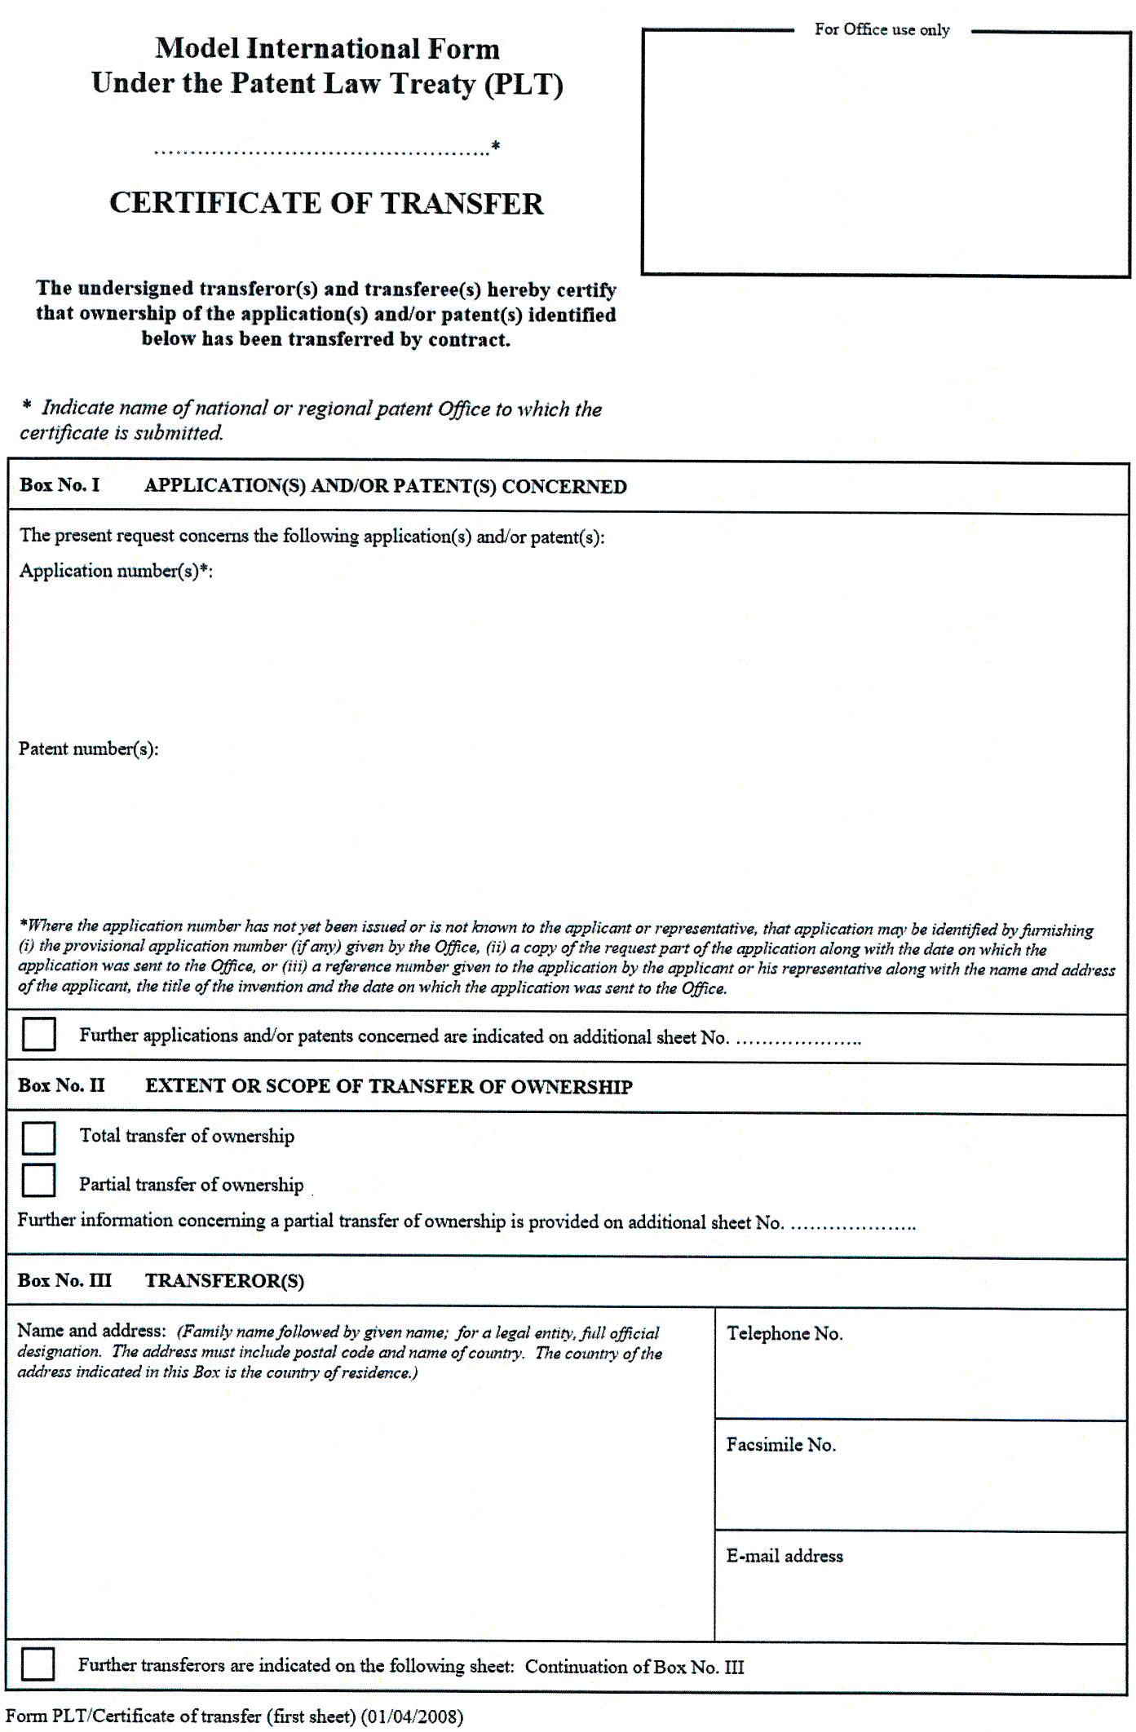

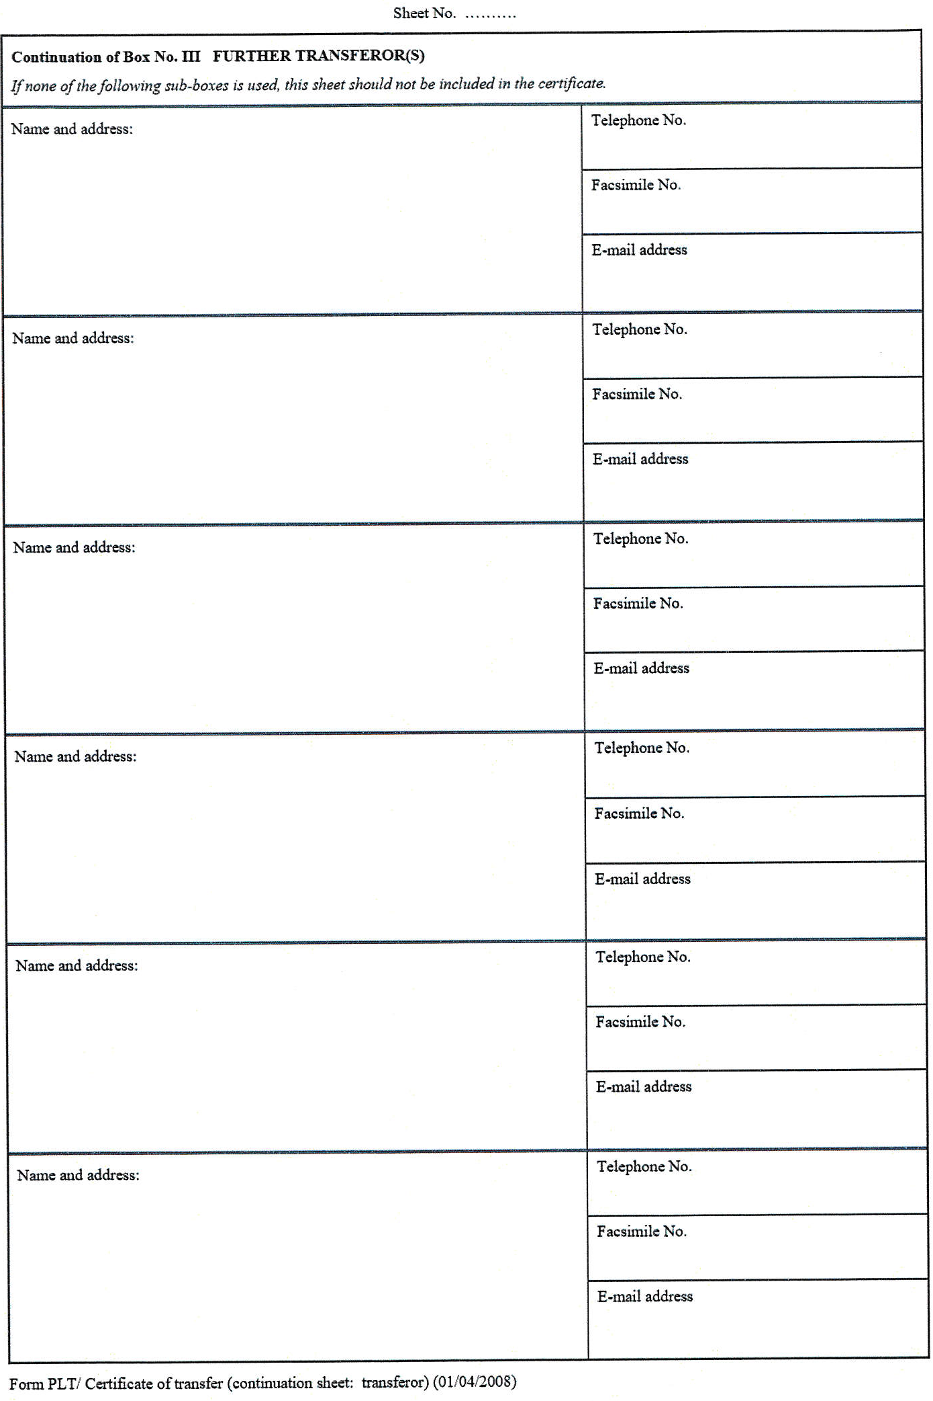

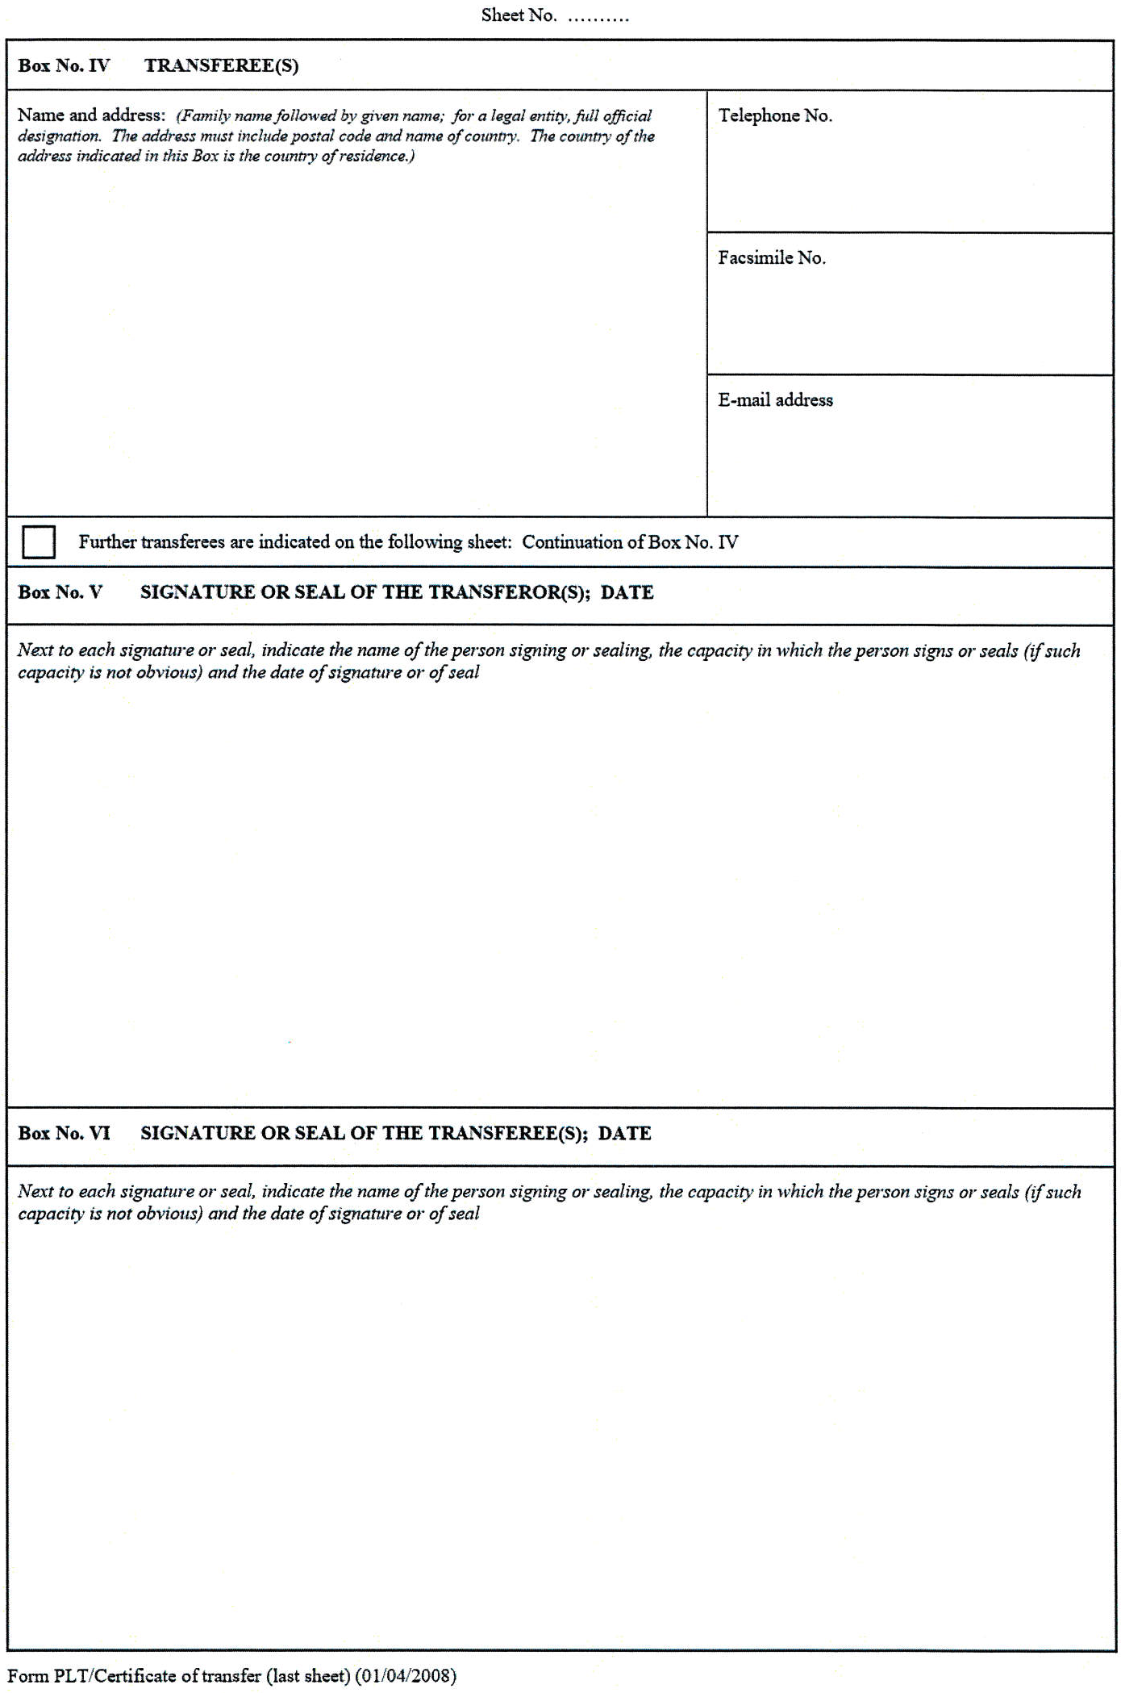

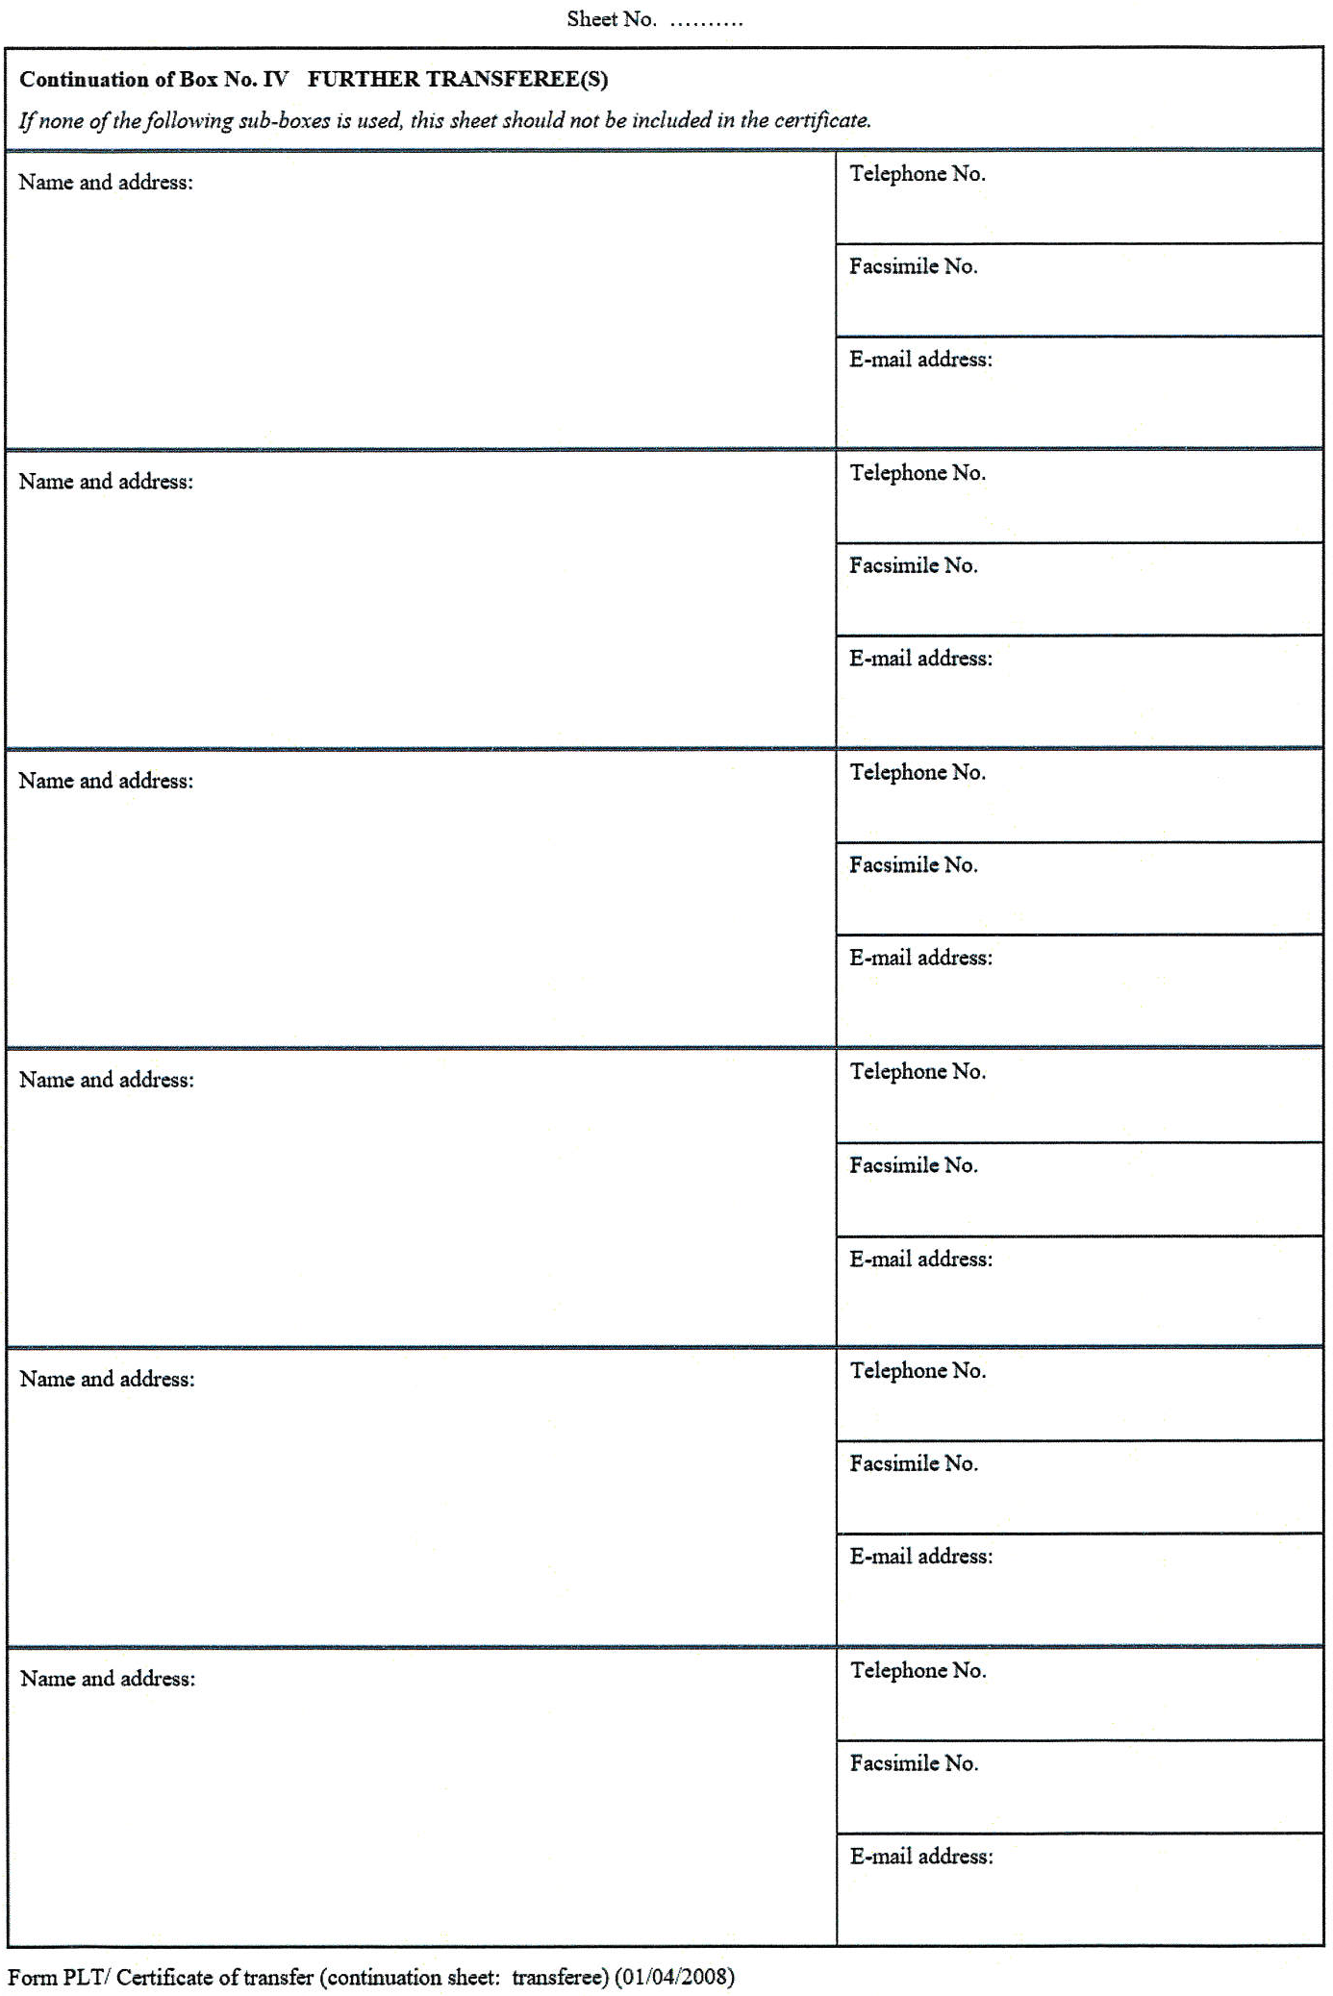

[End of Annex IV and of document]

See document H/LD/WG/3/8 Prov., “Draft Report”, paragraphs 21 to 49.
The expression “standard form” used in documents H/LD/WG/2/2 and H/LD/WG/3/2 is replaced by the expression “standard document” to make it clear that it is a stand-alone document.
The proposed text corresponds to the wording in the Model International Form “Certificate of Transfer” under the PLT, which reads: “Next to each signature or seal, indicate the name of the person signing or sealing, the capacity in which the person signs or seals (if such capacity is not obvious) and the date of signature or of seal.”
In this context, it is worth recalling that the International Bureau would not require the attachment of a standard document to official form DM/2. The International Bureau will record the change in ownership in the International Register upon receipt of a duly completed DM/2 form. Furthermore, in accordance with Article 16(2), the recording in the International Register has the same effect as if it had been made in the Register of the Office of each of the Contracting Parties concerned, except that a Contracting Party may, in a declaration, notify the Director General that a recording of a change in ownership shall not have effect in that Contracting Party until the Office of that Contracting Party has received the statements or documents specified in that declaration.
See, for example, “Agreed Statement by the Diplomatic Conference Regarding the Geneva Act and the Regulations under the Geneva Act” in 1999, or “Resolution by the Diplomatic Conference supplementary to the Singapore Treaty on the Law of Trademarks” in 2006.
See, for example, “Joint Recommendation Concerning Provisions on the Protection of Well-Known Marks adopted by the Assembly of the Paris Union for the Protection of Industrial Property and the General Assembly of the World Intellectual Property Organization (WIPO)” in 1999.
Some bibliographic data in respect of international designs are identified by the INID (Internationally agreed Numbers for the Identification of Data) codes, that is, the codes of Standard ST.80 (“Recommendation concerning bibliographic data relating to industrial designs”), available on the web site of the World Intellectual Property Organization (WIPO), at http://www.wipo.int/standards/en/pdf/03-80-01.pdf).
The details of the transfer by contract shall be provided only in respect of the Contracting Party(ies) to whose Office(s) the present certificate is submitted (list of declarations made by Contracting Parties to the Hague Agreement available at http://www.wipo.int/hague/en/declarations/declarations.html.)
Name of the State(s) or intergovernmental organization(s).
Indication of the effective date of transfer is a mandatory element under the legislation of [China and the Russian Federation].
The date of execution is required under the legislation of the United States of America.
Only those industrial designs which have been transferred in respect of the Contracting Party(ies) to whose Office(s) the present certificate is submitted shall be indicated.
The names to be indicated under (a) and (b) are those which are recorded in the International Register in respect of the international registration(s) to which the present certificate relates.
The words “signature” and “seal” also include the plural form, as the case may be.
The following Contracting Parties require “signature(s)” and do not accept “seal(s)” unaccompanied by a signature: [Russian Federation].
The following Contracting Parties require that both the transferor(s) and the transferee(s) sign the present item. 1 Quelques données bibliographiques concernant les dessins et modèles internationaux sont identifiées par des codes INID (INID signifie “Identification numérique internationale des données bibliographiques”), c’est-à-dire les codes définis dans la norme ST.80 (“Recommandation concernant les données bibliographiques relatives aux dessins et modèles industriels”), qui est disponible sur le site Internet de l’Organisation Mondiale de la Propriété Intellectuelle (OMPI) à l’adresse http://www.wipo.int/standards/fr/pdf/03-80-01.pdf. ² Des renseignements sur la cession par contrat ne doivent être fournis qu’à l’égard de la ou des parties contractantes aux Offices desquelles le présent certificat est présenté (la liste des déclarations faites par les parties contractantes de l’Arrangement de La Haye figure à l’adresse http://www.wipo.int/hague/fr/declarations/declarations.html.) ³ Nom de l’État ou des États, ou de l’organisation ou des organisations intergouvernementale(s). ⁴ L’indication de la date de prise d’effet de la cession est un élément obligatoire selon la législation de [la Chine et la Fédération de Russie]. ⁵ La date d’exécution est exigée en vertu de la législation des États-Unis d’Amérique. ⁶ Indiquer uniquement les dessins ou modèles industriels qui ont été cédés à l’égard de la ou des parties contractantes aux Offices desquelles le présent certificat est présenté. ⁷ Les noms à indiquer sous a) et b) sont ceux qui sont inscrits au registre international à l’égard de l’enregistrement international / des enregistrements internationaux au(x)quel(s) a trait le présent certificat. ⁸ Les termes “signature” et “sceau” s’entendent également au pluriel, selon le cas. ⁹ Les parties contractantes suivantes exigent des “signature(s)” et n’acceptent pas les sceaux non accompagnés d’une signature : [Fédération de Russie].. ¹⁰ Les parties contractantes suivantes exigent que le(s) cédant(s) et le(s) cessionnaire(s) signent le présent point. ¹ Algunos datos bibliográficos relativos a los dibujos y modelos internacionales se identifican con los códigos INID (Identificación Numérica Internacionalmente acordada en materia de Datos bibliográficos), es decir, los códigos de la Norma ST.80 (“Recomendación relativa a los datos bibliográficos sobre dibujos y modelos industriales”), disponible en el sitio Web de la Organización Mundial de la Propiedad Intelectual (OMPI), en http://www.wipo.int/standards/es/pdf/03-80-01.pdf. ² Los detalles de la transferencia por contrato serán indicados exclusivamente respecto de la(s) Parte(s) Contratante(s) a cuya(s) Oficina(s) se remita el presente certificado (la lista de declaraciones efectuadas por las Partes Contratantes del Arreglo de La Haya puede consultarse en http://www.wipo.int/hague/es/declarations/declarations.html.) ³ Nombre del Estado(s) u Organización(es) Intergubernamental(es). ⁴ La indicación de la fecha efectiva de la transferencia es un elemento obligatorio con arreglo a la legislación de [China y la Federación de Rusia]. ⁵ La fecha de ejecución se exige en virtud de la legislación de los Estados Unidos de América. ⁶ Sólo se indicarán los dibujos o modelos industriales que hayan sido transferidos respecto de la(s) Parte(s) Contratante(s) a cuya(s) Oficina(s) se remita el presente certificado. ⁷ Los nombres y apellidos que se han de indicar en a) y b) son los que están inscritos en el Registro Internacional respecto de los registros internacionales a los que se refiere el presente certificado. ⁸ Las palabras “firma” y “sello” se entienden también en su forma plural, según proceda. ⁹ Las Partes Contratantes enumeradas a continuación exigen la firma y no aceptan estampado de sello alguno que no vaya acompañado de una firma: [Federación de Rusia]. ¹⁰ Las siguientes Partes Contratantes exigen que tanto el cedente como el cesionario rellene el presente apartado. [Annex II follows]

