|  |  |  |
| --- | --- | --- |
|  | WIPO-E | **E** |
| wo/pbc/26/INF.1 | | |
| ORIGINAL: ENGLISH | | |
| DATE: May 24, 2017 | | |

**Program and Budget Committee**

**Twenty-Sixth Session**

**Geneva, July 10 to 14, 2017**

FINANCIAL SITUATION AS OF END 2016: PRELIMINARY RESULTS

*Document prepared by the Secretariat*

1. The current document provides the preliminary end of 2016 figures, which are subject to audit and will be reported on formally at the September 2017 session of the Program and Budget Committee (PBC) as audited financial statements for 2016.
2. The document is intended to provide Member States with background information in relation to the Draft Proposed Program and Budget for the 2018/19 Biennium.
3. It is recalled that, since 2010, WIPO’s financial statements have been prepared in accordance with International Public Sector Accounting Standards (IPSAS) whilst the Organization’s budget has continued to be prepared on a modified accrual basis (“budgetary basis”), in accordance with the Organization’s Financial Regulations and Rules. Tables presented below show both income and expenditure[1] on a modified accrual basis, together with their corresponding IPSAS adjustments, where indicated.
4. Table 1 provides an overview of WIPO’s preliminary results and financial parameters for the year ended December 31, 2016. The table also presents figures on the levels of registration activities undertaken under the PCT, Madrid and Hague Systems. Charts 1 and 2 provide a breakdown of WIPO income and expenditure respectively, on an IPSAS basis.
5. Table 1 provides preliminary results and financial parameters as of end 2016.



1. Chart 1 provides information on the breakdown of WIPO’s income on an IPSAS basis in 2016.

Chart 1: 2016 Income by Type

*(in millions of Swiss francs)*

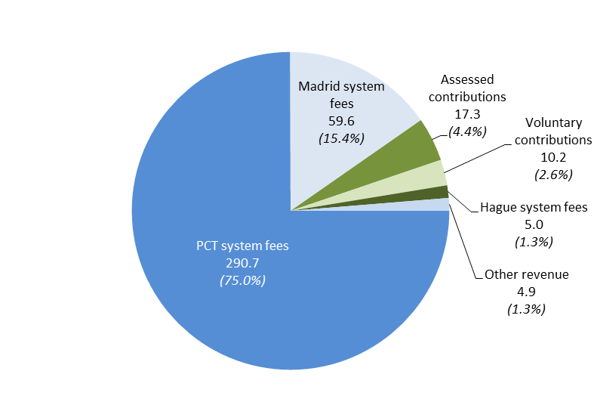

1. Chart 2 provides information on the breakdown of expenditure on an IPSAS basis by type in 2016.

Chart 2: 2016 Expenditure by Type

*(in millions of Swiss francs)*

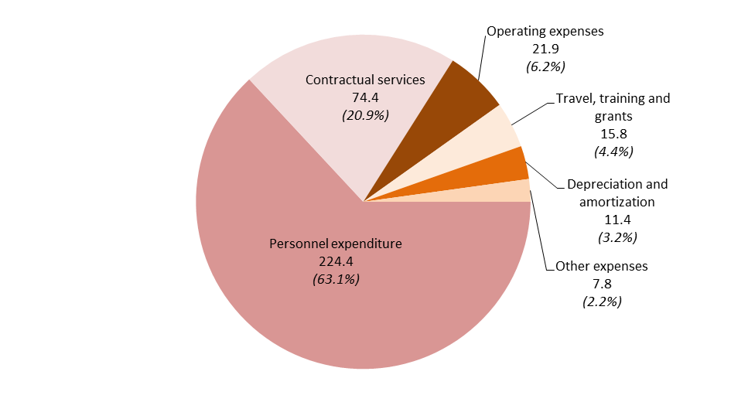

1. Chart 3 provides information on the total assets, total liabilities and net assets (Reserves) of the Organization at the end of 2016.

**1,027.2**

millions of Swiss francs

**715.9**

Other 69.5

Borrowings

88.7

Other 73.8

Employee benefits

188.4

Fixed assets

411.1

Payables and

advance receipts

369.3

Cash & cash

equivalents

and investments

542.3

**Net assets**

**311.3**

**Assets**

**Liabilities**

1. Table 2 presents budget utilization figures by Program for 2016.



1. Table 3 provides the 2016 preliminary results by Unions (Contribution-financed Union, PCT Union, Hague Union and Lisbon Union).



1. Table 4 provides an outlook for the 2016/17 biennium taking into account the financial results for the year ended December 31, 2016.



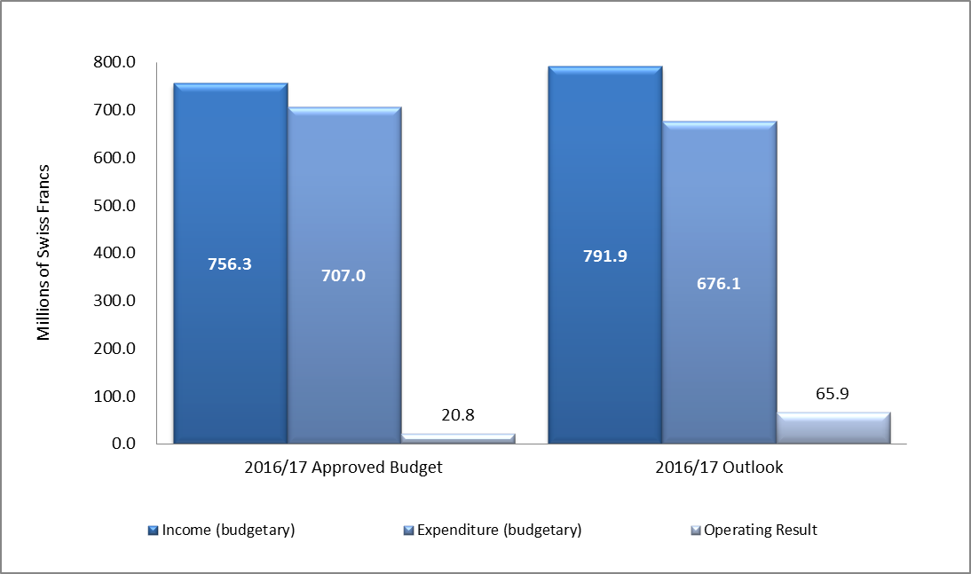

[End of document]

1. Figures exclude Funds-in-Trust.