 |  | E
WO/PBC/21/12
ORIGINAL: ENGLISH
DATE: JULY 1, 2013

Program and Budget Committee

Twenty-First Session
Geneva, September 9 to 13, 2013

PROGRESS REPORT ON THE IMPLEMENTATION OF A COMPREHENSIVE INTEGRATED ENTERPRISE RESOURCE PLANNING (ERP) SYSTEM

prepared by the Secretariat

I. INTRODUCTION

- The forty-eighth session of the Assemblies of Member States of WIPO in September 2010, approved the Secretariat’s proposal for the Implementation of a Comprehensive Integrated Enterprise Resource Planning (ERP) System (documents WO/PBC/15/17 and A/48/14), with a view to: (i) modernize WIPO’s core administrative, management and customer-service functions; (ii) improve efficiency and productivity of WIPO’s administrative and management processes; and (iii) enhance the capability to provide better information to Member States, stakeholders and management.
- This report provides Member States with an overview of progress made, milestones achieved and budget utilization under the ERP Portfolio of Projects during the period June 2012 to May 2013. It complements previous project progress reports submitted to the Program and Budget Committee.

iI. OBJECTIVES, Scope AND APPROACH – BACKGRound

- The ERP system is being implemented through a portfolio of inter-related projects.
- A first project aims at providing WIPO with a comprehensive set of tools to strengthen Human Resource Management (HRM), comprising position management, benefits and entitlements, payroll, recruitment, staff performance, learning and development.
- A second project aims at providing WIPO with a set of tools to strengthen the implementation of Results-Based Management (RBM), comprising biennial planning, annual work planning, implementation monitoring and performance assessment and reporting.
- A third project aims at enhancing the existing finance, procurement and travel systems, including improvements to business processes and the use of Business Intelligence (BI) analytical tools to provide the necessary management information to support decision making. As the HRM and RBM streams progress, more data will become available within WIPO’s ERP system which will gradually increase the comprehensiveness of the Organization’s reporting capabilities on organizational performance, results, human and financial resources to Member States, management and staff through the BI solution. As part of this initiative WIPO will strengthen the Chart of Accounts (COA), which is the back-bone of financial data in the ERP system.
- In addition, the ERP portfolio of projects will lay the foundation for improved Customer Relationship Management (CRM), in the latter part of the implementation timeframe.
- The true benefits of an ERP system can only be harvested if WIPO embraces the opportunities to improve the way it works by re-engineering business processes, training staff to take advantage of the new tools, and establishing robust enabling policies within a comprehensive regulatory framework.
- WIPO’s implementation approach to the ERP portfolio fully recognizes these success factors, and therefore ensures that the project is fully anchored in the Strategic Realignment Program (SRP), along with other related projects and initiatives. The implementation is based on a clear blueprint and plan which will help gradually evolve the ERP system over a five-year timeframe in a coherent and measured manner.

III. Key Achievements

HUMAN RESOURCE MANAGEMENT (HRM)

- An essential component of the ERP portfolio of projects consists of the implementation of an integrated HR and payroll solution based on PeopleSoft software. During the period under review, the initial project phase (Phase I) has focused on implementing the core HR and payroll processing capabilities. Phase I will deliver the foundation that enables future phases to provide enhanced functionality over time as described below:
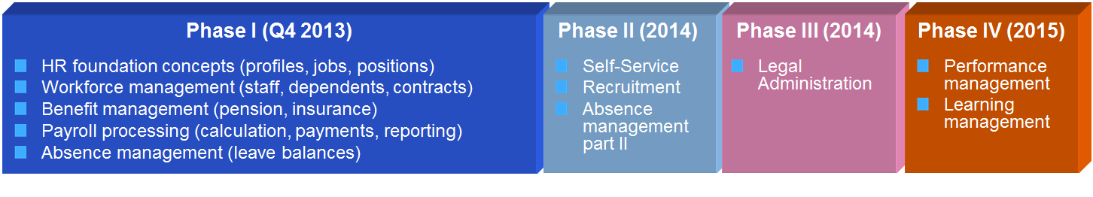
- The selection of an experienced PeopleSoft HR implementation partner with a solid understanding of WIPO’s business and systems, and with a proven track record of similar United Nations (UN) solution implementations, enabled the project to make steady progress and deliver results right from the beginning of the design stage in August 2012. Thorough contract negotiations with the implementation partner resulted in a fixed price agreement that ensures strict management of resources and reduced risks for unplanned expenditures.
- Adopting a baseline solution already in use by a sister UN agency, a detailed “fit/gap” analysis was performed in the second half of 2012. The objectives were to ensure that the WIPO solution would satisfy the needs and requirements of business processes in the WIPO environment. The analysis enabled WIPO to identify process improvements to provide better services internally, some of which have already been implemented. The “fit/gap” analysis also clarified the scope of the technical solution and resulted in the go-live date to be confirmed for October 2013. Extensive participation has allowed key users from within the Secretariat to gain early exposure to the future functions of the solution.
- The design stage was completed in early 2013 following an extensive analysis of the required functions, reporting needs, data migration from existing systems and integration with other WIPO processes and systems. The design stage was followed by the build of the solution on the PeopleSoft platform.
- An analysis of management reporting needs has also been initiated. Phase I will set the stage for a more complete integration of data sources and better data quality in subsequent project phases. Evolving BI needs are being considered and implemented as part of subsequent project phases.
- A sequenced testing strategy has been defined to ensure completeness and user acceptance of the solution. Thorough testing by the business users has been planned and will be conducted to ensure a smooth and successful transition with minimal disruption to business processes. Particular emphasis will be given to a smooth transition of the payroll process. The project milestones concerning the initial project phase (Phase I) implementation are summarized below.
 | Milestones 2012/2013
Phase I - core HR and payroll | Delivery of Core HR and Payroll  Functionalities  - Supports the implementation of HR foundation concepts such as profiles, jobs and position;  - Supports the workforce management functions for contract management, staff information and dependents;  - Supports benefit management for pension and insurances;  - Supports Payroll processing;  - Supports the leave and absence tracking.  System access: Access to system by end-users in HRMD and Finance Department  Technology: (PeopleSoft)

- Communications to staff remains a key focus and “Learning at WIPO” information sessions were conducted to inform staff of the upcoming changes and the impact on their daily work. Training will be conducted for all affected staff to ensure that their roles can continue to be performed efficiently with minimal disruption.
- A strong governance structure continues to support and oversee the execution of project activities. A HR Project Board constituted of key business stakeholders meets frequently to steer project activities, assess risks and resolve issues. The following table highlights the key risks identified and their mitigation strategies currently under implementation.
Risk | Description | Risk Mitigation
Disruption of HR and/or Payroll services to WIPO staff and non-staff | The rollout of the new ERP HR and Payroll functions in the last quarter of 2013 might slow down or disrupt services provided to staff. Staff efficiency and system issues may impact service levels. | Avoid system issues by sufficient testing of the new solutions in conditions that are as close as possible to real life situations.  Three parallel testing runs have been planned that enable actual comparison of payroll results between the current and future solutions.  Ensure user readiness by delivering scenario-based training programs to all impacted staff before the rollout of the solution.
Maximum value is not obtained from the new implemented HR and Payroll solutions. | The delivered HR and Payroll solution may not incorporate enough business process review and re-engineering to fully streamline processes and improve services to staff. | Confirm business benefits by performing periodic reviews of business processes and performing business process oriented testing events.  Ensure early business end user involvement in all stages of the project.

Results-Based Management (through the implementation of (enterprise performance management (EPM) tools)

- During the period under review, the EPM project successfully developed and deployed a Hyperion EPM application to manage the end-to-end biennial planning process for 2014/15 (Program and Budget 2014/15), in accordance with WIPO’s RBM Framework. The EPM application strengthens and reinforces WIPO’s core RBM philosophy and principles enabling consistent results-based resource management along with the capability for Program Managers to develop their biennial plans online in a user-friendly and integrated manner. The tool provides the Organization with a sound audit trail and ensures that all high level activities are linked to WIPO’s expected results with the associated human and financial resources. The deployment of the EPM Program and Budget 2014/15 application and business process has provided Program Managers with a significantly improved mechanism for their Program and Budget development and review, reducing the time and effort to verify, consolidate and analyze the biennial planning information, and increasing the accuracy, reliability and traceability of the planning data.
- The reporting capability developed as a core component of the current EPM application has also provided management with real-time, cross-organizational consolidated analytical information on the Program and Budget 2014/15. The project milestones in respect of biennial planning are summarized in the table below:
 | Milestones 2012 / 2013 | Milestones 2014 / 2015
Biennial Planning 2014/15 | Biennial planning 2014/15  Functionalities  - Supports planning of high-level biennial program activities linked to expected results and performance indicators;  - Supports budgeting of resources (personnel and non-personnel) for high level program activities;  - Supports estimation of development share of the budget;  - Supports estimation of results-based budget and budget by cost category; and  - Supports analysis of planning dimensions (expected result, cost category, Development Agenda etc.) by Program, Sector and/or Unit.  System access: Access to system by end-users  Technology: (Essbase, Hyperion Planning) | Biennial planning 2016/17  Functionalities  Biennial planning for 2014/15 with additional functionalities:  - Supports the publication of the Program and Budget document;  - Supports the automation of workflows and approval hierarchies.  System access: Access to system by end-users  Technology: (Essbase, Hyperion Planning, BI publisher)

- The next phase of Hyperion EPM development will cover the key RBM processes of annual workplanning and implementation and monitoring. The annual workplanning EPM application for 2014/15 will incorporate the lessons learned from the first phase EPM workplanning application which was deployed to central facilitating organizational Units (Program Management and Performance and Budget) in the 2012/13 biennium, and will be built on the existing EPM biennial planning application. This application will extend the capability to Program Managers to plan and manage annual workplan activities. The future bi-directional integration with WIPO’s Administrative Integrated Management System (AIMS), Enhancements and PeopleSoft HR applications, and the revised AIMS Chart of Accounts will ensure that program content and human and financial resources can be planned, managed and monitored, in a consistent and integrated manner. In particular, the integration with PeopleSoft HR will greatly facilitate the management of the most significant portion of the Organization’s resources, i.e. personnel resources. The project milestones concerning annual workplanning and monitoring of implementation are summarized below:
 | Milestones 2012 | Milestones 2013 | Milestones 2014 / 2015
Annual work-planning (WP),  Implement-tation & monitoring | Annual WP 2012/13  Functionalities  - Supports planning and update of activities linked to expected results;  - Supports allocation and adjustments of non-personnel and personnel resources at program activity level;  - Supports analysis of workplan information on several dimensions, i.e. results and implementing entity;  - Supports generation of reports directly from Essbase (i.e. staffing authorization tables, actuals versus budget in the workplans, etc.);  - Supports capability to generate budget journals for upload into AIMS; and  - Supports the feedback of actual expenditure by AIMS activity to managers in quarterly reports.  System access: Central access only (Budget and Program Management and Performance Sections)  Technology: (Essbase with Excel supported interface) | Annual WP 2014/15  Functionalities  Annual workplanning for 2012/13 with additional functionalities:  - Supports planning of, and tracking of status of workplan activities in 2014/15 linked to performance indicators and expected results;  - Position level planning;  - Supports (re)assigning positions to program activities;  - First phase integration with PeopleSoft HR and AIMS; and  - Supports generating a large number of reports from EPM for both end-users and central teams.  System access: Access to system by end-users  Technology: (Essbase; Hyperion Planning) | Annual WP 2016/17  Functionalities  Annual workplanning functionalities for 2014/15 with additional fine-tuning based on user feedback;  Full integration with PeopleSoft HR and AIMS; and  Supports generating integrated reports from both end-users and central teams from BI.  System access: Access to system by end-users  Technology: (Essbase; Hyperion Planning and BI)

- As with all of the projects under the ERP Portfolio, risks are being diligently tracked and managed. The following table highlights the key risks on the EPM work stream:
Risk | Description | Risk Mitigation
Maximum value from Enterprise Performance Management is not realized. | Whilst an appropriate technology solution may be implemented, the business does not use the system in a way that maximizes the potential value. | Well-defined requirements with participation from the business areas. Ensure close integration with related ERP applications and quality application delivery. Adequate training and change management activities around effective business processes.
Maximum value from Business Intelligence is not realized. | The business may not be able to extract the optimal benefit from the Business Intelligence capabilities. | Well-defined requirements with participation from all stakeholders. Consistent view of key-organizational data across WIPO’s applications. Controls over data quality and consistency. Well-managed security regarding confidential information.

STRENGTHENED BUSINESS PROCESSES AND INTELLIGENCE (ENHANCEMENTS TO THE EXISTING AIMS FINANCIAL AND PROCUREMENT SYSTEM)

- Since the last progress report, the project has developed several proof-of-concepts for BI in preparation of the BI development work currently underway. This first phase of BI development is designed to establish a core BI competency within the Organization, and commence delivery of a combination of standard and limited custom analytical dashboards and reports to key senior management. BI development will expand to include the provision of cross-functional analytical capabilities to a variety of key internal and external stakeholders, to enable them to better understand the key drivers and performance characteristics of their Programs. The rollout of this BI capability will progress in a controlled and phased manner to ensure that best practice principles are observed, and that information is based on agreed data sources and meets well-defined data quality standards.

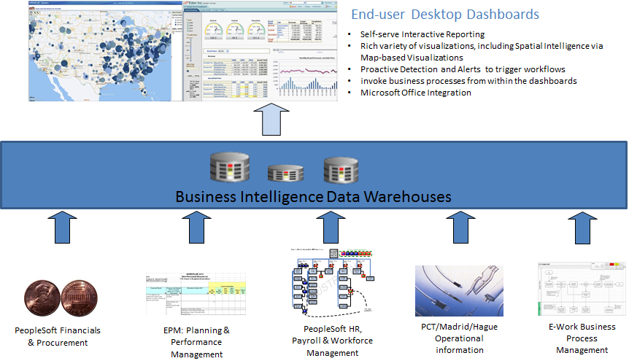

Milestones 2012 / 2013 | Milestones 2014 / 2015
Functionalities  - Oracle Business Intelligence Applications for Finance and Procurement Departments; and  - Prototype customized dashboards for Senior Management.  System access: Access to system for specific key users.  Technology: Oracle Business Intelligence. | Functionalities  - Customized Dashboards for Senior Management;  - Oracle Business Intelligence Applications for HR;  - Customized HR Workforce Management Dashboards; and  - Customized Member States Dashboards.  System access: Access to system for extended stakeholders.  Technology: Oracle Business Intelligence.

- A number of initiatives are currently in progress aimed at improving the efficiency of WIPO’s business processes. These include the implementation of an online travel booking tool designed to reduce travel process lead time and costs; improved business processes supported by the ERP in the Patent Cooperation Treaty (PCT) translation services; a review of the current customization of WIPO’s existing accounts receivable and billing applications, and a review of WIPO’s financial chart of accounts to ensure optimal integration with the Hyperion EPM and PeopleSoft HR applications.
Risk | Description | Risk Mitigation
AIMS users are insufficiently trained to be efficient in the execution of their work. | Improvements in business processes and the delivery of new ERP modules result in changed roles and responsibilities of AIMS users change. If users do not sufficiently understand the business processes or have insufficient knowledge of the tools, the system will be used in a sub-optimal manner. | Develop and implement a training strategy. Address training needs for projects as well as training in the context of on-going operations. Institutionalize training in accordance with the needs in collaboration with the Program Management and Performance Section.
AIMS Support team provides insufficient support to the users and system. | Insufficient understanding of the new ERP modules by the AIMS Support team and inability to cope with the work load required to support the users and the system. | Ensure that the AIMS Support team fully participates in the respective projects to acquire a thorough understanding of the new technical and business functions. Ensure their involvement in the preparation of test plans, test execution and sign-off during User Acceptance Testing. This will ensure enhanced quality of new system resulting in less need for end-user support.

ENABLING TECHNOLOGY AND CROSS-STREAM ACHIEVEMENTS

- The ERP portfolio of projects made good progress during the period under review on cross-cutting enabling initiatives aimed at ensuring maximum value from the ERP system, in particular:
  - The ERP portfolio continues to collaborate closely with the Information and Communication Technology Department (ICTD) to ensure that the necessary technology management and control mechanisms are in place;
  - WIPO has adopted an Identity Management (IDM) solution, providing access to AIMS in 2013, with subsequent single sign-on access to EPM, BI and PeopleSoft HR following deployment of these solutions;
  - The technical infrastructure to support a pilot project to link an Electronic Document Management System (EDMS) solution to AIMS has been established. Functional and technical requirements have been defined with an emphasis on minimal customizations and disturbance to users. Work is currently ongoing to identify the most optimal way of integrating the two systems;
  - Technical systems infrastructure has been established at the United Nations International Computing Center (UNICC) to support current and future projects.

IV. ADAPTED GOVERNANCE STRUCTURE

- The Information and Communications Technology (ICT) Board, chaired by the Director General, regularly reviews the progress of implementation of projects under the ERP portfolio.
- The HR Project Board, comprising key business stakeholders, meets on a regular basis to assess progress, steer project activities, identify risks and mitigation strategies and resolve issues.
- A number of work streams under the ERP portfolio have become more dependent on each other, both from a solution and resource perspective. To ensure optimal synergies and a fully integrated approach to the final technical solutions, the project boards for EPM, BI and AIMS Enhancements were merged in early 2013 into a single project board. The following diagram shows the adapted governance structure:

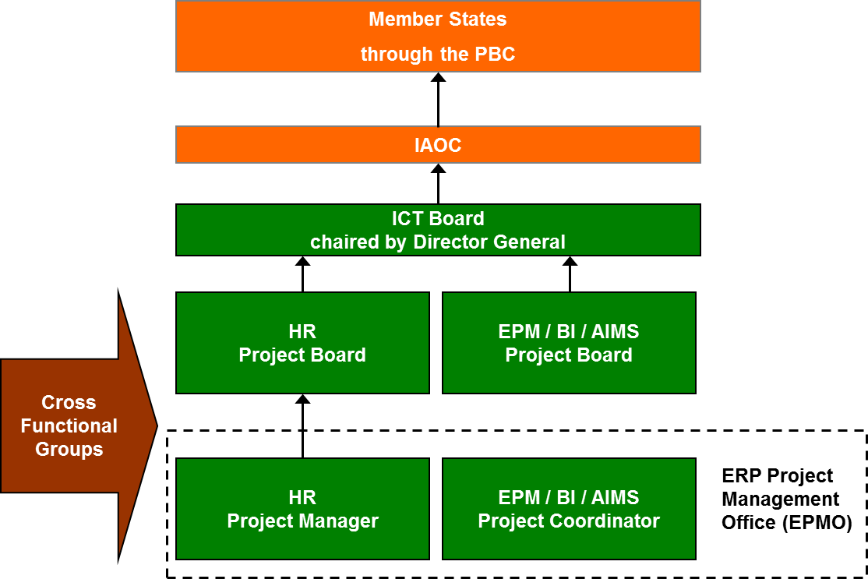

- A tender is currently in progress to engage an external service provider to perform an Independent Verification and Validation (IV&V) review of the ERP portfolio. This review is expected to be completed during the second half of 2013 focusing on the quality of the ERP portfolio implementation and delivered solutions with resulting recommendations for improvements. The results of the review will be submitted to the ICT Board.
- The ERP portfolio of projects continues to engage with staff at all levels. A communication leaflet on the ERP and its expected benefits to the Organization and staff was prepared and issued in 2012. A number of ERP information sessions held during the period under review were well attended by staff. Furthermore, a user-friendly and informative Intranet site was launched, which is continuously kept up-to-date with new information as each project under the portfolio evolves.

V. ERP Project Budget Utilization

- The overall estimated cost for the implementation of the ERP portfolio of projects amounts to approximately 25 million Swiss francs over a five-year time frame. The estimated costs include application hosting, software acquisition, project personnel, user back-filling resources, external implementation partner fees, training and communication as well as other project-related costs. As the systems are deployed and become operational, the recurring costs of maintenance and system operation will be included in successive Program and Budget proposals as part of the regular budget. A judicious mix of using external versus internal project personnel resources, including the use of low cost off-shore resources, has resulted in the delivery of planned functionality within a tightly managed project budget.
- A summary of budget utilization to date by major functional area and cost element, together with the estimated budget utilization until the end of 2013, is presented in the tables below:
ERP Portfolio of Projects Budget Utilization (by Major Functional Area)
(In Swiss francs, as at May 31, 2013)

Major Functional Area | Project Budget | Actuals to Date¹ | Estimated budget utilization by end 2013²
Program and Change Management | 3,830,200 | 1,240,623 | 2,047,736
Human Resource Management and Development | 8,945,755 | 3,094,827 | 5,380,391
Enterprise Performance Management | 6,017,982 | 2,859,843 | 4,193,154
Customer Relationship Management | 1,955,690 | 108,925 | 108,925
AIMS Enhancements | 4,591,840 | 2,266,690 | 3,724,926
Total³ | 25,341,467 | 9,570,908 | 15,455,132

¹ Actuals to date include expenditures and commitments as of May 31, 2013.
² Estimated budget utilization by end 2013, includes actuals to date (May 31, 2013) and expected expenditure until end 2013, based on the current spending assumptions.
³ The original budget estimated actual expenditure to reach 19 million Swiss francs by the end of 2013. The current forecast is significantly lower than the original budget, with the difference expected to be spent in forthcoming project phases.

ERP Portfolio of Projects Budget Utilization (by Cost Element)
(In Swiss francs, as at May 31, 2013)

Cost Element | Project Budget | Actuals to Date¹ | Estimated budget utilization by end 2013²
Application Hosting | 1,383,360 | 144,429 | 739,029
Software Acquisition | 3,989,738 | 2,063,896 | 2,723,937
Project Personnel | 5,564,680 | 2,216,805 | 3,448,993
User back-filling resources | 2,703,800 | 617,139 | 1,027,653
External Implementation Partner | 9,896,109 | 4,477,288 | 6,883,368
Training | 1,253,780 | 35,737 | 511,893
Communications and other | 550,000 | 15,614 | 120,259
Total³ | 25,341,467 | 9,570,908 | 15,455,132

¹ Actuals to date include expenditures and commitments as of May 31, 2013.
² Estimated budget utilization by end 2013, includes actuals to date (May 31, 2013) and expected expenditure until end 2013, based on the current spending assumptions.
³ The original budget estimated actual expenditure to reach 19 million Swiss francs by the end of 2013. The current forecast is significantly lower than the original budget, with the difference expected to be spent in forthcoming project phases.

vI. Portfolio schedule

- Despite some minor delays in the implementation of certain work streams under the ERP portfolio, the portfolio of projects is on track for completion within the estimated five-year time frame.

vII. PORTFOLIO Risks

- The ERP portfolio of projects continues to comprehensively identify, monitor and manage risks through the implementation of mitigation strategies. The table below highlights the key risks identified for the portfolio of projects as a whole.
Risk | Description | Risk Mitigation
User expectations are not met. | User expectations may exceed the original scope of the portfolio which could impact the ability to successfully conclude the ERP project. | User involvement in defining expectations takes place as early as possible. Manage the portfolio scope carefully through the ICT and project boards and prioritize activities based on solid user requirements. Communicate regularly and clearly.
Change is not well managed. | Staff do not use the system as planned and do not respond well to change. Services provided by existing systems are disrupted as changes needed to support the ERP portfolio requirements are introduced. | Change Management efforts focus on ownership and involvement of users and business process owners at multiple levels.  Full involvement of ICTD, AIMS enhancements are fully integrated into the ERP portfolio governance structure. The project boards review and approve all key changes to the system. Master data and process management disciplines are established.

- The Program and Budget Committee is invited to recommend to
the Assemblies of the Member States of WIPO to take note of the contents of the present document.

[End of document]

