
E

wo/pbc/15/19
OriGINAL: English
DATE: june 8, 2010
Program and Budget Committee
Fifteenth Session
Geneva, September 1 to 3, 2010
progress report on the new construction project
Prepared by the Secretariat
- The purpose of this document is to present to the Program and Budget Committee (“the PBC”) a progress report on the New Construction Project covering the period since the previous report on the Project (document WO/PBC/14/9) was presented to it, on the occasion of its fourteenth session held from September 14 to 16, 2009.

THE NEW CONSTRUCTION PROJECT (NEW ADMINISTRATIVE BUILDING AND ADDITIONAL UNDERGROUND LINK BETWEEN THE AB BUILDING AND THE NEW BUILDING)

Progress of the construction site
- Construction remains on schedule for a completion date of October 8, 2010 (original completion date fixed in the contract), in respect of about 80% of the surface area concerned, while the remaining 20% will be completed on November 5, 2010. The 80% of surface area include the second to the fifth floors and the second to the fourth basement levels of the new building, as well as the fourth and fifth basement levels of the additional underground link between the AB Building and the new building. The 20% of surface area include the groundfloor, first floor and first underground floor of the new building, as well as the second and third basement levels of the additional underground link between the AB Building and the new building.
- The delivery of the completed Project on two dates, by zones clearly identified through an addendum to the contract, is due mainly to the substantial volume of additional work that was requested from the General Contractor, in terms of modifications (covered by the dedicated Contingency Provision for Project Modifications (see paragraph 10 below)) and unforeseen work (covered by the dedicated Contingency Provision for Miscellaneous and Unforeseen (see paragraph 11 below)), all of which amount to more than 10 million Swiss francs of additional work, or about 10% of the original fixed price contract. The severe weather conditions in the winter of 2009-2010 have also had an influence on the progress of work. As a consequence, the delay in delivery of part of the Project could have been much longer. However, because of the significant and timely measures agreed upon and adopted in situ by the Pilot and the General Contractor, this delay should impact only 20% of the work over four additional weeks only, beyond the 30-month construction period ending on October 8, 2010.
- In March 2010, on the basis of a recommendation from the Project Pilot and the Internal Project Monitoring Team, the Construction Committee approved the following: (i) delivery of the Project on two dates and (ii) preparation of an addendum to the contract with the General Contractor in order to fix contractually the new delivery date for 20% of the works and other related contractual conditions.
- The last six to seven months of works in the new building (“Phase I”) and in the new underground link between the AB Building and the new building (“Phase II”) will be mostly devoted to facades, fixtures and fittings, interior layout, landscaping for the roof and part of the surroundings of the new building (noting that part of the originally planned surroundings will be affected by the construction site of the future conference hall and future security perimeter around all buildings).
- The opening of the new ramp to the AB Building underground parking took place on February 22, 2010, later than had been originally anticipated (November 2009), mainly due to severe weather conditions.
- The excavation work for the underground link between the AB Building and the new building (“Phase III”), modified to fit with the excavation work for the then-approved New Conference Hall Project, started on February 22, 2010. Construction work in that underground area will progress until the completion dates of October 8 and November 5, 2010, depending on the floor concerned, in line with the completion of Phases I and II, as outlined above.
- The updated Indicative Construction Phase Timetable is enclosed in the Annex.

Utilization of the approved budget and contingency provisions
- It is recalled that the PBC recommended, and the Assemblies approved, at their respective sessions held in December 2008, the updated and consolidated budget for the Project (amounting to about 145 million Swiss francs), as well as a “Provision for Project Modifications” and a “Provision for Miscellaneous and Unforeseen” (provisions amounting to a cumulative total of 16 million Swiss francs) (documents WO/PBC/13/6(b), WO/PBC/13/10 (report, paragraph 129), and A/46/12 (report, paragraph 45)).
- As had been indicated to the PBC at its 14th session, the “Provision for Project Modifications” (amounting to about 8.2 million Swiss francs) has been fully utilized to cover additional modifications relating to the Data Center, implementation of UN H-MOSS security measures in the new building, IP telephony and layout for a variety of storage in the new building.
- As of the date of this document, the “Provision for Miscellaneous and Unforeseen” (about 7.8 million Swiss francs) has been used or committed to cover a number of items for an amount of about 2.3 million Swiss francs. The resulting amount of about 5.5 million Swiss francs remains in that Provision for unforeseen matters that could occur during the last months of construction. The items concerned are the following: (a) the remaining cost of the layout for a variety of storage in the new building (about 660,000 Swiss francs), (b) underground reinforcement infrastructure work, certain safety and UN H-MOSS security measures in and around the new building, and certain minor interior installations adjustments (about 650,000 Swiss francs), (c) adaptation of technical installations in the existing basement levels of the AB Building connecting with the new additional basement levels (about 50,000 Swiss francs), (d) installation of fiber-optic liaison or redundant external liaison between the Data Center and other buildings (about 105,000 Swiss francs), (e) rectification of heating and ventilation system installations (about 60,000 Swiss francs), (f) fire safety measures (about 450,000 Swiss francs), (g) various technical measures in the ceiling and partitions walls of the offices and the atriums (about 370,000 Swiss francs) and corresponding honoraria (40,000 Swiss francs).

Loan and effect of the project on the WIPO regular budget
- It is recalled that, for the purposes of the Revised Program and Budget for the 2008/09 biennium presented to the PBC in December 2008, an amount of 4.9 million Swiss francs was approved (under Program 29) to cover mainly the honoraria for the Project Pilot and the interest on the loan. The first drawdown on the loan (for 50 million Swiss francs), originally planned for December 2008, was delayed until March 2009 in order to benefit from lower interest rates. As a consequence, the approved amount under the regular budget was not fully used within the biennium. Similarly, the approved Program and Budget for the 2010/11 biennium covers (under Program 29) the honoraria for the Project Pilot and the interest on the loan, on the assumption that up to two more drawdowns would take place between the end of 2010 and the beginning of 2011.
- The regular budget (Program 24.4) continues to bear the rental cost of non-WIPO-owned premises in the 2008/2009 and 2010/2011 biennia pending completion of the project. The regular budget, in the 2010/2011 biennium, will also bear the cost of the moves of employees and various installations, equipment and storage to the new building, as well as the cost of vacating the rented premises before returning them to their respective owners.

WIPO Construction Projects Charter and Risk Registers
- The Charter, which has been renamed the “WIPO Construction Projects Charter” (instead of “Charter for the New Construction Project”), has been revised substantially to take into account the following main events or factors which occurred since the previous version of the Charter was issued (i.e., version v.08 (2009) in March 2009): (a) a conceptual change through the introduction of a clear separation between the New Construction Project and the New Conference Hall Project by covering each project under a separate Chapter, which resulted in some restructuring of the text; (b) other modifications in the text and in the collection of Annexes having become necessary due to several obvious updates (new Senior Management Team, composition of the Construction Committee and of the Internal Project Monitoring Team, introduction of IPSAS and the new Financial Rules and Regulations).
- The revised version of the Charter, version v.09 (2010), dated March 26, 2010, which was presented to the Audit Committee at its April 2010 meeting, is available upon request.
- The WIPO Risk Register and the Pilot Risk Register continue to be updated on a monthly basis.

IMPLEMENTATION OF UN H-MOSS SECURITY MEASURES RELATING TO THE NEW CONSTRUCTION PROJECT
- Implementation of all UN H-MOSS security measures relating to the Project is included in the overall work progress and covered by the consolidated budget or respective contingency provisions, depending on the kind of measures (see paragraphs 10 and 11, above).
- Reference is made to the separate Progress Report dedicated to UN H-MOSS security measures implementation as it relates to the WIPO existing buildings.

REGULAR CONTROL AND AUDIT OF THE NEW CONSTRUCTION PROJECT
- The New Construction Project continues to be the subject of regular audits, by the External Auditor, the WIPO Audit Committee and the Internal Audit and Oversight Division.

20. The Program and Budget Committee is invited to take note of this Progress Report.

[Annex follows]

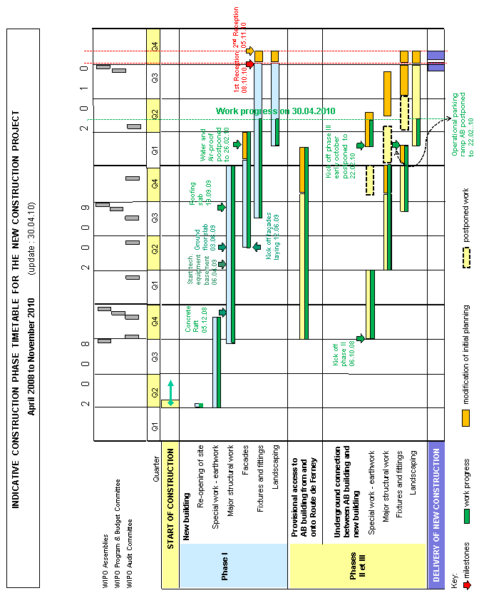

[End of Annex and of Document]

The delivery date of the Data Center (located in the underground of the new building) is November 25, 2010, as had been contractually agreed in 2009 through an addendum to the contract with the General Contractor, as the Data Center was a major modification introduced in the Project beyond the technical specifications covered by the original contract.

