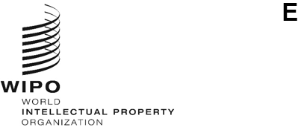
WO/GA/56/1
ORIGINAL: ENGLISH
DATE: MAY 5, 2023
WIPO General Assembly
Fifty-Sixth (26th Ordinary) Session
Geneva, July 6 to 14, 2023
COMPOSITION OF THE PROGRAM AND BUDGET COMMITtEE
Document prepared by the Secretariat
The members of the WIPO Program and Budget Committee (PBC) are elected for a period of two years.
At its meeting in October 2021, the WIPO General Assembly unanimously elected the following States as members of the PBC: Algeria, Argentina, Armenia (2021-2022), Azerbaijan (2021-2022), Bangladesh (2021-2022), Belarus (2022-2023), Brazil, Canada, Chile, China, Colombia, Czech Republic, Egypt, El Salvador, Estonia, France, Germany, Ghana, Greece, Guatemala, Hungary, India, Indonesia (2022-2023), Iran (Islamic Republic of) (2021-2022), Iraq (2022-2023), Italy, Jamaica, Japan, Kazakhstan (2021-2022), Kenya, Kyrgyzstan (2022-2023), Malaysia (2021-2022), Mexico, Mongolia (2022-2023), Morocco, Namibia, Nigeria, Oman (2022-2023), Pakistan (2021-2022), Panama, Poland, Qatar (2021-2022),Republic of Korea (2021-2022), Romania, Russian Federation, Saudi Arabia, Serbia, Singapore (2022-2023), Slovakia, South Africa, Spain, Sweden, Switzerland (ex officio), Syrian Arab Republic
(2022-2023), Tajikistan (2022-2023), Tunisia, Türkiye, Turkmenistan (2022-2023), Uganda, United Arab Emirates (2022-2023), United Kingdom, United States of America, Uzbekistan (2021-2022), Viet Nam (2021-2022) (53).

As the mandate of the current members of the PBC expires this year, new members must be elected by the WIPO General Assembly. It is recalled in this context that since the last mandate of the PBC, there was a shift of dates of the meetings of the Assemblies of the Member States of WIPO in 2022, from October to July. It is therefore proposed that the new members be elected for the period starting from the close of the present session to the close of the next ordinary session of the General Assembly in 2025.
The WIPO General Assembly is invited to decide on the membership and composition of the Program and Budget Committee for the period as provided in paragraph 3 of document WO/GA/56/1.
[End of document]

