E
WO/GA/49/4
ORIGINAL: ENGLISH
DATE: AUGUST 17, 2017

WIPO General Assembly

Forty-Ninth (23rd Ordinary) Session
Geneva, October 2 to 11, 2017

APPOINTMENT OF THE EXTERNAL AUDITOR

Document prepared by the Selection Panel

1. The present document contains the Report of the Selection Panel for the Appointment of the WIPO External Auditor, which provides an overview of the selection process conducted by the Panel, and the recommendation of the Selection Panel for the appointment of the WIPO External Auditor.

2. The WIPO General Assembly is invited to appoint the Comptroller and Auditor General of the United Kingdom as the WIPO External Auditor for a period of six years to begin on January 1, 2018.

[Annex follows]

REPORT OF THE SELECTION PANEL FOR THE APPOINTMENT
OF THE WIPO EXTERNAL AUDITOR

Background

- The mandate of the current WIPO's External Auditor – namely the Comptroller and Auditor General of India – will end on December 31, 2017. Under Regulation 8.2 of WIPO’s Financial Regulations and Rules, the appointment as External Auditor of WIPO is limited to a term of office of six years non-renewable consecutively. As a result, it was necessary to launch a selection process in order to appoint a new External Auditor for another six-year period (the financial periods 2018-2019, 2020-2021 and 2022-2023), in accordance with the selection process approved by the General Assembly on October 1, 2009 (document WO/GA/38/20).

Appointment of Selection Panel

- Pursuant to the above mentioned selection process, a Selection Panel was appointed, comprised of the Coordinators of each of the seven Groups of WIPO Member States. The invitation was sent by the Director General to the Permanent Representatives of WIPO Member States acting as the Coordinators of each of the seven Groups of WIPO Member States.

- The following were appointed as Members of the Selection Panel for the Appointment of the WIPO External Auditor:

Ms. Chichi UMESI (Nigeria)
Mr. Parviz EMOMOV (Tajikistan)
Ms. Marcela PAIVA (Chile)
Ms. Rhea TSITSANI (Greece)
Mr. Sumit SETH (India)
Ms. Liene GRIKE (Latvia)
Mr. Shi YUEFENG (The People’s Republic of China)

- The Selection Panel met initially in September 2016. During the first Session, the Panel adopted its Rules of Procedure and elected Ms. Chichi UMESI as President and Mr. Parviz EMOMOV as Vice-President of the Panel.

- In accordance with the Rules of Procedure, the Director General appointed
Mr. Denis COHEN, Head, Contracts and General Legal Section, Office of the Legal Counsel, as Secretary to the Selection Panel.

Evaluation Matrix and Evaluation Process

- Representatives of the Finance Division and the Internal Oversight Division (IOD) of WIPO, together with WIPO’s Independent Advisory Oversight Committee (IAOC), prepared a list of draft selection criteria with appropriate weightings (the evaluation matrix), which was submitted to the Selection Panel for its consideration.

- The Panel reviewed the evaluation matrix to be used for the evaluation of the proposals, and agreed on the following selection criteria:

- Independence: demonstrated autonomy from other institutions or bodies of the government; integrity; objectivity in the discharge of duties and responsibilities; and ability to self-determine scope of audit.

- Qualifications of Officials and Staff: conformity to the auditing standards of the United Nations Panel of External Auditors and ethics governing their work and to International Standards on Accounting, Financial Reporting and Auditing; professional qualifications, skills, and size of work force and size of proposed team; membership in internationally recognized accounting or auditing bodies such as the International Organization of the Supreme Audit Institutions (INTOSAI), the International Federation of Accountants (IFAC), etc.; proficiency in English or French; and knowledge of IPSAS.

- Training and experience: existence of a program for continuing professional education for staff; experience in the audit of United Nations organizations or other national or international public sector or non-governmental organizations; staff adequately trained in modern trends of auditing and with extensive audit experience; and experience in auditing ERP systems and in use of computer aided audit techniques.

- Audit Approach and Strategy: comprehensive work plans to ensure adequate audit coverage of all WIPO resources; performance of financial and compliance audits as well as economy, efficiency and value-for-money audits; and collaboration with WIPO’s internal and external oversight bodies to optimize the use of limited audit resources.

- Audit Reports: proposed structure and format of reports and management letters by which the results of audit work will be communicated to management and to WIPO’s competent bodies.

- Cost: the most competitive fees.

- On October 5, 2016, all proposals received by the closing date were opened according to standard procurement procedure. The President of the Panel was present during the opening of the proposals.

- A preliminary evaluation of the candidates’ proposals was carried out by representatives of the Finance Division and IOD. Such preliminary evaluation was subsequently reviewed by IAOC. The views and comments expressed by the Finance Division, IOD and IAOC were submitted to the Selection Panel for its consideration.

Shortlist and Oral presentations

- Following its review of the preliminary evaluations carried out by the Finance Division, IOD and IAOC, the Selection Panel agreed upon the following shortlist of candidates:

(a) the Auditor General of Canada; and
(b) the Comptroller and Auditor General of the United Kingdom.

- The shortlisted candidates were invited to make oral presentations to the Selection Panel, followed by question and answer sessions. Both candidates were presented with a number of questions in advance which had been prepared by the Selection Panel. The purpose of the oral presentations and question and answer sessions was to enable Panel members to have a better appreciation of the proposals and to provide an opportunity to seek additional information and clarification in order to facilitate the selection process.

- The oral presentations were held on April 10 and 20, 2017.
Recommendation of the Selection Panel

- The Selection Panel deliberated on its recommendation on May 2, 2017. The Panel undertook a thorough review of the candidates’ proposals. Information resulting from the oral presentations was used as part of the Panel’s evaluation.

- As part of its deliberations, the Panel considered that both the UK and Canadian candidates submitted thorough, serious and solid proposals, from which it appeared that they would both be fit to fulfill the position of External Auditor at WIPO and deliver high quality external audit services.

- Following the deliberation process, a consensus was reached among members of the Panel. In accordance with this consensus, the Selection Panel recommends to the WIPO General Assembly, as new WIPO External Auditor for a period of six years, to begin on
January 1, 2018, the appointment of:

the Comptroller and Auditor General of the United Kingdom

- The Selection Panel for the Appointment of the WIPO External Auditor adopted the present Report on May 16, 2017:
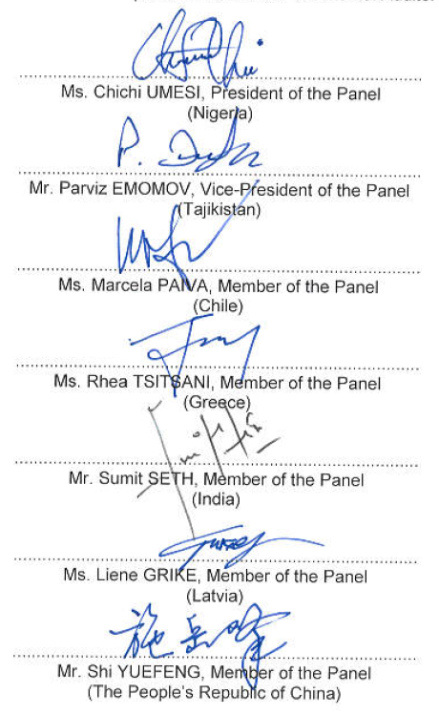
[End of Annex and of document]

