 |  | E
WO/GA/47/16
ORIGINAL: ENGLISH
DATE: July 28, 2015

WIPO General Assembly

Forty-Seventh (22nd Ordinary) Session
Geneva, October 5 to 14, 2015

CONVERSION OF WIPO INTERGOVERNMENTAL COMMITTEE ON INTELLECTUAL PROPERTY AND GENETIC RESOURCES, TRADITIONAL KNOWLEDGE AND
FOLKLORE (IGC) INTO A STANDING COMMITTEE: PROPOSAL BY THE AFRICAN GROUP TO THE 2015 GENERAL ASSEMBLY

Document prepared by the Secretariat

1 In a communication dated July 17, 2015, a copy of which is set out in the Annex, the Delegation of Nigeria, on behalf of the African Group, requested that its submission entitled “Conversion of WIPO Intergovernmental Committee on Intellectual Property and Genetic Resources, Traditional Knowledge and Folklore (IGC) into a Standing Committee: Proposal by the African Group to the General Assembly” be made available as a working document for discussion under Agenda Item 17 “Matters Concerning the Intergovernmental Committee on Intellectual Property and Genetic Resources, Traditional Knowledge and Folklore (IGC)” of the Forty-Seventh (22nd Ordinary) Session of the WIPO General Assembly.

2 The WIPO General Assembly is invited to consider the communication in the Annex to this document.

[Annex follows]

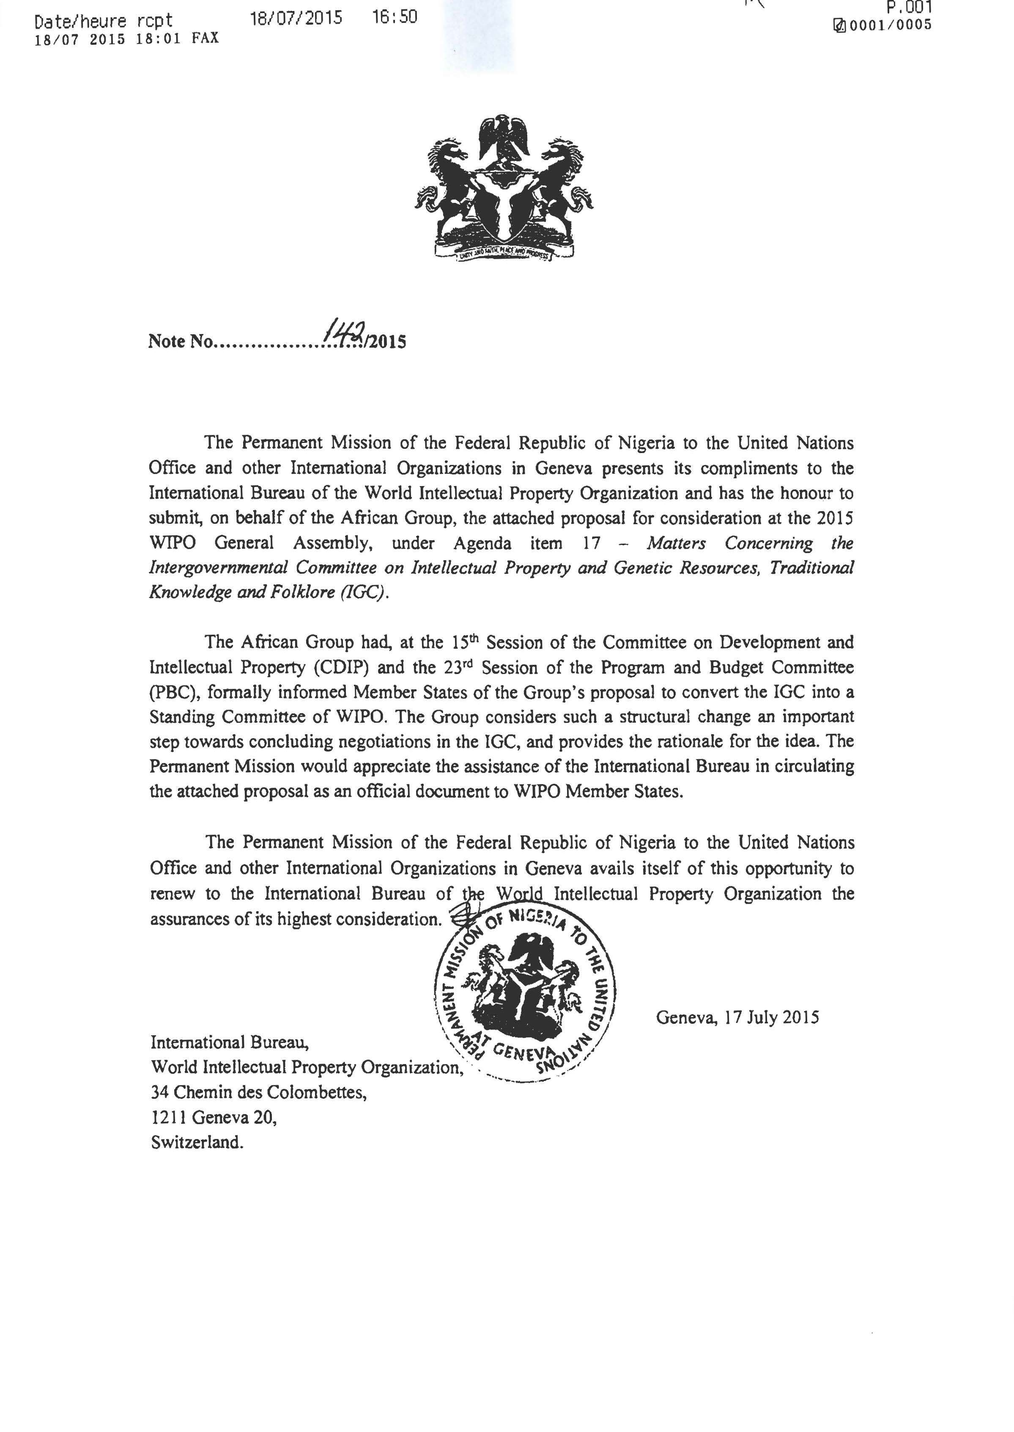

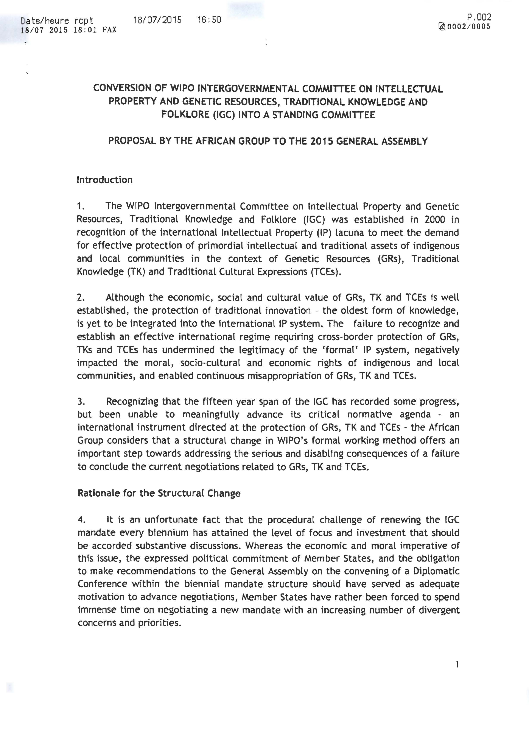

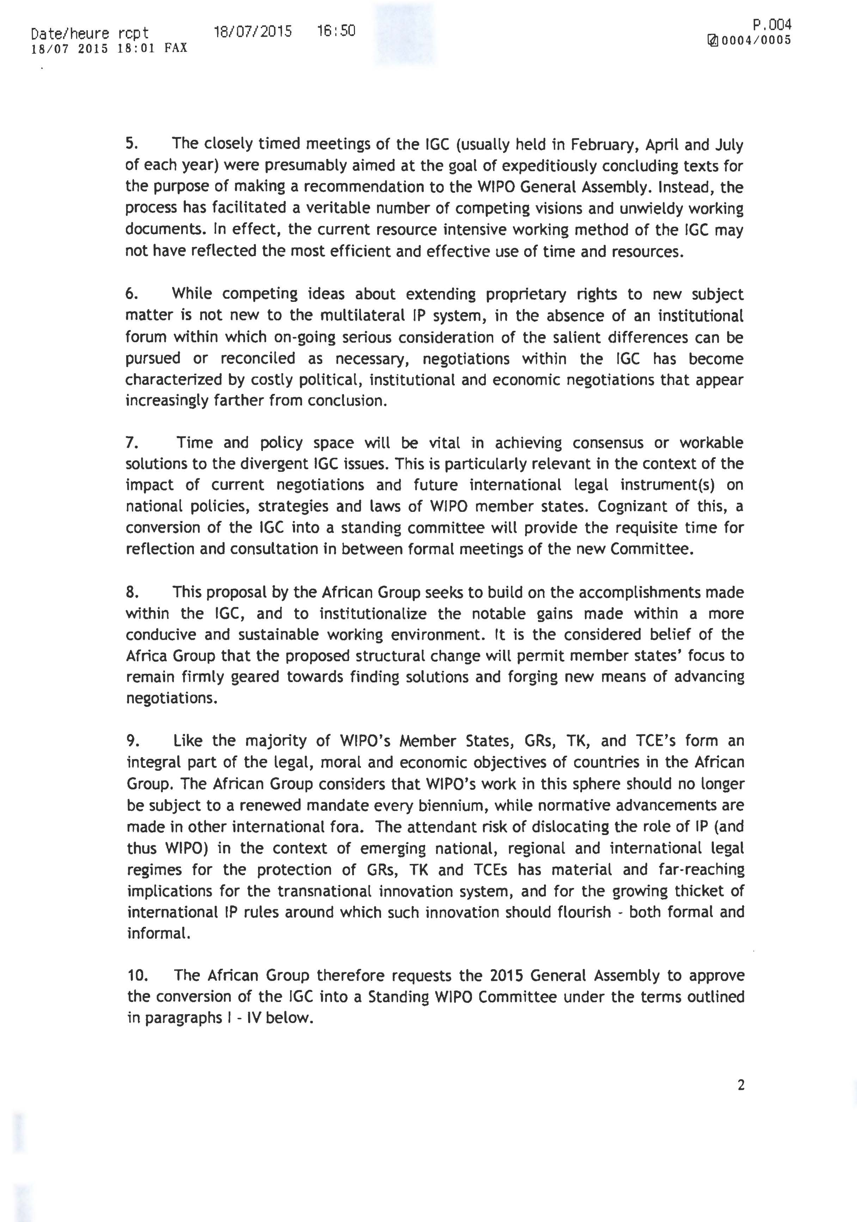
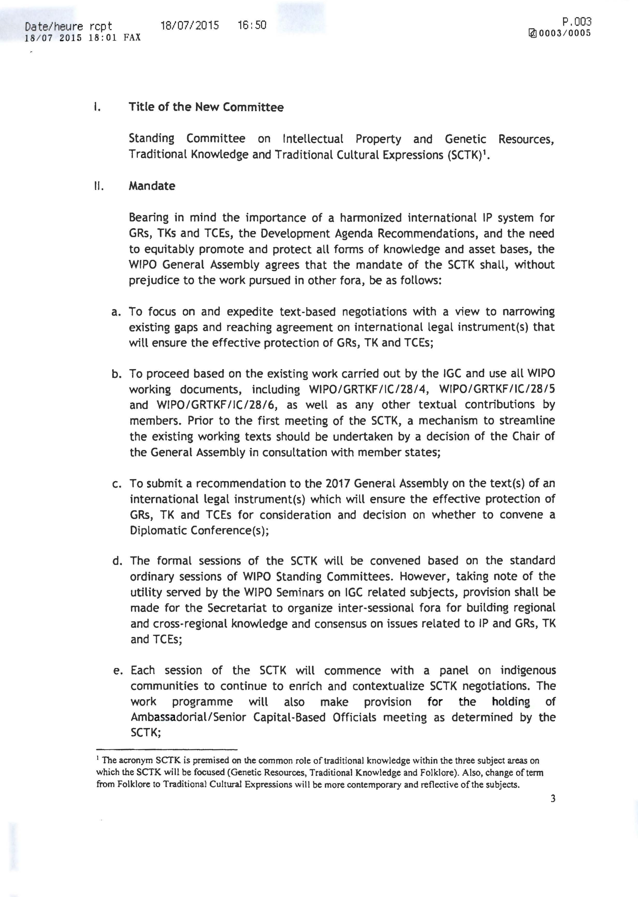

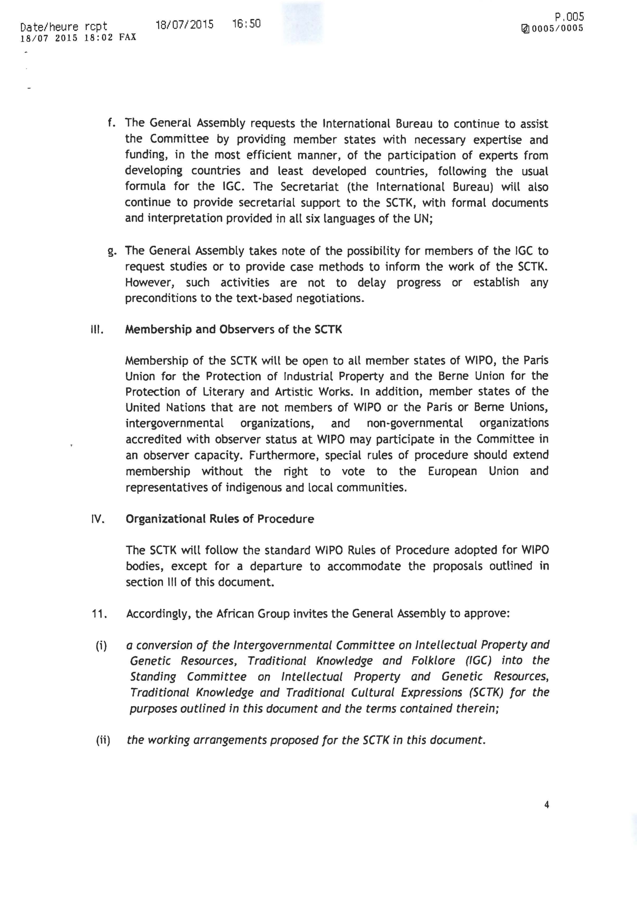
[End of Annex and of document]

