WIPO |  | E  WO/GA/34/11  ORIGINAL: English  DATE: September 17, 2007
WORLD INTELLECTUAL PROPERTY ORGANIZATION
GENEVA

wipo general assembly
Thirty-Fourth (18th Ordinary) Session
Geneva, September 24 to October 3, 2007
the new construction project
Prepared by the Secretariat

1. The Appendix to this document contains the progress report on the New Construction Project presented to the Program and Budget Committee, at its twelfth session, held from September 11 to 13, 2007 (document WO/PBC/12/7), and noted by that Committee.

2. The General Assembly is invited to take note of this document and its Appendix.

[Appendix follows]
WO/GA/34/11

APPENDIX

WIPO |  | E  WO/PBC/12/7  ORIGINAL: English  DATE: August 17, 2007
WORLD INTELLECTUAL PROPERTY ORGANIZATION
GENEVA

PROGRAM AND BUDGET COMMITTEE
Twelfth Session
Geneva, September 11 to 13, 2007
progress report on the new construction project
Prepared by the Secretariat

- The Secretariat presented a progress report on the new construction project on the occasion of the eleventh session of the Program and Budget Committee (“the PBC”), held from June 25 to 28, 2007(document WO/PBC/11/13).

- The purpose of the present document is to provide the PBC with a progress report on the project, along the following main themes:

I. Overall timetable
II. Status of the main pre-construction phases
III. Estimated cost and planned financing
IV. Regular reporting
V. Experts and advisors

I. Overall timetable
2
- The start of construction remains on schedule for February 2008. The construction phase is expected to take about 26 months to end in April 2010. All steps and phases foreseen since April 2006, following the recommendation of the WIPO Audit Committee that the project should proceed, have occurred basically as planned. The current version of the Indicative Timetable is contained in the Annex to this document.

II. status of the main pre-construction phases

Taking up of fonctions by the project pilot

- The project pilot, Burckhardt+Partner SA, was selected by the Selection Board in October 2006, following the preselection stage which had taken place in June 2006. The pilot took up its functions at the end of November 2006, immediately after signature of the contract, and has, since, been directing the project on behalf of WIPO, dealing with all parties concerned from the operational viewpoint (architect, engineers, local authorities). The pilot has also participated extensively in the preparation of the technical documentation for the international tender procedure aimed at selecting the general contractor (see paragraph 5, below). Furthermore, the pilot has established a Risk Register for the project (see paragraph 8, below). Finally, the pilot has carried out a detailed cost audit of the project (see paragraph 10, below).

Selection process for the general contractor

- Following the preselection by the Selection Board in March 2007 of a number of companies, the Secretariat issued the Request for Proposals (RFP) to those preselected companies on April 5, 2007, with a closing date of July 23, 2007. Companies were required to make a “fixed price offer” guaranteed until the end of the construction phase. Evaluation of the offers will be carried out between August and October 2007. The Selection Board is expected to meet towards the end of October 2007 to select the general contractor. The aim is to negotiate, conclude and sign the contract before the end of December 2007.

Selection process for the financing institution

- The Call for Expressions of Interest for the bank loan was launched on May 7, 2007, with a closing date of July 2, 2007. The Selection Board is scheduled to meet in September 2007 to preselect the financing institutions from those which will have expressed an interest. The Request for Proposals (RFP) for the bank loan is planned to be issued in September/October 2007 to the preselected financing institutions. Evaluation of the offers should be carried out in October/November 2007 followed by a session of the Selection Board at the beginning of December 2007 to select the financing institution. The aim is to negotiate, conclude and sign the contract before the end of December 2007 so that the availability of the funds coincides with the start of construction.

Project Charter and Risk Registers
3

- The Project Charter, which was substantially revised in June 2006, has since been updated on the occasion of each meeting of the WIPO Audit Committee, the current version being version v.05 (2007), dated June 20, 2007. Copies are available upon request.

- In addition to the Charter, and at the request of the WIPO Audit Committee, two Risk Registers have been established for the project, one under the responsibility of the pilot and the other under the responsibility of the Secretariat. These Registers, last updated in June 2007, are now updated monthly.

III. ESTIMATED COST AND PLANNED financing

Estimated cost of the project

- Following a recommendation of the WIPO Audit Committee, the External Auditor was requested to carry out an audit of the estimated cost of the project; his report was presented on December 6, 2006. Copies of the report were made available to the PBC, at its third informal session, and were sent to Permanent Missions in Geneva under cover of Note verbale N.2737 dated January 10, 2007. This report showed that the overall estimated cost of the project, approved by Member States in October 2005 (125.4 million Swiss francs), should be updated to 129.8 million Swiss francs.

- The External Auditor recommended, however, that a detailed cost audit be carried out by the pilot; this recommendation was endorsed by the Construction Committee. The audit report of the pilot was presented to the WIPO Audit Committee at its July 2007 meeting. This report showed that the overall estimated cost of the project should be updated to 138.6 million Swiss francs as follows: (i) to correct a minor miscalculation of one item (building facades) in the 2005 estimated cost; (ii) to take into account the increase in construction costs based on the higher Geneva index (rather than the lower Zurich index used by the External Auditor) and (iii) to take into account the fact that the companies are required to offer a fixed price which will have to be guaranteed until the end of construction, i.e., until April 2010. In addition, the pilot strongly recommended that an amount corresponding to a conservative 5% of the total estimated cost (about 7 million Swiss francs) be included for miscellaneous and unforeseen, in view of the scope and size of the project.

- It should be noted that after the date of approval of the new construction project, the UN system issued new directives on the security of the premises of UN organizations (United Nations Headquarters Minimum Operating Security Standards (UN H-MOSS)). As a result, it is anticipated that the cost initially estimated for the project may increase because of new security elements, to be mandatorily integrated in the original plan. For further details on the estimated cost of these additional security elements, in accordance with UN H-MOSS, reference is made to the document presented to the PBC, at its twelfth session (document WO/PBC/12/4(d)).

- However, the actual construction cost of the project will eventually depend on the actual price that the Organization will pay to the selected general contractor. The selection of the general contractor will be made by the Selection Board (composed of Member States representatives). This price will be expressed as a fixed-price.
4

Financing of the project

- On the recommendation given by the PBC in April 2005, the Assemblies of the Member States approved in October 2005 the financing of the project by means of a commercial loan for an amount of 113.6 million Swiss francs, representing the difference between the overall estimated cost and amounts already disbursed or committed at that time (documents A/41/17, paragraph 194(iv) and WO/PBC/8/INF/1, paragraphs 10 and 12).

- Subject to recommendation by the PBC at its present session and to subsequent approval by Member States at the 2007 session of the Assemblies, the Organization will reduce the amount of this loan by covering from funds drawn from the reserves part of the cost of the construction. The maximum amount of such down payment from reserves funds shall be also determined by the Member States. For further information, refer to document WO/PBC/12/4(b).

Effect of the project on the WIPO regular budget

- Due to the postponement of the start of the project, the cost incurred under the regular budget (Program 31) in the 2006/2007 biennium will be marginal. This is reflected in the revised budget for the 2006/07 biennium (document WO/PBC/12/2). On the other hand, an amount of 5.2 million Swiss francs has been budgeted under Program 31 in the Proposed Program and Budget for the 2008/09 biennium (document WO/PBC/12/4), to cover mainly the cost of the pilot and the estimated cost of the bank loan. In addition, the regular budget (Program 29) will continue to bear the rental cost of non-WIPO-owned premises in the 2008/2009 and 2010/2011 biennia pending completion of the project.

IV. regular reporting

WIPO Audit Committee

- The Secretariat presented progress reports to the WIPO Audit Committee at its third, fourth and fifth meetings held in October 2006, March 2007 and July 2007. The Committee made a number of recommendations which were subsequently reflected in the various processes and documents relating to the project.

- The WIPO Audit Committee also met with the pilot in December 2006 and in March and July 2007.

External Auditor
5

- The project was audited by the External Auditor on the occasion of a special audit in November 2006 (see paragraph 9, above) and in the course of the first semester audit for 2007.

- The External Auditor also met with the pilot in April 2007 on the occasion of the first semester audit for 2007.

Internal Auditor

- The Internal Audit and Oversight Division provided general comments on the WIPO Risk Register in connection with the June 2007 version of that Register (see paragraph 8, above) and is currently carrying out a formal audit of that Register.

V. EXPERTS AND ADVISORS

FIPOI

- The Secretariat had, in 2005, engaged the services of FIPOI in connection with the preselection and selection processes for the pilot. A FIPOI representative presented independent evaluation reports to the Selection Board during the sessions dealing, respectively with the preselection for, and selection of, the pilot (June and October 2006).

Institut pour le droit suisse et international de la construction

- The Secretariat engaged in July 2006 the Institut pour le droit suisse et international de la construction (Swiss and International Construction Law Institute), attached to the University of Fribourg, Switzerland, to advise on a number of matters relating to the project (tender procedures, definition and weighing of preselection and selection criteria, draft contracts, penalty provisions for delays in construction timetable, arbitration and other settlement of dispute mechanisms, etc.). The advise provided by the Institut has been, and continues to be, most beneficial to the Secretariat.

Financial expert

- The Secretariat also engaged in July 2007 a financial expert to advise on matters relating to the selection of the financing institution (tender procedure, definition and weighing of selection criteria, draft contract, etc.).

24. The Program and Budget Committee is invited to take note of this document.

[Annex follows]

WO/GA/34/11
Appendix, page 6

WO/PBC/12/7
ANNEX

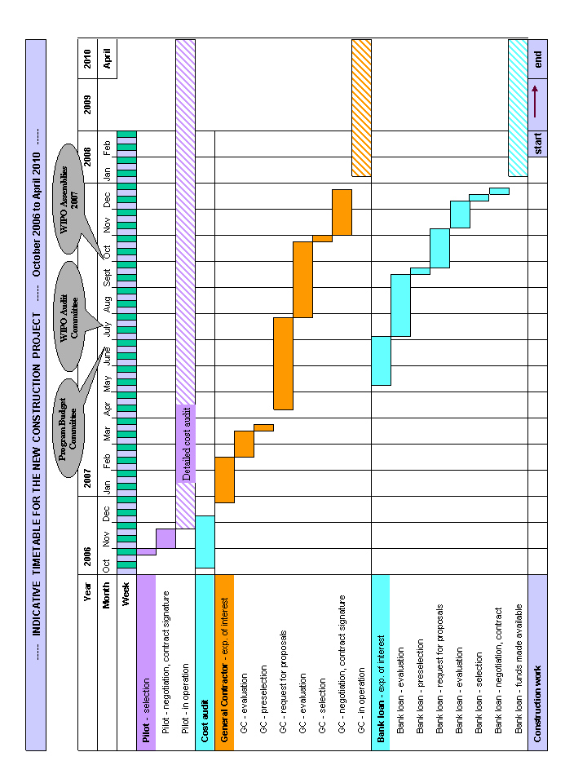
[End of Annex and of document]

[End of Appendix and of document]

