WIPO |  | E  WO/GA/26/8  ORIGINAL: English  DATE: September 22, 2000
WORLD INTELLECTUAL PROPERTY ORGANIZATION
GENEVA

wipo general assembly
Twenty-Sixth (12th Extraordinary) Session
Geneva, September 25 to October 3, 2000
PREMISES PLAN 2000 TO 2007
PROGRESS REPORT ON NEW CONSTRUCTION
AND STUDY ON ENERGY STATION
Memorandum of the Director General

1 The Program and Budget Committee, at its second session from September 20 to 22, 2000, discussed the proposals on the Premises Plan 2000 to 2007, the Progress Report on New Construction and Study on Energy Station (document WO/PBC/2/5) which is annexed to this document. The views of the Member States represented at the Committee on these proposals, are contained in its report (document WO/PBC/2/6*).

2 The General Assembly is invited to take note of the information contained in the Annex.

[Attachment follows]
WO/GA/26/8
ATTACHMENT

I. Introduction

3 This document is intended to inform Member States on the status of current activities and planning with regard to WIPO premises. Part II provides a premises plan for the period 2000-2007. This is followed by a progress report on the new construction in Part III, including, in particular, the results of the international architectural competition. Finally, Part IV presents the outcome of a study on the establishment of an energy station for the WIPO facilities.

II. premises plan 2000 to 2007

4 The premises plan presents projections on WIPO working place and parking space requirements for the period from 2000 to 2007. This is compared to the projected availability of WIPO-owned and rented premises. It is indicated that the gradual increase in requirements is met by new WIPO-owned premises, with the ex-WMO building being occupied in early 2003 and the new construction in the second half of 2004. This will allow for the gradual phase-out of rented premises and a corresponding reduction in rental costs. The premises plan also includes the requirements of UPOV and is an update of a similar presentation which was made available to Member States in March 1998 (see document WO/GA/22/1) in connection with the launch of major building initiatives.
Projected working place requirements and availability

5 Working place requirements and availability are indicated in Annex A. The requirements include working places for the regular staff and other employees, including consultants, short-term employees, translators working under special service agreements and sub-contractors. The requirements also take into account a 5 per cent reserve in accordance with the 1998 premises plan. Available working places are indicated for each WIPO-owned or rented facility by WIPO. As compared to the 1998 premises plan, the data has been revised to include working places for sub-contractors, including the security and cafeteria operation.

6 As of August 2000, actual requirements amounted to 1,266 working places (see column A of Annex A). These compared to the availability of 1,185 working places. The shortfall of 81 places was accommodated through a temporary reduction in office standards for a number of employees. Of the total working places available, 585 places, or 49.4 per cent, were located in three WIPO-owned buildings (A. Bogsch, G. Bodenhausen I and II). Additional 600 working places, or 50.6 per cent, were provided through rented facilities in eight buildings, including in seven buildings in Geneva (Centre administratif des Morillons (CAM), Union Carbide (UC), International Business Machines (IBM), Chambésy, Procter and Gamble (P&G), International Organization for Migration (IOM) and Sogival) and in one building in New York (United Nations Plaza (DCII)) to accommodate the WIPO liaison office.

7 The actual working place requirements of 1,266 for August 2000 exceed the projected 1,017 working place requirements for December 2000 which were presented in the 1998 premises plan. The difference is mainly due to the greater than expected expansion of demand for intellectual property protection. The increase by 249 working places or 24.5 per cent could only be accommodated through the rental of additional facilities. As a result, the rental cost of 10 million Swiss francs for 2000 represents nearly a 65 per cent increase from the previous year. In addition, operating costs are incurred due to the dispersal of staff in a number of buildings in Geneva.

8 The projected working place requirements for the period 2001 to 2007 are presented in Annex A. The projections reflect an increase of 5 per cent annually similar to the assumption utilized for the 1998 premises plan. This compares to an actual increase of 11.3 per cent annually for the last 5 years and of 9.9 per cent annually for the last 10 years. On the basis of the growth assumption and taking into account the reserve provision, the working place requirements are estimated to increase to 1,287 by January 2001, to 1,419 by January 2003 and to 1,565 by January 2005. By 2007, there will be a need for 1,725 working places.

9 By January 2001, total requirements of 1,287 working places will be accommodated by 1,351 available places. This reflects an increase by 182 in the working places rented in the P&G building, partly offset by a discontinuation of the rental arrangement for 16 working places in the IOM building. With the completion of the renovation, modernization and extension of the ex-WMO building (see document WO/PBC/2/4), 450 additional WIPO-owned working places will become available in early 2003. This will allow WIPO to discontinue the rental arrangements in the UC, Sogival and IBM buildings, resulting in a reduction of rental costs from 11.5 million Swiss francs in 2002 to 9 million Swiss francs in 2003. As compared to August 2000, the number of WIPO-owned working places will nearly double from 585 to 1,035 by 2003.

10 With the completion of the new construction (see part III below), 500 additional working places will become available in the second half of 2004, increasing the number of available working places in WIPO-owned buildings to 1,535. As a result, the rental arrangement in the P&G building will be discontinued as of 2005, providing for a reduction in rental costs from 9 million Swiss francs in 2004 to approximately 3 million Swiss francs in 2005. WIPO will continue to rent 193 working places at three premises, namely the CAM and Chambésy buildings in Geneva and the DCII building in New York. With the new WIPO-owned buildings becoming available, some excess capacity in working places is anticipated in particular for the years 2003 and 2005. Provided that the actual requirements are not higher than expected, efforts will be made to sub-lease such excess capacity.

11 It is anticipated that in 2007, the available working places of 1,728 will be sufficient to accommodate the working place requirements of 1,725. By 2007, WIPO will own approximately 88.8 per cent of the total available working places, as compared to only 49.4 per cent in August 2000, resulting in reduced rental costs. Moreover, with the discontinuation of the use of a number of buildings in Geneva and the use of co-located facilities in 2007, reductions in operating costs can be anticipated.

Projected parking space requirements and availability

12 The parking space requirements and availability for the period from 2000 to 2007 are indicated in Annex B. In accordance with actual experience, the requirements for parking spaces are identified as 80 per cent of the working place requirements. In August 2000, actual requirements amounted to 1,013 parking spaces. This compared to the availability of 869, which represents a shortfall of 144 parking spaces, with the consequence that many staff members have to wait for a long time before getting a parking space. Of the total 869 parking spaces available, 239 spaces, or 27.5 per cent, were located in two WIPO-owned buildings (A. Bogsch, G. Bodenhausen I) and an additional 630 parking spaces were provided through seven rented facilities at a total cost of approximately one million Swiss francs annually. Parking spaces are rented by WIPO to staff members resulting in a total estimated income of 0.3 million Swiss francs for 2000.

13 In 2001, the number of parking spaces will increase to 1,040 with the renting of 171 additional parking spaces in the P&G building along with the additional working places as described above. New arrangements in 2003 will result in an increase in parking spaces from 1,040 by 24 to 1,064. This reflects the availability of 144 new spaces in the ex-WMO building, which will be occupied in early 2003, and the discontinuation of rental arrangements for 120 spaces in the UC, IBM and Sogival buildings. A further increase in parking spaces from 1,064 by 305 to 1,369 will be realized in the second half of 2004. This will be the result of the new constructions becoming available and providing 580 additional parking spaces, partly offset by a reduction in 275 rented parking spaces due to the discontinuation of the rental arrangement for the P&G building. It is anticipated that sufficient parking spaces will be available in 2007. At that time, WIPO will own approximately 70.3 per cent of the total available parking spaces as compared to only 27.5 per cent in August 2000.

III. Progress report on new construction

14 The General Assembly approved the new construction in September 1998 at a cost of up to 82,500,000 Swiss francs (see paragraph 30 of document WO/GA/23/7). The new lot for the new construction was purchased in 1998 at an additional cost of 13,554,000 Swiss francs based on the decision of the General Assembly (see paragraph 9(d) of WO/GA/22/2). All project costs are covered under the Special Reserve Fund for Additional Premises and Computerization.

15 As outlined in document WO/GA/23/5, the new construction will include a new office building with 500 working places, a 300-seat cafeteria and 300 underground parking spaces, a new main conference room with approximately 600 seats for delegates and additional underground parking facilities with a capacity of 280 spaces. An international architectural competition was approved to determine the best solution for the construction elements. It was anticipated that the competition would start following the 1998 sessions of the WIPO Assemblies and end after 12 months in September/October 1999. Following the selection of the winning architect, the detailed specifications would be developed, based on which the international tendering for the construction could commence. The construction work was tentatively estimated to begin in early 2000 and be completed by the end of 2002.

16 Table 1 below provides a summary by main activities of the schedule of implementation and of the approved budget for the new construction. Of the total budget of 82,500,000 Swiss francs, 1,500,000 Swiss francs were approved for the international architectural competition, 2,000,000 Swiss francs for the development of detailed specifications, 51,000,000 Swiss francs for the construction work of the new office building, 15,000,000 Swiss francs for the construction work of the new conference building, 8,000,000 Swiss francs for the construction of additional parking spaces and 5,000,000 Swiss francs for furniture and equipment.
Table 1
Schedule of implementation and approved budget
for the new construction by main activities
In thousand Swiss francs
 |  | Schedule of implementation |  |  |  | Approved budget
Activities |  | Initial | Revised
 |  | Estimate | estimate
International architectural competition |  | Sep. 1998-Sep. 1999 | Nov. 1998-Mar. 2000 |  | 1,500
Development of detailed specifications |  | Oct. 1999-Apr. 2000 | Sep. 2000-Oct. 2001 |  | 2,000
Construction work of new office building |  | Apr. 2000-Dec. 2002 | Oct. 2001-Jul. 2004 |  | 51,000
Construction of new conference building |  | Apr. 2000-Dec. 2002 | Oct. 2001-Jul. 2004 |  | 15,000
Construction of additional parking spaces |  | Apr. 2000-Dec. 2002 | Oct. 2001-Jul. 2004 |  | 8,000
Furniture and equipment |  | First half of 2003 | Second half of 2004 |  | 5,000
TOTAL |  |  |  |  | 82,500

17 A comparison between initial and revised project plans is elaborated in Annex C. According to the revised project plan, it is anticipated that the new building will be occupied in the second half of 2004, rather than in early 2003 as initially planned. This delay is the result of longer time required to finalize the international architectural competition and to arrive at a detailed agreement with the winning architect as well as more time envisaged for the preparation of architectural and engineering studies and the selection of the general contractor. The milestones in project implementation are elaborated below.

18 Following the approval of the project in September 1998, the international architectural competition was launched in November 1998 to determine the best project design. The competition, open to architects from all Member States of WIPO, was overseen by an international jury appointed by WIPO which held its first meeting from June 7 to 8, 1999. The 15-member international jury was made up of a number of prominent architects, senior government officials and legal experts representing five continents. The jury, which was supported by a team of technical experts, was responsible for ensuring that the selection of the winning architectural design for the new construction was undertaken in a highly professional, objective and transparent manner. Competition procedures, rules and programs were established by the jury during its two organizational meetings held in Geneva in June and September of 1999. The list of jury members is attached as Annex D.

19 Following the launch of the competition, some 800 architectural offices from 62 countries expressed their interest to participate in the competition. Out of them, 186 applicants followed through by submitting their profiles. The jury met to review the pre-qualification submissions in Geneva from September 6 to 8, 1999. This resulted in the selection of 28 firms from 18 countries for the final competition. The competition brief outlined the main project concept and called for a design which included intelligence from a technological point of view, respect of the environment, efficiency in terms of operation, use, cost, energy and technology and congenial atmosphere for all staff and visitors. All installations were to be designed with built-in flexibility for rapid and low-cost alterations without the necessity for technical interventions or major structural modifications.

20 Out of 28 finalists, 27 architectural firms representing 18 countries submitted detailed proposals. Each firm that submitted a project received 10,000 Swiss francs. Neither the organizers nor the jurors knew the authorship of any of the submissions. The team of technical experts comprised of architects and engineers examined each submission for conformity with existing regulations and prepared cost analyses and energy ratings. Afterwards, the jury met for the third time from February 28 to March 2, 2000, at WIPO headquarters to select the winning design for the new construction.

21 Following the selection of the winning proposals by the jury, the Secretariat opened the sealed envelopes to reveal the author of each project. The jury awarded the first prize of 100,000 Swiss francs to Behnisch, Behnisch & Partner from Germany and summed up their decision by saying “It is a contemporary expression, respectful of its environment with an eye on the future – a project for a new generation”. The project proposed by Behnisch, Behnisch & Partner incorporates three green interior courtyards. While conveying this general concept, the chosen approach left details for discussion with WIPO to be further planned and developed. The jury summarized that “The overall concept integrates the building skillfully into the site, setting the building in a way that interacts with the landscape and draws the outside in. The informal office spaces are the most flexible and pluralistic.” The project emphasized sensitivity to environmental conditions, priority for high-quality human working places and low cost and energy efficiency.

22 The international architectural jury awarded the second prize of 50,000 Swiss francs to Massimiliano Fuksas Architecte from Italy. In addition, four third prizes of 25,000 Swiss francs were awarded to Snøhetta, Norway, Luscher Architectes, Switzerland, Richter & Dahl Rocha, Switzerland and Bernard Tschumi, United States of America. The WIPO press release on the designation of the winning design is attached as Annex E. From April 17 to 28, 2000, all the prize winning projects plus the finalists were put on display in the lobby of the A. Bogsch building for three weeks.

23 Negotiations with the selected architect Behnisch, Behnisch & Partner were undertaken from March 2000 through August 2000. This resulted in the approval of a pre-agreement, which determines the main features of the contractual arrangement, including the sharing of work between the Behnisch, Behnisch & Partner and the general contractor to be selected.

24 The request for building permits will be submitted to Geneva authorities at the end of 2000. Based on the architectural and engineering studies to be carried out, the tendering process to identify a general contractor will commence by April 2001. According to the revised plan, the construction work would start in October 2001 and finish in mid-2004. It is anticipated that the new construction will be occupied in the second half of 2004.

25 The approved budget for the new building facility amounts to 82,500,000 Swiss francs. In accordance with the project design as proposed by Behnisch, Behnisch & Partner, it is anticipated that development of detailed project specifications will continue during early 2001. This will be done by making every effort to stay within the approved budget. A progress report, including an update of budgetary estimates, will be presented to the Program and Budget Committee and the General Assembly during 2001.

IV. Study ON the energy station

26 Studies in connection with the new construction indicate that a new technical solution for serving the energy needs might hold considerable benefits. This includes the establishment of a central energy station which would not only serve the new construction, but also all other WIPO-owned facilities such as A. Bogsch, G. Bodenhausen I and II and ex-WMO buildings.

27 When the renovation of the ex-WMO building and the new construction are completed, WIPO will have on the existing and enlarged site of some 350,000 square meters, office facilities with 1,535 working places, meeting and conference rooms with a total of 1,000 seats for delegates, three cafeterias with a total capacity of 800 seats and parking facilities for 963 vehicles. At present, energy for electrical, heating and air-conditioning installations is provided separately for each of the WIPO-owned premises. This duplication of facilities is not considered cost-effective. A central facility – an energy station – provides the potential to rationalize the energy infrastructure, energy production and maintenance costs. Central energy facilities are already in use by CERN and other multi-building organizations, such as the United States Patent and Trademark Office.

28 In accordance with a modern, environmentally friendly energy concept, the energy station would utilize gas as a primary power source and water as a means of cooling engines. Water could be brought to the energy center from Lake Geneva through pipes installed by the Services Industriels de Genève. The energy station could consist of an underground building located in the south of G. Bodenhausen I and II buildings. The facility would not be visible from outside and the existing park would be preserved in its present condition.

29 The central energy station would pre-empt the need to establish separate facilities for the ex-WMO building and the new construction. Decision on an energy station should therefore be taken in conjunction with the related construction and renovation work. In addition, the central station will pre-empt the need to replace the aging and separate energy facilities currently utilized for the A. Bogsch and G. Bodenhausen I and II buildings. The concept of an energy station will not only lead to greater economies of scale but also will ensure better maintenance and durability of technical installations and free up valuable space in the buildings for use for other purposes. Improvements will also be achieved in the buildings security as frequent visits by maintenance workers from outside will be discontinued.

30 Preliminary studies indicate that the energy center will result in substantial cost savings for WIPO as shown in Table 2 below. The cost of an energy station is estimated in the range of 19,000,000 Swiss francs. Savings in capital investments in the range of 7,500,000 Swiss francs can be anticipated due to the non-installation or non-replacement of technical facilities in planned and existing facilities. As a result, the net investment for the energy station will amount to 11,500,000 Swiss francs. The useful life of an energy center is estimated at 20 years.
Table 2
Financial indicators for the energy center

Indicators |  | Amounts  (in thousands Swiss francs)
A. Total cost of energy station |  | 19,000
B. Savings in capital investments (non-installation of technical facilities in existing and planned premises) |  | 7,500
C. Net cost of energy station (A-C) |  | 11,500
D. Annual energy costs without the center |  | 4,000
E. Annual energy costs with the center |  | 2,500
F. Annual savings in energy costs (D-E) |  | 1,500
G. Discounted payback period |  | 9.1 years
H. Internal rate of return |  | 12 %

31 Furthermore, at present, WIPO incurs 1,200,000 Swiss francs, or 10.1 Swiss francs per square meter, in regular energy costs per year. These costs will increase to 4,000,000 Swiss francs per year, or 11.4 Swiss francs per square meter, when the new construction becomes operational. With the introduction of an energy station, total costs are estimated to decrease to 2,500,000 Swiss francs per year, or 7.1 Swiss francs per square meter, and generate savings of 1,500,000 Swiss francs per year. Based on this preliminary assessment, the discounted payback period for the investment in an energy station is estimated at 9.1 years, assuming a required rate on investment of 3.5 per cent. The internal rate of return is calculated at approximately 12 per cent, based on an economic life of 20 years for the energy station.

32 The concept of an energy station for WIPO-owned facilities may hold considerable economic benefits. It is the intention of the Director General to study this option in more detail and to present concrete proposals, if considered advantageous, to the Program and Budget Committee and the General Assembly during 2001. Since such a station would result in considerable savings in installations and energy costs for the new building premises, it is intended to cover the cost of the initial study phase estimated at up to 1,000,000 Swiss francs under the approved budget of 51,000,000 Swiss francs for construction work of the new office building.

33 The Program and Budget Committee and the WIPO General Assembly are invited to:

(i) take note of the premises plan 2000-2007 and of the progress report on the new construction;

(ii) take note of the intention of the Director General to conduct further studies on an energy station for the WIPO-owned buildings;

(iii) take note of the intention of the Director General to submit a progress report on the new construction in 2001, including an update of budgetary estimates.

[Annexes follow]

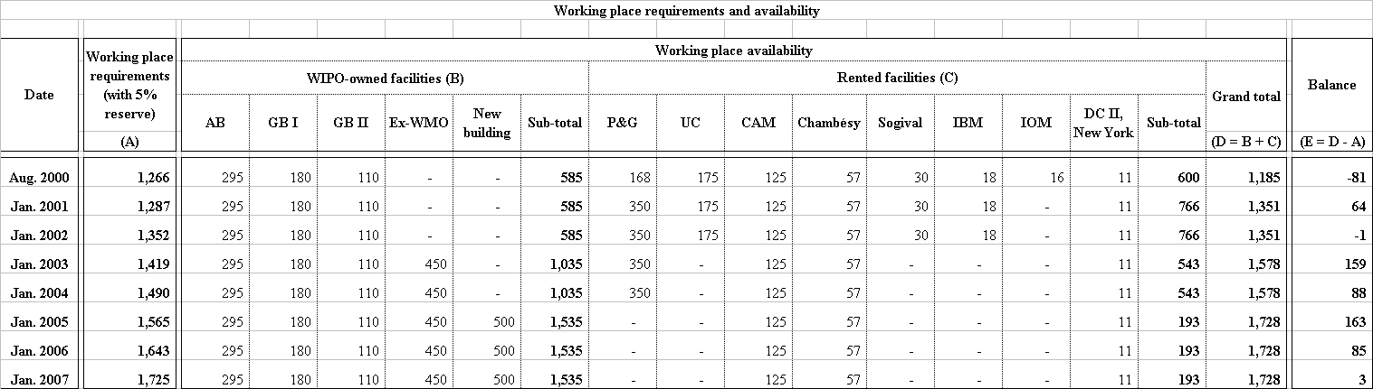
WO/GA/26/8

ANNEX A
[Annex B follows]
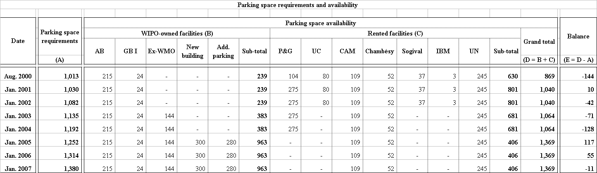
WO/GA/26/8

ANNEX B
[Annex C follows]

[Annex C follows]
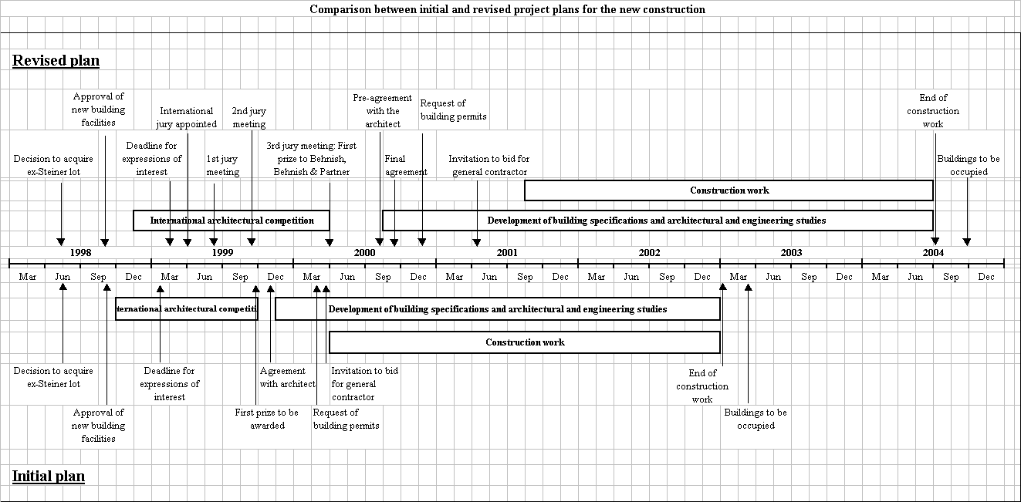
WO/GA/26/8

ANNEX C
[Annex D follows]

[Annex D follows]

ANNEX D

Members of the jury for international architectural competition

The jury is composed of the following members in alphabetical order:

Chairman
Mr. Shigeki SUMI (Japan)
Vice-Chairmen
Mr. Charles CORREA * (India)
Mr. Francis GURRY (Australia)
Members
Mr. Alexandr BAVYKIN (Russian Federation)
Mr. Claude Dassys BÉKÉ (Ivory Coast)
Mr. Pierre BRAILLARD * (Switzerland)
Mrs. Odile DECQ * (France)
Mr. Mohammad KHREISAT (Jordan)
Mrs. Rosario LAGARMILLA (Uruguay)
Mr. Abdelaziz LAZRAK * (Morocco)
Mr. William LIM * (Singapore)
Mr. Stanislav PICEK * (Czech Republic)
Mr. Jorge RIGAMONTI * (Venezuela)
Mr. Rafael VIÑOLY * (United States of America)
Mr. Olivier VODOZ (Switzerland)
Reserve members
Mr. Alberto DANIEL * (Spain)
Mr. Ettore De LELLIS * (Italy)
Mr. Yoshiyuki TAKAGI (Japan)
Experts
Mrs. Françoise ARCHAMBAULT * (Switzerland)
Mr. Yves BRAUNSCHWEIG * (Switzerland)
Mr. Pierre STAEHELIN * (Switzerland)
Mr. Jean-Marc TSCHOPP (Switzerland)

Secretariat
Mr. Thierry ESTOPPEY * (France)

The jury has drawn up the shortlist of the candidates selected at the end of the pre-qualification stage and will adjudicate on the projects submitted in the course of the competition.

The jury’s decision will be final, and no appeal will be entertained.

* Architect

[Annex E follows]

ANNEX E

SELECTION OF ARCHITECT
(Copy of press release PR/208/2000 (E), Geneva, March 2, 2000)

JURY DESIGNATES WINNING DESIGN FOR WIPO BUILDING

The international jury appointed by the World Intellectual Property Organization (WIPO) to oversee an international architectural competition to extend its premises awarded on Thursday the first prize to German firm Behnisch, Behnisch & Partner. Of the 27 proposals submitted from 18 countries, the jury also conferred awards on five other entries presented by architects from Italy, Switzerland, Norway and United States of America. The 15 member jury, which includes a number of eminent architects, senior government officials and legal experts from across the globe, met at WIPO headquarters from February 28 to March 2 to select the winning designs.

Commenting on the jury’s decision, the Director General of WIPO, Dr. Kamil Idris, said “[The winning project] reflects the vision of WIPO to create a building of architectural beauty and technical excellence, which will symbolize creativity, facilitate our activities and incorporate technology of the twenty-first century.”

The second prize went to Massimiliano Fuksas, Italy. In addition, four third prizes were awarded to: Luscher Architectes, Switzerland, Riechter & Dahl Rocha, Switzerland, Snøhetta, Norway, and Bernard Tschumi, the United States of America.

In its final report, the jury noted that the winning design is “a project for a new generation.” The jury stated “The overall concept for this project can be found in its integration with the surrounding environment. It is completely coherent -- the whole is the sum of its parts. The building is inserted into its site in a way that plays with the existing landscape and brings the outside in”. In his submission to the jury, the winning architect emphasized the importance of integrating the surrounding landscape into the design. “People should perceive their environment not so much as fixed building but rather as a three-dimensional, open-spatial structure, which can be “filled” according to changing requirements,” the architect said.

Mr. Shigeki Sumi, President of the jury, said “The successful entries were judged to be those that offered the most suitable architectural, environmentally-friendly, and operationally efficient proposals”. He added, “We were very impressed by the interesting and imaginative proposals, and by the extremely high standard of the entries.”

The winner of the competition will be awarded a cash sum of 100,000 Swiss francs. Second prize will receive 50,000 Swiss Francs. Third prizes will receive 25,000 Swiss Francs each. All entrants whose proposals complied with the rules of the competition and that were examined by the jury will receive a sum of 10,000 Swiss francs.

Mr. Francis Gurry, jury Vice-President and Assistant Director General of WIPO, said “This project is a contemporary expression oriented towards both the environment and the future.”

All prizes will be conferred at an awards ceremony in April 2000. At that time, the top proposals will be displayed at an exhibition, featuring a scale model of the first prize entry, at WIPO headquarters in Geneva.

The competition was launched following a decision by WIPO member states in June 1998 to authorize the acquisition of additional land adjacent to the existing headquarters’
building for expansion of its administrative headquarters in Geneva. In February 1999 some 800 architectural practices from 62 countries had expressed interest in the competition. Of these, 186 applicants followed through by submitting profiles and were the basis of selection for the finalists.

An international jury, appointed in June 1999 and made up of fifteen permanent members and three substitutes supported by a team of technical experts, was responsible for ensuring that the selection process was undertaken in an objective and transparent manner according to pre-defined standards. The jury established the competition procedures during an organizational meeting held in June 1999.

At a meeting in September 1999, the jury chose the finalists to compete in the last leg of the competition. Mr. Sumi stated “The finalists not only represent the diversity of architectural practice in the world today, but also hold sufficient professional resources to meet the specialized needs of WIPO.”

The competition covers the design of a complex comprised of:

(1) An office building with some 500 work places, several meeting rooms, an underground car park for about 300 vehicles, a cafeteria, service areas and a link to the main building.
(2) A conference room, offering about 600 seats for delegates and equipped with modern six-language interpretation facilities and appropriate computer and audiovisual equipment, located in immediate proximity to the existing WIPO conference and meeting facilities.
(3) Enlargement and restructuring of the lower floors to provide parking facilities for delegates and visitors.
With the decision of the jury, WIPO will now move into the next phase of implementing the construction project.

The growing importance of intellectual property issues and the consequent expansion of WIPO’s activities has created a pressing practical need for additional premises. The new complex will bring all WIPO headquarters’ staff together. Currently, WIPO rents office space in several commercial buildings located in Geneva.

[End of Annex E and of document]

* document WO/PBC/2/6 is available for reference

