WIPO |  | E  WO/GA/26/3  ORIGINAL: English  DATE: August 7, 2000
WORLD INTELLECTUAL PROPERTY ORGANIZATION
GENEVA

wipo general assembly
Twenty-Sixth (12th Extraordinary) Session
Geneva, September 25 to October 3, 2000
INTERNET DOMAIN NAMES
Memorandum of the Director General

1 Over the past two years, WIPO has played a leading role in developing recommendations and solutions to the problems arising out of the interface between Internet domain names and intellectual property rights. One area, in particular, which has received widespread attention during the first half of the current year has been the establishment of an international dispute-resolution procedure available for rights holders to resolve their domain name disputes.

2 On December 1, 1999, the Uniform Domain Name Dispute Resolution Policy (UDRP), adopted by the Internet Corporation for Assigned Names and Numbers (ICANN), came into effect. Modeled on recommendations made by WIPO in the Report on the WIPO Internet Domain Name Process (see documents WO/GA/24/1 and WO/GA/24/10), the policy provides holders of trademark rights with an administrative mechanism for the efficient resolution of disputes arising out of the bad-faith registration and use by third parties of Internet domain names, in the generic top-level domains (gTLDs) .com, .net and .org, corresponding to those trademark rights.

3 On December 2, 1999, the WIPO Arbitration and Mediation Center (the Center) received the first domain name complaint filed under the UDRP. Some six weeks later, a panelist appointed by the Center decided that the domain name at issue, “worldwrestlingfederation.com,” was to be transferred to the complainant, World Wrestling Federation Entertainment, Inc. In the seven months since that first case, some 700 more complaints have been filed with the Center, nearly half of which have been resolved.

4 The purpose of the present document is

(i) to provide an updated report on this WIPO activity, and

(ii) to provide information on continuing related work being undertaken on these issues.

WIPO’s Administration of Disputes under the UDRP

5 As of June 30, 2000, there are more than 17.7 million domain names registered worldwide, over 13.5 million of which are registered in the gTLDs. This rapid growth in domain name registrations is expected to continue, particularly in light of the introduction of competition in 1999 among registration authorities (i.e., registrars) for the gTLDs. As a result of this growth and of their commercial application, domain names have increasingly come into conflict with trademarks and other intellectual property rights. Previous memoranda presented to these Assemblies have detailed the issues involved and have provided information on the Report of the WIPO Internet Domain Name Process, published by WIPO on April 30, 1999. (See document WO/GA/24/1; see also WIPO’s web site at http://ecommerce.wipo.int.)

6 Of the recommendations contained in WIPO’s Report, it was the recommendation for the adoption of a mandatory and uniform dispute-resolution policy for registrants in all gTLDs that led ICANN, with drafting input from WIPO, to introduce the UDRP and a set of accompanying procedural Rules. As a result, trademark right holders can submit complaints to dispute-resolution providers for disputes involving all domain names that have been registered by ICANN-accredited gTLD registrars. The procedure is optional for trademark owners: instead of or in addition to availing themselves of the UDRP, they may go to court. By contrast, domain name registrants must submit to the UDRP procedure, once a complaint has been filed concerning the domain name held by them.

7 The UDRP is limited to cases of bad-faith registration and use. For a complaint to succeed, the complainant must establish that the following three cumulative criteria are met:

(i) the domain name is identical or confusingly similar to a trademark or service mark in which the complainant has rights;

(ii) the registrant of the domain name has no rights or legitimate interests in respect of the domain name;

(iii) the domain name has been registered and is being used in bad faith.

8 The UDRP lists several examples of such bad faith, such as indications that the domain name has been registered for the purpose of selling it to the trademark owner or attracting visitors to the registrant’s site by creating a likelihood of confusion with a third party’s trademark.

9 Once a case has been initiated through the complaint, the respondent has 20 days to file a response. A reasoned decision is taken two weeks later by an independent one- or three-member panel appointed by the Center. If the panel orders the transfer or cancellation of the domain name (these are the sole remedies available; in particular, monetary damages are excluded), the registrar is obliged to implement the decision, except if the losing domain name registrant files a court case against the complainant within ten days of the panel decision. Notice of the filing of a case under the UDRP and the full text of decisions are published on the Internet (see http://arbiter.wipo.int).

10 As the first dispute-resolution provider accredited by ICANN, the Center has established services especially designed for the submission and conduct of UDRP cases. In addition to advising ICANN on the procedural framework, the Center has adopted Supplemental Rules regulating such aspects as the applicable fees. The Center has also created a special roster of neutrals from 35 countries, from which it can select the panel for a particular case.

11 The Center’s web site (http://arbiter.wipo.int) provides parties with an efficient online infrastructure for the Center’s domain name dispute-resolution services. It offers extensive biographical information on the neutrals on the Center’s panel, who are independent trademark and Internet specialists from a multitude of jurisdictions. In addition to source documents, a procedural flowchart and a practical guide, the Center has posted model forms for the filing as well as defending of a case. These forms can be submitted to the Center online through the Center site or as an e-mail attachment. The entire WIPO procedure is conducted and managed largely online, providing significant time and cost benefits to all concerned.

12 Table 1 illustrates the substantial demand which the WIPO services are meeting. As of the end of June 2000, the WIPO Center had received 719 complaints, more than any other provider administering UDRP cases. The filing rate has climbed steadily,
from one per calendar day in January 2000 to some six per calendar day in June. Complainants entrusting their cases to the Center include household names that are known around the world, in every sector of commerce or public life. However, the

Table 1

gTLD Uniform Dispute Resolution Procedure
Cases Filed with WIPO
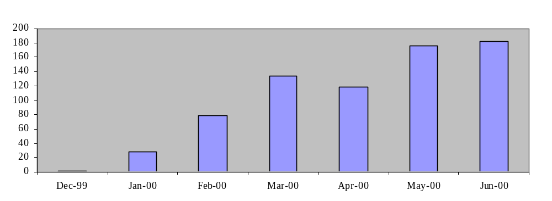

UDRP is also used by many smaller enterprises and individuals. The total WIPO case load concerns well over 2000 specific domain names, primarily in the .com domain but also in .net and .org (a full listing of all complainant and domain names is posted on the Center’s web site). Reflecting the global reach of the Internet but also the uneven distribution of access thereto, the parties filing or defending WIPO cases have come from 56 countries on every continent (Table 2). This international spread has put a premium on the Center’s online communication facilities.

Table 2

gTLD Uniform Dispute Resolution Procedure
Domicile of Parties

Country | Complainant |  | Respondent
Algeria | 0 | 0% | 1 | 0.1%
Antigua and Barbuda | 0 | 0% | 1 | 0.1%
Australia | 16 | 2.2% | 16 | 2.2%
Austria | 3 | 0.4% | 2 | 0.3%
Bahamas | 1 | 0.1% | 1 | 0.1%
Belgium | 6 | 0.8% | 3 | 0.4%
Brazil | 12 | 1.7% | 8 | 1.1%
Canada | 8 | 1.1% | 31 | 4.3%
China | 6 | 0.8% | 10 | 1.4%
Colombia | 1 | 0.1% | 1 | 0.1%
Czech Republic | 0 | 0% | 2 | 0.3%
Denmark | 3 | 0.4% | 0 | 0%
Egypt | 0 | 0% | 1 | 0.1%
Finland | 1 | 0.1% | 1 | 0.1%
France | 40 | 5.6% | 13 | 1.8%
Germany | 18 | 2.5% | 4 | 0.6%
Guatemala | 1 | 0.1% | 1 | 0.1%
Hungary | 1 | 0.1% | 1 | 0.1%
India | 17 | 2.4% | 6 | 0.8%
Iran (Islamic Republic of) | 0 | 0% | 3 | 0.4%
Ireland | 7 | 1.0% | 8 | 1.1%
Israel | 1 | 0.1% | 5 | 0.7%
Italy | 10 | 1.4% | 6 | 0.8%
Jamaica | 2 | 0.3% | 2 | 0.3%
Japan | 17 | 2.4% | 4 | 0.6%
Kenya | 0 | 0% | 1 | 0.1%
Lebanon | 1 | 0.1% | 1 | 0.1%
Libyan Arab Jamahiriya | 0 | 0% | 1 | 0.1%
Malaysia | 0 | 0% | 3 | 0.4%
Mexico | 2 | 0.3% | 3 | 0.4%
Monaco | 0 | 0% | 1 | 0.1%
Netherlands | 10 | 1.4% | 3 | 0.4%
New Zealand | 3 | 0.4% | 4 | 0.6%
Oman | 0 | 0% | 1 | 0.1%
Pakistan | 0 | 0% | 2 | 0.3%
Panama | 0 | 0% | 3 | 0.4%
Philippines | 0 | 0% | 3 | 0.4%
Poland | 1 | 0.1% | 1 | 0.1%
Portugal | 1 | 0.1% | 1 | 0.1%
Qatar | 0 | 0% | 1 | 0.1%
Republic of Korea | 3 | 0.4% | 18 | 2.5%
Russian Federation | 0 | 0% | 1 | 0.1%
Saint Lucia | 0 | 0% | 1 | 0.1%
Singapore | 7 | 1.0% | 3 | 0.4%
Slovenia | 0 | 0% | 1 | 0.1%
South Africa | 3 | 0.4% | 1 | 0.1%
Spain | 26 | 3.6% | 32 | 4.5%
Sweden | 18 | 2.5% | 15 | 2.1%
Switzerland | 23 | 3.2% | 10 | 1.4%
Thailand | 1 | 0.1% | 2 | 0.3%
Turkey | 0 | 0% | 3 | 0.4%
United Arab Emirates | 0 | 0% | 3 | 0.4%
United Kingdom | 68 | 9.5% | 48 | 6.7%
Uruguay | 0 | 0% | 2 | 0.3%
United States of America | 378 | 52.6% | 416 | 57.9%
Venezuela | 2 | 0.3% | 2 | 0.3%

13 Table 3 below shows the results of completed cases. As of June 30, 2000, WIPO panels have issued decisions on 256 complaints. Complainants have prevailed in four out of five cases, obtaining the transfer of the domain name(s). The procedure also has a high rate of

Table 3
gTLD Uniform Dispute Resolution Procedure
Results of Decisions

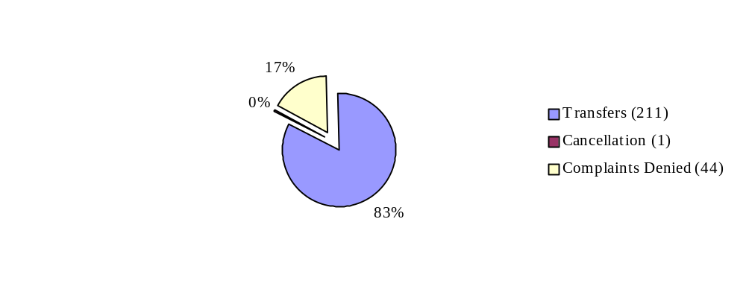

settlement; transfers were agreed between the parties in another 78 cases.
Appointed on the basis of the nationality of the parties and other specifics of the case, the WIPO panelists so far have come from 35 jurisdictions, with new persons being appointed where the need arises. Their decisions, which are posted on the Internet by WIPO and ICANN, have been widely recognized for their professional quality and are an essential condition for the success of this public mechanism.

14 The success of the UDRP also owes much to the efficiency of the filing procedures and to the direct enforcement of the resulting decisions. Supported by the WIPO model complaint, the online filing facility, the Center’s e-mail communication facilities for parties and panelists, and the public posting of relevant information, WIPO procedures are completed on average within 45 days. The simplicity of the system also extends to the schedule of fees. The costs of the procedure are borne by complainants, who pay a fixed amount that covers both the Center’s services and the remuneration of the panel. The actual level of the fee depends on the number of domain names concerned and on whether the case is to be decided by a single- or three-member panel.

15 The UDRP marks the first attempt to deal internationally with cybersquatting in a systematic and effective manner. Not surprisingly, therefore, the UDRP has received widespread attention. This is true for the legal and trademark community—WIPO staff receive numerous inquiries from counsel and businesses every day—but also for the general media, whose interest is raised further by the well known personalities (e.g., Julia Roberts, Peter Gabriel, Sting, Johnny Carson, Jimi Hendrix) represented among complainants.

16 The demands raised by the increasing caseload, the introduction of dispute-resolution services to certain country top-level domain (ccTLD) registrars (discussed below), the possibility that the scope of the UDRP will be broadened to encompass domain name disputes affecting other intellectual property-related rights (see below), and the possible introduction by ICANN of new gTLDs, make it likely that the role of WIPO and its Arbitration and Mediation Center will expand.

Continuing Work on Domain Names

17 At their Assemblies in September 1999, WIPO’s Member States expressed their broad support for the WIPO Internet Domain Name Process and its recommendations and indicated that WIPO should continue its work in this area (see document WO/GA/24/12, paragraphs 5 to 13). The program and budget for the 2000-2001 biennium reflects this member State mandate, identifying Internet domain names and related intellectual property and dispute-resolution issues as one of the four principal activities of Sub-program 03.4 (Electronic Commerce and Intellectual Property).

18 On June 28, 2000, the Director General of WIPO received two letters from the Minister for Communications, Information Technology and the Arts for the Government of Australia, in which WIPO is requested by the Australian Government on its own behalf and on behalf of 18 other Member States:

(i) to initiate a study aimed at addressing certain domain name and related intellectual property issues where continuing concern and uncertainty remains, and

(ii) to develop, for the assistance of the administrators of the country domain registries (ccTLDs), voluntary guidelines for the development of practices and policies to curb abusive and bad faith registration of protected names, and to resolve related disputes.

19 An attachment to each of the two letters indicates that the two requests are endorsed by the following States and the European Union: Argentina, Australia, Canada, Denmark, France, United States of America, European Union. Each attachment also states that the Government of Brazil will communicate its support through its diplomatic mission in Geneva. The letters are set out in the Annexes to this Memorandum (Annexes I and II).

20 The invitation of the Australian Government and of the other Member States identified in these letters provides further support for WIPO’s role in the area of domain names and intellectual property, which, as noted above, has been recognized by the Member States in the current program and budget. Indeed, the letters recognize that these requests should be undertaken as partial fulfillment of Sub-program 03.4.

21 The Director General has replied to the letters of invitation, welcoming and accepting the requests conveyed by them.

22 Second WIPO Internet Domain Name Process. The Final Report of the WIPO Internet Domain Name Process acknowledged that its recommendations targeted only the most egregious problems caused by the conflict between domain names and trademarks, and that other issues would require further consultation. The recent requests to WIPO call upon WIPO—in a process similar to the consultation process used in the first WIPO Domain Name Process—to initiate a study of, and to develop recommendations on, these outstanding issues, which are suggested to include the bad faith, abusive, misleading or unfair use of:

- Personal names

- International Nonproprietary Names (INNs) for Pharmaceutical Substances

- Names of international intergovernmental organizations

- Geographical indications, geographical terms, or indications of source

- Tradenames

23 On July 7, 2000, WIPO initiated the Second WIPO Internet Domain Name Process. A web site has been established to provide information about the Process and the issues it is addressing (URL). Similar to the first WIPO Process, the Second Process is being conducted in a manner that allows the broadest possible participation, inviting intellectual property holders and other members of the Internet community to provide their views. The objective, as in the first exercise, is to achieve rough consensus among all interested parties on the issues concerned.

24 It is proposed that the Second WIPO Process be conducted on the basis of three requests for comments, which will be widely circulated and published on the web site. The first request for comments (RFC-1) was posted on July 10, 2000, and is annexed to this document (Annex III). RFC-1 requests comments on the terms of reference for the Second Process, including the proposed procedures and timetable. The final date for comments on RFC-1 is August 15, 2000. It is expected that RFC-2, requesting comments on the substantive issues to be addressed in the Second Process, will be published on September 8, 2000. Following RFC-3, which will request comments on an interim report of conclusions and recommendations, the final report for the Second WIPO Internet Domain Name Report is expected to be published towards the end of the first half of 2001.

25 Program of work for ccTLDs. As noted above, the Report from the first WIPO Internet Domain Name Process was directed only at the gTLDs and the UDRP procedure is mandatory only for gTLDs. The second letter recently addressed to the Director General (Annex II) invited WIPO to extend its assistance to the administrators of ccTLDs, to provide guidance on best practices for the registration of domain names and to minimize intellectual property concerns arising in their domains.

26 In recognition of the intellectual property (trademark) issues confronting them, a number of administrators of certain country code top-level domains (ccTLDs) had already sought WIPO’s advice in relation to their domain name registration practices and voluntary adoption of the UDRP, or of a similar uniform dispute-resolution policy based on the Center’s advice and input. As a result of these efforts, certain ccTLDs have adopted WIPO’s recommendations and retained the Center as dispute resolution service provider, while others are in active discussion with the Center regarding these matters. The Center now provides case administration services for a number of ccTLDs, including

- Ascencion Island (.AC)
- British Indian Ocean Territory (.IO)
- Guatemala (.GT)
- Niue (.NU)
- St. Helena (.SH)
- Trinidad and Tobago (.TT)
- Tuvalu (.TV)
- Western Samoa (.WS)

The first case filed with the WIPO Center concerning a ccTLD registration was in the .NU domain.

27 A new phase of assistance to ccTLDs, as requested in the letter in Annex II, has been initiated. A letter to all ccTLD administrators (there are more than 200) was sent in early July 2000, offering them WIPO’s services for (1) the design of appropriate domain name registration practices and dispute resolution procedures that fit their local requirements, and (2) the administration of domain name disputes through the WIPO Arbitration and Mediation Center. Information about this assistance has been published on the web sites of the WIPO Electronic Commerce Section and the Arbitration and Mediation Center. It is proposed to organize a conference on ccTLD best practices and dispute resolution at WIPO headquarters in February 2001. The purpose of this conference will be to focus the attention of the ccTLD administrators on the solutions that WIPO can offer in the area of domain name best practices and dispute resolution.

28 The General Assembly is invited to note the contents of this Memorandum and the work accomplished and planned in the area of Internet domain names and intellectual property.

[Annexes follow]

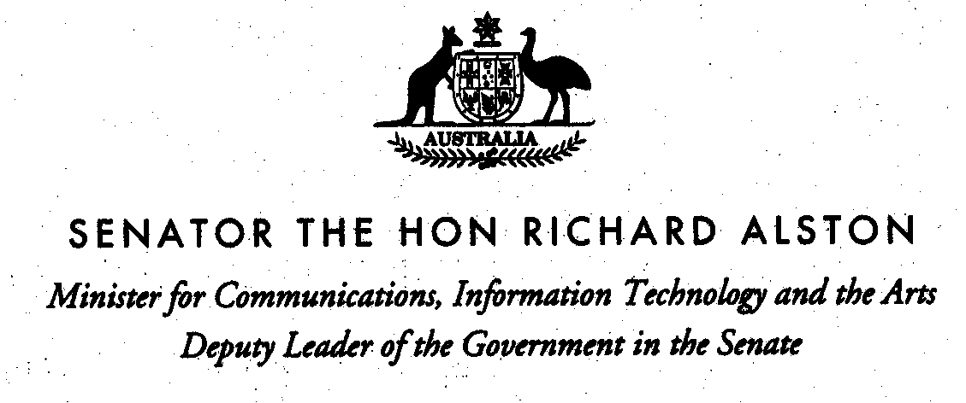
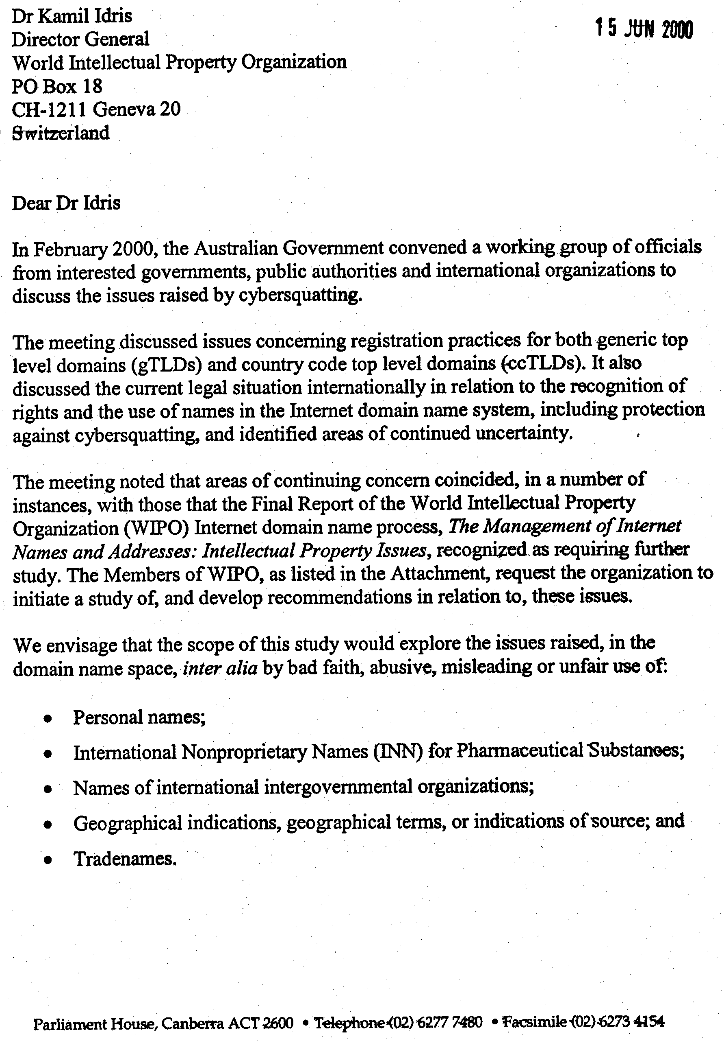

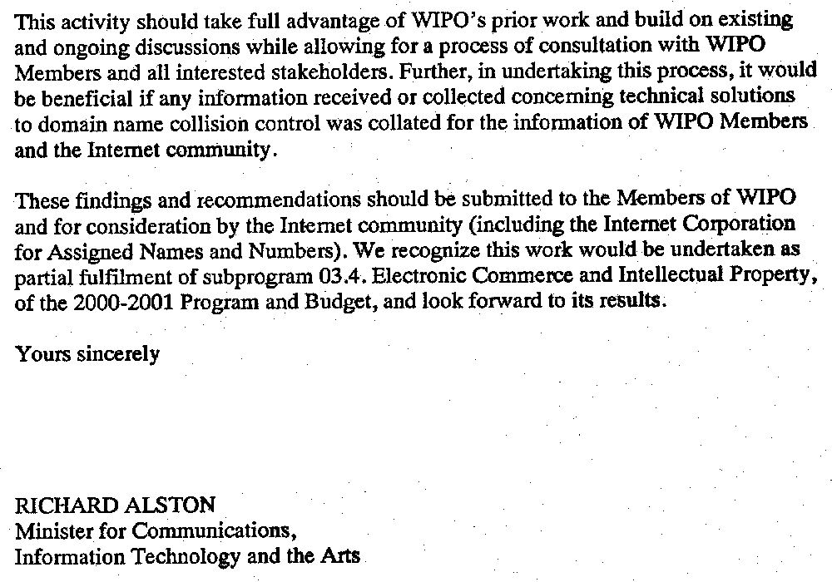
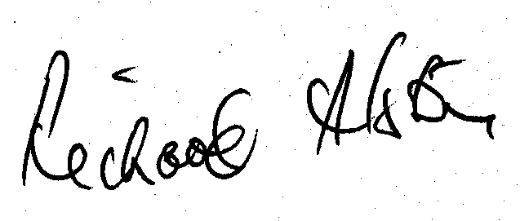
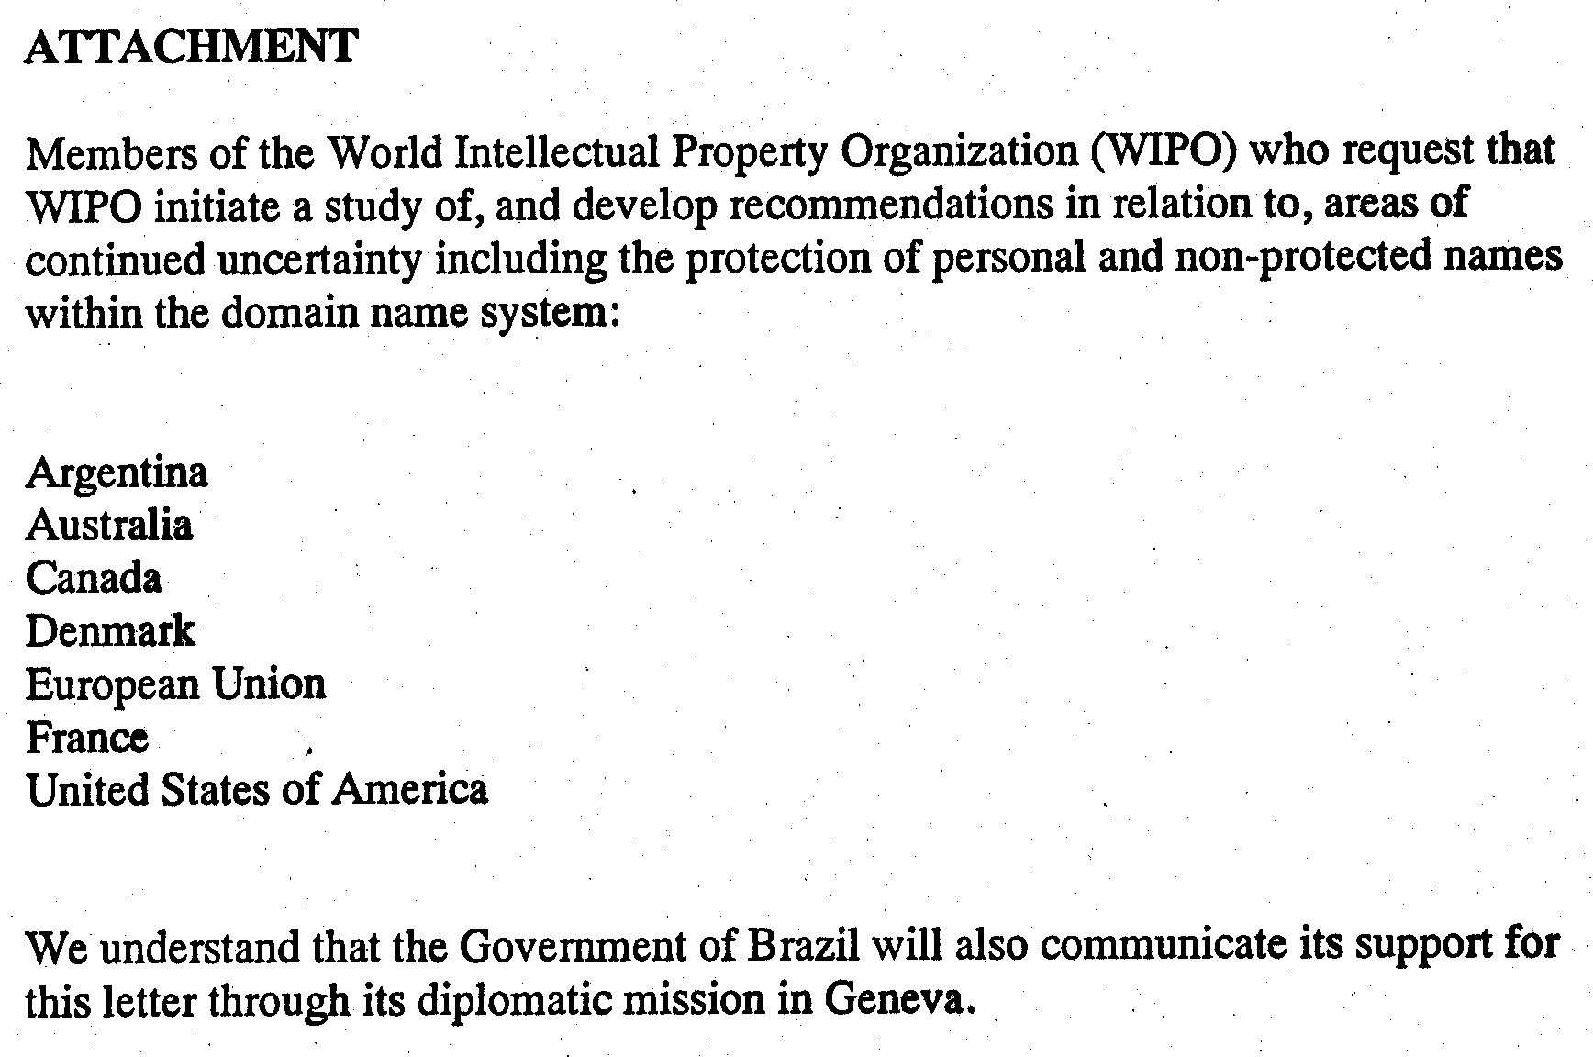

[Annex II follows]

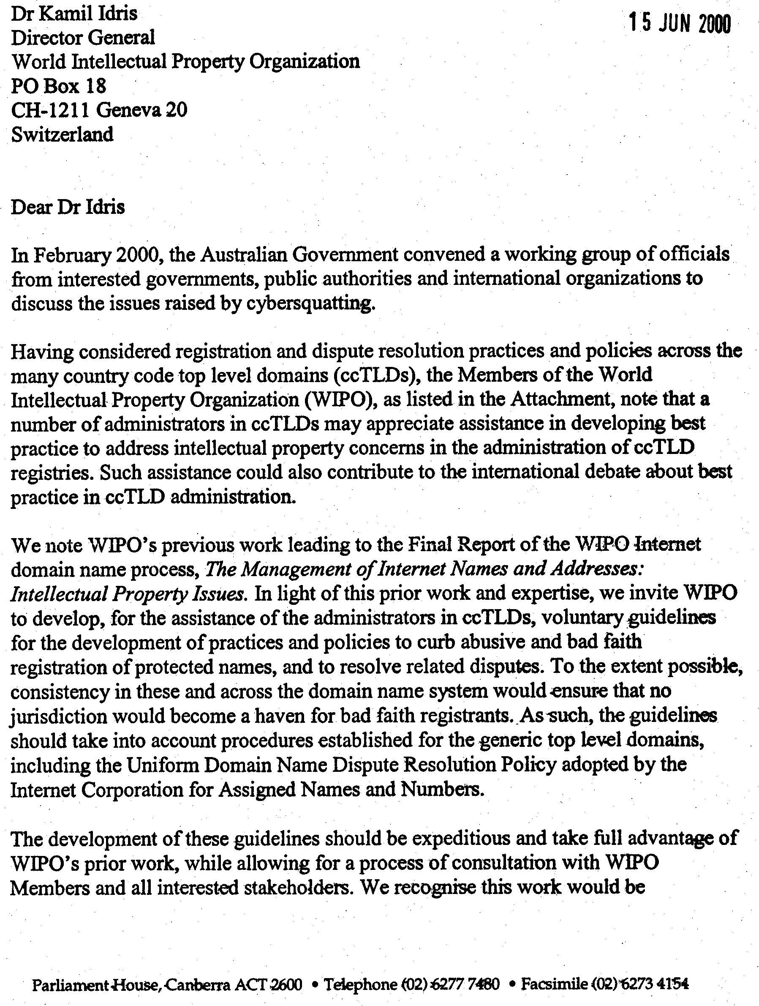

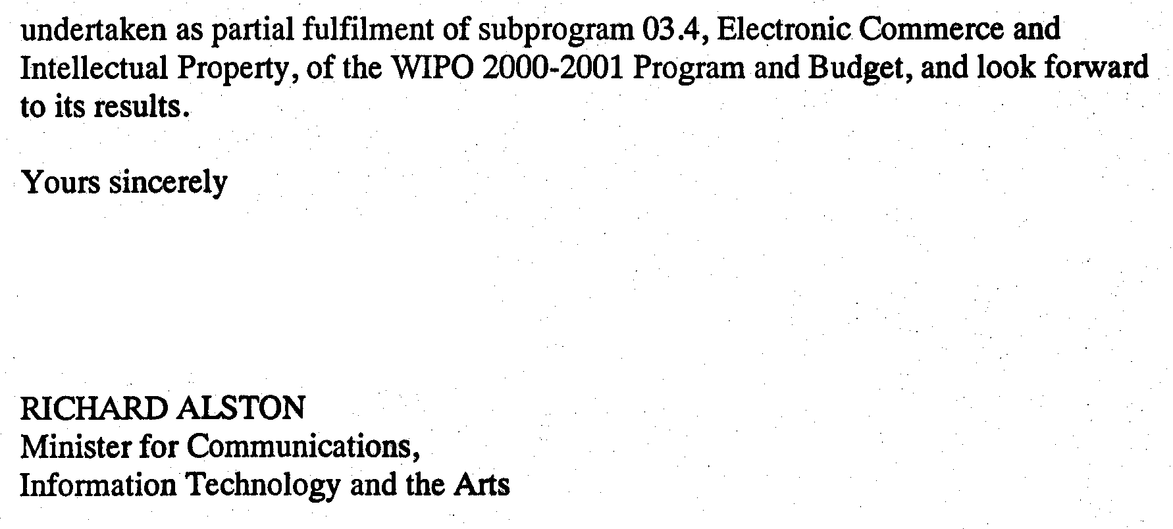

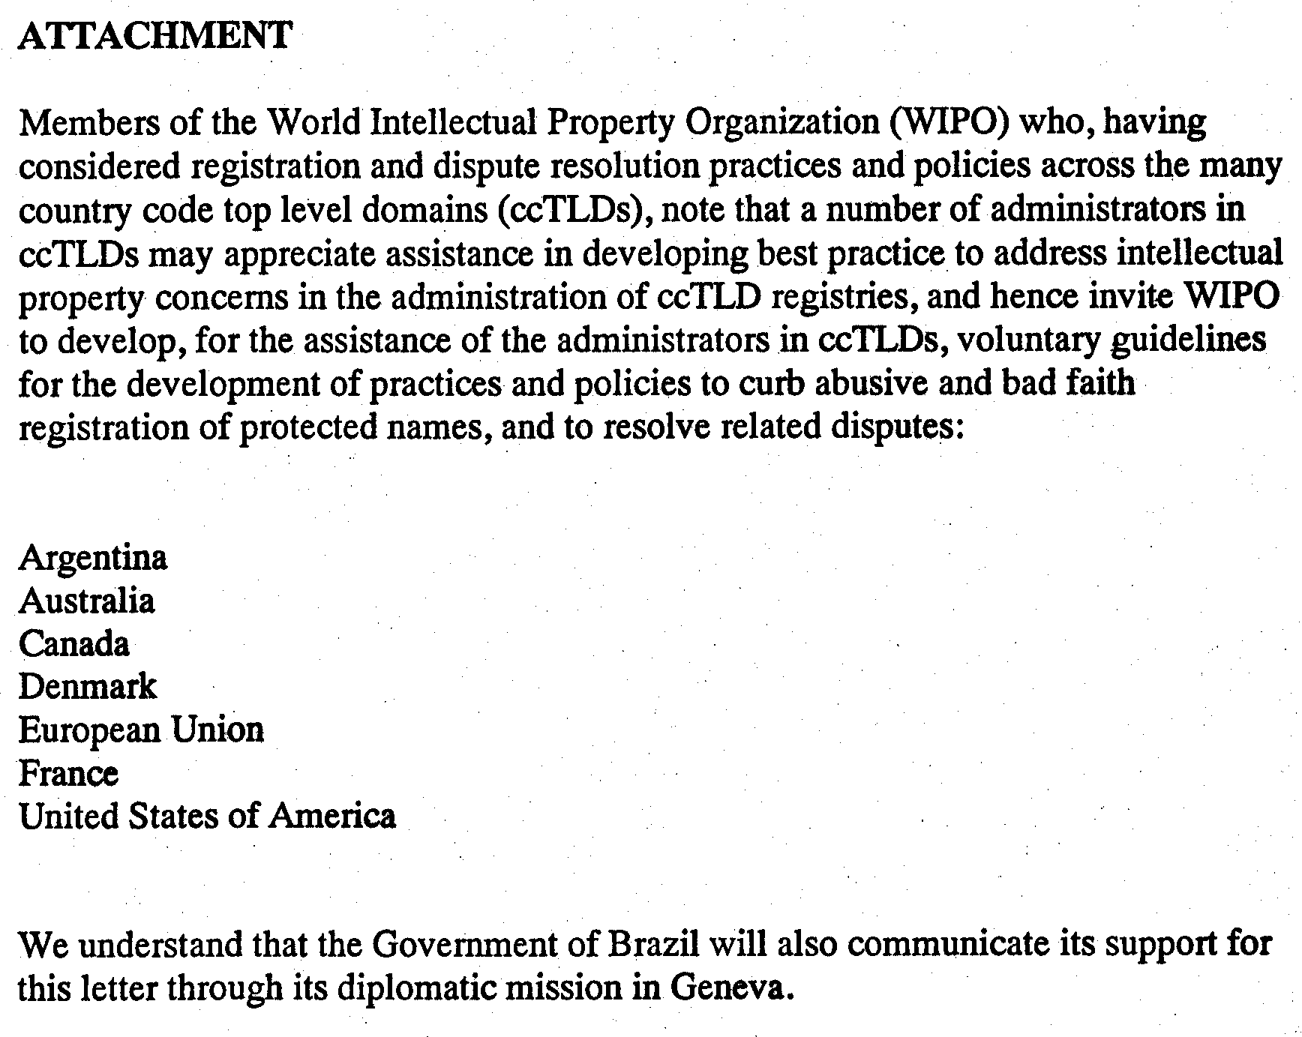

[Annex III follows]

July 10, 2000

WIPO RFC-1

REQUEST FOR COMMENTS
ON TERMS OF REFERENCE, PROCEDURES AND TIMETABLE
FOR THE
SECOND WIPO INTERNET DOMAIN NAME PROCESS

1. This is a Request for Comments (RFC) on the proposed terms of reference, proposed procedures and suggested timetable for the Second WIPO Internet Domain Name Process, to be convened by the World Intellectual Property Organization (WIPO).

Introductory Remarks

2. The Report of the first WIPO Internet Domain Name Process (The Management of Internet Names and Addresses: Intellectual Property Issues) (the Final Report), published in April 1999, acknowledged that its recommendations targeted only the most egregious problems caused by the tension between domain names and trademarks, and that other issues would require further consultation. Since the publication of the Report, the Internet Corporation for Assigned Names and Numbers (ICANN) has adopted a number of the recommendations contained in it, including suggested best practices for registration authorities and the establishment of a mandatory and uniform dispute resolution policy for the generic top-level domains (gTLDs). In particular, the adoption by ICANN of the Uniform Dispute Resolution Policy (UDRP) on December 1, 1999, has demonstrated -- through the very substantial number of cases filed -- that an administrative procedure for rightholders to resolve their domain name disputes is of great value to the Internet community.

3. On June 28, 2000, the Director General of WIPO received a request from 19 of WIPO’s Member States to initiate a new study, to address certain issues involving the recognition of rights and the use of names in the Internet domain name system (DNS) where uncertainty and concern remains. The request calls upon WIPO -- through a consultation process similar to the first WIPO Process - to initiate a study of, and to develop recommendations on, these outstanding domain name issues, which it is suggested should include, inter alia, the “bad faith, abusive, misleading or unfair use of:

- personal names;
- International Nonproprietary Names (INNs) for Pharmaceutical Substances;
- names of international intergovernmental organizations;
- geographical indications, geographical terms, or indications of source; and
- tradenames.”

4. The request specifies that “this activity should take full advantage of WIPO’s prior work and build on existing and ongoing discussions while allowing for a process of consultation with WIPO Members and all interested stakeholders.” Further, it directs that the “findings and recommendations should be submitted to the Members of WIPO and for consideration by the Internet community (including the Internet Corporation for Assigned Names and Numbers).” It also states that, “in undertaking this process, it would be beneficial if any information received or collected concerning technical solutions to domain name collision control was collated for the information of WIPO Members and the Internet community.”

5. Since the time of the first WIPO Process, discussions have continued in various fora, particularly at the meetings of ICANN, in respect of the management of the DNS. WIPO intends that the Second WIPO Process should take full account of, and build on, the substantial progress that has been made in the course of these discussions, insofar as they relate to the intellectual property issues to be addressed in the Second Process. WIPO will cooperate closely with ICANN throughout the Second Process to consult and to coordinate developments in this area.

Draft Terms of Reference

6. The following proposed terms of reference are intended to define the scope of the Second WIPO Process, and the principal issues it will address. Comments are sought from interested parties on these terms of reference and, in particular, whether they properly define all questions that should be addressed. Interested parties are requested not to address the substance of the issues described in the terms of reference at this stage, but to address only whether issues mentioned are appropriate for the Process, whether they are adequately described, and whether any further issues should be included. After the terms of reference have been finalized, the second RFC to be published will request comment on the substance of the issues raised in the terms of reference.

- Scope of Issues in the Second WIPO Process: The Second WIPO Process will explore, and develop findings and recommendations in relation to, issues raised in the DNS, inter alia, by bad faith, abusive, misleading or unfair use of:
- personal names,
- International Nonproprietary Names (INNs) for Pharmaceutical Substances,
- names and acronyms of international intergovernmental organizations,
- geographical indications, geographical terms, or indications of source, and
- tradenames.

A different set of considerations, based on the nature of the rights or interests involved in each of these areas, may be brought to bear on the questions of whether any protection should be accorded, and, if so, in what circumstances and how. Therefore, a separate list of issues for comment is provided below for each area.

While undertaking to develop findings and recommendations on these issues, the Second Process will also investigate the availability of any technical solutions that might serve to reduce the tension between domain names and other protected rights.

Parties are invited to submit comments on whether there are any further areas to those listed above, relating to the interface between intellectual property and cognate rights and the DNS, which it would be appropriate to include in this study and consultation.

- Personal Names: Recommendations will be formulated on whether any protection against abusive registration as a domain name in the gTLDs should be accorded to personal names and, if so, in what circumstances and how.

List of Issues:

The list below is submitted for comment by interested parties as the suggested list of
issues to be covered in the study:

(i) Should personal names be protected against bad faith, abusive, misleading or unfair registration and use in the DNS?
(ii) Which personal names, if any, should be protected:
— all names,
— names of famous persons,
— names of government officials or other persons in the public eye.
(iii) How do you define bad faith, abusive, misleading or unfair registration and use in respect of personal names?
(iv) How do you deal with multiple incidences of the same name?
(v) What provision, if any, should be made for dispute resolution with respect to disputes concerning personal names registered as domain names?
(vi) Would directory, listing or other similar services aimed at avoiding domain name conflicts concerning personal names be useful, and, if so, please describe such services?

- International Nonproprietary Names (INNs) for Pharmaceutical Substances: Recommendations will be formulated on whether any protection against abusive registration as a domain name in the gTLDs should be accorded to INNs and, if so, in what circumstances and how.

An “INN” is a specialized, unique name used to identify a pharmaceutical substance or active pharmaceutical ingredient (e.g., ampicillin). INNs are selected by the World Health Organization (WHO) in order to promote and protect the safety and health of patients worldwide, by providing a single, globally available name for each such substance. WHO maintains a list of protected INNs, now numbering approximately 7,500. To qualify, INNs must be distinctive in sound and spelling, so as not to be liable to confusion with other commonly used names, and must be in the public domain and therefore freely available for this use.

List of Issues:

The list below is submitted for comment by interested parties as the suggested list of issues to be covered in the study:

(i) Should INNs be protected against bad faith, abusive, misleading or unfair registration and use in the DNS?
(ii) How do you define bad faith, abusive, misleading or unfair registration and use in respect of INNs?
(iii) What provision, if any, should be made for dispute resolution with respect to disputes concerning INNs registered as domain names?
(iv) What provision, if any, should be made for the establishment of exclusions for INNs?
(v) If an exclusion is considered to be useful, how should any exclusion protection take place?
(vi) Would directory, listing or similar other services aimed at avoiding domain name conflicts concerning INNs be useful, and, if so, please describe such services?

- Names of international intergovernmental organizations: Recommendations will be formulated on whether any protection against abusive registration as a domain name in the gTLDs should be accorded to the names and acronyms of international intergovernmental organizations and, if so, in what circumstances and how.

Names and acronyms of international intergovernmental organizations are currently protected against use and registration as trademarks by the Paris Convention for the Protection of Industrial Property (Paris Convention) and through the Agreement on Trade-Related Aspects of Intellectual Property Rights (TRIPS Agreement).

List of Issues:

The list below is submitted for comment by interested parties as the suggested list of issues to be covered in the study:

(i) Should the names and acronyms of international intergovernmental organizations be protected against bad faith, abusive, misleading or unfair registration and use in the DNS?
(ii) How do you define bad faith, abusive, misleading or unfair registration and use in respect of the names and acronyms of international intergovernmental organizations?
(iii) What provision, if any, should be made for dispute resolution with respect to disputes concerning the names and acronyms of international intergovernmental organizations registered as domain names?
(iv) What provision, if any, should be made for the establishment of exclusions for the names and acronyms of international intergovernmental organizations?
(v) If an exclusion were considered to be useful, how would any exclusion be implemented?
(vi) Would directory, listing or similar other services aimed at avoiding domain name conflicts concerning the names and acronyms of international intergovernmental organizations be useful, and, if so, please describe such services?
(vii) Which international intergovernmental organizations should receive any such protection in the DNS (e.g., international or regional organizations, all organizations that have followed the notification provisions of the Paris Convention)?

- Geographical indications, geographical terms, or indications of source: Recommendations will be formulated on whether any protection against abusive registration as a domain name in the gTLDs should be accorded to geographical indications, geographical terms, or indications of source and, if so, in what circumstances and how.

Geographical indications, geographical terms, or indications of source (collectively “geographical indications”) receive protection under the Paris Convention, the Madrid Agreement for the Repression of False or Deceptive Indications of Source of Goods (Madrid Agreement), the Lisbon Agreement for the Protection of Appellations of Origin and their International Registration (Lisbon Agreement) and the TRIPS Agreement. A “geographical indication” is one which identifies a good as originating in a territory, or region or locality within a territory, where a given quality, reputation or other characteristic of that good is essentially attributable to its geographic origin. An “indication of source” is a term that refers to an indication of a geographic place of origin of a product (e.g., Florida oranges).

List of Issues:

The list below is submitted for comment by interested parties as the suggested list of issues to be covered in the study:

(i) Should geographical indications be protected against bad faith, abusive, misleading or unfair registration and use in the DNS?
(ii) How do you define bad faith, abusive, misleading or unfair registration and use in respect of geographical indications?
(iii) Which geographical indications, if any, should be so protected (e.g., those receiving protection under the Paris Convention, Madrid Agreement, Lisbon Agreement, TRIPS Agreement, others)?
(iv) What provision, if any, should be made for dispute resolution with respect to disputes concerning geographical indications registered as domain names?
(v) What provision, if any, should be made for the establishment of exclusions for geographical indications?
(vi) If an exclusion is considered to be useful, how should any exclusion protection take place?
(vii) Would directory, listing or similar other services aimed at avoiding domain name conflicts concerning geographical indications be useful, and, if so, please describe such services?

- Tradenames: Recommendations will be formulated on whether any protection against abusive registration as a domain name in the gTLDs should be accorded to tradenames and, if so, in what circumstances and how.

A “tradename” is a name adopted, and often registered, by a business enterprise to distinguish itself, as a commercial entity, from other enterprises. Unlike trademarks and service marks, tradenames operate to distinguish a business on the basis of its character, independently of the goods or services that the business offers. Tradenames receive protection under the Paris Convention (Article 8), without the obligation of a filing or registration.

List of Issues:

The list below is submitted for comment by interested parties as the suggested list of issues to be covered in the study:

(i) Should tradenames be protected against bad faith, abusive, misleading or unfair registration and use in the DNS?
(ii) How do you define which tradenames would be eligible for any such protection?
(iii) How do you define bad faith, abusive, misleading or unfair registration and use in respect of tradenames?
(iv) What provision, if any, should be made for dispute resolution with respect to disputes concerning tradenames registered as domain names?
(v) Would directory, listing or similar other services aimed at avoiding domain name conflicts concerning tradenames be useful, and, if so, please describe such services?

- Technical Solutions for Domain Name Collision Control: An investigation will be made into the availability of any technical solutions to reduce the tension and minimize disputes concerning rights and interests in domain names. In the first WIPO Process, comments were sought, in the context of the prevention of domain names disputes, on the following aspects:

“The requirements of any domain name databases (including the type of information to be stored therein) that may be developed to allow domain name applicants, holders of intellectual property rights, and other interested parties to search for and obtain information for purposes of evaluating and protecting any potentially related intellectual property rights. These requirements may include, in particular, the need to make the information accessible through a common interface and to interlink databases that may be maintained by various registries and/or registrars in order to permit single comprehensive searches.

The possible use of directory and listing services, gateway pages or other methods aimed at avoiding trademark and domain name conflicts by allowing identical names to co-exist, thus overcoming the technical requirement that each domain name be unique.”

In the intervening period, new technical solutions may have developed that could serve to reduce the tension and prevent conflicts between competing interests in each unique domain name, principally where the competition is between persons or entities with good faith interests in the name. Information is now sought on the development of such technical solutions, and comments are sought on whether these technical solutions may offer realistic options for resolving conflicts between rightholders and domain name registrants.

7. While the above are the main topics to be addressed, WIPO will, on the basis of comments received on this Request for Comments (WIPO RFC-1), develop a final listing of all issues on which comments shall be solicited and recommendations formulated.

Proposed Procedures

8. As with the first WIPO Internet Domain Name Process, the Second WIPO Process will be conducted in a balanced and transparent manner with a view to the international Internet community. To that end, WIPO invites all interested parties to participate, with the aim of achieving consensus among all stakeholders of the Internet on the issues concerned.

9. The Second Process will be undertaken through a combination of Internet-based discussions and in-person consultations. It will be conducted on the basis of a number RFCs that are to be made available to the public through publication on the web site and through transmittal by electronic or regular mail. All interested parties are invited to submit comments on the RFCs through a special form that is available under the Comments section of the web site, or by electronic or regular mail if necessary.

10. WIPO will acknowledge receipt of each comment and post it publicly on the web site. WIPO reserves the right not to post any comment that is obscene or otherwise clearly fails to constitute a contribution relevant to the discussion of the issues raised in the RFCs. WIPO will not issue any specific responses to the comments it receives. All comments, however, will form the basis for the findings and recommendations to be developed.

11. In order to ensure that interested parties have the opportunity to present their views on the issues to be addressed by the process, WIPO will also hold a series of regional consultations. The location of these meetings will be determined with a view to ensuring wide geographical representation. The views presented at these meetings will, in addition to the comments on the RFCs, serve as the basis for WIPO findings and recommendations.

Timetable

12. The Second WIPO Process is intended to consist of the following steps, culminating in a final report to be submitted to the Member States of WIPO and for consideration by the Internet community including ICANN:

(a) Publication of the present WIPO RFC-1 on the draft terms of reference setting out the proposed scope of the project, including the issues to be addressed, the proposed procedures and a suggested timetable for completion of the work;
(b) Publication of WIPO RFC-2 containing the finalized terms of reference and issues to be addressed;
(c) Regional consultations to receive comments on WIPO RFC-2;
(d) Preparation of a draft interim report on the basis of all comments received on WIPO RFC-2;
(e) Publication of the interim report as WIPO RFC-3;
(f) Regional consultations to receive comments on WIPO RFC-3;
(g) Preparation and publication of the final report on the basis of all comments received during consultations and on WIPO RFC-3.

13. It is expected that the Process will take less than nine months to be completed. As mentioned above, WIPO will seek to coordinate its plans with ICANN. The following table proposes a draft implementation plan, reflecting the various stages in the Process.

Date | Activity
July 10 | Announcement of Second WIPO Process  Publication of WIPO RFC-1 on draft terms of reference
August 2-3 | Consultation in conjunction with WIPO Ecommerce  Regional Meeting in São Paolo, Brazil
August 3-4 | Consultation in conjunction with WIPO Ecommerce  Regional Meeting in Chiang Mai, Thailand
August 15 | Final date for comments on WIPO RFC-1
September 8 | Publication of WIPO RFC-2 (issues to be addressed)
September 18-20, 2000 | Consultation in conjunction with WIPO Ecommerce  Regional Meeting in Ahman, Jordan
October 25-26 | Consultation in conjunction with WIPO Ecommerce  Regional Meeting in Krakow, Poland
November 17 | Final date for comments on issues in WIPO RFC-2
Nov. 20 – Dec. 31 | Drafting of Interim Report
January 26, 2001 | Publication of Interim Report (WIPO RFC-3)
February – March | Further Regional Consultations
March 31 | Final date for comments on WIPO RFC-3 (Interim Report)
April | Drafting of Final Report
May 2001 | Publication of Final Report

Request for Comments

14. This WIPO RFC-1 requests participating parties to submit comments on:

(a) The draft terms of reference, as specified in paragraphs 6 and 7, above;
(b) The proposed procedures, as specified in paragraphs 8 to 11, above;
(c) The proposed timetable, as specified in paragraphs 12 and 13, above.

15. Comments can be submitted by the following means:

(a) Through the Submit Comment form that is available under the Comments section of the web site. We recommend that you choose this method for the submission of your comments;
(b) By electronic mail to the following address: process.mail@wipo.int;
(c) By regular mail to the following address: WIPO Internet Domain Name Process, World Intellectual Property Organization, 34 chemin des Colombettes, P.O. Box 18, 1211 Geneva 20, Switzerland.

16. All comments must be received by August 15, 2000.

[End of Annex III and of document]

Report of the WIPO Internet Domain Name Process (April 30, 1999), WIPO Publication No. 439(E); see also http://ecommerce.wipo.int/domains/process/eng/processhome.html.
See Report, Executive Summary, First Steps and Outstanding Issues, pp. 8-9.
The request is made in a letter from the Minister for Communications, Information Technology and the Arts for the Government of Australia, in which WIPO is requested by the Australian Government on its own behalf and on behalf of 18 other member States to initiate the new study. An attachment to the letter indicates that the following States and the European Union endorse the request: Argentina, Australia, Canada, Denmark, France, United States of America, European Union. The attachment also states that the Government of Brazil will communicate its support through its diplomatic mission in Geneva. A copy of the letter is available on the WIPO web site at http://wipo2.wipo.int/process1/report.

