E
WO/CC/72/2
ORIGINAL: English
DATE: July 12, 2016

WIPO Coordination Committee

Seventy Second (26th Extraordinary) Session
Geneva, September 12, 2016

Appointment of Deputy Director General, Copyright AND CREATIVE INDUSTRIES SECTOR

Document prepared by the Director General

- Article 9(7) of the Convention Establishing the World Intellectual Property Organization (WIPO) provides that the Director General shall appoint the Deputy Directors General after approval by the WIPO Coordination Committee.

- The Deputy Director General for the Culture and Creative Industries Sector resigned from WIPO on December 1, 2015. In a letter sent to Member States on December 21, 2015
(C. N 3660), the Director General invited governments to submit proposals of candidates by February 29, 2016. A general announcement in the form of a “Call for Applications” was also published on the WIPO Careers website inviting direct applications from interested qualified candidates.

- The Copyright and Creative Industries Sector is responsible for the Organization's programs on copyright and related rights and on communications. The sector supports the work of Member States in the Standing Committee on Copyright and Related Rights (SCCR); develops copyright infrastructure, including support to collective management organizations and national copyright offices; builds capacity in developing countries to use the copyright system to extract greater economic value from their cultural and other creative works; supports the Accessible Books Consortium; and delivers WIPO's programs on communications.

- The present document describes the selection process for the vacant post and identifies the candidate which the Director General wishes to propose for appointment as Deputy Director General, Copyright and Creative Industries Sector.

Selection Process

- A total of 301 applications were received, either from Member States or directly in response to the call for applications published on the WIPO Careers website, and considered by the Director General. The highest number of applications came from Western Europe (24.3%), followed by Africa (19.6%) and the Middle East (19.6%) (see figure 1). Just over a quarter of the applications were from female candidates (see figure 2).

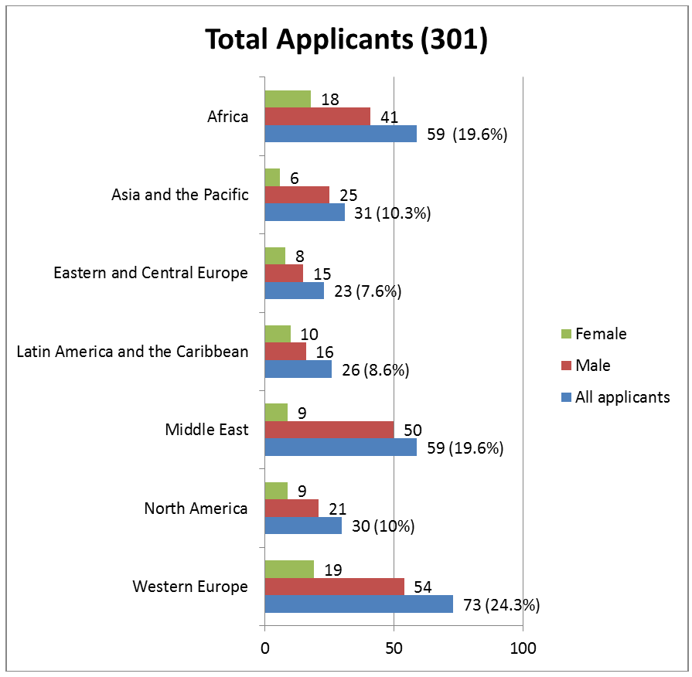

Figure 1: Geographical and gender distribution by region of applicants

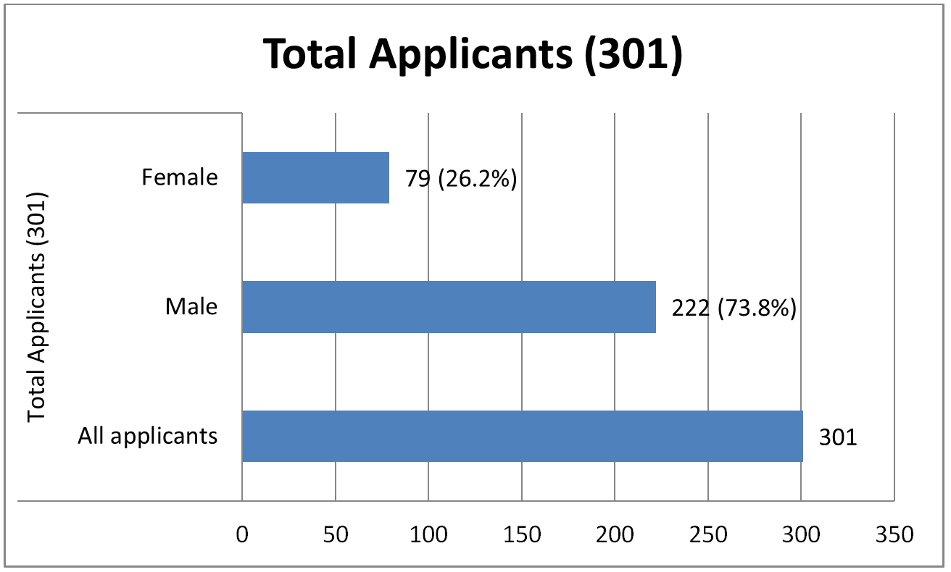

Figure 2: Gender distribution of applicants

- On the basis of the qualifications, experience and skills of the applications received, six candidates were invited to participate in a one-day assessment conducted by an external assessment service provider. The assessment focused on the competencies outlined in the vacancy announcement such as managerial and leadership skills, communication skills, integrity and accountability and included a combination of tests, exercises and an in-depth interview. The Director General met with a senior representative of the service provider prior to the assessment to ensure that the assessment was appropriately tailored to WIPO and covered all key elements of the job.

- All six candidates were also interviewed by the Director General, in particular to evaluate their technical expertise. The assessment and interviews took place in the period of
March 14 to 23, 2016.

- No list of applicants has been made public in the interest of confidentiality.

Proposed Appointment

- The Director General proposes Ms. Sylvie Forbin, a national of France, for appointment as Deputy Director General, Copyright and Creative Industries Sector.

- The curriculum vitae of Ms. Forbin is set out in the Annex to this document.

- The appointment to the position of Deputy Director General, Copyright and Creative Industries Sector is made subject to future modifications to the portfolio, at the Director General’s discretion, taking into account the evolving operational needs of the Organization and appropriate consultations with the incumbent concerned.

Term of Office

- The Director General further proposes a term of office for this appointment which coincides with his mandate. The Director General was reappointed by the WIPO General Assembly in May 2014 for a second six-year term from October 1, 2014, to September 30, 2020. The term of office of the current Deputy Directors General and Assistant Directors General will expire on September 30, 2020. It is proposed that the term of office of the incoming Deputy Director General start on September 18, 2016, and expires on
September 30, 2020. However, should the term of office of the Director General come to an end more than six months before its stated term on September 30, 2020, the terms of office of the Deputy Director General will end six months after the end of the Director General’s appointment.

- The WIPO Coordination Committee is invited to approve the appointment as Deputy Director General of Ms. Sylvie Forbin for the period indicated in paragraph 12, above.

[Annex follows]

CURRICULUM VITAE OF MS. SYLVIE FORBIN

Date of birth: May 16, 1956
National of: France

Education

1982 - 1983 M.A. in International Economics, Foundation of Political Sciences, Paris, France

1978 - 1980 M.A. in International Relations, Institut d’études politiques de Paris, Paris, France

1974 - 1977 B.A. in Classics and Literature, University Paris Sorbonne, Paris, France

Work Experience

2001 - 2016 Senior Vice President for Public and European Affairs, VIVENDI, Paris, France

1993 - 2001 General Manager of Eureka Audiovisual, Brussels, Belgium

1990 - 1992 Diplomat, Vice Cultural Counsellor at the French Embassy, Rome, Italy

1989 - 1990 Diplomat, Counsellor at the Permanent Representation of France to the European Union, Brussels, Belgium

1986 - 1988 Diplomat, Head of the Communications and Press Services, French Embassy, Beijing, China

1983 - 1986 Diplomat, Asia and Pacific Directorate, Ministry of Foreign Affairs, Paris, France

[End of Annex and of document]

To be renamed Copyright and Creative Industries Sector
This external service provider is one of two external providers selected through an international tender for the provision of assessment services in the context of the enhanced professionalization of WIPO’s recruitment processes.

