E
wo/cc/67/3
ORIGINAL: English
DATE: SePTEMBER 16, 2013

WIPO Coordination Committee

Sixty-Seventh (44th Ordinary) Session
Geneva, September 23 to October 2, 2013

Revision of THE Staff Regulations and Rules

prepared by the Director General

TABLE OF CONTENTS

Sections of document WO/CC/67/3

I. Amendments to the Staff Regulations and Rules (SRR) on internal justice reform - for approval

II. Amendments to certain Staff Regulations, for approval, to be effective on
January 1, 2014, and certain annexes amended in 2013, for notification - based on Recommendations of the International Civil Service Commission (ICSC)

III. Amendments to other Staff Regulations to be effective on January 1, 2014 - for approval

IV. Amendments to certain Staff Rules already implemented in 2013 - for notification

V. Editorial amendments to certain Staff Rules and annexes to be effective on
January 1, 2014 - for notification

Annexes

Annex I Summary of proposed amendments to the SRR relating to WIPO’s internal justice reform

Annex II Proposed amendments to the SRR relating to WIPO’s internal justice reform to be effective on January 1, 2014 – for approval

Annex III Part 1: Amendments to certain Staff Regulations and annexes based on
Recommendations of the ICSC – for approval and notification

Part 2: Amendments to other Staff Regulations to be effective on
January 1, 2014 - for approval and notification

Part 3 Amendments to certain Staff Rules already implemented in 2013 – for notification

Part 4 Editorial amendments to certain Staff Rules and annexes to be effective on January 1, 2014 - for notification

Annex IV Revised Standards of Conduct for the International Civil Service

I. AMENDMENTS TO THE STAFF REGULATIONS AND RULES (SRR) ON INTERNAL JUSTICE REFORM - FOR APPROVAL

The process of revision

In 2012, the WIPO Coordination Committee approved revisions to 10 chapters of the World Intellectual Property Organization’s (WIPO) SRR. Two chapters were excluded from the 2012 reform, i.e., Chapter X on “Disciplinary Measures” and Chapter XI on “Appeals”, as well as Staff Regulation 8.2 on “Staff Consultation”, pending review and reform of the internal justice system. This review has taken place and the present proposal is for a revision of the two remaining chapters and Staff Regulation 8.2.

The reform of the internal justice system was undertaken with broadest consultation of all key stakeholders including the chairpersons and members of the WIPO Appeal Board (WAB), the Joint Advisory Committee (JAC) and the Joint Grievance Panel (JGP), the Office of the Legal Counsel (OLC), the Internal Audit and Oversight Division (IAOD), the Ombudsperson, the Ethics Office, the Staff Council, and the Human Resources Management Department (HRMD). In addition, the Director General constituted a new Consultative Group consisting of equal numbers of management representatives and representatives of the staff. A senior consultant with broad experience of internal justice systems in the United Nations (UN) and other international organizations was contracted to conduct a review of WIPO’s current system and to provide advice and recommendations to WIPO on the internal justice reform process.

The senior consultant engaged all parties during his review. Three joint consultation sessions were held with stakeholders. In addition, the senior consultant had separate meetings with individual stakeholders. The senior consultant provided a report with a number of recommendations. These recommendations were then considered by the new Consultative Group which was tasked by the Director General with providing a draft revision of Chapter X, Chapter XI and Staff Regulation 8.2, taking into account the views expressed by stakeholders. The new Consultative Group also conducted further consultations with stakeholders, and ensured that information concerning their discussions was shared with all WIPO staff in a timely manner. The draft revisions proposed by the new Consultative Group were further refined in consultation with OLC, IAOD, the Ombudsperson, the Ethics Office and HRMD. The Staff Council was also consulted separately.

The present proposal, which is provided to the WIPO Coordination Committee for approval, provides for an improved and accessible internal justice system which meets the needs of staff and the Organization. A summary of the new features and characteristics resulting from the internal justice reform is provided in Annex I. The proposed system foresees the strengthening of informal dispute resolution through the Office of the Ombudsperson, it eliminates overlaps which are a feature of the current process and it provides streamlined decision-making on internal staff appeals. Due process rights of staff, as well as checks and balances have been assured throughout. In order to operationalize the revised SRR, a number of Office Instructions with detailed procedures will be required and some Office Instructions need to be updated. This task will be undertaken in the last quarter of 2013. The new internal justice system can be implemented effective January 1, 2014.

The WIPO Coordination Committee is invited to approve the amendments to the SRR concerning the internal justice system, as provided in Annex II.

II. AMENDMENTS TO CERTAIN STAFF REGULATIONS, FOR APPROVAL, TO BE EFFECTIVE ON JANUARY 1, 2014, AND CERTAIN ANNEXES AMENDED IN 2013, FOR NOTIFICATION - BASED ON RECOMMENDATIONS OF THE INTERNATIONAL CIVIL SERVICE COMMISSION (ICSC)

Paragraphs 60 to 63 and 66 of the Annual Report on Human Resources (document WO/CC/67/2) bring to the attention of the WIPO Coordination Committee for approval and notification, the amendments to the SRR based on recommendations of the ICSC, that have been approved by the UN General Assembly. These are: raising the retirement age to 65 years for staff appointed as of January 1, 2014, adopting the revised “Standards of Conduct for the International Civil Service”, and amending the education grant amounts and the salary scales to implement the new rates of pensionable remuneration. By amending the SRR to incorporate these changes, WIPO ensures the alignment of the International Bureau with personnel policies within the UN common system. The amendments to the SRR are provided in Annex III, Part 1, and are subject of paragraphs 61 (for approval) and 66 (for notification) of document WO/CC/67/2.

III. AMENDMENTS TO OTHER STAFF REGULATIONS TO BE EFFECTIVE ON
JANUARY 1, 2014 - FOR APPROVAL

- Further amendments to the SRR are presented to the WIPO Coordination Committee as follows:

- Two amendments are proposed to Regulation 1.6 “Activities and Interests outside the International Bureau” to accommodate the broader IPSAS requirements that now apply at WIPO, and to reflect the fact that disclosures may also cover non-financial interests, such as membership in organizations and leave of absence from national governments;

- An amendment is proposed to Regulation 4.4 “Promotion” to ensure consistency between Regulation 4.4(b) and Rule 2.2.1 “Implementation of a Reclassification Decision”;

- Minor editorial amendments are proposed to Regulation 3.1 “Salaries”, Regulation 4.10 “Appointment Boards” and Regulation 4.19 “Permanent Appointments”.

These amendments are provided in Annex III, Part 2.

- The WIPO Coordination Committee is invited to approve the amendments to Regulation 1.6 “Activities and Interest outside the International Bureau”, Regulation 4.4 “Promotion”, Regulation 3.1 “Salaries”, Regulation 4.10 “Appointment Boards”, and Regulation 4.19 “Permanent Appointments”, effective January 1, 2014, as provided in
Annex III, Part 2.

IV. AMENDMENTS TO CERTAIN STAFF RULES ALREADY IMPLEMENTED IN 2013 - FOR NOTIFICATION

- The following Staff Rules were amended by the Director General in 2013:

- Rule 3.6.2 “Advancement within Grade for Temporary Staff Members” was amended, effective January 1, 2013, to enable temporary staff in the Professional category who converted into temporary staff status prior to January 1, 2013, to enjoy a one-step increment during their second year of service;

- Rule 2.2.1 “Implementation of a Reclassification Decision” was amended, effective May 27, 2013, to introduce some changes necessary to bring in the new policy on classification and reclassification of posts (elaborated in Office Instruction No. 19/2013).

These amendments are provided in Annex III, Part 3.

- The WIPO Coordination Committee is invited to note the amendments to Staff Rule 3.6.2 “Advancement within Grade for Temporary Staff Members” and Staff Rule 2.2.1 “Implementation of a Reclassification Decision”, as provided in Annex III, Part 3.

V. EDITORIAL AMENDMENTS TO CERTAIN STAFF RULES AND ANNEXES TO BE EFFECTIVE ON JANUARY 1, 2014 - FOR NOTIFICATION

- Minor editorial amendments are proposed to the following Staff Rules, to be effective January 1, 2014.

- Rule 7.2.9(b)(1) “Daily Subsistence Allowance”;

- Rule 9.8.1(b) “Termination Indemnity for Temporary Staff Members” (French version);

- Annex II “Salaries and Allowances”, Article 1(b); and

- Annex IV “Rules of Procedure of Appointment Boards”, Article 1(a), French version.

These amendments are provided in Annex III, Part 4.

- The WIPO Coordination Committee is invited to note the amendments to Rule 7.2.9 “Daily Subsistence Allowance”, Rule 9.8.1 “Termination Indemnity for Temporary Staff Members”, Annex II “Salaries and Allowances”, Article 1(b) and Annex IV “Rules of Procedure of Appointment Boards”, Article 1(a).

[Annexes follow]

Summary of the Proposed Amendments to the SRR Relating
to WIPO’s Internal Justice REFORM

The main aims of the present proposed revisions to the SRR are to:

- Codify the role of informal conflict resolution and strengthen supporting mechanisms:

- Anchor informal conflict resolution in the SRR and establish guiding principles of independence, impartiality, confidentiality and on conflict of interest;

- Creation of a respectful and harmonious workplace is a duty of each staff;

- Anchor Office of the Ombudsperson in Staff Rule (previously it was established by Office Instruction);

- Recognize the authority of the Director General to establish other measures/mechanisms;

- Provide adequate time for informal conflict resolution before timelines for formal mechanism start to run;

- Express possibilities to have the formal procedures suspended pending informal resolution.
- Streamline and simplify formal conflict resolution:
- Replace current three layers of internal review with two layers, i.e., Director General/HRMD and WAB/Director General;

- Establish discretion of HRMD to refer grievance or conflict to investigation to replace current mandatory referral for investigation;

- Strengthen the WAB by increasing membership and providing for the ability to sit in two Panels;

- Increase transparency of recommendations made and decisions issued.

- Establish a responsive disciplinary process:

- Codify disciplinary procedure and expressly recognize principle of proportionality;

- Codify standard of proof;

- Introduce administrative (non-disciplinary) measures;
- Introduce summary dismissal for serious misconduct and definition of serious misconduct.

- Enhance staff participation:

- Maintain advisory body (Joint Advisory Group) on personnel or administrative matters;

- Introduce the option of staff initiative (petition) to raise a matter with the Joint Advisory Group.

[Annex II follows]
PROPOSED AMENDMENTS TO THE SRR RELATING TO WIPO’S INTERNAL JUSTICE REFORM TO BE EFFECTIVE ON JANUARY 1, 2014 – FOR APPROVAL

CHAPTER X

DISCIPLINARY MEASURES

Regulation 10.1

Disciplinary Measures

- A staff member who fails to observe the Staff Regulations and Rules, the standards of conduct required of an international civil servant or any other obligation of staff members of the International Bureau may be subject to disciplinary measures.

- Any disciplinary measure applied to a staff member shall be proportionate to the nature and gravity of his or her misconduct.

- No disciplinary measure shall be applied to a staff member without giving him or her an opportunity to present his or her defense.

Rule 10.1.1 – Disciplinary Measures

(a) Disciplinary measures may take one or more of the following forms only:

(1) written reprimand;
(2) delayed advancement, for a specified period of time, to the next salary step;
(3) relegation to a lower salary step within the same grade;

(4) demotion to a lower grade for a specified period of time;

(5) dismissal; and
(6) summary dismissal for serious misconduct.

- Measures other than those listed under Rule 10.1.1(a) shall not be considered to be disciplinary measures within the meaning of the present Rule.

Rule 10.1.2 – Procedure

(a) Before the application of any disciplinary measure(s), the Director of HRMD shall send a letter to the staff member concerned (the “respondent”) setting out in detail the alleged misconduct, providing the evidentiary basis for the alleged misconduct, including any investigation report, and inviting him or her to submit a detailed response within thirty (30) calendar days from the date of receipt of the letter.

(b) Following the receipt of the response, the Director of HRMD, or the Director General (as the case may be), shall consider all relevant facts (including the response by the respondent) and shall decide whether the alleged misconduct occurred, and, if so, what disciplinary measure(s) to apply. The respondent shall be notified in writing of the decision, which shall include detailed reasoning, within thirty (30) calendar days from the date of receipt of the respondent’s response. Where no response is received from the respondent within the time-limit of thirty (30) calendar days for providing a response, the Director of HRMD, or the Director General (as the case may be), shall take his or her decision within thirty (30) calendar days following the expiration of the time limit for providing the response.

(c) If the disciplinary measure envisaged is summary dismissal, all the time lines indicated in paragraphs (a) and (b) above shall be seven (7) calendar days, instead of thirty (30) calendar days.

- Disciplinary measures under Rule 10.1.1(a)(1) to (4) shall be applied by the Director of HRMD.

- Disciplinary measures under Rule 10.1.1(a)(5) and (6) shall be applied by the Director General. In the case of summary dismissal, the appointment of the staff member concerned shall be considered terminated as of the date of the decision of the Director General applying the disciplinary measure.

(f) In disciplinary proceedings, the burden of proof for alleged misconduct shall lie with the International Bureau and the standard of proof shall be clear and convincing evidence.

Rule 10.1.3 – Temporary Suspension from Duty

(a) The Director of HRMD may suspend temporarily a staff member from duty, pending the results of an investigation and/or until the completion of any disciplinary process, if he or she considers that the staff member’s continuance in office might be prejudicial to the interests of the International Bureau. In exceptional circumstances, the Director of HRMD may suspend temporarily a staff member from duty if he or she considers that the staff member’s continuance in office would be detrimental to the interests of the International Bureau, including by presenting a risk of serious disturbance at the workplace or to its staff.

(b) A staff member placed under temporary suspension pursuant to paragraph (a) above shall be given a written statement of the reason(s) for such temporary suspension from duty. In so far as practicable, a temporary suspension from duty should not exceed ninety (90) calendar days. A suspension can be extended for one or several additional periods of up to ninety (90) calendar days if warranted by exceptional and compelling reasons, which reasons shall also be given in writing to the staff member concerned.

(c) Suspension from duty shall be with or without pay. If suspension is without pay and either the allegations of misconduct are subsequently not sustained or it is subsequently found that the conduct at issue does not warrant dismissal or summary dismissal, any pay withheld shall be reimbursed without delay.

(d) Suspension from duty shall be without prejudice to the rights of the staff member and shall not constitute a disciplinary measure.
Rule 10.1.4 – Serious Misconduct

For the purposes of Rule 10.1.1(a)(6), serious misconduct shall mean a serious and patent failure to observe the Staff Regulations and Rules and/or the standards of conduct required of an international civil servant, or any other obligation of staff members of the International Bureau such as an act of violence or a threat of violence by a staff member(s) against (an)other staff member(s), or theft or fraud.

Rule 10.1.5 – Appeal

All decisions taken under this Chapter can be appealed under Chapter XI. A decision to apply a disciplinary measure under Rule 10.1.2 can be appealed directly to the WIPO Appeal Board under Regulation 11.5. A decision to impose a temporary suspension from duty under Rule 10.1.3 can be reviewed under Rule 11.4.3.

Rule 10.1.6 – Calculation of Time Limits

Time limits shall be calculated in accordance with Annex [Calculation of Time Limits for the Purposes of Chapter X and Chapter XI].

CHAPTER XI

CONFLICT RESOLUTION

Regulation 11.1

Respectful Workplace

All staff members have a duty to contribute to a respectful and harmonious workplace.

Regulation 11.2

Independence, Impartiality, Conflict of Interest and Confidentiality

- All persons entrusted with a function in informal and formal conflict resolution shall at all times act in an independent and impartial manner and shall avoid actual, potential or apparent conflicts of interest.

- They shall in all instances uphold confidentiality in their dealings. All communications initiated or received in connection with the performance of that function shall be confidential.

- The Director General may prescribe provisions relating to the disclosure and resolution of conflicts of interest by Office Instruction.

Regulation 11.3

Informal Conflict Resolution

A staff member who:

- believes that he or she has been subjected to discrimination and/or harassment; or

- wishes to rebut his or her performance appraisal; or

- wishes to file a request for review of an administrative decision other than a disciplinary measure,

is strongly encouraged to resolve the matter through informal conflict resolution, without prejudice to the right to request a review of the matter in accordance with Regulation 11.4. Resort to informal resolution of conflicts shall not in any way affect the deadlines relating to the formal resolution of conflicts, which remain intact unless expressly suspended or extended in accordance with the provisions of Chapter XI.

Rule 11.3.1 – Means of Informal Conflict Resolution

(a) A staff member who wishes to resolve any of the matters referred to in Regulation 11.3 by way of informal conflict resolution may seek the assistance of the following:

(1) the Office of the Ombudsperson;

(2) HRMD or a higher level supervisor;

(3) any other informal conflict resolution mechanism established by the Director General.

- There shall be no formal record of any of the informal processes referred to above.

- The Director General may establish by Office Instruction measures to support a respectful and harmonious workplace.

Rule 11.3.2 – Office of the Ombudsperson

(a) The Ombudsperson shall assist with the fair resolution of workplace-related conflicts or grievances. He or she shall act as a neutral interlocutor, who mediates in conflicts between individual staff members or with management towards reaching amicable solutions to workplace-related difficulties. In all of his or her actions, the Ombudsperson shall act in an independent and impartial manner and shall in all instances uphold confidentiality in his or her dealings. All communications with the Ombudsperson shall be considered privileged.

(b) Provisions concerning the mandate of the Ombudsperson, the applicable procedures and reporting shall be prescribed by the Director General by Office Instruction.

Regulation 11.4

Formal Conflict Resolution

(a) A staff member who:

- believes that he or she has been subjected to discrimination and/or harassment; or

- wishes to rebut his or her performance appraisal; or

- wishes to file a request for review of an administrative decision

shall have the right to request a review of the matter in accordance with the procedures set out hereunder.

(b) The Director General shall review and take a decision on any matter referred to in subparagraph (a) above in respect of which he or she has already taken a decision. The Director General may delegate his or her authority to review such decisions. The Director of HRMD shall review and take a decision on any matter referred to in subparagraph (a) above in respect of which the Director General has not already taken a decision.
(c) The initiation of formal conflict resolution procedures shall not preclude recourse to informal conflict resolution at any time.

Rule 11.4.1 – Administrative Resolution of Workplace-Related Conflicts and Grievances

- A staff member who believes that he or she has been subjected to discrimination and/or harassment (the “complainant”) shall submit a complaint to the Director of HRMD in writing within ninety (90) calendar days from the date of the occurrence of the incident or the treatment complained of (or in the case of more than one incident, within ninety (90) calendar days from the occurrence of the last incident). The complaint shall describe the specific conduct that is the subject of the complaint and the specific circumstances under which it allegedly occurred. The complaint shall be accompanied by all relevant evidence available.

- The staff member(s) subject of the complaint (the “respondent(s)”) shall be notified by the Director of HRMD of the complaint within fifteen (15) calendar days from his or her receipt thereof. The respondent(s) shall have thirty (30) calendar days from the date of receipt of such notification to provide a response.

- The Director of HRMD shall review the complaint and response and notify the parties in writing of a reasoned decision within sixty (60) calendar days from the date of receipt of the response to the complaint. Where the complaint concerns the conduct of the Director of HRMD, the review of the relevant complaint shall be made by the Director General. Upon agreement of the parties, the Director of HRMD shall suspend this time limit up to ninety (90) calendar days in order to engage in informal conflict resolution. Upon expiration of the period of suspension, the formal review process shall resume, unless the complainant withdraws the complaint in writing.
- The Director of HRMD shall, where deemed necessary, refer a complaint for an independent investigation and notify the parties accordingly, including any interim measure(s) he or she intends to apply. In case a complaint has been referred for an independent investigation, the time limit under paragraph (c) shall be suspended and a reasoned decision shall be notified to the parties not later than sixty (60) calendar days following the communication of the investigation report to the Director of HRMD.

- If a party disagrees with a decision under paragraph (c) or (d) above, or in the absence of a decision within the applicable time limit, he or she shall be entitled to file an appeal under Regulation 11.5 within ninety (90) calendar days from the date of the notification of the decision or, in the absence of a decision, within ninety (90) calendar days from the expiration of the applicable time limit. Failure by the Director of HRMD to take a decision within the applicable time limit shall be considered a rejection of the complaint.

Rule 11.4.2 – Administrative Resolution of Rebuttal of Performance Appraisals

- A staff member who wishes to rebut his or her performance appraisal under Regulation 4.20 shall submit his or her rebuttal to the Director of HRMD in writing within thirty (30) calendar days from the date of the decision of the reviewing officer. The Director of HRMD shall review any such rebuttal and notify the staff member in writing of a reasoned decision within thirty (30) calendar days from the receipt of the rebuttal. Where the supervisor or reviewing officer is the Director General, the review of the relevant request shall be made by the Director General. Where the Director of HRMD and the staff member agree that the matter may still be resolved through informal conflict resolution, this time limit may be suspended up to ninety (90) calendar days. Upon expiration of the period of suspension, the formal review process shall resume, unless the staff member withdraws the rebuttal in writing.

- If the staff member disagrees with a decision under paragraph (a) above, or in the absence of a decision within the applicable time limit, he or she shall be entitled to file an appeal under Regulation 11.5 within ninety (90) calendar days from the date of the notification of the decision or, in the absence of a decision, within ninety (90) calendar days from the expiration of the applicable time limit. Failure by the Director of HRMD to take a decision within the applicable time limit shall be considered a rejection of the rebuttal.

Rule 11.4.3 – Administrative Resolution of Requests for Review of Other Administrative Decisions

- A staff member who wishes to file a request for review of an administrative decision other than a decision under Rule 11.4.1 and Rule 11.4.2 above, and other than a decision to apply a disciplinary measure under Regulation 10.1 above, shall submit the request in writing within ninety (90) calendar days from the date on which the staff member has received written notification of the decision. The request shall be addressed to the Director General if it relates to an administrative decision that was taken by him or her. In all other cases, the request shall be addressed to the Director of HRMD. Such a request shall contain detailed reasons and any supporting documentation. The Director General, or the Director of HRMD (as the case may be), shall review any such request and notify the staff member in writing of a reasoned decision within sixty (60) calendar days from the date of receipt of the request. Where the Director General, or the Director of HRMD (as the case may be), and the staff member agree that the matter may still be resolved through informal conflict resolution, this time limit may be suspended up to ninety (90) calendar days. Upon expiration of the period of suspension, the formal review process shall resume, unless the staff member withdraws the request for review in writing.

- If the staff member disagrees with a decision under paragraph (a) above, or in the absence of a decision within the applicable time limit, he or she shall be entitled to file an appeal under Regulation 11.5 within ninety (90) calendar days from the date of the notification of the decision or, in the absence of a decision, within ninety (90) calendar days from the expiration of the applicable time limit. Failure by the Director General, or the Director of HRMD (as the case may be), to take a decision within the applicable time limit shall be considered a rejection of the request for review.

Rule 11.4.4 – Extension of Time limits

In case of exceptional circumstances, the Director General, or the Director of HRMD (as the case may be), may extend the applicable time limits under Rule 11.4.1, Rule 11.4.2 or Rule 11.4.3, and notify the parties in writing accordingly.

Rule 11.4.5 – Calculation of Time Limits

Time limits shall be calculated in accordance with Annex [Calculation of Time Limits for the Purposes of Chapter X and Chapter XI]

APPEALS

Regulation 11.5

Internal Appeal

The Director General shall establish an administrative body with staff participation to advise him or her whenever a staff member, a former staff member or a duly qualified beneficiary to the rights of a deceased staff member, appeals against a decision taken under Regulation 1.4, or a disciplinary decision taken under Rule 10.1.2.

Rule 11.5.1 – Appeal Board

- The administrative body provided for in Regulation 11.5 shall be called the WIPO Appeal Board.

- The Appeal Board shall be composed as follows:

(1) A Chair and a Deputy Chair designated by the WIPO Coordination Committee on a proposal made by the Director General after consultation with the Staff Council, from among persons having experience in the law of the international civil service or equivalent experience in applicable administrative law, who are not staff members or former staff members for the past 10 years of the International Bureau.

(2) Two members designated by the Director General from among the staff members of the International Bureau.

(3) Two members elected by the staff members of the International Bureau, according to a procedure to be established, after consultation with the Staff Council, by the Director General.

- For each of the members referred to in subparagraphs (b)(2) and (b)(3) above, one alternate, who shall sit on the Appeal Board when the member is unable to do so, shall be designated or elected in the same way as the member.

- No member or former member for the past three years of the Joint Advisory Group, the Office of the Legal Counsel, the Internal Audit and Oversight Division, HRMD or the Staff Council may serve as a member of the Appeal Board.

- The Chair and Deputy Chair shall be designated for a term of five years, renewable once. The other members shall be designated, renewable once, or elected for a period of two years and shall be eligible for re-election.

- Should the post of Chair fall vacant between two sessions of the WIPO Coordination Committee, the Deputy Chair shall fulfill the function of Chair until a new Chair is designated by the Coordination Committee, on a proposal made by the Director General, after consultation with the Staff Council, from among persons meeting the conditions set forth in subparagraph (b)(1) above.

- Each appeal shall be considered by a Panel consisting of the Chair or Deputy Chair, one member referred to in subparagraph (b)(2) above and one member referred to in subparagraph (b)(3) above. The Panel members shall be selected by the Chair. Panels may sit in parallel.

- The Deputy Chair shall assume the functions of the Chair when the Chair is unable to do so.

- The Director General shall designate a Secretary and an alternate Secretary to the Appeal Board. No member of the Joint Advisory Group, the Office of the Legal Counsel, the Internal Audit and Oversight Division, HRMD or the Staff Council may serve as a Secretary or alternate Secretary of the Appeal Board. The Secretary, or Alternate Secretary, shall attend the meetings of the Board but shall not take part in its deliberations.

- The Chair of the Appeal Board may make proposals to the Director General for supplementary rules of procedure or for amendments to the existing rules of procedure.

- The Appeal Board may decide to join appeals involving similar facts and raising similar issues of law, if it deems that this is in accordance with the principle of economy and the good administration of justice.

- The Appeal Board shall have two periods of annual recess, from December 24 to January 5, over the holiday season, and from July 1 to August 15, over the summer period. During the Appeal Board’s recess, all time limits before the Appeal Board are suspended for the duration of the recess.

Rule 11.5.2 – Filing of an Appeal

- No appeal shall be filed before the Appeal Board until all applicable processes have been exhausted.

- An appellant who wishes to appeal against a decision taken under Regulation 11.4, or a disciplinary decision taken under Rule 10.1.2, shall submit his or her appeal in writing to the Chair of the Appeal Board within ninety (90) calendar days from the date of his or her receipt of the decision.

- An appeal which is not made within the time limits specified above shall not be receivable; the Appeal Board may however waive the time limits in exceptional circumstances.

Rule 11.5.3 – Procedure before the Appeal Board

- A staff member wishing to appeal (“the appellant”) shall set down his or her arguments in writing and address them to the Chair of the Appeal Board; the Chair shall promptly transmit a copy of the appeal to the Director General who shall, subject to the provisions of subparagraphs (c) and (d), below, reply in writing.

- The appellant who submits an appeal shall at all times be entitled to obtain the assistance of any person whom he or she may choose.

- If the Chair considers an appeal to be clearly irreceivable or devoid of merit, he or she may instruct the Secretary to forward it to the Director General for information only.

- When the Appeal Board takes up such an appeal, it may either dismiss it summarily as irreceivable or devoid of merit, or else order that the procedure prescribed below be followed.

- The parties to the appeal may jointly request a suspension of the proceedings before the Appeal Board, in particular with a view to reaching a settlement of the dispute. The suspension may be granted by the Board, at its discretion. Such suspension shall not exceed ninety (90) calendar days.

- The Director General shall have sixty (60) calendar days from the date of receipt by the Appeal Board of the appeal to submit his or her reply, a copy of which shall be transmitted to the appellant.

- The appellant may submit a rejoinder within thirty (30) calendar days from the date of the Appeal Board’s receipt of the Director General’s reply, a copy of which shall be transmitted to the Director General, and the Director General may submit a surrejoinder within thirty (30) calendar days from the Appeal Board’s receipt of the rejoinder, a copy of which shall be transmitted to the appellant.

- Upon receipt of the Director General’s reply, or in the case that a rejoinder and surrejoinder are submitted, the pleadings shall be considered closed upon receipt of the reply or surrejoinder, as the case may be. Neither party shall file any further submissions without having first obtained authorization from the Appeal Board to file an additional submission (which authorization should only be granted in exceptional circumstances). Where the Appeal Board considers that new facts raised in a surrejoinder warrant a response from the appellant, it may invite the appellant to respond to the surrejoinder.

- The Appeal Board shall have the discretion to extend the foregoing deadlines in exceptional circumstances.

- Where the Appeal Board determines that an appellant has manifestly abused the proceedings before it, it may recommend the award of costs against him or her.

- The conclusions and recommendations of the Appeal Board should, so far as practicable, be communicated in writing to the Director General within sixty (60) calendar days of the close of pleadings. The opinions and recommendations of the Appeal Board shall be advisory in character. The Director General shall give them full consideration when taking the final decision. In cases where the Director General departs from the recommendations of the Appeal Board, the decision shall indicate the reasons for any such departure. The Director General shall take a final decision within sixty (60) calendar days from receipt of the conclusions and recommendations of the Appeal Board and promptly communicate that decision to the appellant (together with the conclusions and recommendations of the Appeal Board) and to the Chair of the Appeal Board.

- The Appeal Board shall prepare an annual report to the Director General, setting out a summary of the appeals received redacting the names of the appellants. The Director General shall make such report available to staff.

Rule 11.5.4 – Calculation of Time Limits

Time limits shall be calculated in accordance with Annex [Calculation of Time Limits for the Purposes of Chapter X and Chapter XI].

Regulation 11.6

Litigious Appeal

After having exhausted all means available to him or her under Regulation 11.5, a staff member shall have the right to appeal to the Administrative Tribunal of the International Labour Organization (“Tribunal”) in accordance with the conditions set forth in the Statute of that Tribunal.

Rule 11.6.1 – Administrative Tribunal

- Any staff member, former staff member or a duly qualified beneficiary of the rights of a deceased official of the International Bureau shall have the right to appeal to the Tribunal, which is also competent to deal with cases affecting staff members of the International Bureau. Such appeals shall be made in accordance with the conditions set forth in the Statute of the Tribunal and in the agreement concluded between the Tribunal and WIPO.

- The Tribunal shall be competent to hear complaints alleging non-observance, in substance or in form, of the terms of appointment of officials and the provisions of the Staff Regulations and Rules.

- No appeal shall be made to the Tribunal before the appeal procedure within the International Bureau has been exhausted.

Regulation 8.2

Advisory Body

The Director General shall establish an advisory body with staff participation. The advisory body shall advise the Director General on any personnel or administrative matters which he or she wishes to refer to it, including provisions of the Staff Regulations and Rules or Office Instructions. The advisory body may also give advice to the Director General on its own initiative on such matters.

Rule 8.2.1 – Joint Advisory Group

(a) The advisory body provided for in Regulation 8.2 shall be called the Joint Advisory Group and be composed as follows:

- three members and three alternates elected by the staff members of the International Bureau, from among the said staff members, according to a procedure established by the Director General;

- three members and three alternates designated by the Director General from among the staff members of the International Bureau;

- ex officio, as Secretary of the Group, the Director of HRMD or his or her alternate.

(b) The Director General shall appoint a chair and one alternate chair who shall sit in the Group when the chair is unable to do so, from among the group members.

(c) The members of the Joint Advisory Group and their alternates shall be elected or designated for two years. They shall be eligible for re-election or re-designation, and shall remain in office until their successors are elected or designated.

- Meetings of the Joint Advisory Group shall be convened as necessary, either upon convocation by the Director General, the Director of HRMD, the Chair, at the request of at least two of its members, or at the request of at least fifty (50) staff members.

- The Joint Advisory Group shall prepare an annual report to the Director General, setting out a summary of the matters referred to it redacting the names of any individual staff members. The Director General shall make such report available to staff.

Rule 8.2.2 – Petition by Staff Members

Staff members may directly petition the Joint Advisory Group to consider and give advice or recommendations to the Director General on any matter concerning personnel administration or staff welfare, provided that a minimum number of fifty (50) staff members sign such petition, indicating their full name. The petition shall be addressed to the Joint Advisory Group with copies to the Director General, the Director of HRMD and the Staff Council. The petition shall identify and clearly explain the matter being referred to the Joint Advisory Group. The Joint Advisory Group should, as far as practicable, issue recommendations or advice within thirty (30) calendar days from receipt of such petition, which shall be addressed to the Director General with copies to the petitioning staff members, the Director of HRMD and the Staff Council. Following the advice or recommendation of the Joint Advisory Group, the Director General shall respond by general email to all staff members concerning the matter subject of the petition.

Regulation 12.5

Transitional Measures

[…]

(h) Any matter or procedure initiated under Chapter X and Chapter XI of the Staff Regulations and Rules applicable prior to the entry into force of the amendment of Chapter X and Chapter XI and Staff Regulation 8.2, including the Staff Rules thereunder, [on date], shall be concluded under the Staff Regulations and Rules or Office Instruction in force at the time when that matter or procedure was officially commenced.

[Annex “Calculation of Time Limits for the Purposes of Chapter X and Chapter XI” follows]

ANNEX

CALCULATION OF TIME LIMITS FOR THE PURPOSES OF CHAPTER X AND
CHAPTER XI

[…]

Time limits indicated in Chapter X and Chapter XI shall be calculated according to the following principles:

- Time limits shall start on the day following the day on which the relevant event occurred, including the receipt of a document or communication of a decision. All dates and time limits shall be calculated based on the date at the headquarters of the International Bureau in Geneva.

- When a time limit is expressed as a certain number of days, it shall expire on the day on which the last day of the count has been reached.

- If the expiration of any time limit falls on a Saturday, Sunday or official WIPO holiday, it shall expire on the first working day thereafter.

[Annex III follows]

Part 1

AMENDMENTS TO CERTAIN STAFF REGULATIONS AND ANNEXES BASED ON RECOMMENDATIONS OF THE ICSC – FOR APPROVAL AND FOR NOTIFICATION

Staff Regulation | Former text | New text | Description of amendment
- Regulation 9.10  “Age Limit for Retirement” | (a) Staff members whose appointments took effect on or after November 1, 1990, shall not be retained in service beyond the age of 62.  (b) Staff members whose appointment took effect on or after November 1, 1977, and prior to November 1, 1990, shall not be retained in service beyond the age of 60.  (c) Notwithstanding paragraphs (a) and (b) above, the Director General may authorize, in specific cases, extension of these limits up to the age of 65 if he or she considers it to be in the interests of the Organization.  (d) Retirement shall not be regarded as termination within the meaning of Regulations 9.2 and 9.4 | (a) Staff members whose appointments took effect on or after January 1, 2014, shall not be retained in service beyond the age of 65.  (b) Staff members whose appointments took effect on or after November 1, 1990, shall not be retained in service beyond the age of 62.  (c) Staff members whose appointment took effect on or after November 1, 1977, and prior to November 1, 1990, shall not be retained in service beyond the age of 60.  (d) Notwithstanding paragraphs (b) and (c) above, the Director General may authorize, in specific cases, extension of these limits up to the age of 65 if he or she considers it to be in the interests of the Organization.  (e) Retirement shall not be regarded as termination within the meaning of Regulations 9.2 and 9.4. | New paragraph (a) to reflect UN GA resolution 67/257.
- Regulation 1.5  “Conduct” |  | New footnote: “the revised standards of conduct for the International Civil Service have been adopted by the WIPO Coordination Committee, effective  January 1, 2014.” | New footnote to indicate that the revised standards of conduct now apply. The revised standards of conduct are attached in Annex IV to this document.

Part 1
(Cont.)

The amounts applicable for the purposes of the Education Grant (Annex II of the SRR, Article 1(f))
Country of study | Currency | Maximum Amount of Admissible Expenses | Lump Sum in respect of Boarding Expenses | Maximum Amount of Education Grant and Lump sum | Maximum Amount of Special Education Grant and Lump sum
Austria | Euro | 18,240 | 3,882 | 13,680 | 18,240
Belgium | Euro | 16,014 | 3,647 | 12,011 | 16,014
Denmark | Danish krone | 122,525 | 28,089 | 91,894 | 122,525
France | Euro | 11,497 | 3,127 | 8,623 | 11,497
Germany | Euro | 20,130 | 4, 322 | 15,098 | 20,130
Ireland | Euro | 17,045 | 3,147 | 12,784 | 17,045
Italy | Euro | 21,601 | 3,223 | 16,201 | 21,601
Japan | Yen | 2,324,131 | 609,526 | 1,743,098 | 2,324,131
The Netherlands | Euro | 18,037 | 3,993 | 13,528 | 18,037
Spain | Euro | 17,153 | 3,198 | 12,864 | 17,153
Sweden | Swedish krona | 157,950 | 26,219 | 118,462 | 157,950
Switzerland | Swiss franc | 32,932 | 5,540 | 24,699 | 32,932
United Kingdom | Pound sterling | 25,864 | 3,821 | 19,398 | 25,864
USA | USD | 45,586 | 6,265 | 34,190 | 45,586
Other countries | USD | 21,428 | 3,823 | 16,071 | 21,428

Part 1
(Cont.)

Catégorie professionnelle / Professional Category
Barème en vigueur à partir du 1er février 2013 / Scale in force as from February 1, 2013
(montants annuels en dollars É.-U. / annual amounts in US dollars)
Grade |  | ECH. 1 | ECH. 2 | ECH. 3 | ECH. 4 | ECH. 5 | ECH. 6 | ECH. 7 | ECH. 8 | ECH. 9 | ECH. 10 | ECH. 11 | ECH. 12 | ECH. 13 | ECH. 14 | ECH. 15
 |  | STEP 1 | STEP 2 | STEP 3 | STEP 4 | STEP 5 | STEP 6 | STEP 7 | STEP 8 | STEP 9 | STEP 10 | STEP 11 | STEP 12 | STEP 13 | STEP 14 | STEP 15
P-5 | P | 175'226 | 178'897 | 182'568 | 186'245 | 189'915 | 193'588 | 197'258 | 200'934 | 204'605 | 208'278 | 211'951 | 215'632 | 219'569
 | G | 106'718 | 108'955 | 111'195 | 113'430 | 115'670 | 117'905 | 120'147 | 122'384 | 124'622 | 126'860 | 129'099 | 131'336 | 133'575
 | D | 86'904 | 88'537 | 90'172 | 91'804 | 93'439 | 95'071 | 96'707 | 98'340 | 99'974 | 101'608 | 103'242 | 104'875 | 106'510
 | S | 80'734 | 82'186 | 83'633 | 85'079 | 86'524 | 87'963 | 89'402 | 90'838 | 92'272 | 93'703 | 95'132 | 96'556 | 97'981
P-4 | P | 143'031 | 146'571 | 150'103 | 153'637 | 157'180 | 160'711 | 164'248 | 167'788 | 171'321 | 174'854 | 178'387 | 181'935 | 185'465 | 189'002 | 192'540
 | G | 87'933 | 89'929 | 91'924 | 93'919 | 95'916 | 97'910 | 99'908 | 102'059 | 104'219 | 106'377 | 108'540 | 110'696 | 112'856 | 115'018 | 117'178
 | D | 72'467 | 74'044 | 75'620 | 77'196 | 78'774 | 80'349 | 81'927 | 83'503 | 85'080 | 86'655 | 88'234 | 89'808 | 91'385 | 92'963 | 94'540
 | S | 67'483 | 68'918 | 70'354 | 71'784 | 73'215 | 74'645 | 76'074 | 77'500 | 78'924 | 80'349 | 81'770 | 83'191 | 84'612 | 86'030 | 87'447
P-3 | P | 117'554 | 120'559 | 123'558 | 126'554 | 129'559 | 132'557 | 135'557 | 138'562 | 141'702 | 144'985 | 148'264 | 151'543 | 154'825 | 158'104 | 161'384
 | G | 72'267 | 74'114 | 75'962 | 77'808 | 79'657 | 81'503 | 83'348 | 85'199 | 87'046 | 88'892 | 90'742 | 92'586 | 94'437 | 96'282 | 98'128
 | D | 60'091 | 61'550 | 63'010 | 64'468 | 65'929 | 67'387 | 68'845 | 70'307 | 71'766 | 73'225 | 74'686 | 76'143 | 77'605 | 79'063 | 80'521
 | S | 56'091 | 57'433 | 58'777 | 60'118 | 61'462 | 62'803 | 64'143 | 65'488 | 66'828 | 68'170 | 69'508 | 70'847 | 72'182 | 73'521 | 74'859
P-2 | P | 96'441 | 99'131 | 101'810 | 104'495 | 107'179 | 109'862 | 112'545 | 115'226 | 117'913 | 120'597 | 123'276 | 125'962
 | G | 59'267 | 60'920 | 62'571 | 64'225 | 65'877 | 67'528 | 69'182 | 70'832 | 72'485 | 74'139 | 75'790 | 77'443
 | D | 49'821 | 51'127 | 52'431 | 53'738 | 55'043 | 56'347 | 57'654 | 58'957 | 60'263 | 61'570 | 62'874 | 64'180
 | S | 46'730 | 47'915 | 49'096 | 50'279 | 51'461 | 52'645 | 53'847 | 55'046 | 56'251 | 57'452 | 58'650 | 59'854
P-1 | P | 75'099 | 77'684 | 80'261 | 82'838 | 85'419 | 87'995 | 90'580 | 93'155 | 95'735 | 98'313
 | G | 46'399 | 47'878 | 49'348 | 50'891 | 52'476 | 54'063 | 55'653 | 57'243 | 58'827 | 60'415
 | D | 39'439 | 40'696 | 41'946 | 43'204 | 44'456 | 45'710 | 46'966 | 48'222 | 49'473 | 50'728
 | S | 37'202 | 38'359 | 39'516 | 40'671 | 41'827 | 42'982 | 44'138 | 45'280 | 46'416 | 47'553

In force as from February 1, 2013: P = Pensionable remuneration (Regulation 3.17).
In force as from January 1, 2012: G = Gross salaries: basis for internal taxation (Regulation 3.19), D = Net salaries: staff members with dependent spouse and/or dependent child(ren), S = Net salaries: staff members without dependent spouse and without dependent child(ren).

Part 1
(Cont.)

Catégories spéciale et supérieures / Special and Higher Categories
Barème en vigueur à partir du 1er février 2013 / Scale in force as from February 1, 2013
(montants annuels en dollars É.-U. / annual amounts in US dollars)
Grade |  | ECH. 1 | ECH. 2 | ECH. 3 | ECH. 4 | ECH. 5 | ECH. 6 | ECH. 7 | ECH. 8 | ECH. 9 | ECH. 10 | ECH. 11 | ECH. 12 | ECH. 13 | ECH. 14 | ECH. 15
 |  | STEP 1 | STEP 2 | STEP 3 | STEP 4 | STEP 5 | STEP 6 | STEP 7 | STEP 8 | STEP 9 | STEP 10 | STEP 11 | STEP 12 | STEP 13 | STEP 14 | STEP 15
VDG / DDG | P | 301'443
 | G | 189'349
 | D | 146'044
 | S | 131'432
SDG / ADG | P | 278'617
 | G | 172'071
 | D | 133'950
 | S | 121'297
D-2 | P | 231'676 | 236'943 | 242'208 | 247'468 | 252'732 | 257'995
 | G | 141'227 | 144'223 | 147'221 | 150'227 | 153'351 | 156'476
 | D | 112'096 | 114'283 | 116'471 | 118'659 | 120'846 | 123'033
 | S | 102'981 | 104'827 | 106'666 | 108'500 | 110'329 | 112'147
D-1 | P | 210'577 | 214'896 | 219'215 | 223'524 | 227'842 | 232'374 | 237'003 | 241'629 | 246'248
 | G | 129'047 | 131'678 | 134'304 | 136'936 | 139'568 | 142'197 | 144'830 | 147'459 | 150'093
 | D | 103'204 | 105'125 | 107'042 | 108'963 | 110'885 | 112'804 | 114'726 | 116'645 | 118'565
 | S | 95'394 | 97'062 | 98'728 | 100'388 | 102'047 | 103'702 | 105'349 | 106'996 | 108'638

In force as from February 1, 2013: P = Pensionable remuneration (Regulation 3.17).
In force as from January 1, 2012: G = Gross salaries: basis for internal taxation (Regulation 3.19), D = Net salaries: staff members with dependent spouse and/or dependent child(ren), S = Net salaries: staff members without dependent spouse and without dependent child(ren).

Part 1
(Cont.)

Directeur général / Director General
Barème en vigueur à partir du 1er février 2013 / Scale in force as from February 1, 2013
(montants annuels en dollars É.-U. / annual amounts in US dollars)

Grade
DG |  | P  G  D  S | 358’936  232’859  176’902  157’319

In force as from February 1, 2013:
P = Pensionable remuneration (Regulation 3.17).

In force as from January 1, 2012:
G = Gross salaries: basis for internal taxation (Regulation 3.19).
D = Net salaries: staff member with dependent spouse and/or dependent child(ren).
S = Net salaries: staff member without dependent spouse and without dependent child(ren).
Part 2

AMENDMENTS TO OTHER STAFF REGULATIONS TO BE EFFECTIVE ON JANUARY 1, 2014 – FOR APPROVAL AND NOTIFICATION

Staff Regulation or Rule | Former text | New text | Description of Amendment
- Regulation 1.6(g) and (i)  “Activities and Interests Outside the International Bureau” | (g) All staff members at the level of D-1 and above, as well as other designated categories, shall be required to file a declaration in a designated form and disclosing designated types of interests for themselves, their spouses and dependent family members. Such declarations shall be filed upon appointment and at designated intervals. Such declarations shall remain confidential.  […. . ]  (i) The Director General shall prescribe procedures for requests for authorization and for the filing of financial disclosure declarations under this Regulation. | (g) All staff members at the level of D-1 and above, as well as other designated categories, shall be required to file a declaration in a designated form and disclosing designated types of interests for themselves, their spouses and designated family members. Such declarations shall be filed upon appointment and at designated intervals. Such declarations shall remain confidential.  […. . ]  (i) The Director General shall prescribe procedures for requests for authorization and for the filing of disclosure declarations under this Regulation. | “dependent family members” is replaced by “designated family members” in paragraph (g) to accommodate the broader IPSAS requirements that now apply at WIPO.  The word "financial" is deleted, as declarations will not be limited to financial disclosures but will be extended to disclosures relating to other interests, such as membership in organizations and leave of absence from national governments.
- Regulation 4.4(b) “Promotion” | (b) Every staff member shall be entitled to promotion as a result of the reclassification of a post within his or her category of not more than one grade higher than the post to which he or she is assigned, provided he or she has the qualifications and his or her performance is satisfactory. | (b) Every staff member shall be entitled to promotion as a result of the reclassification of a post within his or her category of not more than one grade higher than the post to which he or she is assigned, provided that he or she has the qualifications and his or her performance ratings under the performance appraisal mechanism are effective or better for the two years preceding promotion, and provided that the post he or she encumbers has not been reclassified more than once with the same incumbent without the initiation of a competitive process. | Addition of “provided that he or she has the qualifications and his or her performance ratings under the performance appraisal mechanism are effective or better for the two years preceding promotion, and provided that the post he or she encumbers has not been reclassified more than once with the same incumbent without the initiation of a competitive process.” to ensure consistency between Regulation 4.4(b) and Rule 2.2.1(b)(3) and Rule 2.2.1(d) on “Implementation of a Reclassification Decision”.

Part 2
(Cont.)

Staff Regulation or Rule | Former text | New text | Description of Amendment
- Regulation 3.1(a)  “Salaries”, French version |  |  | The reference to “Regulation 3.18” is corrected to “Regulation 3.19.”
- Regulation 3.1 “Salaries”,  Footnote 1 | Explanatory note: these salaries correspond to those in force within the United Nations Common System. They may be adjusted in accordance with Regulation 12.1. | Explanatory note: these salaries correspond to those in force within the United Nations Common System. They may be adjusted by the Director General, in accordance with any adjustments approved within the United Nations Common system. | The footnote is modified as the salary scales are contained in Annex II to the revised Staff Regulations and Rules, therefore an amendment to Regulation 3.1 is no longer required to implement the new scales.
- Regulation 4.10(a) “Appointment Boards”,  Regulation 4.19 (a) “Permanent Appointments”, |  |  | References to “Special” category are replaced by “Director” category to align with use elsewhere in Staff Regulations and Rules.

Part 3

AMENDMENTS TO CERTAIN STAFF RULES ALREADY IMPLEMENTED IN 2013 – FOR NOTIFICATION

Staff Rule | Former text | New text | Description of Amendment
- Staff Rule 2.2.1  “Implementation of a Reclassification Decision” | (a) If the post under review is vacant, the classification review decision shall be implemented in accordance with the above Regulation.  (b) If the post under review is encumbered, the classification review decision shall be implemented as follows:  (1) If the review confirms the same grade of the post as initially classified, there shall be no change in either the post or the personal grade of the staff member concerned;  (2) If the review leads to a lower grade of the post than initially classified, then the grade of the post shall be so adjusted, but the staff member concerned shall retain his or her personal grade subject to these Regulations and Rules;  (i) The International Bureau shall ensure that the staff member concerned is treated with dignity and fairness, and upon request of the staff member, HRMD shall make reasonable efforts to provide him or her with reasonable transfer possibilities.  (3) If the review leads to a higher grade of the post than initially classified, but only by a single grade, within the G or P categories, then the incumbent shall be promoted as a result of reclassification of the post to which he or she is assigned, provided he or she fully meets the post requirements and his or her performance ratings under the performance appraisal mechanism are effective or better for the two years preceding promotion. As a general rule, reclassification within the D category will be subject to competition in accordance with the established procedures. In exceptional cases the incumbent may be promoted without a competition provided he or she fully meets the requirements of the post and his or her | (a) If the post under review is vacant, the classification review decision shall be implemented in accordance with the above Regulation.  (b) If the post under review is encumbered, the classification review decision shall be implemented as follows:  (1) If the review confirms the same grade of the post as initially classified, there shall be no change in either the post or the personal grade of the staff member concerned;  (2) If the review leads to a lower grade of the post than initially classified, then the grade of the post shall be so adjusted, but the staff member concerned shall retain his or her personal grade subject to these Regulations and Rules;  (i) The International Bureau shall ensure that the staff member concerned is treated with dignity and fairness, and upon request of the staff member, HRMD shall make reasonable efforts to provide him or her with reasonable transfer possibilities.  (3) if the review leads to a higher grade of the post than initially classified, but only by a single grade, within the General Service or Professional categories, then the incumbent shall be promoted as a result of reclassification of the post to which he or she is assigned, provided he or she fully meets the post requirements and his or her performance ratings under the performance appraisal mechanism are effective or better for the two years preceding promotion. As a general rule, reclassification within the Director category will be subject to competition in accordance with the established procedures. In exceptional cases the incumbent may be promoted without a competition provided he or she fully meets the requirements of the post and his or her | No change.  No change.  No change.  No change.  No change.  “General Service, Director and “Professional” in unabbreviated form.

Part 3
(Cont.)

Staff Rule | Former text | New text | Description of Amendment
 | performance ratings in the performance appraisal mechanism are effective or better for the two years preceding promotion. In such an exceptional case, the Director General shall record the reasons for his or her decision in writing;  (4) If the review leads to a higher grade of the post than initially classified, resulting in a change of category, or by two or more grades within the same category, or normally, within the D category, then the post shall be subject to competition, in accordance with the established selection procedures. Provided the incumbent meets the requirements of the post, the incumbent shall be given due consideration in the competition.  (c) In cases where the incumbent elects not to enter a competition for the reclassified post:  (1) where the incumbent holds a fixed-term appointment, permanent or continuing appointment, he or she shall be given the opportunity for a transfer to another post in accordance with Regulation 4.3, entitled “Transfers,” pending the appointment of the successful candidate to the reclassified post. If within the period of the competition no suitable post is identified, the contract of the incumbent of the reclassified post shall be terminated in accordance with Regulation 9.2.  (d) In cases where the incumbent elects to enter the competition for the reclassified post, but another candidate is selected for the post:  (1) Where the incumbent holds a fixed-term appointment, permanent or continuing appointment, he or she shall be  given the opportunity for a transfer to another post in accordance with Regulation 4.3, “Transfers,” pending the appointment of the successful candidate to the | performance ratings in the performance appraisal mechanism are effective or better for the two years preceding promotion. In such an exceptional case, the Director General shall record the reasons for his or her decision in writing;  (4) if the review leads to a higher grade of the post than initially classified, resulting in a change of category, or by two or more grades within the same category, or normally, within the Director category, then the post shall be subject to competition, in accordance with the established selection procedures. Provided the incumbent meets the requirements of the post, the incumbent shall be given due consideration in the competition.  (c) In cases where the incumbent is not selected in the competition for his or her reclassified post:  (1) where the incumbent holds a fixed-term, permanent or continuing appointment, he or she shall be given the opportunity for a transfer to another post after the period of  the competition, in accordance with  Regulation 4.3 “Transfers.” If no suitable post is identified, | “Director” category in unabbreviated form.  Former paragraph (c) deleted to be consistent with Regulation 4.10(b) “Appointment Boards”. Following paragraphs renumbered accordingly.  Amended to reflect the deletion of the preceding paragraph. Also, if the incumbent of a post  is not selected in a competition, the search for a transfer will take place after and not during the competition.  Reference to Regulation 9.7 “Notice of Termination” inserted.

Part 3
(Cont.)

Staff Rule | Former text | New text | Description of Amendment
 | reclassified post. If within the period of the competition no suitable post is identified, the contract of the incumbent of the reclassified post shall be terminated in accordance with Regulation 9.2.  (e) No encumbered post shall be re-classified more than once with the same incumbent without initiating a competitive promotion process.  (f) The Director General shall have the authority to approve the promotion of staff members resulting from post reclassifications to and within the Professional Category and above. The Director of HRMD shall have the authority to approve the promotion of staff members within the General Services Category.  (g) Promotion of the incumbent to the grade of the post shall be backdated to the date on which the post was reclassified, i.e., the first day of the month following the Director General’s decision. | the contract of the incumbent of the reclassified post shall be terminated in accordance with Regulation 9.2 “Termination” and Regulation 9.7 “Notice of Termination.”  (d) No encumbered post shall be reclassified more than once with the same incumbent without initiating a competitive process.  (e) The Director General shall have the authority to approve the promotion of staff members resulting from post reclassifications within the Professional category and within the Director category. The Director of HRMD shall have the authority to approve the promotion of staff members within the General Service category.  (f) Promotion of the incumbent to the grade of the post shall be backdated to the date on which the post was reclassified, i.e., the first day of the month following the Director General’s decision. | Paragraph renumbered.  “to” the Professional category is deleted, and “above” is replaced by “within the Director category”, as any reclassification of a post to a different category will require a competition.  Paragraph renumbered.
- Rule 3.6.2  “Advancement Within Grade for Temporary Staff Members” | Temporary staff members shall be eligible for the award of one step in their grade from the second year of service. | Temporary staff members shall be eligible for the award of one step in their grade from the second year of service. Temporary staff members in the Professional category who are subject to Regulation 12.5(a)(1) and 12.5(b)(1) shall be eligible for this award on a one-time basis, in their second year under these Regulations and Rules. | To enable temporary staff in the Professional category who converted into temporary staff status prior to  January 1, 2013, to enjoy, under the new contractual regime of the revised Staff Regulations and Rules, a one-step increment during their second year of service.

Part 4

EDITORIAL AMENDMENTS TO CERTAIN STAFF RULES AND ANNEXES TO BE EFFECTIVE ON JANUARY 1, 2014 – FOR NOTIFICATION

Staff Regulation or Rule | Former text | New text | Description of Amendment
Rule 7.2.9(b)(1) “Daily Subsistence Allowance” |  |  | Reference to “Special” category are replaced by “Director” category to align with use elsewhere in SRR.
Rule 9.8.1(b) “Termination Indemnity for Temporary Staff Members”, French version |  |  | “ six months’ net salary” is corrected to “six weeks’ net salary”.
Annex II, “Salaries and Allowances”, Article I(b) |  |  | Reference to “Special” category are replaced by “Director” category to align with use elsewhere in SRR.
Annex IV “Rules Of Procedure Of Appointment Boards”, Article 1(a), French version |  |  | The reference to “Regulation 4.9” is corrected to “Regulation 4.10.”

[Annex IV follows]
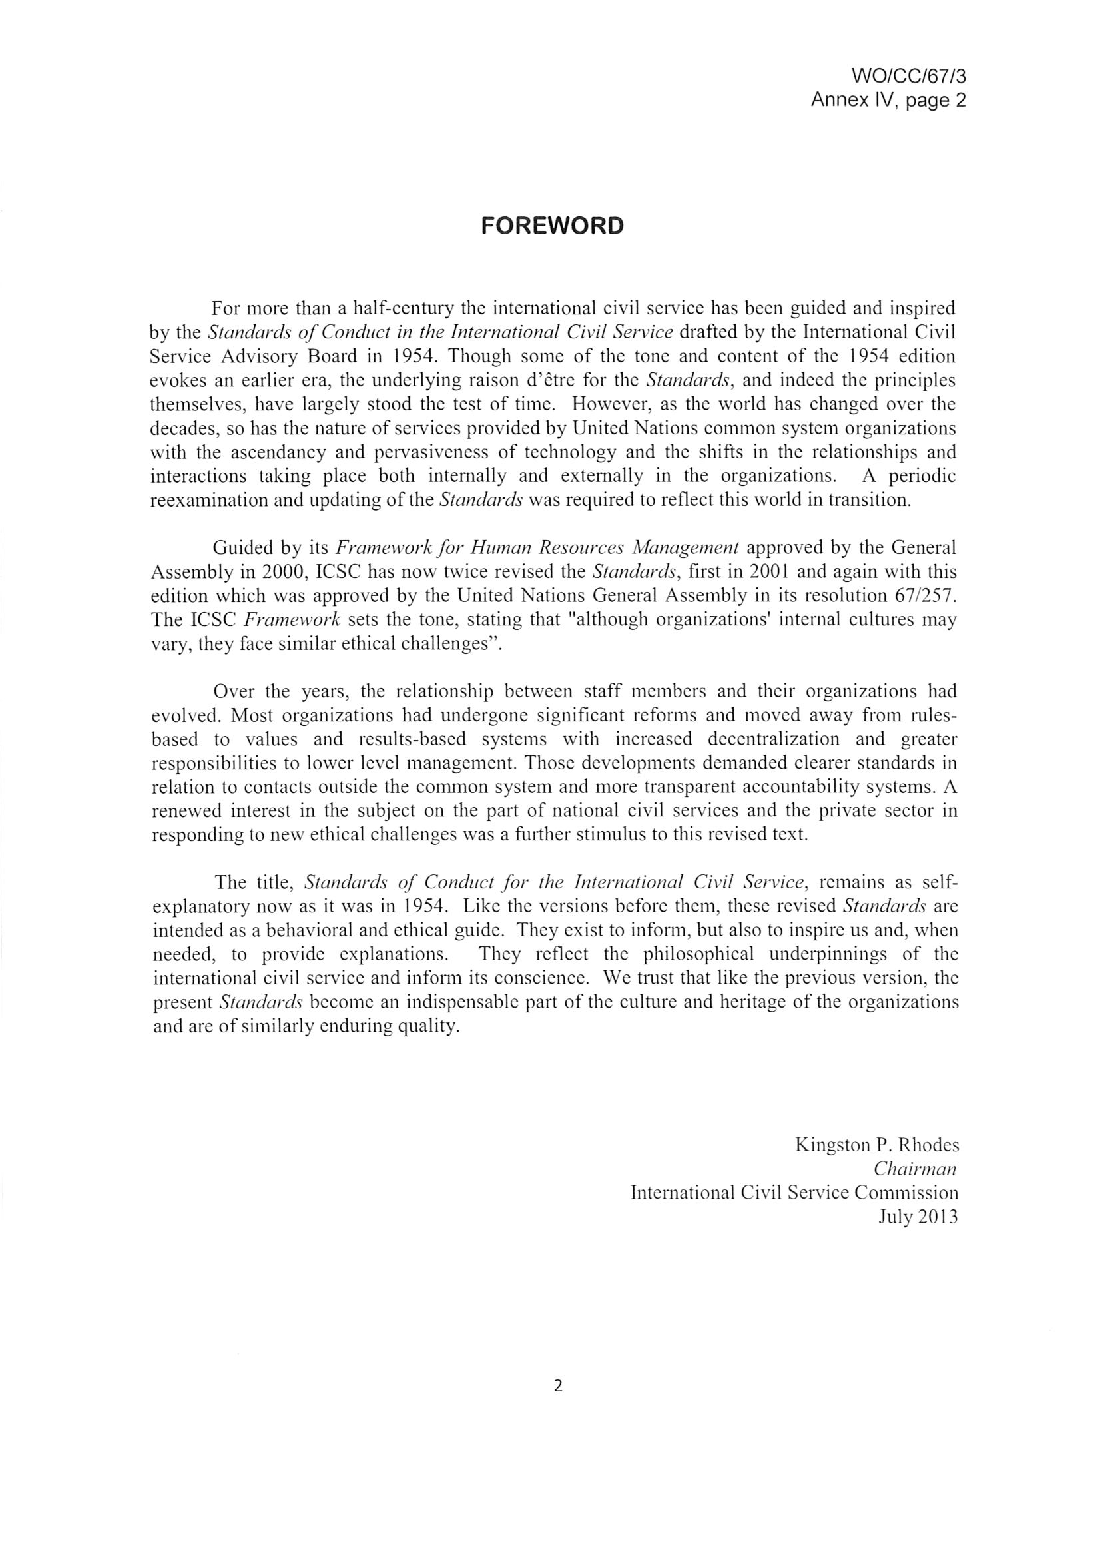
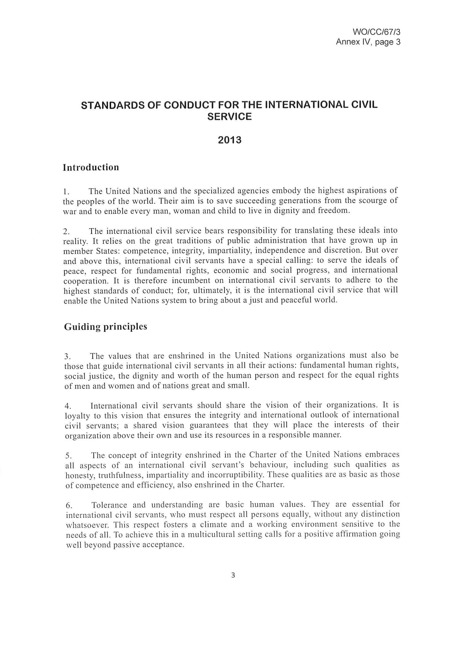
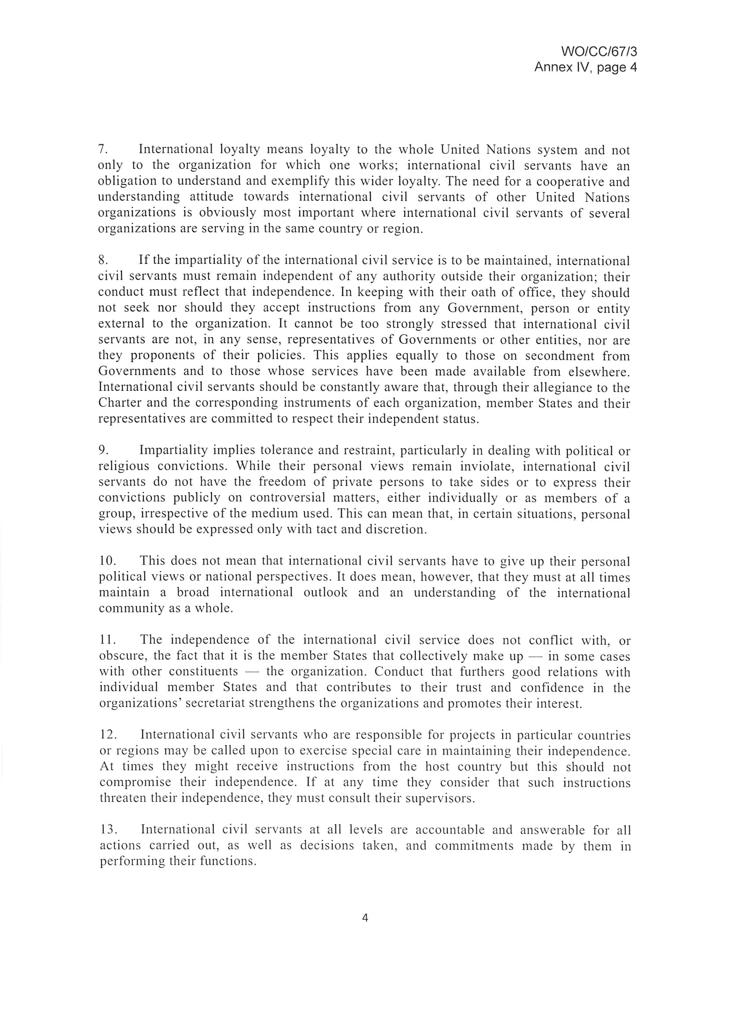

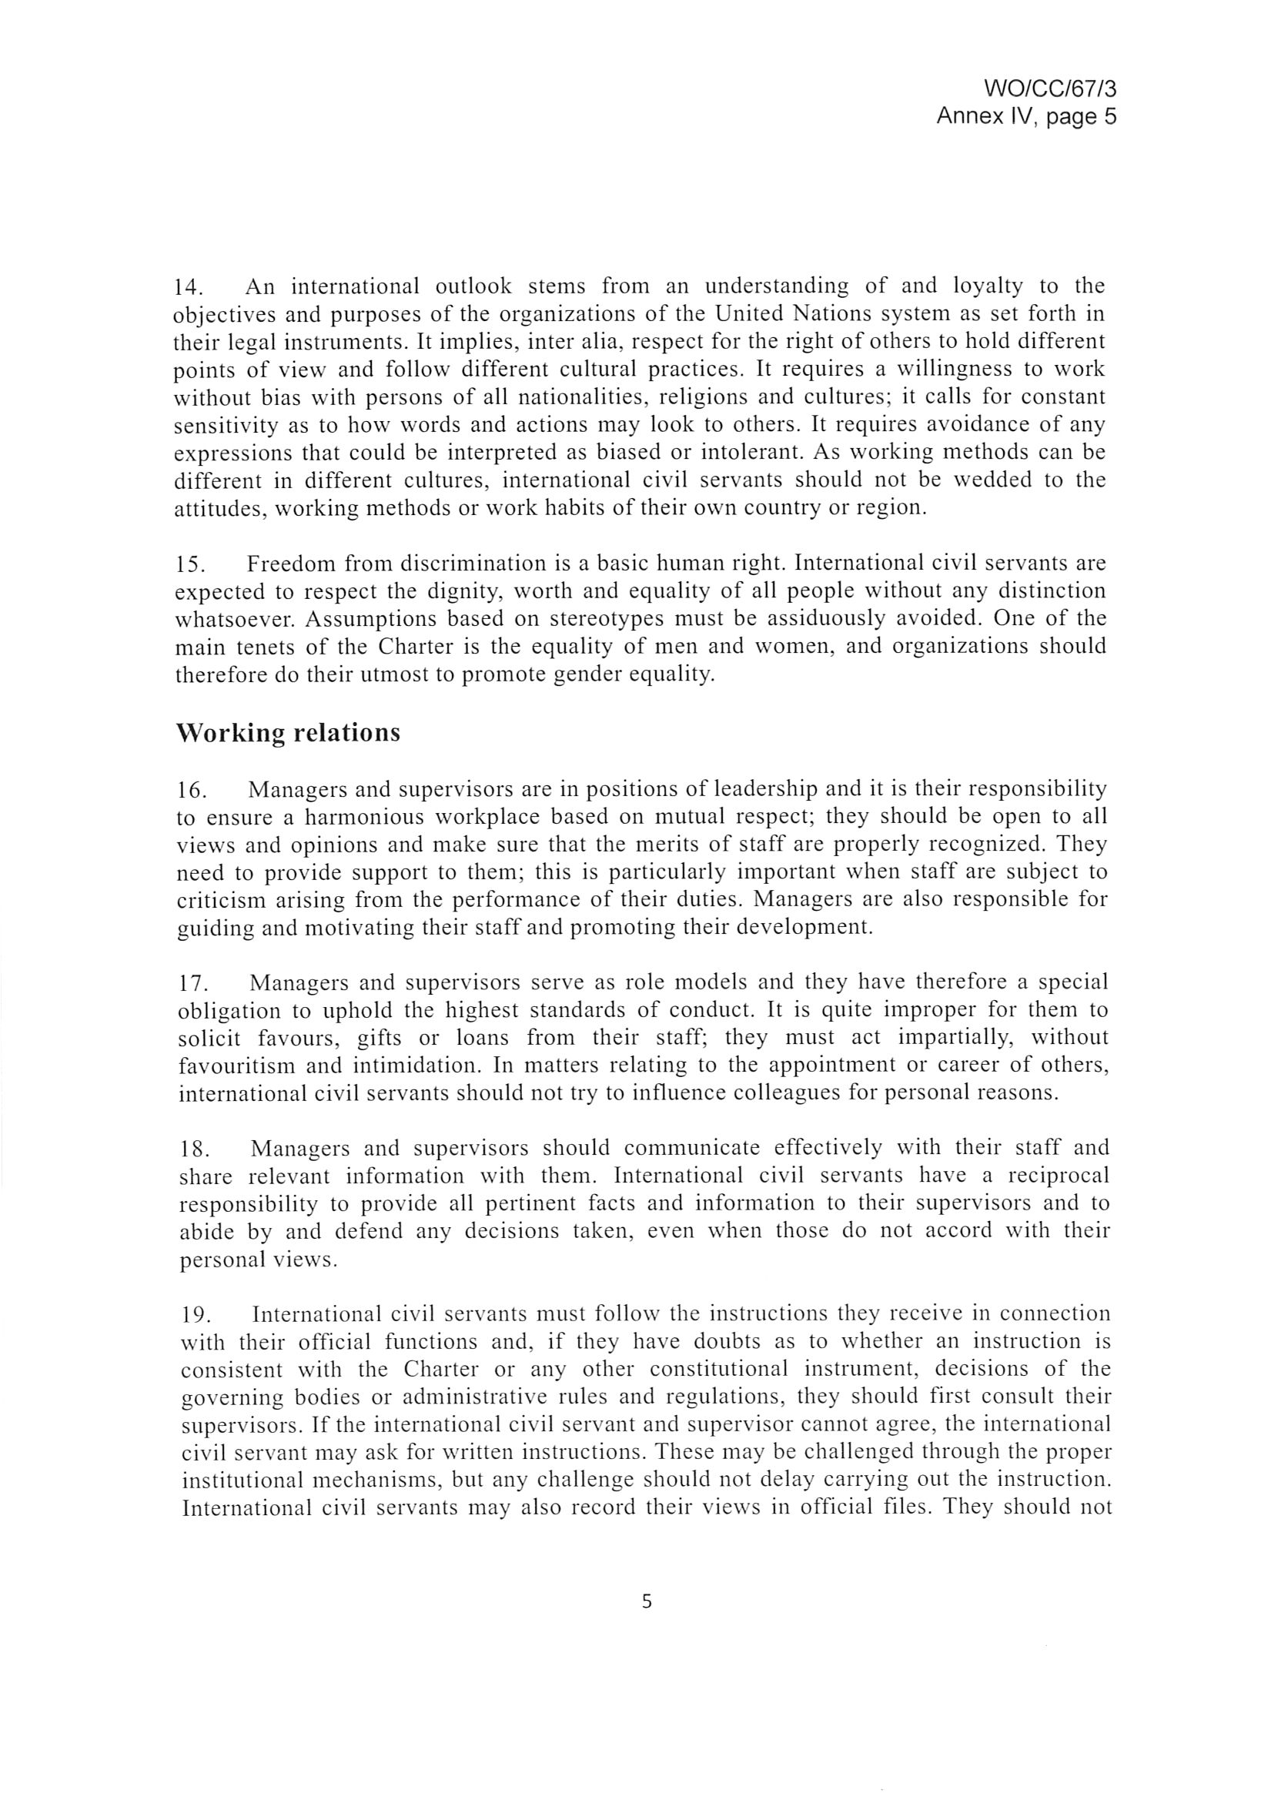

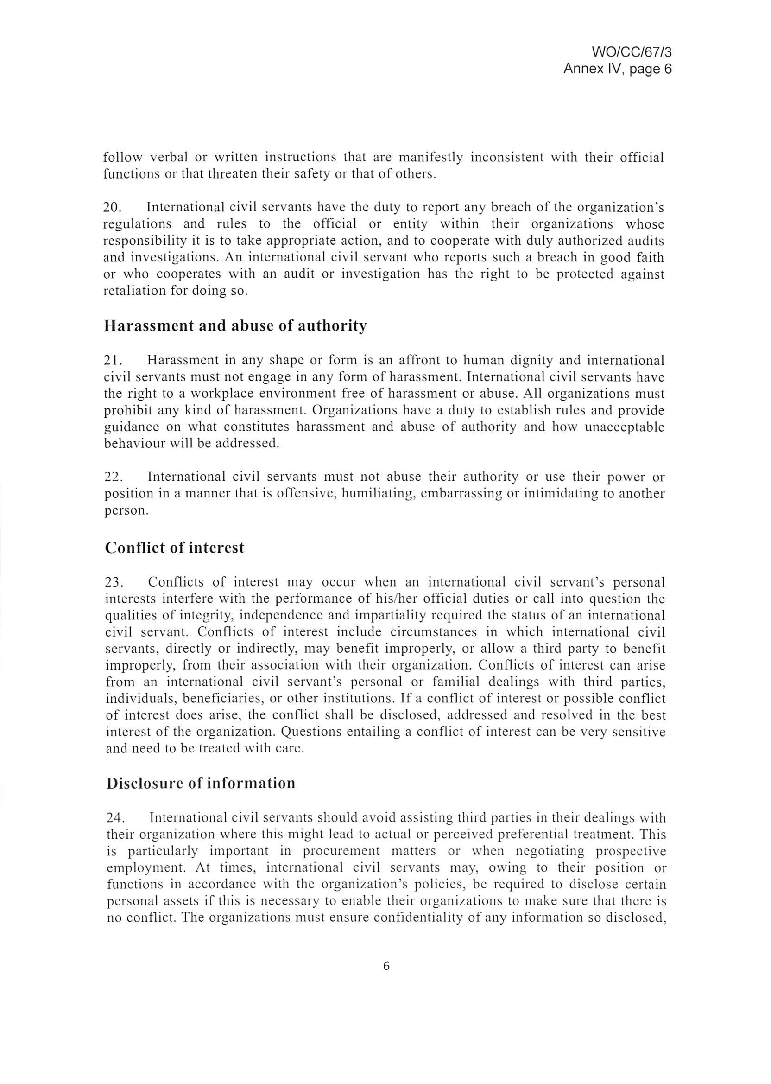

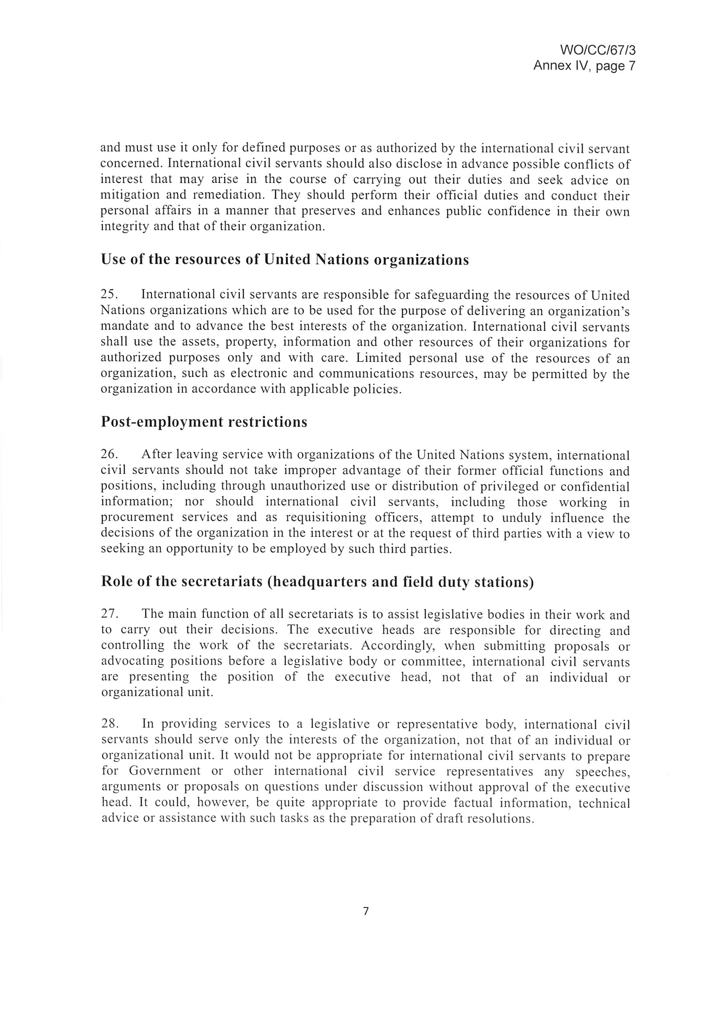

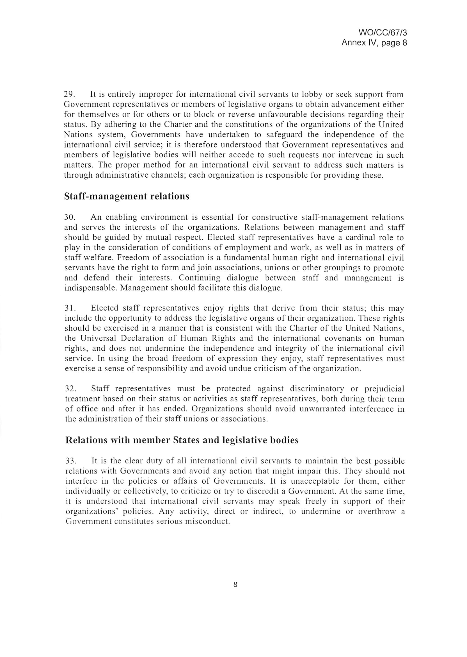

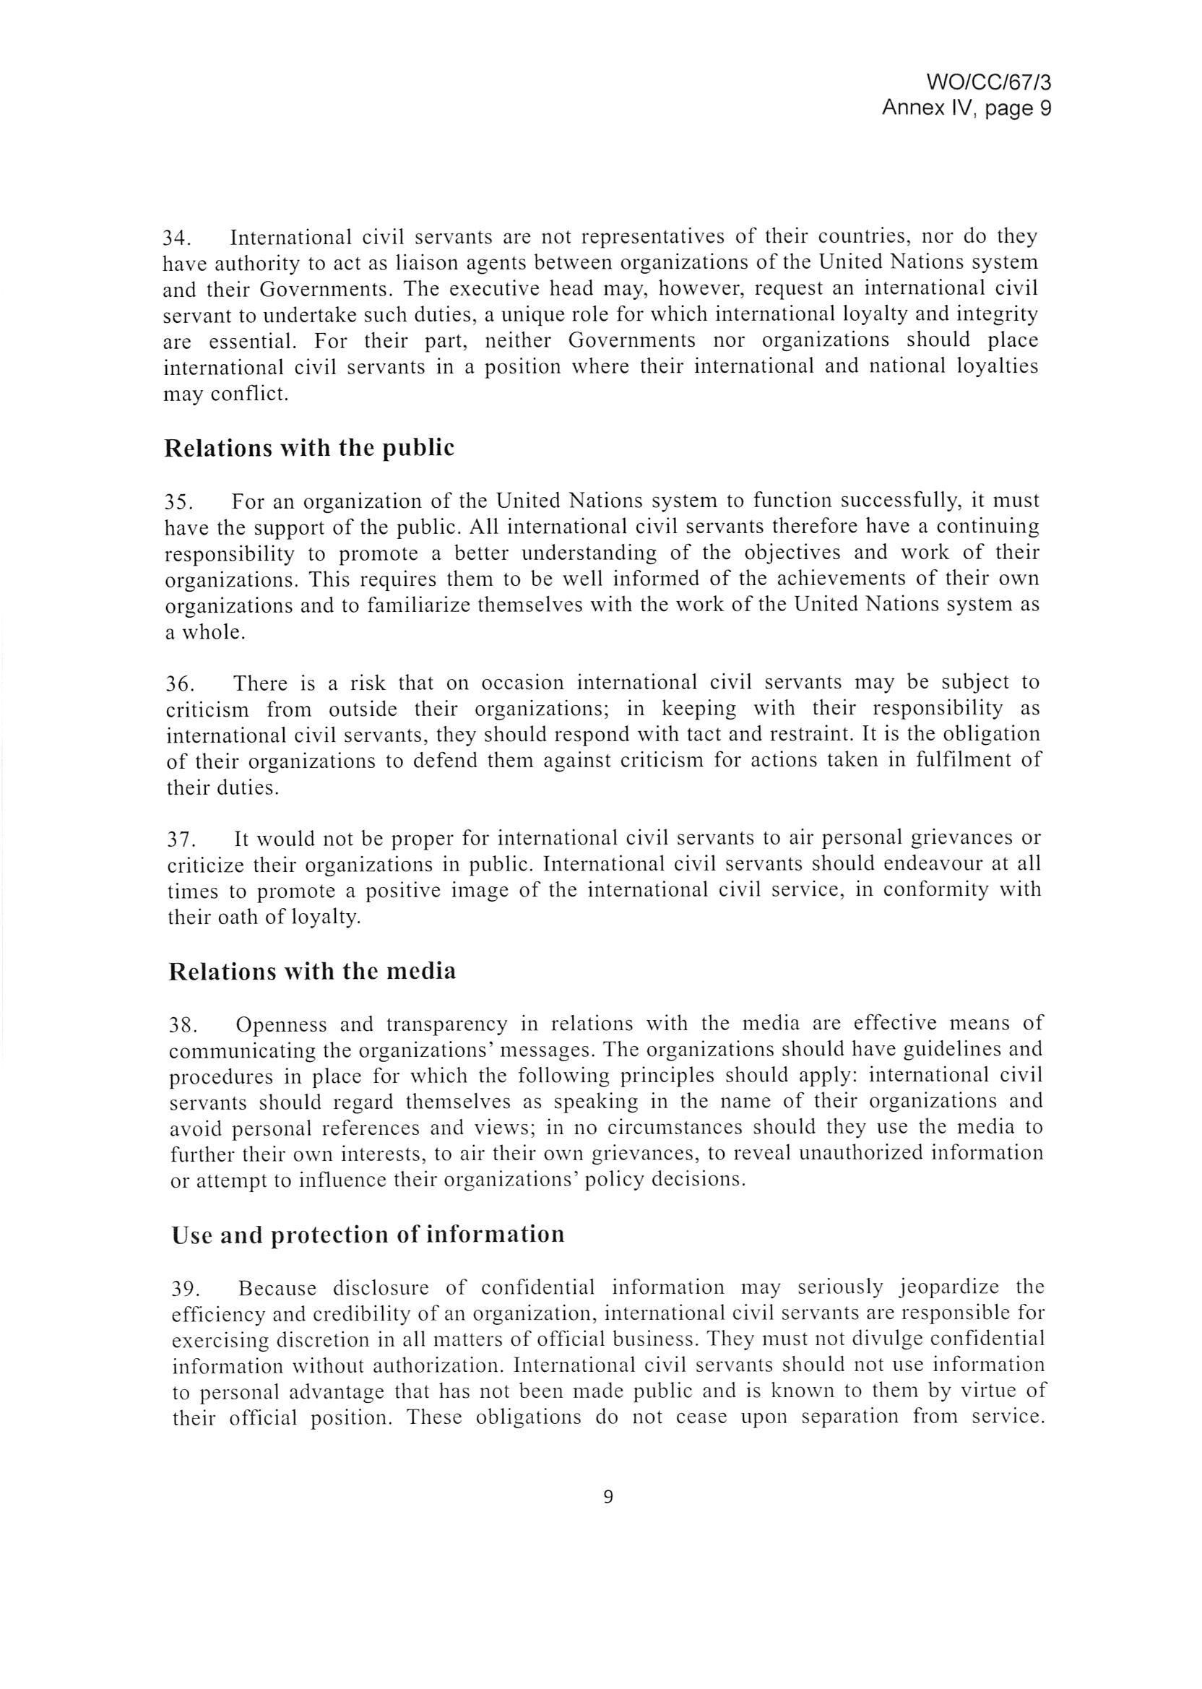

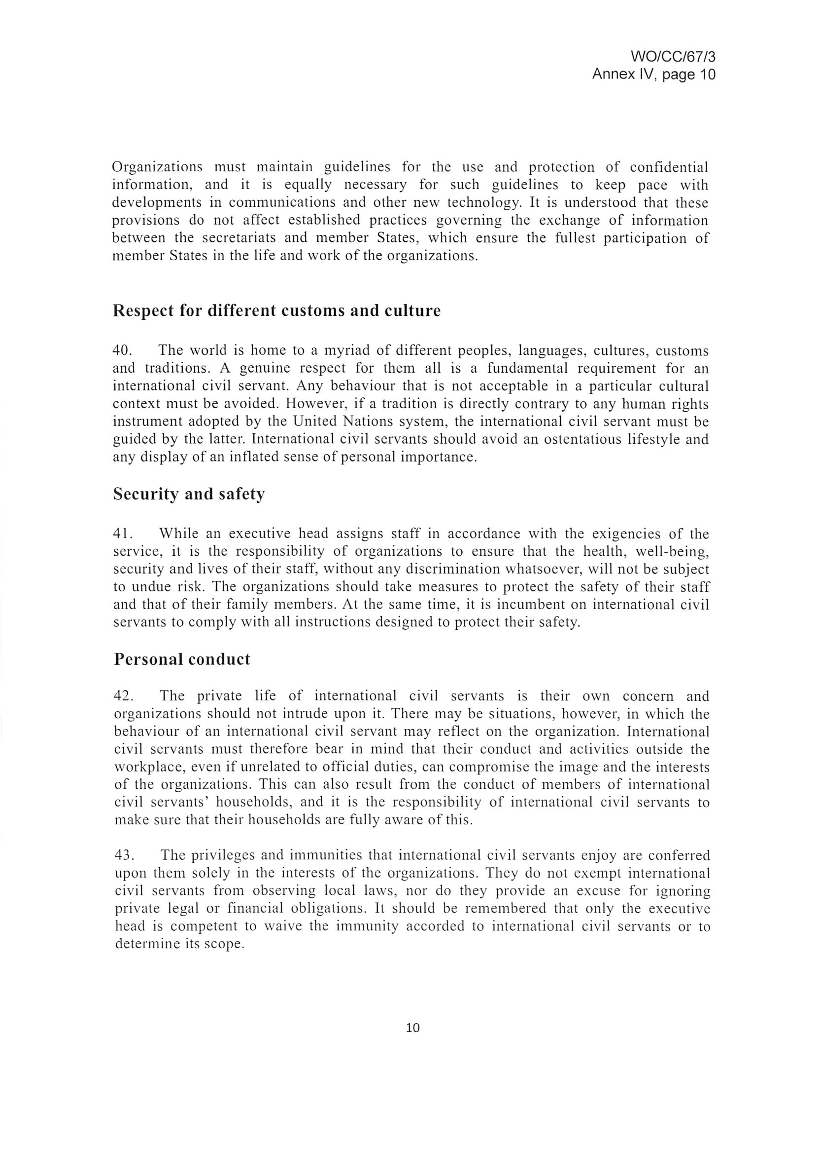

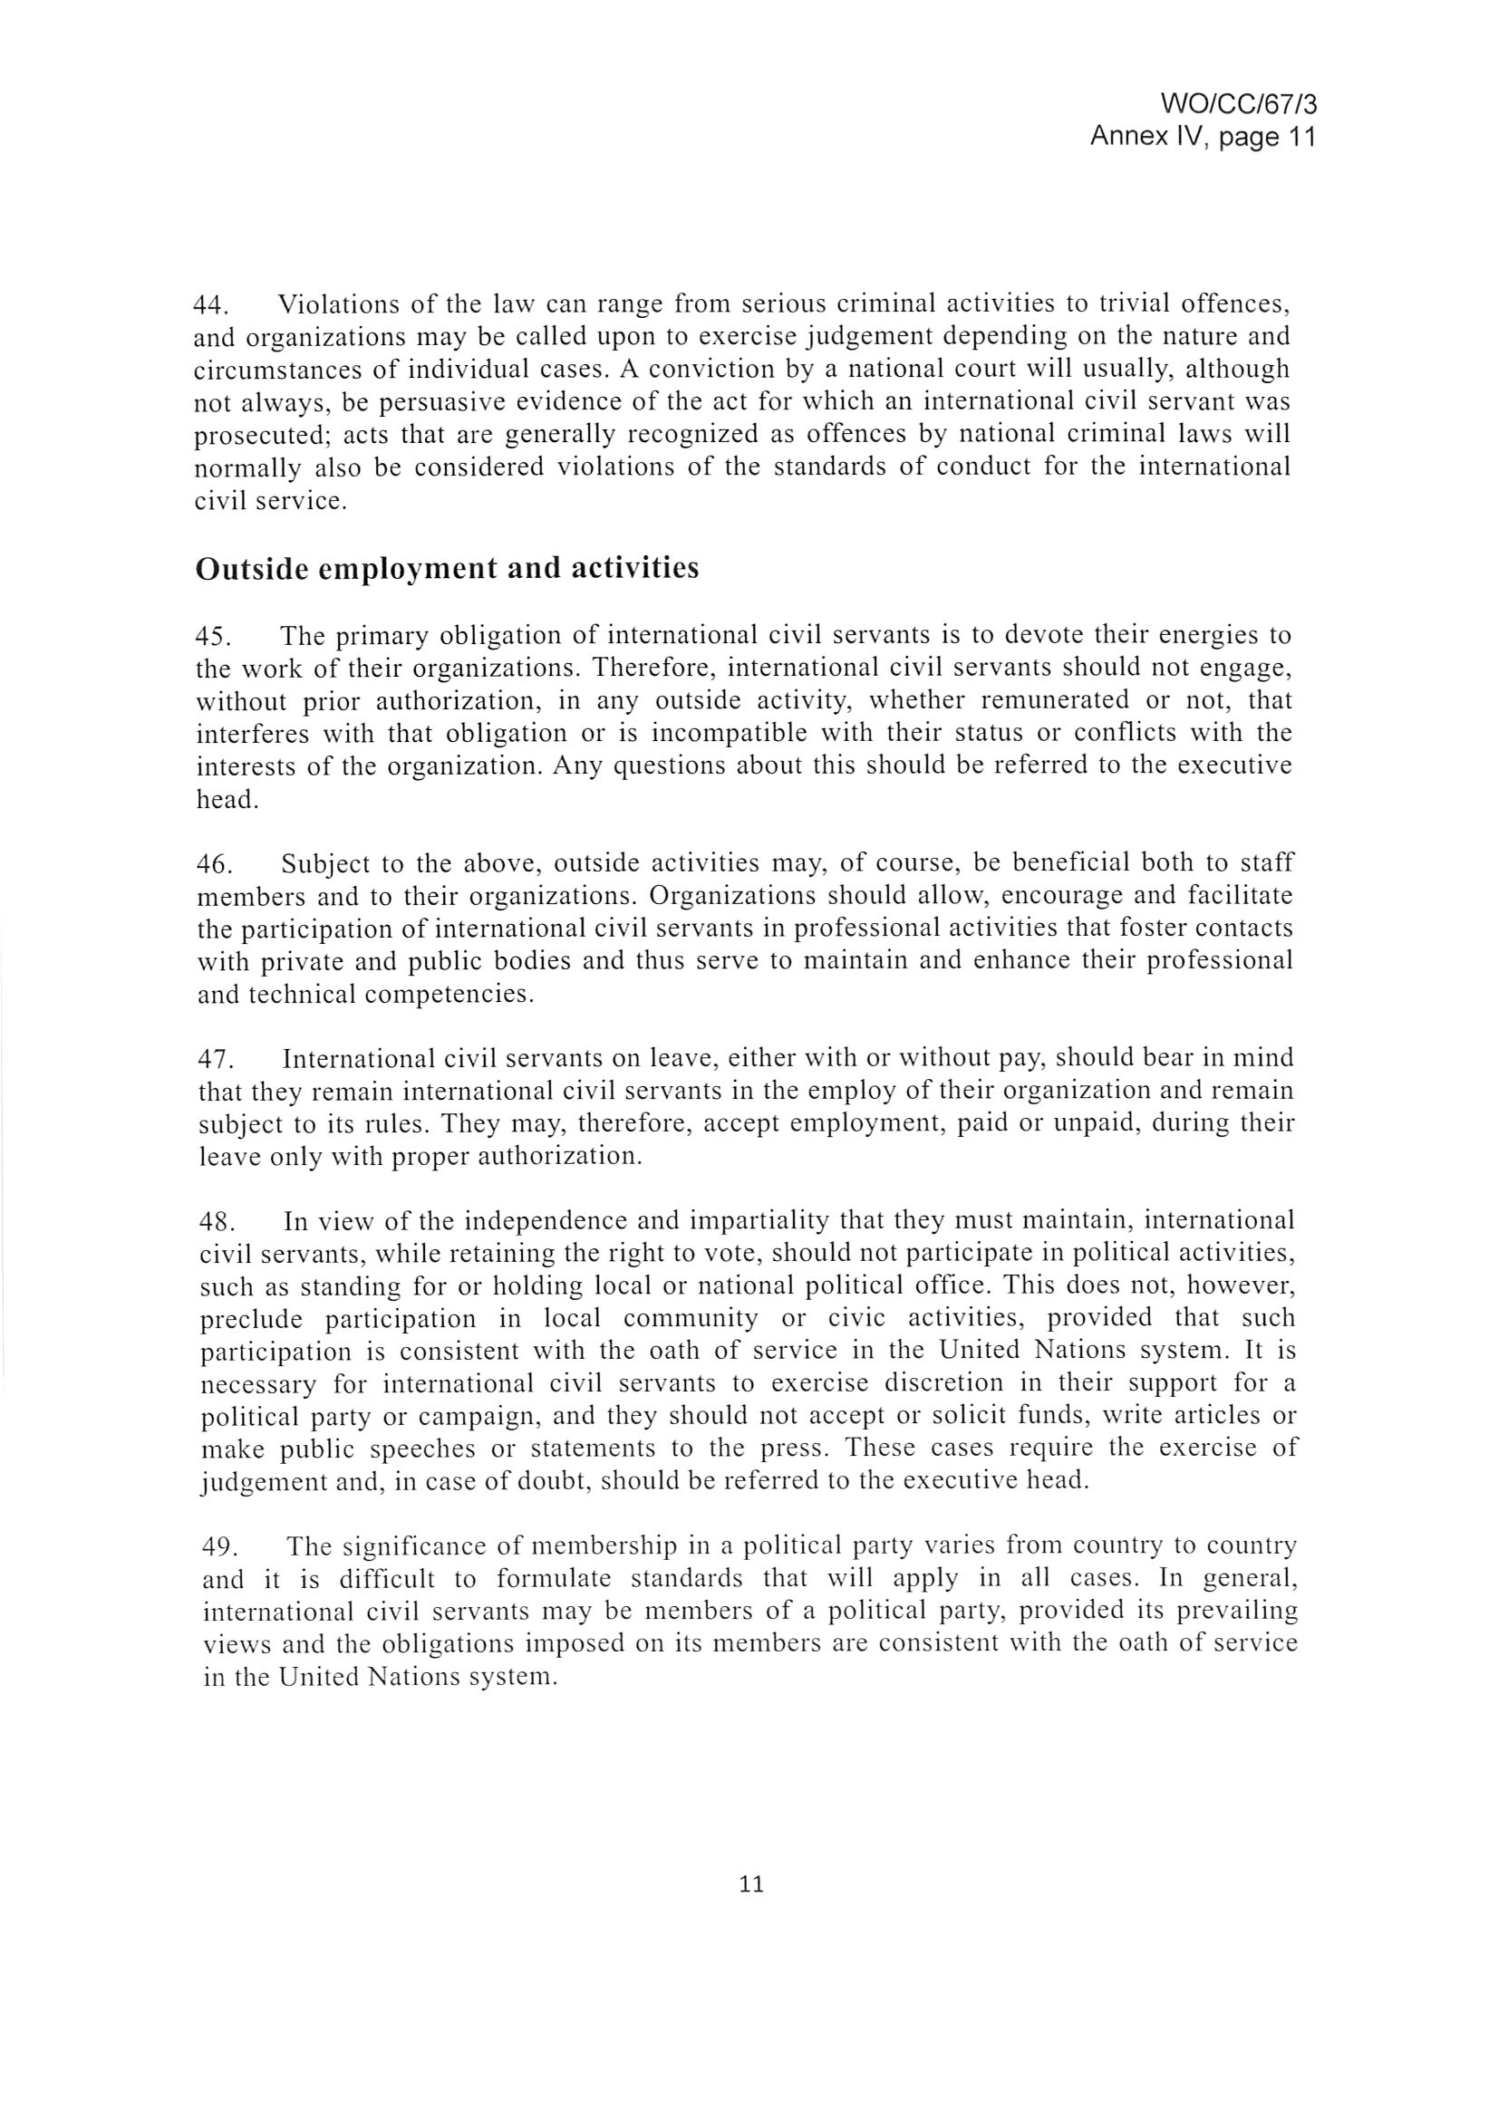

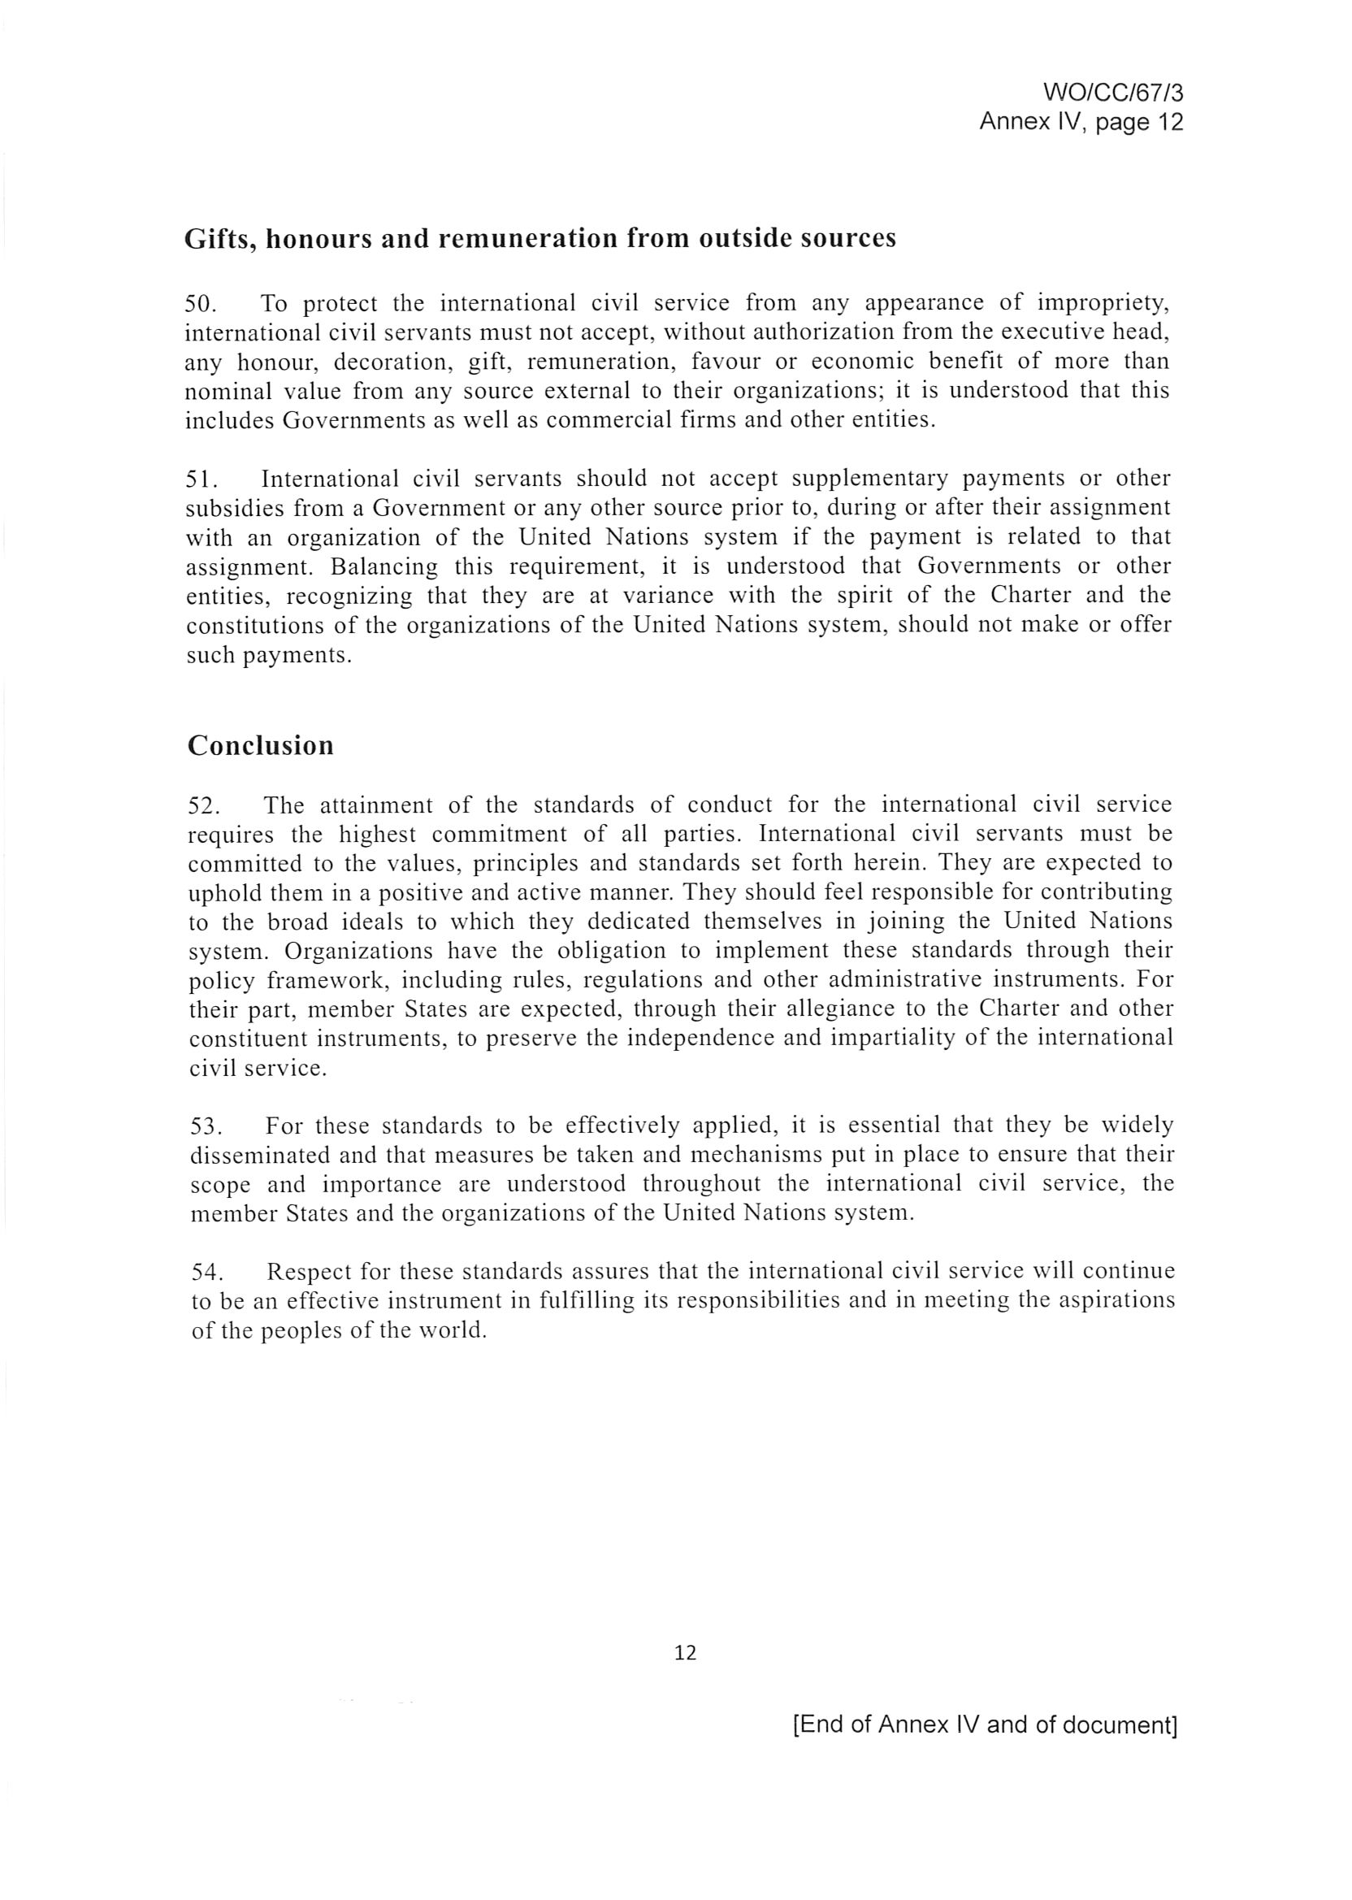

Amended with effect as of the school year in progress on January 1, 2013.
For France, a separate maximum admissible expense level equal to that applicable to the United States of America is established for the following educational institutions: American School of Paris, British School of Paris, International School of Paris, American University of Paris, Marymount School of Paris, École Active Bilingue Victor Hugo, École Active Bilingue Jeanine Manuel and the European Management School of Lyon.
Including educational institutions in China, Hungary, Indonesia, the Russian Federation, Thailand, the American Cooperative School in Tunis, and the American International School of Johannesburg, South Africa.
Applicable to all other countries not listed.

