 |  | E
mm/A/48/2
ORIGINAL: English
DATE: June 23, 2014

Special Union for the International Registration of Marks
(Madrid Union)

Assembly

Forty-Eight (28th Extraordinary) Session
Geneva, September 22 to 30, 2014

MADRID SYSTEM GOODS AND SERVICES DATABASE: PROGRESS REPORT

prepared by the International Bureau

INTRODUCTION

1 The purpose of this document is to present a progress report on the development of the database of acceptable indications of goods and services for the purposes of the Madrid System procedures (hereinafter referred to as the “Madrid System Goods and Services Database” or “MGS Database”).

2 In September 2009, the Assembly of the Madrid Union approved a two-year project aimed at the construction of the MGS Database, as described in document MM/A/42/3, and an amount of 1.2 million Swiss francs funding from the Madrid Union Reserve Funds for its implementation during the 2010-2011 biennium (see document MM/A/42/4, paragraph 28). Five previous Progress Reports have been presented to the Assembly of the Madrid Union (see documents MM/A/42/3, MM/A/43/2, MM/A/44/3, MM/A/45/2 and MM/A/46/2).

3 On January 1, 2012, the MGS Database project transitioned into operational mode which meant that ongoing operational support was thereafter funded from the regular budget.

4 The present document is a report on the progress of the MGS Database since the previous Progress Report (see document MM/A/46/2 Rev.), that is, between June 1, 2013, and May 30, 2014.

RESULTS ACHIEVED

5 It is recalled that on May 1, 2013, a new version of the Madrid Goods and Services Manager (MGS) was deployed on the public web site of the World Intellectual Property Organization (WIPO) with the following features:

- the addition of five new language interfaces, namely simplified Chinese, traditional Chinese, Japanese, Norwegian and Turkish;

- an extended translation functionality enabling translation from and into any of the 15 available languages (insofar as translations in the target languages were provided by the relevant Offices);

- a new function called “Check acceptance by designated Contracting Party (dCP)” displaying the status of acceptance of indications by MGS-participating Contracting Parties. The information displayed enables a trademark applicant to know whether certain indications accepted by the International Bureau are rejected by a given Contracting Party and would provoke the communication of a provisional refusal from that Contracting Party.

6 It is further recalled that translations integrated into MGS in languages other than the three Madrid working languages as well as information relating to acceptance status are obtained through cooperation with national Offices. In this respect, the International Bureau established further cooperation regarding MGS with national Offices having requested integration since May 1, 2013, namely:

- the Intellectual Property Office of the Republic of Serbia (IPO),
- the State Intellectual Property Service of Ukraine (SIPS), and
- the Mexican Institute of Industrial Property (IMPI).

7 For a better understanding of the figures in the below-mentioned Annexes I and II (see paragraphs 9 and 10), it is also recalled that the MGS Database is structured in the same way as the Nice Classification Alphabetical List of goods and services, in which synonymous indications are grouped in “concepts” having each a single identification number. The advantage of grouping indications of goods and services in concepts is three-fold:

- national Offices translating into their national languages are not required to provide more than one translation per concept, which reduces considerably the translation workload;

- it reduces the number of duplicates in translation given that all languages cannot accurately reflect nuances existing in English (the core database language); and

- MGS warns users when they select synonymous indications from the Search results.

LANGUAGE DIVERSITY

8 New language interfaces have been prepared in cooperation with the respective national Offices:

- the Serbian language interface was published in March 2014,
- the Korean language interface was published in May 2014,
- the Ukrainian language interface was under initial development in May 2014.

9 Annex I presents the content of the MGS Database in terms of data volume per language, as published in May 2014 on the WIPO web site.

10 Annex II gives an overview of the relative translation “fill-up” in terms of concepts translated into the MGS languages. It should be noted that the translation fill-up in the non-Madrid languages depends on the progress of the translation process carried out by the cooperating national Offices.

ACCEPTANCE CHECKING OF THE MGS DATABASE

11 Annex III gives an overview of the relative “fill-up” of the MGS Database in terms of acceptance status by Contracting Parties as displayed in the function “Check acceptance by designated Contracting Party (dCP)”. Since May 1, 2013, the number of countries selectable in this function increased to 19, with the addition of the three following new participating countries:

- Belarus,
- Serbia, and
- Ukraine.

12 It should be noted that the acceptance status available for each of the 19 participating Contracting Parties was gathered from a variety of sources:

– acceptance information provided directly by national Offices that translated the database and/or checked acceptance or rejection of each English concept;

– the harmonized TM5 - ID list of goods and services to which four Offices currently contribute: the Japan Patent Office (JPO), the Korean Intellectual Property Office (KIPO), the Office for Harmonization in the Internal Market (Trade Marks and Designs) (OHIM) and the United States Patent and Trademark Office (USPTO);

– the KIPO’s list of Acceptable Identifications of Goods and Services; and

– the USPTO Manual of Acceptable Identifications of Goods and Services.

OTHER RESULTS IN THE FIRST HALF OF 2014

13 On January 1, 2014, the MGS Database was brought into line with the 2014 version of the tenth edition of the Nice Classification. Updates were integrated in the 14 languages then available on-line.

14 In order to respond to European harmonization relating to the acceptance of the “general indications” extracted from the Nice class headings, all MGS-participating countries agreed to provide their acceptance position so that MGS could provide useful information on these indications as of January 2014.

15 From April 2014, the function “Check acceptance by WIPO” was extended through the use of numerous descriptions of goods and services that are deemed acceptable for operational examination of international applications in the International Bureau (i.e., acceptable for “internal use”) but are not suggested for selection in the Browse and Search functions of MGS. With the progressive addition of more and more of these “internal use” descriptions in the future, MGS will become further aligned with the classification examination policy of the Madrid Registry.

16 Following discussions with the JPO and the KIPO, display in MGS of the similar group codes used respectively in Japan and the Republic of Korea is under preparation. These codes are associated with groups of goods or services deemed to be similar to each other in trademark examination and are organized in a hierarchical tree-structure adapted to similarity searches in the respective national trademark databases. Trademark applicants in Japan and the Republic of Korea are encouraged to refer to these codes before filing a trademark application in order to search for the existence of similar registered trademarks.

FURTHER ENRICHMENT OF THE MGS DATABASE

ACCEPTANCE CHECKING BY NATIONAL OFFICES

17 Annex IV shows the list of Contracting Parties of the Madrid System ranked according to the number of provisional refusals issued in 2013.

18 Cooperation between the International Bureau and Contracting Parties in the above-mentioned list, with a view to increasing the amount of acceptance information available for indications in the MGS Database, will provide trademark applicants using the Madrid System with very useful information for the purpose of international filing. In particular, trademark applicants using MGS to compile and check acceptance of a list of goods and services will know in advance whether certain indications would provoke a provisional refusal from countries they designate.

19 During the first half of 2014, the USPTO completed its review of the Nice Alphabetical List of goods and services so that the rejection by the United States of America of some 30% of Nice indications could be displayed in MGS. Given the importance of the Nice Alphabetical List for trademark applicants, and even though the Alphabetical List accounts for only one fourth of the MGS Database, the display of these rejections in MGS provides valuable information aimed at limiting the number of provisional refusals issued by the USPTO. The USPTO further agreed to check acceptance of other parts of the MGS Database that are most relevant for US designations.

20 In February 2013, Mexico joined the Madrid Protocol and by the end of the year, it already ranked 16th in number of designations in international applications. For this reason, the Mexican Institute of Industrial Property (IMPI) requested to cooperate with the International Bureau to check its acceptance of the goods and services proposed in MGS so as to limit the number of provisional refusals to be issued by IMPI.

21 Furthermore, the Republic of Korea and Serbia will continue to check their acceptance of the MGS Database in parallel with the translation process they have engaged in.

INTEGRATION OF NEW INDICATIONS OF GOODS AND SERVICES

22 In order to make MGS as relevant as possible to trademark applicants for international as well as national filing, the MGS Database will continue to be enriched with indications of goods and services extracted from various sources and carefully reviewed before integration. The main sources to be considered in 2014 are:

- the International Trademark Register from which frequently used indications can be extracted on a regular basis;

- the harmonized TM5 ID-list of English indications of goods and services resulting from the cooperation between the JPO, KIPO, OHIM and the USPTO;

- national lists of goods and services received from the national Offices of the following countries: China, Germany, Japan, Republic of Korea, Switzerland, as well as from the ASEAN group;

- national trademark registers from countries cooperating with WIPO in the Global Brand Database project, and from which frequently used indications not already present in MGS will be reviewed for potential integration. Frequent indications have so far been extracted from the national registers of Australia, Israel, the Russian Federation, Singapore, Switzerland, and the United States of America.

MGS USAGE IN FIGURES

23 Some figures are representative of the growing public interest in MGS:

- from its launch in 2011 until March 2014, the number of visits to MGS increased by 245%;

- the number of visits doubled in January 2012 when seven national languages were made available in addition to the three Madrid filing languages;

- in March 2014, the main functions (Search, Validate, Browse, Translate, Export, Import) generated some 10,000 page views per day;

- the most popular function is the Search function (88% of page views);

- the languages used most frequently in the Search function are in order: English, Spanish, French and Russian;

- some countries that recently joined the Madrid System (e.g. Colombia, India and Mexico) as well as countries that are not yet members of the Madrid System (Chile, Peru, Argentina, Indonesia and Malaysia) are already top users of MGS.

BUDGET

24 In 2013, the Assembly of the Madrid Union approved the use of project funds remaining at the end of 2013 to assist some national Offices in the translation of the MGS Database into their national languages (see document MM/A/46/2, paragraph 33).

25 Annex V presents a table indicating the breakdown of the initial allocation
(232,000 Swiss francs) made available by WIPO for the translation of the MGS Database and the actual payments made up to May 30, 2014, for the translation work carried out by national Offices originally selected or having requested to receive financial support. In particular, the table shows, under “Balance”, the funds still available for each participating Office to continue with the translation of the MGS Database.

26 As of May 2014, a total amount of 117,343 Swiss francs remained available for financing the translation of the MGS Database into the seven languages for which a Memorandum of Understanding has been signed between WIPO and the corresponding national Office.
27 The Assembly is invited to:

- take note of the Progress Report of the Madrid System Goods and Services Database (document MM/A/48/2), including its paragraph 26 related to the remaining project funds; and

- request the International
Bureau to submit to the Assembly in 2015 a new Progress Report of the Madrid System Goods and Services Database, including the use of remaining project funds.

[Annexes follow]
MGS Database Content
May 2014

MGS |  |  | Concepts | Indications of  goods and services
EN | - | English | 34,018 | 51,944
ES | - | Spanish | 27,477 | 34,377
FR | - | French | 27,322 | 34,512
AR | - | Arabic | 18,583 | 24,287
DE | - | German | 24,071 | 25,939
HE | - | Hebrew | 28,091 | 29,335
IT | - | Italian | 26,766 | 29,508
JP | - | Japanese | 22,631 | 23,090
KR | - | Korean | 10,572 | 11,587
NL | - | Dutch | 22,477 | 23,717
NO | - | Norwegian | 24,457 | 30,225
PT | - | Portuguese | 26,378 | 27,888
RU | - | Russian | 26,559 | 26,884
SR | - | Serbian | 8,155 | 8,778
TR | - | Turkish | 8,037 | 9,498
ZH | - | Chinese | 18,499 | 19,062

[Annex II follows]

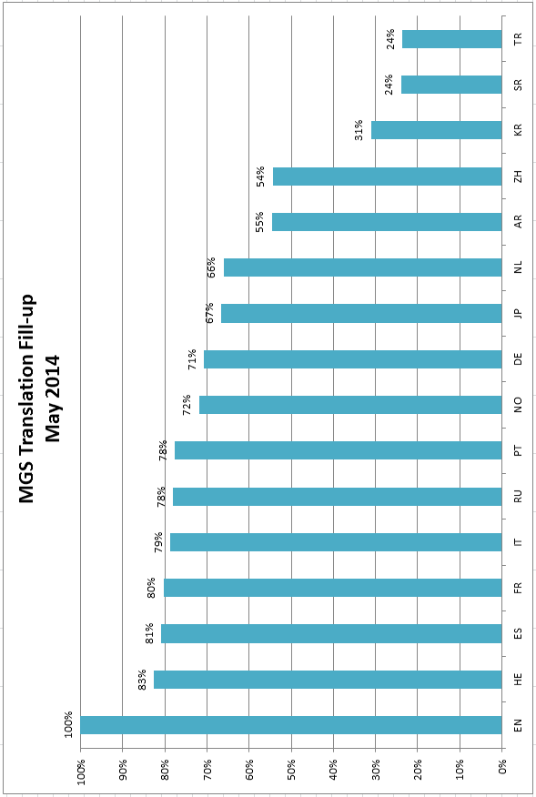

[Annex III follows]

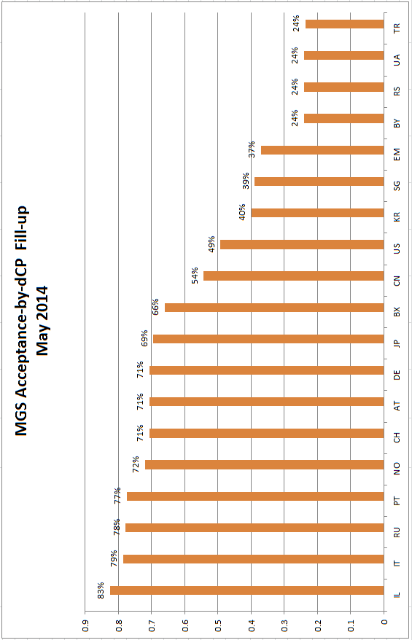

[Annex IV follows]

Provisional Refusals by Contracting Party
 | CP | Contracting party | 2011 | 2012 | 2013
1 | US | United States of America | 14,959 | 14,938 | 17,629
2 | JP | Japan | 5,936 | 7,724 | 7,890
3 | RU | Russian Federation | 5,671 | 5,649 | 6,765
4 | KR | Republic of Korea | 7,475 | 5,996 | 6,478
5 | CN | China | 7,613 | 8,894 | 6,435
6 | AU | Australia | 3,290 | 3,028 | 3,455
7 | SG | Singapore | 2,424 | 3,760 | 3,143
8 | TR | Turkey | 1,162 | 1,105 | 2,393
9 | EM | European Union | 1,876 | 2,189 | 2,340
10 | NO | Norway | 2,062 | 2,370 | 2,170
11 | IL | Israel | 537 | 934 | 2,038
12 | CH | Switzerland | 1,757 | 1,932 | 1,808
13 | KZ | Kazakhstan | 1,049 | 1,280 | 1,454
14 | VN | Viet Nam | 1,042 | 1,381 | 1,343
15 | UA | Ukraine | 991 | 1,025 | 1,272
16 | SY | Syrian Arab Republic | 712 | 1,358 | 1,167
17 | IR | Iran (Islamic Republic of ) | 569 | 509 | 1,075
18 | DE | Germany | 935 | 939 | 940
19 | MD | Republic of Moldova | 1,043 | 1,150 | 933
20 | GB | United Kingdom | 551 | 540 | 714
21 | PL | Poland | 857 | 806 | 634
22 | AM | Armenia | 431 | 469 | 632
23 | EG | Egypt | 535 | 727 | 598
24 | IE | Ireland | 449 | 516 | 568
25 | RO | Romania | 186 | 175 | 547
26 | NZ | New Zealand | 0 | 0 | 544
27 | SE | Sweden | 900 | 608 | 533
28 | FI | Finland | 529 | 453 | 527
29 | BY | Belarus | 325 | 495 | 490
30 | UZ | Uzbekistan | 501 | 495 | 486
31 | TJ | Tajikistan | 125 | 168 | 477
32 | CO | Colombia | 0 | 0 | 437
33 | DZ | Algeria | 248 | 233 | 407
34 | EE | Estonia | 441 | 413 | 407
35 | ES | Spain | 426 | 370 | 389
36 | KP | Democratic People's Republic of Korea | 377 | 294 | 377
37 | RS | Serbia | 442 | 569 | 347
38 | PT | Portugal | 291 | 278 | 333
39 | CZ | Czech Republic | 312 | 332 | 322
40 | OM | Oman | 24 | 72 | 294
41 | BX | Benelux | 278 | 264 | 256
42 | FR | France | 188 | 211 | 252
43 | MX | Mexico | 0 | 0 | 247
44 | GR | Greece | 187 | 80 | 229
45 | GE | Georgia | 181 | 285 | 224
46 | AG | Antigua and Barbuda | 94 | 93 | 213
47 | DK | Denmark | 181 | 178 | 212
48 | IS | Iceland | 223 | 224 | 212
49 | KG | Kyrgyzstan | 118 | 267 | 209
50 | AT | Austria | 254 | 207 | 191
 |  | Acceptance data available (fully or partly)

[Annex V follows]

[End of Annex V and of document]

