 |  | E
mm/A/46/2 REV
ORIGINAL: English
DATE: SEPTEMBER 30, 2013

Special Union for the International Registration of Marks
(Madrid Union)

Assembly

Forty-Sixth (20th Ordinary) Session
Geneva, September 23 to October 2, 2013

MADRID SYSTEM GOODS AND SERVICES DATABASE: PROGRESS REPORT

prepared by the International Bureau

INTRODUCTION

- The purpose of this document is to present a progress report on the development of the database of acceptable indications of goods and services for the purposes of Madrid system procedures (hereinafter referred to as the “Madrid System Goods and Services Database” or “MGS Database”).

- In September 2009, the Assembly of the Madrid Union approved a two-year project aimed at the construction of the MGS Database, as described in document MM/A/42/3, and an amount of 1.2 million Swiss francs funding from Reserve Funds for implementation during the 2010-2011 biennium (see document MM/A/42/4, paragraph 28). Four previous Progress Reports have been presented to the Assembly of the Madrid Union (see documents MM/A/42/3, MM/A/43/2, MM/A/44/3 and MM/A/45/2).

- On January 1, 2012, the MGS Database project transitioned into operational mode which meant that ongoing operational support was funded from the regular budget.

- The present document is a report on the progress of the MGS Database since the previous Progress Report (see document MM/A/45/2) and presents implementation status up to
May 30, 2013.

RESULTS ACHIEVED

- It is recalled that on January 1, 2012, the Madrid System Goods & Services Manager (hereinafter referred to as “MGS”) was launched in 10 languages, seven of which were non-Madrid filing languages for which the first batch of (good or service) concepts integrated by the International Bureau of the World Intellectual Property Organization (WIPO)
(the “2011 Batch” comprising 11,299 concepts) had been translated. In early May 2012, participating National Offices received a second batch of concepts for translation
(the “2012 Batch” comprising 6,123 concepts).

- It is further recalled that translations integrated into MGS in languages other than the three Madrid filing languages have been obtained through cooperation with the following national Offices:

– Arabic: Directorate of Commercial and Industrial Property Protection
(DCIP) of the Syrian Arab Republic;

- Chinese: State Administration for Industry and Commerce of the People’s Republic
of China (SAIC);

– Dutch: Benelux Office for Intellectual Property (BOIP);

– German: Austrian Patent Office, German Patent and Trade Mark Office (DPMA)
and Swiss Federal Institute of Intellectual Property (IPI);

– Hebrew: Israel Patent Office;

– Italian: Italian Patent and Trademark Office (UIBM);

– Japanese: Japan Patent Office (JPO);

– Norwegian: Patentstyret (Norwegian Industrial Property Office) (NIPO);

– Portuguese: National Institute of Industrial Property of Portugal (INPI);

– Russian: Federal Service for Intellectual Property (ROSPATENT); and

– Turkish: Turkish Patent Institute (TPI).

- On January 1, 2013, the MGS Database was updated on WIPO’s public web site and thus brought into line with the 2013 version of the tenth edition of the Nice Classification. Updates are being integrated in all languages available on line.

- In the “2013 Batch”, to be sent in early June 2013, the new concepts for translation by participating Offices will be in English only in the absence of French and Spanish translations, which will be provided at a later stage by the International Bureau of WIPO.

- The table below summarizes the content of the MGS Database in each language according to the volume of translations received in time for publication on January 1, 2013.

Public launch on January 1, 2013 | NCL10  2013 version | MGS  2011-Batch  (11,299 concepts) | MGS  2012-Batch  (6,123 concepts)
English | OK | OK | OK
French | OK | OK | OK
Spanish | OK | OK | OK
Arabic | NCL10-2012 | OK
Dutch | OK | Ok | OK
German | OK | OK
Hebrew | OK | OK | OK
Italian | OK | OK
Portuguese | OK | OK
Russian | OK | OK | OK

- On May 1, 2013, a new version of MGS was launched with five new language interfaces, namely Chinese (simplified and traditional), Japanese, Norwegian and Turkish. The table below summarizes the content of the MGS Database in each language according to the volume of translations received in time for publication on May 1, 2013.

Public launch on  May 1, 2013 |  | NCL10  2013 version | MGS  2011-Batch  (11,299 concepts) | MGS  2012-Batch  (6,123 concepts)
 | English | OK | OK | OK
 | French | OK | OK | OK
 | Spanish | OK | OK | OK
 | Arabic | NCL10-2012 | OK
NEW | Chinese (simplified) | OK | Ok
NEW | Chinese  (traditional) | OK | OK
 | Dutch | OK | OK | OK
 | German | OK | OK
 | Hebrew | OK | OK | OK
 | Italian | OK | OK | 77%
NEW | Japanese | OK | OK
NEW | Norwegian | OK | OK | OK
 | Portuguese | OK | OK
 | Russian | OK | OK | OK
NEW | Turkish | OK

- In addition to the new languages, the version of MGS deployed on the WIPO public web site on May 1, 2013, included two important new features:

– an extended translation functionality enabling translation from and into any of the
15 available languages (in so far as translations in the target languages have been provided by the relevant Offices);

– a function known as “Check acceptance by designated Contracting Party (dCP)”.

- The development of the new “Check acceptance by designated Contracting Party (dCP)” function is the result of cooperation between the International Bureau of WIPO and Intellectual Property (IP) Offices in the Madrid system. For each term accepted by the International Bureau of WIPO, the function displays the status of acceptance in any of the 16 participating national Offices that have provided the International Bureau of WIPO with this information (for at least part of the MGS Database). Until the acceptance status of a term has been communicated by a participating national Office, the status of the term remains “Unknown”.

- The “Check acceptance by designated Contracting Party (dCP)” function is an exclusive feature of MGS in that it indicates not only that a term selected from the MGS Database is accepted by a Contracting Party, but also that certain terms accepted by the International Bureau of WIPO are not accepted by a given Contracting Party and would provoke the communication of a provisional refusal from that Contracting Party.

- In the “Check acceptance by designated Contracting Party (dCP)” function, the acceptance status in respect of a Contracting Party is displayed with colored boxes containing the two-letter abbreviation of the dCP, as follows:

– green box: term accepted by the dCP;

– red box: term rejected by the dCP;

– no color: acceptance status unknown because it has not yet been communicated by the dCP.

- Annex I presents a screenshot of the results returned by the “Check acceptance by designated Contracting Party (dCP)” function for a number of terms that all appear in green boxes because they have been selected from the MGS Database and are therefore accepted by the International Bureau of WIPO.

- Annex II demonstrates the volume of acceptance status information for the 16 Contracting Parties for which such information is available.

- It should be noted that the acceptance status available for each of the 16 Contracting Parties displayed by the “Check acceptance by designated Contracting Party (dCP)” function was gathered from a variety of sources:

– acceptance information provided directly by national Offices who translated the
database and checked their acceptance or rejection of each English concept in the batches they received for translation;

– the content of the Trilateral list of goods and services established and maintained by
three Offices (the Japan Patent Office, the Office for Harmonization in the Internal Market (Trade Marks and Designs) (OHIM) and the United States Patent and Trademark Office (USPTO)) who were joined by the Korean Intellectual Property Office (KIPO) in the course of 2012;

– the content of the USPTO Manual of Acceptable Identifications of Goods and Services.

AREAS OF COOPERATION WITH OFFICES

TRANSLATION OF THE MGS DATABASE

- In addition to ongoing cooperation with all offices that have contributed a language version of MGS, there is further cooperation with Offices of Contracting Parties of the Madrid system that have expressed an interest in either starting to translate the MGS Database with the aim of
making it available online in their national language or pursuing their efforts to provide national users with a more comprehensive database in their national language.

- It should be noted that when offices are invited to translate the MGS Database or review outsourced translations, they are also invited to check their acceptance of the goods and services in the MGS Database and provide the International Bureau of WIPO with acceptance status information for display in MGS in their capacity as a dCP.

ACCEPTANCE CHECKING BY OFFICES NOT REQUIRED TO TRANSLATE

- Regarding the number of provisional refusals issued by the most frequently designated Contracting Parties and relating to the descriptions of goods and services, it is important for some offices to cooperate with the International Bureau of WIPO in checking their acceptance of the terms used to describe goods and services in the MGS Database. Thus, trademark applicants using MGS to compile a list of goods and services will know in advance whether certain terms would provoke a provisional refusal.

- Annex IV demonstrates the list of dCPs ranked according to the number of provisional refusals issued in 2012. Although provisional refusals are not always linked to actual descriptions of goods and services, this list can be considered as being indicative of offices that could check their acceptance of the MGS Database with a view to reducing the number of provisional refusals communicated, and thereby, benefiting Madrid system users.

- In order to provide trademark applicants using the Madrid system with as much acceptance/rejection information as possible, it would be helpful if national Offices in the top 20 of the above-mentioned list cooperated with the International Bureau of WIPO to check their acceptance/rejection of terms in the MGS Database.

INTEGRATION OF NATIONAL LISTS OF GOODS AND SERVICES

- In order to make MGS as relevant and attractive as possible to national trademark applicants (in addition to Madrid system applicants), lists of goods and services provided by national Offices will be carefully reviewed with a view to being integrated into the MGS Database. For this purpose, and to facilitate the validation of the International Bureau of WIPO, national Offices are invited to provide the International Bureau of WIPO with English translations of their national lists.

- Some national Offices have already shared their national lists of goods and services with the International Bureau of WIPO with a view to integration. These Offices include the Offices of China, Germany, Japan, Switzerland and Turkey.

- Furthermore, the International Bureau of WIPO will consider integrating terms from several Asian countries, and continue to integrate terms from the Trilateral list and the USPTO Manual of Acceptable Identifications of Goods and Services.

BUDGET

- In 2012, the Assembly of the Madrid Union approved the use of project funds remaining at the end of 2012 to help some offices pay for translation of the MGS Database
(see document MM/A/45/2, paragraphs 17 and 64).

- Annex III presents a table indicating the initial funds made available for the translation of the MGS Database and the actual payments made up to May 30, 2013, for the translation work carried out by offices originally selected to receive financial support. In particular, the table shows (under “Balance”) the funds still available for each participating Office to continue with the translation of the MGS Database.

OTHER BENEFITS OF THE MGS DATABASE

- As indicated in previous reports, work on the MGS Database can help the Nice Classification progress towards greater relevance in two ways:

– the compilation of a list of Nice indications rejected by a number of offices could
make it possible to identify excessively generic terms that might provoke provisional refusals and could be considered for deletion;

– an analysis of the most frequently used terms in the MGS Database could be used to generate a list of terms worth adding to the alphabetical list.

- With the addition of new language versions to MGS, a number of offices can now rely on cooperation with the International Bureau of WIPO before proceeding to publish a translation of the Nice alphabetical list in their respective national languages.

MGS USAGE INDICATORS AND MONITORING OF BENEFITS

- After a steady figure of 1,000 MGS visits per week in 2011, that figure steadily increased to 2,000 weekly visits in 2012, and 3,000 in the first quarter of 2013, even though no major functional update had taken place. This indicator of MGS access will be monitored to measure the impact of the new version of MGS released in May 2013. Other indicators are under consideration, such as:

– the number of national Offices that advertise MGS on their web site for national and international filings;

– the percentage of translations into each national language.

- A user satisfaction survey will be carried out before the end of 2013, and again at regular intervals, to measure overall user satisfaction and gather feedback on possible future developments of MGS.

FUTURE DEVELOPMENTS

- To meet the needs of all MGS users, namely trademark applicants, trademark representatives, national Offices and the International Bureau of WIPO, the following developments are needed, and shall be funded from regular budget resources:

– extension of the “Export” functionality to enable the transfer of a list of goods and services compiled in MGS into the MM international application forms;

– display of live statistics on the content of MGS in all available languages;

- display of comments where terms are not accepted by a specific Office of a designated Contracting Party so as to guide applicants with information provided by said Office and possibly display alternative terms that can be accepted;

– set-up of a process enabling automatic updating of the acceptance status by Offices participating in harmonized lists, such as the Trilateral list;

– set-up of a process enabling participating Offices to manage their own acceptance status directly;

– set-up of a database update flow managed by the International Bureau of WIPO and intended to increase data volume and relevance;

– development of a back-office application enabling database management by non-IT specialists within the International Bureau of WIPO.

- The Assembly is invited to:

- take note of the progress
made in the implementation of the MGS Database, as described in this document, up to May 30, 2013;

- take note of the continued
use of the remaining project funds (see paragraph 26 of the present document) to provide financial assistance to certain interested and relevant offices to enable them to translate the MGS Database and make it
available in their national languages;

- request the International
Bureau of WIPO to report to the Assembly in 2014 on the operational status of the implementation of the MGS Database and the use of remaining project funds.

[Annexes follow]

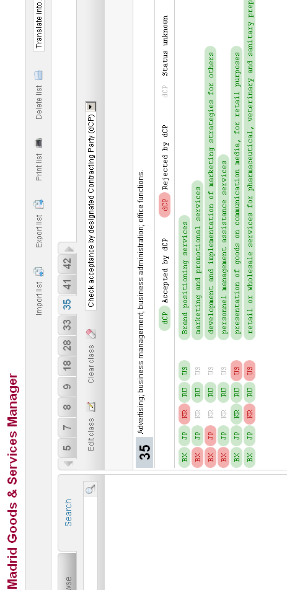

[Annex II follows]

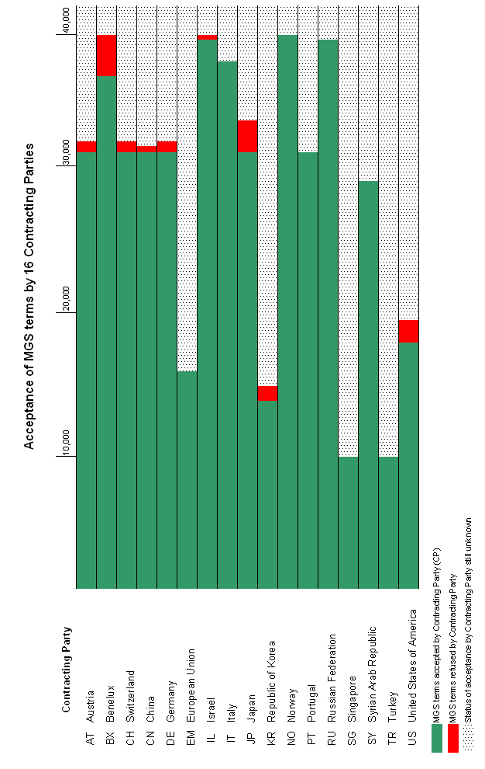

[Annex III follows]

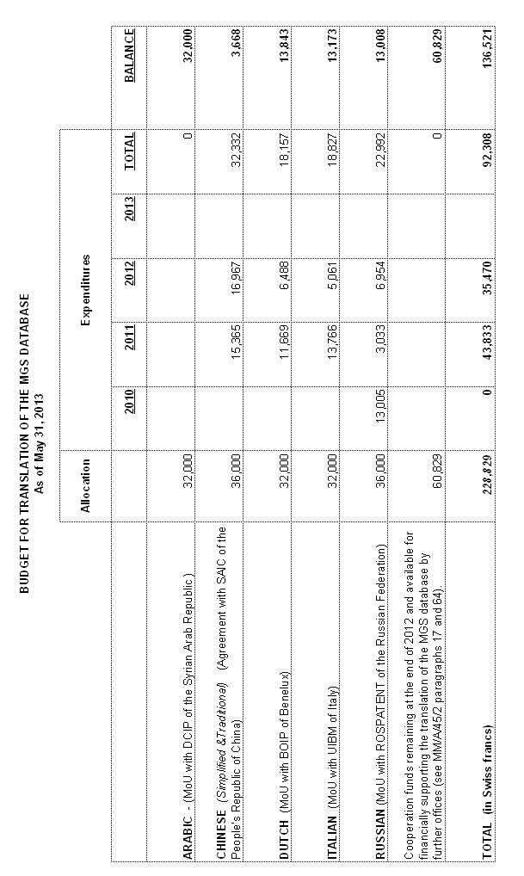

[Annex IV follows]

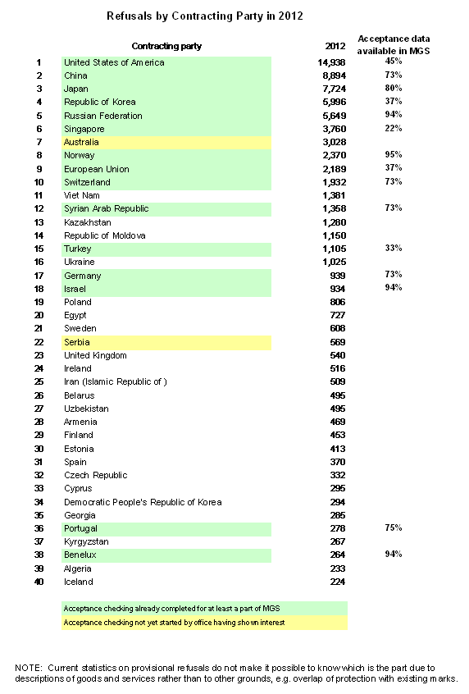

[End of Annex IV and of document]

