 |  | E
mm/a/45/2
ORIGINAL: English
DATE: July 2, 2012

Special Union for the International Registration of Marks
(Madrid Union)

Assembly

Forty-Fifth (26th Extraordinary) Session
Geneva, October 1 to 9, 2012

MADRID SYSTEM GOODS AND SERVICES DATABASE: PROGRESS REPORT

prepared by the International Bureau

INTRODUCTION

- The purpose of this document is to present a progress report on the development of the database of acceptable indications of goods and services for the purposes of the Madrid system procedures (hereinafter referred to as the “Madrid System Goods and Services Database” or “G&S Database”).

- In September 2009, the Assembly of the Madrid Union approved a two-year project aimed at accelerating the pace of the construction of the G&S Database, as described in document MM/A/42/3, and an amount of 1.2 million Swiss francs was allocated from the Madrid Union Reserve Fund for its implementation in the course of the biennium 2010-2011
(see document MM/A/42/4, paragraph 28). It is recalled that a first progress report on the implementation of the G&S Database was presented to the Assembly of the Madrid Union in 2010 (see document MM/A/43/2) and that a second progress report recording the progress made up to June 30, 2011, was presented to the Madrid Assembly in 2011 (see document MM/A/44/2).

- The present document reports on the progress of the G&S Database since the last report was made in June 2011 and especially on the deliverables achieved by the end of the two-year project on December 31, 2011.

- This document presents the transition of the project infrastructure into the operational mode, a process that took place in January 2012 and entailed that operation of the G&S Database was funded from the World Intellectual Property Organization’s (WIPO) regular budget.

- A further purpose of this document is to present the development of new functionalities in the Goods & Services Manager (G&S Manager), the web-based classification tool associated with the G&S Database, that will best meet the needs of all direct beneficiaries of the
G&S Database, most notably the display of information stored in the G&S Database and relating to the acceptance status of goods or services by Contracting Parties, with a view to reducing the number of provisional refusals dealt with in the Madrid system community.

- Finally, this document addresses the issue of the gradual enhancement of the linguistic diversity of the database with a view to promoting its use both for national filing and international filing. In 2011, the Assembly of the Madrid Union approved the use of the remaining project funds, beyond project close-out, in order to finalize the implementation of cooperation agreements established with Offices of interested Madrid Union members for the purposes of making the G&S Database available in the languages included in the pilot project relating to the feasibility of introducing additional languages in the Madrid system (see document MM/A/44/5, paragraph 48). This year, the Assembly of the Madrid Union will be requested to approve the use of unspent funds from those countries that have declined the offer of financial support, for assisting other offices whose languages were not originally selected (see document MM/A/42/1, paragraph 7) but which are important in terms of volume of international filings.

BACKGROUND AND ORIGINAL SCOPE

THE MADRID SYSTEM GOODS AND SERVICES DATABASE (PURPOSE, STRUCTURE AND SOURCES)

- The G&S Database is a WIPO administered database of indications of goods and services established for the purposes of the international registration of marks. Its purpose, structure and initial data sources have been described in details in preceding reports
(see document MM/A/43/2, paragraphs 4 to 13 and document MM/A/44/3, paragraphs 7 to15).

- The G&S Database contains indications of goods and services grouped by concepts regrouping synonyms describing a single good or service. It should be stressed here that the structuring of the G&S Database in concepts had two purposes:

– avoid the creation of duplicates in translation, when several synonymous wordings can only be translated in the same way in a given language;

– require less translation effort from national offices since only one translation is required per concept.

- Also, for a better understanding of the present document, it should be recalled that:

– it has always been an objective for the G&S Database to contain information on the acceptability of those indications by the Offices of Madrid Union members that may be designated in an international application (see document MM/A/42/3,
paragraph 20, document MM/A/43/2, paragraphs 51 and 52 and
document MM/A/44/3, paragraphs 46 to 49);

– in the project initiation document (see document MM/A/42/3), it had been envisaged that WIPO would provide financial support for the translation of the G&S Database into any of the languages qualifying for participation in Phase I of the pilot project to study the implications of a possible introduction of additional languages in the Madrid system, namely Arabic, Chinese, Dutch, German, Italian, Japanese, Portuguese and Russian (see document MM/A/42/1, paragraph 7).

STATUS After PROJECT CLOSE-OUT

PROJECT DELIVERABLES

- The deliverables expected from the implementation of the G&S Database project validated by the 2009 Assembly of the Madrid Union (see document MM/A/42/3, paragraph 30) were successfully completed over the two years of the project. In order to complement the information given in the 2011 progress report (see document MM/A/44/3) that took stock of the development as of June 30, 2011, it should be noted that the following results were delivered as planned before the end of 2011:

– in December 2011, the G&S Database contained 40,000 English indications of goods and services, validated by the International Bureau of WIPO and grouped in a number of concepts that were all associated with their respective French and Spanish translations and were accessible through a new version of the
G&S Manager on January 1, 2012;

– the new version of the G&S Manager launched on January 1, 2012, on the WIPO public web site also provided a number of web services giving access to the main functionalities of the G&S Database (Extract Nice class headings, Search, Check WIPO Acceptance and Translate) to Offices of Madrid Union members interested in incorporating such web services into their own electronic filing system, these web services also enabling further development of the electronic filing application developed within the IRPI (International Registration Process Integration) pilot project, which is part of Phase I of the MAPS Modernization project in the
Brands and Designs Sector;

– in January 2012, the G&S Database had been fully translated into most of the languages included in the pilot project on the study of the possible introduction of additional languages in the Madrid system, namely Arabic, Dutch, German, Italian, Portuguese and Russian. The Chinese version was then about to be completed and in early 2012 the Japanese Office provided WIPO with a draft version of the full
G&S database in Japanese still requiring finalization. Therefore, six versions of the G&S Database, together with a Hebrew version, were made available through language-specific interfaces of the G&S Manager, along with the three Madrid working languages.

- In addition to the expected project deliverables, the G&S Database was adapted to the tenth edition (NCL10) of the International Classification of Goods and Services for the Purposes of the Registration of Marks (Nice Classification), which entered into force on January 1, 2012:

– some five hundred NCL10 amendments (additions and modifications) to the
Nice alphabetical list were translated into Spanish by the G&S Database team and these translations were proposed to all Spanish-speaking offices for validation;

– cooperation was established with the 11 Offices which had previously provided a translation of the ninth edition of the Nice alphabetical list, namely the offices having provided a translation in Arabic, Chinese, Dutch, German, Hebrew, Italian, Japanese, Korean, Norwegian, Portuguese and Russian, so that the alphabetical list could be adapted in all of these languages;

– the G&S Database was reviewed so as to be compliant with the
NCL10 amendments to ensure that all indications classified by analogy with those Nice indications that were transferred from one class to another were also moved to the new class to avoid any misclassification in the G&S Manager from
January 1, 2012, when the tenth edition of the Nice Classification entered into force. For example, “electric hair rollers” was moved from class 9 to class 26 by analogy with the Nice indication “hair curlers, other than hand implements”
(basic number 260127) that was reworded and transferred from class 9 to class 26; and

– additional information was stored in the G&S Database during the review so that all indications were flagged as being either acceptable only under the ninth edition or only under the 10th edition or under both editions, with a view to providing the Madrid Registry Operations Service at WIPO with data enabling proper examination of trademark applications filed before and after January 1, 2012.

BUDGET
- In 2009, the Madrid Union approved a budget of 1.2 million Swiss francs from the Madrid Union Reserve Fund for the implementation of the project aimed at accelerating the pace of construction of the G&S Database (see document MM/A/42/4, paragraph 28). It further took note that the International Bureau of WIPO would assign additional resources to the project, financed from WIPO’s regular budget, in particular experienced staff in the areas of project management, trademark classification, translation and administrative support.

- Annex I provides a summary of budget allocations and expenditures after project close-out and as of May 31, 2012. It is recalled that in September 2011, the Assembly of the Madrid Union approved the use of project funds beyond project close-out, in order to finalize the implementation of cooperation agreements established with interested members of the Madrid Union for the purposes of making the G&S Database available in the languages included in the pilot project relating to the feasibility of introducing additional languages in the Madrid system (see document MM/A/44/5, paragraph 48). Consequently, a total of 175,162 Swiss francs
(CHF232,000, minus CHF13,005, minus CHF43,833) remaining at the end of 2011 was made available for the payment of translation outsourcing from January 1, 2012. Given the payments honored in 2012, the remaining balance available for translation outsourcing as of June 1, 2012, is 142,523 Swiss francs.

- A negative balance of 3,171 Swiss francs resulted from the part of the initial budget allocated for staff and missions expenditures (968,000 Swiss francs).

- It is recalled that the eight languages eligible to share the financial support provided by WIPO were those that had been selected in the “Study on the Introduction of Additional Filing languages in the Madrid system” (see document MM/A/42/1, paragraph 7).

- The Portuguese Office committed itself at the onset of the project to provide a translation of the G&S Database without any financial support from WIPO. Among the seven other languages selected (Arabic, Chinese, Dutch, German, Italian, Japanese and Russian), those for which a translation of the Nice alphabetical list was already available were allocated an amount

of 32,000 Swiss francs (Arabic, Dutch, German, Italian and Japanese); the two others for which translation of the Nice alphabetical list was not available (Chinese and Russian) were allocated an amount of 36,000 Swiss francs under the agreement that a lump sum of 4,000 Swiss francs would be paid for the translation of the whole Nice alphabetical list.

- The amount of available funds remaining for each of the seven above-mentioned languages as of June 1, 2012, is shown in Annex I. It should be noted here that the
Japan Patent Office (JPO) and the German Office (DPMA) declined the financial support offered by WIPO amounting to 64,000 Swiss francs for both Offices. Consequently, and taking into account the negative balance of the staff and missions expenditures, an amount of 60,829 Swiss francs (CHF64,000, minus CHF3,171) remains available for cooperation with other offices for the purpose of translation of the G&S Database.

TRANSITION INTO OPERATIONAL MODE

- After project close-out, project staff on short-term contracts (two translators and one
Information Technology (IT) consultant) were released and WIPO staff (four translators) from the Madrid Registry returned to their previous roles, leaving a reduced human resource allocation for further development of the G&S Database (and the G&S Manager), as well as for the day-to-day administration of the database.

- In addition to a management capability, two classification experts (funded from
WIPO regular budget) and one IT consultant (funded from the IT Modernization Program) were retained in the G&S Database team, with the understanding that extra translation support would be provided by the translation units of the Madrid Registry according to needs on the
G&S Database side and availability on the operational side, as work volumes dictate.

- The principal aim of entering the operational mode was to fund future operation and development of the G&S Database and G&S Manager from the approved budget of Program 6 under the regular budget (biennium 2012/2013).

- Work carried out in operational mode should enable the consolidation of the two-year project deliverables and especially focus on:

– developing the functionality related to the checking of acceptance by
Contracting Parties designated in an international application, as envisaged from the onset of the G&S Database project in 2009 (see document MM/A/42/3,
paragraph 20) and confirmed over time in 2010 and 2011
(see document MM/A/43/2, paragraphs 51 and 52 and document MM/A/44/3, paragraphs 46 to 49);

– periodically introducing new relevant indications, as well as translations of new indications in close coordination with concerned offices;

– integrating indications from national sources into the G&S Database so as to encourage use of the G&S Manager by trademark applicants for the benefit of both national offices and the International Bureau of WIPO;

– increasing the linguistic diversity by developing new language versions of the
G&S Database through further cooperation with interested offices, upon request;

– assessing the usage of the system through the establishment of system utilization benchmark data and subsequent monitoring of system usage against those benchmarks.

Relationship between the G&S Manager and the Nice Classification

- The revision of indications from the Nice Classification alphabetical list during the process of populating the G&S Manager Database generated a long list of proposed error corrections and improvements to English/French term pairs. The list was submitted to the Committee of
Experts in 2010 and led to numerous enhancements which have been included in the tenth edition that came into force on January 1, 2012.

- A thorough and exhaustive review of the Nice alphabetical list was initiated at the end of 2010 within the G&S Manager project team with a view to correcting inconsistencies between English and French indications (for example, 010351 “petroleum dispersants” / “agents pour détruire le pétrole”), replacing archaic terms (e.g. 010131 “wood alcohol” to be replaced by “methanol”), adding American spelling where appropriate (e.g. 010094: “nitrogenous fertilizers” to be added to “nitrogenous fertilisers”), and so on. Reports produced in the course of this review were submitted to the International Classifications and WIPO Standards Service in order to be proposed for consideration by the Nice Committee of Experts. This review was suspended due to the re-allocation of staff after project close-out.

- The creation of the G&S Database has made it possible to produce a Nice alphabetical list in “database format” with no inversions of the kind required on a hard copy (such as
“Agriculture (Manure for -)”) and no duplications, i.e. no identical indications with two different basic numbers (such as 110062 “Roasters (Coffee-)” and 110066 “Coffee roasters”). The trilingual (English, French, Spanish) list in database format is used as the basis for compiling quadrilingual lists that could be used for the officialization of Nice in various languages.

- A compilation of Nice indications that are rejected by a number of offices could be used to identify a set of terms likely to trigger numerous refusals. The Nice Committee of Experts could then examine these terms and could opt to delete them from the alphabetical list.

- A compilation of duplicate entries arising from translation into a range of languages could be used to identify Nice indications that have different basic numbers but cover the same goods or services and do not warrant differentiation (for example, 120005 is “air vehicles” and 120184 is “aircraft”).

- In future, the extraction of indications which are most frequently used in international applications and included in the G&S Database could provide new descriptions of goods and services to be proposed for integration into the Nice alphabetical list in order to further develop the Nice Classification in line with applicant behavior.

LANGUAGES

- For all the following languages a translation of the ninth edition of the Nice alphabetical list was prepared in 2010-2011 in cooperation with the concerned office(s) and was integrated into the G&S Database: Arabic, Chinese, Dutch, German, Hebrew, Italian, Japanese, Korean, Norwegian, Portuguese and Russian.

AVAILABILITY OF LANGUAGES FOR PUBLIC LAUNCH ON JANUARY 1, 2012

- On January 1, 2012, when the tenth edition of the Nice Classification entered into force, a new version of the G&S Database, reviewed so as to be in accordance with the modifications for this new edition, was published on the WIPO public site with the volume of data

(40,000 English indications) that was expected to be delivered at the end of the two-year project. Around 25,000 concepts were published in the three Madrid working languages and included:

– around 40,000 English indications,
– around 33,000 French indications,
– around 32,500 Spanish indications.

- By the end of December 2011, the tenth edition of the Nice Classification (class headings and alphabetical list including 7,889 Nice concepts) was available in most languages for which a version of the ninth edition had previously been provided to WIPO, which means that the translations of the modifications to the tenth edition had also been completed. These languages were: Arabic, Dutch, German, Hebrew, Italian, Norwegian, Portuguese and Russian.

- Annex II shows that among all languages for which cooperation had started in 2010 or 2011, seven non-Madrid languages were available for online publication on January 1, 2012, taking into account that, besides the availability of the tenth edition of the Nice Classification, the publication also required in each language:

– the translation of the initial volume of the G&S Database as launched on December 20, 2010, and provided to offices in 2011 (the “2011-batch” including 11,299 “non-Nice” concepts each requiring at least one translation);

– the translation and preparation of the G&S Manager interface (screen text, Disclaimer, FAQ and Help modules).

- Consequently on January 1, 2012, the G&S Manager was launched in a total of ten language versions, including the three Madrid working languages (Annex II also shows the number of terms that were made available to users in each published language on
January 1, 2012):

– Arabic,
– Dutch,
– English,
– French,
– German,
– Hebrew,
– Italian,
– Portuguese,
– Russian,
– Spanish.

STATUS OF LANGUAGE AVAILABILITY ON MAY 31, 2012

- At the end of May 2012, the Chinese version of the G&S Database was fully ready and about to be extensively tested by the Chinese Office before an official launch on the WIPO public site. It should be mentioned that the Chinese Office provided the International Bureau of WIPO with the G&S Database in two versions of the Chinese language, one version in simplified characters and one in traditional characters, for the benefit of the various Chinese communities:

– simplified Chinese characters are standardized Chinese characters officially used in China and Singapore;

– traditional Chinese characters are used in Hong Kong, China, Macao, China, and in many overseas Chinese communities.

- In the first months of 2012, all offices that had cooperated with the International Bureau of WIPO so that their national language could be online on January 1, 2012, received a batch of new “non-Nice” concepts for translation: the “2012-complement” batch including
6,123 concepts.

- At the end of May 2012, the status of availability in all languages for which cooperation had started was as shown in Annex III:

– simplified Chinese: Nice-10 and 2011-batch completed;
– traditional Chinese: Nice-10 and 2011-batch completed;
– Dutch: Nice-10 and 2011-batch completed; 2012-complement batch under way;
– German: Nice-10 and 2011-batch completed; 2012-complement batch under way;
– Hebrew: Nice-10 and 2011-batch completed; 2012-complement batch under way;
– Italian: Nice-10 and 2011-batch completed; 2012-complement batch under way;
– Japanese: Nice-10 completed; provisional translations received for 2011-batch;
– Korean: Nice-10 not completed;
– Norwegian: Nice-10 completed; translation of 2012-full batch under way;
– Portuguese: Nice-10 and 2011-batch completed; 2012-complement batch under way;
– Russian: Nice-10 and 2011-batch completed; 2012-complement batch under way;
– Turkish: Nice-10 under way.

- Annex IV contains the list of the major filing Contracting Parties in the Madrid system and displays in particular statistics on Offices of origin by decreasing number of international applications recorded in 2011. This list of the major filing countries shows that the languages currently in the G&S Database, or under preparation, cover the needs of all but two top
20 Offices of origin. It should be noted that among the top 20 filing offices, four have started cooperation with the International Bureau of WIPO, or expressed their interest in participating in the G&S Database project, but are still far from completion (namely, Norway, Republic of Korea, Turkey and Ukraine).

- Consequently, given that an amount of 60,829 Swiss francs remains available as cooperation funds (see paragraph 17, above), a redistribution of these funds can be envisaged to help those Offices, at least amongst the four above-mentioned Offices (Norway, Republic of Korea, Turkey and Ukraine), that may request financial support to accelerate the completion of the translation of the G&S Database. The 2012 Madrid Union Assembly will be invited to approve such redistribution of available cooperation funds.

- Taking into account that before the end of 2012 the G&S Database may be available in some 13 languages in addition to the three Madrid filing languages, as shown in Annex III, and given the current economic climate, it seems appropriate to propose the postponement of the study on the introduction of additional filing languages in the Madrid system and instead focus on the enhancement of the linguistic diversity in the G&S Database and on the integration of relevant Contracting Party data.

- Finally, following the request of many offices and trademark representatives, the translation functionality of the G&S Manager will be extended in 2012 so as to offer the possibility to translate a list of goods and services not only from any language into one of the three Madrid filing languages, but also from any language into any other language available in the G&S Manager. Thus, an English-speaking company, for example, settled in Israel or in the
Russian Federation, will have the possibility to compile a list of goods and services in English and to translate it into Hebrew or Russian for national filing purposes, which will then make it easier to file internationally on the basis of the national application.

Areas of Cooperation with the Offices of Contracting Parties

- Possible areas of cooperation with the Offices of the Madrid Union members were first identified in the 2009 project initiating document (see document MM/A/42/3,
paragraphs 14 to 20) and further developed in the report to the 2010 Madrid Assembly
(see document MM/A/43/2, paragraphs 48 to 52) and in the report to the 2011 Madrid Assembly (see document MM/A/44/3, paragraphs 46 to 54). Implementation of the project has confirmed the importance of a continued cooperation between the Offices of Contracting Parties of the Madrid system and WIPO after project close-out.

COOPERATION IN CHECKING THE ACCEPTANCE OF THE CONTENTS OF THE G&S DATABASE BY DESIGNATED CONTRACTING PARTIES

- For trademark applicants using the Madrid system, it is useful to know whether a given indication will be accepted by the International Bureau of WIPO. But it is even more important for them to know whether that indication will also be accepted by each of the Contracting Parties designated in the international application, so as to diminish the risk of notifications of refusals. Consequently, in order to ensure that the G&S Database offers maximum benefits for users, it is important to make sure that the G&S Database can also provide as much information as possible on the acceptance of the indications it contains by designated Contracting Parties.

- Although increased use of the G&S Database will undoubtedly bring about a strong degree of harmonization, it is unlikely to achieve full harmonization of national policies at a global level in the near future. This idea has been formalized in the Memorandum of Understanding (MoU) signed by the Office for Harmonization in the Internal Market (Trade Marks and Designs) (OHIM) and WIPO in December 2009, whereby a long-term goal shared by the two Organizations was that “OHIM supports WIPO piloting a global database initiative among its members to establish a database of classified indications of goods and services that can be accepted by as many offices as possible”. This obviously implies that, in the management of the G&S Database as such a global database, WIPO bears the responsibility of dealing with the indications of goods and services that cannot be accepted by all offices.

- In order to store relevant data on the status of acceptance by Contracting Parties of the Madrid system in the G&S Database, WIPO has made it possible for national offices that agreed to translate the database into their national languages to include their acceptance information alongside their translations. Some offices (e.g. the Offices of Benelux, China, Israel, Japan, Republic of Korea and Singapore) have already provided WIPO with status information indicating the non-acceptance of indications from the G&S Database and even, for some of them, from the Nice alphabetical list.

- Annex V displays statistics about offices as designated Contracting Parties (dCP) listed by decreasing number of designations in international registrations and subsequent designations recorded in 2011. It should be noted that many of the top 20 most designated Contracting Parties have already provided WIPO with their acceptance and rejection data, or will do so in the near future, through the cooperation established for the translation of the G&S Database. However, this list highlights the need for WIPO to set up cooperation with at least the Offices of Australia, Ukraine and the United States of America, to make very useful information available to trademark applicants on the risks of notification of refusals by the most designated Contracting Parties.

- Any other office in this ranked list of designated Contracting Parties would be welcome to request cooperation with WIPO with a view to checking their acceptance of the contents of the G&S Database and thereby reduce the number of provisional refusals they would have to notify.
DISPLAY OF ACCEPTANCE STATUS BY DESIGNATED CONTRACTING PARTIES IN THE G&S MANAGER

- Annex VI shows a prototype version of the G&S Manager with the screens of a new function “Check Acceptance by designated Contracting Party (dCP)”, where acceptance status will be displayed for a list of goods and services selected from the G&S Database and therefore accepted by the International Bureau of WIPO.

- With this new function “Check Acceptance by dCP”, the user will be given the possibility to select the countries he wishes to designate among all those participating in the G&S Manager. Then, for each term of the list of goods and services, the acceptance status relative to a designated Contracting Party will be displayed in three different colors applied to each country icon:

– green: Accepted by the dCP
– red: Rejected by the dCP
– orange: Not known (acceptance not yet checked by the dCP).

- Concerning cooperation to be established with a view to checking the acceptance of indications in the G&S Database, it is important to stress that, especially for all offices not required to translate the G&S Database into their national language, cooperation could be envisaged with interested offices at a pace that would suit their internal organization and availability of resources. Indeed, the way the acceptance status will be displayed with three colors in the function “Check Acceptance by dCP” will enable a progressive integration of information. For as long as a participating country has not fully checked the G&S Database content, the un-reviewed terms will remain displayed in orange, thus indicating to users of the G&S Manager that the concerned Contracting Party has not yet checked its acceptance of these terms.

COOPERATION IN THE IDENTIFICATION OF INDICATIONS TO BE INCLUDED IN THE DATABASE

- In addition to the full list of indications from the Alphabetical List of Goods and Services of the Nice Classification, the G&S Database contains indications drawn from other sources, including lists of indications of goods and services made available to the International Bureau of WIPO by the Offices of certain Madrid Union members, such as the Acceptable Identification of Goods and Services Manual provided by the United States Patent and Trademark Office (USPTO) and the Trilateral list of goods and services validated by the JPO, the USPTO and OHIM.

- During project implementation, other Offices of Madrid Union members have shared or promised to share with the International Bureau of WIPO their national lists of goods and services for inclusion in the G&S Database, on the basis that these lists are made available together with their translations into one of the three Madrid working languages. In particular:

- the Office of China has provided a list of some 2,000 Chinese specific indications;

- the Offices of Germany and Switzerland have provided a list of some 1,200 German specific indications;

- the Office of Japan could provide a list of several thousand Japanese specific indications;

- the Office of Turkey will provide WIPO with a list of a few hundred terms that compose the list of goods and services managed by the Turkish Office and used extensively by Turkish trademark applicants; and

- the Office of the Republic of Korea started the translation into English of some
7,000 Korean specific indications in 2011.

- Any national list of goods and services made available to the International Bureau of WIPO will be subject to meticulous scrutiny before being accepted, one term at a time, for inclusion in the G&S Database, either as a new concept or as part of an existing concept.

- All indications of goods and services stemming from national lists and accepted by the International Bureau of WIPO will be made available in the three Madrid working languages in the G&S Manager and at least in the national language of the office having provided the data.

- The inclusion of these national lists will make the G&S Manager even more attractive to trademark applicants in the associated Madrid Union members, both for national and international filings, thus producing ever greater benefits for Offices of Madrid Union members and the International Bureau of WIPO.

G&S Manager Usage Statistics

- In 2012, the number of visits to the G&S Manager grew rapidly after January 1, when the tool was made available on the WIPO public site in an updated version aligned with the
tenth edition of the Nice Classification and featuring 10 language interfaces (English, French and Spanish, as well as Arabic, Dutch, German, Hebrew, Italian, Portuguese and Russian). The number of visits grew even more after the new version of the G&S Manager was advertised with a Madrid Information Notice around mid-March, after modifications sent by various offices were integrated into the G&S Database. The following results were then recorded:

– some 2,000 visits per week, i.e. a 100% increase in comparison to 2011;

– visitors were still located in over 140 different countries;

– as shown in Annex VII, the top 10 countries with the highest number of visits remain more or less the same as last year but in a different ranking order: the Russian Federation, France, the Netherlands, Singapore, Japan, Belarus, Ukraine, Italy, Germany and Switzerland;

– as also shown in Annex VII, many countries that are not yet members of the
Madrid system or are about to adhere to the Madrid Protocol are found in the top 50 visiting countries (e.g. Chile, Peru, Argentina, India, Costa Rica, Brazil, Indonesia, New Zealand), thus indicating the interest of applicants and offices outside the Madrid system.

FUTURE DEVELOPMENTS

- From the preceding text of this document, it is clear that the following developments have to be carried out by WIPO in order to best meet the needs of all direct beneficiaries of the
G&S Database, i.e. of trademark applicants, the national offices and the
International Bureau of WIPO:

– implementing new language versions of the G&S Manager;

– making it possible to translate into any language available in the G&S Manager;

– exporting lists of goods and services directly to the MM international application forms;

– integrating lists of goods and services from national sources into the G&S Database;

– checking the acceptance of WIPO-accepted terms by cooperating Contracting Parties of the Madrid system;

– updating the G&S Database in line with future new versions or editions of the International (Nice) Classification;

– further developing the web services along with the new functionalities of the
G&S Manager.

- The implementation of new language versions in the G&S Manager will depend on the pace of translation of the G&S Database by national offices that have started cooperation with WIPO in this regard or expressed a strong interest in translating the G&S Database in their national language but have not yet been able to start:

– a simplified Chinese interface and a traditional Chinese interface will be tested by the State Administration for Industry and Commerce of the People’s Republic of China (SAIC) as of mid-2012 and should be made available for public access in the course of 2012;

– a Japanese interface should be made available for public access before the end of 2012 given that a finalized translation and validation of the G&S Database is due to be completed in September 2012 by the JPO;

– a Norwegian interface should be made available before the end of 2012 following completion of translation by the Norwegian Industrial Property Office (NIPO) expected in the second half of the year;

– a Turkish interface should be made available before the end of 2012 following completion of translation by the Turkish Patent Institute (TPI) expected in the second half of the year;

– other language versions, such as versions in Korean and Ukrainian, should also be given priority among all possible new languages in view of their high position in the list of the major international filing countries.

- As previously mentioned in paragraph 39, the translation functionality in the G&S Manager will be extended in 2012 so as to offer trademark applicants the possibility to translate a list of goods and services not only from any language into one of the three Madrid filing languages for the purpose of an international application, but also from any language into any other language available in the G&S Manager.

- The “Export” function available in the G&S Manager currently enables users to save a list of goods and services in a text file with a view to “importing” it at a later date so that they could continue working on their list until finalization. This “Export” function will be extended with a possibility to directly integrate a finalized list of goods and services into a MM form (Item 10) required for the international registration of a mark.

- As previously mentioned in paragraph 50, lists of goods and services specific to certain countries have already been provided to WIPO by national offices for inclusion into the G&S Database because of their importance for national trademark applicants. These lists will be meticulously reviewed by the International Bureau of WIPO before integration into the
G&S Database.

- Every year, starting from January 1, 2013, a new version of the Nice Classification will introduce new amendments to the Nice alphabetical list such as additions, modifications and deletions, which will require alignment of the G&S Database. Every five years, a new edition of the Nice Classification will come into force and will possibly bring about class transfers to deal with in the G&S Database.

- Last, but not least, among the future developments listed in paragraph 55, the new function “Check acceptance by dCP” will be added to the G&S Manager, as described in paragraphs 46 to 48. With this function, information will be provided to users about the rejection status by some Contracting Parties they designate, which will help to reduce the number of notifications of provisional refusals.

- The above-mentioned developments will have a direct influence on the content of the G&S Database and on the functionalities available to users in the G&S Manager. Consequently, they should produce a further increase in the use of the G&S Manager, thereby resulting in ever greater benefits over time for both the national offices and the
International Bureau of WIPO.

- Other IT-related developments will also have to be implemented in 2012 and 2013.
They include:

– the finalization of the back-office application designed for the internal management of the G&S Database;

– the creation of an update flow to enable smooth and coordinated maintenance and evolution of the G&S Database; and

– the implementation of a usage monitoring system.

64. The Assembly is invited to:
(i) take note of the progress made in the implementation of the Madrid System Goods and Services Database, as described in this document, as of May 31, 2012;
(ii) approve the use of the remaining cooperation funds (see paragraph 37 of the present document), in order to financially help some offices to finalize the translation of the G&S Database for the purposes of making it available in languages not included in the pilot project relating to the feasibility of introducing additional languages in the Madrid system;

(iii) approve the postponement of the study on the introduction of additional filing languages in the Madrid system (see paragraph 38 of the present document) and instead support the efforts of the International Bureau of WIPO in further increasing the relevancy and linguistic diversity of the G&S Database; and
(iv) request the International Bureau of WIPO to report to the Assembly in 2013 on the operational status of the implementation of the G&S Database.

[Annexes follow]

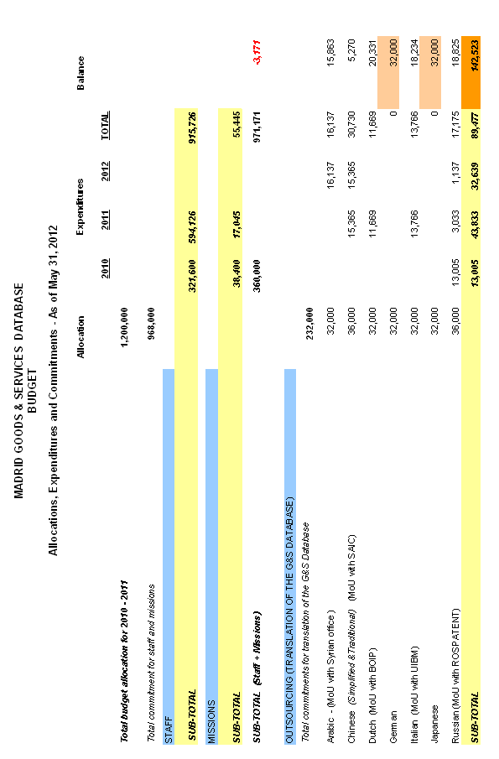

[Annex II follows]

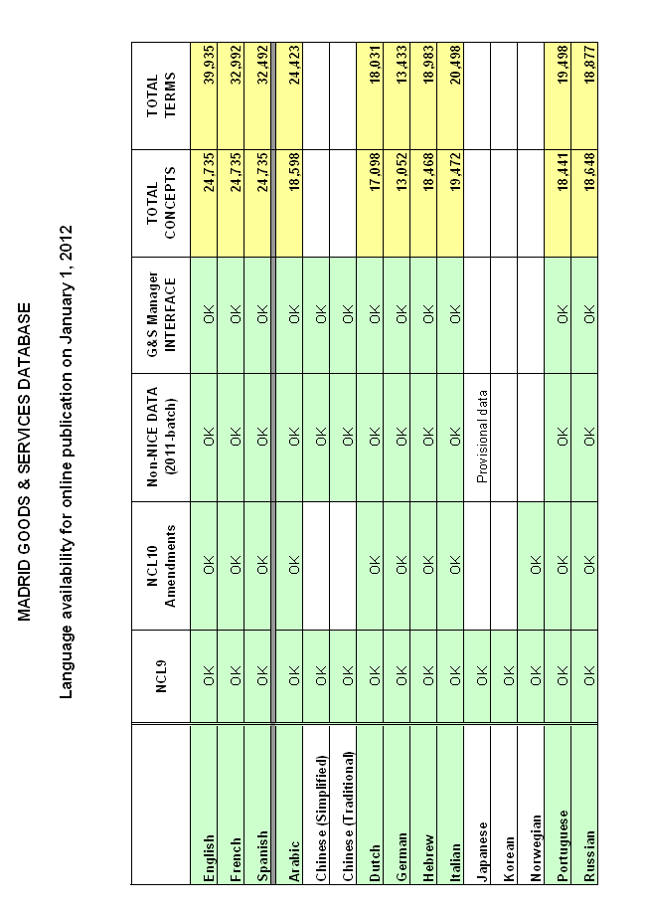

[Annex III follows]

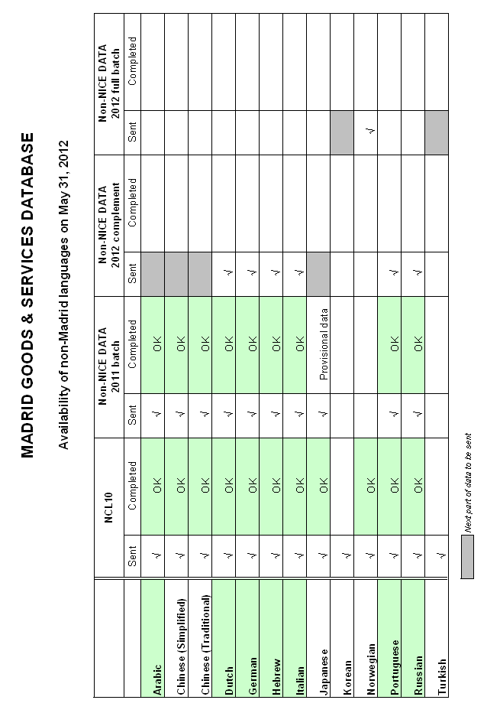

[Annex IV follows]

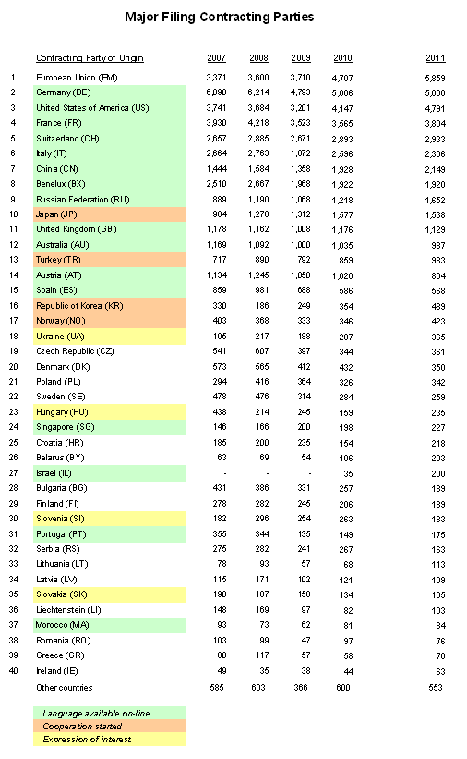

[Annex V follows]

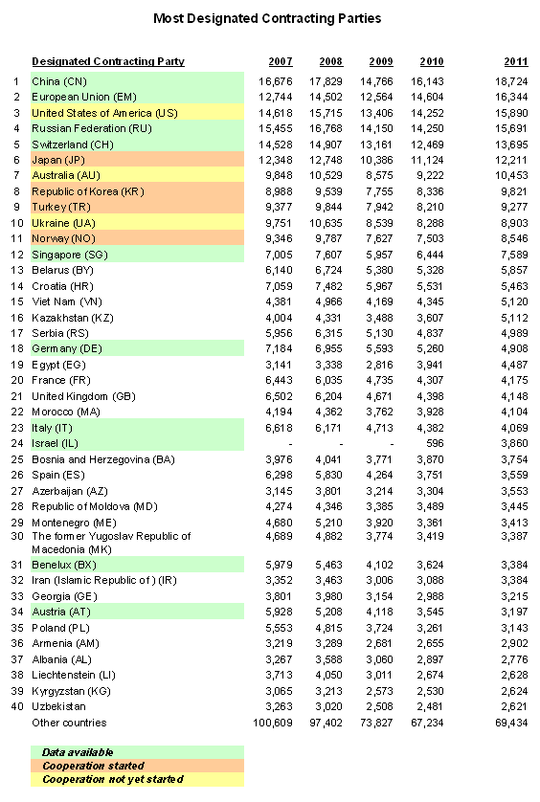

[Annex VI follows]
GOODS & SERVICES MANAGER

Prototype showing function “Check acceptance by dCP”

Screen 1

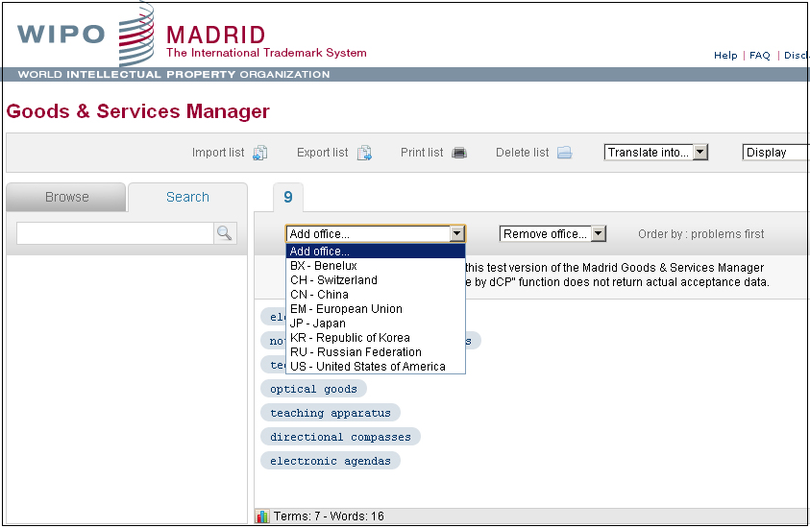

Screen 2

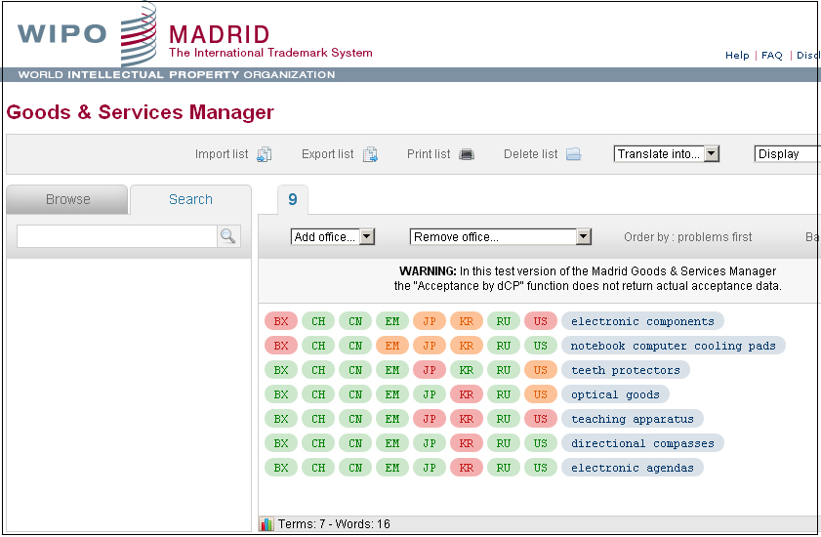

[Annex VII follows]

GOODS & SERVICES MANAGER

Number of visits in April-May 2012

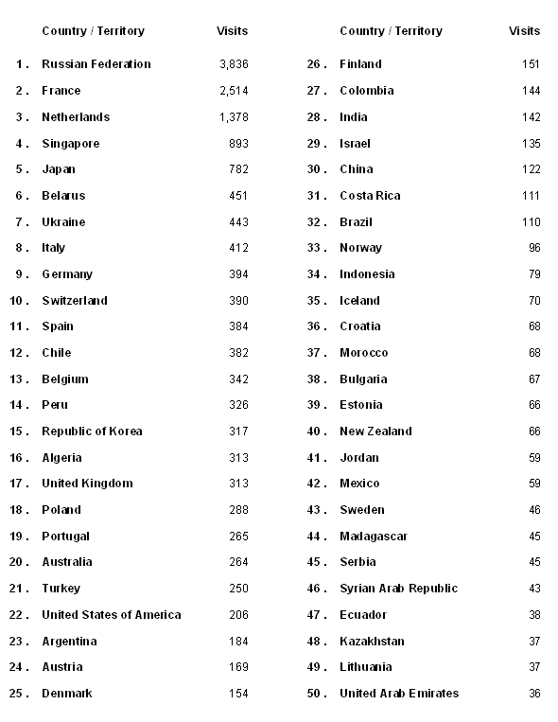

[End of Annex VII and of document]

