WIPO |  | E  MM/A/40/3  ORIGINAL: English  DATE: August 15, 2008
WORLD INTELLECTUAL PROPERTY ORGANIZATION
GENEVA
SPECIAL UNION FOR THE INTERNATIONAL REGISTRATION OF MARKS
(MADRID UNION)
ASSEMBLY
Fortieth (23rd Extraordinary) Session
Geneva, September 22 to 30, 2008
INFORMATION TECHNOLOGY MODERNIZATION Program:
status report
prepared by the International Bureau

I. INTRODUCTION

1 The Assemblies of the Madrid Union and the Hague Union, at their ordinary sessions held in Geneva in 2007, approved the initiation in 2008 of the Information Technology Modernization Program under the Madrid and Hague Systems, as had been proposed by the International Bureau in documents MM/A/38/4 and H/A/24/2.

2 The IT Modernization Program described in those documents comprises three categories of sub-projects (internal operation, external communication and governance and technical), as summarized in Annex I, below, to be implemented in three phases, over a period of four years (2008-2011), for a total estimated cost of some 15.3 million Swiss francs. In 2007, the Assemblies approved the implementation of Phase I of the program against an estimated investment cost of 5.028 million Swiss francs, to be financed as follows:

– 2.9 million Swiss francs from programs 18 (1 million) and 27 (1.9 million) under the Program and Budget for 2008/09;
– 2.128 million Swiss francs from the surplus generated by the Madrid Union budget by the end of 2007.

3 Phase I of the IT Modernization Program in 2008/09 should allow the implementation of the projects indicated in Annex II and would be financed from the Madrid Union budget for an amount of an estimated 4.569 million Swiss francs and from the Hague Union budget for an amount of an estimated 459 thousand Swiss francs. The proposed participation by the Hague Union budget relates to Project C4 – which, unlike the other projects of Phase I, will result in a direct benefit for the Hague Union, as it will reduce the DMAPS operational costs borne by the budget of that Union. This participation of the Hague Union budget in the financing of Phase I is included within the 1.9 million Swiss francs financed from Program 27.

4 The Madrid Union Assembly further approved that any amount of the above-mentioned surplus exceeding the amount necessary to reach the target level of reserves (25 per cent of the estimated biennial expenditure in the 2008/09 biennium (PBE factor)) be kept within the Madrid Union Reserve and Working Capital Funds with a view to contributing to the financing of subsequent stages of the IT Modernization Program. By December 31, 2007, the budget of the Madrid Union in 2006/07 had generated a surplus of 24.7 million Swiss francs, bringing the total level of reserves under the Madrid Union Reserve Fund to an amount of 39.773 million Swiss francs.

II. ORGANIZATION AND GOVERNANCE OF THE MODERNIZATION PROGRAM

5 Following the Assembly decisions, the International Bureau initiated the IT Modernization Program by setting up, in January 2008, a Project Board for the purpose of monitoring the program’s implementation and achieving the smoothest possible delivery in terms of efficiency and timing. The Project Board, chaired by an Executive Sponsor, meets once a month and comprises key staff from the business areas involved as well as those responsible with regard to technical or financial questions.
6 Furthermore, a Project Manager, heading a Project Team of three staff members, was appointed for the day-to-day execution of the modernization program. This team was reinforced with three consultants – for the duration of the project – as it was considered preferable to involve members of the current MAPS/DMAPS IT Support Team as much as possible, so as to allow them to continue to be engaged in ongoing maintenance as well as to assist in the development of the modernization program, thus exploiting their significant business knowledge base at a maximum. An administrative assistant was added to the Project Team for the necessary support in respect of the administration of the Program as a whole.

7 Moreover, for the high priority projects indicated in the next section of the present document, Technical Teams were created for the necessary assistance of the Project Team by users representing the relevant business areas and knowledgeable about the business requirements. Consequently, the Program is run by WIPO with external assistance as and when required.

III. CALENDAR FOR ACHIEVING THE GOALS ESTABLISHED FOR PHASE I

8 At the outset of the implementation of the modernization program, the sub-projects of Phase I were divided on the basis of the objective that they aim to achieve and a calendar established accordingly. This resulted in the following goals and timetable.

(a) Laying the foundations for modification of the system (high priority projects)

(i) In addition to sub-project C1 (Project Organization and Change Management), the sub-projects which set the architectural basis for the development of Phase I – sub-projects C2 and C3 – are a sine qua non for the realization of the other sub-projects. Their implementation is therefore being given the highest possible priority.

(ii) The same goes for sub-project C4, which aims to run the current MAPS/DMAPS application on a new hardware platform based on a UNIX environment instead of an IBM mainframe platform. As the substantial savings in operational costs of running the MAPS/DMAPS systems that can thus be achieved are, moreover, included in the overall budget for Phase I, implementation of this sub-project is also being given the highest priority.

(b) Enhancing internal productivity

Sub-projects A1 to A7 are aimed to contribute to a more efficient performance by the International Bureau in discharging of its tasks in various stages of the registration procedures (translation, classification, notification, issuing of extracts, text and image handling).
(c) Expansion of electronic business with offices, holders and representatives

Sub-projects B1 to B6 are aimed to enhance electronic filing and communication under the international registration procedures. In addition, the objective of sub-project C5 (which includes sub-projects B4 and B6) and sub-project C6 is to enable the International Bureau to test selected technologies in a pilot project with a national or regional office, while sub-project C7 is aimed to result in technical enhancements related to the database management.

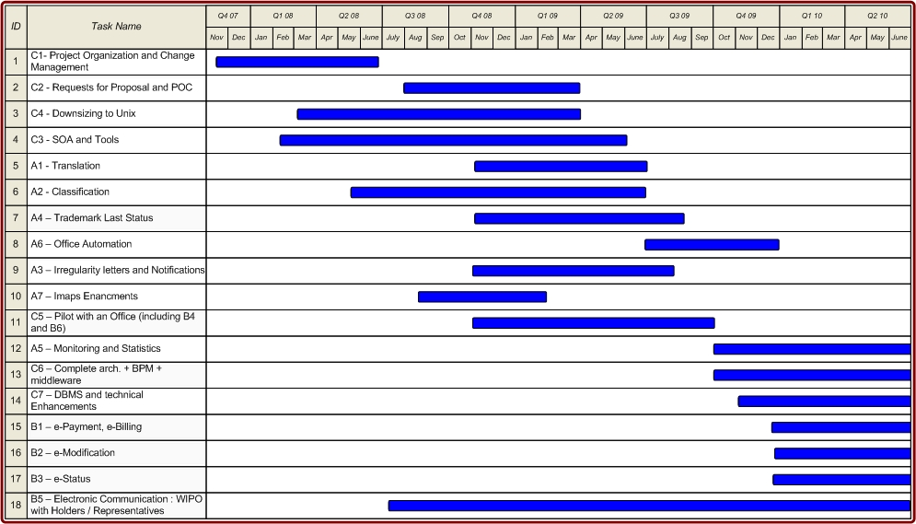

IV. SUB-PROJECT IMPLEMENTATION STATUS

(a) Laying the foundations for modification of the system (high priority projects)

(i) Architectural basis – implementing a SOA platform

9 This goal will be achieved with the completion of sub-projects C2 – Requests for Proposal (tenders) and Proof of Concept (technical solution) – and C3 – SOA and Tools (a sub-project necessary to establish the technical architecture for allowing the MAPS and DMAPS functionality to be made available over the Internet via web services). These sub-projects are crucial for the implementation of the other sub-projects of Phase I, as the sub-projects using the architecture cannot be commenced before the completion of sub-projects C2 and C3. Sub-projects C2 and C3 are, therefore, being tackled first, in parallel with sub-project C4, as explained above.
10 SOA is a form of virtualization that aims to extend the utilization of the functionality delivered by application programs. SOA provides abstraction that removes the complexity of dealing with many different technologies, exposing the application functionality as technology-independent services. The aim of SOA is to make the functionality that is present in an application more easily accessible, and independent of the technologies used to build them. When carried out effectively, the result is a pool of services that can be combined and re-combined in many different ways to meet changing business requirements. The capabilities delivered by these multiple levels of abstraction are at the heart of the business benefits that can be realized.

11 In the case of the MAPS modernization project, the implementation of SOA tools will enable the access to existing programs, redesigned as services, from outside applications. It will also enable the creation of new applications based on services made from existing programs and services made from new programs based on another technology. SOA will be useful in extending access to certain internal applications from outside offices.

12 The SOA platform being a new kind of IT architecture, external expertise was engaged for the identification of the SOA levels and SOA tools necessary for the completion of Phase I.

13 Having thus established the level of SOA required for the project, currently, the requirements of the request for proposals are being written that would result in the selection of the SOA tools to be implemented. Implementation of sub-projects C2 and C3 is scheduled to be completed by March 2009.

(ii) Savings in operational costs of running the MAPS/DMAPS systems

14 This goal will be achieved with the completion of sub-project C4 – Downsizing to UNIX. As the savings in operational costs expected after completion of the downsizing exercise by the end of 2008 are included in the overall budget of Phase I, the timing and implementation of this sub-project will have an impact on the timing, financing and implementation of other sub-projects.

15 Under sub-project C4, the MAPS/DMAPS systems will be migrated from the IBM mainframe at the UN International Computer Center (“UNICC”) to a UNIX environment. The actual hosting of the UNIX environment will most likely be outsourced (to UNICC). Furthermore, the technical capability will be built for underpinning the e-business strategic evolution as well as the future availability of MAPS/DMAPS 24 hours/day, seven days/week.

16 For its implementation, sub-project C4 has been divided in three stages:

Stage I (rough analysis): This stage comprised: (i) the identification of the hardware resources required; (ii) an analysis of the compatibility, and work to be done for the various components, of software (Data files, Source code, Batch code) involved in the project; and (iii) an estimate of the license fees required for the UNIX system. Stage I was completed in April 2008 with a report by the external company engaged to undertake the rough analysis for the migration.
Stage II (detailed analysis): This stage is scheduled for completion by September 1, 2008. A preliminary report was presented on July 30, 2008, by the external company engaged to undertake the analysis.

Stage III (migration): The migration is estimated to last around three months. A detailed workplan and the costs involved will be available at the end of Stage II. For the reason mentioned in paragraph 14, above, Stage III should be completed by the end of 2008.

- Enhancing internal productivity

17 This goal will be achieved with the completion of the following sub-projects:

  - A1 – Translation
  - A2 – Classification
  - A3 – Irregularity Letters and Notifications
  - A4 – Trademark Last Status
  - A5 – Monitoring and Statistics
  - A6 – Office Automation
  - A7 – IMAPS Enhancements

18 These sub-projects are dependent on the completion of the implementation of SOA tools. Therefore, most of the sub-projects in question, if already started, are still in an early stage of project development.

19 In respect of sub-project A7 – IMAPS Enhancements – certain modifications are required in IMAPS. These modifications concern the availability to access some documents from a Web application. Implementation of these modifications is in preparation.

(c) Expanding electronic business with offices, holders and representatives

20 This goal will be achieved with the completion of the following sub-projects:

    - C5 – Pilot with an Office (including sub-projects B4 and B6)
    - B1 – e-Payment, e-Billing
    - B2 – e-Modification
    - B3 – e-Status
    - B5 – Electronic communication from WIPO to holders/representatives
21 These sub-projects are dependent on the completion of the implementation of SOA tools. However, work on sub-project B5 could be started as far as the development of a web-based Gazette is concerned, and has started. This work is scheduled to be completed by the end of 2008 and, consequently, as from 2009, publication of the Gazette is scheduled to be web-based.
V. BUDGET STATUS

22 The following table and graphic reflect the status of commitments and expenses concerning the implementation of the IT Modernization Program by the end of July 2008:

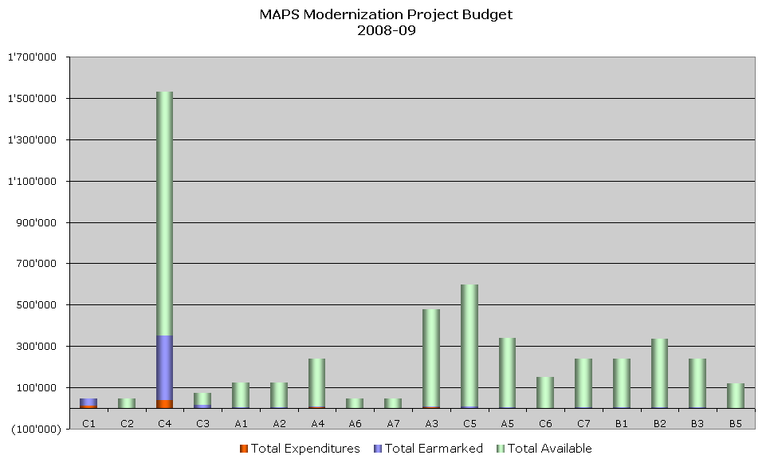
VI. OUTLOOK

23 Phase I of the implementation of the IT Modernization Program is expected to continue on the basis of the timetable shown in paragraph 8, above.

24 A next progress report will be presented to the Madrid and Hague Union Assemblies in 2009.

25. The Assembly is invited to take note of this status report.

[Annexes follow]

Table 1: Internal Operation

Seq. | Project | Description | Category
A1 | Translation | Update translation tools to replace in-house translation tools with commercial ones. | Operational
A2 | Classification | Update Nice classification tools by integrating database of accepted goods and services into classification procedure. Make the tools available on the Internet. | Operational
A3 | Irregularity Letters and Notifications | Update the letter generation process to produce more understandable documents. | Operational
A4 | Trademark Last Status | Create tools to show the goods and services protected within a given designated Contracting Party, and show how these change over time. | Operational
A5 | Monitoring and Statistics | Create tools to monitor and analyze operational processes. Create statistics for internal and external use. | Analytical
A6 | Office Automation | Integrate internal administrative tasks into the MAPS/IMAPS system, e.g., importing Word documents, e-mails, etc. directly into MAPS/IMAPS. | Operational
A7 | IMAPS Enhancements | IMAPS enhancements (e.g., search capabilities, new document formats, tighter integration with MAPS, …). | Operational

Table 2: External Communication

Seq. | Project | Description | Category
B1 | e-Payment,  e-Billing | Create e-Billing (for extracts from the International Register) and e-Payment (for other transactions) for holders. | e-Business
B2 | e-Modification | Allow holders to submit transactions electronically and to further automate their processing within MAPS. | e-Business
B3 | e-Status | Allow holders to monitor the status of their communications to WIPO. | e-Business
B4 | Electronic Communication:  Offices → WIPO | Enhance the transmission of information from national or regional offices to WIPO. | e-Business
B5 | Electronic Communication:  WIPO → Holders/Representatives | Enhance the transmission of information from WIPO to holders and representatives. | e-Business
B6 | Electronic Communication:  WIPO → Offices | Create tools that enhance collaboration between WIPO and national or regional offices with respect to the international procedure. | e-Business

Table 3: Governance and Technical

Seq. | Project | Description | Category
C1 | Project Organization and Change Management | Put procedures into place which will facilitate the implementation of these projects. | Governance
C2 | Requests for Proposal and POC | Requests for Proposal (tenders) and Proof of Concept of technical solution. | Governance
C3 | SOA and Tools | Create the IT architecture (SOA) and provide the necessary tools for its use. | Architecture
C4 | Downsizing on Unix | Migrate MAPS and DMAPS from the UNICC mainframe to a UNIX environment. | Downsizing
C5 | Pilot with an Office | Pilot project with a single national office based on direct access to MAPS. (SOA+BPM+e-Business +Portal+RIA). | Conversion
C6 | Complete Architecture + BPM + Middleware | Adapt the IT architecture and BPM processes based on experience with Pilot (C5) to allow expansion to other interested offices. | Conversion
C7 | DBMS and Technical Enhancements | Improve the database design of MAPS and resolve any technical issues. | Conversion
C8 | Remaining  BPM, Portal and RIA | Migrate business logic from Natural to Java, but retain Adabas. | Conversion

Seq. | Project | Description | Category
C9 | Remaining Interactive Web Services | If needed, define processes and develop a new user interface with common technology for WIPO and national or regional offices. | Conversion
C10 | Publication | Modernize the publication process including the replacement of the legacy Visual Basic programs. | Architecture
C11 | Remaining Java / Oracle Conversion | Migrate the remaining Natural /Adabas programs to Java/Oracle if and when needed, but not before 2010. | Conversion

[Annex II follows]

ROADMAP

Phase I – 2008/2009

Seq. | Project | Madrid  Optimized Cost  in Swiss francs | Hague  Optimized Cost  in Swiss francs | Madrid + Hague Optimized Cost  in Swiss francs
C1 | Project Organization and Change Management | 48,000 | 0 | 48,000
C2 | Requests for Proposal and POC | 48,000 | 0 | 48,000
C4 | Downsizing to Unix | 1,070,913 | 458,963 | 1,529,875
C3 | SOA and Tools | 72,000 | 0 | 72,000
A1 | Translation | 124,500 | 0 | 124,500
A2 | Classification | 124,500 | 0 | 124,500
A4 | Trademark Last Status | 240,000 | 0 | 240,000
A6 | Office Automation | 48,000 | 0 | 48,000
A7 | IMAPS Enhancements | 48,000 | 0 | 48,000
A3 | Irregularity Letters and Notifications | 480,000 | 0 | 480,000
C5 | Pilot with an Office (includes B4 and B6) | 599,200 | 0 | 599,200
A5 | Monitoring and Statistics | 340,000 | 0 | 340,000
C6 | Complete Architecture + BPM + Middleware | 150,000 | 0 | 150,000
C7 | DBMS and Technical Enhancements | 240,000 | 0 | 240,000
B1 | e-Payment, e-Billing | 240,000 | 0 | 240,000
B2 | e-Modification | 336,000 | 0 | 336,000
B3 | e-Status | 240,000 | 0 | 240,000
B5 | Electronic Communication: WIPO → Holders/Representatives | 120,000 | 0 | 120,000
 | Total: | 4,569,113 | 458,963 | 5,028,075

[End of Annex II and of document]

Paragraphs 28 to 31 of document MM/A/38/4 and paragraphs 26 to 28 of document H/A/24/2.
Paragraphs 35, 36 and 42 of document MM/A/38/4, and paragraph 14 of document H/A/24/2.
Document MM/A/38/6, paragraph 41.
When the Madrid Union Assembly approved that the surplus of the Madrid Union budget for 2006/07 be kept within the Madrid Union Reserve and Working Capital Funds (RWCF) with a view to contributing to the financing of subsequent stages of the IT modernization program, the expected surplus of 8.8 million Swiss francs was estimated on the assumption that the proposed revised budget for the 2006/07 biennium would be approved. In the absence of approval by the Member States of the proposed revised budget, expenditures were contained within the level of approved initial budget, with adjustments to the latter made to the extent allowed within the authority of the Director General. Combined with the higher than budgeted income level, this led to a surplus of 24.7 million Swiss francs.
Service-Oriented Architecture: an architecture that uses loosely coupled services to support the requirements of business processes and users.
For the content of these sub-projects, reference is made to Annex I, Table 1.
For the content of these sub-projects, reference is made to Annex I, Table 2.
Proof of Concept: verifying that the proposed technical architecture performs according to specifications.
Service-Oriented Architecture: an architecture that uses loosely coupled services to support the requirements of business processes and users.
Business Process Management.
Portal: a Web interface which provides individualized access to users based on their security profile.
Rich Internet Application: a Web application that has the features and functionality of traditional desktop applications.
Database Management System.
See Annex I, Table 2.

