|  |  |  |
| --- | --- | --- |
|  |  | **E** |
| H/A/35/1 | | |
| ORIGINAL: English | | |
| DATE: JuLY 7, 2015 | | |

**Special Union for the International Deposit of Industrial Designs (Hague Union)**

**Assembly**

**Thirty-Fifth (20th Ordinary) Session**

**Geneva, October 5 to 14, 2015**

FINAL REPORT ON THE INFORMATION TECHNOLOGY MODERNIZATION PROGRAM (HAGUE INTERNATIONAL REGISTRATION SYSTEM)

*prepared by the International Bureau*

# INTRODUCTION

The purpose of this document is to outline progress on the Information Technology (IT) Modernization Program (hereafter referred to as “the Program”) since the last Assembly of the Hague Union (hereinafter referred to as “the Assembly”) in September 2014. On this occasion, the document also serves as the final report to update members of the Assembly on the implementation of the Program.

Document H/A/34/1 contains the previous Program Progress Report.

It is recalled that the Program is to be undertaken in three phases: Phase I, Phase II and Phase III. Phase I consists of sub-projects aimed to produce immediate positive results or to lay down the technical foundations for Phase II. Phase II is the actual one-to-one technical conversion from the current IT legacy system, supporting both the Madrid and Hague international registration procedures, to a modern technology that will ensure Madrid and Hague System stakeholders benefit in the years to come from an industry standard technical platform. Phase III is an optional phase to be undertaken by the International Bureau to cater for any necessary stabilization activities of the new system, together with any ergonomic adjustments that are necessary after the official go-live date.

Document H/A/34/1 reported the completion of all activities under Phase I, together with the reporting of the reception of a major deliverable of Phase II of the Program, namely the Design International Registration Information System (DIRIS) Beta version, which had at that time been received by the International Bureau, and was ready to be subjected to technical deployment, to be followed by a series of system test procedures.

Document H/A/34/1 also reported that prior to the end of 2013, it was evident that the upcoming accession of new Member States (China, Japan, Republic of Korea and the United States of America) to the Hague Agreement Concerning the International Registration of Industrial Designs, would require modifications to the Hague System procedure and therefore to the legacy ICT system (DMAPS). Therefore, and in order to minimize the operational risk in externally developing such new functions, it was decided to address these important functional requirements with internal development resources, and directly within the legacy system, DMAPS, and to restart the technical conversion exercise at a later date. As a result, the external implementation partner was promptly informed to suspend activities related to the technical conversion of DMAPS, until the necessary modifications to the legacy DMAPS System had been deployed and had become stabilized.

The Hague System entered into operation in respect of the Republic of Korea on July 1, 2014, and in respect of Japan and the United States of America on May 13, 2015, and is currently being administered by the Hague Registry using the legacy ICT system DMAPS.

# PROGRAM IMPLEMENTATION STATUS

Document H/A/34/1 also reported that the challenges to the Hague Registry when the IT Modernization Program began in 2008 are fundamentally different to the challenges of today. Given the very dynamic and fluid nature of the Hague international registration procedures, it is extremely important that the DIRIS System is able to address the original, as well as any new challenges. In order to mitigate any associated risks, an external review of the IT Modernization Program has been initiated late in the second quarter of 2014, whilst noting that, following an internal audit of the Brands and Designs Sector revenue processes, there is a recommendation that a post IT Modernization Phase II implementation review should be undertaken. The terms of reference of the review includes overall approach, system functionality, system performance, testing processes, and commissioning strategies. Such a review would allow the International Bureau to more accurately determine the scheduled DIRIS go-live date.

The review, known as the Independent Validation and Verification (IVV) exercise, was concluded in November 2014. The IVV confirmed the overall approach and system functionality, whilst raising issues relating to user and system testing processes, and commissioning strategies. One of its most important recommendations included the appointment of a newly identified role, that of a Transformation Manager in the Registries Support Division, designed to assist in raising the operational maturity levels of the ICT service delivery processes. Following a competition, the Transformation Manager commenced duties within the Registries Support Division in May 2015. Annex I lists the remainder of the IVV recommendations, which will be progressively implemented during the remainder of 2015 and beyond.

The internal processes and procedures governing the reception of new DIRIS System versions from the external supplier, together with the technical activities related to the deployment of new DIRIS versions into a technical environment where system and user testing can take place, have been proven through the reception and deployment of a number of DIRIS versions for testing purposes. These established processes and procedures are repeatable for all of the future versions of DIRIS.

With the delivery of the major Phase II deliverable (DIRIS Beta), together with the repeatable processes and procedures for the reception and deployment of versions of DIRIS, the Program has been deemed to have been completed. All remaining activity related to the technical deployment into production of subsequent DIRIS versions, following user testing and acceptance, shall be undertaken by internal staff. The remaining funds in the Program have been earmarked for such subsequent DIRIS versions. Annex II presents a list of Program deliverables.

As indicated in earlier IT Modernization Program Progress Reports, and only if needed, the International Bureau will propose to enter into the execution of Phase III of the Program to accommodate post-go-live activities, such as bug-fixes, performance improvements as well as the transformation of the end-user interface and possible process reengineering. Since the need for a possible Phase III can only be evaluated after Phase II deployment, the details of a possible Phase III will be elaborated in due course, as part of standard system life cycle maintenance activities, and will be funded through the regular budget.

# PHASE II DEPLOYMENT PLAN

The DIRIS System shares a common platform with MIRIS, its Madrid Registry equivalent, which is scheduled for business testing and deployment between the summer of 2015 and April 2016. In order to avoid duplication of effort and over allocation of key resources, it has been decided that MIRIS should be deployed first so that the DIRIS testing and deployment effort may be left to focus mostly on the non-shared elements of the system that specifically support Hague Registry functions.

An additional effect on the overall schedule is the accession of Japan and the United States of America to the Hague Treaty which has necessitated the immediate implementation of changes to the incumbent DMAPS System. These changes are in place, but must be followed by a period of six months systems stabilization (scheduled to end in December 2015) in order to avoid any unforeseen business interruption.

Detailed planning for the final testing and deployment of DIRIS will take place during September and October of 2015. This timing is necessary in order for the schedule to incorporate the progress and outlook of the MIRIS deployment project (which will, by then, be sufficiently advanced to provide a reliable schedule forecast) along with the additional design and build effort that is expected from other Hague functionality enhancement initiatives, such as the design for increased granularity, which will take place between July and September 2015.

Subject to the final, detailed planning described above, the technical build of DIRIS is expected to take place between January and April 2016 with the final testing and deployment to follow between May and August 2016.

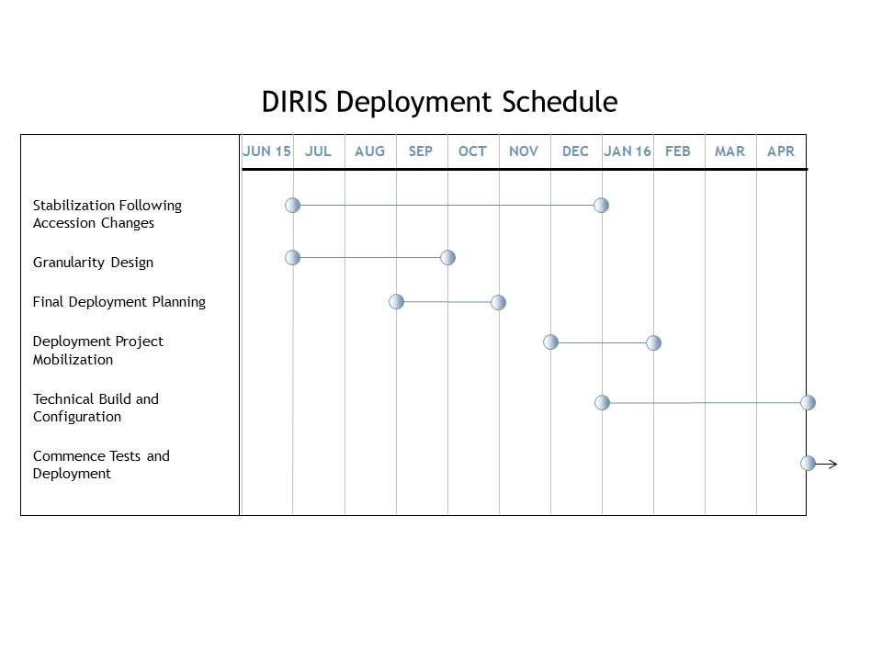

Figure 1- Phase II High Level DIRIS Project Plan

**BUDGET UTILIZATION**

A total resource envelope of 13.804 million Swiss francs was approved for the project (10.804 million Swiss francs by the Assembly of the Madrid Union and 3 million Swiss francs by the Assembly of the Hague Union). To date, actual expenditure on the project amounts to 13.527 million Swiss francs, or 98 per cent of the project budget.

Table - Financing Status (in thousands of Swiss francs)



*The Assembly is invited to take note of the “Final Report on the Information Technology Modernization Program (Hague International Registration System)” (document H/A/35/1).*

[Annexes follow]

**RELEVANT RECOMMENDATIONS OF THE INDEPENDENT VERIFICATION AND VALIDATION REPORT OF THE IT MODERNIZATION PROGRAM**

1. Define all current and expected projects to acceptable standard.

2. Implement project and program measurement and progress reporting.

3. Introduce project accounting discipline.

4. Transfer control of portfolio budget to Reform Program Board / Task Force.

5. Re-visit and verify Project Initiation Document for MIRIS.

6. Review and verify MIRIS deployment plan.

7. Mobilize new project for complete, end-to-end requirements analysis of all business under the remit of the Reform Program.

8. Establish cross-functional processes to handle enhancement requests and essential fixes.

9. Revise risk and issue recording and management.

10. Assign data ownership appropriately between users, support and system administration.

11. Define roles for Technical Manager, Release Manager and Change Control Manager.

12. Define effort levels for the three roles mentioned in item 11, distinct levels of technical and user support.

13. Implement cross-functional process around Operations Team’s Continuous Improvement Program and Registries Support Division’s change control process.

14. Establish in-house Project Library.

15. Implement practical standard for project documents.

16. Assign a Training Manager to Program and Project Boards.

17. Add training impact assessment to change process.

18. Document business processes and data.

19. Add performance requirements / constraints to MIRIS project definition.

20. Implement “arm’s length” interface management process between the Registries Support Division and AIMS Support.

21. Include external dependencies in project planning.

22. Re-plan and design testing based on outputs of business requirements and data documentation exercise.

23. Implement processes for Business Change Management.

[Annex II follows]

**IT MODERNIZATION PROGRAM ACHIEVEMENTS**

1. Migration of legacy system operating in a mainframe environment to a UNIX environment.

2. New IT infrastructure Proof of Concept.

3. New IT infrastructure Office Pilot – Madrid eFiling.

4. Hague eRenewal.

5. Hague eFiling revision.

6. Hague eFiling Portfolio Manager.

7. Deployment of SDL WorldServer translation tool for all Madrid and Hague translations.

8. Deployment of TAPTA machine translation tool.

9. Madrid Portfolio Manager (MPM).

10. Madrid Electronic Alert (MEA).

11. Madrid Real-time Status (MRS).

12. Madrid Office Portal (MOP).

13. Intelligent web forms for Madrid (MM4, MM5, MM6, MM7, MM8, MM9, MM10, MM12).

14. Madrid and Hague Publication and Notification system revision.

[End of Annex II and of document]