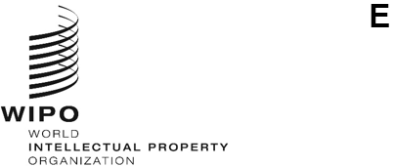
A/62/10
ORIGINAL: English
DATE: July 8, 2021
Assemblies of the Member States of WIPO
Sixty-Second Series of Meetings
Geneva, October 4 to 8, 2021
Joint-Proposal on behalf of the Group of Central Asian Caucasian and Eastern European Countries, the Group of the Central European and Baltic States, Group B and the Group of Latin American and Caribbean Countries on the allocation of the vacant seats for the election of the composition of the WIPO Coordination Committee
submitted by the Group of Central Asian Caucasian and Eastern European Countries, the Group of the Central European and Baltic States, Group B and the Group of Latin American and Caribbean Countries
In a communication to the Secretariat received on July 2, 2021, the Group of Central Asian Caucasian and Eastern European Countries, the Group of the Central European and Baltic States, Group B and the Group of Latin American and Caribbean Countries, submitted the enclosed joint-proposal in the framework of Agenda Item 8, “Composition of the WIPO Coordination Committee, and of the Executive Committees of the Paris and Berne Unions”.
[Annex follows]
Joint-Proposal
on behalf of the Group of Central Asian Caucasian and Eastern European Countries, the Group of the Central European and Baltic States, Group B and the Group of Latin American and Caribbean Countries on the allocation of the vacant seats for the election
of the composition of the WIPO Coordination Committee

Context
- This Joint Proposal is put forward by four Regional Groups of the World Intellectual Property Organization (WIPO), namely CACEEC, CEBS, Group B and GRULAC to propose a path towards a consensual decision on the allocation of additional seats of the WIPO Coordination Committee.

- This Joint Proposal takes into account the results of several rounds of consultations of WIPO member States and views expressed.

- The composition of the Coordination Committee has remained the same since 2007, despite having additional seats to be allocated since 2013: one available in 2013, two available in 2015, four available in 2017, and six available now.

- In 2003, 2005 and 2007, four additional seats were allocated as follows: African Group received one additional seat in 2003 and one in 2007, Asia and the Pacific Group and Group B received one additional seat each in 2005.

- In 2001, 7 additional seats were available. Member States agreed on a solution where all Regional Groups, except China and the Asia and the Pacific Group, received one additional seat, and the Asia and the Pacific Group received two additional seats.

- Before 2001, WIPO Member States were unable to find consensus on allocation of the growing number of vacant seats.

- Therefore, from the above, a total of eleven seats were allocated in the last two decades as follows: Asia and the Pacific Group 3, African Group 3, Group B 2,
CACEEC 1, CEBS 1, GRULAC 1.

- We also note that three WIPO regional groups, namely the Group of Central Asian Caucasian and Eastern European Countries, the Group of the Central European and Baltic States, the Group of Latin American and Caribbean Countries, have not received an additional seat at the WIPO Coordination Committee since 2001.

- We once again reiterate that multiple principles regarding the election of the memberships of the Paris and Berne Executive Committees had been envisaged in Article 14 of the Paris Convention and Article 23 of the Berne Convention as well as in subsequent discussions among WIPO Member States.

- We further reiterate that the WIPO Coordination Committee is, in accordance with Article 8 of the WIPO Convention, tasked with coordinating the Unions administered by WIPO, including Unions of the Special Agreements envisaged by the Paris and Berne Convention, as opposed to coordinating the WIPO Membership.

Proposed draft Decision for the Assemblies of the Paris and Berne Unions, and the WIPO Conference, each in so far as it is concerned.
Listed in the Annex (follows).

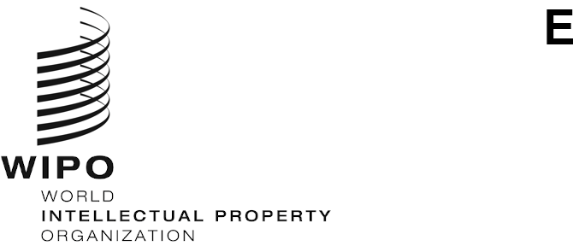
A/62/[X]
ORIGINAL: English
DATE: OCTOBER [X], 2021

Assemblies of the Member States of WIPO

Sixty-Second Series of Meetings

Geneva, October 4 to 8, 2021

composition of the WIPO Coordination Committee
Document prepared by the Secretariat
The Assemblies of WIPO, each in so far as it is concerned, decide:
to allocate six vacant seats of the Coordination Committee in the following manner: Asia and the Pacific Group (1 seat), African Group (1 seat), Group of Central Asian Caucasian and Eastern European Countries (1 seat), the Group of the Central European and Baltic States
(1 seat), Group B (1 seat), and the Group of Latin American and Caribbean Countries (1 seat).
to allocate the next three available seats automatically in the following manner: the first available to [X], the second available to [Y], the third available to [Z].

[End of Annex and of document]

Paris Convention for the Protection of Industrial Property https://www.wipo.int/edocs/lexdocs/treaties/en/paris/trt_paris_001en.pdf
Berne Convention for the Protection of Literary and Artistic Works https://www.wipo.int/edocs/lexdocs/treaties/en/berne/trt_berne_001en.pdf
Convention Establishing the World Intellectual Property Organization https://wipolex.wipo.int/en/text/283833

