 |  | E
A/50/7
ORIGINAL: ENGLISH
DATE: AUGUST 13, 2012

Assemblies of the Member States of WIPO

Fiftieth Series of Meetings
Geneva, October 1 to 9, 2012

FINANCIAL OVERVIEW FOR 2012; PROGRESS REPORT ON THE IMPLEMENTATION OF COST EFFICIENCY MEASURES

Document prepared by the Secretariat

- The present document contains Financial Overview for 2012; Progress Report on the Implementation of Cost Efficiency Measures (document WO/PBC/19/9), which is being submitted to the WIPO Program and Budget Committee (PBC) at its nineteenth session (September 10 to 14, 2012).

- The recommendation of the PBC in respect of this document will be included in the “Summary of Recommendations made by the Program and Budget Committee at its Nineteenth Session held from September 10 to 14, 2012” (document A/50/14).

3. The Assemblies of the Member States of WIPO and of the Unions administered by it, each as far as it is concerned, are invited to approve the recommendation made by the Program and Budget Committee in respect of document WO/PBC/19/9, as recorded in document A/50/14.

[Document WO/PBC/19/9 follows]

E
wo/pbc/19/9
ORIGINAL: ENGLISH
DATE: AUGUST 13, 2012

Program and Budget Committee

Nineteenth Session
Geneva, September 10 to 14, 2012

FINANCIAL OVERVIEW FOR 2012; PROGRESS REPORT ON THE IMPLEMENTATION OF COST EFFICIENCY MEASURES

Document prepared by the Secretariat

- This document provides (i) an overview of the financial situation of WIPO up to the end of June 2012 (unaudited figures for information); and (ii) an overview of progress to date on the implementation of the cost efficiency measures foreseen to be put in place over the course of the current biennium.
2. The Program and Budget Committee is invited to recommend to the Assemblies of the Member States of WIPO to take note of the contents of the present document.

[Financial Overview for 2012 follows]
OVERVIEW OF THE FINANCIAL SITUATION OF WIPO AS OF END JUNE 2012

INCOME
- As shown in Table 1 below, the overall result for the first half of 2012 was a surplus of 12.2 million Swiss francs, including a budgetary surplus of 26.7 million Swiss francs, reserve expenditure of 9.0 million Swiss francs and 5.4 million Swiss francs in estimated IPSAS adjustments.
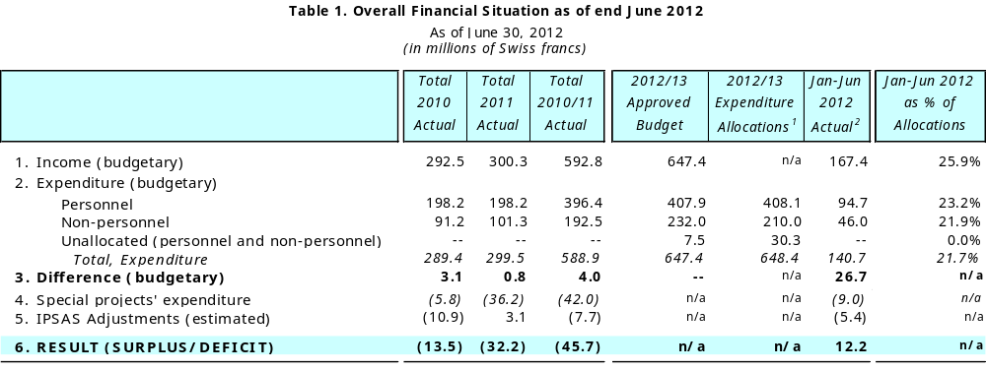
¹ 2012/13 allocations reflect the creation of five "flexibility" posts for PCT (increase by Sfr982 thousand), in line with Financial Regulation 5.6 on Flexibility Adjustments, whereby the Director General has flexibility to make adjustments to the resources appropriated for the operations of the PCT, Madrid and Hague systems, and for WIPO programs providing administrative support to these operations, on the basis of unbudgeted variations in the volume of registration activities.
² Includes an estimated amount of Sfr5.8 million of accrued expenditure under the Regular budget, of which Sfr0.2 million is under Travel and Fellowships, Sfr3.3 million is under Contractual Services, Sfr2.1 million is under Operating Expenses and Sfr0.1 million is under Equipment and Supplies (rounded numbers).
³ Includes an estimated amount of Sfr0.4 million of accrued expenditure
⁴ IPSAS Adjustments as of June 2012 were estimated at -Sfr5.4 million Swiss francs. These adjustments include (i) the deferral of income received but not earned; (ii) depreciation and amortization; (iii) changes in employee benefit liabilities and (iv) the capitalization of construction costs.

- Overall, income levels track the budgeted estimate, with almost 26 per cent of estimated income received at end June 2012 (25 per cent of the biennial time span elapsed). For comparison, in the previous biennium, less than 23 per cent of estimated income had been received by end June of the first year of the biennium i.e. 2010. Compared to budgeted estimates, PCT fee income, Publications and Arbitration income are above, while Madrid and Hague fees and Miscellaneous income are below the time-proportional 25 per cent level. Since not all elements of income are equally even and predictable in nature with respect to the timing of their receipt, these figures are not deemed to signal any significant cause for concern at this early stage. There are indications, however, that some specific income elements may fall below the levels foreseen in the biennial estimates, such as interest income, where the continued drop in interest rates has had an adverse impact.
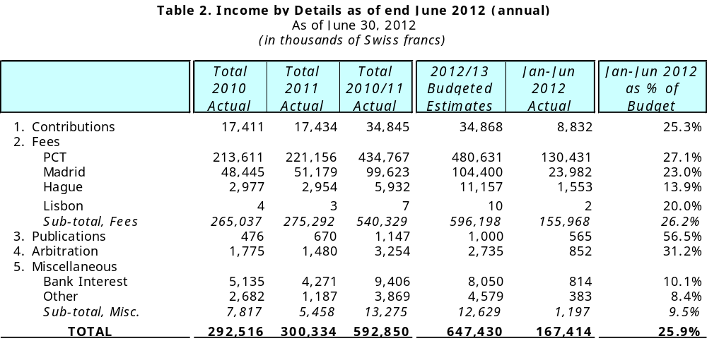

- Income was also higher for the Publications, Arbitration and Other categories compared to 2011, primarily related to increases in the sales of publications for the PCT and the Nice Classification systems, and an increase in the caseload handled by the Arbitration and Mediation Center. Fee income for the Madrid and Hague registration systems shows an increase compared to 2010, but a slight drop relative to the first half of 2011.

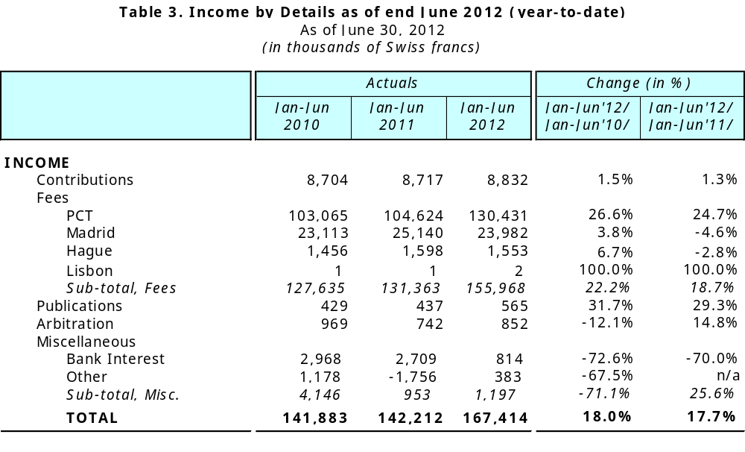
- In comparison to prior periods, overall income in the first half of 2012 increased by 17.7 per cent from the same period a year ago and by 18.0 per cent from the same period in 2010, primarily as a result of higher than estimated income from the PCT fees, which include a positive foreign exchange rate impact of approximately 3.7 million Swiss francs for the first six months of the year.
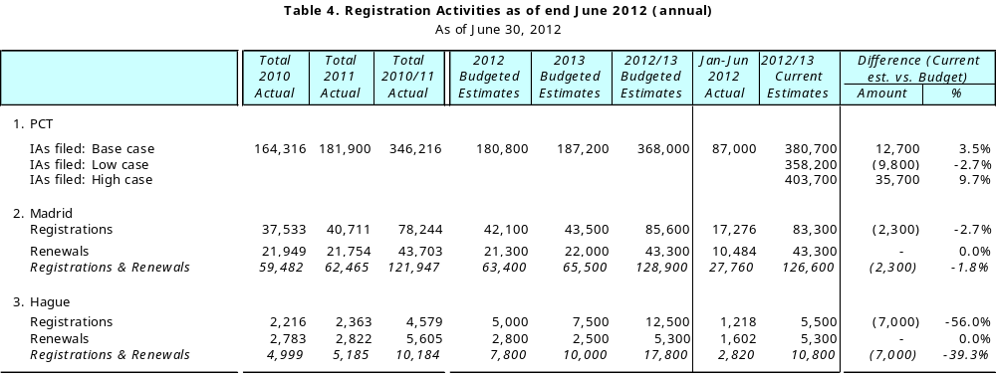
- Estimates for registration activities are regularly updated, and the latest such estimates, prepared in June 2012, indicate an upward trend for PCT forecasts, from the budgeted biennial estimate of 368,000 International Applications (IAs) to 380,700 IAs, an increase of 3.5 per cent. Current estimates for the Madrid and Hague systems show reductions relative to the budgeted estimates. In accordance with Financial Regulation 5.6 on Flexibility Adjustments, and in line with the flexibility formula defined in PCT/A/36/5, additional resources have been allocated to PCT for the administration of the PCT system (five flexibility posts were created, representing an additional financial resource allocation of 982 thousand Swiss francs). This has contributed to alleviating the pressure for resources, primarily required to cope with the need for language skills and the additional, unbudgeted volume of applications.
- Table 5 below provides a comparison of registration activities in the first half of 2012 relative to the same periods in the previous two years. In the case of PCT, the number of IAs filed in the first six months of 2012 is on the same level as in 2011. Due to the delay in receiving data from National Offices, means that the data in the table below is preliminary only. Based on income levels recorded, and the International Bureau’s own estimates, the volume of IAs for the first half of 2012 has comfortably exceeded both 2010 and 2011 levels for the same period.
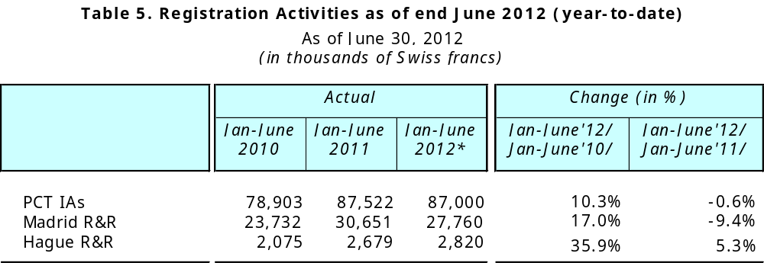
* Data for June 2012 PCT international applications is incomplete due to delays in data receipt from receiving offices.

- Registrations and renewals (R&R) for the first six months of 2012 under the Madrid system were 17 per cent higher than for the same period in 2010, but lower by 9 per cent against 2011. The same comparison for the Hague system indicates a significant increase of just under 36 per cent against 2010, and an increase of 5 per cent against 2011. New accessions to the Madrid and Hague systems (Philippines, Columbia, Mexico, India, and New Zealand) are expected to generate revenues for the Organization only in the course of 2013/14, while the need to process R&Rs increases significantly well before then.
EXPENDITURE
- Expenditure under the regular budget amounted to 140.7 million Swiss francs in the first half of 2012, representing a budget utilization rate of just under 22 per cent for the biennium (with 25 per cent of biennial time elapsed), well in line with the targeted cost efficiency reductions demanded by Member States. Likewise, the utilization rate for Personnel Resources is at 23 per cent, while that of Non-Personnel Resources is 20 per cent.

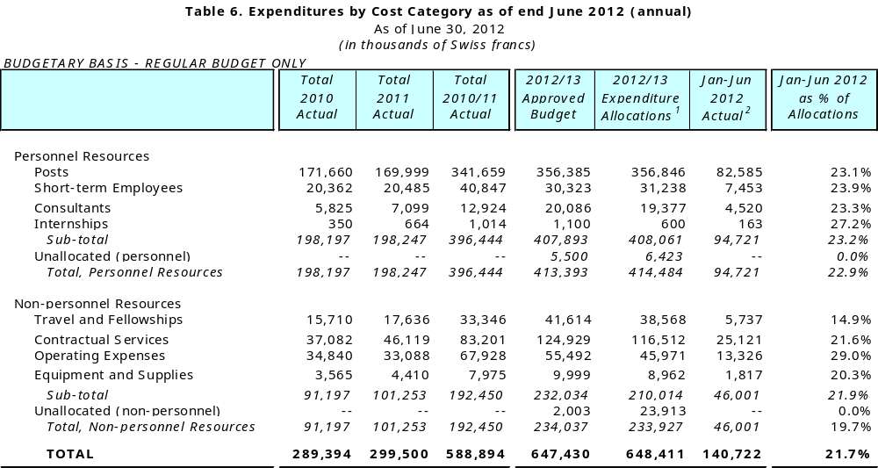
¹ 2012/13 allocations reflect the creation of five "flexibility" posts for PCT (increase by Sfr982 thousand), in line with Financial Regulation 5.6 on Flexibility Adjustments, whereby the Director General has flexibility to make adjustments to the resources appropriated for the operations of the PCT, Madrid and Hague systems, and for WIPO programs providing administrative support to these operations, on the basis of unbudgeted variations in the volume of registration activities.
² Includes an estimated amount of Sfr5.8 million of accrued expenditure under the Regular budget, of which Sfr0.2 million is under Travel and Fellowships, Sfr3.3 million is under Contractual Services, Sfr2.1 million is under Operating Expenses and Sfr0.1 million is under Equipment and Supplies (rounded numbers).

- As indicated in Table 7 following, overall expenditure against the regular budget in the first half of 2012 was on the same level as in 2011, with a small decline of 0.6 per cent. However, despite the overall expenditure remaining at the same level, the relative mix by expenditure category has changed significantly, largely due to a number of pro-active measures taken, as illustrated in the following table.
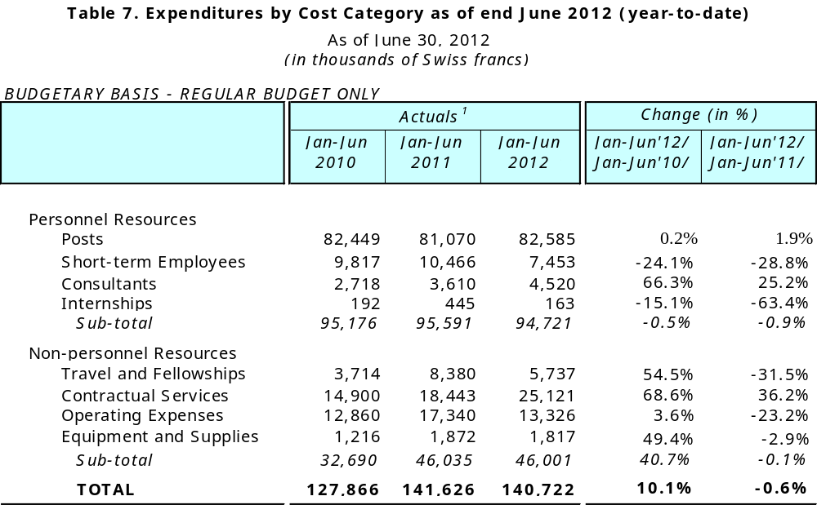
¹ Includes accruals for 2011 and 2012; accruals for 2010 were not reported within the expenditure figures.
² Includes an estimated amount of Sfr5.8 million of accrued expenditure under the regular budget, of which Sfr0.2 million is under Travel and Fellowships, Sfr3.3 million is under Contractual Services, Sfr2.1 million is under Operating Expenses and Sfr0.1 million is under Equipment and Supplies (rounded figures).

- Personnel expenditure was lower by 0.5 per cent against 2010 and just under 1 per cent against 2011. Higher overall expenditure under Posts and Consultants were offset by lower expenditure under Short-term employees. Higher expenditure under Posts and lower expenditure under Short-term employees are in line with the changing contract structure of WIPO’s personnel. As illustrated by Table 8 following, there are 35 more employees on fixed-term contracts under the regular budget, offset by a reduction in the number of short-term employees by 31 as of end June 2012 compared to end 2011. It should be noted that this is partly a result of the use of the regularization posts approved by Member States for activation in the 2012/13 biennium, but also partly the result of the conscious and focused approach of the Organization to encourage the application of internal candidates for competitions announced for vacant posts.
- It is recalled that in September 2011, during its Sixty Fifth (42nd Ordinary) Session, the Coordination Committee adopted a number of changes to the contractual framework of the Organization. The aim of the changes was to allow WIPO to improve its contractual framework through the introduction of transparency in contract types; improved benefits for temporary staff; and a resolution of the conditions of service of long-serving temporary employees. On the basis of the ongoing implementation process, it is estimated that the related cost can be absorbed within the approved 2012/13 budget envelope of the Organization.
- The level of non-personnel expenditure has not changed materially against the same period last year, although it is significantly higher, primarily due to the increase in Contractual Services costs, than 2010, which is primarily due to increased translation costs under PCT and the increased language outsourcing and related cost of translation work following the adoption of the new language policy in 2011. There is, however a sizeable reduction in the expenditure on Travel and Fellowships, down by 32 per cent, primarily as a result of cost efficiency measures put in place, and Operating Expenses (including rent, office space maintenance, communication, representation, bank charges, etc.), down by 23 per cent, offset by the continued increase in expenditure under Contractual Services (including conference costs, publishing, SSAs and commercial service providers), up by 36 per cent.
- Table 8 provides an overview of the evolution of the numbers of employees on board in 2012, comparing with year-end numbers for 2010 and 2011. Total employees on board, funded from the regular budget, were 1,193, representing a small increase from December 2010 of 2 per cent, and almost no change since December 2011, other than the structural changes highlighted above. Including short-term conference staff, whose numbers have started to increase in preparation for the Assemblies, and interns, the total number of employees funded against the regular budget was 1,227, representing a small increase from the year end.
- Headcount under the Reserve-financed projects was 24, showing some decrease from last year as some DA activities were mainstreamed and their personnel brought onto the regular budget in accordance with the 2012/13 Program and Budget. Employees under Funds-in-Trust totaled 22, which represents no change from December 2011, and a small increase of two additional employees since December 2010.
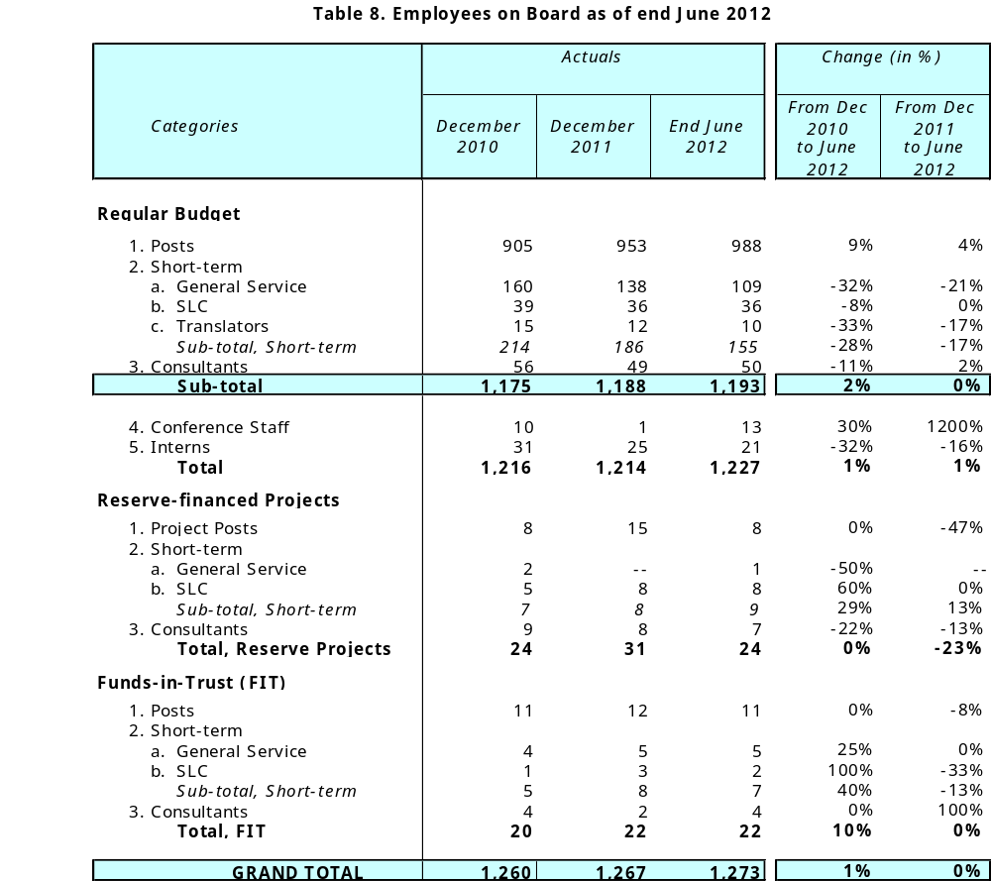
PROGRESS REPORT ON THE IMPLEMENTATION OF COST EFFICIENCY MEASURES
- It is recalled that the Assemblies of the Member States of WIPO approved the 2012/13 Program and Budget, subject to “efforts by the Secretariat to reduce expenditure through cost efficiency measures by 10.2 million Swiss francs, from 647.4 million Swiss francs to 637.2 million Swiss francs, through, inter alia, travel policies for staff and third parties, premises management, policies for payments of SSAs and honoraria for experts and lecturers, internship programs, receptions and rental of premises and equipment during conferences and a reduction of personnel costs through improved organization design.”
- In accordance with this commitment, the Secretariat takes this opportunity to report on the progress to date on the implementation of the efficiency measures. Further updates and details will be provided in the annual Program Performance Report for 2012, which will be presented to Member States for their review in 2013.
Premises management
- Since the approval of the 2012/13 Program and Budget, the Organization has further reinforced its efforts to achieve cost efficiencies and resource savings. These efforts targeted a wide range of areas, such as premises management, travel, organization of meetings, procurement of goods and services, etc. The details of these measures are provided below.
- The following measures are undertaken in the area of Premises management in order to achieve cost reductions:
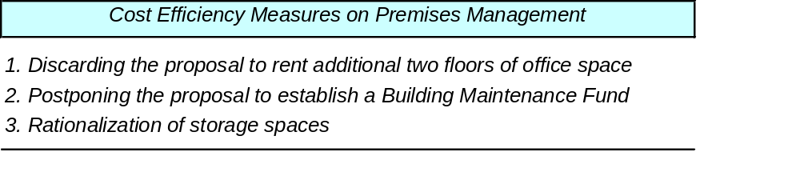
- It is recalled that the 2012/13 Program and Budget included provisions to rent an additional two floors of office space and to establish a Building Maintenance Fund. As a result of foregoing these provisions, the Organization will be able to save approximately 4.5 million Swiss francs for the biennium.
- The new office space allocation policy, issued in December 2010, was fully implemented by the beginning of 2012 across all buildings including the New Building, with the result that sufficient flexibility in managing office space has now been achieved for the current biennium and, subject to the evolution of WIPO registration activities in the coming years, also probably for the beginning of the next biennium.
- The Building Maintenance Fund, which had been foreseen to start in the current biennium, has been postponed as a means of contributing to the ongoing cost efficiency measures. However, consideration will be given to the establishment of such a Building Maintenance Fund in the future, subject to IPSAS requirements, and with a view to enabling the Organization to deal adequately and in a timely manner with technical renovations of the older buildings. It is noted that, in a number of cases, these renovations would bring lower energy consumptions as a return on investment over periods of five to ten years, depending on the building concerned and the type of technical renovation.
- As part of the rationalization of storage space, the Organization has discontinued some of its rented storage area located in Meyrin and Collex. Biennial savings as compared with the budget are estimated at 38 thousand Swiss francs.
Travel of staff and third parties
- The Organization has put in place stricter guidelines related to travel. These measures were further reinforced following the approval of the 2012/13 Program and Budget through additional measurements put in place by the Director General, including:

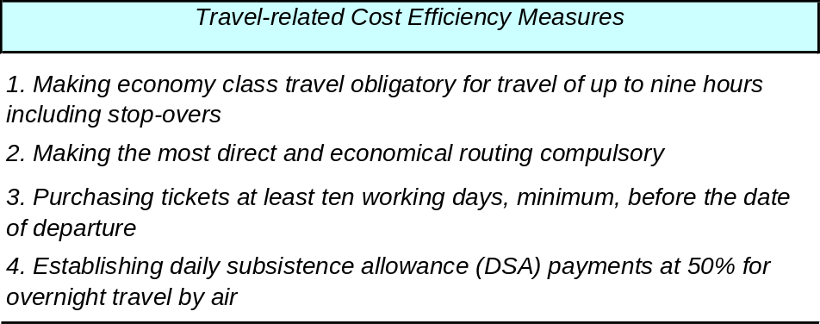

- These and other related measures were communicated to all WIPO staff through an internal Office Instruction on Official Travel and Related Expenses issued in early 2012. In addition, the Organization continues to participate in the ongoing works of the Joint Airline Negotiations to achieve better prices and conditions from airline companies. This work is done in cooperation with other UN agencies within the framework of the UN Common Procurement Activities Group (CPAG). Savings achieved in this area by WIPO were estimated at close to 1 million Swiss francs for 2011 (CPAG Annual Report for 2011).
- As a result of the above measures, the Organization has been able to reduce its expenditure on travel. While the accurate quantification of some of the related savings is quite challenging, specific savings have been identified in the amount of approximately 150 thousand Swiss francs for the first six months of 2012. While this may appear limited compared to the total amount spent on travel by the Organization, it is recalled that in comparison with 2011, the drop in travel related expenditures is quite evident (see Table 7). Overall, as of June 2012, the total expenditure on Staff missions in the first six months of 2012 amounted to 2.7 million Swiss francs, as compared to the biennial budget of 15.7 million Swiss francs, which represents 17.2 per cent of the biennial budget with 25 per cent of the biennium elapsed; 25 per cent utilization would have amounted to a total of 3.9 million Swiss francs.
Organization of meetings and events
- The following measures have been further reinforced following the approval of the 2012/13 Program and Budget in relation to the organization of meetings and events.

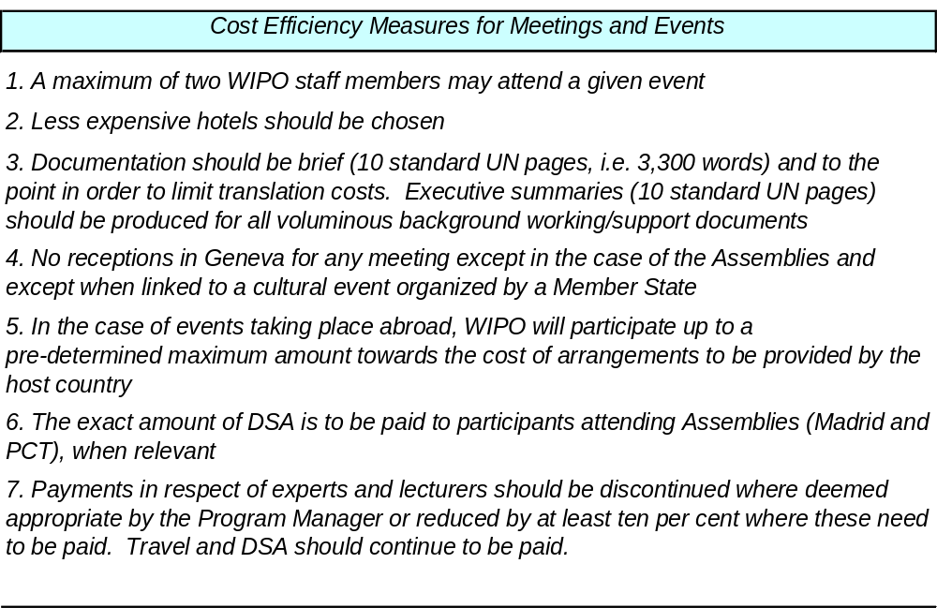
- In addition to the above, the Organization continues to implement the following other measures:
- Wider use of Videoconferencing and Webcasting for events and meetings, where it does not compromise the quality of WIPO’s participation, as well as for recruitment activities (interviews);
- Better planning of meetings through back-to-back meetings to increase cost-efficiency;
- Taking full advantage of the WIPO Coordination Offices to secure WIPO’s attendance or representation in meetings in a cost-effective manner.
- Revised internal Office Instructions on Official Hospitality and on the Payment of Honoraria for Speakers were issued to all staff in the first half of 2012, reflecting cost efficiency measures introduced.
- As of June 2012, the expenditure related to the organization of meetings (not including staff missions and third party travel) amounted to 1.2 million Swiss francs, as compared to the biennial budget of 8.7 million Swiss francs, which represents 13.8 per cent of biennial budget with 25 per cent of biennium elapsed; 25 per cent utilization would have amounted to a total of 2.2 million Swiss francs.
- It should be highlighted that the adoption of the new Language Policy in 2011 has generated a significant increase in the number of translation requests. While considering the policy, Member States had recognized that more concise working documents would facilitate deliberations, and therefore approved the proposal of the Secretariat to further reduce the average length of the working documents. Member States approved the policy on the understanding that such a reduction would not be a statutory requirement but an indication of principle, and that it would not apply to documents submitted to the Secretariat by Member States. In respect of exceptionally voluminous documents commissioned by certain Committees, Member States further noted that these would be made available only in the original languages with a summary to be prepared by the Secretariat in all six languages, with the proviso that if a Member State or group of Member States were to express specific interest in one of such documents, the Secretariat would translate its full text in the required language.
- As a result of the adoption of the new policy, the increase in workload has been 57 per cent in the first five months of 2012, as compared to the same period in 2011, both as a result of the increase in number and length of documents. With no increase in the staffing levels of the Conference and Language Services Program, the additional work has necessarily been outsourced; resulting in 69 per cent of the work being outsourced as compared to 45 per cent over the same period in 2011. The additional cost implications for this increase are significant, estimated at approximately 1.5 to 2.0 million Swiss francs per annum which is not sustainable. As a consequence, internal procedures and practices are being further reviewed and aligned within the spirit of the policy approved by Member States.
Other Measures
Special Service Agreements (SSAs)
- The following measure is currently under implementation:
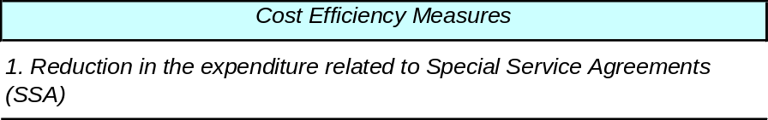
- The 2012/13 Program and Budget included an overall provision of around 24 million Swiss francs for the services provided on Special Service Agreements (SSAs). Overall expenditure on SSAs in the first half of 2012 was around 5 million Swiss francs, which represents 20 per cent of the biennial budget with 25 per cent of the biennium elapsed; 25 per cent utilization would have amounted to a total of 6 million Swiss francs. It is noted that a sizeable share of the SSA budget is related to translation costs, in particular in the areas of PCT and Madrid systems, where the Organization has continued to strengthen the use of various automated productivity tools to assist in the translation work, thus reducing related expenditure.
Procurement contracts
- WIPO has focused its attention on the re-negotiation and re-tendering of various procurement contracts for goods and services in order to achieve better prices and conditions from the suppliers. These contracts cover a wide range of areas, including premises, IT, translation services, security services, etc. A number of major contracts were re-tendered in 2012, including the provision of translation services for the Patent Cooperation Treaty (PCT system); provision of software licenses for the ERP project and the provision of security services for the WIPO installations and infrastructure. While the re-tendering has been beneficial and cost effective in most cases, there were some cases where efforts for efficiency savings by lowering of required services has nevertheless resulted in a net cost increase as a result of cost of living adjustments.
- In addition, extensive work is done by WIPO as part of the UN Common Procurement Activities Group (CPAG) in order to achieve savings and efficiencies through collaborative procurement. WIPO has most recently benefited from common tenders in the areas of electricity provision and the purchase of desktop and laptop computers. Some of the other areas in IT, communication and travel related services will also be targeted for re-negotiation/re-tendering in 2012.

Personnel Resources
- The following measure is currently under implementation:
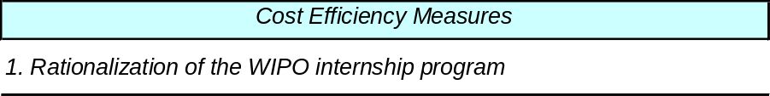

- The Organization continues to rationalize its internship program on the basis of program needs. Overall expenditure on interns in the first half of 2012 was 0.2 million Swiss francs, compared to the 2012/13 biennial budget of 1.1 million Swiss francs. This is the result of a limitation put in place on the overall number of interns at any given time to 30, which represents a cut on the initially envisaged figure under the Program and Budget.

[End of document]

