WIPO |  | E  A/47/7  ORIGINAL: English  DATE: August 15, 2009
WORLD INTELLECTUAL PROPERTY ORGANIZATION
GENEVA

assemblies of the member states of wipo
Forty-Seventh Series of Meetings
Geneva, September 22 to October 1, 2009
COMPOSITION OF THE WIPO COORDINATION COMMITTEE;
ELECTION OF THE MEMBERS OF THE EXECUTIVE COMMITTEES
OF the pARIS AND BERNE UNIONS AND DESIGNATION OF THE AD HOC MEMBERS OF THE WIPO COORDINATION COMMITTEE
Document prepared by the Secretariat

Introduction

1 The membership of the WIPO Coordination Committee consists of States drawn from three other bodies, namely

(i) the Executive Committee of the Paris Union;

(ii) the Executive Committee of the Berne Union; and

(iii) one-fourth of the States party to the Convention Establishing the World Intellectual Property Organization (“the WIPO Convention”) that are not members of any of the Unions administered by WIPO.
In addition, Switzerland, as the host State, is an ex officio member of the Coordination Committee.

2 The membership of the Coordination Committee is established once every two years, at the ordinary sessions of the Assemblies of the Member States (“the Assemblies”). The terms of office of the present members of the Executive Committee of the Paris Union, the Executive Committee of the Berne Union and the WIPO Coordination Committee expire at the close of the present (September 22 to October 1, 2009) ordinary sessions of the Assemblies. New members of each of those Committees must therefore be elected during the present sessions of the Assemblies. Those new members will serve until the close of the next ordinary sessions of the Assemblies, which will be held in September 2011.

3 The present document deals with the composition of the Committees that are to be elected and the decisions that the corresponding Assemblies and other bodies are invited to take in order to elect the new members of the Committees.

I. Executive Committee of the Paris Union

4 Present Composition. The Executive Committee of the Paris Union comprises, at present, 42 members, consisting of 41 ordinary members, and one ex officio member. The names of the present members are underlined in List No. 1 in the Annex to this document.

5 Limits to Re-eligibility for Election. Members of the Executive Committee of the Paris Union may be re-elected, but only up to a maximum of two-thirds of the ordinary members plus the ex officio member. There being 42 such members, the number of elected ordinary members eligible for re-election is 28.

6 New Composition. The Executive Committee of the Paris Union to serve from the close of the present sessions of the Assemblies to the close of the next ordinary sessions of the Assemblies should have 42 members, consisting of:

(i) 41 elected ordinary members, to be elected by the Assembly of the Paris Union; out of the present 41 elected members, 27 may and 14 may not be re-elected;
(ii) one ex officio member (Switzerland).

7 Accordingly, the Assembly of the Paris Union is invited to elect, from among its members, 41 States to the Executive Committee of the Paris Union, in the capacity of ordinary members; these 41 States must not include more than 27 States which, at present, are ordinary members of that Committee.

II. Executive Committee of the Berne Union

8 Present Composition. The Executive Committee of the Berne Union comprises, at present, 40 members, consisting of 39 ordinary members and one ex officio member. The names of the present members are underlined in List No. 2 in the Annex to this document.

9 Limits to Re-eligibility for Election. Members of the Executive Committee of the Berne Union may be re-elected, but only up to a maximum of two-thirds of the ordinary members plus the ex officio member. There being 40 such members, the number of elected ordinary members eligible for re-election is 27.

10 New Composition. The Executive Committee of the Berne Union to serve from the close of the present sessions of the Assemblies to the close of the next ordinary sessions of the Assemblies should have 40 members, consisting of:

(i) 39 elected ordinary members, to be elected by the Assembly of the Berne Union; out of the present 39 elected members, 26 may and 13 may not be re-elected;

(ii) one ex officio member (Switzerland).

11 Accordingly, the Assembly of the Berne Union is invited to elect, from among its members, 39 States to the Executive Committee of the Berne Union; these 39 States must not include more than 26 States which, at present, are members of that Committee.

III. WIPO Coordination Committee

12 Rules of Composition. The WIPO Coordination Committee is composed of the following categories of members:

(i) the elected ordinary members of the Executive Committee of the Paris Union and of the Executive Committee of the Berne Union;
(ii) Switzerland, as the State on whose territory the Organization has its headquarters;
(iii) one-fourth of the States party to the WIPO Convention that are not members of any of the Unions, which are designated by the WIPO Conference and which serve as ad hoc members of the WIPO Coordination Committee.

13 The names of the present ad hoc members are underlined in List No. 3 in the Annex to this document.

14 New Composition. It follows that the WIPO Coordination Committee to serve from the close of the present sessions of the Assemblies to the close of the next ordinary sessions of the Assemblies should have 83 members, consisting of:

(i) the 41 ordinary members of the Executive Committee of the Paris Union to be elected by the Assembly of the Paris Union in the present sessions (see paragraph 6(i), above);
(ii) the 39 ordinary members of the Executive Committee of the Berne Union to be elected by the Assembly of the Berne Union in the present sessions (see paragraph 10(i), above);
(iii) Switzerland; and
(iv) two ad hoc members to be designated by the WIPO Conference in the present sessions.
15 Accordingly, the WIPO Conference is invited to designate, from among its members that are not members of any of the Unions, two States to be ad hoc members of the WIPO Coordination Committee.

[Annex follows]
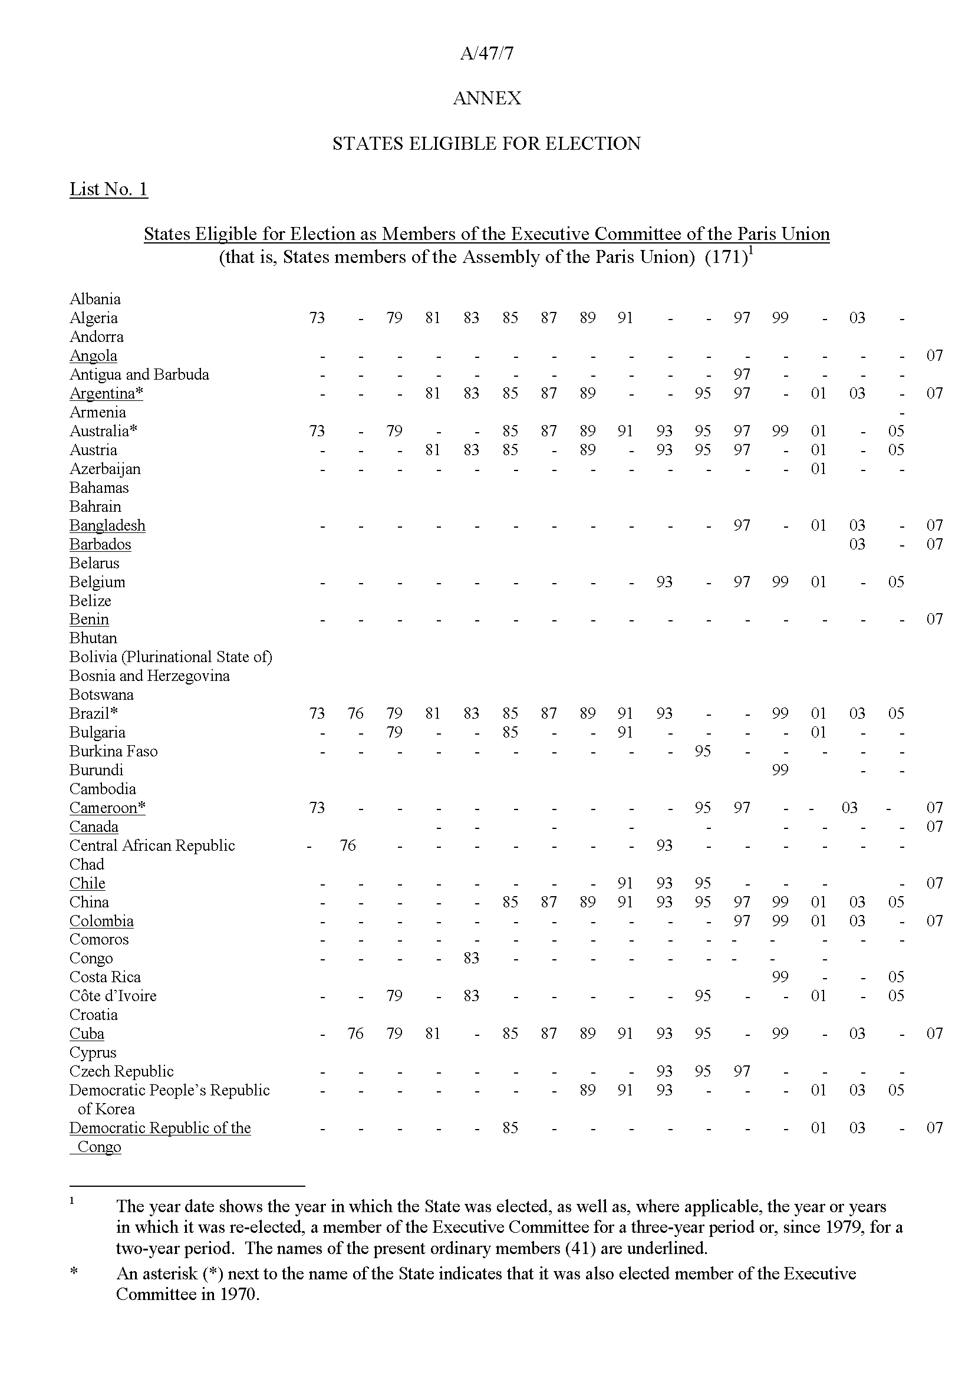

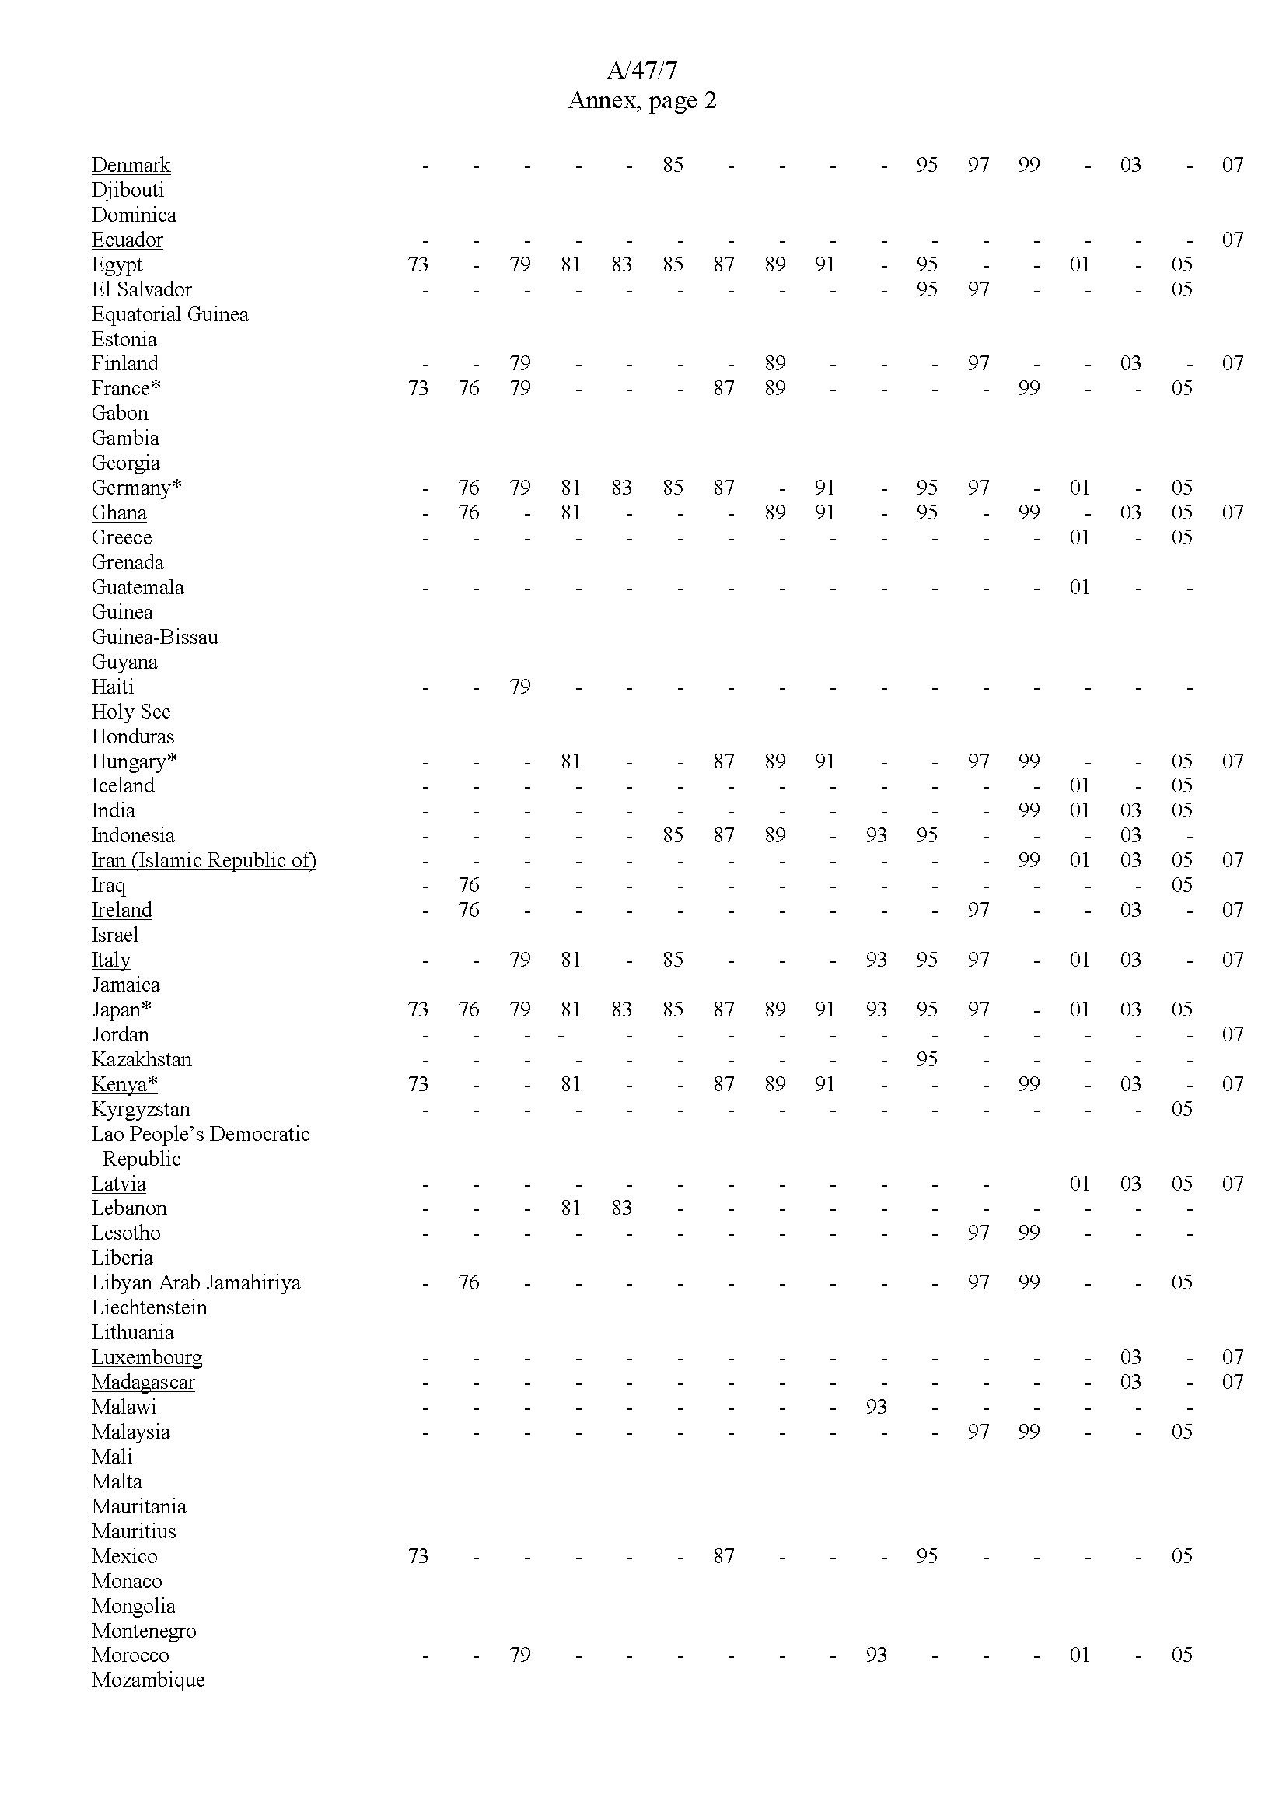

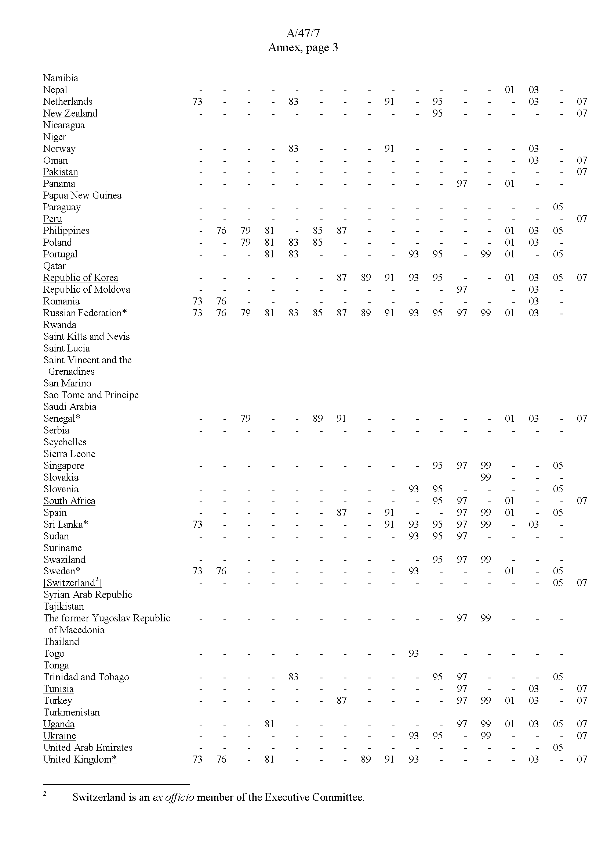

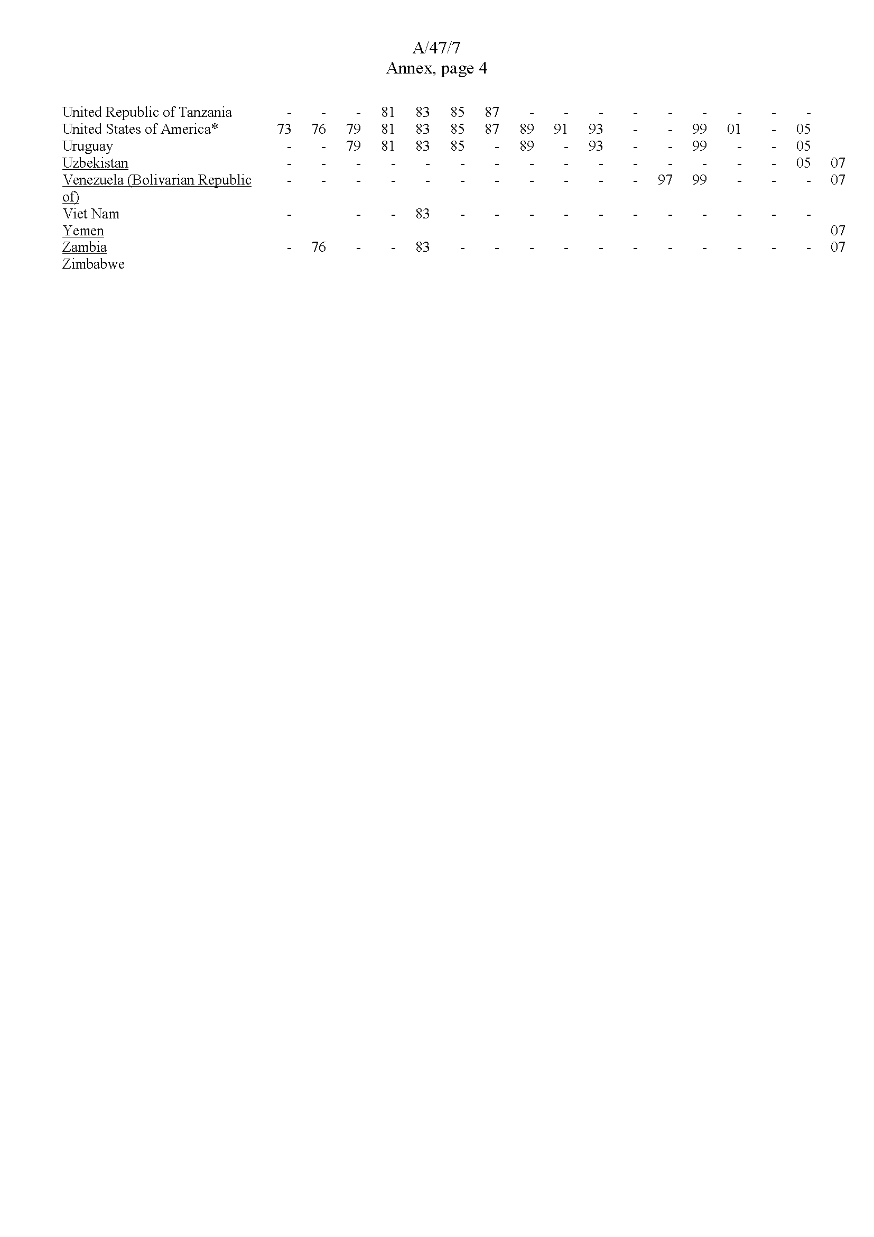
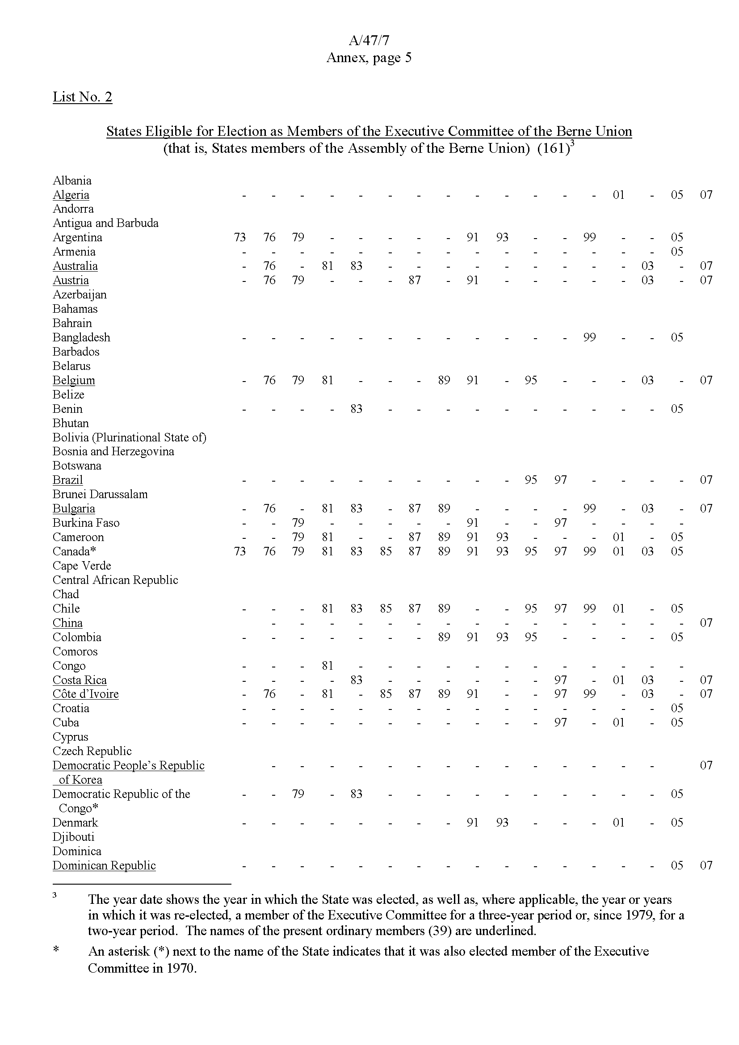

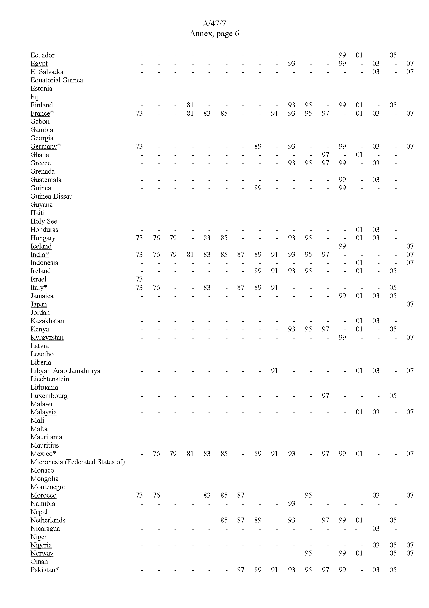

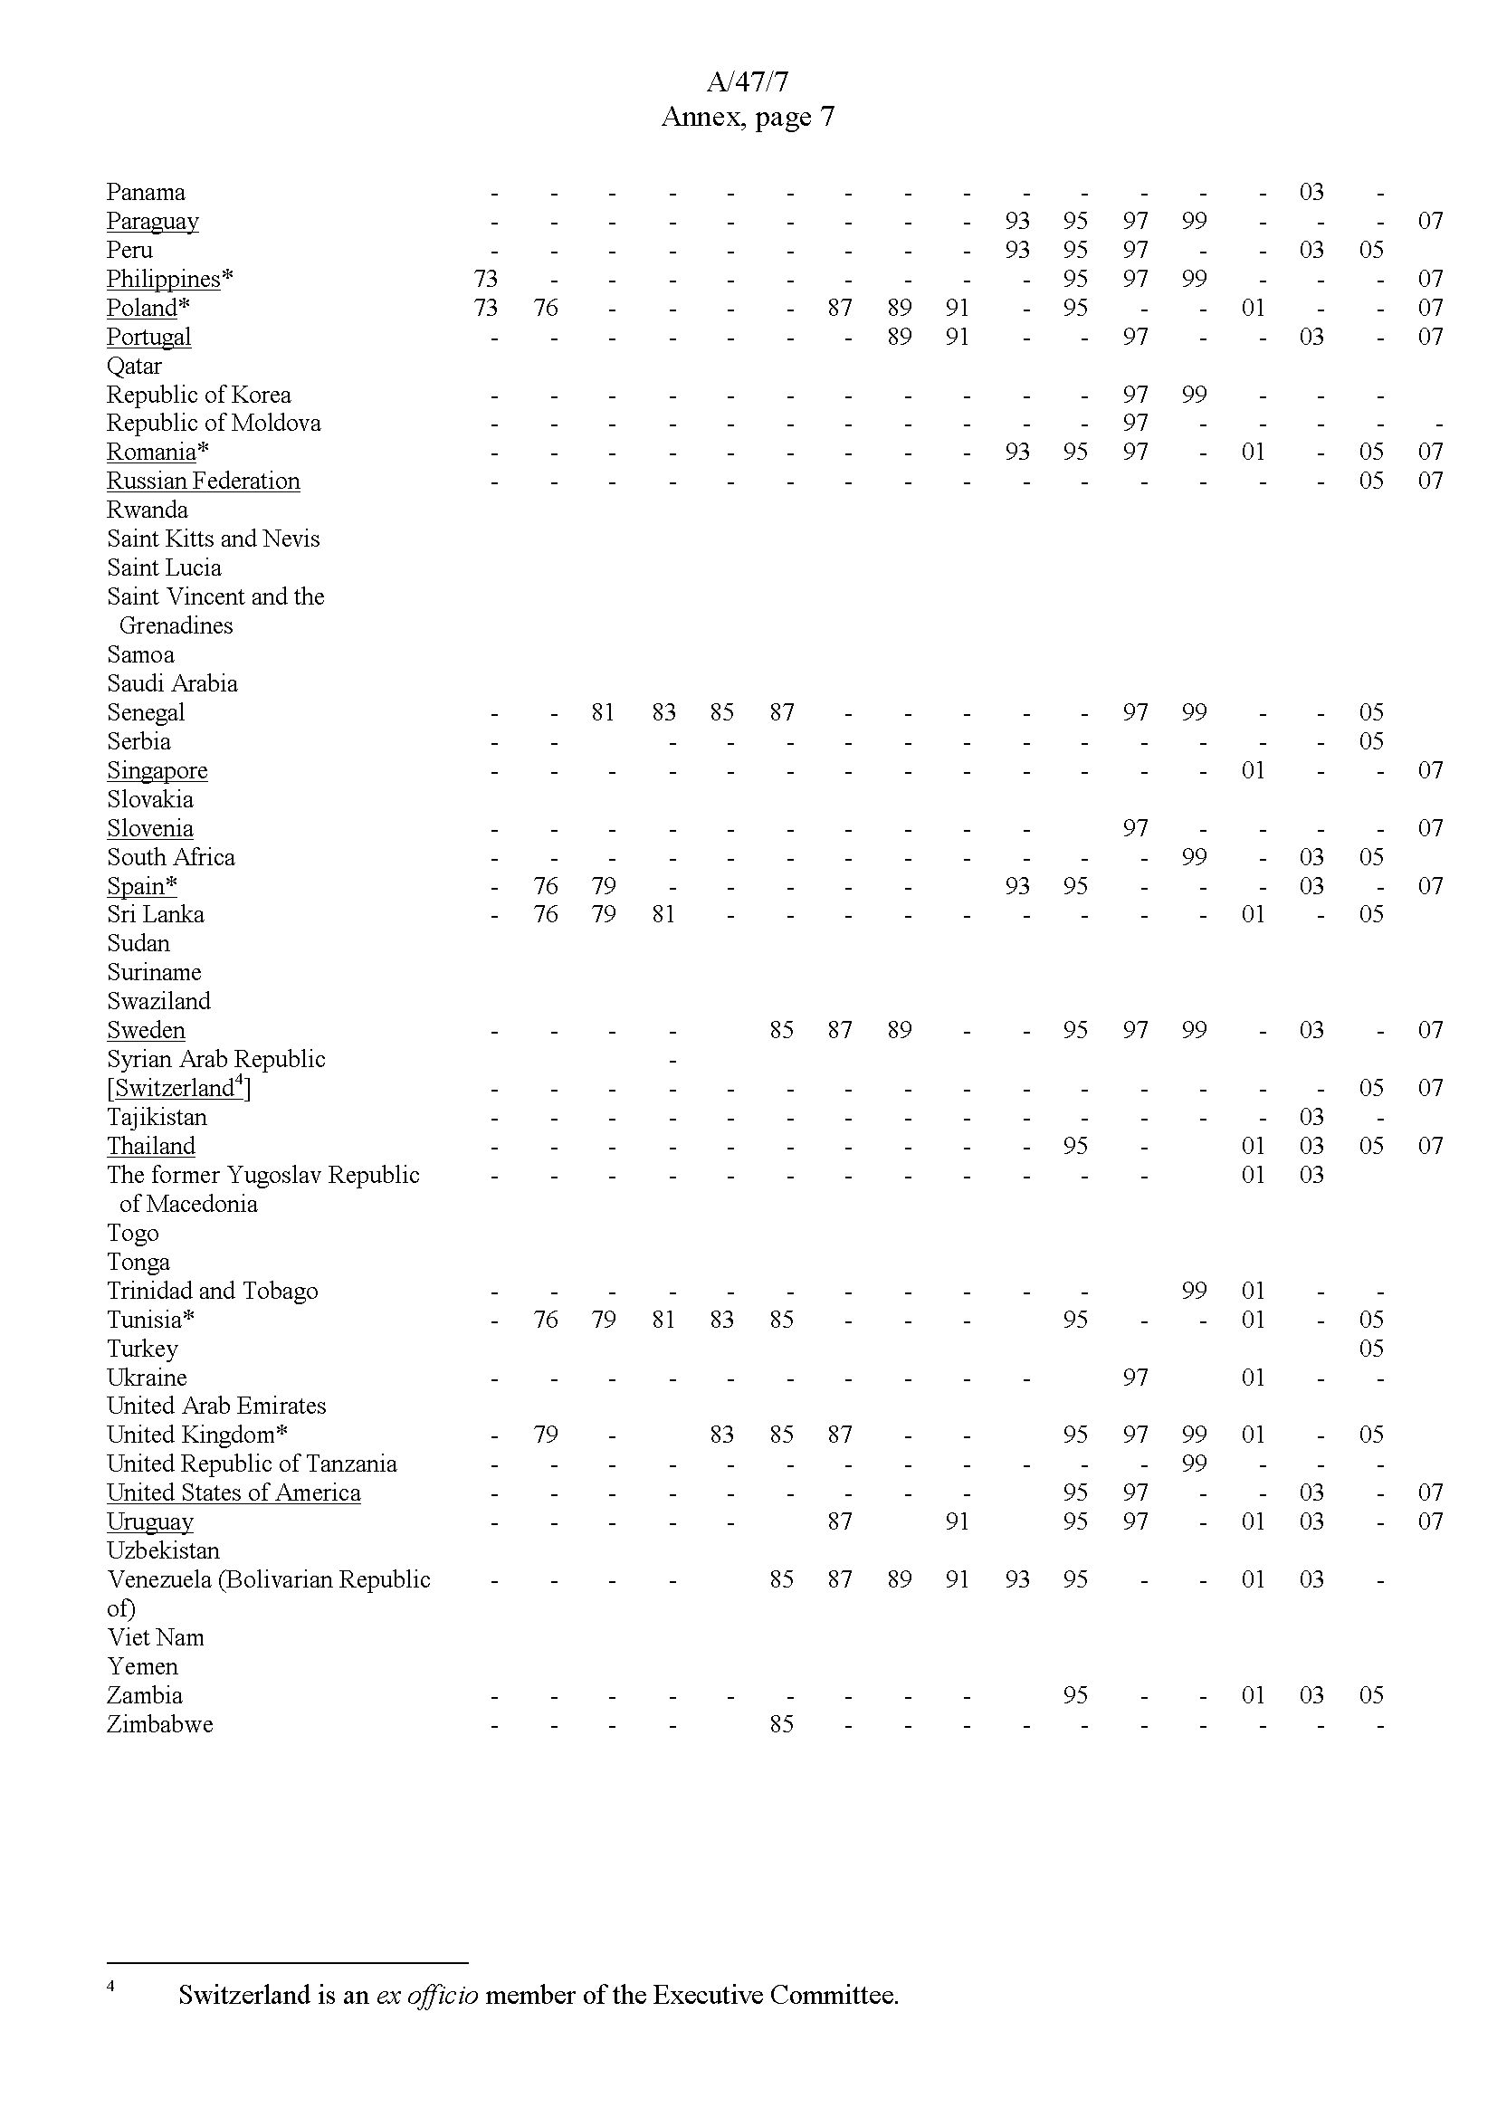

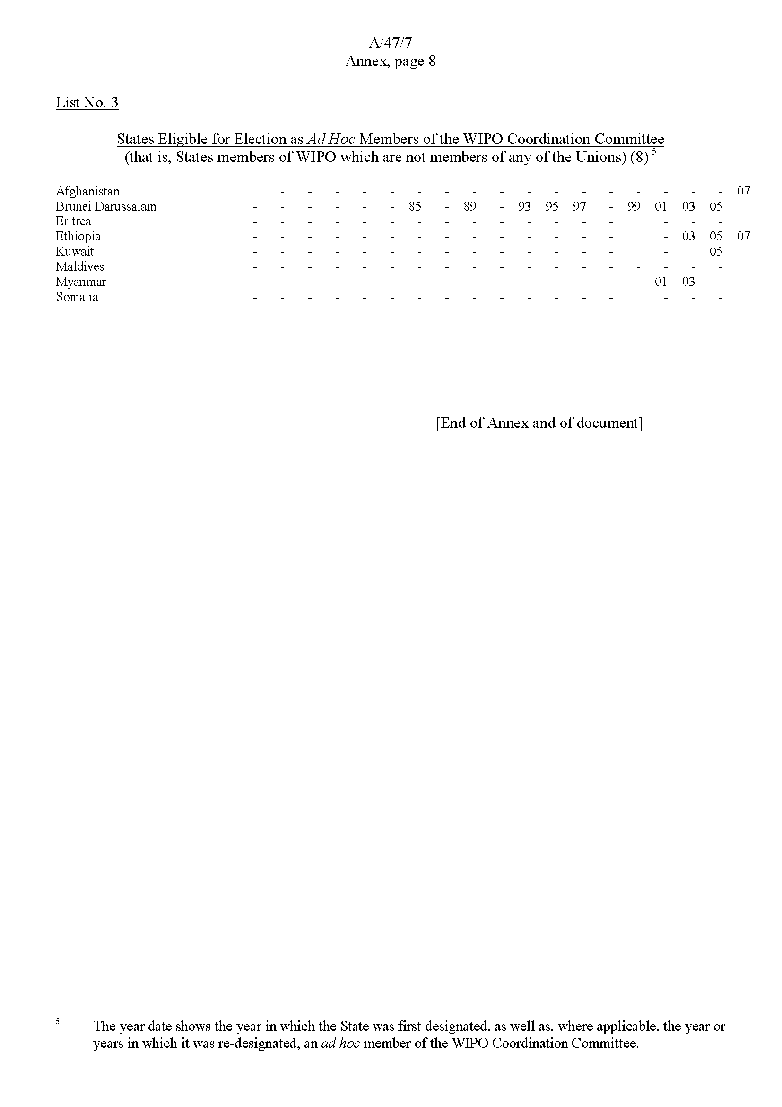

Article 8(1)(a) and (c), WIPO Convention.
Article 11(9)(a), WIPO Convention.
Elected by the Assembly of the Paris Union (see Article 14(2)(a) of the Paris Convention and Rule 3(1) of the Rules of Procedure of the Assembly of the Paris Union (document AB/XXIV/INF/2)).
The State on whose territory the Organization has its headquarters (Switzerland) is the ex officio member (see Article 14(2)(a) of the Paris Convention).
See Article 14(5)(b) of the Paris Convention.
42x2/3=28.
Forty-two represents one-fourth of the number of States members of the Assembly of the Paris Union, discounting any remainders after division by four (see Article 14(3) of the Paris Convention). There are 171 members of the Assembly, whose names are set out in List No. 1 in the Annex.
Elected by the Assembly of the Berne Union (see Article 23(2)(a) of the Berne Convention and Rule 3(1) of the Rules of Procedure of the Assembly of the Berne Union (document AB/XXIV/INF/2)).
The State on whose territory the Organization has its headquarters (Switzerland) is the ex officio member (see Article 23(2)(a) of the Berne Convention).
See Article 23(5)(b) of the Berne Convention.
40x2/3=26.6, which, by convention, is rounded to the nearest whole number.
Forty represents one-fourth of the number of States members of the Assembly of the Berne Union, discounting any remainders after division by four (see Article 23(3) of the Berne Convention). There are 161 members of the Assembly, whose names are set out in List No. 2 in the Annex.
See Article 8(1)(a) of the WIPO Convention.
See Article 11(9)(a) of the WIPO Convention.
See Article 8(1)(c) of the WIPO Convention.
In addition, the Coordination Committee comprises, in theory, any associate members of the Executive Committee of the Paris Union or the Executive Committee of the Berne Union, which serve as associate members of the WIPO Coordination Committee. The class of associate members is, however, now redundant (see notes 7 and 13, above, and Rule 2(3) of the Rules of Procedure of the WIPO Coordination Committee (document AB/XXV/INF/2)).
There are 8 States members of the WIPO Conference that are not members of any of the Unions. Their names are set out in List No. 3 in the Annex. The number of ad hoc members of the WIPO Coordination Committee to be designated by the WIPO Conference is thus two.

