WIPO |  | E  A/36/13  ORIGINAL: English  DATE: August 6, 2001
WORLD INTELLECTUAL PROPERTY ORGANIZATION
GENEVA

assemblies of the member states of wipo
Thirty-Sixth Series of Meetings
Geneva, September 24 to October 3, 2001
RESOLUTIONS CONCERNING THE PARTICIPATION OF yUGOSLAVIA
IN WIPO MEETINGS
Document prepared by the Secretariat

1 At their sessions held in September 1992, the Governing Bodies of WIPO and of the Unions administered by WIPO convened for those sessions adopted the following decision:

“The Governing Bodies of WIPO and the Unions administered by WIPO, meeting during the period September 21 to 29, 1992,

Noting United Nations Security Council Resolution 777 of 19 September 1992, and United Nations General Assembly Resolution A/47/RES/1 of 22 September 1992,

Decide that the Federal Republic of Yugoslavia (Serbia and Montenegro) shall not participate in any meetings of the said Governing Bodies. This decision will be reviewed by the said Governing Bodies in the light of future decisions taken by the United Nations General Assembly.”
(document AB/XXIII/6, paragraph 120).
2 Not all of the Governing Bodies of WIPO and of the Unions administered by WIPO (there were over 20 such Governing Bodies at the time) were in session when the decision set out in the preceding paragraph was adopted in 1992. Accordingly, when all the Governing Bodies of WIPO met in ordinary session the following year in September 1993, they adopted the following decision:

“The decision which the Governing Bodies of WIPO took in 1992 is extended to cover the sessions of the Governing Bodies of WIPO and the Unions administered by WIPO, meeting during the present period of September 20 to 29, 1993. That decision would be reviewed by the Governing Bodies in the light of future decisions taken by the United Nations General Assembly.”
(document AB/XXIV/18, paragraph 49).

3 The foregoing decisions were modeled on Resolution 47/1 of September 22, 1992, of the United Nations General Assembly (UNGA).

4 On November 1, 2000, the Federal Republic of Yugoslavia (FRY) was admitted to membership in the United Nations by UNGA Resolution 55/12. On June 14, 2001, FRY deposited with the Director General of WIPO an Instrument of Notification of Succession and Confirmation. Under that Instrument, FRY notifies its succession to the WIPO-administered treaties to which the former Socialist Federal Republic of Yugoslavia was party as from April 27, 1992, the date on which FRY assumed responsibility for its international relations, and confirms all WIPO-administered treaty actions made by FRY after April 27, 1992. A copy of the corresponding treaty notification is set out in the Annex to this document.

5 Having regard to the explicit linkage between the decisions of the Governing Bodies in 1992 and 1993 and UNGA Resolution 47/1, as well as “future decisions taken by the United Nations General Assembly,” and in light of the deposit by FRY of the Instrument of Notification of Succession and Confirmation, the Assemblies of the Member States of WIPO may deem it appropriate to review the 1992 and 1993 resolutions concerning the participation of Yugoslavia in WIPO.

6 The Assemblies of the Member States of WIPO are invited, each in so far as it is concerned, to consider the resolutions that were passed in 1992 and 1993 and that are set out in paragraphs 1 and 2, above, and to decide what action they may wish to take with respect to those resolutions.

[Annex follows]
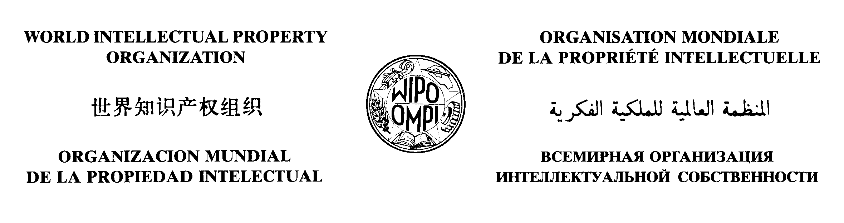
./.

WIPO Notification No. 206
PARIS Notification No. 204
BERNE Notification No. 222
MADRID (MARKS) Notification No. 133
NICE Notification No. 110
LOCARNO Notification No. 52

CONVENTION ESTABLISHING
THE WORLD INTELLECTUAL PROPERTY ORGANIZATION
AND CERTAIN OTHER TREATIES ADMINISTERED BY WIPO

Declaration by
the Federal Republic of Yugoslavia

The Director General of the World Intellectual Property Organization (WIPO) presents his compliments to the Minister for Foreign Affairs and has the honor to notify him of the deposit by the Government of the Federal Republic of Yugoslavia, on June 14, 2001, of an instrument declaring that the Federal Republic of Yugoslavia is to be considered from April 27, 1992, as having succeeded to the Convention Establishing the World Intellectual Property Organization and certain other treaties specified therein, as well as confirming certain treaty actions, also specified in the said instrument, that have been made since April 27, 1992. The text of the said instrument is attached to this Notification.

June 14, 2001

INSTRUMENT OF NOTIFICATION OF SUCCESSION AND CONFIRMATION THE WORLD INTELLECTUAL PROPERTY ORGANIZATION (WIPO)

Whereas the Socialist Federal Republic of Yugoslavia was a State party or signatory to the treaties listed in the attached Annex 1;
Whereas the Federal Republic of Yugoslavia is a successor State to the Socialist Federal Republic of Yugoslavia;
Now, therefore, the Government of the Federal Republic of Yugoslavia, having considered the treaties listed in the attached Annex 1 , succeeds to the same and undertakes faithfully to perform and carry out its obligations contained therein as from April 27, 1992, the date on which the Federal Republic of Yugoslavia assumed responsibility for its international relations.
Furthermore, the Government of the Federal Republic of Yugoslavia maintains the signatures, reservations, declarations and objections made by the Socialist Federal Republic of Yugoslavia to the treaties listed in the attached Annex 1, prior to April 27, 1992;
The Government of the Federal Republic of Yugoslavia further confirms all those treaty actions and any accompanying declarations made by the Government of the Federal Republic of Yugoslavia after April 27 , 1992, and which are listed in the attached Annex 2.

Done at Belgrade, on 11 June 2001.

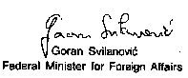
Annex 1 to Instrument of Notification
of Succession and Confirmation. WIPO

List of WIPO Treaties to which the Socialist Federal Republic of Yugoslavia
was a State Party before April 27, 1992

- Convention Establishing the World Intellectual Property Organization (WIPO Convention).
- Paris Convention for the Protection of Industrial Property (Paris Convention).
- Berne Convention for the Protection of Literary and Artistic Works (Bern Convention). Madrid Agreement Concerning the International Registration of Marks (Madrid Agreement).
- Nice Agreement Concerning the International Classification of Goods and Services for the Purposes of the Registration of Marks (Nice Agreement).
- Locarno Agreement Establishing an International Classification for Industrial Designs (Locarno Agreement).
- Convention Relating to the Distribution of Programme-Carrying Signals Transmitted by Satellite (Satellite Convention).

List of WIPO Treaties to which the Socialist Federal Republic of Yugoslavia was Signatory (without yet being Party) before April 27, 1992)

- Patent Cooperation Treaty (PCT).
- Protocol Relating to the Madrid Agreement Concerning the International Registration of Marks (Madrid Protocol).
- Hague Agreement Concerning the International Deposit of Industrial Designs (Hague Agreement).
Annex 2 to Instrument of Notification
of Succession and Confirmation, WIPO

Treaty Actions by the Federal Republic of Yugoslavia (FRY) after April 27, 1992

- On November 25, 1993, FRY deposited its instrument of accession to the Budapest Treaty on the International Recognition of the Deposit of Microorganisms for the Purposes of Patent Procedure (see Budapest Notification No.121 dated November 30, 1993).
- On November 25, 1993, FRY deposited its instrument of ratification of the Hague Agreement Concerning the International Deposit of Industrial Designs (see Hague Notification No.36 dated November 30, 1993). The former SFRY had signed the Hague Act (1960) of the Agreement in 1960.
- On November 1, 1996, FRY deposited its instrument of ratification of the Patent Cooperation Treaty (see PCT Notification No.115 dated November 4, 1996). The former SFRY had signed the PCT in 1970.
- On November 17, 1997, FRY deposited its instrument of ratification of the Protocol Relating to the Madrid Agreement Concerning the International Registration of Marks (see Madrid (Marks) Notification No.97 dated November 17,1997). The former SFRY had signed the Madrid Protocol in 1989.
- On June 15, 1998, FRY deposited its instrument of accession to the Trademark Law Treaty (see TL T Notification No.25 dated June 15, 1998).
- On March 1, 1999, FRY deposited its instrument of accession to the Lisbon Agreement for the Protection of Appellations of Origin and their International Registration (see Lisbon Notification No.23 dated March 1 , 1999).
- On February 18, 2000, FRY deposited its instrument of accession to the Nairobi Treaty on the Protection of the Olympic Symbol (see Nairobi Notification No.45 dated February 18, 2000).
- On February 18, 2000, FRY deposited its instrument of accession to the Madrid Agreement for the Repression of False or Deceptive Indications of Source on Goods (see Madrid (Indications of Source) Notification No. 26 dated February 18, 2000).

[End of Annex and of document]

