WIPO |  | E  A/35/9  ORIGINAL: English  DATE: September 22, 2000
WORLD INTELLECTUAL PROPERTY ORGANIZATION
GENEVA

assemblies of the member states of wipo
Thirty-Fifth Series of Meetings
Geneva, September 25 to October 3, 2000
PROGRAM 12 (INFORMATION TECHNOLOGY PROJECTS): REAPPROPRIATION of ELAPSED BUDGET AUTHORITY 1998-1999 FINANCED BY THE SPECIAL RESERVE FUND (SRF) for additional premises and computerization
Memorandum of the Director General

1 The Program and Budget Committee, at its second session from September 20 to 22, 2000, discussed the proposals on Program 12 (Information Technology Projects): Reappropriation of Elapsed Budget Authority 1998-1999 Financed by the Special Reserve Fund (SRF) for Additional Premises and Computerization (document WO/PBC/2/3) which is annexed to this document. The views of the Member States represented at the Committee on these proposals, are contained in its report (document WO/PBC/2/6*).

2 The Assemblies of the Member States of WIPO and the Unions administered by WIPO are invited, each as far as it is concerned, to approve the reappropriation of the elapsed budget authority for Program 12 activities financed by the Special Reserve Fund for additional premises and computerization.

[Attachment follows]
A/35/9
ATTACHMENT

INTRODUCTION

1. The Standing Committee on Information Technology (SCIT) at its fourth Plenary Session, held from December 6 to 10, 1999, while noting the progress on the Establishment and Operation of the WIPONET Project made inter alia the following recommendation (contained in document SCIT/4/8):

“28. The SCIT Plenary agreed …

(b) to recommend to the Program and Budget Committee that:

(i) the Program 12 (SRF) unspent balance for the 1998-99 biennium, arising from the delay in the award of a contract for WIPONET, be reappropriated to WIPONET for the 2000-01 biennium; and

(ii) funds be made available in future biennial program and budgets to meet the running costs resulting from WIPONET project deployment; ….

29. In agreeing the above the SCIT Plenary noted that, with reference to
paragraph 28(b)(ii), above, the sharing of running costs between WIPO and the IPOs (Intellectual Property Offices) needs to be carefully considered on an ongoing basis…”

2. Discussion of the WIPONET Project was based on document SCIT/WG/2/2. At the time of the SCIT Plenary session in December 1999, it was estimated that the Program 12 (SRF) unspent balance would be approximately 10 million Swiss francs. Since then the International Bureau has finalized the accounts for 1998-1999 and has confirmed a Program 12 (SRF) underspend of 15.3 million Swiss francs. This can be broken down as follows:

Sub-program | Budget  1998- 1999 | Unspent  Balance | Comments
(in thousands of Swiss
francs)
12.0 – Staff costs | 2,967 | 1,832 | Delay in many program activities (see below) impacted staffing numbers and costs.
12.1 – Establishment and operation of Global Information Network | 11,603 | 6,406 | Underspend due to delay in contract signature for WIPONET Project deployment.
12.2 – Provision of IP information services | 7,615 | 5,997 | Delayed start of the upgrading of the IPC database management system.  Implementation of IPDL Project deferred to 2000-2001 biennium.  PCT OCR Project contract awarded in June 1999 but start of chargeable work delayed until November 1.
12.3 – Standing Committee on IT | 1,237 | 633 | Costs associated with servicing of 5 SCIT sessions lower than expected.
12.4 – Internal network services | 1,526 | 458 | Funding was allocated for purposes of upgrading of office computing equipment and system migration to a Windows NT environment. Some of this work was covered under the requirement to make existing WIPO systems Year 2000 compliant and was subsequently charged elsewhere in Main Program 12.
SRF total for  1998-1999 biennium: | 24,948 | 15,326

3. The International Bureau proposes that the entire amount of 15.3 million Swiss francs be reappropriated for the 2000-2001 biennium for the following activities. Justification for these allocations follows.

Sub-program | Amount  (in Swiss francs) | Activity
12.1 – WIPONET | 10 million  3.3 million | WIPONET Project implementation, including deployment in Member States with no Internet access from any IPO (see paragraphs 5 to 7)  FOCUS Project (see paragraphs 9 and 10)
12.2 – IPI Services | 2 million | PCT OCR Project (see paragraphs 7 and 8)

4. The impact of the reappropriation on the existing Program 12 budget for the 2000-2001 biennium is shown in the Annex to this document.

JUSTIFICATIONS FOR USE OF REAPPROPRIATED FUNDS: WIPONET

5. At the fifth SCIT Plenary session, held from July 10 to 14, 2000, delegates noted a WIPONET Project implementation strategy (contained in document SCIT/5/4) which set out a timetable and goals for deployment. This strategy was based on a number of basic principles including the need to ensure that the Project provides for an equitable level of access for all Member States and is sustainable by focusing on justified requirements. Therefore, any request from an intellectual property office (IPO) for a change in the package offered must be cost-effective and based on agreed business needs.

2000-2001 Biennium:
- provision of Internet connectivity to Member States with no Internet access from any IPO (approximately 64)
- establishment of WIPONET Central Services which will be available to all IPOs that already have Internet access (approximately 164)
- implementation of the necessary infrastructure within the International Bureau
- provision of Helpdesk and training facilities

2002-2003 Biennium:
- provision of Internet connectivity to remaining IPOs (approximately 87)
- maintenance of 64 IPOs connected in previous biennium, including running costs
- 360 hours dial-up Internet connectivity per IPO, per annum
- provision of operational services, e.g., Helpdesk and International Bureau server farm
- addition of new WIPONET Services based on agreed business requirements

6. The cost of the Project for 2000-2001 is estimated at 20 million Swiss francs of which 10 million Swiss francs is available within the current Program and Budget. If the 1998-1999 funds (totaling 10 million Swiss francs for WIPONET) are not made available for the 2000-2001 biennium, the scope of the Project rollout will need to be substantially revised to the extent that it will only cover the provision of Central Services and will not be able to undertake the deployment of Internet connectivity in Member States.

7. Document SCIT/5/4 recommended that the continuation of the WIPONET Project be covered by the relevant Program and Budget in the 2002-2003 biennium at a cost of 24.6 million Swiss francs. Financial sustainability of the WIPONET beyond 2003 will be a consideration for Member States when examining the Program and Budget for 2004-2005. However, it is expected that the downward trend in global telecommunications costs will continue in the intervening period and currently unforeseen technological advances may reduce network overheads even further. Finally, it should be noted that one of the recognized critical success factors with WIPONET is the provision of quality services that benefit the work processes of individual IPOs. When this is achieved, it will then allow for a gradual transfer of financial responsibility from WIPO to individual Member States, if so desired.

PCT OCR PROJECT

8. The objective of the PCT OCR (Optical Character Recognition) Project is to convert electronic facsimile pages (claims and descriptions only) of PCT International Applications into mixed-mode format, such that the full text of the PCT Applications in character coded form can be included in the WIPO Intellectual Property Digital Library (IPDL). The scope of the Project is the conversion to electronic media of all PCT pamphlets written in English, French, Spanish and German published between April 1998 and December 2000.

9. A Request for Proposal (RFP) was issued for the Project by the International Bureau in February 1999 and a contract was subsequently awarded to the successful bidder in May 1999. An amount of 2 million Swiss francs was allocated to cover the work. PCT conversion work begun in November 1999 and will continue until the end of December 2000. However, although the financial commitment for the contract award was carried over into the 2000-2001 biennium, the budget authority for the allocated sum elapsed on January 1 this year. If the money is not reappropriated into the current biennium, the contract value of 2 million Swiss francs will need to be found from within the existing budget for 2000-2001. This would require savings from Main Program 12 of some 5 per cent from the total budget for non-staff costs which would restrict both the work of the IT Projects and Services Divisions.

FOCUS PROJECT

10. The Information Technology Strategic Implementation Plan agreed by the SCIT in December 1999 included the terms of reference for 14 distinct information technology projects or activities. The last of these, titled “Information Technology Infrastructure Improvements” detailed the work that needed to be carried out internally by the International Bureau to consolidate computer room space and to carry out network upgrades necessary to optimize existing systems and to allow for the operation of projects such as PCT IMPACT and WIPONET. Since then, extensive work has been carried out by the International Bureau to initiate the Project under its new name of FOCUS (Failsafe, Organization-wide,
Customer-oriented, Upgradeable, Secure IT infrastructure).

11. As part of the project management methodology now adopted by the International Bureau, a detailed budget was prepared which estimated a total cost for the Project of 4,040,000 Swiss francs (inclusive of human resource costs). No budgetary provision was made for the work in the 2000-2001 biennium; however, the Project is fundamental to the success of the PCT IMPACT, WIPONET and IPDL Projects. In recognition of this fact the three projects have provided start-up funds to FOCUS, totaling 1,200,000 Swiss francs. Therefore, the addition of 3.3 million Swiss francs from the 1998-1999 biennium would meet the balance of the FOCUS budget estimate. If the reappropriation is not forthcoming the IMPACT, WIPONET and IPDL Projects will be forced to contribute the balance of funds from their respective budget allocations, which in turn could have a serious negative impact on project scope and delivery.

12. The Program and Budget Committee is invited to recommend to the General Assembly the reappropriation of the 1998-1999 elapsed budget authority for Program 12 activities funded by the Special Reserve Fund for Additional Premises and Computerization, as proposed in paragraph 3, above.

[Annex follows]

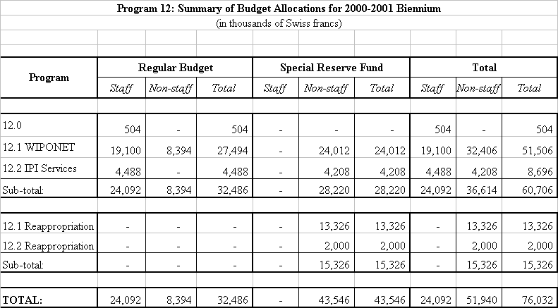
A/35/9
Annex, page 6

[End of Annex and of document]

* document WO/PBC/2/6 is available for reference

