 |  | E
WIPO/ACE/8/9
_ORIGINAL: English
DATE: October 15, 2012

Advisory Committee on Enforcement

Eighth Session
Geneva, December 19 and 20, 2012

ANTI-COUNTERFEITING POLICIES OF THE KOREAN INTELLECTUAL PROPERTY OFFICE (KIPO)

prepared by Mr. Koo Bonchul, Deputy Director, KIPO Industrial Property Protection Team∗

I. Background

1 With 370,000 patent, trademark, and design applications, the Republic of Korea had the fourth highest number of industrial property applications worldwide in 2011. The importance of protecting intellectual property rights is further emphasized with the growing rate of IPR creation. Accordingly, KIPO is expanding its efforts to form a social infrastructure in which intellectual property rights are respected and fairly optimized.

2 Counterfeit goods not only threaten the safety of consumers and hinder a sound commercial order, they also cause serious harm to the national economy by devaluing the national brand and deterring foreign investment. In particular, the distribution of counterfeit medications and automobile parts threatens the health and safety of users. Counterfeit goods also wither investment and development from companies which in turn decreases the number of jobs. Therefore, KIPO is doing its utmost to eradicate the distribution of counterfeit goods.

3 To this end, KIPO inaugurated the Special Judicial Police Force for trademark rights in 2010 to enforce the Unfair Competition Act against the illegal distribution of counterfeit goods. In 2011, KIPO established an online investigation team with increased enforcement power to criminally charge persons responsible for distributing counterfeit goods.

4 Furthermore, KIPO is operating a monetary reward system for the reporting of counterfeit goods to systematically gather information about the manufacture and distribution of counterfeit goods. It is also conducting a number of public campaigns to raise awareness of the harmful effects of counterfeit goods.

II. The Anti-counterfeiting Enforcement Activities of the Special Judicial Police Force for Trademark Rights

5 Following the passing of an amendment allocating special judicial authority to KIPO for the creation of an anti-counterfeiting police squad, KIPO inaugurated the Special Judicial Police Force (SJPF) for trademark rights in September 2010 with the power to directly investigate counterfeit goods-related crimes.

6 Accordingly, the SJPF has set up offices in major metropolitan areas such as Seoul, Busan, and Daejeon and strengthened its enforcement efforts with the capacity to criminally charge suspects. In December 2011, KIPO created an online investigation team equipped with digital forensics tools within the SJPF to crack down on the rapidly increasing online distribution of counterfeit goods.

7 So far, the SJPF has seen positive results with criminal charges against 139 suspects and the confiscation of about 30,000 counterfeit goods in 2011. There has been a major upturn in enforcement since the implementation of the SJPF as a result of its professionalism and focus on manufacturers and large-scale distributors of counterfeit goods.

< Enforcement Statistics of the SJPF>
Type |  | Before Introduction of the SJPF*  (2010.1∼8) | After Introduction of the SJPF
 |  | Before Introduction of the SJPF*  (2010.1∼8) | 2010.9∼12 | 2011 | 2012.1∼6 | Subtotal
Criminal Charges | Persons | 15  (1.9/month) | 45 | 139 | 159 | 343  (15.6/month)
Criminal Charges | Confiscated goods | 2,860  (357/month) | 28,629 | 28,589 | 77,726 | 134,944  (6,133/month)
* Includes accomplishments of co-detection between police and prosecution

8 Most of the confiscated goods consisted of bags, clothing, accessories, and shoes replicating famous brands.

<Enforcement Statistics by Item (2011)>
Item | Bags | Clothing | Accessories | Shoes | Glasses | Watches | Other | Total
Pieces | 4,158 | 2,751 | 1,443 | 1,176 | 223 | 171 | 18,667 | 28,589

9 Meanwhile, for efficient enforcement to address counterfeit goods, it is necessary to build cooperation between the government and civilians such as voluntary reporting of counterfeit goods by citizens.

10 To this end, KIPO has been operating a monetary reward system for the reporting of counterfeit goods since 2006 to systematically gather information about the manufacture and distribution of counterfeit goods.

11 Any member of the public may report a manufacturer, distributor, or seller of counterfeit goods. If the report leads to an indictment, the individual receives a monetary reward based on the market value of the genuine goods counterfeited.

12 In 2011, KIPO paid a total of $191,000 USD for 219 reports. By content, the reports included 109 of wholesale distribution ($92,000 USD); five of online sales ($2,000 USD); 39 of warehouse storage ($35,000 USD); and 66 of manufacture ($62,000 USD).

13 From 2006 to 2011, KIPO awarded a total of $1,292,000 USD through the monetary reward system including $286,000 USD for 107 reports in 2006, the first year of operation.
The monetary reward system has been proven to be highly beneficial with the market value of the genuine prices of the counterfeit goods totaled $1,802,000,000 USD, which is
1,400 times the reward money paid.

<Results of the Monetary Reward System>
Type | 2006 | 2007 | 2008 | 2009 | 2010 | 2011 | Total
Payment Amount  (Thousand USD) | 286 | 222 | 195 | 221 | 177 | 191 | 1,292
Value of Genuine Goods (Million USD) | 303.9 | 280.9 | 316.6 | 250 | 271.4 | 379.1 | 1,802
Results as a Multiple of Payment | 1,062 | 1,264 | 1,637 | 1,131 | 1,532 | 1,985 | 1,395

III. Online Anti-counterfeiting Enforcement through IPOMS

14 With the expansion of online open markets, online distribution of counterfeit goods has shown a steep yearly increase with the means of distribution continuing to grow.

15 In response to this, KIPO has built IPOMS (Intellectual Property On-line Monitoring System) to intensify enforcement efforts in order to eradicate the online open market distribution of counterfeit goods and shut down personal online shopping mall sites.

16 IPOMS, in operation since 2010, is a constant online monitoring system that detects postings of counterfeit goods distributed through Korean online open markets and personal online shopping malls. It stops the sale of counterfeit goods by deleting such posts and blocking access to sites through requests by the Korean IP Protection Association (KIPRA)
to the online open market.

17 IPOMS uses an automatic detection system which aggregates information about sales postings on online open markets and detects counterfeit goods by comparing detection keywords, blacklists, and price information. If the system confirms the presence of counterfeit goods, the results are sent to the managers of the relevant open markets that voluntarily implement a cessation of sale.

<Flow Chart of Online Anti-counterfeiting Enforcement through IPOMS>
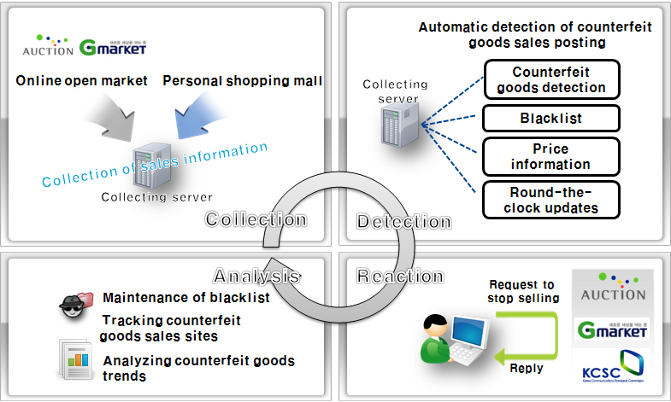

18 The owners of online open markets and personal shopping malls actively cooperate with IPOMS because they would lose credibility and be forced to pay for damages to consumers if counterfeit goods are found to be traded on their website (based on the law protecting consumers during online trading).

19 If a good is identified as counterfeit and its sale ceases, the system prevents further offenses by blacklisting the seller’s ID. The managing companies of online open markets also monitor the registration of blacklisted sellers using the same personal information.

20 Furthermore, if a shopping mall is caught by IPOMS selling counterfeit goods, professional monitors gather evidence of additional sales and request review by the Korea Communications Standards Commission, thereby blocking access to the site or shutting it down. Repeat and large-scale sellers are investigated by a special online squad depending on the circumstances of the case.

21 In 2010, KIPO stopped 2,890 sales in open markets and shut down 207 shopping malls. In 2011, 3,566 sales were stopped and 364 shopping malls shut down. IPOMS succeeded in stopping the sale of a total of 10,107 counterfeit goods between 2010 and 2011. Most goods replicated clothing, bags, wallets, and fashion accessories of famous Korean and foreign brands.

<Results of Anti-counterfeiting Enforcement in Open Markets >
Type | 2010 | 2011 | Total
Open Markets  Deletion of Ads | 2,890 | 3,566 | 6,456
Shopping Malls  Cessation of sale | 207 | 364 | 571

<Anti-counterfeiting Enforcement through IPOMS by Item (2010~2011)>
Item | Bags | Wallets | Clothing | Accessories | Shoes | Other | Total
Number (pieces) | 1,232 | 1,066 | 4,304 | 2,908 | 441 | 156 | 10,107

22 Lately, companies have been asking IPOMS to monitor their online products through KIPRA. KIPRA not only provides monitoring data feedback, it also stops the sale of counterfeit goods when detected through requests by KIPRA to the online open market.

23 In addition to that, we are constantly working to improve IPOMS to respond to the increasing sophistication and diversification of the online distribution of counterfeit goods. For instance, for items such as bags, watches, and shoes, the counterfeit sales of which take place in a short period, IPOMS is set up to automatically check posts within one hour of posting to open markets. Also, aggregation is extended beyond shopping mall sites promoted on portal sites to include blogs, communities, and social network sites, minimizing blind spots in the information-gathering stage.

IV. Raising Consumer Awareness for the Eradication of Counterfeit Goods Distribution

24 In addition to strong enforcement action against the manufacture and sale of counterfeit goods, KIPO is conducting various promotional activities with consumers to raise awareness of the importance of eradicating the distribution and consumption of counterfeit goods.

25 KIPO conducts public campaigns through a number of media channels including televised public service announcements, television broadcasts, newspaper advertisements, portal sites, blogs, and social network sites like Twitter to raise consumer awareness of the importance of protecting intellectual property. In particular, the public service announcements and TV broadcasts aim to publicize the harmful effects of counterfeit goods and to form a social consensus for a culture of consuming genuine goods.

26 Furthermore, KIPO is encouraging voluntary participation of consumers by staging boycotts of counterfeit goods in areas of frequent distribution with multiple consumer groups.
It is also running educational programs targeted at homemakers and college students.

27 In addition, KIPO has created entertaining video content dealing with the harmful effects of counterfeit goods for elementary and middle school students. It also administers learning programs for young adults to help them compare genuine and counterfeit goods.

28 In the future, KIPO will continue to raise consumer awareness of the harmfulness of counterfeit goods through such means as televised commercials and other promotional efforts. It plans to strengthen promotion and education in conjunction with consumer and other civilian groups to prevent the harmful effects of counterfeit goods.

V. Conclusion

29 For the formation of a social infrastructure that respects intellectual property rights, KIPO will further expand the personnel and organization of the Special Judicial Police Force for trademark rights and invigorate the online investigation team for stronger tracking and investigation of counterfeit goods distribution.

30 In particular, it will strengthen enforcement efforts against repeat offenders, areas of frequent counterfeit goods distribution, and those that threaten the safety of the public through counterfeit medication, among others.

31 Additionally, realizing that consumer awareness is key to the eradication of counterfeit goods, KIPO plans to run promotional campaigns targeting diverse consumer groups such as college students, homemakers, and office workers to shape a culture respectful of intellectual property.

[End of document]

 The views expressed in this document are those of the author and not necessarily those of the Secretariat or of the Member States of WIPO.
Online transaction sites, such as ebay, where third-parties (an individual or small-sized enterprise) sell their products.
Sites being operated directly by sellers who sell their own products.

