PROPOSAL FOR THE EXTENSION OF WIPO STANDARD ST.96 TO INCORPORATE EXTENSIBLE MARKUP LANGUAGE (XML) SCHEMA FOR ORPHAN WORKS
Document prepared by the UK IPO
The UK IPO proposed to the Committee on WIPO Standards (CWS) in May 2014 (CWS/4/3) that the data exchange standard known as WIPO Standard ST.96 should be extended to include orphan works in addition to the other IP rights of Patents Trade Marks and Designs.
The prompt for extending ST.96 was the UK IPO’s orphan works licensing scheme (where rights holders cannot be located) to allow the reproduction of orphan works for use in the UK only. For this the UK IPO has developed an online application process and a public database of identified orphan works subject to the UK IPO’s verification process and those it has agreed to license.
The EUIPO administers the EU orphan works system which also holds records of identified orphan works within the EU that are being used through the EU Directive on orphan works. Whilst the UK scheme is different to that of the EU, the similarities between the systems and the core information they hold around the orphan work, the rights holders, diligent searches etc. is fundamentally the same.
The UK IPO therefore considers that WIPO Standard ST.96 using XML, used as the UK IPO’s naming standard and for internal/external data-exchange relating to patents, trade marks and registered designs, should be available for use with data relating to orphan works.
It should be noted that the UK IPO is not suggesting there should be any mandatory registration of copyright as this would contravene the Berne Convention, nor is it asking other countries to set up orphan works schemes; this proposal is about facilitating mutually-compatible technical standards.
The UK IPO would therefore like to extend ST.96 to cover orphan works. The UK IPO has prepared a draft XML schema based on ST.96 for discussion by the expert group of the CWS, i.e. XML4IP Task Force, if the CWS approves this proposal (see Annex to this proposal.)

[Annex to the proposal follows]

ANNEX TO THE PROPOSAL
APPENDIX A - DRAFT XML SCHEMA FOR ORPHAN WORKS (OrphanWorkSchema_Draft.zip)
APPENDIX B - DIAGRAM OF DRAFT XML SCHEMA FOR ORPHAN WORKS
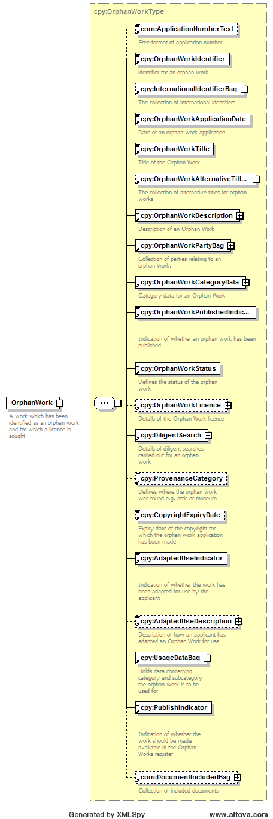

[Annex II follows]

