STATUS REPORT ON APPLICANT NAME STANDARDIZATION OF IP5 GLOBAL DOSSIER INITIATIVES
Document prepared by the Korean Intellectual Property Office (KIPO)

Background
- Information of patent applications including applicant names is a key element of patent searches as it is not only crucial for identifying the owner of a given patent, but also for aiding users in retrieving other necessary information.
- Unfortunately, applicant names have been a source of confusion. This may be caused by spelling errors made by applicants or their agents, mistakes by offices, or confusion relating to the suffix of a company (e.g. Corp., Inc., Co., Ltd.). This often occurs when applicant names are translated or transliterated into a foreign language so as to file applications in other countries.
- Therefore, inconsistencies in applicant names occur not only among national applications, but also between family applications at multiple offices.

Business case and Status of IP5 Applicant Name Standardization Initiative
- The problem with inconsistencies in applicant names motivated the Korean Intellectual Property Office (KIPO) to initiate the Applicant Name Standardization initiative in 2014. KIPO believed that other offices might have experienced similar problems, and so it viewed further discussion and cooperation on this issue as being beneficial to all IP5 Offices in enhancing their search efficiency and user convenience.
- Heads of the IP5 Offices endorsed the vision statement of Applicant Name Standardization initiative in 2015. The vision was to harmonize applicant names across IP5 patent document collections. By improving the consistency of the applicant names used in publication databases across the IP5, the public and examiners will benefit from higher quality search results and simplified statistical analysis. The consistency will also be beneficial for administering applicants’ accounts for cross filing.
- A proposal for implementing applicant name standardization was presented by KIPO at the WG2 meeting in 2016. The proposal introduced a standardization procedure including intra-office standardization and inter-office standardization in order to make a mapping table from IP5 family patents under the principle that family patents should have the same applicant’s information at the time of priority.
- Heads of the IP5 Offices endorsed the enhanced scope document of Applicant Name Standardization (Annex 1) in 2016.
- The progress on Applicant Name Standardization Initiative, including intra-office harmonization with KIPO’s own applicant names and the future timeline were presented by KIPO at the WG2 meeting in 2017. For the next stage, it was decided to conduct a pilot with 20 relevant applicants during 2017. In addition, the IP5 Offices agreed to present a status report on the Applicant Name Standardization Initiative at the IP5 level for consideration by the fifth session of the Committee on WIPO Standards (CWS).

IP5 Future Activities
- According to the scope document (see Annex I), the main product which will be delivered to the IP5 Offices from Applicant Name Standardization Initiative is a mapping table between the original applicant names and the standardized names. In order to make the best use of the mapping table in the IP5 Offices in the future, accuracy, efficiency, and sustainability should be considered when the mapping table is being built.
- If information of databases containing standardized applicant names can be shared between patent offices, organizations, and IP information providing companies, it is highly expected that the accuracy of the mapping table for the IP5 can be increased. Intra-office standardization for a specific office can be more accurately conducted based on well-established databases containing standardized applicant names by linking them with patent family information. KIPO and the EPO established their own standardized applicant names. It is widely known that the OECD and Thomson Reuters which are not member/observer of the IP5 WG2 meeting have the well-established database of standardized applicant or assignee names such as HAN database (OECD), DWPI assignee data (Thomson Reuters).
- Some IP5 Offices expressed concerns over the manual jobs for applicant name standardization at the WG2 meetings. In fact, manual jobs may include checking errors in automated process caused by spelling variations, typographical errors, acronyms, and so on. The errors come from various reasons depending on languages. If reasons causing manual jobs and algorithms to solve the errors in an automated way are collected as much as possible, manual jobs will be reduced and the efficiency of applicant name standardization for the IP5 Offices will be increased.
- Even though a well-established mapping table between the IP5 Offices is made, a sustainable way to maintain the mapping table needs to be considered. A company may submit its patent applications with other new applicant names by mistake which were not considered when the mapping table was established. A best practice or a standard to manage and assign one unique applicant name or identifier may be useful for the IP5 Offices.

IP5 High-level Roadmap

2017
- Pilot test with 20 companies (each IP5 Office recommends 4 companies, if possible) which have high number of patent applications with several applicant names

2018 or after
- Standardization of applicant names for all family applications in all IP5 Offices.
- Establishment and distribution of a mapping table of standardized applicant names.

[Annex I to the present document follows]

Annex I
“APPLICANT NAME STANDARDIZATION” SCOPE DOCUMENT
Contents
BACKGROUND 4
WHY DO WE ENGAGE IN THIS ACTIVITY? 5
Activity objectives 5
Benefits 5
Main products delivered 5
ACTIVITY SCOPE 6
In scope 6
Out of scope 6
CONSTRAINTS AND ASSUMPTIONS 7
NEXT STEPS 7
Timeline of activities 7

BACKGROUND
In order to facilitate easier and more convenient searches of patent information, intellectual property (IP) offices continue to enhance the search functionalities of their respective search systems. In particular, when it comes to original patent information (including information regarding its applicants), users require accurate and highly efficient searching methods that allow them to utilize patent information to its fullest extent.
Applicant information is a key element of patent searches as it is not only crucial for identifying the owner of a given patent, but also for aiding users in retrieving other necessary information.
Unfortunately, applicant names have been a source of confusion. This may be caused by spelling errors made by the applicant or its agent, mistakes by offices, or confusion relating to the suffix of a company (e.g. Corp., Inc., Co., Ltd.). This often occurs when an applicant name is translated into a foreign language so as to file an application in another country. Therefore, inconsistencies in applicant names occur not only among national applications, as shown in Table 1, but also between family applications at multiple offices, as shown in Table 2.
The problem with inconsistencies in applicant names motivated KIPO to initiate the “Applicant Name Standardization” Project in 2014. KIPO believes that other offices may have experienced similar problems, and so it views further discussion and cooperation on this issue as being beneficial to all IP5 Offices in enhancing their search efficiency and user convenience.
Table 1.Inconsistent applicant names in an office
Application No | Applicant Name
10-1995-0000123 A | ABC CO., LTD.
10-1996-0000111 A | ABD CO., LTD
20-1996-0001123 U | ABC CO LTD
10-1996-7001123 A | ABC Corp.
10-1996-7000123 A | A BEE CEE CO., LTD.
Table 2.Inconsistent applicant names in family patents
Applicant Name - Office A | Applicant Name - Office B
NORDSON CORP. | NORDSON CORPORATION
CYMER, LLC | CYMER, INC.
YANG, TAI HER | Tai-Her YANG
NIKE INNOVATE C.V. | NIKE, INC.
SHIN-ETSU QUARTZ PRODUCTS CO., LTD. | Heraeus Shin-Etsu America, Inc.

WHY DO WE ENGAGE IN THIS ACTIVITY?

Activity objectives
The “Applicant Name Standardization” Project is designed to eliminate the confusion caused by multiple versions of an applicant name by unifying them into a single, standardized name. As shown in Figure 1, the various alternate spellings of an applicant name (left) will be standardized to “ABC CO., LTD.”(right) thanks to this project.
Figure 1. Concept of Standardized Applicant Names
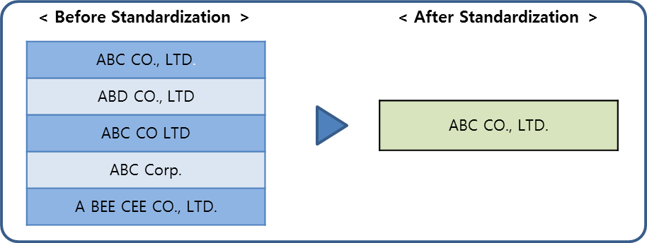

Benefits
Standardized applicant names are useful for search-related, analytical, statistical, and administrative purposes. For example, the center picture in Figure 2 shows the top 36 brands over the world, and it highlights the fact that many of these brands, including Apple, Samsung, Oracle, and Amazon, own valuable patents. KIPO believes that a unified applicant name database would be useful for analyses because inconsistencies in applicant names impede an accurate assessment of the patents owned by a given applicant.
Figure 2. Usage of Standardized Applicant Name
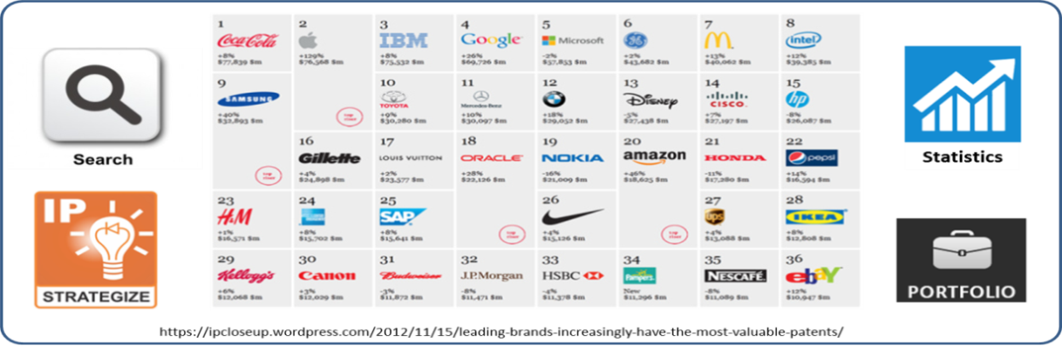

Main products delivered
A mapping table between the original applicant name and the standardized name will be built and provided to the other IP5 Offices. Although an applicant name in an IP office cannot be changed without the permission of the applicant, the mapping table may be utilized to guide applicants into using a standardized name hereafter. Another purpose is to improve the accuracy of search systems by enabling a thesaurus of names in prior art searches.

ACTIVITY SCOPE

In scope
Applicant names should be consistent not only within an office’s database, but also between offices due to cross-filed applications. Therefore, KIPO’s approach on the applicant name standardization is composed of two steps: intra-office and inter-office standardization.
1) Intra-office Standardization
Based on the applicant names of KIPO and EPO, who created their own standardization project in the past and already have a relatively standardized database, the applicant names in USPTO, JPO, and SIPO are standardized, respectively, as follows:
i. Applications in USPTO, JPO, and SIPO that have family applications in KIPO or EPO are to be grouped under the standardized applicant name within KIPO or EPO. The applications in one group are supposed to be filed by the same applicant and thus they should have the same applicant name.
ii. If the applicant names in a group are inconsistent, the most common or up-to-date applicant name is chosen as the representative name, and the other different names are categorized by cause of inconsistency, i.e. typos (spelling, space, punctuation, or company extension), translation errors, changes of entity, etc.
iii. Obvious typos can simply be fixed and standardized into the representative name, but other types of inconsistencies will be explored for better solutions which will then be provided to all other IP5Offices in order to help them standardize their applicant names database.
2) Inter-office Standardization
The standardized applicant names of eachIP5 Office are collated to cross-check the accuracy of the intra-office standardization. Finally, each office’s standardized table is connected together to build a mapping table of standardized applicant names.

Out of scope
This project is mostly comprised of analyses of applicant names in published bibliographic data, and thus, the standardization of applicant names in unpublished applications are out-of-scope. Besides, Applicant name standardization will be pursued based on the family information of an application among the IP5 Offices, so applicants with a single application which does not have family applications are out of scope.
This project is not intended to change the applicant names themselves, which are registered in IP5 offices, but to provide each office with a mapping table between original applicant names and presumed standardized names. As mentioned in 2.3., an actual change to the applicant names would require each office to receive permission from the individual applicants.

CONSTRAINTS AND ASSUMPTIONS
Applicant names in an application may go through changes as applicants change their names or transfer their rights of application to other entities. These changes may not be same in all applications belonged to a single family resulting in inconsistent applicant names within the family, and this causes difficulty in KIPO’s approach of relating the family information with applicant names. Moreover, the changes may not be reflected in the bibliographic data where KIPO plans to extract applicant names’ information, especially when the changes occur after the publication of the bibliographic data. So unless the applicant name changes are properly managed or tracked by each IP office, a mapping of applicant names between offices will be difficult.

NEXT STEPS

Timeline of activities

2015
- Surveys on the current status of applicant names in all IP5 Offices (Completed)
- Conceptual design of an approach to applicant name standardization (Completed)

2016
- Surveys on how each IP office manages the changes to an applicant name within its system
- Making efforts on modelling of applicant name standardization

2017
- Pilot test with the top 20 companies who have a high number of patent applications and refinement of the standardization model

2018 or after
- Standardization of applicant names for all family applications in all IP5 offices
- Establishment and distribution of a mapping table of standardized applicant names

[End of Annex I to the present document]

[End of Annex and of document]

