E
Conference
WIPO/SCCR/RR/GE/17/2
ORIGINAL: English
DATE: April 27, 2017

International Conference on Artist’s Resale Right

organized by
the World Intellectual Property Organization (WIPO)

Geneva, April 27 - 28, 2017

BIOGRAPHIES OF SPEAKERS

prepared by the International Bureau of WIPO

Session 1: The International Development of the Art Market

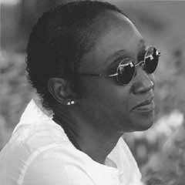
Keynote Speaker: Ms. N’Goné Fall
Curator, Dakar, Senegal

Ms. N’Goné Fall is an independent curator, art critic, and consultant in cultural engineering. She graduated from the École Spéciale d’Architecture in Paris, France and was editorial director of the Paris-based contemporary African art magazine, Revue Noire, from 1994 to 2001.

Ms. Fall has edited books on contemporary visual arts and photography in Africa and has curated exhibitions in Africa, Europe, and the United States of America. She was one of the curators of the African photography Biennale in Bamako, Mali, in 2001, and was a guest curator at the 2002 Dakar Biennale in Senegal.

Ms. Fall is an Associate Professor at the Senghor University in Alexandria, Egypt. As a consultant in cultural engineering, she is the author of strategic plans, orientation programs, and evaluation reports for Senegalese and international cultural institutions. Fall is also a founding member of the Dakar-based collective Gaw-Lab, a platform for research and production in the field of new media and visual arts.

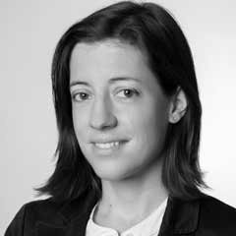
Moderator: Ms. Emilie Mermillod
Seydoux & Associés Fine Art, Geneva, Switzerland

Ms. Emilie Mermillod is the Director of Seydoux & Associés Fine Art, a Geneva-based company specializing in private sales in the field of Impressionist and Modern Art.

Prior to assuming her current position in 2013, Ms. Mermillod worked for several auctioneering houses including Christie’s and, Sotheby’s. Before then, Ms. Mermillod worked in several law firms in France and other countries, as an art law lawyer.

Ms. Mermillod holds a Master of Laws in Cultural and Communication Industries Law from the University of Lyon III in France.

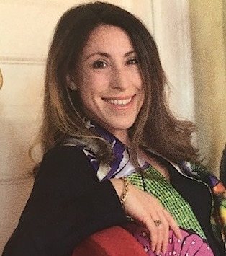
Speaker: Ms. Celine Moine
Economist, ArtPrice, Paris, France

With a background in art history and art economics, Ms. Celine Moine is an author and co-author of several hundred articles and reports on the art market.

Since 2005, Ms. Moine has worked for ArtPrice, a French online art price database. With more than 27 million entries commented on by its art historians, and covering as many as 500,000 artists from all over the world, ArtPrice is the world leading online art price database.

Since 2010, Moine has worked as a gallery owner, supporting emerging French artists.

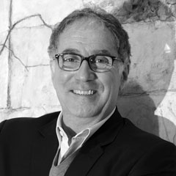
Speaker: Mr. Jany Jansem
JANY JANSEM Modern & Contemporary Art, Paris, France

Mr. Jany Jansem has been actively involved in the French Artists scene as well as the French Art Market since his childhood. The son of famous painters, he is the founder of the art gallery, Galérie Matignon in Paris (1977).

In the 1980s, Mr. Jansem developed the international activities of Galérie Matignon, before founding Galérie 10, specializing in contemporary art. In 2005, he returned to the Galérie Matignon, which conventionally featured the art works of Jansem and post-war French art, and opened it to the works of living and emerging visual artists.

Galérie Matignon was closed in 2016, but Mr. Jansem has continued to work as an art dealer, art collection manager and advisor in the purchase and sale of works of art.

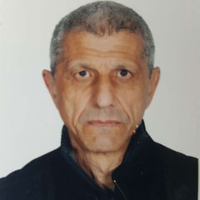
Speaker: Mr. Hellal Zoubir
Artist, Algiers, Algeria

Having obtained diplomas at the École Supérieure des Beaux-Arts in Algiers, and at the École Nationale Supérieure des Arts Décoratifs in Paris, Mr. Hellal Zoubir was responsible higher education institutions in art in Algiers from the 1970s until 2010.

Mr. Zoubir is one of the founders of the Algerian artists group, “Essebaghine,” founded with the purpose to redevelop the country’s contemporary art works after its difficult period of conflict.

In recent years, Mr. Zoubir has vigorously continued his artistic carrier. In 2016, he organized an exhibition of Algerian designers, "D'Zair Art and Craft,” featured at the African Design Museum in Johannesburg, South Africa. Also in 2016, dedicated to interactive design Mr. Zoubir presented the exhibition "Algeria Pavilion," at Dubai Design Week.

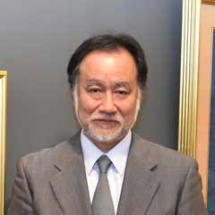
Speaker: Mr. Kazuhiko Fukuoji
Artist, Tokyo, Japan

The son of famous painter, Horin Fukuoji, Mr. Kazuhko Fukuoji started learning Japanese traditional painting from his father in his early teenage years.

In his long 50-year career as a successful painter, Mr. Fukuoji has been the winner of many awards from both national and international exhibitions.

Since 2010, Mr. Fukuoji has been a member of the Japan Art Academy, one of the most prestigious institutions consisting of Japanese artists. He has also been a member of the Copyright Committee in the Japanese Artists Association since 2006, and the Chairman of JASPAR (Japanese Society for Protecting Artist's Rights) since 2012.

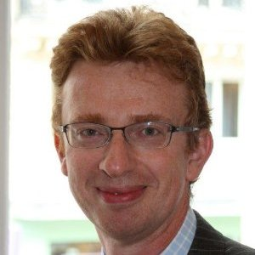
Speaker: Mr. Pierre Taugourdeau
Deputy Secretary General, Conseil des Ventes, Paris, France

Mr. Pierre Taugourdeau is the Deputy Secretary General and the Legal Director at the Conseil des Ventes, a French regulation entity established in 2000.

The main mission of Conseil des Ventes is to audit compliance with French regulations in voluntary sales of movables at public auctions, and to accompany such dealings with a modern legal framework, ensuring the best protection for both sellers and buyers.

Mr. Taugourdeau is a qualified attorney in France and holds a Master of Anglo-Saxon Business Law from the University of Paris I (Pantheon-Sorbonne).

Session 2: The Importance of Resale Right for Artists

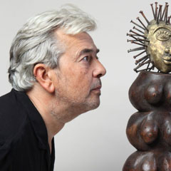
Keynote Speaker: Mr. Hervé Di Rosa
President, CIAGP (International Council of Graphic, Plastic and Photographic Designers), Lisbon, Portugal

French painter, Mr. Hervé Di Rosa graduated from the Ecole Nationale Supérieure des Arts Décoratifs in Paris, France.

Co-founding the movement of “Free Figuration” in 1979, in 1989, Mr. Di Rosa diversified his artistic approaches, practicing all techniques of creation for example paintings, statues, tapestries, frescos, ceramics, e-images, etc. In 2000, Mr. Di Rosa founded the French International Museum of Modest Arts, where he presented numerous artists from all over the world and organized exhibitions that questioned the boundaries of contemporary art.
Mr. Di Rosa is President of CIAGP (International Council of Graphic, Plastic and Photographic Designers) and is member of the Board of Directors of the ADAGP (Society of Authors in Graphic and Plastic Arts).

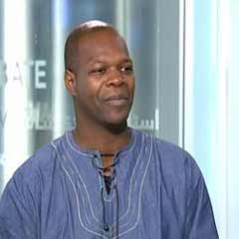
Moderator: Mr. Amobé Mévégué
Cultural Editor of France 24, Paris, France

Born in Cameroon and raised in France, Mr. Amobé Mévégué is an audiovisual producer.

Mr. Mévégué produces and runs programs in the field of culture, among others, on a large number of media outlets including RFI, CFI, MCM Africa, TV5, France O and France 24. Some of his programs have been broadcasted on all the Francophone African national channels.

Mr. Mévégué founded the international channel, UBIZNEWS TV, broadcasted in both African countries and France via satellite.

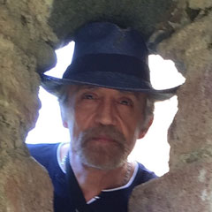
Speaker: Mr. Julio Carrasco Bretón
Visual Artist, Mexico City, Mexico

Mr. Julio Carrasco Bretón is an internationally recognized Mexican painter.

Mr. Bretón studied painting at the National School of Plastic Arts of San Carlos Don Lino Picasso and Cuevas. Since 1973, with his unique technique of using silicone and powdered marble, Bretón has completed 70 wall paintings in Mexico (including two for the Chamber of Deputies), Canada, Spain, Cuba, Ecuador, Argentina, France, Hungary, Colombia, Bulgaria and Switzerland,

Creator of more than 1,200 works, he has participated in more than 60 individual exhibitions and 200 collective exhibitions, in 20 countries. Mr. Bretón has also given more than 70 lectures on the subject of copyright and culture in Latin American countries and in other regions.

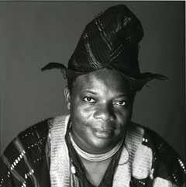
Speaker: Mr. Romuald Hazoumè
Artist, Porto-Novo, Benin

One of his ancestors being a high priest of the Fa at the court of the King of Porto-Novo, Mr. Romuald Hazoumè was descended from a prestigious family: He has developed an art form in close connection with his Yoruba (ethnic group living mostly in West Africa) culture where the mask holds a central place.

The artist restyles the forms and shakes up the conventions of ancestral knowledge, using everyday objects. A few simple gestures (positioning and adding one or two elements) are enough to reveal the face behind the mask.

His masks are usually made from plastic cans from around the world that he gets in his country where they are recycled and enable the illegal transport of petrol from Nigeria. While denouncing this petrol traffic, as lucrative as it is dangerous for those who indulge in it, Mr. Hazoumè plays on African stereotypes by offering these jerry cans a new existence that propels them into the field of art while returning to the Occident the trash that the consumer society is in the habit of disposing of on the continent.

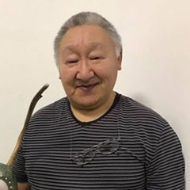
Speaker: Mr. Mattiusi Iyaituk
Artist, Ivujivik, Quebec, Canada

Following in the footsteps of his father and brother, who were both sculptors, Mr. Mattiusi Iyaituk began sculpting in his early teenage years.

In 1984, the Canada Council Grant enabled Mr. Iyaituk, then a policeman, to give up police work and devote himself to a fulltime career as an artist. In 1996, he became President of the Inuit Art Foundation and remained in that position for 16 years.

Mr. Iyaituk is currently one of the few Inuit artists to have traveled extensively, teaching workshops in places like Siberia and China. Mr. Iyaituk works with a variety of materials, often recording personal experiences in abstract sculptural forms. He has been the subject of numerous articles, and his work has been featured in many exhibitions, both nationally and internationally.

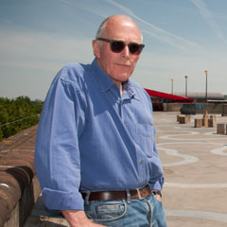
Speaker: Mr. Richard Wentworth
Artist, London, United Kingdom

Mr. Richard Wentworth is a chronicler of daily life. Since the 1970s, he has played a leading role in British sculpture, isolating both the formal and sculptural qualities of everyday objects.

Mr. Wentworth’extensive archive of photographs, Making Do and Getting By (1974 onwards), captures the provisional ways in which people modify the world they inhabit. It suggests an infinite syntax of adjustment, modification and appropriation.

The private smile which spectators experience when looking at his work is associated with a deep human capacity to associate the inventive and creative with an internalized highway code for survival.

Presentation of study on resale right for SCCR

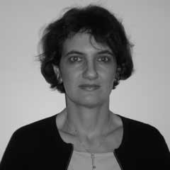
Speaker: Dr. Joelle Farchy
Professor, University Paris I (Pantheon-Sorbonne), Paris, France

Dr. Joelle Farchy is aprofessor of Information and Communication Sciences at University Paris I (Pantheon-Sorbonne), where she obtained a PhD degree in Economics. Before arriving at University Paris I in 2005, she was lecturer at University of Paris XI (Paris-Sud).

Dr. Farchy is the Director of the Ecole des Médias et du Numérique de la Sorbonne, a training and research center that develops digital economy projects in close collaboration with University Paris I. Dr. Farchy is also a qualified member in the High Council of Literary and Artistic Property, an advisory organization of the French Ministry of Culture.

In addition to her extensive number of publications in the field of economy in cultural industries, she is also a member of the French National Commission on Informatics and Civil Liberties, an independent administrative authority responsible for ensuring that information technology does not infringe human’s fundamental rights. Dr. Farchy is an expert in issues of culture and information technologies, among others.

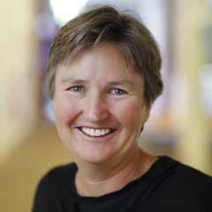
Speaker: Dr. Kathryn Graddy
Economist, Brandeis International Business School, Waltham, Massachusetts, United States of America

Dr. Kathryn Graddy is Senior Associate Dean at Brandeis International Business School and the Fred and Rita Richman Distinguished Professor of Economics at Brandeis University.

Her research focuses on the economics of art and culture and more generally, industrial organization. She has published extensively in the field of the economics of the arts, with papers in top international journals. She also has written policy papers on Artist Resale Rights for the UK Patent Office, and she is currently Editor of the Journal of Cultural Economics.

She has taught Game Theory and Industrial Organization to advanced undergraduates, advanced microeconomics to PhD students, and co-teaches a course on the Economics of the Arts. She served as Chair of the Economics Department at Brandeis from 2011-2014 and the Director of the PhD program at Brandeis International Business School from 2015-2016.

Dr. Graddy came to Brandeis in 2007 from Oxford University, where she was a Fellow of Exeter College. Prior to Oxford, she was Assistant Professor of Economics at the London Business School and a Junior Research Fellow at Jesus College, Oxford. She received her PhD in Economics from Princeton University, her MBA from Columbia University, and her BS and BA in Mathematics and Russian from Tulane University.

Session 3: The Implementation of Resale Right

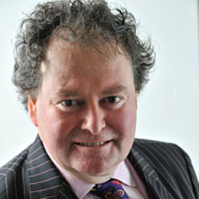
Keynote speaker: Mr. Mark Stephens
Chairman of DACS, London, United Kingdom

Specializing in International, Appellate and Complex litigation, Constitutional, Human Rights, IP, Media & Regulatory work, defamation, privacy, media, art and cultural property, data protection and freedom of information, intellectual property and international arbitration, Mr. Mark Stephens has undertaken some of the highest profile cases in the United Kingdom and abroad.

Mr. Stephens is also extremely active in many other areas, having been appointed by the Foreign Secretary to the FCO Free Expression advisory board and the Lord Chancellor to be a Champion for the Community Legal Service.

In December 2009, Stephens first appeared in “Who’s Who” where he is described as a “lawyer, broadcaster, writer and lecturer.” Mr. Stephens regularly appears in print and on the radio and television.

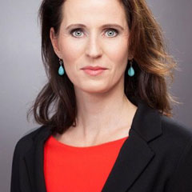
Moderator: Ms. Claudia Von Selle
President of Art Law Commission of the International Association of Lawyers (UIA), Berlin, Germany

Ms. Claudia Von Selle has extensive experience in the field of art law, which she has accumulated through her work as a member of the Commission of German Museum Association or as mediator at ICOM (International Council of Museums), among others.

As an international art lawyer based in Paris and Berlin, Ms. Von Selle has advised the French State Commission on the compensation of victims of spoliation and fought to protect the rights of families and institutions claiming looted art from WWII and supported the claimants of stolen or illegally acquired false art works. Ms. Von Selle has a wide reach of clients including TV channels, galleries, artists, fashion designers to writers.

Ms. Von Selle is the President of the Art Law Commission of the International Union of Attorneys and also President of the Foundation for Sculpturing.

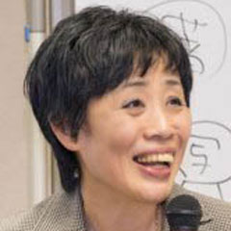
Speaker: Dr. Akiko Ogawa
Adjunct Researcher, RCLIP (Research Center for the Legal System of IntellectualProperty), Waseda University, Tokyo, Japan

Dr. Akiko Ogawa is an Adjunct Researcher at RCLIP, the Research Center for the Legal system for Intellectual Property, at Waseda University, Japan. She also teaches copyright law and intellectual property at several universities in Japan.
Dr. Ogawa has extensive academic experience on the topic of protection of artists. Among the articles she has written on the topic of ARR since 2003, Dr. Ogawa published a book on the topic in 2011 and has participated and organized several seminars and lectures on the topic.
She is also currently one of the managing directors for JASPAR (Japanese Society for Protecting Artist's Rights).

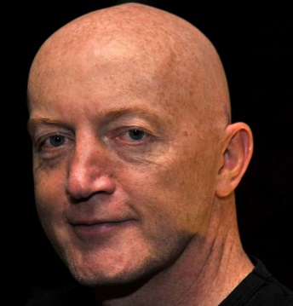
Speaker: Mr. James Sey
Consultant, Aspire Art Auctions, Johannesburg, South Africa

Mr. James Sey is an artist, art writer and theorist who consults to Aspire Art Auctions, a South African-based auctioneering company formed in the climate of the country’s rapidly growing art industry.

Mr. Sey has a long career in the art world in South Africa and internationally, and has been widely published in art magazines, catalogues and books.

Speaker: Ms. Janet Hicks
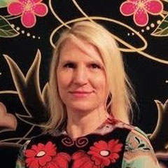
Director of Permissions, ARS (Artists Right Society), New York, United States of America

Ms. Janet Hicks is the Vice President and Director of Permissions at Artists Rights Society (ARS), representing the rights and permission interests of over 80,000 artists.

During her 19 years at ARS, she has acted as the visual artist’s representative within the IFRRO (International Federation of Reproduction Rights Organizations) and CISAC (International Confederation of Societies of Authors and Composers) and is currently on the Executive Committee of the visual arts subsection of CISAC.

Ms. Hicks is the Director of One Mile Gallery, an art gallery in New York that has recently exhibited at the Outsider Art Fairs in Paris and New York. She has a Masterin Art History from University of Oregon.

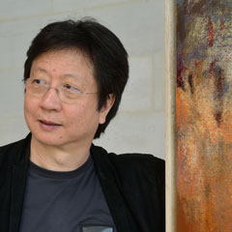
Speaker: Mr. Wang Yan Cheng
Artist, Beijing, China

Painter and master of lyrical abstraction, Mr. Wang Yan Cheng lives between France and China.

Mr. Wang studied art at the University of Saint-Etienne, France and has been a visiting professor at several Chinese art universities since 1995, and the Secretary General of the World Chinese Artists Association since 1996. In 2002, Mr. Wang was the Vice-President of IACA (International Association of Visual Arts) of UNESCO, founded to stimulate international cultural cooperation among artists.

Mr.Wang’s works entered Chinese public collections in several museums in 1998. He also produced nine paintings for the Beijing Diaoyutai State Guesthouse, a compound consisting of sixteen houses and two ancient architectural complexes, built in 1958 by the Chinese Government for the purpose of welcoming foreign representatives. In 2007, he created, for the Peking Opera, a huge painting inspired by music.

Session 4: The Management of Resale Right

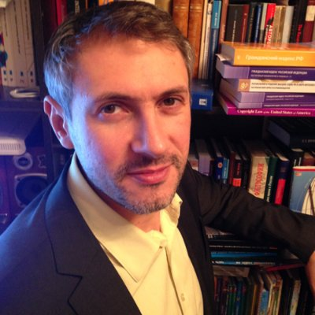
Keynote Speaker: Mr. Erik Valdes-Martines
RUR (The Russian Union of Right-holders), Deputy Director, Moscow, Russia

Mr. Erik Valdes-Martines is the Deputy Director and Head of International Offices at RUR, a private copying collective management society, and a collective management society of neighbouring rights (VOIS).

Mr. Valdes-Martines is also the Deputy Director at UPRAVIS, a non-governmental visual art society, and the advisor to the director general for international relations at the RAO (Russian Author Society).

Having learned at the Police Academia at Saint-Petersburg, Mr. Valdes-Martines started his career as a lawyer. Prior to assuming his current position, he worked in a private company in the movie industry and in a collective management society in the field of music.

Moderator: Ms. Claudia Von Selle (See the biography in Session 3)

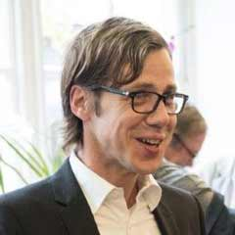
Speaker: Mr. Daniel Rudd
Head of Artists’ Services, DACS, London, United Kingdom

Having previously worked in public relations, Mr. Daniel Rudd has worked in the art industry for over 10 years,

Mr. Rudd is responsible for both artist and artists’ estate management at DACS, a not-for-profit visual artists’ rights management organization, and works closely with leading galleries and auctions houses on a range of issues.

At DACS, Mr. Rudd has managed ARR since 2008, overseeing the successful extension of resale right of artists’ heirs and beneficiaries in 2012.

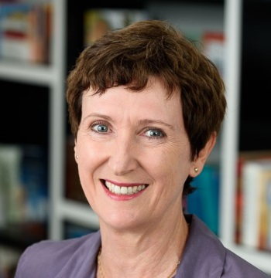
Speaker: Ms. Judy Grady
Manager, Visual Arts at Copyright Agency | Viscopy, Sydney, Australia

As the Manager at Visual Arts at Copyright Agency | Viscopy, Ms. Judy Grady is responsible for the successful implementation and management of Australia’s Resale Royalty Scheme since its introduction in Australia in 2010.

In addition to the Resale Royalty Scheme, she also leads Copyright Agency | Viscopy’s team of visual arts licensing staff, who are responsible for building revenue for visual artists through the licensing and the reproduction of their artworks.

Ms. Grady has a strong background in advocacy on behalf of creators and artists, and has established and nurtured effective relationships with not only the art sector, but also with key government representatives. Over the course of her work with Copyright Agency | Viscopy, she has driven high levels of compliance for the Resale Royalty Scheme and has improved Viscopy’s Australian licensing by almost 7% since the two organisations entered into a service agreement in 2012.

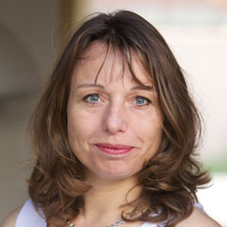
Speaker: Ms. Marie-Anne Ferry-Fall
CEO of ADAGP (Société des Auteurs dans les Arts Graphiques et Plastiques), Paris, France

Ms. Marie-Anne Ferry-Fall is CEO of ADAGP, a French collective rights management society in the field of visual arts.

Ms. Ferry-Fall is President of EVA (European Visual Artists), which brings together 26 European collecting societies with more than 100,000 visual artists.

Ms. Ferry-Fall is also President of AVA (Société Arts Visuels Associés), a collecting society dedicated to reprographic and educational uses, and is Vice-President of SORIMAGE, the French collecting society for the private copy remuneration of visual arts representing both authors and publishers.

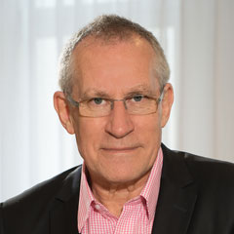
Speaker: Mr. Mats Lindberg
CEO of BUS-Bildupphovsrätt, Stockholm, Sweden

Mr. Mats Lindberg is the CEO of the Visual Collecting Society in Sweden, BUS-Bildupphovsrätt.

Mr. Lindberg represents visual creators in the board of the IFRRO (International Federation of Reproduction Rights Organizations) as well as the board of CISAC (International Confederation of Societies of Authors and Composers).

Mr. Lindberg has been working with artists and copyright issues for 35 years. He was one of the initiators in the introduction of the Resale Right in Sweden.

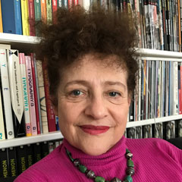
Speaker: Ms. Meret Meyer
Vice-President, Marc Chagall Committee, Paris, France

Grand-daughter of Marc Chagall, Ms. Meret Meyer went to school in Switzerland and Germany, and obtained a Master in German Literature and Linguistics, Philosophy and Theater Science at the University of Cologne.
The Marc Chagall Committee was created in 1988 for the protection of the work of the great painter. Ms. Meyer became the Vice-President of the Committee in 1997 and is in charge of the publication of catalogs of monographic exhibitions. Ms. Meyer also serves as the Vice-President of the Association of Friends of the Marc Chagall National Museum.
In the last 20 years, Ms. Meyer has also worked as a freelance editor, working for publishing companies that publish art books for. She is a member of the Board of Directors and the Cultural Action of ADAGP (Société des Auteurs dans les Arts Graphiques et Plastiques).

[End of document]

