E
WIPO/CR/VIL/99/4
ORIGINAL: English
DATE: April 14, 1999
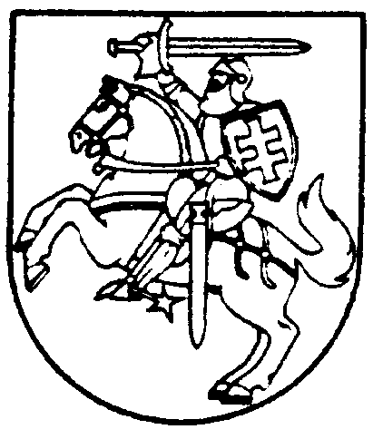 | 
MINISTRY OF CULTURE  REPUBLIC OF LITHUANIA | WORLD INTELLECTUAL  PROPERTY ORGANIZATION
regional roundtable on the protection of rights of broadcasting organizations and on the protection of databases
organized by
the World Intellectual Property Organization (WIPO)
in cooperation with
the Ministry of Culture of the Republic of Lithuania
Vilnius, April 20 to 22, 1999
the neighboring right of broadcasters:
better days ahead?
by Werner Rumphorst
Director, Legal Department,
European Broadcasting Union (EBU), Geneva

[End of document]

