E
WIPO/CR/CAI/09/INF 1
ORIGINAL: English
DATE: October 23, 2009
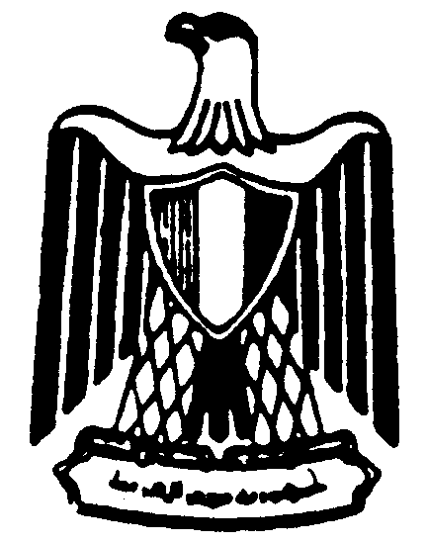 | 
ARAB REPUBLIC OF EGYPT | WORLD INTELLECTUAL  PROPERTY ORGANIZATION
AFRICAN-ARAB SEMINAR ON COPYRIGHT
LIMITATIONS AND EXCEPTIONS: Addressing the Needs of Affected Constituencies

organized by
The World Intellectual Property Organization (WIPO)
in cooperation with
the Ministry of Foreign Affairs of Egypt
Cairo, November 2, 2009
PROGRAM
prepared by the International Bureau of WIPO

09.00–09.30 | OPENING CEREMONY  Welcome addresses by:  Ambassador Naela Gabr, Assistant Minister of Foreign Affairs for International Organizations, Ministry of Foreign Affairs of Egypt, Cairo  Mr. Sherif Saadallah, Executive Director, Department of External Relations, World Intellectual Property Organization (WIPO), Geneva  Dr. Mohamed Nour Farahat, Director of Copyright Protection Office, Cairo
09.30 –10.30 | Topic one: | Copyright Limitations and Exceptions in International Treaties and Beyond: Developing Countries and Access to Knowledge
Mrs. Geidy Lung, Senior Legal Officer, Copyright Law Division, WIPO, Geneva

Mr. Hannu Wager, Counsellor, Intellectual Property Division, World Trade Organization, Geneva

Dr. Hassan Badrawy, Assistant Minister of Justice, Cairo
10.30–11.15 | Topic two: | Fair Use, Fair Dealing and Other Open-Ended Exceptions. The Application of the 3-Step Test
Dr. Henning Grosse Ruse – Khan, Max Planck Institute, Munich, Germany

Mr. Mohamed Hegazy, Manager, Intellectual Property Office, Information Technology Industry Development Agency, Ministry of Communications and Information Technology, Cairo
11.15–11.30 | Coffee/Tea Break

/...

11.30–12.15 | Topic three: | Limitations and Exceptions for Libraries, Archives and Museums
Mrs. Hala Essalmawi, IPR Officer, Library of Alexandria, Alexandria, Egypt

Mrs. Denise Nicholson, Librarian, University of the Witwatersrand, Johannesbourg, South Africa
12.15–13.00 | Topic four: | Dissemination and Use of Copyrighted Works for Education and Research
Dr. Bassem Awad, Chief Judge, Egyptian Ministry of Justice, Cairo

Mr. Mohammed El Said, Lecturer in International Trade Law, University of Central Lancashire, Preston, United Kingdom
13.00–13.30 | Topic five: | Intellectual Property and the Rights of Persons with Disabilities
 |  | Speaker: to be confirmed
13.30–14.45 | Topic six: | Roundtable: The needs of the visually impaired and other persons with reading disabilities: Member States’ and Stakeholders’ views
10 Invited Member States (Arab and African countries)

Dr. Mohamed Nour Farahat

Mr. Chris Friend, World Blind Union, London

Mr. Dipendra Manocha, Daisy Consortium, New Delhi

Mr. Olav Stokkmo, International Federation of Reproduction Rights Organisations (IFRRO), Brussels

Mr. Ahmed Bedeir, International Publishers Association, Cairo
/...

14.45–15.00 | Final Remarks | The way ahead for developing countries: African and Arab countries
 |  | Dr. Maha Bekheit, Director of IP unit, League of Arab States, Cairo
15.00–15.30 |  | CLOSING CEREMONY  Ambassador Naela Gabr  Mr. Sherif Saadallah  Dr. Mohamed Nour Farahat

Lunch offered by WIPO

[End of document]

