
E
SCCR/21/5
OriGINAL: English
DATE: September 22, 2010
Standing Committee on Copyright and Related Rights
Twenty-First Session
Geneva, November 8 to 12, 2010
Comments on the Draft Text of the WIPO Treaty on
the Protection of Audiovisual Performances
Document submitted by India

1. By a Note Verbale dated September 17, 2010, the Permanent Mission of India submitted comments on the draft WIPO Treaty on the Protection of Audiovisual Performances (SCCR/19/9) Background Document on the Main Questions and Positions Concerning the International Protection of Audiovisual Performances.

2. The Note Verbale is annexed to the document.

[Annex follows]

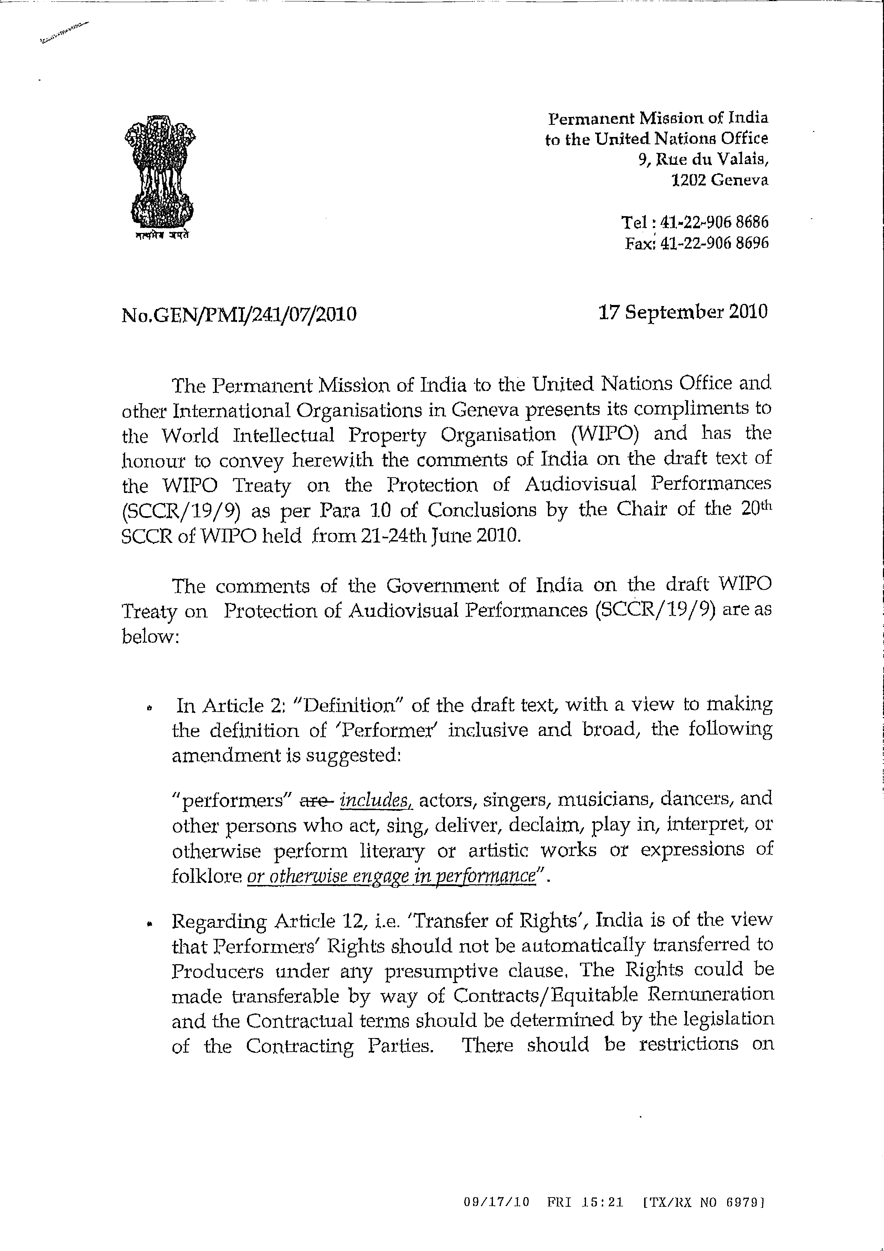

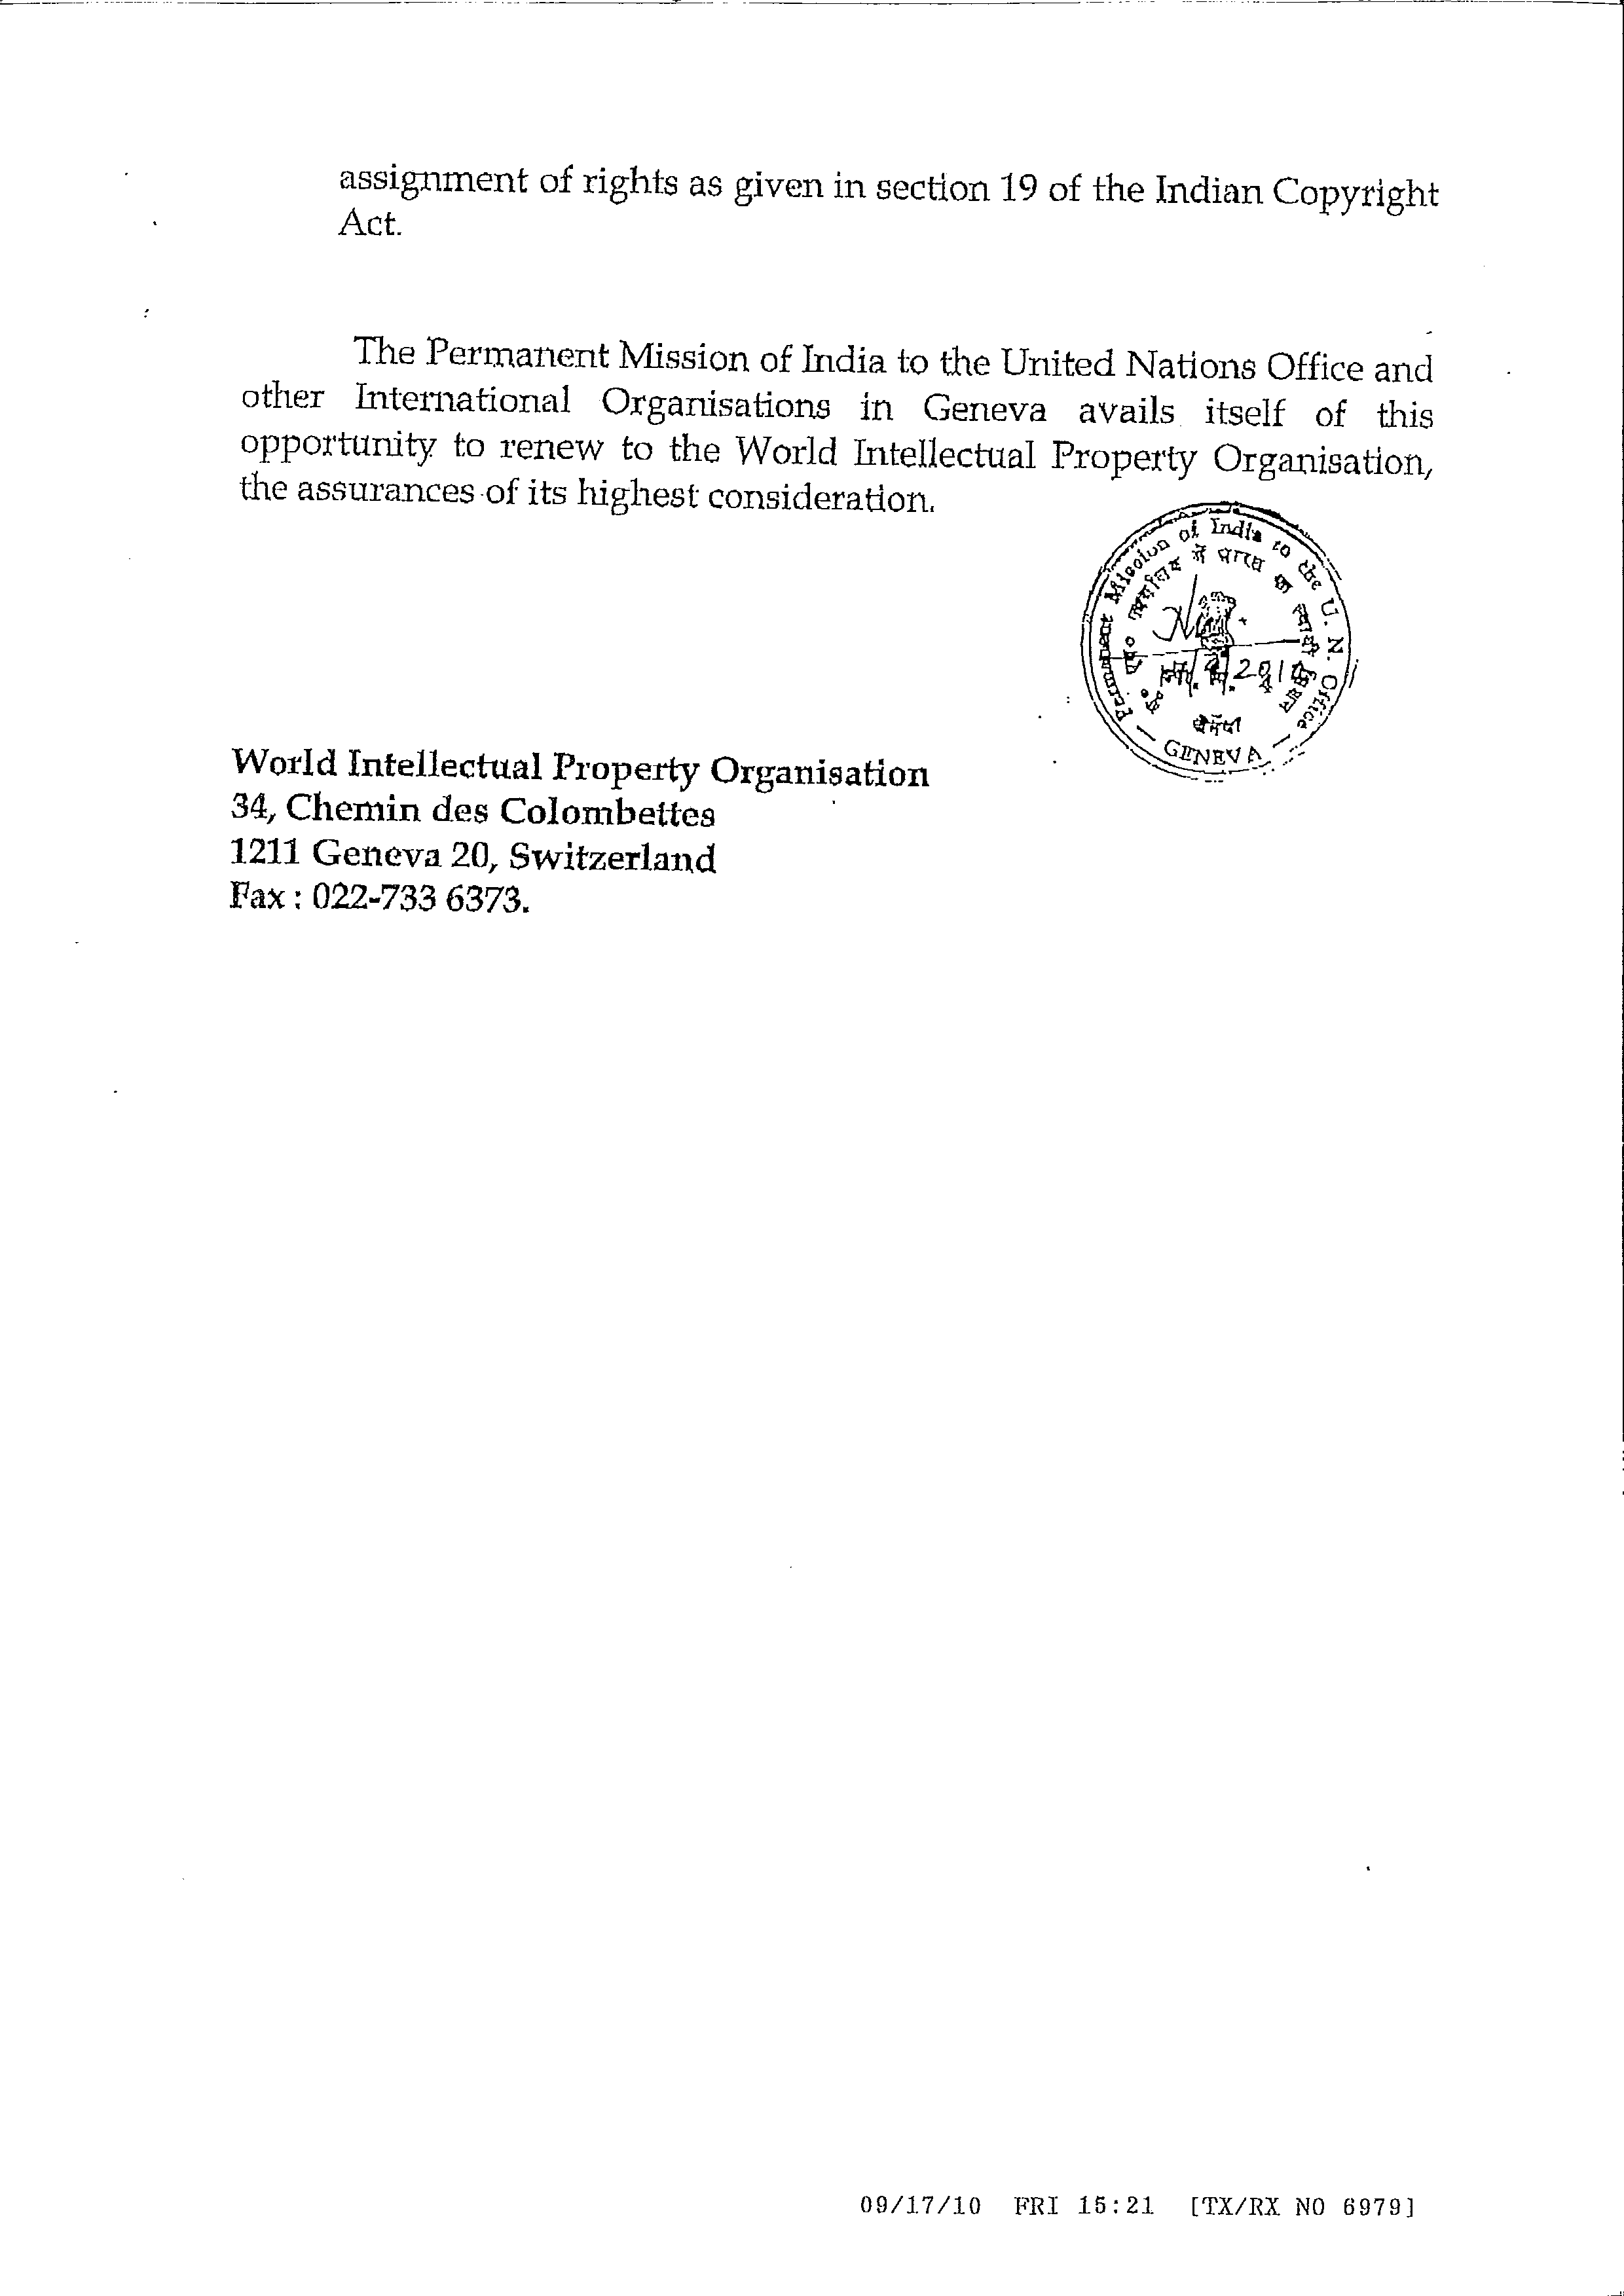

[End of Annex and of document]

