 |  |  | E
WIPO/IP/CWS_BC/GE/19/INF/1
ORIGINAL: English
DATE: may 7, 2019

WIPO STANDARDS WORKSHOP
ON BLOCKCHAIN

organized by
the World Intellectual Property Organization (WIPO)

Geneva, April 29 to 30, 2019

iStock / Getty Images Plus / ipopba

PROGRAM

prepared by the International Bureau of WIPO

Monday April 29, 2019

08:00 - 09:30 | Registration: WIPO Access Center
09:30 - 09:45 | Welcome address  Mr. Yoshiyuki Takagi, Assistant Director General, WIPO
Facilitator of Workshop:
Mr. Young-Woo Yun, Head, Standards Section, WIPO

09:45 - 10:00 | Keynote 1: Blockchain technology - why does it matter?  Dr. Thomas Struck, Executive Partner, Gartner
 | Session 1: Blockchain technology - opportunities and challenges
10:00 - 10:20  10:20 - 10:40  10:40 - 10:50 | What is Blockchain and how does Blockchain work?  Presentation:  Mr. Shashank Rai, Senior Strategic Technology Specialist, UNICC  Patent landscape in the field of Blockchain technology  Presentation:  Mr. Nikolay Popov, Head of the Center for Advanced Technologies, Rospatent  Q&A
10:50 - 11:10 | Coffee
11:10 - 11:50  11:50 - 12:00 | Opportunities and challenges in leveraging Blockchain  Presentation:  Dr. Kari Kostiainen, Senior Scientist, ETH Zurich  Q&A
12:00 - 13:30 | Lunch
 | Session 2: Blockchain technologies at our fingertips
13:30 - 14:30  14:30 - 14:40 | Characteristics of different Blockchain platforms  Presentations:  Dr. Jean-Marc Seigneur, Director of the Blockchain Certificate of Advanced Studies, University of Geneva  Ms. Marta Piekarska, Director of Ecosystem, Hyperledger  Mr. Fabian Vogelsteller, Founder, Lukso  Q&A
14:40 - 15:10 | Public, private, and mixed blockchains: what benefits does each platform offer?  Panel discussion  Moderator:  Dr. Jean-Marc Seigneur, Director of the Blockchain Certificate of Advanced Studies, University of Geneva  Panelists:  Ms. Marta Piekarska, Director of Ecosystem, Hyperledger  Mr. Shashank Rai, Senior Strategic Technology Specialist, UNICC  Mr. Fabian Vogelsteller, Founder, Lukso
15:10 - 15:30 | Coffee
15:30 - 15:50  15:50 - 16:10  16:10 - 16:20 | Session 3: Blockchain and public services  Selected use cases of Blockchain: national, regional or international level  Presentation:  Ms. Virginia Cram-Martos, CEO, Triangularity SàRL  Policy, legislation and governance issues surrounding Blockchain  Presentation:  Ms. Emmanuelle Ganne, Senior Analyst, WTO  Q&A
 | Session 4: Blockchain and Standardization
16:20 - 17:20  17:20 - 17:30 | Standardization related to Blockchain: objectives, areas, challenges and plans  Presentations:  Mr. Martin Adolph, Study Group Advisor, ITU  Mr. Henry Cuschieri, Head of Membership and External Relations, ISO  Mr. Lance Thompson, Secretary to UN/CEFACT, UNECE  Q&A
17:30 - 18:00 | What are the challenges for standardization on Blockchain and potential cooperation areas?  Panel discussion  Moderator:  Mr. Martin Adolph, Study Group Advisor, ITU  Panelists:  Mr. Henry Cuschieri, Head of Membership and External Relations, ISO  Ms. Marta Piekarska, Director of Ecosystem, Hyperledger  Mr. Lance Thompson, Secretary, UN/CEFACT, UNECE  Mr. Fabian Vogelsteller, Founder, Lukso
Tuesday April, 30 2019

08:00 - 09:00 | Registration: WIPO Access Center
09:00 - 09:20  09:20 - 09:30 | Keynote 2: Blockchain technology and Intellectual Property  Dr. Birgit Clark, Lead Knowledge Lawyer, Baker McKenzie  Summary of first day sessions
09:30 - 10:30  10:30 - 10:45 | Session 5: Blockchain applications for Intellectual Property  Blockchain products/services for Intellectual Property  Presentations:  Mr. Ilya Kononenko, Head of IT Division for Portal Solutions, Rospatent/FIPS  Mr. Vaughn McKenzie, CEO, JAAK  Mr. Michael Burn, Assistant Director, International ICT Cooperation, IP Australia  Mr. Erich Spangenberg, CEO and co-founder, IPwe  Q&A
10:45 - 11:00 | Coffee
11:00 - 11:40  11:40 - 11:50 | Blockchain case studies or Proof of Concepts for Intellectual Property  Presentations:  Mr. Vladislav Mamontov, Principal Specialist, International Cooperation Department, Rospatent  Mr. Grantly Mailes, Associate Director, Boston Consulting Group  Q&A
11:50 - 12:30 | What are good potential use cases of Blockchain for Intellectual Property?  Panel discussion  Moderator:  Mr. Nelson Yang, Acting Director, USPTO  Panelists:  Mr. Ilya Kononenko, Head of IT Division for Portal Solutions, Rospatent/FIPS  Mr. Vladislav Mamontov, Principal Specialist, International Cooperation Department, Rospatent  Mr. Vaughn McKenzie, CEO, JAAK  Mr. Erich Spangenberg, CEO and co-founder, IPwe
12:30 - 14:00 | Lunch
14:00 - 15:00  15:00 - 15:10 | Session 6: Blockchain - Opportunities and challenges for IP ecosystem  Opportunities and challenges in leveraging Blockchain for IP ecosystem  Presentations:  Mr. Erling Vestergaard, IP Enforcement Expert, EUIPO  Mr. Kevin Fournier, Counsel, Intellectual Property Law, IBM  Q&A
15:10 - 15:40 | How can the private sector and public sector work together with Blockchain for IP ecosystem?  Panel discussion  Moderator:  Mr. Robert McNeill, IP Australia  Panelists:  Mr. Kevin Fournier, Counsel, Intellectual Property Law, IBM  Mr. Grantly Mailes, Associate Director, Boston Consulting Group  Mr. Erling Vestergaard, IP Enforcement Expert, EUIPO
15:40 - 16:00 | Coffee
16:00 - 16:20  16:20 - 16:30 | Session 7: Blockchain - Standardization for Intellectual Property Data  Potential areas and candidates for standardization of Blockchain on IP data  Presentation:  Mr. Michael Burn, Assistant Director, International ICT Cooperation,  IP Australia  Q&A
16:30 - 17:10 | What should be standardized for IP data leveraging Blockchain technology?  Panel discussion  Moderator:  Mr. Young-Woo Yun, Head of Standards Section, WIPO  Panelists:  Mr. Grantly Mailes, Associate Director, Boston Consulting Group  Mr. Vaughn McKenzie, CEO, JAAK  Mr. Erich Spangenberg, CEO and co-founder, IPwe  Mr. Lance Thompson, UNECE Economic Affairs Officer, Secretary to UN/CEFACT
17:10 - 17:20 | Closing remarks  Mr. Yoshiyuki Takagi, Assistant Director General, WIPO  [Annex follows]

SPEAKERS’ PROFILES

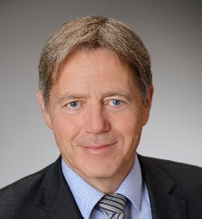
Dr. Thomas Struck
Executive Partner, Gartner

Thomas has more than 25 years of experience in IT, Business Process and Transformation Management. He enjoys helping organizations to prepare for the future by aligning their business model, structure, processes, and IT to conditions marked by continuous change and limited predictability. Thomas studied Mechanical Engineering at Leibniz University Hanover. He started his career as an advisor for Computer Integrated Manufacturing technologies (CIMTT). In Birmingham, he worked as a researcher and lecturer for requirements engineering at Nottingham University, while doing a PhD at the University of Birmingham on Knowledge and Business Process Management. In the last years, Thomas was head of Scheer Management Consulting. In this capacity Thomas acted as coach and trusted advisor to prestigious clients. He was responsible for the delivery of national and international strategy and digitalization projects mainly in public, banking, manufacturing, automotive and telecommunication sectors.

Dr. Birgit Clark
Lead Knowledge Lawyer, Intellectual Property & Technology, Baker McKenzie

Based in Baker McKenzie’s London Office, Dr Birgit Clark is the Lead Knowledge Lawyer for the firm’s global Intellectual Property and Technology practice group. Birgit originally qualified as Attorney-at-Law (Rechtsanwältin) in Germany and subsequently also as UK solicitor and Chartered UK trade mark attorney. Birgit is an extensively published legal author, blogger and commentator with a particular focus on how modern technology interlinks with Intellectual Property law principles.

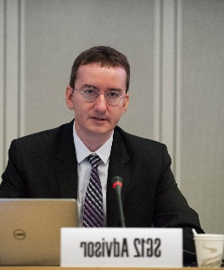
Mr. Martin Adolph
Study Group Advisor, International Telecommunication Union (ITU)

Martin Adolph is a Study Group Advisor with the ITU, the United Nations’ specialized agency for information and communications technologies. Working in ITU’s standardization bureau, he is coordinating activities in the field of performance, quality of service, and quality of experience, and distributed ledger technology. Martin holds diplomas in Computer Science from TU Dresden and in Engineering from École Centrale Paris.

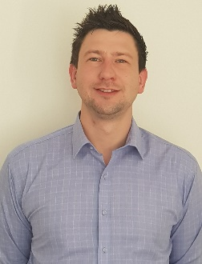
Mr. Michael Burn
Assistant Director, International ICT Cooperation, Innovation & Technology Group, IP Australia

Mr. Burn is responsible for building IP Australia’s authority at an International level in technological fields and advancements through leadership, collaboration and cooperation across IP Offices by proactively engaging in International working groups, task forces, standards development, project and ICT deliverables in order to harmonise and build common practice, systems and process to the benefit of our stakeholders. A frequent speaker at International fora including the Committee on WIPO Standards (CWS) and ICT working groups he has significant knowledge and experience in the IP Rights domain; representing Australia at the CWS, managing their contribution across many Task Forces, including leadership of the Blockchain Task Force. Michael has recently overseen the delivery of IP Australia’s authority file, the launch of IPOcollab (an online platform for IPOs to connect, collaborate and share knowledge on projects and topics of choice), and is presently leading development work on common APIs for structured data transfer.

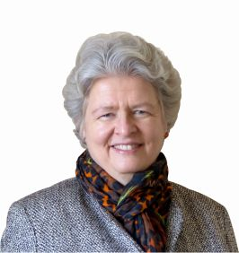
Ms. Virginia Cram-Martos
CEO, Triangularity SàRL

Virginia Cram-Martos is the CEO of Triangularity SàRL, which supports economic development through Innovation, eCommerce and Trade. She also participates as an expert in a range of activities related to blockchain technology. This includes being the project leader for the United Nations Centre for Trade Facilitation and Electronic Business (UN/CEFACT) Whitepaper on Blockchain in Trade Facilitation and participating in blockchain for a of the International Telecommunications Union (ITU), the International Organization for Standardization (ISO), the European Union and the World Economic Forum. Prior to Triangularity she worked for 25 years at the United Nations Economic Commission for Europe in Geneva. During her last 11 years at the UN, she was a Director responsible for: trade facilitation, global UN electronic business standards, regulatory cooperation, national innovation frameworks and public-private partnerships. She holds an MBA from the University of Chicago and a Masters in Finance from the Université Catholique de Louvain in Belgium.

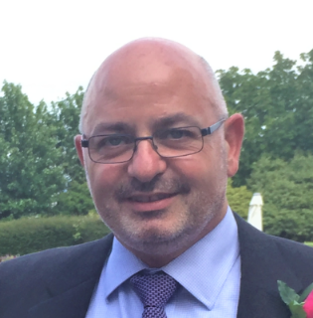
Mr. Henry Cuschieri
Head of membership and external relations, International Organization for Standardization

Henry Cuschieri has been with the International Organization for Standardization (ISO) in Geneva, Switzerland since 2011. Currently he is the Head of Membership and External Relations. In this capacity he is responsible for maintaining close, efficient and productive relationships between the ISO Central Secretariat and the more than 160 national standards bodies that make up ISO’s membership, and between ISO and its partners. Prior to taking on this role he served as Head of Standards Development overseeing a number of sectors including information and communications technology. Originally from the UK, prior to moving to Switzerland Mr. Cuschieri spent more than 20 years in the USA working for nationally-accredited organizations developing American National Standards, and overseeing a 3rd Generation CMDA Wireless Communications standardization programme between North America and Asia for the Telecommunications Industry Association in Washington, DC.
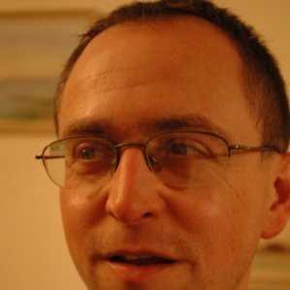
Mr. Kevin Fournier
Counsel, Intellectual Property Law, IBM

Kevin Fournier is an intellectual property (IP) lawyer for IBM, located in the United Kingdom, and handling IP legal matters on behalf of IBM, across Europe, the Middle East and Africa. Kevin provides legal advice and counsel to the IBM business on intellectual property issues in transactions such as technology joint research and development projects, joint ventures, business consulting, applications development and maintenance, strategic outsourcing, mergers and acquisitions, software licensing, patent licensing, and IP assignments. He also negotiates the relevant agreements on behalf of IBM, with the other parties. Kevin also carries out invention protection work, patent application filing and prosecution before the European Patent Office, United Kingdom Intellectual Property Office and United States Patent & Trademark Office, including extensive use of the Patent Cooperation Treaty.

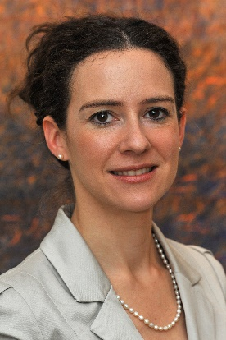
Ms. Emmanuelle Ganne
Senior Analyst, Economic Research and Statistics Division, World Trade Organization

Emmanuelle Ganne is Senior Analyst in the Economic Research and Statistics Division of the World Trade Organization (WTO) where she leads WTO work on Blockchain. She is the author of a recently published book entitled „Can Blockchain Revolutionize International Trade?“ Ms.
Ganne is also WTO’s lead on micro, small and medium side enterprises. From 2015 to 2017, she held the position of Vice-President for Europe at the Allam Advisory Group (AAG), a team of former C-level executives and senior diplomats that specializes in helping businesses expand their operations globally. Before this, Ms. Ganne held various positions at the WTO, including as Counselor to Director-General Pascal Lamy, and in the Accessions Division where she assessed trade policies of governments wishing to join the WTO and advised them on how to improve their business environment. Before joining the WTO in 2002, Ms. Ganne worked for the Organization of Economic Cooperation and Development.

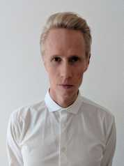
Dr. Kari Kostianen
Senior Scientist, ETH Zurich

Dr. Kari Kostiainen is Senior Scientist at ETH Zurich and Coordinator of Zurich Information Security and Privacy Center (ZISC). Before joining ETH, Kari was a researcher at Nokia Research Center. He holds a doctorate in computer science from Aalto University. Kari’s research focuses on system security. Recent research topics include smartphone security, trusted computing, secure user interaction and blockchain security.

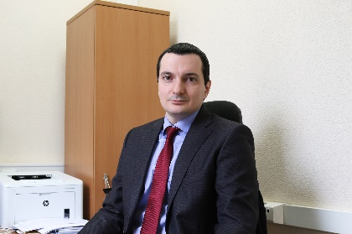
Mr. Ilya Kononenko
Head of IT Division for Portal Solutions, Rospatent/FIPS

Ilya Kononenko is Head of Division of Federal Institute of Industrial Property (FIPS) of Russian Intellectual Property Office (Rospatent). He worked for several positions in information technology area in Rospatent since march of 2005. He is in charge of developing and managing publication system of Rospatent, e-filing system and internet retriewal system. Mr. Kononenko is also involved in several international cooperation projects in the area of patent, trademark and design information and participate in the Task Forces of the Committee on Standards of WIPO.

Mr. Grantly Mailes
Associate Director, Boston Consulting Group and Co-founder, Civic Ledger Pty Ltd

Grantly is an Associate Director of Boston Consulting Group (BCG) and a co-founder of Civic Ledger, one of Australia’s leading blockchain based FinTechs. He leads the emerging technologies topic for BCG in Asia Pacific where he works with clients to extract commercial and public value from technologies such as blockchain and artificial intelligence. He has worked on blockchain cases with clients in trade and structured finance, supply chain provenance and financial services. Grantly is also a co-founder of Civic Ledger, an award-winning blockchain focused FinTech that creates registration and trading platforms for commodities such as agricultural water, intellectual property and equities. Civic Ledger has developed a platform to register intellectual property rights allow rights holders to trade or licence their rights in an open market.

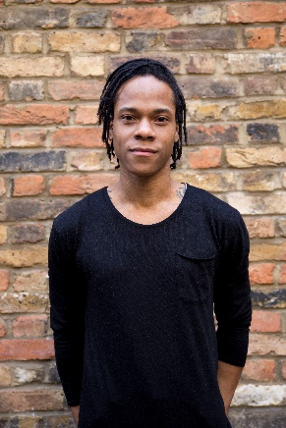
Mr. Vaughn McKenzie-Landell
CEO & Founder, JAAK

Vaughn McKenzie-Landell is CEO and co-founder at JAAK. He has been a pivotal figure in communicating the bold vision of JAAK to build a space for convergence and collaboration for media industries, and has spoken at conferences around the world including SXSW, FastForward and EthCC. Following an initial spell in finance at Dow Jones, Vaughn co-founded music production group, The Arcade, before venturing into the world of User Experience Design and Product Development. Vaughn most recently spent four years consulting at Virgin Media on Software Adoption. In early 2018, Vaughn was named one of Forbes’
‘30 Under 30’.

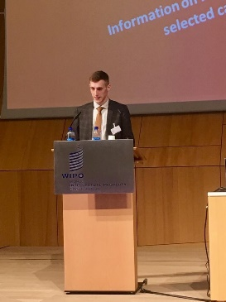
Mr. Vladislav Mamontov
Principal Specialist, International Cooperation Department, Rospatent

Vladislav Mamontov is a principal specialist of the International Cooperation Department of Rospatent. He is responsible for cooperation between Russian and foreign experts, particularly in IT related issues as well as for collaboration with WIPO on standardization issues.

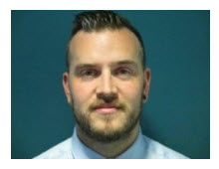
Mr. Robert McNeill
Assistant Director, Digital Engagement, IP Australia

With over eight years’ experience with IP Rights systems ranging from databases to digital customer platforms, Rob has a comprehensive knowledge of customers within Australia’s IP rights system. He is currently responsible digital identity and customer engagement across IP Australia’s various services and manages ongoing efforts to ensure its quality.

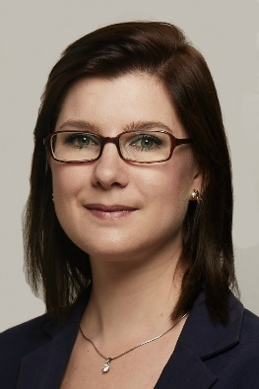
Ms. Marta Piekarska
Director of Ecosystem, Hyperledger

Marta obtained her BSc in Electrical and Computer Engineering from Warsaw University of Technology and a double Master from Computer Science and Informatics at Technical University of Berlin and Warsaw University of Technology. Marta received PhD in User-Informed Design of Privacy Tools while working at one of the hottest startups in Silicon Valley - Blockstream. Marta also taught at Technical University of Berlin as a Post-doc. As part of her role in Hyperledger Marta evangelizes the technology and Open Source at conferences around the world and helps enterprises with applying permissioned Blockchains to their use-cases. Marta is passionate about how Blockchain can help in non-traditional spaces, such as identity, last mile aid and education delivery and sustainability. She leads the public speaking and outreach at Hyperledger, has given numerous interviews, both written and in visual media. Marta also formed the W3C Blockchain community Group and is a valued member of the technical advisory to ID2020, DIF and participated in Rebooting Web of Trust on regular basis.

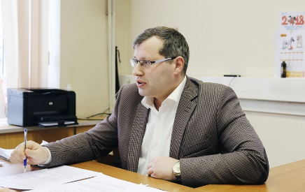
Mr. Nikolay Popov
Deputy Head of the FIPS Project Office, Head of Patent Analytics Division of Federal Institute of Industrial Property, Rospatent

I’ve been working at Russian patent office since 2001. Started my career at the Department of patent information services and marketing of FIPS, where I was responsible for dissemination RU patent information for Russian companies as well as commercial providers all over the world. I was a speaker on WIPO TISCs events many times. Since 2013 I’ve started patent analytics practice at the FIPS. In 2015 I became a co-founder of FIPS Project Office – special unit within the structure of Rospatent, which provides technological and business consulting based on patent analytics in a wide range of industries: oil&gas, medicine, transport and logistic, chemistry etc.

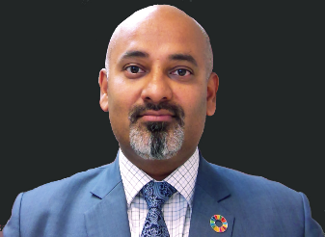
Mr. Shashank Rai
Senior Strategic Technology Specialist, United Nations International Computing Centre

Shashank Rai heads the Strategic Consulting Unit at the United Nations International Computing Centre since 2016, focusing on digital transformation and emerging technologies with a view to support the Sustainable Development Goals. He has broad experience in leading major transformation projects in multiple industry verticals – telecommunication, aviation, bio-technology and financial services. With his rich domain knowledge and as a technologist at heart, has been involved in exploring the business applications of the blockchain and distributed ledger technology from the onset. Shashank was the technology advisor in a recent World Trade Organization’s publication – „Can Blockchain Revolutionize International Trade”, which explored real-world examples of the technology making an impact in global trade and supply chain. Shashank is actively leading a Hyperledger Indy based implementation of Distributed Digital Identity coupled with biometric authentication for an UN agency as well as exploring implementation of blockchain for micro-payments in developing nations.

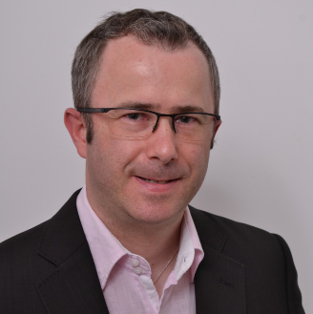
Dr. Jean-Marc Seigneur
Director of the Blockchain Certificate of Advanced Studies, University of Geneva

PD Dr Jean-Marc Seigneur has published internationally more than 100 scientific papers on decentralized trust management from computational trust, online reputation management and blockchain. With a Ph.D. in Computer Science from Trinity College Dublin in 2005, he has managed several EU-funded multi-million EUR R&D IT projects. In 2016, he has obtained a Google Award for Excellent Research in Academia. In 2018, he has passed his Habilitation à Diriger des Recherches (HDR) at the University of Reims Champagne-Ardenne on the topic of Augmented Human Trust. He has advised companies like Philips, Amazon and Thales. He has been a team member of ICOs that have raised more than 36 million USD. He is now director of the blockchain certificate of advanced studies at the University of Geneva and President of the French blockchain startup specialized in attack-resistant products relational value certification with a patent-pending hardened crypto wallet for real-time KYC/AML-enforced Bitcoin/tokens transactions, even offline.

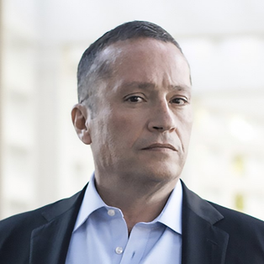
Mr. Erich Spangenberg
CEO and co-founder, IPwe

Erich Spangenberg is the CEO and co-founder of IPwe. IPwe was founded in 2017. IPwe is a company using blockchain and artificial intelligence to create the patent asset class. From 2003 - 2013, he was the founder and CEO of IPNav, a company that was a pioneer in patent monetization. From 2014 - 2017, Erich was CEO of nXn Partners, a company focused on predictive analytics. Erich is widely recognized as one of the world’s leading IP strategists. He is regularly recognized for his work in many industry publications. Intellectual Asset Management (IAM) named Erich as #2 of the top 40 IP „market makers” whose „connections, decisions and actions drive the ever-expanding global IP marketplace.” Managing Intellectual Property listed Erich as one of „The 50 People Shaping the Future of IP.” Erich has changed the way people think about and use patents.

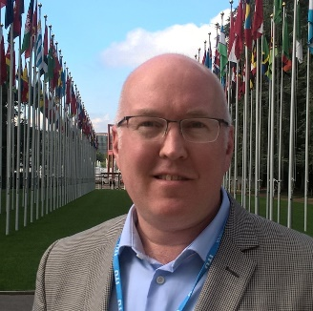
Mr. Lance Thompson
UNECE Economic Affairs Officer, Secretary to UN/CEFACT

Originally from New York, Lance Thompson has lived and worked in the United States, France, Japan and now at the United Nations in Switzerland. He has completed a doctorate in social anthropology at the Sorbonne and an MBA specialized in International Business where he finished as valedictorian. He has been passionate about standardization and facilitating international trade for nearly two decades, holding key roles within the UN Centre for Trade Facilitation and Electronic Business, UN/CEFACT (including chair, vice chair and project leader), as well as the World Customs Organization’s Data Model Project Team (Focal Point coordinator of the Implementation group 2014-2016) and active member in the French Trade Facilitation organization ODASCE (administrator 2015-2016) and the International Air Transport Association. Today, Lance Thompson supports the work of the entire organization, ensuring its continual progression and represents the Centre at meeting around the world. He is very active in key projects such as the Single Window guidance projects. He is also working to better promote and disseminate the deliverables offered by UN/CEFACT.

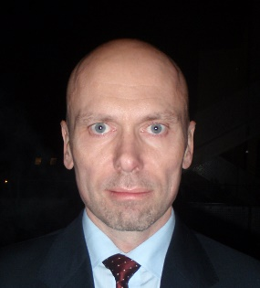
Mr. Erling Vestergaard
IP Enforcement Expert, EUIPO

Erling Vestergaard has been a Danish lawyer for 30 years, more than 20 of those serving as a Danish prosecutor specialising in economic crime. From 2006 to 2014 he coordinated all Danish criminal IP cases, only interrupted by a 2-year period working for the DKPTO. Erling Vestergaard has taken a special interest in Internet related issues and the impact of new disruptive and transformative technologies. Since November 2014 he has worked for the EUIPO Observatory on Infringements of IPRs.

Mr. Fabian Vogelsteller
Founder, LUKSO

Fabian is an undisputed authority on blockchain technology. He has built many Ethereum user and developer-facing projects including the Ethereum Mist browser, the Ethereum Wallet and web3.js - the Ethereum’s space most used JavaScript library. Together with Vitalik Buterin, he proposed the ERC20 token standard, which initiated the world ICO wave and redefined investment and crowd ownership as we know it. Today Fabian is leading the concept, architecture, and development of the LUKSO Blockchain.

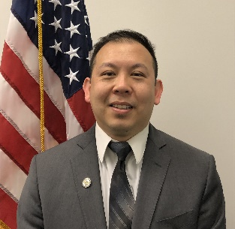
Mr. Nelson Yang
Acting Director, International Patent Business Solutions, International Work Sharing Planning and Implementation, USPTO

Nelson Yang is currently Acting Director of International Patent Business Solutions and of International Work Sharing Planning and Implementation, within the Office of International Patent Cooperation at the United States Patent and Trademark Office. At the USPTO, Mr. Yang has been involved in many key initiatives, including the Global Dossier, the Global Patent Search Network (GPSN), the Hague Agreement, and Patents End to End (PE2E). Prior to being Acting Director of IPBS and IWPI, Mr. Yang worked as a patent business analyst and as a biotechnology patent examiner at the USPTO. Mr. Yang graduated from Johns Hopkins University with Bachelors of Science degrees in Biomedical Engineering and Computer Engineering, and a Master of Science in Engineering degree in Biomedical Engineering.

[End of Annex and of document]

The headquarters of WIPO, 34, chemin des Colombettes, Geneva (WIPO Conference Hall).

