INDUSTRIAL PROPERTY OFFICE OF THE CZECH REPUBLIC
The Study on the Improvement of the Designs Classification

The Identification of the Problem
The registration of an industrial design protects the appearance features, i.e. the design of a particular product. According to the Czech law such a product may be an industrial or handicraft item, a graphic symbol, get-up, packaging or typographic typeface. That is a wide range of objects, which are qualified for the protection by registration of industrial designs. It is a collection of very diverse and not easily defined objects. All the items are to be represented by their appearance or better the reproduction of their appearance and as such they should be classified and searched. The existing search engines are designed for word-base search. (The computer systems recognising automatically the appearance of products – content-base image retrieval systems, face problems and they have not been successfully applied in this field as far as we know). Using the Locarno Classification the design as the subject of classification is determined by the indication of the product in which it is embodied. The protection of a particular design is, however, valid for all products bearing the same appearance features regardless the indication of the use or function of the product itself. The classification cannot meet the needs to find all relevant designs as they are distributed in various classes and sub-classes.

The main discrepancy is between the principal of classification of the registered designs according to the use of the products in which they are embodied, while the primary interest of the one who searches for relevant designs is to retrieve designs of the same or similar appearance regardless the use or function of the product itself.

The History
At the Conference on revision of Hague Agreement concerning international registration of industrial designs in 1960 a decision was made to start preparation of international classification of industrial designs. In 1968 in Locarno 33 members of the Paris Convention approved proposal of Expert Committee and after some amendments the classification containing 32 mutually exclusive classes was approved. The aim was to establish a unified classification, which would be preserved from unauthorized changes made by the individual Locarno Union members. It was, however, presumed that it is a kind of framing classification and the members will establish more detail levels according to their national needs (for instance by implementation of the classification of goods used by producers or traders in a particular country). The classification is based on the sorting products according to their purpose, use or function. The present valid, 8th issue of the classification is divided into 32 classes and 223 subclasses. Every subclass contains the alphabetical list of goods in the scope of the particular subclass. The classification is furnished with short explanatory notes and the alphabetical list of products.

In times of the establishment of the classification it was understood that it was a tool for administration, sorting, preserving and retrieval of registered industrial designs. It resulted from the experience with the classification of goods and services for administration of trademarks – the Nice Classification. Another – Vienna Classification was established for the purpose of retrieval of the same or similar trademarks bearing into account the figurative elements in trademarks. The situation in the industrial designs is similar. While the Locarno Classification is sufficient for the administrative purposes, for the purpose of retrieval of the same or similar designs, which condition registrations of new designs, is terribly inefficient. Fast developing IT and retrieval systems reveal shortcomings of the classification. In the attempt to keep international character of the classification, most of countries did not establish their own detailed subclasses. The growing number of registered designs in public databases (the RCD-ONLINE contains over 280 000 records) makes from certain Locarno subclasses unsorted and irretrievable collections.

The Locarno Classification does not require permanent maintenance, nevertheless, the periodicity of a new edition in five-year interval causes that the classification is not flexible enough to reflect the development on the market. The classification lacks the definitions of products. Especially regional products popular in some parts of the world can be hardly identified and understood.

Locarno shortcomings:
- Two level structure – broad subclasses and their unbalanced scope;
- Overloaded subclasses;
- No classification according to the appearance features of products;
- Lack of the definition of products – classification terms;
- Insufficient reflection of the market;
- Insufficient retrieval tool even in combination with the indication of a product;
- Out-of-date retrieval tool in relation to the abilities of automated retrieval systems.

Proposed Changes
The nation law defines industrial design as the appearance of a product resulting from the features of, in particular, the shape, lines, colours, ornamentation and other features. Thus the law names the categories, which are decisive for the definition of the design. In these categories the designs should be classified and retrieved. The question is how to define the exact scope and content of such categories to form and establish a reliable system for retrieval of designs.

While the current classifications enumerate all existing items and sort them into the classes and sub-classes, the proposed system is based on the analytico-synthetic approach using the advantages of principles of classification of information. The analysis is based on the idea that not designs themselves but certain features – categories within these designs occur repeatedly. The classification scheme is very short and general, based on the selected features of the designs. The classmark – the code assigned to the classified design consists of individual notations of concepts within the main class reflecting the appearance features of the classified design. The critical point in this approach is to choose the proper categories and concepts to be mutually exclusive and unambiguous. The analytico-synthetic classifications are easily automated; they can be easily updated and enlarged. They are flexible in the form and they have a high predicative value.

We propose to keep the current structure of the main classes of the Locarno classification. The main classes can be understood as individual collections of products of similar features. Within these collections we propose to arrange the categories of products and their features. Third we propose to create new tools, which enable effective retrieval according to decisive criteria, which is the appearance of a product.

We propose the following:
1. To restructure the subclasses by analytico-synthetic approach;
2. To establish universal categories and special symbols for classification of the appearance features of products;
3. To establish thesaurus of classification terms.

1. The Design of Locarno Subclasses
Instead of enumeration of products – the subjects of the classification in the subclasses, we propose to define concepts - features, which repeat in the products of the main class. These concepts would be grouped into facets. The classmark assigned to a classified design would result from the combination of the concepts in facets. The facets would substitute the non-coordinated list of products in the present individual subclasses.

Example: Class 06 – Furniture

Facet of recognized objects (incomplete – only example)

01 seats
02 chairs
03 armchairs
04 sofas
05 benches
06 stools
07 kneeling chairs
08 beds
For example – a Seat would be 06-01

Facet of a person

A1 for babies
A2 for children
A3 for disabled/handicapped
For example – a Seat for a Child would be 06-01 A2

Facet of a profession/purpose

B1 outdoor/garden
B2 indoor
B3 in the means of transport
B4 in auditorium
B5 in school/office
B6 medicine/cosmetics/dental/massages
B7 sport/hobby
For example – a Seat for a Child for use in a Car would be 06-01 A2 B3

Facet of an action

C1 swinging/hanging
C2 folding
C3 revolving
C4 compound

For example – a Folding Seat for a Child for use in a Car would be 06-01 A2 B3 C2

2. Universal Categories and Special Symbols
The categories of shape, surface, ornamentation and colour are universal categories recognized in all products. We determined these categories being universal facets, which should describe the features decisive for recognition of similar designs. The facets are descriptive, i.e. it is possible to use more than one concept in each category. The classmark assigned to a particular design thus should give the enumerative list of substantial features appearing in the design. The category of colour is the exception. Only one concept can be selected.

W THE CATEGORY OF SHAPE

WA The two-dimensional item or the item of insignificant third dimension (graphic symbols, sheets of paper, stickers, cloths, foils and other flat products).
WB The three-dimensional shape with low vertical profile (tiles, trays, flat decorative products like fridge magnets etc.).
WC The simple geometric shape (i.e. the design is embodied in an item of cylindrical, cubic, cuboidal, pyramidal, conical shapes, or in the shape of a drop, ball etc., and in the segments of such shapes. The shapes should be simple, not complicated as whole and they should be symmetrical at least according to one axis).
WD The figurative item
WE The item in the shape of a body part
WF The item which forms its shape according to its content (clothing but also sacks, bags etc.). (The notation should not be used for packaging or designs of the products packed in cartons, boxes, containers etc.). The items of this concept are hollow as such. That is why notation XH (see bellow) should not be applied on them.
WG The item of an abstract /symbolic shape (Abstract means not to simulate or imitate any real object but to result from the imagination of the creator. They are various decorations, ornamental candlesticks etc. Symbolic means iconic representations that carry particular conventional meanings. Decorative items generally, like vases or candles, should not be assigned by this notation just for that reason they are decorative items).

X THE CATEGORY OF SURFACE
XA The smooth surface
XB The visible texture
XC The relief, elements breaking surface
XD The net, fine perforation
XE Holes, windows, the very coarse perforation, grille
XF Buttons, switches, knobs, keys, signal controls
XG The ergonomic shapes (in the sense of harmonization of the design with the needs of human body)
XH The item is hollow (not applicable for designs of WF category and where it is not the substantial feature of the design)
XI The textile, unwoven fabrics, leather, hairs

Y THE CATEGORY OF ORNAMENTATION
YA Letters
YB Figures
YC Body parts
YD Products, known objects
YE Symmetrical, geometric shapes
YF Abstract /symbolic ornamentations
YG Others

Z THE CATEGORY OF COLOUR
It should be used very considerably. The users must be informed that they should apply these selective criteria in a search query only if the colour is the essential distinctive feature of the design. Otherwise the search results will be affected by omitting the designs, which would be relevant if the colour was not applied.

ZA The colour is not stated (drawings, black and white photos)
ZB One colour (colour photos or drawings)
ZC Two colours (colour photos or drawings)
ZD More then two colours (colour photos or drawings)

FEATURES APPLICABLE WITHIN THE CATEGORIES OF SHAPE AND ORNAMENTATION
a The rectilinear shape (triangle, square, rectangle, cuboid, spire, cube, basic polyhedron symmetrical at least about one central-line)
b The curvilinear shape (circle, ellipse, but also semicircle, sector of circle, drop or heart shape, cylinder, cone, ball/sphere, their segments, and other round symmetrical shapes at least about one central-line)
c Animals
d Plants/flowers
e Humans
f Fantastic figures (robots, other than c, d, e)
g The head/face
h The neck
i The chest
j The upper body as a whole
k The waist and hips
l The lower body as a whole
m Arms, hands
n Legs, feet
o Simulative/shape of other item (if classified add the notation here)

SPECIAL SYMBOLS

If a compound product is classified, consisting of items which are classified on their own, add “+” and the notation of such items – the notation of a product as such and a spare part (armrests, footrests, wheels, working desk etc.).

If the design is incorporated in a part of product, which is not classified as such, add “:” before the notation of the product. The symbol says that only part of a product is classified.

If the design is incorporated in a spare part as such, which has its own notation but it is reasonable to express it relation to a product, first goes the notation of such a product, then symbol “;” followed by the notation of the spare part. The classmark thus says that not product itself but only a spare part is classified. The retrieval engine should be able to retrieve both the product (cupboard) and the spare part (handle).

If the product is indefinite or the design repeats and it is represented as such (the profile, moulding, cloth), add “=” before the notation of such a product.

3. The Thesaurus of Classification Terms
The classification should be furnished with thesaurus, which would express the relations among the classified terms – broader, narrower, preferred terms, use-for terms, equivalent terms, and the definitions of the classified terms. The thesaurus should be created by one authority and supplemented continuously in course of time. The thesaurus should be in English version only to allow word-base retrieval in national databases, where subject searches entering the indication of a product must be conducted in national languages. The terms of the thesaurus would be much more reliable searching criteria in comparison to the indications of a product. It would exclude synonyms and homonyms from searches. Where the applicant insists on several indications of a product, or the indication he files, does not correspond to the product in which the design is embodied, the proper thesaurus term could correct it.

An Example of the Classification of a Design
The example compares the classmarks assigned to two designs in the pictures according to the existing classifications of USPTO and UKIPO, and the classmark according to the proposed system:

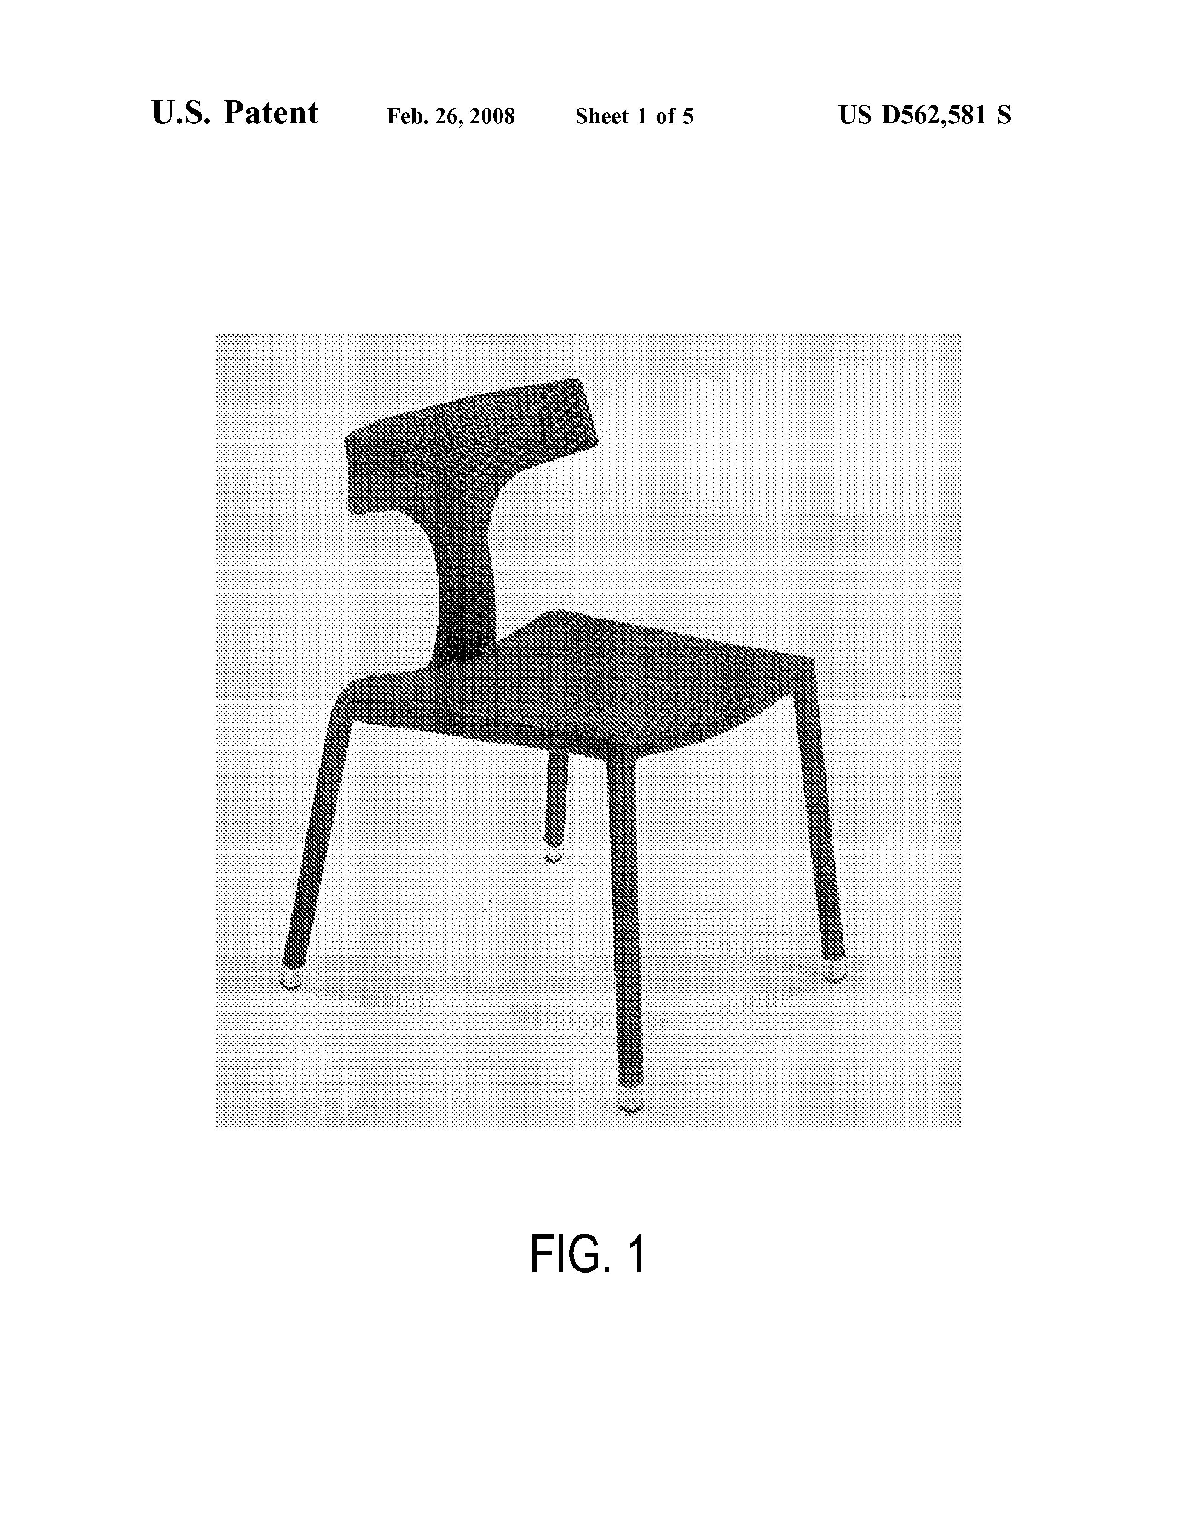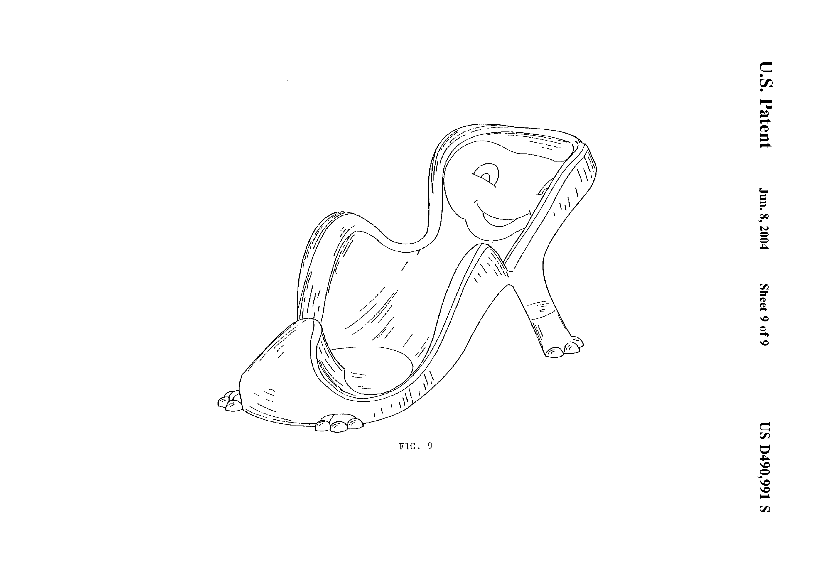
USPTO classification:
D6/369 Interlaced or lashed components, D6/333 Restraining seat or
D6/374 Seat or backrest formed of unitary portable support for juvenile
material D6/359 Seating unit simulative

UKIPO classification:
06 01 08 Cane and wicker chairs, 06 01 11E Child car seats, boosters
06 01 10C Hard dining and garden chairs

Classification according to the proposal:
06-02 XB, XI Chairs, visible texture, unwoven fabrics 06-01 A1 WDc YCg Seats for babies, animal shape, face ornamentation

The Classification of Design Patents of the Patent and Trademark Office of the USA is integral part of the Patent Classification. The Classification has a hierarchical scheme. A unique position in one of particular sub-classes is assigned to each design. The Classification is equipped with a developed system of references and notes. It is divided into 33 main classes (similar to the main classes of the International Classification) according to the function or intended use of the product, in which the design is to be embodied. On the contrary to the International Classification each main class incorporates several hundred sub-classes of different levels, which reflect the special function or distinctive appearance feature of the design. Individual classes and sub-classes should be mutually exclusive. To achieve this goal, the classification is equipped with exclusion notes. Simulative sub-classes are established for products imitating other products. Since 1997 the USPTO has been furnishing the bibliography of designs registrations with Locarno classmark.
The USPTO classification must be permanently updated to create new sub-classes for newly coming designs, which cannot be associated with any existing sub-class. The number of references and exclusion or search notes makes the system complicated. The maintenance of the system is demanding.

UKIPO uses Locarno Classification and adds more detail levels.

Advantages of the Proposed System:
- single classification;
- classification of appearance features of designs;
- flexibility in searches – use of individual parts and combinations of classmarks
- reliable searches according to thesauri terms;
- flexibility of the classification in terms of further enlargement and completion;

The Conclusion
The proposal does not provide for a complete solution. The intention is to show one way of possible development. It strives to consider the appearance features of designs as much as possible, and to simplify and clarify the classification of designs. The system is flexible, the thesaurus should form the unique collection of terms on designs and relations between them. Implementation of such a tool could lead to founding a methodology centre, which would create and manage the thesaurus and classification. It could also provide help to classifiers via electronic mail and issue guidelines and samples of classified designs to build up good practice.
More studies on the proposal are needed. It is impossible to find a perfect solution but our goal should be to try to provide a reliable and predictable mechanism, which would fulfil needs of professionals as well as broad public.

